

A Project Report

On

**“AN INTELLIGENT IOT BASED WATER QUALITY MONITORING SYSTEM USING ARDUINO AND TURBIDITY SENSOR NETWORKS”**

Batch Details

|  |  |  |
| --- | --- | --- |
| Sl. No. | Roll Number | Student Name |
| 1 | 202021CEI0009 | N. BHARATH |
| 2 | 20201CEI0007 | DADA LAKSHMI CHARAN |
| 3 | 20201CEI0073 | K. JYOTHIKA REDDY |

**School of CSE And IS**

**Presidency University, Bengaluru**

Under the guidance of,

**Dr. SASIDHAR BABU SUVANAM**

Professor

School of Computer Science and Engineering

Presidency University, Bengaluru

**CONTENTS**

1. Introduction about Project
2. Literature Review
3. Objectives

## Methodology

1. Timeline for Execution of Project
2. Expected Outcomes
3. Conclusion
4. References

**ABSTRACT**

Wireless communication developments are creating new sensor capabilities. The current developments in the field of sensor networks are critical for environmental applications. Internet of Things (IoT) allows connections among various devices with the ability to exchange and gather data. IoT also extends its capability to environmental issues in addition to automation industry by using industry 4.0.

As water is one of the basic needs of human survival, it is required to incorporate some mechanism to monitor water quality time to time. Around 40% of deaths are caused due to contaminated water in the world. Hence, there is a necessity to ensure supply of purified drinking water for the people both in cities and villages. Water Quality Monitoring (WQM) is a cost-effective and efficient system designed to monitor drinking water quality which makes use of Internet of Things (IoT) technology.

the proposed system consists of several sensors to measure various parameters such as pH value, the turbidity in the water, level of water in the tank, temperature and humidity of the surrounding atmosphere. And also, the Microcontroller Unit (MCU) interfaced with these sensors and further processing is performed at Personal Computer (PC). The obtained data is sent to the cloud by using IoT based ThinkSpeak application to monitor the quality of the water.

**KEYWORDS**

Water treatment, WQM, Temperature, Wireless communication, Turbidity, Humidity, pH, MCU, IoT

1. **INTRODUCTION**

In the 21st century, there were lots of inventions, but at the same time were pollutions, global warming and so on are being formed, because of this there is no safe drinking water for the world’s pollution. Nowadays, water quality monitoring in real time faces challenges because of global warming limited water resources, growing population, etc.

Hence there is need of developing better methodologies to monitor the water quality parameters in real time. The water quality parameters pH measures the concentration of hydrogen ions. It shows the water is acidic or alkaline. Pure water has 7pH value, less than 7pH has acidic, more than 7pH has alkaline. The range of pH is 0-14 pH. For drinking purpose it should be 6.5-8.5pH. Turbidity measures the large number of suspended particles in water that is invisible. Higher the turbidity higher the risk of diarrhea, cholera. Lower the turbidity then the water is clean. Temperature sensor measures how the water is, hot or cold. Flow sensor measures the flow of water through flow sensor.

The traditional methods of water quality monitor involves the manual collection of water samples from different locations. Water pollution is one of the biggest fears for the green globalization. In order to ensure the safe supply of the drinking water the quality needs to be monitor in real time. We present a design and development of a low cost system for real time monitoring of the water quality in IOT (internet of things). The system consist of several sensors is used to measuring physical and chemical parameters of the water. The parameters such as temperature, PH, turbidity, flow sensor of the water can be measured. The measured values from the sensors can be processed by the core controller. The Arduino model can be used as a core controller. Finally, the sensor data can be viewed on internet using WI-FI system. To analyze the water supply selected data when the impurities in the water gets detected, when the value is beneath preset level, then apprehension is automatically raised. Using dissimilar tools the impurity aaccumulation in water be investigated imminent compatibility and actions.

1. **LITERATURE REVIEW**

1) Nikhil Kedia entitled **“Water Quality Monitoring for Rural Areas-A Sensor Cloud Based Economical Project.”** Published in 2015 1st International Conference on Next Generation Computing Technologies (NGCT-2015) Dehradun, India.

Review: This paper highlights the entire water quality monitoring methods, sensors, embedded design, and information dissipation procedure, role of government, network operator and villagers in ensuring proper information dissipation. It also explores the Sensor Cloud domain. While automatically improving the water quality is not feasible at this point, efficient use of technology and economic practices can help improve water quality and awareness among people.

2] Jayti Bhatt,Jignesh Patoliya entitled **“Real Time Water Quality Monitoring System”.**

Review: This paper describes to ensure the safe supply of drinking water the quality should be monitored in real time for that purpose new approach IOT (Internet of Things) based water quality monitoring has been proposed. In this paper, we present the design of IOT based water quality monitoring system that monitor the quality of water in real time. This system consists some sensors which measure the water quality parameter such as pH, turbidity, conductivity, dissolved oxygen, temperature.

3]Michal Lom, Ondrej Pribyl, Miroslav Svitek entitled **“Industry 4.0 as a Part of Smart Cities”.**

Review:This paper describes the conjunction of the Smart City Initiative and the concept of Industry 4.0. The term smart city has been a phenomenon of the last years, which is very inflected especially since 2008 when the world was hit by the financial crisis. The main reasons for the emergence of the Smart City Initiative are to create a sustainable model for cities and preserve quality of life of their citizens.

**4]** Sokratis Kartakis, Weiren Yu, Reza Akhavan, and Julie A. McCann entitled **“Adaptive Edge Analytics for Distributed Networked Control of Water Systems”**

Review: This paper presents the burst detection and localization scheme that combines lightweight compression and anomaly detection with graph topology analytics for water distribution networks. We show that our approach not only significantly reduces the amount of communications between sensor devices and the back end servers, but also can effectively localize water burst events by using the difference in the arrival times of the vibration variations detected at sensor locations. Our results can save up to 90% communications compared with traditional periodical reporting situations.

**5]“Multiple linear regression on water quality parameter modeling detect hexavalent chromium in drink water”** K. Sri Dhivya Krishnan, P.T.V. Bhuvaneswari (2017) signify that state in between pH, Total Dissolved Solidstate (TDS) and Conductivity H2O scheme Choice Parameters (WQPs).Author express those constant quantity will be involved find hexavalent chromium material solventdrinking H2Osystem. The author states the WQPs are obtained for four various hexavalent chromium unclean sample distribution through are search using pH, TDS and conduction sensing component. With use countless accrual figuring calculated principles using numerous sample distribution estimate of WQPs computed. Authorearly the Multiple Linear Regression (MLR) mode used to normalize the co-relational statistics among the considered WQPs. According to the outcome the errors between the actual and estimation the results can be finalized in graphical illustration. The author state that they found figuring values are closer to metric values and the calculation errors lie between 0.33% and 19.18%.

6]"**Design and implementation of cost-effective water quality evaluation system"** by Md. Omar Faruq, Injamamul Hoque Emu, and Md. Nazmul Haque (2017) proposed an Avatarlow cost vastly practiced H2O choice observation system. Authors state scheme is a microcontroller based system with higher degree of accuracy. Authors mainly regulate different parametric quantity of H2O such as temperature, turbidity, potential hydrogen (pH). This system method makes possible to find the sensor values and display it on LCD.

**3.Existing system**

Sensors to detect the hydrocarbons, chemical and metal content in the soil can be combined into a soil tentative and for monitoring the soil quality and waste material content. And sensors for detection pH, conduction, liquid oxygen, turbidity, etc. can be used for measurement the water quality in the rivers, ponds, lakes etc.

Since the work is already done with the detection component like temperature sensor, pH sensor, and few has to check manual short text down the outcome that's been displayed in LCD. And it make more time consumption to note down the results of the improvement quantity that displayed. And it take more time to create the all-purpose results of the change of state processes.

**Advantages**

1. Real-time Monitoring: IoT-based water quality monitoring allows for real-time data collection and analysis, providing immediate feedback on the water quality status. This is crucial for timely response to contamination or quality issues.
2. Cost-effective: Arduino-based systems are generally affordable and can be deployed in various locations, making it cost-effective for large-scale water quality monitoring.
3. Scalability: You can easily expand the sensor network to cover a wider area or more monitoring points by adding more Arduino-based sensors, making it scalable to meet specific requirements.
4. Remote Access: With IoT connectivity, you can access water quality data remotely via the internet. This makes it convenient for users to check the status of water quality without being physically present at the monitoring site.
5. Data Analytics: The collected data can be processed and analyzed using various algorithms and tools to identify patterns and trends in water quality, helping in making informed decisions and predictions.
6. Early Warning System: An intelligent system can trigger alerts or notifications when water quality falls below predefined thresholds, allowing for immediate corrective actions.
7. Integration with Other Systems: IoT-based water quality monitoring systems can be integrated with other environmental monitoring systems, water treatment facilities, or data management platforms for comprehensive analysis.
8. Energy Efficiency: Arduino boards can be configured to operate on low power, making the system energy-efficient, which is essential for remote or off-grid locations.

**Limitations**

1. Sensor Accuracy: The accuracy and reliability of the turbidity sensors and other components used in the system may vary. Calibration and maintenance are crucial to ensure accurate measurements.

2. Power Supply: Ensuring a stable power supply in remote or outdoor locations can be challenging. Solar panels and battery solutions may be required for long-term, off-grid deployments.

3. Connectivity: The system relies on an internet connection for data transmission. In remote areas or locations with poor network coverage, connectivity issues may arise.

4. Data Security: Protecting the collected data from cyber threats and unauthorized access is essential, and this may require additional security measures and protocols.

5. Maintenance: Regular maintenance is necessary to ensure sensors are functioning correctly, and data quality is maintained over time.

6. Initial Setup: Setting up the system, including sensor deployment, calibration, and network configuration, can be complex and time-consuming.

7. Environmental Factors: Environmental conditions, such as extreme temperatures or water turbidity changes due to weather events, can impact sensor performance and data accuracy.

8. Cost of Implementation: While Arduino-based systems are relatively affordable, the cost of implementing a full-scale water quality monitoring network can still be significant, including sensor costs, infrastructure, and data management.

**4.Proposed Method**

The proposed system uses four sensors which are pH, turbidity, ultrasonic, DHT-11, microcontroller unit as the main processing module and one data transmission module ESP8266 Wi-Fi module (NodeMCU). The microcontroller unit is a significant part of the system developed for water quality measurement because The Arduino Mega consumes low power, and it is a small size, where the size is a good use for a crucial point-of-sale technology criterion.

Among four sensors, two of the sensors collect the data in the form of analog signals; the MCU has an on-chip ADC that translates the sensor analog signals into the digital format for further study. So, to get this analog output from the sensor, the sensor's analog output of will be connected to the MCU's analog pins. Whereas the other two sensors output directly connected to the digital pins of the MCU units. All the sensors data processed by the MCU and updated to the ThingSpeak server using the Wi-Fi data communication module ESP8266 (NodeMCU) to the central server.

**5 .OBJECTIVES**

1. **Ensuring Safe Drinking Water and Real-time Monitoring** : The primary objective is to ensure that the water purifier consistently provides safe and clean drinking water to the residents of the home. This includes monitoring for contaminants such as bacteria, viruses, heavy metals, and other harmful substances in the input water and ensuring they are effectively removed in the output water. To provide real-time monitoring of water quality. This allows homeowners to have immediate information about the safety of the water they are consuming.
2. **Early Detection of Contaminants and Energy Efficiency**: Detect contaminants or changes in water quality early, allowing for timely maintenance and replacement of purification components to prevent health risks. Optimize energy usage by the water purifier by only activating the purification process when necessary. For instance, the system could detect when water quality is below a certain threshold and activate purification accordingly.
3. **Water Conservation and User Alerts**: Promote water conservation by ensuring that the water purifier is only treating water that actually requires purification. This is especially relevant in areas facing water scarcity. Notify homeowners when the water quality falls below acceptable levels or when the purification system requires maintenance or replacement of filters. This ensures that users are aware of potential issues and can take corrective action.

**6. METHDOLOGY**

**Hardware Components**:

1. Arduino Boards: Arduino microcontrollers, such as the Arduino Uno or Arduino Mega, are commonly used to interface with the sensors, collect data, and control the system.

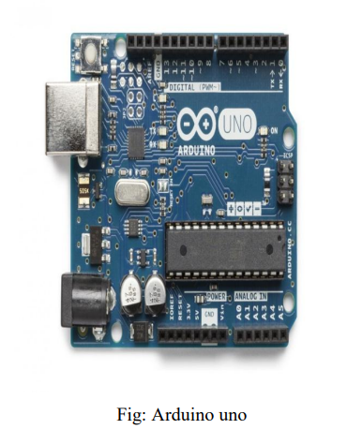

1. Turbidity Sensors: Turbidity sensors are essential for measuring the cloudiness or haziness of the water, which is an indicator of water quality. Various turbidity sensors are available, including optical and nephelometric sensors.

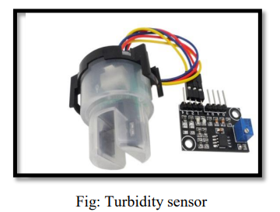

1. IoT Communication Modules: To enable data transmission and remote monitoring, IoT communication modules like Wi-Fi modules (e.g., ESP8266), GSM/3G/4G modules, or LoRa modules are used to connect the Arduino boards to the internet or a local network.
2. Power Supply: Depending on the deployment location, you may need a stable power source. This can include batteries, solar panels, or other power solutions to ensure continuous operation.
3. Wifi module: The ESP8266 WiFi Module is a self-contained SOC with integrated TCP/IP protocol stack that can give any microcontroller access to your WiFi network. The ESP8266 is capable of either hosting an application or offloading all Wi-Fi networking functions from another application processor. Each ESP8266 module comes pre-programmed with an AT command set firmware. The ESP8266 module is an extremely cost-effective board with a huge, and ever growing, community.

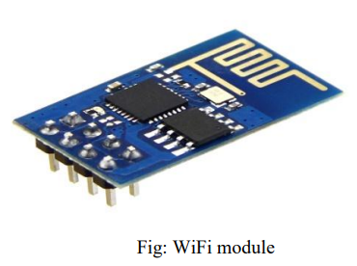

1. Data Storage and Logging: Some systems may use microSD cards or other data storage solutions to log data locally in case of network outages.
2. pH sensor: The pH of a solution is the measure of the acidity or alkalinity of that solution. The pH scale is a logarithmic scale whose range is from 0-14 with a neutral point being 7. Values above 7 indicate a basic or alkaline solution and values below 7 would indicate an acidic solution. It operates on 5V power supply and it is easy to interface with arduino. The normal range of pH is 6 to 8.5.

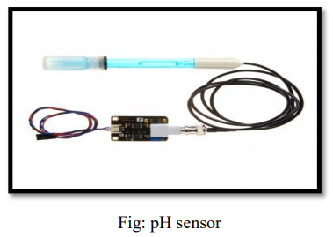

1. Temperature sensor: Water Temperature indicates how water is hot or cold. The range of DS18B20 temperature sensor is -55 to +125 °C. This temperature sensor is digital type which gives accurate reading.

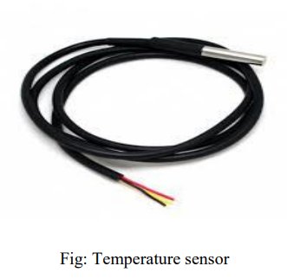

1. Flow sensor: Flow sensor is used to measure the flow of water through the flow sensor. This sensor basically consists of a plastic valve body, a rotor and a Hall Effect sensor. The pinwheel rotor rotates when water / liquid flows through the valve and its speed will be directly proportional to the flow rate. The Hall Effect sensor will provide an electrical pulse with every revolution of the pinwheel rotor.

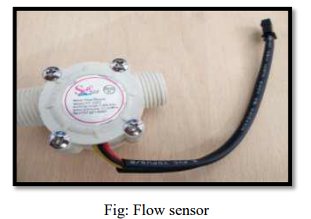

**Software Components**

1. Arduino IDE: The Arduino Integrated Development Environment (IDE) is used for programming the Arduino boards. You can write and upload the firmware (code) to collect and process data from the sensors.

2. Sensor Libraries: Depending on the type of turbidity sensor and other sensors used, you may need specific sensor libraries or drivers to interface with the hardware and collect data.

3. IoT Platform: An IoT platform or cloud service, such as AWS IoT, Azure IoT, or ThingSpeak, is used for data storage, analysis, and remote access. These platforms allow you to visualize data, set alerts, and access data through web or mobile applications.

4. Data Analysis and Visualization Tools: You may use data analysis and visualization tools, such as Python with libraries like pandas, matplotlib, or data visualization dashboards like Grafana or Tableau, to analyze and present the collected data.

5. Mobile/Web Applications: To provide user-friendly interfaces for accessing water quality data, mobile apps and web applications can be developed to display real-time data, alerts, and historical records.

6. Alerting and Notifications: Software components can be configured to send alerts and notifications (email, SMS, etc.) when water quality parameters fall below acceptable levels.

7. Remote Control: Some systems may include software components that allow for remote control and adjustments of the monitoring system settings.

8.Security and Authentication: Implementing security measures to protect data and access to the system is crucial. This may include authentication, encryption, and access control mechanisms

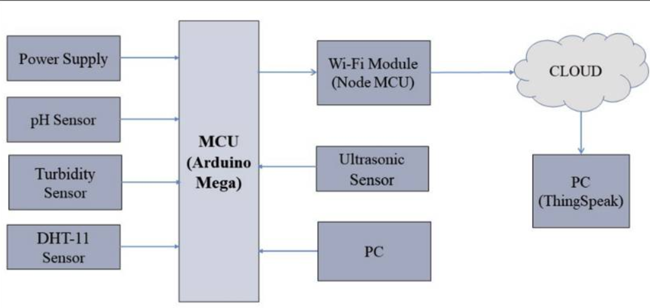

FIG: The block diagram of the system proposed for water quality measurement

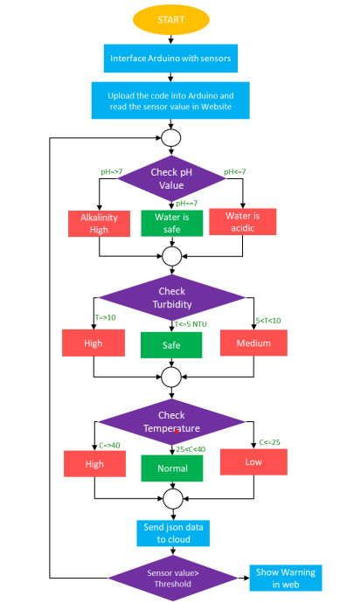

Fig: Flow chart

**Select Sensors**: Choose appropriate sensors to measure key water quality parameters like pH, turbidity, total dissolved solids (TDS), temperature, and conductivity.

**IoT Hardware**: Select suitable IoT hardware, such as microcontrollers (e.g., Arduino or Raspberry Pi) and connectivity modules (Wi-Fi, Bluetooth, etc.).

**Data Acquisition**: Connect the sensors to the IoT hardware to collect data. You may need analog-to-digital converters for some sensors.

**Data Transmission**: Send the collected data to a central server or cloud platform using MQTT, HTTP, or other suitable protocols.

**Cloud Platform**: Utilize a cloud platform (e.g., AWS IoT, Azure IoT, or Google Cloud IoT) to manage and store data. Set up a database to store water quality information.

**Web Architecture**

First, we achieved data from sensor and send it to Firebase. The Firebase process the data and prepare into JSON format for showing into the section in Website. We are going to discuss about how firebase database work in Real-time and we used the technologies which is more efficient even in slow data rate. The quick organization system must be quick and simple to convey and keep up.

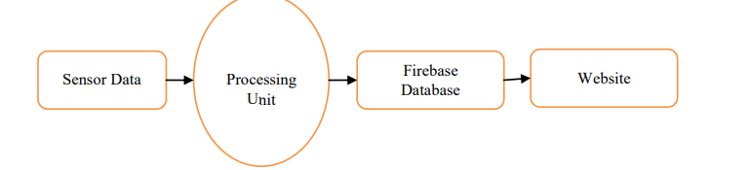

FIG: Diagram of System to Web Dataflow

**Circuit Diagram**

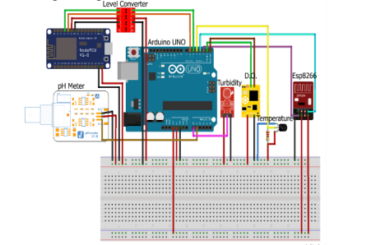

1. **OUTCOMES**

* **Improved Water Safety**: Enhanced monitoring and real-time data analysis can lead to safer drinking water by detecting and mitigating contaminants and impurities more effectively.
* **Consistent Water Quality**: Homeowners can expect a consistent and high level of water quality, ensuring that the water purifier consistently delivers clean and safe water.
* **Early Detection of Contaminants**: The system's ability to detect contaminants early allows for timely maintenance and component replacement, reducing health risks associated with poor water quality.
* **Energy Efficiency**: Optimization of energy usage results in cost savings and a reduced environmental footprint. Homeowners can expect lower utility bills.

**7. TIMELINE OF THE PROJECT/ PROJECT EXECUTION PLAN**

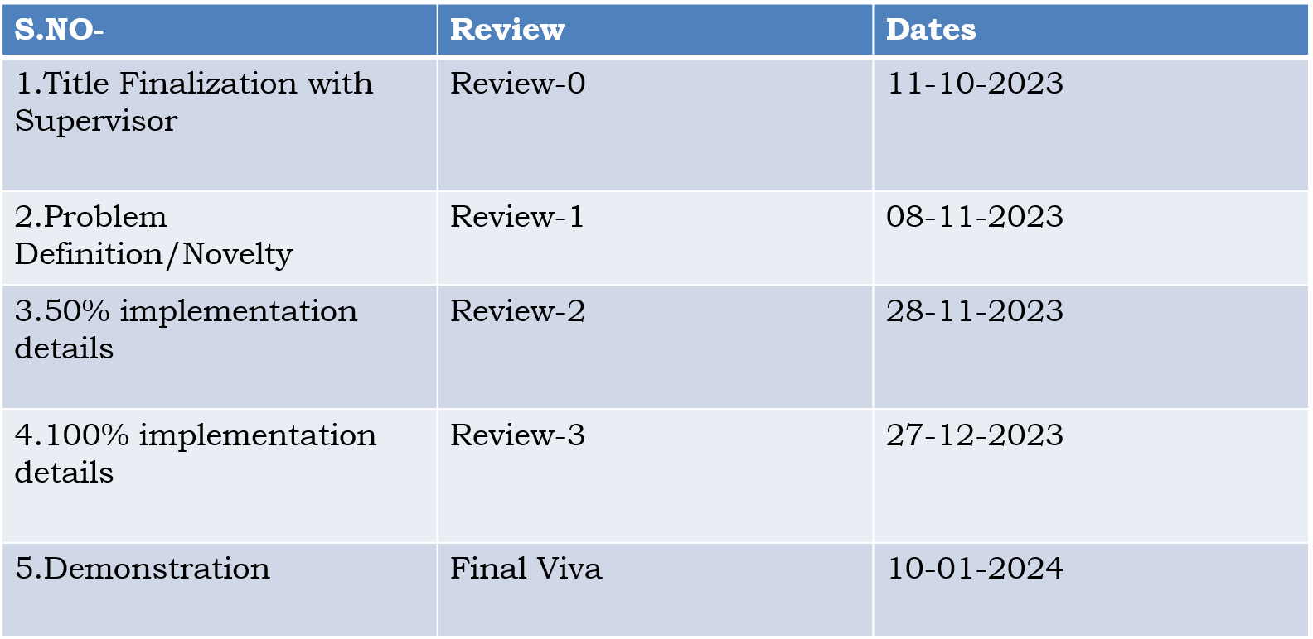

**8. CONCLUSION**

Monitoring of Turbidity, PH & Temperature of Water makes use of water detection sensor with unique advantage and existing GSM network. The system can monitor water quality automatically, and it is low in cost and does not require people on duty. So the water quality testing is likely to be more economical, convenient and fast. The system has good flexibility.

Only by replacing the corresponding sensors and changing the relevant software programs, this system can be used to monitor other water quality parameters. The operation is simple. The system can be expanded to monitor hydrologic, air pollution, industrial and agricultural production and so on. It has widespread application and extension value.

**REFERENCES**

[1] Yaroshenko, I.; Kirsanov, D.; Marjanovic, M.; Lieberzeit, P.A.; Korostynska, O.; Mason, A.; Frau, I.; Legin, A. Real-time water quality monitoring with chemical sensors. Sensors 2020, 20, 3432. [Google Scholar] [CrossRef]

[2] Ruchitra K, Reshma N, Seema LB, Sharanamma, Suvanam Sasidhar Babu, Water Quality Monitoring and Filter System to Preserve Water Resource Using IOT, Published by: The Mattingley Publishing Co., Inc, May-June 2020 ISSN: 0193-4120 Page No. 4156-4159.

[3] Varsha Lakshmikantha, Anjitha Hiriyannagowda, Akshay Manjunath, Aruna Patted, Jagadeesh Basavaiah∗ , Audre Arlene Anthony, IoT based smart water quality monitoring system, Global Transitions Proceedings 2 (2021)

[4] A. N. Prasad, K. A. Mamun, F. R. Islam and H. Haqva, "Smart Water Quality Monitoring System",*2nd Asia-Pacific World Congress on Computer Science and Engineering 1-6.-References-Scientific Research Publishing“*, 2021 IEEE.

[5] G. N. Satya Sai, R. Sudheer, K. S. Manikanta, S. G. Arjula, B. N. Rao and D. V. Sai Maneeswar Mutyala, "IoT based Water Quality Monitoring System," 2021 IEEE 9th Region 10 Humanitarian Technology Conference (R10-HTC), Bangalore, India, 2021, pp. 01-06, doi: 10.1109/R10-HTC53172.2021.9641630.

[6] K. Shanmugam, M. E. Rana, D. Tan Zi Xuen and S. Aruljodey, "Water Quality Monitoring System: A Smart City Application With IoT Innovation," 2021 14th International Conference on Developments in eSystems Engineering (DeSE), Sharjah, United Arab Emirates, 2021, pp. 571-576, doi: 10.1109/DeSE54285.2021.9719480.