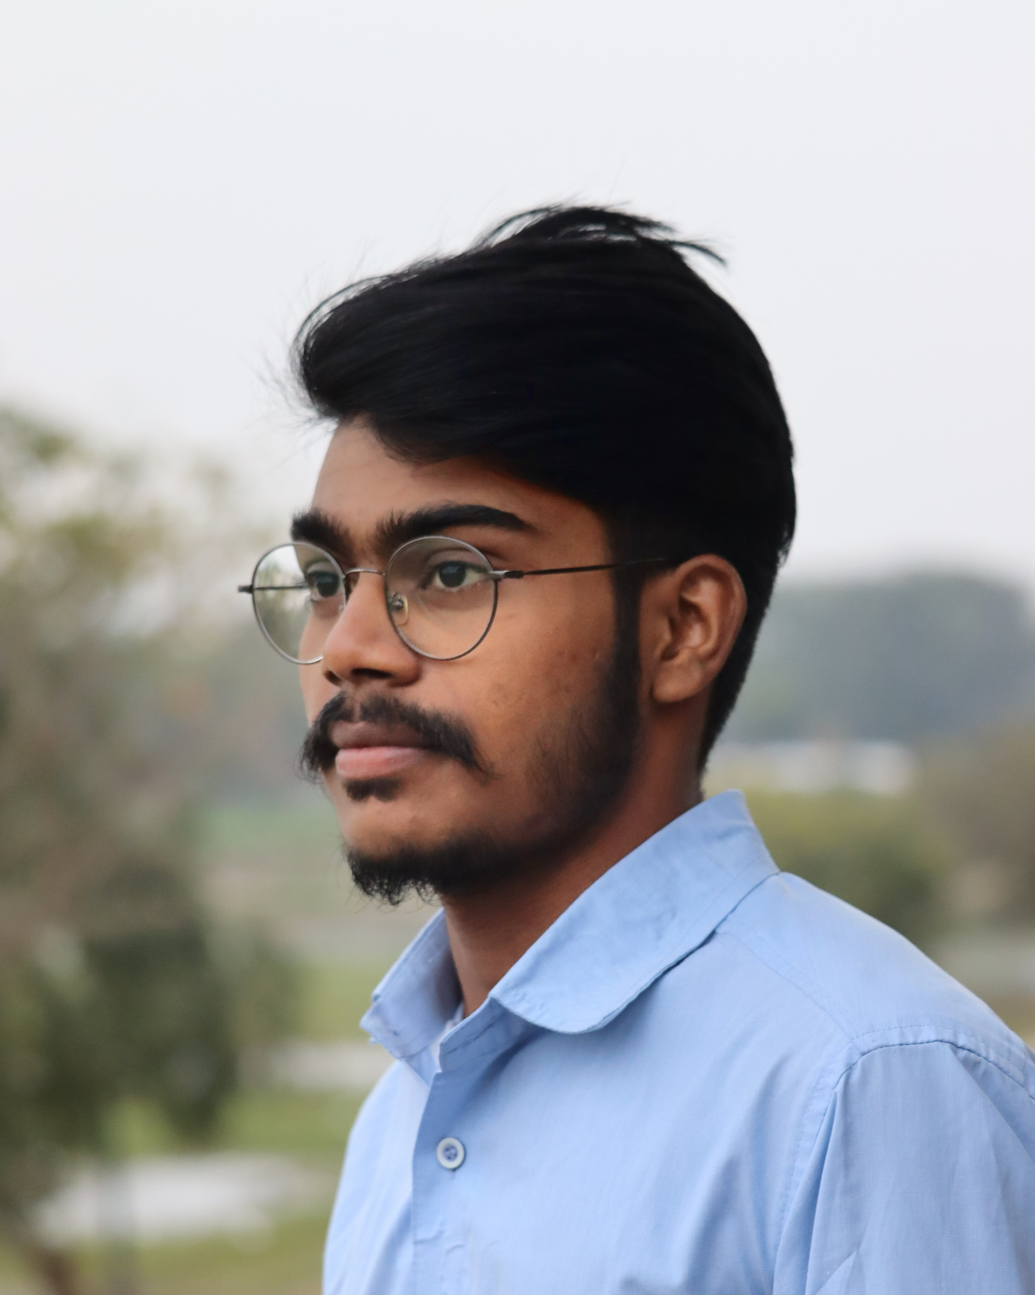

Bharath 9063408534 bharath1104@gmail.com

# About me

I love Python

# Work Experience

**QuickBooks** *2019-2020* media expert

**AmigoesCode** *2020-present*programmer