|  |  |
| --- | --- |
| clear()  setPenThickness(10)  setPosition(0, -250)  def hopForward() = {  val length = 25  forward(length)  hop(length)  }  // Type 'ColorMaker.' and then press Ctrl+Space to access around 70 predefined colors  setPenColor(ColorMaker.lightPink)  hopForward()  setPenColor(Color(51, 51, 255))  hopForward()  setPenColor(randomColor)  hopForward()  setPenColor(cm.darkMagenta)  hopForward()  setPenColor(cm.hsl(120, 1, 0.5))  hopForward() |  |

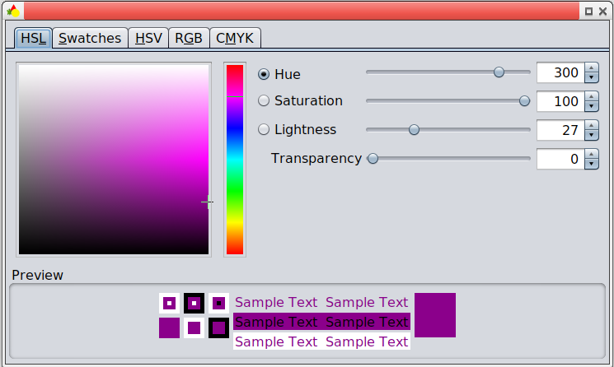// You can Ctrl+Click on a color in the script editor to bring up a color chooser (shown on the right).

// In the color chooser, you can:

// (1) choose the basic color (a number between 0 and 360) via the Hue slider. 0 is red, 120 is green, 240 is blue, and 360 is again red.

// (2) add gray to the color via the Saturation slider. 100 is the pure color; 50 is half color and half gray; 0 is fully gray.

// (3) add white or black to the color via the Lightness slider. 50 is the pure color; numbers greater than 50 add more and more white. Numbers less than 50 add more and more black.

// (4) Increse the transparency of the color via the Transparency slider.

# Diagram Description automatically generated with low confidenceWell Known Angles

# Exercises

# A picture containing accessory Description automatically generatedIcon Description automatically generatedA picture containing accessory, umbrella, vector graphics Description automatically generatedA picture containing fabric Description automatically generated

