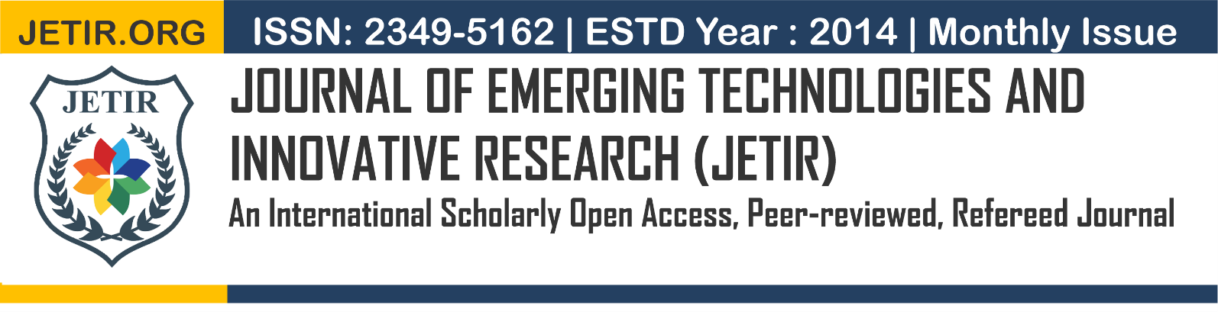
TASKMATE
A Smart Project Management and Collaborative Platform
¹K Arun Babu, ²S Bharath, ³T Durga Prasad, ⁴Y Deepika, ⁵V D Naga Prudhvi
¹Assistant Professor, ²Student, ³Student, ⁴Student, ⁵Student
¹Computer Science and Engineering,
¹Bapatla Engineering College, Bapatla, India
________________________________________________________________________________________________________

Abstract: Managing collaborative projects efficiently has become increasingly important for startups and academic teams. Traditional approaches, such as the use of multiple tools for communication, task tracking, and file sharing, often create coordination challenges. These fragmented workflows can lead to missed deadlines, duplicated work, and reduced accountability among team members. This paper presents TaskMate, a web-based project management and collaboration platform designed to address these issues. The system introduces a structured Workspace–Project–Task hierarchy, role-based access control, and real-time collaboration features to improve workflow organization. TaskMate enables users to manage projects, assign tasks, monitor progress, and communicate through a unified interface. The platform is developed using the MERN stack and incorporates technologies such as Socket.IO for real-time updates, node-cron for automated deadline notifications, and secure authentication mechanisms using JWT and bcrypt. In addition, the system provides features such as task tracking, file attachments, analytics dashboards, and activity logs to improve project transparency and productivity. By integrating multiple project management functionalities into a single platform, TaskMate helps teams coordinate tasks more efficiently and reduces the operational overhead associated with traditional project management methods.

IndexTerms - Project Management System, MERN Stack, Role-Based Access Control, Real-Time Collaboration, Task Management, Web-Based Collaboration Platform, Distributed Teams.

________________________________________________________________________________________________________

Introduction
Modern teamwork in software startups and academic research environments has increasingly shifted toward distributed and hybrid collaboration models. In such environments, the success of a project depends not only on individual technical expertise but also on the effectiveness of team coordination and workflow management.
As organizational workflows become more complex, teams rely heavily on digital tools for task tracking, communication, and progress monitoring. However, many teams still operate using fragmented tools such as email threads, spreadsheets, and separate file-sharing platforms.
This fragmentation creates significant coordination challenges. When project information is distributed across multiple systems, tracking real progress becomes difficult and often leads to coordination overhead, where team members spend excessive time updating task statuses rather than completing actual work. Traditional manual management methods also suffer from delayed communication, resulting in outdated project data, duplicated work, and reduced accountability.
To address these limitations, this paper presents TaskMate, a web-based project management and collaboration platform designed to streamline team workflows. The system organizes work through a scalable Workspace–Project–Task hierarchy, where workspaces contain projects that are further divided into tasks and subtasks. This structure enables teams to manage complex workflows in a clear and organized manner.
TaskMate integrates Role-Based Access Control (RBAC) to regulate user permissions by assigning roles such as Owner, Admin, and Member, ensuring secure management of project resources. The platform also incorporates real-time collaboration using WebSocket technology, enabling instant updates for task changes, notifications, and team communication.
Additionally, TaskMate includes an automated time-tracking and analytics engine that aggregates task-level activity into meaningful productivity insights. By combining workflow organization, secure access control, real-time synchronization, and performance monitoring within a single platform, TaskMate reduces coordination overhead and improves overall project transparency and efficiency.
Goals and Objectives
- To design a scalable Workspace–Project–Task architecture that organizes complex workflows and supports task delegation through subtasks and watchers.
- To implement real-time collaboration using Socket.IO, enabling instant chat, task updates, and automated deadline notifications using Node-cron scheduling.
- To develop a time-tracking aggregation system that converts task-level durations into project and workspace productivity analytics.
- To establish a secure system environment using Arcjet bot protection, Zod schema validation, bcrypt password hashing, and Role-Based Access Control (RBAC) with Multer-based file management.

related work
Bharamagoudar [1] discussed centralized and secure information management in web-based systems. TaskMate strengthens this concept by implementing schema validation, encrypted authentication, and bot protection mechanisms to ensure secure system operations.
Kavitha M. et al. [2] developed a web-based project management system for academic final-year projects that automates idea submission and evaluation workflows using MongoDB. However, the system operates within a fixed academic structure. TaskMate extends this approach through a flexible Workspace–Project–Task hierarchy supported by Role-Based Access Control (RBAC).
Nayak R. et al. [3] proposed an online student project management system using Django and PostgreSQL to improve coordination and progress tracking. Although effective for academic teams, the server-rendered architecture limits real-time interaction. TaskMate addresses this limitation through a React Single Page Application with WebSocket-based updates.Smith J. [4] demonstrated that real-time data tracking improves decision-making speed in project management systems. Inspired by this approach, TaskMate employs Socket.IO communication to synchronize task updates, notifications, and collaboration events instantly.
Garcia M. [5] emphasized the role of automated notifications in preventing missed deadlines within project management platforms. TaskMate incorporates this concept using a Node-cron scheduling mechanism that monitors deadlines and sends timely reminders to users.
Clark R. [6] highlighted the importance of data visualization for understanding project performance metrics. TaskMate addresses this requirement through interactive analytics dashboards that visualize task distribution and project progress.
Haddad R. T. [7] discussed Agile methodologies that promote iterative development and flexible workflow management. TaskMate aligns with these principles by supporting task workflow stages such as To Do, In Progress, and Done.
Brown A. [8] examined task decomposition techniques in project management and found that dividing large tasks into smaller subtasks improves accountability and resource allocation. TaskMate implements this approach through hierarchical task and subtask management.

existing system
Current project management approaches can generally be classified into three main categories.
A. Traditional Project Management Tools
Many organizations still rely on basic tools such as email, spreadsheets, and shared cloud storage for project coordination. These tools allow teams to communicate and track tasks at a basic level. However, because project information is distributed across multiple platforms, maintaining centralized task visibility and monitoring progress becomes difficult.
B. Standalone Task Management Platforms
Platforms such as Trello and Asana provide digital task boards and project tracking capabilities. These systems help teams organize tasks and monitor deadlines effectively. However, they often require additional integrations to support advanced workflow hierarchies, productivity analytics, and secure role-based access management.
C. Communication-Based Collaboration Tools
Communication platforms such as Slack and Microsoft Teams focus primarily on messaging and team interaction. Although they improve communication efficiency, they lack structured task management features, forcing teams to depend on separate systems for project tracking.
Limitations of Existing Systems
• Lack of centralized workflow management
• Limited real-time synchronization across project activities
• Fragmented communication and task tracking
• Weak role-based permission control
• Manual productivity monitoring and reporting

proposed system
To address the limitations of traditional project management approaches, the proposed system introduces TaskMate, a web-based collaboration platform designed to centralize task coordination, communication, and productivity monitoring. The platform integrates multiple project management functions into a single environment, reducing reliance on fragmented tools such as spreadsheets, email threads, and separate file-sharing services.
TaskMate organizes workflows through a hierarchical Workspace–Project–Task structure. A workspace represents a collaborative environment where teams operate together. Within each workspace, multiple projects can be created, and each project is further divided into tasks and subtasks, enabling complex activities to be managed in smaller and well-structured units. The system also incorporates Role-Based Access Control (RBAC), assigning roles such as Owner, Admin, and Member to ensure secure and controlled access to project resources.
To enhance collaboration efficiency, TaskMate integrates real-time communication and notification mechanisms using WebSocket technology. This allows instant synchronization of task updates, assignments, and comments without requiring manual page refreshes. The platform also includes automated deadline monitoring and reminders, helping team members stay aware of upcoming or overdue tasks.
In addition, TaskMate provides task tracking, file sharing, and productivity analytics through a unified dashboard. Features such as subtasks, watchers, comments, file attachments, and activity logs improve workflow transparency, while integrated time-tracking and visual analytics enable managers to monitor project progress and team productivity effectively.
By combining structured workflow management, secure access control, real-time collaboration, and performance analytics, TaskMate offers a comprehensive solution for managing projects in distributed teams and academic project environments.

system architecture
TaskMate follows a three-tier web application architecture consisting of a React client layer, a Node.js/Express application layer, and a MongoDB database layer. This architecture supports scalable collaboration, secure task management, and efficient data handling for distributed teams. Figure X illustrates the overall architecture of the TaskMate platform.
The system integrates supporting technologies such as Socket.IO for real-time communication, Node-cron for automated deadline monitoring, and Multer for file storage management, ensuring synchronized collaboration and reliable workflow execution.
A. Client Layer
The client layer is implemented using React.js, providing a responsive Single Page Application (SPA) interface for user interaction. It handles user-facing modules including authentication, workspace dashboards, project views, and task management interfaces.
The interface is organized into functional areas such as authentication, workspace management, project tracking, and analytics dashboards. API communication allows dynamic data retrieval and updates without full page reloads. Real-time collaboration is supported through Socket.IO connections, enabling instant updates for notifications, task changes, and activity logs. Visualization libraries are used to render project progress and task distribution within the analytics dashboard.
B. Application Layer (API Layer)
The application layer is built using Node.js and the Express.js framework, which provides RESTful APIs for handling system operations including authentication, workspace management, project and task processing, notifications, and file uploads.
Authentication is implemented using JSON Web Tokens (JWT) with bcrypt-based password hashing, while Zod schema validation ensures data integrity. The system also enforces Role-Based Access Control (RBAC), restricting actions based on user roles such as Owner, Admin, and Member.
Real-time collaboration is supported through an integrated Socket.IO server, enabling instant propagation of task updates, comments, and notifications. Additionally, Node-cron background services automatically monitor deadlines and generate reminders for upcoming or overdue tasks.
C. Database Layer
The persistence layer uses MongoDB, a NoSQL database that provides flexible and scalable data storage. Application data is organized into collections including Users, Workspaces, Projects, Tasks, Subtasks, Notifications, Attachments, Comments, and Activity Logs.
Indexes are used to optimize query performance for frequently accessed data such as user tasks and workspace projects. MongoDB’s aggregation capabilities are also utilized to support productivity analytics and time-tracking dashboards.

Methodology
The TaskMate platform is designed using a modular methodology that integrates secure authentication, hierarchical workflow management, real-time collaboration, and automated productivity monitoring. The following subsections describe the core mechanisms implemented in the system.
A. Authentication and Access Control
User authentication is implemented using JSON Web Tokens (JWT) combined with bcrypt-based password hashing to ensure secure credential storage. During registration, user inputs are validated using schema validation before being stored in the database.
After successful login, a JWT token is issued and attached to subsequent API requests. Middleware functions verify the token before granting access to protected routes. TaskMate also enforces Role-Based Access Control (RBAC), assigning roles such as Owner, Admin, and Member. Authorization middleware restricts sensitive actions including workspace configuration, project updates, and member management.
B. Hierarchical Workflow Management
TaskMate organizes project activities through a three-level hierarchy consisting of Workspaces, Projects, and Tasks. Workspaces represent collaborative environments where multiple projects can be created. Each project is further divided into tasks and subtasks to support granular workflow management.
Tasks contain metadata such as status, priority, due dates, and assigned users. Task progression follows a structured lifecycle consisting of To Do, In Progress and Done enabling teams to monitor project progress effectively.
C. Real-Time Communication and Notifications
TaskMate integrates Socket.IO-based WebSocket communication to enable real-time collaboration. The server maintains persistent connections with clients, allowing instant synchronization of task updates, comments, and notifications.
Whenever a user performs an action such as updating a task or posting a comment, an event is emitted and broadcast to relevant users. Notifications are stored in the database while simultaneously delivered to connected clients.

D. Automated Deadline Monitoring
An automated scheduling mechanism using Node-cron continuously monitors project and task deadlines. Scheduled jobs evaluate due dates and generate reminder notifications for upcoming tasks. Overdue tasks trigger escalation alerts to maintain project accountability.
This automated monitoring reduces manual supervision and helps teams adhere to project timelines.
E. File Management
TaskMate allows users to attach files or external links to tasks. File uploads are processed using Multer middleware, which stores files on the server and records metadata such as file name, path, type, and uploader information in the database. This approach ensures that project resources remain accessible within the context of their associated tasks.
F. Productivity Analytics
The platform includes a time-tracking and analytics module that aggregates task-level activity into project-level productivity metrics. These metrics are visualized through dashboard charts showing task distribution, completion status, and workload allocation. This enables project managers to monitor progress and identify potential bottlenecks.
G. Calendar-Based Visualization
TaskMate provides a calendar-based interface for visualizing upcoming deadlines and project schedules. Task due dates are synchronized with the calendar view, allowing users to track milestones more effectively. The interface adapts based on user roles, enabling administrators to monitor project timelines while members view their assigned tasks.

Technology Stack
The TaskMate platform was implemented using a modern full-stack web development architecture based on the MERN Stack. The system integrates multiple technologies to support authentication, real-time collaboration, task management, and analytics visualization. Table I summarizes the primary technologies and frameworks used during the development of the system.

Component | Technology Used | Purpose
Frontend | React.js + TypeScript | Development of a responsive Single Page Application interface
Backend | Node.js, Express.js | Server-side logic and RESTful API development
Database | MongoDB | Storage of project, task, and user data
Routing | React Router | Client-side navigation between application pages
Real-time Communication | Socket.IO | Instant task updates and notifications
Email Service | Nodemailer | Email verification and workspace invitations
Authentication | JWT, bcrypt | Secure authentication and password encryption
Validation | Zod | Schema validation and input verification
File Handling | Multer | Upload and management of task attachments
Scheduling | Node-cron | Automated monitoring of task deadlines
Data Visualization | Recharts | Dashboard charts and productivity analytics

Table I: Technology stack used in TaskMate

Results and Discussion

A. Dashboard and System Analytics
The TaskMate platform provides a centralized dashboard that displays key information about project activities, task distribution, and workspace productivity. The dashboard is accessible to all user roles (Owner, Admin, and Member), while role-based restrictions control access to certain administrative functions.
As shown in Fig. 1.1 & 1.2, the dashboard presents summary metrics such as total projects, total tasks, tasks in progress, and overall time worked. The system automatically updates analytics when the active workspace changes, ensuring that all statistics reflect the selected workspace.
The dashboard also includes visual analytics such as task trend graphs and project status charts, which help users monitor project progress and workload distribution.
Role-based access control is enforced within the interface. While all users can view dashboard analytics, only workspace owners can access workspace settings and archived projects, whereas administrators and members have restricted access to these options.
The interface also integrates calendar access, notifications, and theme switching for improved usability. The calendar highlights the current date and marks overdue activities according to user roles, enabling members to view overdue tasks, administrators to track project tasks, and owners to monitor overdue projects.
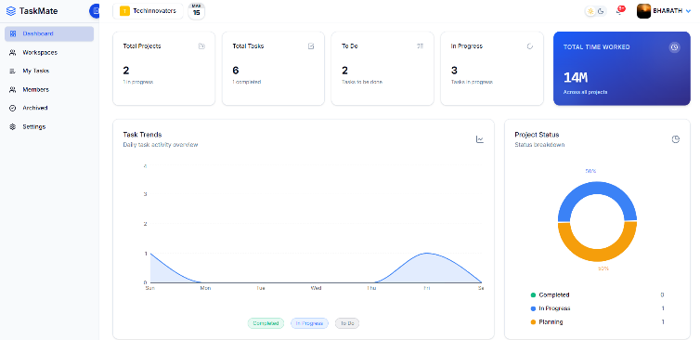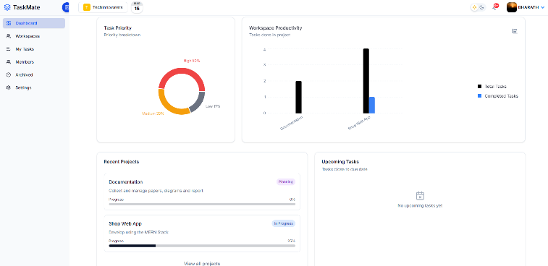
Fig 1.1 TaskMate Dashboard Fig 1.2 TaskMate Dashboard

Future Work
Although TaskMate provides a comprehensive project management solution, several enhancements can further improve the platform’s functionality and scalability.
A. Mobile Application Support
A dedicated mobile application can be developed to improve accessibility for users who prefer managing projects through smartphones or tablets. Cross-platform frameworks such as React Native could allow users to receive notifications, update tasks, and monitor project progress directly from mobile devices.
B. Intelligent Project Performance Insights
Future versions of TaskMate could introduce advanced performance analysis features that evaluate project timelines, task completion rates, and team productivity patterns. These insights could help project managers identify workflow bottlenecks and improve project planning.
C. AI-Based Task Recommendation
An AI-based recommendation system could be incorporated to suggest task assignments or prioritize activities based on team workload, deadlines, and historical performance patterns. Such intelligent assistance could improve task allocation and overall project efficiency.
D. External Tool Integration
Integration with external productivity and development tools, such as version control systems and third-party collaboration platforms, could expand the system’s functionality and enable smoother interoperability between different project management environments.

Conclusion
This study presented TaskMate, a web-based project management and collaboration platform designed to improve coordination and workflow transparency in distributed team environments. The system organizes activities through a structured Workspace–Project–Task hierarchy, enabling teams to manage projects and responsibilities in a scalable manner.
TaskMate integrates key functionalities such as role-based access control, real-time collaboration, task tracking, automated deadline notifications, and analytics dashboards. These features allow users to monitor project progress, communicate efficiently, and maintain accountability across team members.
The implementation results demonstrate that TaskMate successfully centralizes project coordination tasks that are typically distributed across multiple tools. By combining task management, communication, and analytics within a single platform, the system improves efficiency and supports effective collaboration in modern project environments.

Acknowledgment
The authors would like to thank the Department of Computer Science and Engineering, Bapatla Engineering College, for providing the necessary resources and support for this research. The authors also thank the placement cell staff and students who participated in the testing and evaluation of the system.

REFERENCES
[1] S. R. Bharamagoudar, “Web-Based Student Information Management System,” International Journal of Advanced Research in Computer and Communication Engineering, 2012.
[2] M. Kavitha et al., “Project Management Web App,” Journal of Emerging Technologies and Innovative Research (JETIR), vol. 8, no. 7, 2021.
[3] R. Nayak et al., “Online Student Project Management System,” JETIR, vol. 10, no. 10, 2023.
[4] J. Smith, “Real-Time Data Tracking in Project Management Systems,” International Journal of Project Management, 2018.
[5] M. Garcia, “Notifications and Alerts in Project Management: A User-Centric Approach,” International Journal of Project Management, 2021.
[6] R. Clark, “Automated Graph and Chart Generation for Data Visualization,” Journal of Data Science and Analytics, 2020.
[7] R. T. Haddad, “Agile Project Management: Best Practices and Methodologies,” Procedia Computer Science, 2017.
[8] A. Brown, “Task Decomposition in Project Management,” Project Management Journal, 2019.

