**NATIONAL INSTITUTE OF TECHNOLOGY, WARANGAL**

**TELANGANA,INDIA- 506004**

**CAR RENTAL SERVICE DATABASE MANAGEMENT PROJECT**

K NAGA RITVIK(21EEB0B26)

MARUPATLA BHARATH(21EEB0B40)

EEE 4TH YEAR(2024-25)

**—----------------------------------------------------------------------------------------------------------**

**PROBLEM STATEMENT**

In this project we have designed a database management system to store information about car services. The database contains important information about the car services available when searched and accessed by a customer.

This database contains the details of the offices, employees working in the office , specifications of the cars available with the office and also the insurance details of the vehicle. It also has the record of the customers such as customer details, address, gender and customer ID. This database also maintains the transaction details of reservations done by customers such as reservation date,reservation ID, pickup location, number of days of booking and their communication details (email etc).

This database helps the people or customers to choose the type of vehicle they want. It also helps the customers in advance booking of vehicles and keep a copy of transactions as this database also stores payment details.

**CONTENTS**

ER diagram

Tables

Functional Dependencies and Primary Key

Normalisation

Relational Schema

SQL Code

**TABLES:**

1. Employee
2. Office
3. Customer
4. Reservation
5. Vehicle
6. Insurance
7. Payment

**RELATIONS:**

1) Supervision

2)Deal_with

3)Works_on

4)Makes

5)Includes

6)Pays

7)Has

8)Choose

**ER MODEL ASSUMPTIONS**

1)Firstly customer will reserve the slot for the cab through the office.

2) After payment a cab is allotted for that customer.

3)Then customer can see the driver’s name and car number.

4)In these er model Insurance will depend on the Vehicle.

5) Similarly, Employee also depend on the Office.

**ER DIAGRAM**

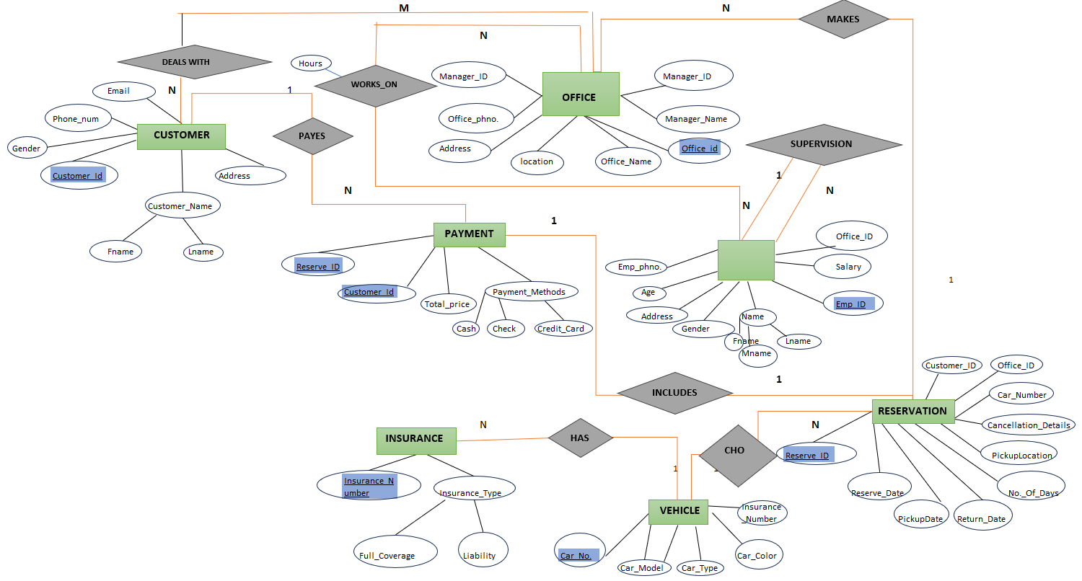

**RELATIONAL SCHEMA**

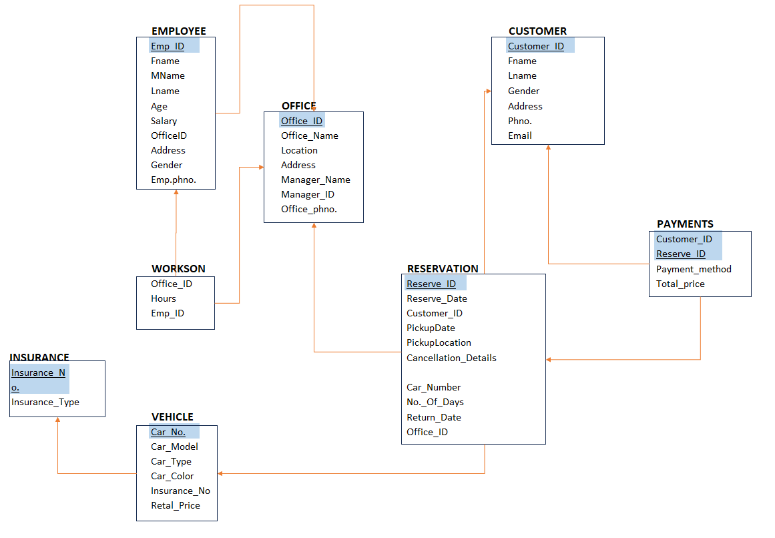

**FUNCTIONAL DEPENDENCIES AND PRIMARY KEYS.**

1)**OFFCE**

Office_ID -> {Manager_ID,Manager_Name,Office_Name,location,

Address,Office_No}

Since all fields depend on Office_ID,(Office_ID)+ -> R

Hence,Office_Id is primary key.

**2)EMPLOYEE**

Emp_ID ->{FName,MName,LName,Salart,Office_ID,Gender,

Address,Age,Emp_phno}

Since all fields depend on Emp_ID,(Emp_ID)+ -> R

Hence,Emp_Id is primary key.

**3)CUSTOMER**

Customer_ID ->{FName,LName,Address, ,Gender,Address,Age,

Phone_num,Email }

Since all fields depend on Customer_ID,(Customer_ID)+ -> R

Hence,Customer_Id is primary key.

**4)INSURANCE**

Insurance_number -> {Insurance_Type}

Since all fields depend on Insurance_number,( Insurance_number)+ -> R

Hence, Insurance_number is primary key.

**5) VEHICLE**

Car_no -> {Insurance_number,Car_Color,Car_Type,Car_Model}

I Since all fields depend on Insurance_number,(Insurance_number)+ -> R

Hence, Insurance_number is primary key.

**6)PAYMENT**

{Reserve_ID,Customer_ID} -> Total_Price,Payment_method

Since all fields depend on {Reserve_ID,Customer_ID}

( {Reserve_ID,Customer_ID})+ -> R

Hence, {Reserve_ID,Customer_ID} is primary key.

**7)RESERVATION**

Reserve_ID -> {Reserve_Date,pickupdate,Return_date,No_of_days,

pickup_Location,Car_no,Office_Id,Customer_ID}

I Since all fields depend on Reserve_ID,( Reserve_ID)+ -> R

Hence, Reserve_ID is primary key.

**NORMALISATION:**

1)**OFFCE**

Primary key: Office_ID

All attributes depend on the Office_ID,hence the table is 2NF.

All attributes depend directly on Office_ID, hence the table is in 3NF.

All determinants (Office_ID) are candidate keys, hence the table is in BCNF.

**2)EMPLOYEE**

Primary key: Emp_ID

All attributes depend on the Emp_ID, hence the table is 2NF.

All attributes depend directly on Emp_ID, hence the table is in 3NF.

All determinants (Emp_ID) are candidate keys, hence the table is in BCNF.

**3)CUSTOMER**

Primary key: Customer_ID

All attributes depend on the Customer_ID, hence the table is 2NF.

All attributes depend directly on Customer_ID, hence the table is in 3NF.

All determinants (Customer_Id) are candidate keys, hence the table is in BCNF.

**4)INSURANCE**

Primary key: Insurance_Number

All attributes depend on the Insurance_Number, hence the table is 2NF.

All attributes depend directly on Insurance_Number, hence the table is in 3NF.

All determinants (Insurance_Number) are candidate keys, hence the table is in BCNF.

**5) VEHICLE**

Primary key: Car_no

All attributes depend on the car_no, hence the table is 2NF.

All attributes depend directly on car_no, hence the table is in 3NF.

All determinants (car_no) are candidate keys, hence the table is in BCNF.

**6)PAYMENT**

Primary key: {Reserve_ID,Customer_ID}

All attributes depend on the {Reserve_ID,Customer_ID}, hence the table is 2NF.

All attributes depend directly on {Reserve_ID,Customer_ID}, hence the table is in 3NF.

All determinants ({Reserve_ID,Customer_ID}) are candidate keys, hence the table is in BCNF.

**7)RESERVATION**

Primary key: Reserve_ID

All attributes depend on the Reserve_ID, hence the table is 2NF.

All attributes depend directly on Reserve_ID, hence the table is in 3NF.

All determinants (Reserve_ID) are candidate keys, hence the table is in BCNF.

**TABLES**

**1) OFFICE**

|  |  |  |
| --- | --- | --- |
| **ATTRIBUTE** | **DATATYPE** | **CONSTRAINTS AND**  **CHARACTERISTICS** |
| Office_ID | INT | NOT NULL,PRIMARY KEY |
| Manager_ID | INT | NOT NULL |
| Manager_Name | VARCHAR(20) | NOT NULL |
| Office_name | VARCHAR(20) | NOT NULL |
| Location | VARCHAR(40) | NOT NULL |
| Address | VARCHAR(40) | NOT NULL |
| Office_phno | BIGINT | NOT NULL |

**2) EMPLOYEE**

|  |  |  |
| --- | --- | --- |
| **ATTRIBUTE** | **DATATYPE** | **CONSTRAINTS AND**  **CHARACTERISTICS** |
| Emp_ID | INT | NOT NULL,PRIMARY KEY |
| Fname | VARCHAR(20) | NOT NULL |
| Mname | VARCHAR(20) | NOT NULL |
| Lname | VARCHAR(20) | NOT NULL |
| Office_ID | INT | NOT NULL,FOREIGN KEY |
| Salary | INT | NOT NULL |
| Gender | VARCHAR(20) | NOT NULL |
| Address | VARCHAR(40) | NOT NULL |
| Age | INT | NOT NULL |
| Emp_phno | BIGINT | NOT NULL |

**3) CUSTOMER**

|  |  |  |
| --- | --- | --- |
| **ATTRIBUTE** | **DATATYPE** | **CONSTRAINTS AND**  **CHARACTERISTICS** |
| Customer_ID | INT | NOT NULL,PRIMARY KEY |
| Fname | VARCHAR(40) | NOT NULL |
| Lname | VARCHAR(40) | NOT NULL |
| Address | VARCHAR(40) | NOT NULL |
| Gender | VARCHAR(40) | NOT NULL |
| Phone_num | BIGINT | NOT NULL |
| Email | VARCHAR(30) | NOT NULL |

**4) INSURANCE**

|  |  |  |
| --- | --- | --- |
| **ATTRIBUTE** | **DATATYPE** | **CONSTRAINTS AND**  **CHARACTERISTICS** |
| Insurance_no | VARCHAR(20) | NOT NULL, PRIMARY KEY |
| Insurance_type | VARCHAR(20) | NOT NULL |

**5) VEHICLE**

|  |  |  |
| --- | --- | --- |
| **ATTRIBUTE** | **DATATYPE** | **CONSTRAINTS AND**  **CHARACTERISTICS** |
| Car_no | VARCHAR(20) | NOT NULL, PRIMARY KEY |
| Car_model | VARCHAR(20) | NOT NULL |
| Car_type | VARCHAR(20) | NOT NULL |
| Car_color | VARCHAR(20) | NOT NULL |
| Insurance_no | VARCHAR(20) | NOT NULL, FOREIGN KEY |

**6) RESERVATION**

|  |  |  |
| --- | --- | --- |
| **ATTRIBUTE** | **DATATYPE** | **CONSTRAINTS AND**  **CHARACTERISTICS** |
| Reserve_ID | INT | NOT NULL, PRIMARY KEY |
| Reserve_date | DATE | NOT NULL |
| Pickupdate | DATE | NOT NULL |
| Return_date | DATE | NOT NULL |
| No_of_days | DATE | NOT NULL |
| Pickup_location | VARCHAR(40) | NOT NULL |
| Car_no | VARCHAR(20) | NOT NULL,FOREIGN KEY |
| Office_ID | INT | NOT NULL, FOREIGN KEY |
| Customer_ID | INT | NOT NULL, FOREIGN KEY |

**7) PAYMENT**

|  |  |  |
| --- | --- | --- |
| **ATTRIBUTE** | **DATATYPE** | **CONSTRAINTS AND**  **CHARACTERISTICS** |
| Reserve_ID | INT | NOT NULL, FOREIGN KEY |
| Customer_ID | INT | NOT NULL, FOREIGN KEY |
| Total_price | INT | NOT NULL |
| Payment_method | VARCHAR(20) | NOT NULL |

**8) WORKS_ON**

|  |  |  |
| --- | --- | --- |
| **ATTRIBUTE** | **DATATYPE** | **CONSTRAINTS AND**  **CHARACTERISTICS** |
| Office_ID | INT | NOT NULL, FOREIGN KEY |
| Emp_ID | INT | NOT NULL, FOREIGN KEY |
| Hours | INT | NOT NULL |

**SQL CODE**

create table OFFICE(

office_ID int primary key,

manager_ID int,

manager_name varchar(20),

office_name varchar(20),

location varchar(40),

address varchar(40),

office_phno bigint

);

create table EMPLOYEE(

emp_ID int primary key,

fname varchar(20),

mname varchar(20),

lname varchar(20),

office_ID int,

salary int,

gender varchar(20),

address varchar(40),

age int,

emp_phno bigint,

foreign key (office_ID) references OFFICE(office_ID)

);

create table CUSTOMER(

customer_ID int primary key,

fname varchar(20),

lname varchar(20),

address varchar(40),

gender varchar(20),

phone_num bigint,

email varchar(30)

);

create table INSURANCE(

insurance_no varchar(20) primary key,

insurance_type varchar(20)

);

create table VEHICLE(

car_no varchar(20) primary key,

car_model varchar(20),

car_type varchar(20),

car_color varchar(20),

insurance_no varchar(20),

foreign key(insurance_no) references INSURANCE(insurance_no)

);

create table RESERVATION(

reserve_ID int primary key,

reserve_date date,

pickupdate date,

return_date date,

no_of_days int,

pickuplocation varchar(40),

car_no varchar(20),

office_ID int,

customer_ID int,

foreign key(car_no) references VEHICLE(car_no),

foreign key(office_ID) references OFFICE(office_ID),

foreign key(customer_ID) references CUSTOMER(customer_ID)

);

create table PAYMENT(

reserve_ID int,

customer_ID int,

total_price int,

payment_method varchar(20),

constraint composite_key primary key(reserve_ID,customer_ID),

foreign key(reserve_ID) references RESERVATION(reserve_ID),

foreign key(customer_ID) references CUSTOMER(customer_ID)

);

create table WORKS_ON(

office_id int,

emp_id int,

hours int,

foreign key(office_ID) references office(office_ID),

foreign key(emp_ID) references employee(emp_ID),

constraint composite_key_2 primary key(office_ID,emp_ID)

);

**OFFICE**

insert into office values(92,12,"Mohan","nice car1","near to busstand",

"4-5-8/5, mandi bazar,hyderabad",8555012459);

insert into office values(71,14,"Raju","soul car","Kukatpally",

"8-3-960/A, park road,hyderabad",7993523852);

insert into office values(39,19,"Ravi","Apna car","Gachibowli",

"3-9-290/2, Gandhi colony,hyderabad",7888781175);

insert into office values(45,11,"Hari","Sm cars","Ameerpet",

"10-5-2, VidyaNagar,hyderabad",9493999468);

insert into office values(64,8,"Ashok","SS travels","Hitech city",

"2/9/58,Janardhan Nagar,hyderabad",9246551381);

insert into office values(26,21,"Ajay","Multicabs","Dilsukhnagar",

"9CX4,7 Tombs road,hyderabad",9989786977);

insert into office values(81,34,"Krishna","Classic Travels","Jubilee Hills",

"8-2-682/A, Road No 12,hyderabad",9133100092);

insert into office values(11,16,"Ram","Car for share","LB Nagar","10-1-118/3,

Ganga Apartments,hyderabad",9054500002);

insert into office values(15,19,"Chakri","Miles by trip","RTC X Roads",

"45/24-R31-E, Sultan bazar,hyderabad",9550005780);

insert into office values(17,32,"Srujan","Blue Drive India","Secundarabad",

"19-5-28/8, Kishan Bagh,Secundrabad",9393464600);

Select * from OFFICE;

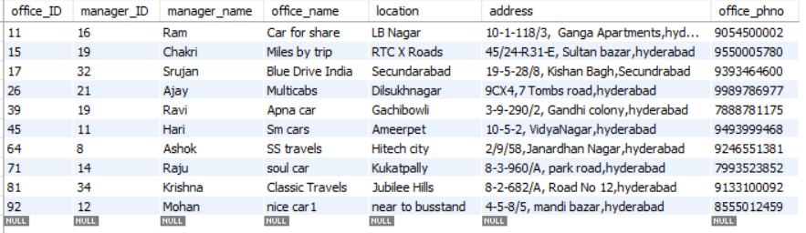

**EMPLOYEE**

insert into employee values (51,"Sravan","kumar","nagilla",92,70000,

"male","3-4-5/1, uppal,hyderabad",35,6303256748);

insert into employee values(101,"Rajat","Kumar","Sharma",71,72000,

"Male","Street No 1,Madhapur,hyderabad",32,6304414773);

insert into employee values(86,"Katta","Naga","Ritvik",39,65000,

"Male","12-2-830/A/151,Mehdipatnam,hyderabad",26,9701458038);

insert into employee values(54,"Manugonda","Raj","Kumar",45,80000,

"Male","5-9-88/A/1,Public Gardens,hyderabad",28,9392423308);

insert into employee values(73,"Vemunuri","Praneeth","Reddy",64,90000,

"Male","16-7-392/1,Malakpet,hyderabad",27,6302820365);

insert into employee values(22,"Hari","Kumar","Chopra",26,55000,

"Male","Santosh Nagar,hyderabad",30,9866236021);

insert into employee values(2,"Pentakota","Venkata","Siddharth",81,40000,

"Male","4-32-1494/1,kukatpally,hyderabad",31,8688265505);

insert into employee values(15,"N","Srinivas","Rahul",11,75000,

"Male","20-4-7,SriNagar Colony,hyderabad",33,9581304374);

insert into employee values(37,"V","Ganga","Charitha",15,45000,

"Female","Flat no 202,Pearls Residency,Gandipet",29,8309056805);

insert into employee values(40,"Aradhyula","Anjali","Devi",17,85000,

"Female","APSRTC Colony,hyderabad",24,7386152390);

insert into employee values(121,"N","Srinivas","Rahul",11,75000,

"Male","20-4-7,SriNagar Colony,hyderabad",33,9581304374);

insert into employee values(133,"V","Ganga","Charitha",15,45000,

"Female","Flat no 202,Pearls Residency,Gandipet",29,8309056805);

insert into employee values(140,"Aradhyula","Anjali","Devi",17,85000,

"Female","APSRTC Colony,hyderabad",24,7386152390);Select * from EMPLOYEE;

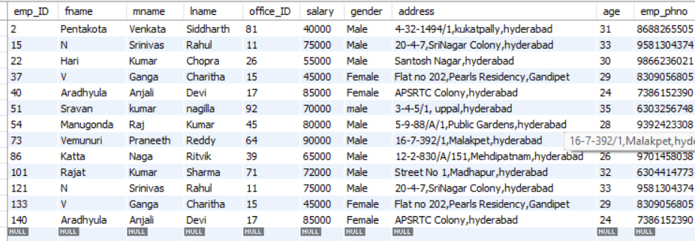

**CUSTOMER**

insert into customer(customer_ID,fname,lname,address,gender,phone_num,email)

values(1465,"Om","Parmar","Road No 27,Hitech city,hyderabad","male",6303296865,"parmar2341@gmail.com");

insert into customer(customer_ID,fname,lname,address,gender,phone_num,email)

values(2134,"Sanjeev","Sreenivas","Airport Road,hyderabad","male",8555078030,"sanjeev145@gmail.com");

insert into customer(customer_ID,fname,lname,address,gender,phone_num,email)

values(5632,"Ritesh","Kumar","Kollur hyderabad","male",7855214697,"ritesh1234@gmail.com");

insert into customer(customer_ID,fname,lname,address,gender,phone_num,email)

values(3675,"Ramesh","babu","2-3-4/A,gachibowli,hyderabad","male",6320155425,"ramesh@gmail.com");

insert into customer(customer_ID,fname,lname,address,gender,phone_num,email)

values(1987,"Rahul","verma","Street No 2,Ameerpet,hyderabad","male",7852146957,"rahul23@gmail.com");

insert into customer(customer_ID,fname,lname,address,gender,phone_num,email)

values(1234,"Jitesh","Singh","Road No 45,kukatpally,hyderabad","male",9852367418,"jiteshsinghr89@gmail.com");

insert into customer(customer_ID,fname,lname,address,gender,phone_num,email)

values(4650,"Manoj","Reddy","venkatadri towers,malakpet,hyderabad","male",7852146932,"manojr2@gmail.com");

insert into customer(customer_ID,fname,lname,address,gender,phone_num,email)

values(2677,"venkatesh","gupta","shine residency,kollur,hyderabad","male",7854126952,"venkygupta@gmail.com");

insert into customer(customer_ID,fname,lname,address,gender,phone_num,email)

values(3879,"V","Srinivas","banjara hills,hyderabad","male",7852146937,"srinsrinivas@gmail.com");

insert into customer(customer_ID,fname,lname,address,gender,phone_num,email)

values(6730,"Ajay","Kumar","gandipet,hyderabad","male",7855214569,"ajay1234@gmail.com");

SELECT * FROM CUSTOMER;

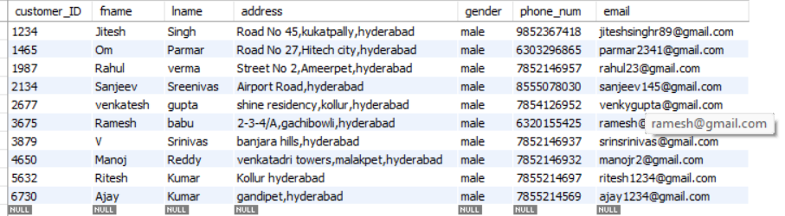

**INSURANCE**

insert into insurance(insurance_no,insurance_type)

values("LIC53223","Full coverage");

insert into insurance(insurance_no,insurance_type)

values("HDFC18972","Liability");

insert into insurance(insurance_no,insurance_type)

values("AIGIND91","Liabilty");

insert into insurance(insurance_no,insurance_type)

values("ICICI18139","Full Coverage");

insert into insurance(insurance_no,insurance_type)

values("MAXL8920","Liabilty");

insert into insurance(insurance_no,insurance_type)

values("KTKM3U42","Full Coverage");

insert into insurance(insurance_no,insurance_type)

values("SBIIND1429","Liability");

insert into insurance(insurance_no,insurance_type)

values("PNBM20378","Full Coverage");

insert into insurance(insurance_no,insurance_type)

values("RIL31034","Liability");

insert into insurance(insurance_no,insurance_type)

values("SAHA9267","Full Coverage");

insert into insurance(insurance_no,insurance_type)

values("SIL48092","Liability");

insert into insurance(insurance_no,insurance_type)

values("AXA1289","Full Coverage");

select * from INSURANCE;

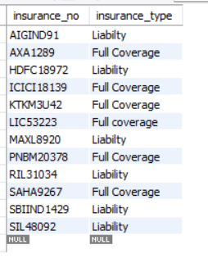

**VEHICLE**

insert into vehicle(car_no,car_model,car_type,car_color,insurance_no)

values("AP 21 BK 2267","Corolla","SUV","black","LIC53223");

insert into vehicle(car_no,car_model,car_type,car_color,insurance_no)

values("KA 51 MA 1479","Creta","Sedan","blue","HDFC18972");

insert into vehicle(car_no,car_model,car_type,car_color,insurance_no)

values("TS 23 EF 9992","Fortuner","Hatchback","red","AIGIND91");

insert into vehicle(car_no,car_model,car_type,car_color,insurance_no)

values("TS 12 AF 7835","Kia","Coupe","violet","ICICI18139");

insert into vehicle(car_no,car_model,car_type,car_color,insurance_no)

values("TN 23 TU 3452","Nexon","Sedan","purple","MAXL8920");

insert into vehicle(car_no,car_model,car_type,car_color,insurance_no)

values("AP 31 SA 5893","Mini","SUV","white","KTKM3U42");

insert into vehicle(car_no,car_model,car_type,car_color,insurance_no)

values("KL 12 NS 4309","Innova","Bolero","yellow","SBIIND1429");

insert into vehicle(car_no,car_model,car_type,car_color,insurance_no)

values("MH 43 RU 7840","Swift","Sedan","silver","PNBM20378");

insert into vehicle(car_no,car_model,car_type,car_color,insurance_no)

values("TS 24 SE 8284","Skoda","SUV","matte","RIL31034");

insert into vehicle(car_no,car_model,car_type,car_color,insurance_no)

values("AP 34 DF 8937","BMW3","Subcompactcar","brown","SAHA9267");

select * from vehicle;

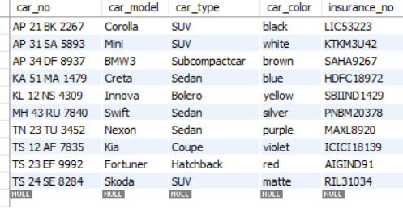

**RESERVATION**

insert into reservation values(129,'2023-02-12','2023-02-14',

'2023-02-16',2,"Ameerpet","AP 21 BK 2267",11,1234);

insert into reservation values(157,'2023-03-07','2023-03-10',

'2023-03-14',4,"Kukatpally","AP 21 BK 2267",15,1465);

insert into reservation values(237,'2023-03-21','2023-03-25',

'2023-03-29',4,"Jubilee hills","AP 31 SA 5893",17,1987);

insert into reservation values(364,'2023-04-21','2023-04-22',

'2023-04-24',2,"BanjaraHills","KA 51 MA 1479",26,2677);

insert into reservation values(318,'2023-05-01','2023-05-03',

'2023-05-06',3,"Hitech city","KL 12 NS 4309",39,3675);

insert into reservation values(497,'2023-06-09','2023-06-16',

'2023-06-19',3,"Shamshabad","TN 23 TU 3452",45,3879);

insert into reservation values(823,'2023-06-20','2023-06-22',

'2023-06-28',6,"Uppal","TN 23 TU 3452",64,4650);

insert into reservation values(741,'2023-07-07','2023-07-10',

'2023-07-12',2,"Madhapur","TS 12 AF 7835",71,5632);

insert into reservation values(786,'2023-07-08','2023-07-11',

'2023-07-15',4,"Somajiguda","TS 24 SE 8284",81,6730);

insert into reservation values(108,'2023-01-27','2023-01-29',

'2023-02-04',6,"Mandi bazar","AP 34 DF 8937",92,2677);

insert into reservation values(159,'2023-03-07','2023-03-10',

'2023-03-14',4,"Kukatpally","AP 21 BK 2267",15,5632);

insert into reservation values(231,'2023-03-21','2023-03-25',

'2023-03-29',4,"Jubilee hills","AP 31 SA 5893",17,5632);

insert into reservation values(367,'2023-04-21','2023-04-22',

'2023-04-24',2,"BanjaraHills","KA 51 MA 1479",26,5632);

select * from reservation;

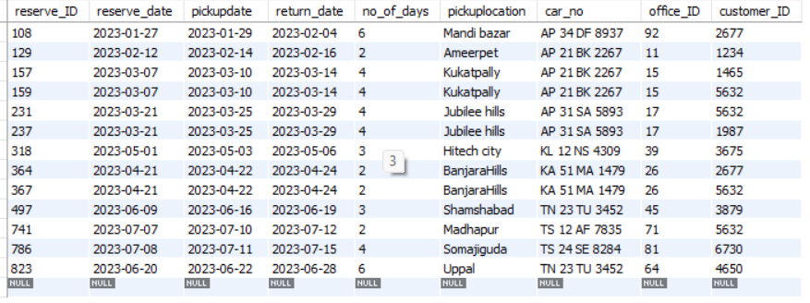

**PAYMENT**

insert into payment(reserve_ID,customer_ID,total_price,payment_method)

values(129,1234,3000,"cash");

insert into payment(reserve_ID,customer_ID,total_price,payment_method)

values(157,1465,2000,"cheque");

insert into payment(reserve_ID,customer_ID,total_price,payment_method)

values(237,1987,3500,"credit_card");

insert into payment(reserve_ID,customer_ID,total_price,payment_method)

values(364,2677,4000,"cash");

insert into payment(reserve_ID,customer_ID,total_price,payment_method)

values(318,3675,1500,"cash");

insert into payment(reserve_ID,customer_ID,total_price,payment_method)

values(497,3879,4500,"cheque");

insert into payment(reserve_ID,customer_ID,total_price,payment_method)

values(823,4650,5000,"credit_card");

insert into payment(reserve_ID,customer_ID,total_price,payment_method)

values(741,5632,4000,"cheque");

insert into payment(reserve_ID,customer_ID,total_price,payment_method)

values(786,6730,2500,"cash");

insert into payment(reserve_ID,customer_ID,total_price,payment_method)

values(108,2134,5500,"cheque");

SELECT * FROM PAYMENT;

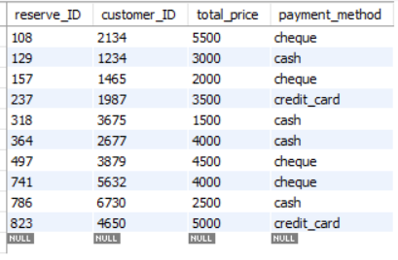

**WORKS_ON**

insert into works_on(office_ID,emp_ID,hours)

values(11,2,6);

insert into works_on(office_ID,emp_ID,hours)

values(15,15,8);

insert into works_on(office_ID,emp_ID,hours)

values(17,22,7);

insert into works_on(office_ID,emp_ID,hours)

values(26,37,7);

insert into works_on(office_ID,emp_ID,hours)

values(39,40,10);

insert into works_on(office_ID,emp_ID,hours)

values(45,51,6);

insert into works_on(office_ID,emp_ID,hours)

values(64,54,7);

insert into works_on(office_ID,emp_ID,hours)

values(71,73,9);

insert into works_on(office_ID,emp_ID,hours)

values(81,86,8);

insert into works_on(office_ID,emp_ID,hours)

values(92,101,9);

insert into works_on(office_ID,emp_ID,hours)

values(11,121,9);

insert into works_on(office_ID,emp_ID,hours)

values(15,133,8);

insert into works_on(office_ID,emp_ID,hours)

values(17,140,9);

select * from works_on;

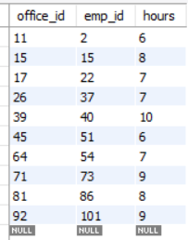

**1)To display number of employee for each office number.**

Select office_id,count(emp_id) as number_of_employee_per_office from works_on group by office_id,order by office_id;

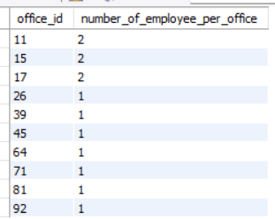

**2) To show number of cars rented of customer his id is 5632**

Select customer_ID,count(*) as contract_of_specific_customer from reservation where customer_id = 5632 ;



**3)To show all car model of (SUV CARS) in the office.**

Select car_no,car_model,car_color from vehicle where car_type = “SUV”

Order by car_model;

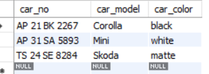

**4)To show customers who reserved on year 2023.**

Select customer_id,pickupdate,return_date from reservation where pickupdate like “%2023%” order by customer_id;

