Submitted by

Satya Bharath Kumar

G Rohith Sai

M Vamsi Krishna

Under the Guidance of

Dr. HJ Jayatheertha

Assistant Professor



Department of Electrical, Electronics and Communication Engineering

GITAM School of Technology

GITAM

(DEEMED TO BE UNIVERSITY)

(Estd. u/s 3 of the UGC act 1956)

NH 207, Nagadenehalli, Doddaballapur taluk, Bengaluru-561203 Karnataka, INDIA.



Department of Electrical, Electronics and Communication Engineering

GITAM School of Technology

DECLARATION

I/We declare that the project work contained in this report is original and it has been done by me under the guidance of my project guide.

Date:

Registration No. Student Name Signature

BU21EECE0100388 Satya Bharath Kumar

BU21EECE0100199 G. Rohith Sai

BU21EECE0100142 M. Vamsi Krishna

Department of Electrical, Electronics and Communication Engineering

GITAM School of Technology, Bengaluru-561203



CERTIFICATE

This is to certify that Satya Bharath Kumar bearing BU21EECE0100388, G. Rohit Sai bearing BU21EECE0100199, M. Vamsi Krishna bearing BU21EECE0100142 has satisfactorily completed Mini Project Entitled in partial fulfillment of the requirements as prescribed by University for VIIth semester, Bachelor of Technology in “Electrical, Electronics and Communication Engineering” and submitted this report during the academic year 2024-2025.

[Signature of the Guide] [Signature of HOD]

Table of contents

Chapter 1: Introduction 1

Chapter 2 : Literature Review 2

Chapter 4 : Methodology 4

Chapter 5:Results 6

Chapter 6: Conclusion 7

Chapter 7 : Future Work 8

Here write Suggestions for further research or development Potential improvements or extensions 8

References 9

# 

# Chapter 1: Introduction

## Overview of the problem statement

## With the rapid advancement of technology and the increasing availability of affordable IoT devices, security concerns have grown in both private and public sectors. Traditional theft detection systems such as CCTV cameras, manual alarms, or security personnel have limitations in terms of coverage, efficiency, and timely response. These systems often rely on human monitoring, which is prone to errors, delays, and a lack of real-time data processing.

## The problem becomes more pronounced in environments like warehouses, parking lots, retail stores, and residential areas where the volume of potential threats is high. The need for a more automated, efficient, and responsive system to detect and prevent theft is crucial.1.2 Objectives and goals

1.2 Objectives and goals:

To develop an IoT-powered system for real-time theft detection and monitoring.

Goals:

Main Goals

* Real-time Monitoring
* Automated Alerts
* Scalability
* Mobile Integration

Additional Goals

* Enhanced Security
* False Alarm Reduction
* Quick Response
* Data Security

# Chapter 2: Literature Review

Key Publications

* AI Based Healthcare Chatbot System by Using Natural Language Processing.
* A Healthcare Chatbot System Using Python And NLP
* Contextual Chatbot for Healthcare Purposes (using Deep Learning)
* Chatbot for Health Care and Oncology Applications Using Artificial Intelligence and Machine Learning: Systematic Review

Google scholar Publications:

<https://ieeexplore.ieee.org/abstract/document/9456304>

https://www.pnrjournal.com/index.php/home/article/view/10131

Github Publications:

https://github.com/manyasrinivas2021/ARTIFICIAL-INTELLIGENCE-HEALTHCARE-CHATBOT--SYSTEM-USING-PYTHON

https://github.com/mmubarak0/AI-Healthcare-chatbot

# Chapter 3: Strategic Analysis and Problem Definition

## 3.1 SWOT Analysis

#### **Strengths:**

#### **Real-time Detection: Immediate identification and alerting of theft activities.**

#### **Automation: Reduces human effort and error by automating surveillance and alerts.**

#### **Scalability: Easily scalable to different environments like homes, businesses, or public spaces.**

#### **Integration: Can integrate with various devices such as cameras, motion sensors, and GPS trackers for comprehensive coverage.**

#### **Weaknesses:**

#### **High Initial Costs: Installation of IoT devices and sensors can be costly.**

#### **Dependency on Internet Connectivity: System performance is dependent on stable internet connections.**

#### **False Alarms: Potential for false positives from sensors leading to unnecessary alerts.**

#### **Security Vulnerabilities: Risks of hacking or data breaches in IoT devices.**

#### **Opportunities:**

#### **Growing Demand for Smart Security: Increasing interest in IoT security solutions for homes and businesses.**

#### **Technological Advancements: Continued improvements in IoT and AI could enhance detection accuracy and system capabilities.**

#### **Partnerships: Collaborations with security companies or law enforcement could expand system use and reliability.**

#### **Threats:**

#### **Cybersecurity Risks: IoT devices are potential targets for hacking, leading to privacy and security breaches.**

#### **Regulatory Changes: Government regulations regarding IoT devices and data privacy could impact system implementation.**

#### **Market Competition: Increasing competition from other IoT-based security systems could challenge market adoption.**

#### 3. Project Plan - GANTT Chart

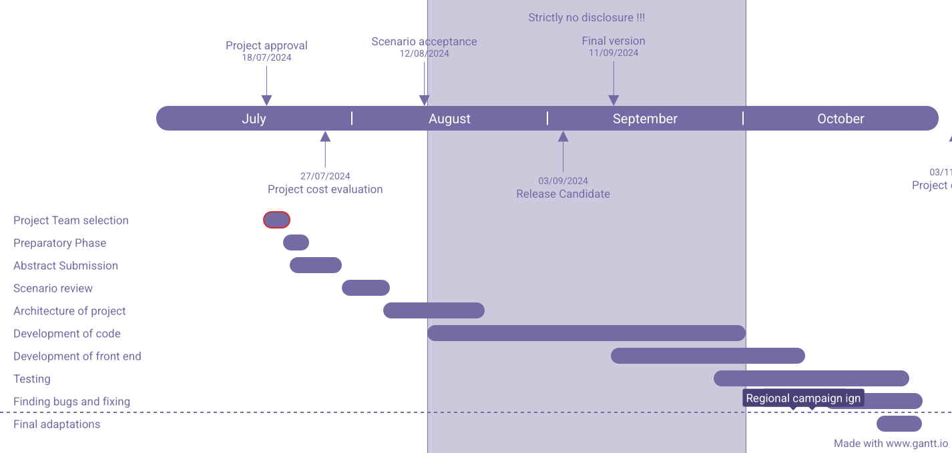

##### 

##### 3.3 Refinement of problem statement

Traditional theft detection systems, such as manual alarms, security personnel, and CCTV cameras, often rely on human intervention, leading to delayed responses and inefficiencies. These systems also face limitations such as poor real-time tracking and coverage gaps. With rising incidents of theft in residential, commercial, and industrial settings, there is a need for an advanced, automated solution that can provide real-time monitoring and detection without constant human oversight.

This project seeks to address these limitations by leveraging Internet of Things (IoT) technology. The proposed IoT-based theft detection system will integrate sensors, motion detectors, cameras, and communication networks to monitor properties in real-time. The system will provide automated alerts to users or authorities whenever suspicious activities are detected, enabling quicker response times and enhancing overall security..

# Chapter 4: Methodology

### **Methodology**

**1**. Requirement Analysis

* Objective: To define the scope of theft detection and identify potential assets or locations vulnerable to theft.
* Activities:
  + Identify the specific types of theft that need to be monitored (e.g., burglary, shoplifting, equipment theft).
  + Define the locations, assets, or vehicles to be monitored using IoT devices.
  + Identify security requirements, such as real-time detection, remote monitoring, and response time.

2. IoT Devices and Sensor Selection

* Objective: To select appropriate IoT devices that will be deployed for theft detection.
* Activities:
  + Research and choose IoT sensors such as motion sensors, GPS trackers, RFID tags, video surveillance, and door/window sensors based on the application.
  + Consider factors such as sensitivity, range, power consumption, and durability.
  + Select communication technologies (e.g., Wi-Fi, LoRaWAN, Bluetooth) to connect the devices to the network.

3. System Architecture Design

* Objective: To design the architecture of the IoT-based theft detection system.
* Activities:
  + Develop a layered architecture that includes sensors, edge devices (e.g., microcontrollers or Raspberry Pi), and cloud or local servers for data processing.
  + Define the communication protocols for transmitting sensor data to the central processing unit.
  + Ensure secure data transmission using encryption protocols to protect data from tampering or interception.

4. Data Collection and Processing

* Objective: To collect real-time data from IoT devices and process it to detect anomalies.
* Activities:
  + Implement data collection mechanisms that transmit data from the IoT devices to the central server in real-time.
  + Process the data using algorithms to detect theft indicators, such as unauthorized entry or abnormal movement.
  + Use machine learning algorithms, if applicable, to enhance detection by learning from previous data patterns and improving accuracy over time.

5. Alert System and Response Mechanism

* Objective: To create an alert system that notifies stakeholders in the event of suspected theft.
* Activities:
  + Design an alert system that triggers notifications via SMS, email, or a mobile app when the system detects unusual activity.
  + Integrate security measures such as automated locks or alarms that can be activated remotely.
  + Create a dashboard that visualizes real-time data and alerts, allowing stakeholders to monitor the status of the assets or premises.

6. Testing and Validation

* Objective: To test the performance of the IoT-based theft detection system under various conditions.
* Activities:
  + Test the system by simulating theft scenarios to verify the accuracy of the detection algorithms and the response time.
  + Ensure that the system functions effectively in different environmental conditions such as lighting changes, weather, or network connectivity issues.
  + Analyze false positives and negatives to improve the detection algorithms and minimize errors.

7. Deployment and Maintenance

* Objective: To deploy the theft detection system in the field and ensure ongoing functionality.
* Activities:
  + Deploy the IoT devices at the designated locations or on the monitored assets.
  + Ensure that the devices are properly installed, secured, and regularly maintained.
  + Monitor the system's performance post-deployment and perform periodic updates or maintenance to improve its reliability.

8. Evaluation and Results Analysis

* Objective: To evaluate the effectiveness of the IoT-based theft detection system in real-world scenarios.
* Activities:
  + Collect and analyze data from the deployed system to measure the number of theft cases detected versus actual incidents.
  + Compare the response time and accuracy with traditional theft prevention methods.
  + Calculate the reduction in theft incidents and the return on investment (ROI) of the IoT system

Chapter 6 Results

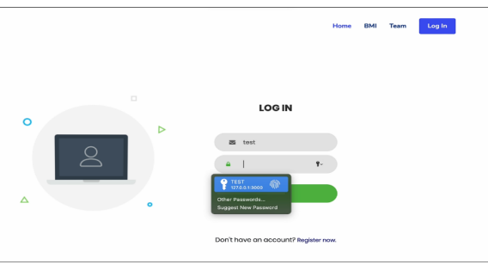

# Chapter 7: Conclusion

### In conclusion, the implementation of IoT-based theft detection provides an innovative and efficient solution to monitoring and safeguarding valuable assets. By leveraging sensors, real-time data analytics, and cloud-based processing, the system ensures immediate detection of unauthorized activities, allowing for swift action. The integration of multiple IoT devices and communication protocols enhances the accuracy and reliability of the system, minimizing false alarms while optimizing response times.

### **Chapter 8: Future plans**

* **Integration with Wearable Devices:**  
  Integration with Advanced Machine Learning Algorithms
* Implement advanced machine learning techniques, such as deep learning, to improve the accuracy of theft detection by learning from complex patterns in sensor data. This would help in reducing false positives and adapting to new theft strategies.
* Enhanced Real-Time Analytics and Predictive Maintenance
* Develop predictive analytics features to anticipate potential security breaches based on historical data and environmental factors. Additionally, integrate predictive maintenance to automatically detect and alert for malfunctioning sensors or devices.
* Use of Artificial Intelligence for Video Surveillance
* Integrate AI-based video surveillance for real-time facial recognition and object detection. This will add another layer of security by monitoring live video feeds and recognizing suspicious activities autonomously.
* Scalability to Smart City Applications
* Expand the system to a larger scale, enabling its use in smart city initiatives to monitor public areas, street lighting, and traffic flows for enhanced urban security and crime prevention.