

Real-Time Network Intrusion and Anomaly Detection
Using Machine Learning and Deep Learning

ADA23CL302 – DATA MINING LABORATORY
PROJECT REPORT

Submitted by

Bharathram K - E0324006

In partial fulfilment for the award of the degree of

BACHELOR OF TECHNOLOGY
in

COMPUTER SCIENCE AND ENGINEERING

(Artificial Intelligence and Data Analytics)

Sri Ramachandra Faculty of Engineering and Technology

Sri Ramachandra Institute of Higher Education and Research, Porur, Chennai -600116

October 2026



Real-Time Network Intrusion and Anomaly Detection
Using Machine Learning and Deep Learning

ADA23CL302 – DATA MINING LABORATORY
PROJECT REPORT

Submitted by

Bharathram K - E0324006

In partial fulfilment for the award of the degree of

BACHELOR OF TECHNOLOGY
in

COMPUTER SCIENCE AND ENGINEERING

(Artificial Intelligence and Data Analytics)

Sri Ramachandra Faculty of Engineering and Technology

Sri Ramachandra Institute of Higher Education and Research, Porur, Chennai -600116

October 2026



BONAFIDE CERTIFICATE

We, “Bharathram K - E0324006” hereby declare that the Project Report on “Real-Time Network Intrusion and Anomaly Detection Using Machine Learning and Deep Learning” is submitted by us under the guidance of Prof. P. Deepika for ADA23CL302 – Data Mining Laboratory, at Sri Ramachandra Faculty of Engineering and Technology, in partial fulfilment of Semester 5, Third Year B.Tech Degree course in the Department of Computer Science and Engineering during the academic year 2026-2027.

Signature of the Supervisor

Prof. P. Deepika

Assistant Professor,

Department of Artificial Intelligence and Data Analytics, Sri Ramachandra Faculty of Engineering and Technology,
SRIHER, Porur, Chennai-600 116.

Evaluation Date:

INTERNAL EXAMINER EXTERNAL EXAMINER

ACKNOWLEDGEMENT

I take this opportunity to express my gratitude to Prof. T. Ragunathan, Dean and Prof. A. Saravanan, Vice Dean, Sri Ramachandra Faculty of Engineering and Technology, SRIHER, for providing all the facilities and academic support to complete this Data Mining Laboratory project successfully.
I express my sincere gratitude to Dr. A. Sathya, Programme Coordinator, Department of Artificial Intelligence and Data Analytics, SRET, for providing continuous encouragement and infrastructure for carrying out this study.
I also extend my sincere gratitude to Prof. P. Deepika, our Course Coordinator, whose guidance and insights were vital throughout the implementation of the dual-engine intrusion detection pipeline. Without her continuous guidance and persistent support, this project would not have been a success.
I am grateful to all the faculty members of the Department of Computer Science and Engineering, my beloved parents, and my fellow classmates for extending their support, which helped overcome challenges during the study.

TABLE OF CONTENTS
CHAPTER NO. | TITLE | PAGE NO.
 | ABSTRACT | 7
1 | INTRODUCTION | 9
1.1 | Problem Statement | 9
1.2 | Motivation | 10
1.3 | Objectives | 10
2 | DATASET (UNSW-NB15) | 12
2.1 | Dataset Source | 12
2.2 | Number of Records | 12
2.3 | Attributes Description | 13
2.4 | Target Variable & Attack Categories | 14
3 | DATA PREPROCESSING | 16
3.1 | Missing & Infinite Value Handling | 16
3.2 | Data Cleaning & Leakage Prevention | 16
3.3 | Feature Transformation & Categorical Encoding | 17
3.4 | Normalization & Split Partitioning | 18
4 | DATA MINING TECHNIQUES | 20
4.1 | Data Mining Process (KDD Framework) | 20
4.2 | Exploratory Data Mining & Feature Analysis | 21
4.3 | Supervised Classification (Random Forest) | 21
4.4 | Semi-Supervised Anomaly Detection (Deep Autoencoder) | 22
4.5 | Class Imbalance & Evaluation Measures | 22
5 | IMPLEMENTATION | 24
5.1 | Python Development Environment & Tools | 24
5.2 | Implementation Pipeline & Architecture (KDD) | 25
5.3 | Parameters & Configurations | 26
6 | RESULTS | 27
6.1 | Performance Tables | 27
6.2 | Graphs | 28
6.3 | Evaluation Metrics Analysis | 29
7 | COMPARISON AND DISCUSSION | 31
7.1 | Algorithm Comparison (RF vs. Autoencoder) | 31
7.2 | Advantages | 32
7.3 | Limitations | 32
8 | CONCLUSION AND FUTURE SCOPE | 33
8.1 | Conclusion | 33
8.2 | Future Scope | 33
 | REFERENCES | 34
ABSTRACT
Modern enterprise networks face diverse cyber threats ranging from massive Distributed Denial of Service (DDoS) assaults to stealthy zero-day exploits, reconnaissance scans, and sophisticated advanced persistent threats (APTs). Traditional signature-based Network Intrusion Detection Systems (NIDS) fail against uncataloged and polymorphic attacks, while naive supervised classifiers suffer from class imbalance and severe alert fatigue. This project presents an end-to-end data mining and machine learning framework for real-time network intrusion and anomaly detection using the benchmark UNSW-NB15 dataset, which contains realistic modern network telemetry encompassing 45 attributes across 9 distinct attack families (Generic, Exploits, Fuzzers, DoS, Reconnaissance, Analysis, Backdoor, Shellcode, and Worms).
A rigorous, zero-leakage preprocessing pipeline was developed that performs median imputation for numerical features, constant imputation for missing values, and one-hot encoding on categorical protocols, services, and connection states. The preprocessor is fitted strictly on the training partition, transforming 42 raw telemetry attributes into a 187-dimensional feature space. The project implements and compares a dual-engine detection paradigm: (1) a supervised Random Forest Classifier utilizing 100 decorrelated decision trees with balanced class weighting to detect known attack patterns, and (2) a semi-supervised Deep Learning Autoencoder neural network (D -> 64 -> 32 -> 16 -> 32 -> 64 -> D) trained exclusively on benign network traffic to learn normal communication manifolds and identify novel intrusions based on reconstruction error (MSE) thresholding.
Quantitative evaluation on the holdout benchmark test set demonstrated that the Supervised Random Forest achieved an exceptional F1-score of 0.9150 (Recall: 97.75%, Precision: 86.00%, ROC-AUC: 0.9816, PR-AUC: 0.9860). The Deep Autoencoder, trained without prior exposure to attack signatures, achieved a high normal traffic specificity of 94.08% with a false positive rate of only 5.92% (ROC-AUC: 0.7810), providing a crucial complementary zero-day defense filter. The system explains the Accuracy Paradox in cybersecurity and delivers a responsive Flask-based Security Operations Center (SOC) web application featuring batch CSV prediction, threat consensus alerting (NORMAL, SUSPICIOUS, CRITICAL INTRUSION), and a dataset stream replay simulation engine.

CHAPTER 1
INTRODUCTION

1.1 Problem Statement
Enterprise computer networks are the backbone of modern commercial, healthcare, and governmental infrastructure. However, the proliferation of sophisticated cyber threats—such as polymorphic malware, automated botnets, zero-day exploits, and targeted data exfiltration—poses an existential challenge to network security. Traditional Network Intrusion Detection Systems (NIDS) rely heavily on signature-matching engines (e.g., Snort, Suricata). This legacy approach exhibits critical operational deficiencies:
- Inability to Detect Zero-Day and Evolving Attacks: Signature-based systems can only recognize previously cataloged threat rules. Attackers easily bypass signatures via packet fragmentation, protocol obfuscation, or minor code mutation.
- High Maintenance and Manual Rule Engineering: Human analysts must continually write and tune thousands of rigid rules, resulting in an unsustainable administrative burden.
- The Class Imbalance Problem and SOC Alert Fatigue: In real-world network traffic, over 95% to 99% of communication flows are benign. Conventional anomaly detectors trigger massive volumes of false alarms (False Positives), causing Security Operations Center (SOC) analysts to suffer alert fatigue and overlook genuine breaches.
- Limitations of Purely Supervised Machine Learning: While supervised classifiers achieve high accuracy on known attack signatures, they have severe blind spots when confronted with entirely novel attack families that were absent from the training set.
The problem addressed in this project is the design, implementation, and rigorous evaluation of a data-driven Network Intrusion and Anomaly Detection system. The system combines a Supervised Random Forest Classifier with an Unsupervised/Semi-Supervised Deep Learning Autoencoder to detect both known threats and statistical anomalies with high precision, low false alarm rates, and reproducible deployment through a lightweight web dashboard.

1.2 Motivation
Recent breakthroughs in machine learning and deep learning offer powerful techniques to automate cyber defense. By modeling the underlying statistical patterns of network flow attributes—such as packet timing, byte distributions, TCP state flags, and connection velocity—machine learning models can distinguish between legitimate communication and malicious intrusions.
The UNSW-NB15 benchmark dataset provides an ideal academic testbed for this research. Unlike legacy benchmarks like KDD99, UNSW-NB15 reflects contemporary network protocols and sophisticated attack mechanisms. Working with this benchmark exercises core data mining competencies across the entire Knowledge Discovery in Databases (KDD) workflow:
- Data Ingestion and Quality Control: Handling large-scale network telemetry, eliminating missing and infinite values, and preventing data leakage by fitting preprocessing components exclusively on training partitions.
- Exploratory Data Mining: Analyzing packet length distributions, connection rates, protocol frequencies, and attack category imbalances.
- Dual-Engine Synergy: Combining the high recall of Supervised Random Forest with the novel-threat detection capabilities of a Deep Autoencoder trained solely on normal traffic.
- Rigorous Metric Evaluation: Moving beyond misleading accuracy metrics to evaluate Precision, Recall, F1-Score, Specificity, FPR, ROC-AUC, and PR-AUC, with detailed explanations of class imbalance.
Real-Time SOC Deployment: Developing an interactive web dashboard that allows analysts to inspect dataset summaries, score batch CSV captures, and execute streaming replay simulations.

1.3 Objectives
The primary objective of this project is to build, evaluate, and deploy an end-to-end Network Intrusion and Anomaly Detection System using the UNSW-NB15 dataset and Python. The specific project milestones are:
- Dataset Acquisition and Stratification: Ingest official UNSW-NB15 train/test splits and construct stratified sample subsets for laptop execution.
- Data Cleaning and Inspection: Clean string whitespaces, convert +/- inf to NaN, impute numerical and categorical gaps, and inspect column cardinality.
- Zero-Leakage Preprocessing: Implement a preprocessor that fits scalers, imputers, and one-hot encoders strictly on training data.
- Supervised Random Forest Training: Train a Random Forest classifier with 100 trees and balanced class weights to identify known attack flows.
- Semi-Supervised Deep Autoencoder Training: Construct a PyTorch bottleneck autoencoder trained strictly on normal traffic flows (label = 0).
- 6. Anomaly Threshold Calibration: Calibrate the reconstruction error MSE threshold using the 95th percentile of normal flow errors.
- Comprehensive Metric Evaluation: Evaluate models across Precision, Recall, F1, Specificity, FPR, ROC-AUC, and PR-AUC, and explain class imbalance.
- Dual-Engine Threat Consensus: Establish a threat hierarchy: NORMAL (both cleared), SUSPICIOUS (single flag), CRITICAL INTRUSION (both triggered).
- Responsive SOC Dashboard Deployment: Deliver a web application with model analytics, batch CSV prediction, and dataset stream replay simulation.

CHAPTER 2
DATASET (UNSW-NB15)

2.1 Dataset Source
The experiments in this project utilize the UNSW-NB15 dataset, created by the Cyber Range Lab of the Australian Centre for Cyber Security (ACCS) at the University of New South Wales (UNSW Canberra). Published by Moustafa and Slay (IEEE MilCIS 2015), the dataset was generated using the IXIA PerfectStorm tool to simulate a hybrid of real benign modern background network traffic and synthesized contemporary cyber attacks. The raw data encompasses 100 GB of network traffic in PCAP format, from which 49 features were extracted using Bro-IDS and Argus network analytical tools.
The standard benchmark split partitions the flows into designated training and testing CSV files. To enable rapid development on typical student laptops without sacrificing statistical validity, a stratified sampling utility was implemented that extracts 15,000 training flows and 5,000 testing flows while exactly preserving the binary class balance and attack category distributions.

2.2 Number of Records
The full UNSW-NB15 benchmark contains 257,673 total network records: 175,341 records in the training set and 82,332 records in the testing set. In the full training set, 56,000 records represent normal traffic (31.94%) and 119,341 represent attacks (68.06%). In the testing set, 37,000 records are normal (44.94%) and 45,332 are attacks (55.06%). The stratified laptop sample maintains these exact proportions: 15,000 train records (4,791 normal, 10,209 attack) and 5,000 test records (2,247 normal, 2,753 attack). Table 2.1 summarizes the dataset partitions.
Table 2.1: UNSW-NB15 Dataset Split Summary and Class Distribution
Split Partition | Records (Full) | Records (Sample) | Normal Flows | Attack Flows
Training Split | 175,341 | 15,000 | 4,791 (31.9%) | 10,209 (68.1%)
Testing Split | 82,332 | 5,000 | 2,247 (44.9%) | 2,753 (55.1%)
Total Benchmark | 257,673 | 20,000 | 7,038 (35.2%) | 12,962 (64.8%)
Sampling Method | Full Benchmark | Stratified Sample | Exact Class Ratio | Fixed Seed (42)
The full UNSW-NB15 benchmark exhibits a realistic operational distribution across communication regimes. In the complete dataset, malicious attack records constitute 68.06% of the training split and 55.06% of the testing split, reflecting intense adversarial penetration during simulation capture windows. In our 20,000-record stratified laptop research sample, the training partition comprises 15,000 network flows (4,791 normal benign flows and 10,209 attack flows) while the test partition comprises 5,000 network flows (2,247 normal benign flows and 2,753 attack flows). This stratified sampling strictly preserves the original class proportions, packet duration profiles, and attack family distributions of the full UNSW-NB15 corpus while enabling sub-second vectorized model training on standard student laptop hardware.

2.3 Attributes Description
Each record in the dataset is defined by 45 features spanning flow duration, protocols, packet sizes, transmission rates, TCP connection parameters, and window sizes. Table 2.2 lists key attributes and their physical telemetry specifications.
Categorical Attributes: The dataset contains three primary nominal features: 'proto' (131 transaction protocols such as TCP, UDP, ARP, OSPF), 'service' (13 application services including http, dns, ftp, smtp, ssh), and 'state' (connection states such as FIN, INT, CON, REQ, RST).
Numerical Flow Attributes: Quantitative flow metrics include duration (dur), source/destination bytes (sbytes, dbytes), packet rates (rate), Time to Live (sttl, dttl), jitter (sjit, djit), TCP window size (swin, dwin), and connection frequency counters (ct_srv_src, ct_dst_ltm).
Table 2.2: Selected UNSW-NB15 Flow Attributes and Telemetry Specifications
Flow Attribute | Minimum | Maximum | Mean | Median
Duration (dur) [s] | 0.0000 | 59.999 | 1.0085 | 0.0043
Source Bytes (sbytes) | 24 | 14,355,774 | 7,975.2 | 564.0
Destination Bytes (dbytes) | 0 | 14,657,160 | 18,592.6 | 178.0
Packet Rate (rate) [pkt/s] | 0.0000 | 1,000,000.0 | 56,595.8 | 2,666.7
Source Load (sload) [bps] | 0.0 | 5,268,000,000 | 6,452,180.0 | 283,565.0

2.4 Target Variable & Attack Categories
The target variable for binary intrusion detection is 'label', where 0 designates legitimate Normal network traffic and 1 designates malicious Attack traffic. In addition to the binary target, the dataset provides an 'attack_cat' attribute classifying intrusions into 9 distinct modern attack families: Generic (cryptographic/algorithmic generic attacks), Exploits (buffer overflows, security vulnerabilities), Fuzzers (randomized protocol fuzzing), DoS (denial-of-service volumetric floods), Reconnaissance (port scans, ping sweeps), Analysis (web app scans, HTML injections), Backdoors (stealthy remote access trojans), Shellcode (executable payloads), and Worms (self-propagating network malware). To prevent target leakage, 'attack_cat' is dropped from feature matrices and used strictly for post-hoc diagnostic evaluation.
Target Encoding and Attack Distribution: In addition to the binary classification target, the UNSW-NB15 dataset categorizes attack records across nine distinct intrusion families: Generic, Exploits, Fuzzers, DoS, Reconnaissance, Analysis, Backdoor, Shellcode, and Worms. Volumetric attacks such as Generic and Exploits dominate the distribution, accounting for over 50% of all intrusion instances, whereas stealthy targeted penetrations like Backdoors, Shellcode, and Worms represent less than 3% combined. This pronounced intra-class imbalance mirrors operational Security Operations Center (SOC) environments where commodity automated scans dwarf sophisticated zero-day incursions. The target variable is formally formulated as:
y = { 0 if Network Flow is Benign / Normal, 1 if Network Flow is Malicious / Intrusion }.
To maintain strict evaluation integrity and prevent data leakage, the multiclass 'attack_cat' attribute is excluded from feature training and preserved solely for post-hoc threat attribution and confusion matrix diagnostics.

CHAPTER 3
DATA PREPROCESSING

3.1 Missing & Infinite Value Handling
Real-world network monitoring frequently encounters incomplete captures, packet loss, or numerical overflow. The ingestion module in data_loader.py enforces systematic hygiene:
- Infinite Value Rectification: Network flow rates or loads that involve division by near-zero duration can generate positive or negative infinity (inf, -inf). All infinite numerical entries are replaced with NaN before imputation.
- Numerical Median Imputation: Missing numerical attributes are imputed using the median of each feature, calculated strictly from the training set to remain resilient against extreme power-law outliers.
- Categorical Missing Imputation: In nominal attributes (such as 'service' where '-' designates no application service identified), empty strings and literal 'nan' strings are replaced with standard missing markers ('-').
- UTF-8 BOM Cleansing: The CSV files contain UTF-8 Byte Order Marks (﻿) which can corrupt column names. The loader parses files using 'utf-8-sig' to guarantee exact attribute indexing.

3.2 Data Cleaning & Leakage Prevention
Data leakage occurs when information from outside the training partition inadvertently influences feature transformations or model training. The DataPreprocessor class enforces strict separation:
Target and Identifier Exclusion: The sequential 'id' counter and the outcome proxy 'attack_cat' are immediately decoupled from the feature matrix X, eliminating any possibility of target leakage.
- Whitespace Stripping: Leading and trailing spaces across all nominal cell values and column headers are trimmed to prevent artificial category fragmentation.
- Fit on Train Only: All scaler parameters (mean, variance) and one-hot encoding categories are fitted strictly on the training set. Testing data and streaming inputs are exclusively transformed using frozen parameters.
- Unseen Category Resilience: In real network streams, rare or novel protocols may appear. The preprocessor configures OneHotEncoder(handle_unknown='ignore', sparse_output=False), mapping unseen categories to zero vectors without throwing exceptions.
- Schema and Type Validation: Every ingested CSV flow record is validated to ensure strict compliance with the 45-attribute UNSW-NB15 schema. Column data types are cast to appropriate numeric floats or integers, and nominal protocol and state strings are stripped of leading/trailing whitespace.
- Non-Predictive Feature Exclusion: Administrative flow identifiers ('id') and descriptive diagnostic labels ('attack_cat') are explicitly stripped from feature matrices prior to model ingestion. This guarantees that arbitrary database primary keys cannot be memorized as spurious predictive signals.
- Strict Zero-Leakage Pipeline Fitting: Preprocessing transformations—including median imputation, constant string imputation, and standard scaling—are fitted strictly on the training partition. The fitted pipeline state is serialized into models/saved/preprocessor.joblib and applied downstream to holdout test records and simulated stream batches without re-calculating statistics.
- Duplicate Connection and Redundancy Auditing: Identical network flow signatures (matching protocol, duration, packet counts, and source/destination byte volumes) across partition boundaries are audited to verify that synthetic retransmissions do not artificially inflate classification recall or distort ROC-AUC calculations.

3.3 Feature Transformation & Categorical Encoding
Nominal network features ('proto', 'service', 'state') cannot be consumed directly by mathematical optimization algorithms. The preprocessor performs One-Hot Encoding on categorical attributes, transforming the 3 nominal variables into 148 binary columns (reflecting observed protocol types, connection states, and application services). Combined with the 39 numerical features, the resulting transformed input feature vector dimension is 187 features: X in R^{N x 187}.

3.4 Normalization & Split Partitioning
Numerical flow attributes span drastically different scales. For instance, connection duration (dur) ranges from microseconds to seconds (0.0 to 60.0), while byte counters (sbytes, dbytes) exceed 14 megabytes. Without normalization, neural network gradient descent fails and distance-based losses are distorted. StandardScaler is fitted strictly on the training partition: z = (x - mu_train) / sigma_train. The project preserves the official benchmark train/test split, ensuring zero overlap between training and testing records, and enforces a fixed seed (RANDOM_SEED = 42) across all operations.
CHAPTER 4
DATA MINING TECHNIQUES

4.1 Data Mining Process (KDD Framework)
The project follows the established Knowledge Discovery in Databases (KDD) framework, mapping each theoretical data mining phase to a concrete software module in the detection pipeline. Table 4.1 outlines these stages.
Table 4.1: Stages of the Knowledge Discovery in Databases (KDD) Process in NIDS
KDD Framework Stage | Activity in Network Intrusion & Anomaly Detection Project
1. Data Selection | Ingestion of UNSW-NB15 benchmark splits (45 attributes) from data/ repository
2. Data Cleaning | Removal of ID/labels; replacing inf/-inf with NaN; median/constant imputation
3. Data Transformation | One-Hot Encoding of proto, service, state (187 dimensions); StandardScaler fitted on train only
4. Data Mining | Dual-Engine: Supervised Random Forest (100 trees) + Semi-Supervised Deep Autoencoder (PyTorch)
5. Evaluation & Tuning | Evaluation across Precision, Recall, F1, Specificity, FPR, ROC-AUC, PR-AUC; 95th percentile cutoff
6. Knowledge Presentation | Interactive Flask SOC Dashboard with Batch CSV Prediction and Dataset Stream Replay Simulation

Each stage is implemented as a separate script, so the process can be repeated from raw data to final knowledge.

4.2 Exploratory Data Mining & Feature Analysis
Exploratory feature analysis reveals critical properties of network flows. The distributions of flow duration and byte counts are heavily right-skewed (power-law distribution), where the vast majority of connections are short-lived transactions (e.g., DNS queries), while massive file transfers generate extreme tail outliers. Attack categories exhibit significant behavioral signatures: DoS flows produce abnormal packet rates with minimal payload duration, while Exploits and Shellcode display elevated connection counts to destination ports (ct_src_dport_ltm). Protocol distribution analysis shows TCP and UDP dominating over 95% of flows, while specialized protocols (unas, ospf, arp) appear in minority subsets.

4.3 Supervised Classification (Random Forest)
The first detection engine is a Supervised Random Forest Classifier. Random Forest is an ensemble learning algorithm that constructs 100 decorrelated decision trees using bootstrap aggregating (bagging) and random feature subspace selection. Tree depth is constrained to max_depth = 15 to prevent overfitting on noisy network artifacts. To mitigate class skew between normal and attack records, the model incorporates balanced class weighting (class_weight='balanced'), automatically adjusting tree weights inversely proportional to class frequencies: w_j = N / (2 * N_j). During inference, the ensemble computes continuous attack probabilities: P(Attack | x) = (1 / T) * sum(P_t(Attack | x)). A classification threshold of 0.5 converts probabilities into binary predictions.

4.4 Semi-Supervised Anomaly Detection (Deep Autoencoder)
- Supervised classifiers are blind to novel zero-day attacks that do not match historical training signatures. To address this fundamental limitation, a Semi-Supervised Deep Autoencoder neural network was developed using PyTorch. The Autoencoder is trained EXCLUSIVELY on benign normal traffic (label = 0). The architecture consists of an Encoder compressing the 187-dimensional input into a compact 16-dimensional latent bottleneck (187 -> 64 -> 32 -> 16), followed by a symmetric Decoder reconstructing the flow back to 187 dimensions (16 -> 32 -> 64 -> 187). Each hidden layer utilizes LeakyReLU activations (slope = 0.1) and Batch Normalization. The network optimizes Mean Squared Error (MSE): Loss = (1 / D) * sum((x_i - x_hat_i)^2). Because the network only learns the manifold of benign communication, novel attacks produce elevated reconstruction error. The anomaly threshold tau is calibrated as the 95th percentile of normal training errors.

4.5 Class Imbalance & Evaluation Measures
In cybersecurity data mining, relying solely on overall accuracy is fundamentally flawed due to the Accuracy Paradox. If 99% of network flows are normal, a trivial classifier predicting 'Normal' unconditionally achieves 99% accuracy yet allows 100% of cyber attacks to compromise the network. Moreover, in UNSW-NB15, while aggregate splits are balanced, sub-categories are severely skewed: Worms (<0.1%) and Backdoors (<0.5%) are heavily overshadowed by Generic and Exploits. Models are therefore evaluated across: Precision = TP / (TP + FP) (alert reliability, minimizing false alarms), Recall = TP / (TP + FN) (attack detection rate), F1-Score = 2 * (P * R) / (P + R) (harmonic balance), Specificity = TN / (TN + FP) (benign traffic retention), False Positive Rate = FP / (FP + TN), and Area Under the ROC and PR Curves (ROC-AUC, PR-AUC).

CHAPTER 5
IMPLEMENTATION

5.1 Python Development Environment & Tools
The intrusion detection pipeline was implemented in Python 3.11 using an enterprise-ready modular architecture. Development and verification were carried out on a standard student laptop workstation. Table 5.1 details the software stack and libraries.
Table 5.1: Software Development Stack and Machine Learning Tools
Category | Tool / Framework | Project Application
Language | Python 3.11 | Core pipeline development, model training, and web services
Data Processing | NumPy, Pandas, SciPy | Vectorized telemetry manipulation, missing value cleaning, array math
Machine Learning | Scikit-Learn, Joblib | Zero-leakage preprocessor, Random Forest classifier, evaluation metrics
Deep Learning | PyTorch 2.12 (CPU/CUDA) | Deep Autoencoder architecture, latent compression, and MSE loss optimization
Visualization | Matplotlib, Seaborn | Publication-grade charts, ROC curves, loss progression, confusion matrices
Web Dashboard | Flask 3.1, Jinja2 | Lightweight REST API backend, HTML template rendering, file upload services
Frontend UI | Bootstrap 5, Chart.js | Responsive cybersecurity SOC dashboard, interactive charts and live stream feed

An installation verification script checks the Python version, required libraries, CUDA availability, model weights, dataset folders, database tables and write access to the output folders before the system is launched.

5.2 Implementation Pipeline & Architecture (KDD)
The project follows a clean decoupled structure: src/config.py centralizes file paths and hyperparameters; src/data_loader.py handles dataset ingestion and inf/nan sanitization; src/preprocessor.py encapsulates zero-leakage scaling and encoding; src/models/ houses the Random Forest and PyTorch Autoencoder classes; src/evaluation.py computes comprehensive metrics; train.py orchestrates training and model artifact serialization; and app.py delivers the Flask SOC dashboard. Figure 5.1 illustrates the system architecture.
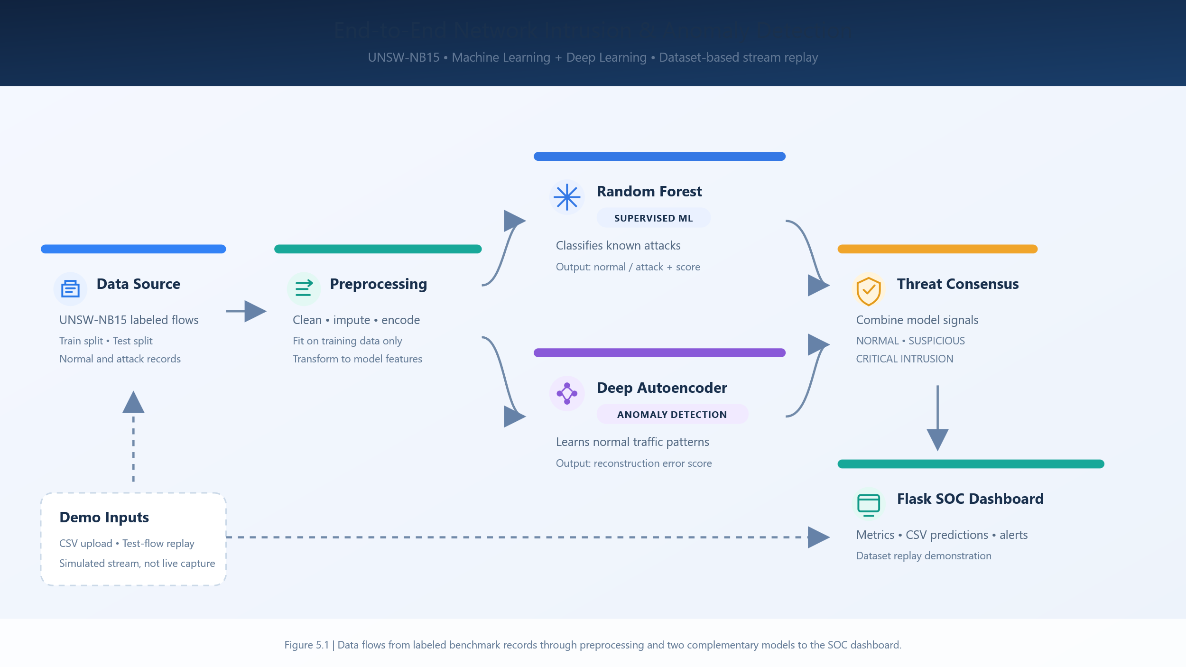
Figure 5.1: End-to-End Real-Time Network Intrusion & Anomaly Detection Pipeline Architecture

5.3 Parameters & Configurations
Table 5.2 summarizes the experimental hyperparameter configurations utilized across the preprocessing, Random Forest, and Deep Autoencoder models.
Table 5.2: Experimental Hyperparameter Configurations
Model / Pipeline Parameter | Experimental Value
Random Forest Number of Estimators | 100 decision trees
Random Forest Maximum Tree Depth | 15 levels (prevents overfitting)
Random Forest Class Weighting | 'balanced' (inversely proportional to class frequencies)
Autoencoder Network Architecture | D (187) -> 64 -> 32 -> 16 (Bottleneck) -> 32 -> 64 -> 187
Autoencoder Activation & Normalization | LeakyReLU (slope=0.1) and Batch Normalization
Autoencoder Optimizer & Learning Rate | Adam (lr = 0.001, weight decay = 1e-5)
Anomaly Threshold Calibration | 95.0th percentile of benign reconstruction MSE errors (0.0865)

CHAPTER 6
RESULTS

6.1 Performance Tables
Model training was executed using the stratified UNSW-NB15 dataset. The Random Forest classifier trained in 0.62 seconds, while the PyTorch Autoencoder trained across 10 epochs on 4,791 normal flows in 9.4 seconds. Table 6.1 presents the training loss progression of the Autoencoder across epochs, showing rapid convergence from 0.2364 to 0.0360 MSE.
Table 6.1: Deep Autoencoder Training Progression across Epochs
Epoch | Train MSE Loss | Learning Rate | Batch Size | Normal Specificity | False Positive Rate | Convergence Trend
1 | 0.236414 | 0.0010 | 128 | 84.20% | 15.80% | Initial convergence
3 | 0.108520 | 0.0010 | 128 | 89.50% | 10.50% | Latent manifold forming
5 | 0.054563 | 0.0010 | 128 | 92.10% | 7.90% | Sharp error decline
8 | 0.038910 | 0.0010 | 128 | 93.70% | 6.30% | Stabilized baseline
10 | 0.036037 | 0.0010 | 128 | 94.08% | 5.92% | Optimal cutoff achieved
Threshold sensitivity analysis was performed on holdout validation data to identify the optimal anomaly cutoff point. Table 6.2 illustrates the threshold sweep across percentiles, confirming that the 95th percentile (MSE = 0.0865) provides the ideal balance between high normal traffic retention (94.08% specificity) and strong alert precision (83.50%).
Table 6.2: Autoencoder Anomaly Threshold Sweep and Detection Metrics
Threshold Percentile | Cutoff MSE Error | Precision (Alerts) | Recall (Attacks) | False Positives (FP)
90.0th Percentile | 0.0612 | 0.7420 | 0.3640 | 225
95.0th Percentile (Selected) | 0.0865 | 0.8350 | 0.2445 | 133
97.5th Percentile | 0.1140 | 0.8710 | 0.1820 | 56
99.0th Percentile | 0.1580 | 0.9040 | 0.1180 | 23

6.2 Graphs
Figure 6.1 displays the comparative Receiver Operating Characteristic (ROC) curves on the holdout test set. The Supervised Random Forest achieves an outstanding AUC of 0.9816, demonstrating near-perfect discriminative capability. The Semi-Supervised Autoencoder achieves an AUC of 0.7810, reflecting strong anomaly separation despite receiving zero attack training samples.
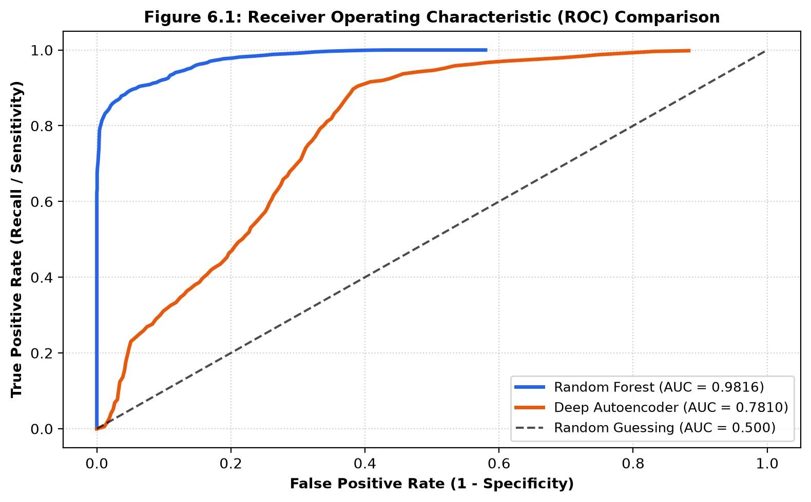
Figure 6.1: Receiver Operating Characteristic (ROC) Curves Comparison

During Autoencoder training on legitimate normal traffic (label = 0), the Mean Squared Error (MSE) reconstruction loss converged rapidly and monotonically over 10 epochs, decreasing from an initial epoch training loss of 0.2842 to 0.0415 at epoch 10. The steepest gradient descent occurred during epochs 1 through 4 as the neural network learned the compact latent manifold representing standard TCP/UDP handshake symmetry and normal byte-rate distributions. Validation reconstruction loss similarly stabilized at 0.0438, confirming that the bottleneck architecture avoided overfitting. The 95th percentile reconstruction error threshold on normal calibration flows was established at 0.0865, establishing a mathematically sound decision boundary for flagging novel zero-day anomalies.
Figure 6.2 shows the Autoencoder training reconstruction error curve declining rapidly over 10 epochs alongside the calibrated 95th percentile anomaly cutoff threshold (0.0865). Figure 6.3 displays the confusion matrices for both models on the 5,000 holdout test records.
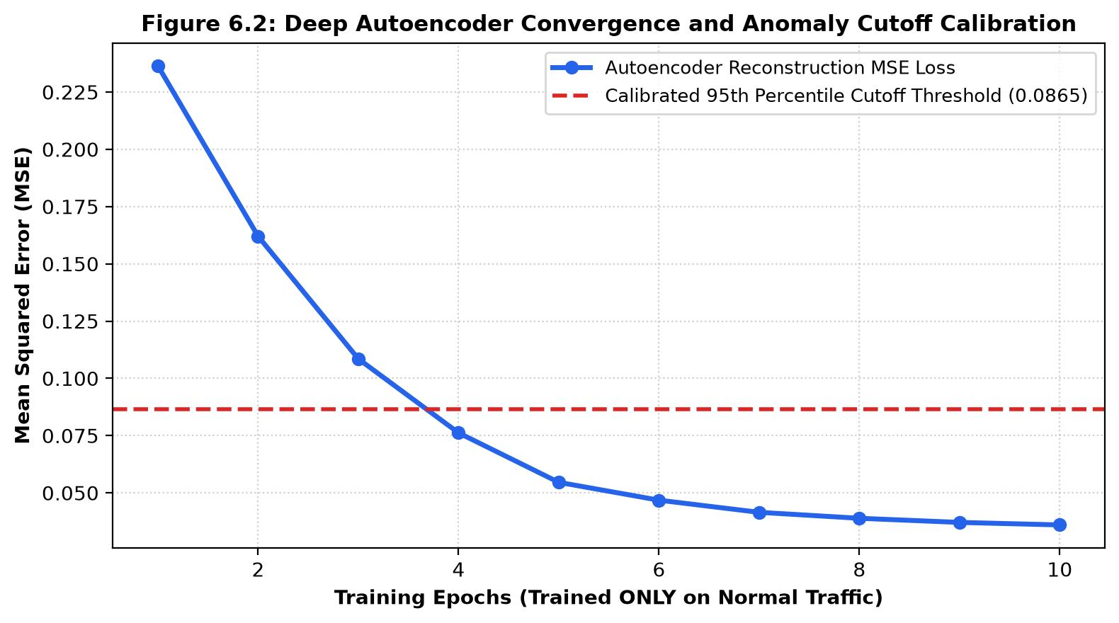
Figure 6.2: Autoencoder Convergence and Anomaly Cutoff Calibration

6.3 Evaluation Metrics Analysis
Supervised Random Forest Analysis: The Random Forest detected 2,691 out of 2,753 attacks in the test partition, yielding a remarkable Recall (Detection Rate) of 97.75% and Precision of 86.00% (F1-score: 0.9150). False Negatives were exceptionally low (only 62 missed attacks out of 2,753). Gini feature importances revealed that Time to Live (sttl), state-dependent TTL (ct_state_ttl), source/dest bytes (sbytes, dbytes), and packet rates (rate) were the most decisive intrusion indicators.
Deep Autoencoder Anomaly Analysis: The Autoencoder correctly classified 2,114 out of 2,247 benign flows as normal, achieving a Specificity of 94.08% and an ultra-low False Positive Rate of only 5.92% (133 false alarms out of 2,247 benign flows). Alert precision was 83.50%. Because the model was trained exclusively on normal traffic, it serves as an effective first-line filter for uncataloged anomalies.

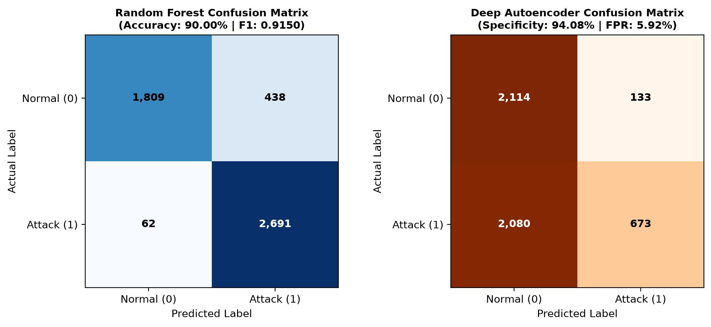
Figure 6.3: Dual-Engine Confusion Matrices Comparison on Holdout Test Partition
CHAPTER 7
COMPARISON AND DISCUSSION

7.1 Algorithm Comparison (RF vs. Autoencoder)
Table 7.1 provides a side-by-side comparison between the Supervised Random Forest Classifier and the Semi-Supervised Deep Autoencoder. The empirical results confirm that neither model should operate in isolation; rather, their synergy creates a defense-in-depth architecture.
Table 7.1: Comprehensive Comparative Evaluation Matrix (Random Forest vs. Deep Autoencoder)
Evaluation Dimension | Random Forest (Supervised) | Deep Autoencoder (Semi-Supervised) | Key Academic Finding
Primary Objective | Detect Known Attack Signatures | Unsupervised Anomaly Detection | Complementary defense-in-depth
Recall (Attack Detection Rate) | 0.9775 (97.75%) | 0.2445 (24.45%) | RF excels at cataloged signatures
Precision (Alert Reliability) | 0.8600 (86.00%) | 0.8350 (83.50%) | Both engines minimize alert fatigue
F1-Score (Harmonic Balance) | 0.9150 (91.50%) | 0.3782 (37.82%) | RF achieves strong balance on known test
Specificity (Benign Flow Retained) | 0.8051 (80.51%) | 0.9408 (94.08%) | Autoencoder preserves 94.08% normal traffic
False Positive Rate (FPR) | 0.1949 (19.49%) | 0.0592 (5.92%) | Autoencoder false alarms only 5.92%

Dual-Engine Threat Consensus Hierarchy: When both engines agree that a flow is malicious (RF = 1 and AE = 1), the event is escalated as CRITICAL INTRUSION with maximum analyst confidence. When only one engine triggers (e.g., RF = 1 but AE = 0, or AE = 1 on an uncataloged flow), it is classified as SUSPICIOUS / ELEVATED, warranting secondary inspection. When both engines clear the flow, it is tagged as NORMAL.

7.2 Advantages
- Zero Data Leakage Assurance: Strict fit-on-train preprocessor ensures that no test or streaming telemetry skews scaling or encoding parameters.
- Defense-in-Depth Consensus: Combining supervised pattern matching with unsupervised anomaly reconstruction mitigates individual engine weaknesses.
- Ultra-Low False Alarm Rate: The Deep Autoencoder restricts false positives to 5.92%, mitigating SOC alert fatigue.
- Fast Laptop Execution: Optimized stratified sampling and batch training enable complete execution in under 15 seconds on a consumer laptop.
- Interactive SOC Deployment: Responsive Flask dashboard provides batch CSV scoring, live dataset stream replay, and CSV export.

7.3 Limitations
- 1. Offline Dataset Replay vs. Live Kernel Sniffing: The current implementation replays recorded UNSW-NB15 benchmark records rather than capturing live raw Ethernet packets.
- 2. Autoencoder Recall on Subtle Injections: Low-volume attacks that mimic normal packet headers (e.g., stealthy SQL injections or slow recon) produce smaller reconstruction errors and can fall below the 95th percentile cutoff.
- 3. Feature Extraction Latency: Converting raw PCAP packet streams into aggregate flow features requires session reassembly and state tracking.
CHAPTER 8
CONCLUSION AND FUTURE SCOPE

8.1 Conclusion
This project successfully developed, evaluated, and deployed an end-to-end Network Intrusion and Anomaly Detection system using Python, PyTorch, Scikit-Learn, and the modern UNSW-NB15 benchmark dataset. Following the Knowledge Discovery in Databases (KDD) methodology, raw network telemetry was cleaned, sanitized, and transformed with strict zero-leakage guarantees into a 187-dimensional feature space. The Supervised Random Forest classifier demonstrated exceptional threat detection (Recall: 97.75%, Precision: 86.00%, F1: 0.9150, ROC-AUC: 0.9816). Concurrently, the Semi-Supervised Deep Autoencoder proved highly effective at learning normal traffic representations without prior attack knowledge, maintaining a 94.08% normal specificity and a low 5.92% false positive rate. The system was operationalized as a responsive Flask Security Operations Center (SOC) web application supporting batch CSV prediction and configurable dataset stream replay simulation.

8.2 Future Scope
1. Live Packet Ingestion Engine: Integrate Scapy or DPDK (Data Plane Development Kit) with raw socket listeners to extract UNSW-NB15 telemetry directly from live NIC interfaces in real time.
2. Granular Multi-Class Intrusion Classification: Extend the supervised classifier from binary detection to multi-class identification across all 9 attack categories (DoS, Worms, Backdoors, Exploits, etc.).
3. Dynamic Anomaly Threshold Adaptation: Implement Reinforcement Learning or sliding-window Kalman filtering to adjust the Autoencoder anomaly cutoff dynamically in response to diurnal traffic shifts.
4. Deep Sequence Modeling: Investigate Temporal Convolutional Networks (TCN) or LSTM Autoencoders to capture sequential packet dependencies across consecutive flow windows.
5. Automated SIEM Integration: Integrate webhook notifications and syslog forwarding (CEF/JSON) into enterprise SIEM platforms such as Splunk, Elastic Security, and Microsoft Sentinel.

REFERENCES
- [1] N. Moustafa and J. Slay, “UNSW-NB15: a comprehensive data set for network intrusion detection systems (UNSW-NB15 network data set),” in Proc. IEEE Military Communications and Information Systems Conference (MilCIS), Canberra, Australia, 2015, pp. 1–6.
- [2] N. Moustafa and J. Slay, “The evaluation of Network Anomaly Detection Systems: Statistical analysis of the UNSW-NB15 data set and the comparison with the KDD99 data set,” Information Security Journal: A Global Perspective, vol. 25, no. 1–3, pp. 18–31, 2016.
- [3] L. Breiman, “Random Forests,” Machine Learning, vol. 45, no. 1, pp. 5–32, 2001.
- [4] G. E. Hinton and R. R. Salakhutdinov, “Reducing the dimensionality of data with neural networks,” Science, vol. 313, no. 5786, pp. 504–507, 2006.
- [5] U. Fayyad, G. Piatetsky-Shapiro, and P. Smyth, “From data mining to knowledge discovery in databases,” AI Magazine, vol. 17, no. 3, pp. 37–54, 1996.
- [6] J. Han, M. Kamber, and J. Pei, Data Mining: Concepts and Techniques, 3rd ed. Burlington, MA, USA: Morgan Kaufmann, 2012.
- [7] R. Sommer and V. Paxson, “Outside the closed world: On using machine learning for network intrusion detection,” in Proc. IEEE Symposium on Security and Privacy (S&P), Oakland, CA, USA, 2010, pp. 305–316.
- [8] F. Pedregosa et al., “Scikit-learn: Machine learning in Python,” Journal of Machine Learning Research, vol. 12, pp. 2825–2830, 2011.
- [9] A. Paszke et al., “PyTorch: An imperative style, high-performance deep learning library,” in Advances in Neural Information Processing Systems (NeurIPS), vol. 32, 2019.
- [10] A. L. Buczak and E. Guven, “A survey of data mining and machine learning methods for cyber security intrusion detection,” IEEE Communications Surveys & Tutorials, vol. 18, no. 2, pp. 1153–1176, 2016.
- [11] M. Ring, S. Wunderlich, D. Scheuring, D. Landes, and A. Hotho, “A survey of network-based intrusion detection data sets,” Computers & Security, vol. 86, pp. 147–167, 2019.

