

SmartVision: Real-Time Supermarket Product
Identification Using YOLOv8

ADA23CL302 – DATA MINING LABORATORY
PROJECT REPORT

Submitted by

Bharathram K - E0324006

In partial fulfilment for the award of the degree of

BACHELOR OF TECHNOLOGY
in

COMPUTER SCIENCE AND ENGINEERING

(Artificial Intelligence and Data Analytics)

Sri Ramachandra Faculty of Engineering and Technology

Sri Ramachandra Institute of Higher Education and Research, Porur, Chennai -600116

October 2026



SmartVision: Real-Time Supermarket Product
Identification Using YOLOv8

ADA23CL302 – DATA MINING LABORATORY
PROJECT REPORT

Submitted by

Bharathram K - E0324006

In partial fulfilment for the award of the degree of

BACHELOR OF TECHNOLOGY
in

COMPUTER SCIENCE AND ENGINEERING

(Artificial Intelligence and Data Analytics)

Sri Ramachandra Faculty of Engineering and Technology

Sri Ramachandra Institute of Higher Education and Research, Porur, Chennai -600116

October 2026



BONAFIDE CERTIFICATE

We, “Bharathram K - E0324006” hereby declare that the Project Report on “SmartVision: Real-Time Supermarket Product Identification Using YOLOv8” is submitted by us under the guidance of Prof. P. Deepika for ADA23CL302 – Data Mining Laboratory, at Sri Ramachandra Faculty of Engineering and Technology, in partial fulfilment of Semester 5, Third Year B.Tech Degree course in the Department of Computer Science and Engineering during the academic year 2026-2027.

Signature of the Supervisor

Prof. P. Deepika

Assistant Professor,

Department of Artificial Intelligence and Data Analytics, Sri Ramachandra Faculty of Engineering and Technology,
SRIHER, Porur, Chennai-600 116.

Evaluation Date:

INTERNAL EXAMINER EXTERNAL EXAMINER

ACKNOWLEDGEMENT

I take this opportunity to express my gratitude to Prof. T. Ragunathan, Dean and Prof. A. Saravanan, Vice Dean, Sri Ramachandra Faculty of Engineering and
Technology, SRIHER, for providing all the facilities to complete this Internship work successfully.
I express my sincere gratitude to Dr. A. Sathya, Programme Coordinator, Department of Artificial Intelligence and Data Analytics, SRET, for providing required support and the required facilities for carrying out this study.
I also extend my sincere gratitude to Prof. P .Deepika , our Course Coordinator, whose efforts in facilitating my internship were vital in this learning experience. Without his/her continuous guidance and persistent help, this project would not have been a success for me.
I am grateful to all the members of the Sri Ramachandra Faculty of Engineering and Technology, my beloved parents and my friends for extending their support, which helped us to overcome obstacles in the study.

TABLE OF CONTENTS
CHAPTER NO. TITLE PAGE NO.
ABSTRACT 3
- INTRODUCTION 4
  - Problem Statement 4
  - Motivation 4
  - Objectives 5
- DATASET 7
  - Dataset Source 7
  - Number of Records 7
  - Attributes 8
  - Target Variable 9
- DATA PREPROCESSING 10
  - Missing Values 10
  - Cleaning 10
  - Transformation 11
  - Normalization & Partitioning 12
- DATA MINING TECHNIQUES 14
  - Data Mining Process (KDD 14
Framework)
  - Exploratory Data Mining & Feature 15
Analysis
  - Supervised Classification & Detection 16
Model
  - Pattern Discovery & Temporal Mining 16
- IMPLEMENTATION 18
  - Python Development Environment & 18
Tools
  - Implementation Pipeline & 18
Architecture (KDD)
  - Parameters & Configurations 20
- RESULTS 21
  - Tables 21
CHAPTER NO. TITLE PAGE NO.
  - Graphs 22
6.4 Evaluation Metrics Analysis 23
- COMPARISON AND DISCUSSION 24
  - Algorithm Comparison 24
  - Advantages 25
  - Limitations 25
- CONCLUSION AND FUTURE SCOPE 26
  - Conclusion 26
  - Future Scope 26
REFERENCES 27

ABSTRACT
In modern retail, shelf availability, product placement and stock accuracy directly determine sales and customer satisfaction, yet most stores still audit shelves by manual inspection, which is slow, costly and error-prone. This project presents an end-to-end data mining and computer vision framework, the Smart Live Vision Copilot (Verity), for automated retail shelf monitoring, dense product detection, counting and inventory analytics. The system is built on the SKU-110K benchmark, whose images are densely packed supermarket shelves containing roughly 50 to 250 or more tightly arranged, often overlapping products per image.
A complete data preparation pipeline was developed. It converts raw CSV bounding box annotations into normalized single-class YOLO format and validates image integrity, label correctness and cross-split duplicates. Exploratory data analysis then profiles product density, bounding box dimensions, aspect ratios and the share of small objects. Preprocessing combines stride-aware letterboxing with mosaic, affine, photometric and flip augmentations. A pretrained YOLOv8n detector (3.13 million parameters) was fine-tuned on an NVIDIA RTX 3050 Laptop GPU (6 GB VRAM) at 640×640 resolution with mixed-precision training. Within five epochs, validation mAP@50 rose from 0.0551 to 0.4279, with a recall of 61.34% and a precision of 43.98%.
On a held-out test set of 20 shelf images containing 2,914 products, a confidence threshold sweep showed that raising the threshold from 0.25 to 0.50 reduced the mean absolute counting error from 267.7 to 171.4 items (a 36.0% reduction). It also eliminated 1,854 false positives and raised precision from 21.76% to 27.23%, while recall stayed close to 59%. Inference benchmarks showed that CUDA execution is up to 9.6 times faster than CPU at 1280×1280, with a peak of 16.6 FPS.
The detector is extended with ByteTrack-based multi-object tracking, virtual line counting, polygon shelf-zone occupancy, planogram compliance checks, blur detection, kernel density heatmaps, and depletion and restock event detection. Detections and alerts are logged to an SQLite audit store. The platform is delivered as a FastAPI backend with a React dashboard, and all 58 automated tests pass.

CHAPTER 1
INTRODUCTION

1.1 Problem Statement
Retail stores depend on well-stocked, correctly arranged shelves. When a product runs out, is misplaced or is placed against the planogram, the store loses sales and the customer has a worse experience. In most stores, shelf auditing is still done by staff who walk the aisles, count products by eye and record the results by hand. This approach has several limitations:
- Manual Counting is Slow and Error-Prone: A single shelf image can contain anywhere from 50 to over 250 closely packed products. Counting them by hand is tedious, and human error grows with density.
- Audits are Infrequent: Manual inspections happen at fixed intervals, so stock-outs and misplaced items between two audits go unnoticed.
- Dense Packaging is Hard for Generic Detectors: In shelf scenes, products are tightly packed, partly occluded, visually similar and often very small in the image. Generalpurpose object detectors trained on datasets such as COCO are not designed for this and miss or merge many items.
- Raw Detections are Not Actionable: Even an accurate detector only outputs boxes. Store managers need counts, shelf occupancy, restocking alerts and a historical record, which require tracking, analytics and storage on top of detection.
The problem addressed in this project is the design of a data-driven retail shelf monitoring framework. It should detect and count densely packed products in shelf images and video, track them across frames, evaluate shelf occupancy and compliance, and produce alerts and analytics through a deployable web application, while running at practical speeds on consumer-grade GPU hardware.

1.2 Motivation
Advances in deep learning, especially single-stage object detectors such as the YOLO family, have made accurate real-time detection feasible on modest hardware. Retail is a natural application area. Cameras are already present in many stores, and automated shelf monitoring can reduce labour effort, shorten the time it takes to notice an empty shelf and improve datadriven decisions about replenishment.
The SKU-110K benchmark makes this challenge concrete. It consists of real supermarket shelf images with extremely high object density, and it is widely used to evaluate detection in crowded scenes. Working with such data also exercises core data mining skills across the whole workflow:
- Data Preparation and Quality: Raw CSV annotations must be converted, normalized and validated, and corrupted images, invalid boxes and duplicate leakage across splits must be detected.
- Exploratory Data Analysis: Product density, bounding box scale, aspect ratio and the proportion of small objects must be profiled to guide model and threshold choices.
- Model Training and Evaluation: Training, confidence-threshold optimization and error analysis must be driven by measurable metrics such as precision, recall, mAP and counting error, not by visual impressions alone.
- Analytics and Deployment: Detection output must be turned into knowledge, such as occupancy, depletion and restock events, heatmaps and alerts, and served through an interface that non-technical users can operate.
This project is motivated by the need to combine these stages into one reproducible pipeline that covers dataset preparation, model fine-tuning, quantitative evaluation, real-time tracking and analytics, and deployment.

1.3 Objectives
The overall objective of this project is to design, implement and evaluate an end-to-end retail shelf monitoring system, the Smart Live Vision Copilot (Verity), using the SKU-110K dataset and the YOLOv8 object detection architecture. The specific objectives are:
- Dataset Acquisition and Conversion: Obtain a verified subset of the SKU-110K dataset and convert its raw CSV bounding box annotations into normalized singleclass YOLO format, with coordinate validation and clamping.
- Dataset Validation and Exploratory Analysis: Verify image readability, label integrity and cross-split duplicates, and analyze the number of products per image, bounding box dimensions, aspect ratios and the proportion of small objects.
- Preprocessing and Augmentation: Implement stride-aware letterbox resizing with inverse box mapping, and apply mosaic, affine, photometric and horizontal-flip augmentations while safeguarding small objects.
- Model Fine-Tuning: Fine-tune a pretrained YOLOv8n detector for single-class product detection on a 6 GB GPU, using mixed-precision training, an adjusted batch size and a high detection limit (max_det = 1000) suited to dense scenes.
- Quantitative Evaluation: Evaluate the model on a held-out test set using precision, recall, mAP, false positives and counting error (MAE), and determine the best confidence threshold with a threshold sweep.
- Tracking and Counting: Integrate multi-object tracking with virtual counting lines to count entries and exits of products across video frames.
- Shelf Intelligence and Analytics: Implement polygon shelf-zone occupancy, planogram compliance checks, blur detection, density heatmaps, depletion and restock event detection, and an alert engine with persistent audit logging.
- Performance Benchmarking: Measure latency, throughput and memory use of the detector and the full pipeline at 640, 960 and 1280 resolutions on GPU and CPU.
- Deployment and Verification: Deliver the system as a FastAPI backend with a React dashboard, and verify its correctness with an automated test suite of 58 tests.

CHAPTER 2
DATASET

2.1 Dataset Source
The experiments in this project use the SKU-110K dataset, introduced by Goldman et al. in the paper “Precise Detection in Densely Packed Scenes” (IEEE/CVF Conference on Computer Vision and Pattern Recognition, CVPR 2019). The dataset was collected by Trax from supermarket shelves in many stores around the world. The full benchmark contains more than 11,000 shelf images and over 1.7 million manually annotated product bounding boxes. It is a standard benchmark for detection in crowded scenes, because the products are packed tightly, are often identical in appearance, overlap one another and vary greatly in size.
A verified subset was therefore built with the project’s download script, which takes images and their bounding boxes from the official train, validation and test splits of the dataset. For each image the script saves the original high-resolution photograph and writes its annotations in the original CSV format (image name, x1, y1, x2, y2, class, image width, image height).

2.2 Number of Records
The verified subset contains 80 high-resolution images with 11,787 annotated products. The images are divided into three non-overlapping splits, as shown in Table 2.1.
Table 2.1: Dataset split summary
Split |  | Images | Annotated products | Mean products per image
Train | 40 |  | 5,999 | 150.0
Validation | 20 |  | 2,874 | 143.7
Test | 20 |  | 2,914 | 145.7
Total | 80 |  | 11,787 | 147.3
The density of the images is very high. The number of products per image has a mean of 147.3 and a median of 135, with a minimum of 65 and a maximum of 501. The mean is higher than the median because a few very crowded images pull the average upward. Even the sparsest image contains 65 products, so every sample is a challenging, crowded scene.

2.3 Attributes
Each record in the dataset can be described at two levels, the image and the bounding box.
Image attributes. The images are JPEG photographs, taken mostly in portrait orientation with a handheld camera, which is typical for shelf photography. Their sizes vary from 1,920 to 3,840 pixels in width and from 1,920 to 4,608 pixels in height. The most common size is 2448 × 3264 pixels, which accounts for 31 of the 80 images. Because the resolution is not uniform, all images are letterboxed to a fixed square size before being passed to the detector, so that products keep their natural shape.
Bounding box attributes. Each product is annotated with a rectangular box. The original annotation stores two corner points, the top-left (x1, y1) and the bottom-right (x2, y2) in pixels. From these raw values, the exploratory analysis derived further attributes for every box: the width and height in pixels and in normalized units, the area, the aspect ratio (width divided by height), the position of the box centre, and an indicator marking small objects. Normalizing by the image size makes boxes from images of different resolution directly comparable. Table 2.2 summarizes these attributes.
Table 2.1: Dataset Attribute Description and Physical Telemetry Specifications
Attribute | Minimum | Maximum | Mean | Median
Normalized width | 0.0080 | 0.8588 | 0.0502 | 0.0445
Normalized height | 0.0061 | 0.3411 | 0.0610 | 0.0594
Width (pixels) | 21.0 | 2,226.0 | 123.4 | 106.0
Height (pixels) | 21.0 | 1,118.0 | 188.8 | 184.0
Normalized area | 0.0001 | 0.2084 | 0.0029 | 0.0025

2.4 Target Variable
In supervised learning, the target variable is the quantity the model is trained to predict. In this project the task is single-class object detection, and the target combines two parts.
Class label. There is only one class, called “product”, which has index 0. Every one of the 11,787 annotations belongs to this class, so there is no class imbalance, which is a common problem in classification tasks. Everything else in the image, such as shelf edges, price tags and the background, is treated as the background class. The model therefore performs binary classification for each candidate region, deciding whether it contains a product or not. Bounding box. For a region classified as a product, the model must also predict its location, which is a regression task. The box is described by four values normalized between 0 and 1: the x-coordinate of the centre, the y-coordinate of the centre, the width and the height. The labels are stored in one text file per image, with one line per product in the form class_id x_centre y_centre width height. For example, the line 0 0.104167 0.223380 0.070767 0.091601 describes a product centred at about 10.4% of the image width and 22.3% of the image height, which is about 7.1% as wide and 9.2% as tall as the image.

CHAPTER 3
DATA PREPROCESSING

3.1 Missing Values
For an image detection dataset, “missing values” are missing or unusable annotations, labels and image metadata, not empty cells. Four kinds of gaps were checked and handled:
- Malformed Annotation Rows: While reading each split CSV, rows that were empty or had fewer than five fields were skipped. Rows whose coordinates could not be parsed as numbers were also discarded, so incomplete records never reached the label files.
- Missing Image Dimensions: The true width and height of each image are read directly from the image file. If an image cannot be opened, the dimensions stored in the CSV are used as a fallback. If those are also unavailable, a default of 1920 × 1080 is assumed. This guarantees that every box can be normalized.
- Missing and Empty Label Files: The validation script checks that every image has a matching label file with the same name. Images without a label file are reported as missing annotations, and label files with no lines are reported as empty annotations.
- Unreadable Images: Each image is opened and verified with the PIL library. Corrupted or truncated files are recorded with the error message and counted in the validation report.
All findings are written to a JSON integrity report, so the number of missing, empty and corrupted items can be reported for every split.

3.2 Cleaning
Data cleaning was applied at two stages: during annotation conversion and again during dataset validation.
Annotation-level cleaning (conversion stage):
- Coordinate Order Check: A box was rejected if x2 ≤ x1 or y2 ≤ y1, because such boxes have zero or negative area.
- Boundary Clamping: Box centres were clamped to the range [0, 1], and widths and heights to [0.0001, 1], so boxes touching the image border do not produce out-ofrange values.
- Semantic Validation: Each normalized box was passed through a YOLO box validator that checks the class index (single class, index 0) and the centre, width and height values. Boxes that failed were rejected and counted.
- Small-Object Preservation: Boxes with a normalized area below 0.002 were counted as small objects but deliberately kept. In dense shelf images, tiny products are common, and removing them would bias both training and evaluation.
Dataset-level cleaning (validation stage):
- File Format Check: Only .jpg, .jpeg and .png files are accepted. Other extensions are flagged.
- Line Format Check: Every label line must contain exactly five values (class, x-centre, y-centre, width, height) and all values must be numeric.
- Duplicate Box Check: Identical boxes within the same image, compared at four decimal places, are flagged.
- Cross-Split Leakage Check: Image hashes are compared across the train, validation and test splits. A shared hash means the same image appears in two splits, which would inflate the evaluation results, so any such case triggers a warning status.

3.3 Transformation
Annotation transformation. The SKU-110K annotations store each product as a cornerformat box (x1, y1, x2, y2) in pixels. The YOLO architecture requires normalized centreformat boxes, so each box was converted using the image width W and height H:
- x_centre = (x1 + x2) / (2 × W)
- y_centre = (y1 + y2) / (2 × H)
- width = (x2 − x1) / W
- height = (y2 − y1) / H
Each image receives one text file with one line per product in the form: class_id x_centre y_centre width height. The class index is always 0, because the task is defined as single-class product detection. The conversion rewrites each label file from scratch, so it can be repeated safely.
Derived attributes. The exploratory analysis script loads every label file and computes a box-level table with the following attributes: split, image name, normalized width and height, pixel width and height, normalized area, pixel area, aspect ratio (width ÷ height) and a smallobject flag. A box is flagged as small if its pixel area is below 32 × 32 or its normalized area is below 0.002. A second, image-level table records each image’s resolution, aspect ratio and the number of products it contains.
Statistical summaries. Box-level records are aggregated to image level (products per image) and to split level (number of images, number of boxes, and the mean, median, minimum and maximum products per image). The share of small boxes and the mean and median box aspect ratio are also computed. The results are stored as CSV reports (bounding_box_statistics.csv and image_statistics.csv) and a JSON summary (eda_summary.json).
Visualizations. Three figures were produced: the distribution of products per image, the bounding box width, height and aspect-ratio distributions, and the comparison of image and annotation counts across the train, validation and test splits. These guided the choice of model resolution, the maximum detection limit and the preservation of small objects.

3.4 Normalization & Partitioning
Image normalization and letterboxing. The detector expects fixed-size, square input. Resizing shelf images directly would distort product shapes, so a letterbox transform was used:
- The scaling ratio is calculated as the smaller of (target height ÷ image height) and (target width ÷ image width), which preserves the aspect ratio.
- The image is resized by this ratio.
- The remaining space is padded equally on both sides with a neutral grey value (114, 114, 114).
The target size is stride-aligned. The supported resolutions are 640, 960 and 1280, all multiples of 32, the stride of the YOLO network. Optional automatic stride padding is also available.
Bounding boxes are transformed with the same ratio and padding, using x’ = x × ratio + pad_w and y’ = y × ratio + pad_h, and are clipped to the new image. An inverse transform maps predictions back to original image coordinates, so counts and boxes can be reported on the original frame. After letterboxing, pixel values are scaled from [0, 255] to [0.0, 1.0] as float32 and rearranged from height-width-channel to channel-height-width format.
Small-object safeguard. After letterboxing, the pipeline counts boxes whose area is below 16 × 16 pixels. This shows how many products would become hard to detect at a given resolution, and it motivates benchmarking at 960 and 1280 in addition to 640.
Data augmentation. For training, the pipeline can apply augmentations that increase variety without changing the labels’ meaning:
- Photometric Augmentation: Colour jitter, to imitate store lighting differences.
- Geometric (Affine) Augmentation: Small rotation (up to 5°) and translation (up to 5%). Boxes that fall outside the image after the transform are dropped, and the pipeline reports how many boxes were retained and how many were removed.
- Horizontal Flip: To create mirrored shelf layouts.
- Mosaic Augmentation: Combining several images into one, which exposes the model to more objects and more scales per training sample.
The augmentations are applied only in training mode. Evaluation uses letterboxing only, so test results are not affected by random changes.
Dataset partitioning. The dataset follows the official SKU-110K training, validation and test splits, organized as separate image and label folders (images/train, images/val, images/test and the matching labels folders). The dataset configuration file points the detector to these folders and declares one class named “product”. Keeping the official splits, together with the SHA-256 cross-split check in Section 3.2, ensures that no image is shared between training and testing, so the evaluation reflects performance on unseen shelves. The held-out test split of 20 images (2,914 products) is used only for final evaluation and for selecting the confidence threshold.

CHAPTER 4
DATA MINING TECHNIQUES

4.1 Data Mining Process (KDD Framework)
The project steps correspond to the stages of the KDD process as follows:
Table 4.1 Stages of the KDD process
KDD Stage | Activity in this project
Data selection | A verified subset of the SKU-110K dataset with official train, validation and test splits
Data cleaning | Removal of malformed rows, invalid boxes and corrupted images; duplicate and leakage detection
Data transformation | Conversion to normalized YOLO format, letterboxing, pixel normalization and augmentation
Data mining | Statistical profiling, supervised classification and detection, tracking-based association, density estimation and temporal event mining
Evaluation | Precision, recall, mAP, F1, confusion matrix, counting error and threshold sweep
Knowledge presentation | Counts, occupancy, heatmaps, alerts and trends in a web dashboard and audit database

Each stage is implemented as a separate script, so the process can be repeated from raw data to final knowledge.

4.2 Exploratory Data Mining & Feature Analysis

Before building a model, the data was profiled to understand its structure. Each annotated product was described by a set of features:
- Normalized width and height
- Pixel width and height
- Normalized area and pixel area
- Aspect ratio (width ÷ height)
- Position (x-centre, y-centre)
- Small-object indicator
- Image-level features: resolution, aspect ratio and product count per image
Descriptive statistics. The mean, median, minimum and maximum were computed for products per image, box area and aspect ratio. Medians were reported alongside means because shelf images are heavily skewed: a few very dense images pull the mean upward.
Distribution analysis. Histograms of products per image, box dimensions and aspect ratios show how the data are distributed, and they revealed that a large share of products are small. This directly influenced the project design: small boxes were kept, a high detection limit of 1000 was set, and higher input resolutions were benchmarked.
Outlier and noise removal. Boxes with reversed or zero-area coordinates, or with values outside the valid range, were treated as noisy records and removed. The proportion of retained boxes was recorded.
Duplicate detection. A SHA-256 hash of each image file was used to find exact duplicates. Comparing the hash sets of the three splits detects data leakage between training and testing. Feature relevance. Box size, aspect ratio and density were analysed because they determine how hard an image is to detect. For example, a high share of small boxes indicates that the model needs higher resolution or more careful confidence tuning. This analysis replaced the manual feature selection used for tabular data.

4.3 Supervised Classification & Detection Model
Product detection is a supervised learning problem. Every candidate region in an image is classified as either “product” or “background”, and for the product class the model also predicts the box location, which makes it a classification-plus-regression task. The labelled data from the SKU-110K annotations provide the ground truth.
The classifier used is YOLOv8n, a single-stage convolutional neural network with about 3.13 million parameters. It was selected because it is fast, light enough for a 6 GB GPU and suitable for real-time use. It consists of a backbone that extracts features, a neck that combines features at several scales, and an anchor-free head that predicts a class confidence and box coordinates for each location.
Transfer learning. The model starts from weights pretrained on the COCO dataset and is fine-tuned on shelf data. This lets the project reach useful accuracy with a small training subset and only five epochs.
Training procedure. The model was optimized with AdamW (initial learning rate 0.002) using a combined loss of box (IoU-based), classification (binary cross-entropy) and distribution focal terms. Mixed-precision training, a batch size of 4, early stopping and a fixed random seed were used. The detection limit was set to 1000 per image.
Post-processing. Non-maximum suppression removes duplicate overlapping predictions by keeping the highest-confidence box and discarding neighbours whose IoU exceeds the threshold. A confidence threshold then filters weak predictions.

4.4 Model Evaluation & Threshold Optimization
The classifier was evaluated using standard data mining measures:
- Precision = TP ÷ (TP + FP)
- Recall = TP ÷ (TP + FN)
- F1-score = 2 × Precision × Recall ÷ (Precision + Recall)
- mAP@50 and mAP@50-95: the mean average precision at one and at several IoU thresholds
- Precision-Recall curve and normalized confusion matrix
- Mean Absolute Error (MAE) of the product count: the average of |predicted count − true count| per image
Threshold optimization. The confidence threshold controls the balance between precision and recall. It was tuned by a sweep from 0.05 to 0.50 on held-out data, recording precision, recall, F1, false positives and counting error at each value. This is a form of hyperparameter tuning, and it showed that the highest F1 and the lowest counting error were reached at a threshold of 0.50.
Error analysis. Predictions were visualized with colour codes: green for true positives, red for false positives and blue for false negatives. This showed where the model fails, for example on heavily occluded or very small products, and supports the discussion of limitations.
Baseline comparison. A pretrained COCO model was benchmarked as a baseline to show that a generic classifier is unsuitable for dense retail scenes and that fine-tuning is needed.

4.5 Pattern Discovery & Temporal Mining
Detections were treated as a stream of records, from which several kinds of pattern were mined.
Association by matching (tracking). To follow items across video frames, each new detection is matched with an existing track using IoU as the similarity measure. A detection joins the track with the highest overlap above a threshold, otherwise a new track starts, and tracks unmatched for too long are removed. The tracker’s parameters are the maximum age (15 frames), the minimum hits (2) and the IoU threshold (0.3).
Event detection (virtual line counting). The side of a line on which a tracked object lies is compared in consecutive frames. A change of side is recorded as an entry or exit event, with a cooldown to avoid repeated counts.
Spatial density estimation. Kernel density estimation was applied to the centre positions of detected products, producing two-dimensional heatmaps that show where products are concentrated on a shelf and where gaps are.
Rule-based anomaly detection. For each shelf zone defined as a polygon, the detected count is compared with a reference count. A large shortfall is flagged as an anomaly, such as a stock-out or planogram violation. Alerts are confirmed over several frames and suppressed during a cooldown period, which reduces false alarms.
Temporal pattern mining. Changes in the count over time are used to detect depletion and restock events, and a trend forecast estimates how stock will develop. All detections, events and alerts are stored in a SQLite database, giving an audit trail that can be queried later.

CHAPTER 5
IMPLEMENTATION

5.1 Python Development Environment & Tools
The entire data mining pipeline was implemented in Python, with a JavaScript front end for the dashboard. Development and testing were carried out on a laptop with an NVIDIA GeForce RTX 3050 GPU (6 GB VRAM). The system falls back to the CPU automatically if CUDA is not available. The tools used are listed in Table 5.1.
Table 5.1: Tools and libraries
Category | Tool | Purpose
Language | Python 3.10+ | Data preparation, mining, training, evaluation and  services
Data handling | NumPy, Pandas, PyYAML | Numerical processing, statistical tables and  configuration files
Image processing | OpenCV, Pillow | Image reading, letterboxing and annotation drawing
Visualization | Matplotlib, Plotly | EDA figures, heatmaps and analytics charts
Classification model | PyTorch, Ultralytics  YOLOv8 | Supervised detection model training and inference
Web backend | FastAPI, Uvicorn | REST and WebSocket services
Testing | Pytest | Automated unit and integration tests

An installation verification script checks the Python version, required libraries, CUDA availability, model weights, dataset folders, database tables and write access to the output folders before the system is launched.

5.2 Implementation Pipeline & Architecture (KDD Workflow)
The implementation follows the Knowledge Discovery in Databases (KDD) stages described, Each stage is a separate script or module, so the whole process can be repeated from raw data to final knowledge.
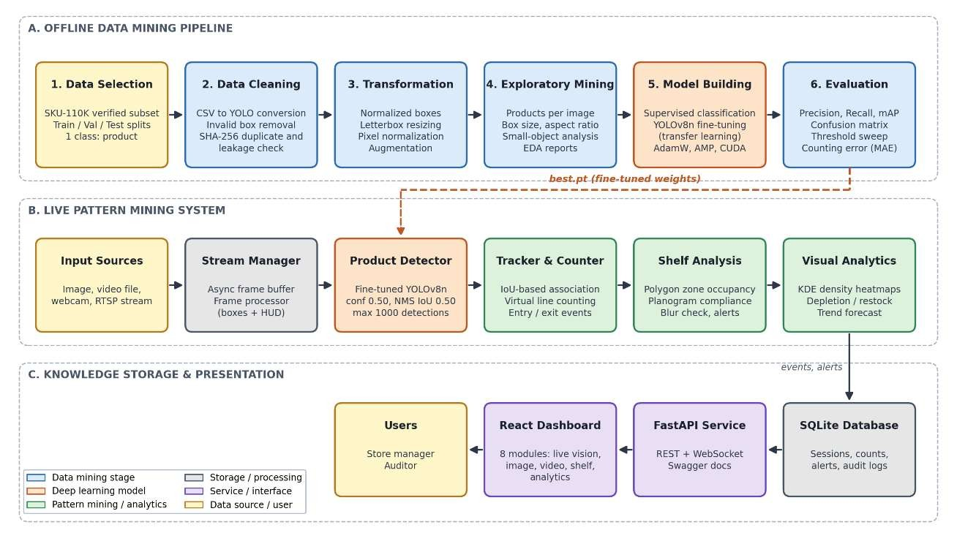
Figure 5.1: System architecture

Data selection and acquisition. A downloader script obtains a verified subset of the SKU110K dataset with its official train, validation and test splits. It checks free disk space before starting. For the full 12 GB archive it supports resumable downloads.
Data cleaning. The annotation converter reads the raw CSV files, skips malformed rows, rejects boxes with invalid coordinates and clamps values to the valid range. The dataset validator then checks image readability, label format, duplicate boxes and duplicate images, and uses SHA-256 hashes to detect leakage between splits. Results are saved as a JSON report.
Data transformation. Annotations are converted to normalized YOLO format. The preprocessing pipeline applies letterbox resizing, pixel normalization and, for training, augmentation.
Exploratory data mining. The analysis script builds box-level and image-level tables, computes statistical summaries and generates the distribution figures. A separate script draws ground-truth boxes on sample images, to check the labels visually.
Model building (supervised classification). The training script fine-tunes the pretrained
YOLOv8n model, adjusts the batch size automatically if memory is limited, and saves the best and last checkpoints together with a metadata file.
Evaluation. The evaluation scripts measure precision, recall, mAP and counting error on the held-out test set, run the confidence threshold sweep and save error-analysis images. A tracking and counting evaluation checks line-crossing accuracy on synthetic trajectories. A baseline script compares the pretrained model with the fine-tuned one.

5.3 Parameters & Configurations
The parameters used in each stage are summarized in the following tables.
Table 5.1: Algorithm and Experimental Hyperparameter Configurations
Parameter | Value
Dataset | SKU-110K (verified subset), 1 class  (“product”)
Annotation format | Normalized YOLO: class, x-centre, y-centre, width, height
Valid width/height range after clamping | 0.0001 to 1.0
Small-object threshold | Normalized area < 0.002 (or pixel area < 32  × 32)
Letterbox padding colour | Grey (114, 114, 114)
Supported resolutions | 640, 960, 1280 (multiples of 32)
Duplicate detection | SHA-256 file hash

Model Training Parameters. The detector is a YOLOv8n model initialized with weights pretrained on the COCO dataset, which is the transfer learning approach described in Chapter 4. The model was fine-tuned for 5 epochs at an input resolution of 640 × 640 pixels with a batch size of 4.
Augmentation Parameters. Data augmentation is applied only during training, and its purpose is to expose the model to more variety than the small training subset contains. Mosaic augmentation, which joins several images into one training sample, is applied with a probability of 0.5.
Detection Parameters. Two decisions at inference time strongly influence the quality of the counts. The first is the confidence threshold, which removes predictions that the model is not sure about.
CHAPTER 6
RESULTS

6.1 Tables
Training results. The YOLOv8n model was fine-tuned for 5 epochs, which took 93.75 seconds in total on the RTX 3050 GPU, with a peak memory use of 805 MB. Table 6.1 shows the training losses and validation metrics after each epoch.
Table 6.1: Training and validation results per epoch
Epoch | Train box  loss | Train cls loss | Val precision | Val recall | Val  mAP@50 | Val  mAP@50-95
1 | 2.674 | 4.746 | 0.101 | 0.523 | 0.055 | 0.021
2 | 2.642 | 4.715 | 0.089 | 0.463 | 0.044 | 0.017
3 | 2.780 | 4.727 | 0.089 | 0.463 | 0.044 | 0.017
4 | 2.404 | 2.673 | 0.445 | 0.402 | 0.265 | 0.093
5 | 2.131 | 2.131 | 0.440 | 0.613 | 0.425 | 0.176
Confidence threshold sweep. To choose the operating point, the confidence threshold was swept from 0.05 to 0.50 on the 20 validation images (2,874 products). Table 6.2 lists selected values.
Table 6.2: Threshold sweep on the validation split
Threshold | Precision | Recall | F1-score | False positives
0.05 | 0.174 | 0.706 | 0.280 | 9,612
0.10 | 0.207 | 0.700 | 0.319 | 7,728
0.25 | 0.274 | 0.689 | 0.392 | 5,248
0.35 | 0.307 | 0.681 | 0.423 | 4,421

6.2 Graphs
Training behaviour. Figure 6.1 shows the loss curves and validation metrics recorded during training, and Figure 6.2 summarizes the validation precision, recall and mAP@50 for each epoch.
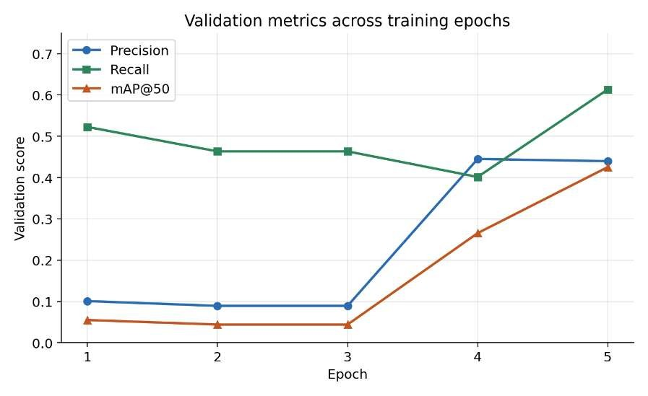
Fig 6.1 validation metrics

During the first three epochs the validation scores stayed low and flat, with mAP@50 between 0.04 and 0.06. This coincides with the learning-rate warm-up, during which the learning rate rises gradually from 0.0006 to about 0.0012. The model was still replacing the 80-class COCO output layer with a single “product” class. In epochs 4 and 5 the classification loss fell sharply, from 4.73 to 2.13, and validation mAP@50 rose from 0.055 to 0.425, which is an increase of about 670% from the first epoch.
Threshold selection. Figure 6.3 shows how precision, recall and F1-score change with the confidence threshold, together with the number of false positives.
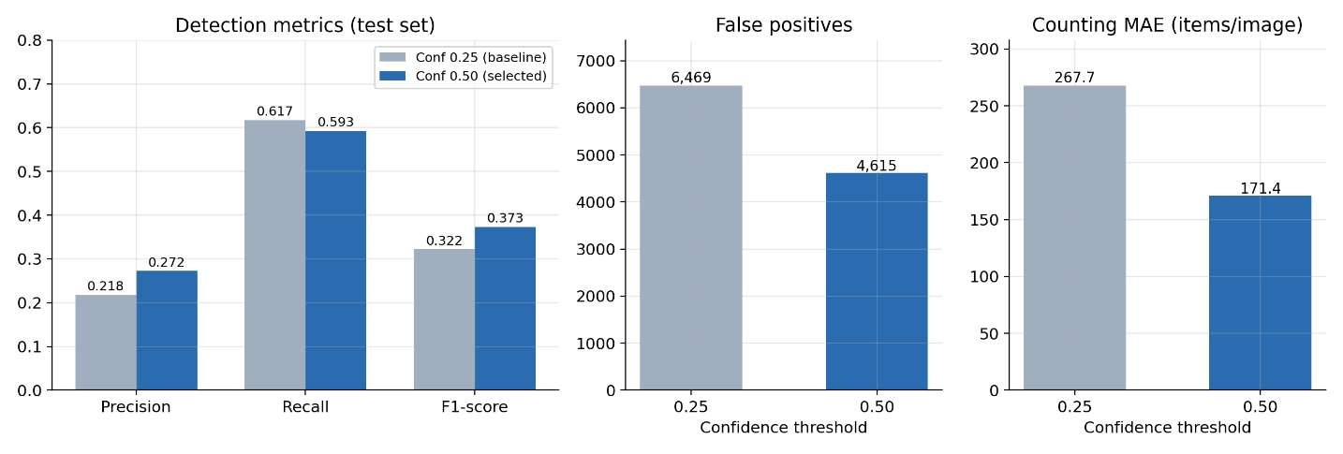
Fig.6.3 threshold comparison

6.3 Evaluation Metrics Analysis
Detection quality. The model finds most of the products but also produces many extra boxes. At the selected threshold it located 59.3% of the products (recall) but only 27.2% of its predictions were correct (precision). The low precision is the main weakness of the current model.
Effect of the confidence threshold. The threshold was the most effective tuning step in the project. Moving from 0.25 to 0.50 removed 1,854 false positives and reduced the counting error by 36.0%, at the cost of a 2.5 point fall in recall. Precision improved by 25.1% in relative terms and the F1-score by 16.0%.
Counting performance. The mean absolute counting error was 171.4 products per image, against an average of 145.7 real products per image. The error has the same value as the signed bias, which means that the system over-counted in every one of the 20 images. Performance by shelf density. The test images were grouped by the number of products they contain. For the 17 images with 120 to 200 products, which is the most common case, the F1-score was 0.399, the recall 0.63 and the counting error 167.8.
Small objects. About 37.7% of all products are small. The recall for small products on the test set was 32.1%, which is far lower than the overall recall of 59.3


Fig.6.4 Overview
CHAPTER 7
COMPARISON AND DISCUSSION

7.1 Algorithm Comparison
The template for this chapter compares several classification algorithms side by side. This project uses one detection model, so the comparison is instead made between the techniques, settings and hardware options that were actually tested. Every number below comes from the experiments in Chapter 6. Table 7.1 summarizes them.
Table 7.1: Comparison of the configurations evaluated
Comparison | Option A | Option B | Outcome
Training progress (validation mAP@50) | Epoch 1: 0.055 | Epoch 5: 0.425 | About 7.7 times higher after finetuning
Confidence threshold  (test F1-score) | 0.25: 0.322 | 0.50: 0.373 | 16.0% better
Confidence threshold  (counting MAE) | 0.25: 267.7 | 0.50: 171.4 | 36.0% lower error
Confidence threshold  (false positives) | 0.25: 6,469 | 0.50: 4,615 | 1,854 fewer
Hardware at 1280 ×  1280 (latency) | CPU: 578.6 ms | GPU: 60.4 ms | 9.6 times faster on  GPU
Shelf density (test  F1-score) | High (17 images):  0.399 | Extreme (1 image):  0.123 | Much worse on very crowded shelves
Pretrained model versus fine-tuned model. A YOLOv8n model pretrained on COCO already knows general shapes and textures, but its output layer was designed for 80 everyday object classes and not for tightly packed retail products.
Low threshold versus high threshold. The comparison between thresholds is a good example of a data mining decision that costs nothing in computation but changes the outcome considerably. A threshold of 0.25 accepts more candidate boxes.

7.2 Advantages
- Complete and repeatable pipeline. The project covers the whole data mining process, from raw annotations to a deployed dashboard. Every stage is a separate script, so the experime can be repeated from the beginning with the same random seed.
- Strong data quality control. The validator checks image integrity, label format, duplicate boxes and duplicate images, and compares image hashes across splits to detect leakage. All 11,787 annotations passed, so the reported results are not inflated by data problems.
- Preservation of small objects. Small products (about 37.7% of the data) were deliberately kept during cleaning, and the detection limit was raised to 1000 per image. This keeps the training data faithful to real shelves.
- Useful results from very little data. Transfer learning produced a working detector from only 40 training images and under two minutes of training.
- Tuning based on measurements. The confidence threshold was chosen from a measured sweep on validation data and then confirmed on separate test data, which avoids tuning on the test set.
- More than detection. Tracking, virtual line counting, shelf-zone occupancy, alerts, heatmaps and an audit database turn raw detections into information that a store manager can act on.

7.3 Limitations
- Very short training. The model was trained for five epochs and was still improving at the end. The validation classification loss was also unstable in epoch 4, so the model has not converged.
- Low precision and systematic over-counting. At the selected threshold only 27.2% of predictions were correct, and the system over-counted in all 20 test images (MAE 171.4 products per image). The counts are not accurate enough for real inventory decisions.
- Localization errors dominate. About 70% of false positives were boxes that overlapped a real product but fell below the 0.5 IoU requirement. Duplicate boxes on identical neighbouring packages and background false alarms add to the problem.
CHAPTER 8
CONCLUSION AND FUTURE SCOPE

8.1 Conclusion
This project set out to build a retail shelf monitoring system that can detect, count and analyze densely packed products, and to carry out the work as a complete data mining process. Following the Knowledge Discovery in Databases (KDD) stages, a verified subset of the SKU-110K dataset (80 shelf images with 11,787 annotated products) was selected, cleaned, transformed, explored, modelled, evaluated and finally turned into usable knowledge through a web dashboard. The results also show clearly what remains to be done. Precision is low (27.2% at the selected threshold), the system over-counts on every test image, recall is weak for small products (32.1%) and for extremely crowded shelves, and the evaluation is based on a small subset of 20 test images. The current counts are therefore not accurate enough for real inventory decisions.

8.2 Future Scope
- Use the full dataset and train for longer. Training on the full SKU-110K collection of more than 11,000 images, for many more epochs.
- Try larger models and higher resolution. Larger variants such as YOLOv8s or
YOLOv8m, or a higher training resolution, could improve recall on small products.
- Improve post-processing for dense shelves. Most false positives were near-miss localization errors and duplicate boxes on identical neighbouring packages.
- Add direct counting methods. Because the aim is an accurate total, a densityestimation or count-regression model could be combined with the detector, and its prediction used to correct the over-counting.
- Recognize individual products. The model detects a generic “product”. Extending it to multi-class recognition, for example with the Retail Product Checkout (RPC) dataset whose download and extraction scripts are already included in the project, would allow real planogram checks, price verification and per-item stock tracking.

REFERENCES
- E. Goldman, R. Herzig, A. Eisenschtat, J. Goldberger, and T. Hassner, “Precise detection in densely packed scenes,” in Proc. IEEE/CVF Conf. Computer Vision and Pattern Recognition (CVPR), 2019, pp. 5227–5236.
- J. Redmon, S. Divvala, R. Girshick, and A. Farhadi, “You only look once: Unified, realtime object detection,” in Proc. IEEE Conf. Computer Vision and Pattern Recognition (CVPR), 2016, pp. 779–788.
- T.-Y. Lin et al., “Microsoft COCO: Common objects in context,” in Proc. European Conf. Computer Vision (ECCV), 2014, pp. 740–755.
- U. Fayyad, G. Piatetsky-Shapiro, and P. Smyth, “From data mining to knowledge discovery in databases,” AI Magazine, vol. 17, no. 3, pp. 37–54, 1996.
- J. Han, M. Kamber, and J. Pei, Data Mining: Concepts and Techniques, 3rd ed. Burlington, MA, USA: Morgan Kaufmann, 2012.
- M. Everingham, L. Van Gool, C. K. I. Williams, J. Winn, and A. Zisserman, “The PASCAL visual object classes (VOC) challenge,” Int. J. Computer Vision, vol. 88, no. 2, pp. 303–338, 2010.
- Y. Zhang et al., “ByteTrack: Multi-object tracking by associating every detection box,” in Proc. European Conf. Computer Vision (ECCV), 2022.
- I. Loshchilov and F. Hutter, “Decoupled weight decay regularization,” in Proc. Int. Conf. Learning Representations (ICLR), 2019.
- P. Micikevicius et al., “Mixed precision training,” in Proc. Int. Conf. Learning Representations (ICLR), 2018.
- A. Neubeck and L. Van Gool, “Efficient non-maximum suppression,” in Proc. Int. Conf. Pattern Recognition (ICPR), vol. 3, 2006, pp. 850–855.
- X.-S. Wei, Q. Cui, L. Yang, P. Wang, and L. Liu, “RPC: A large-scale retail product checkout dataset,” arXiv:1901.07249, 2019.

