Model: "sequential_1"

_________________________________________________________________

Layer (type) Output Shape Param #

=================================================================

conv2d (Conv2D) (None, 30, 30, 32) 896

max_pooling2d (MaxPooling2 D) (None, 15, 15, 32) 0

conv2d_1 (Conv2D) (None, 13, 13, 64) 18496

max_pooling2d_1 (MaxPoolin g2D) (None, 6, 6, 64) 0

flatten_1 (Flatten) (None, 2304) 0

dense_3 (Dense) (None, 64) 147520

dense_4 (Dense) (None, 10) 650

=================================================================

Total params: 167562 (654.54 KB)

Trainable params: 167562 (654.54 KB)

Non-trainable params: 0 (0.00 Byte)

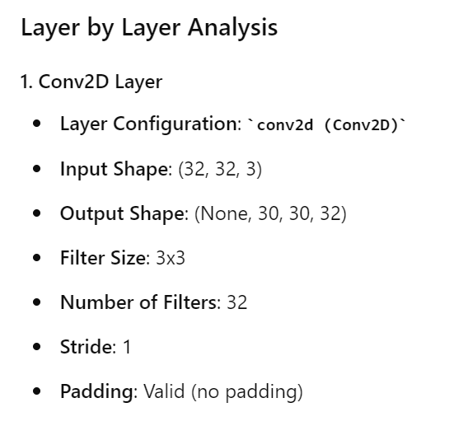

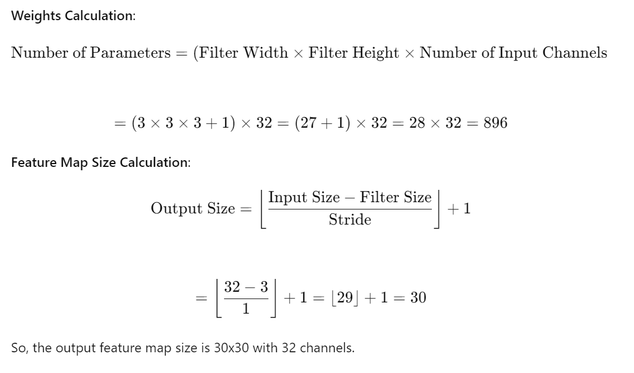

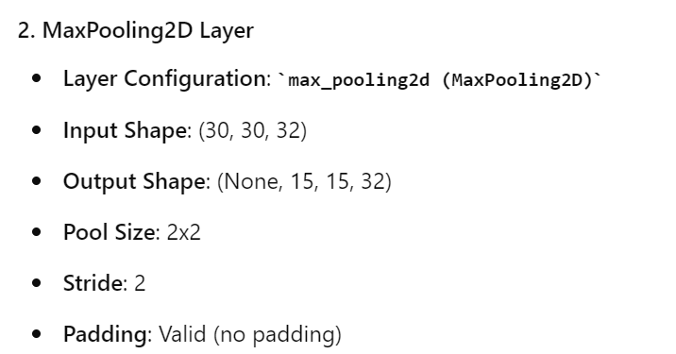

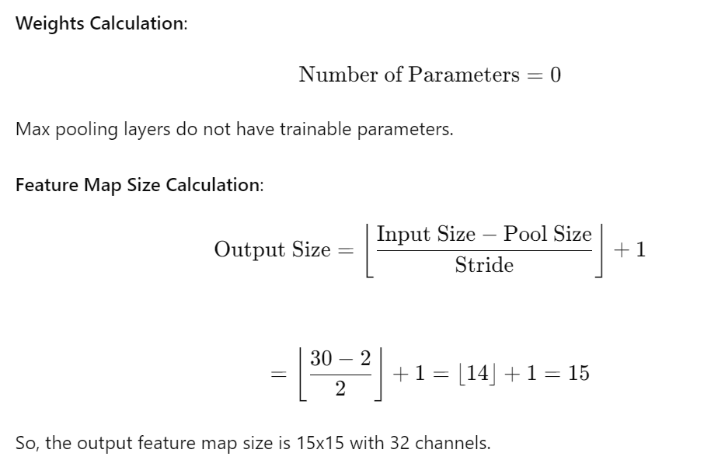

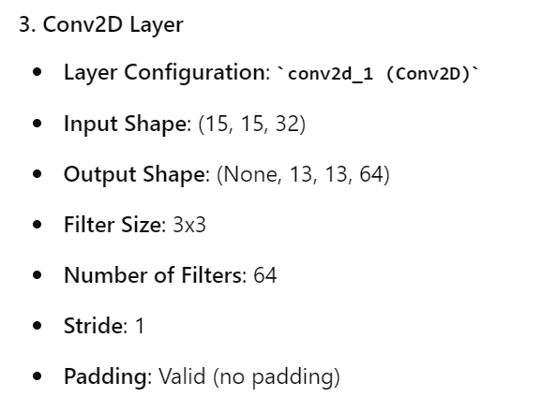

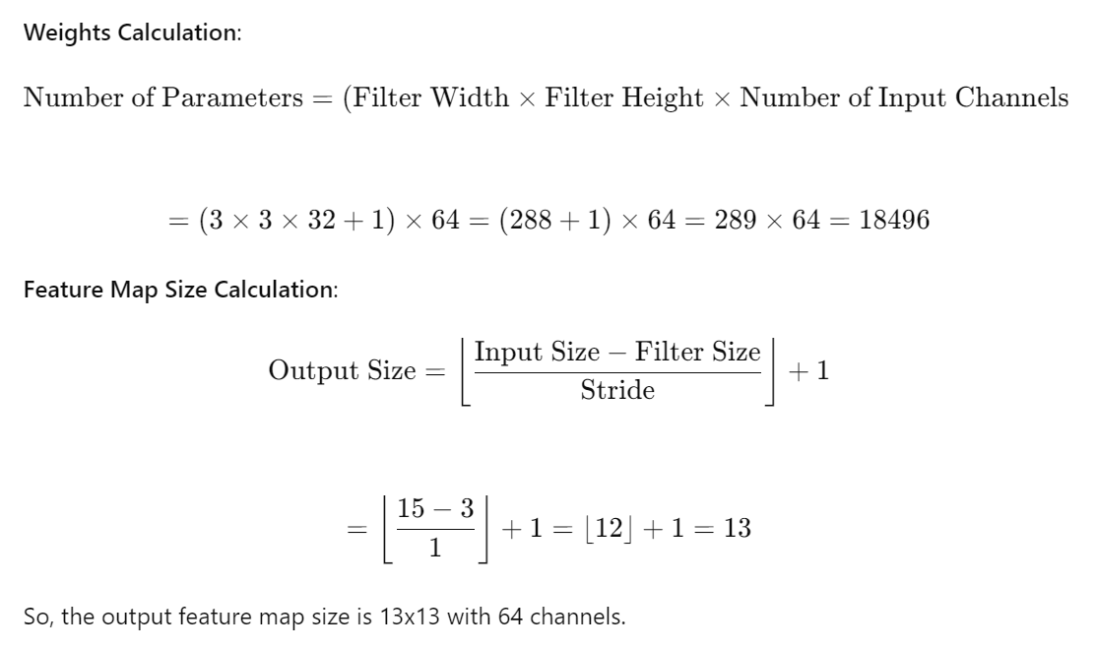

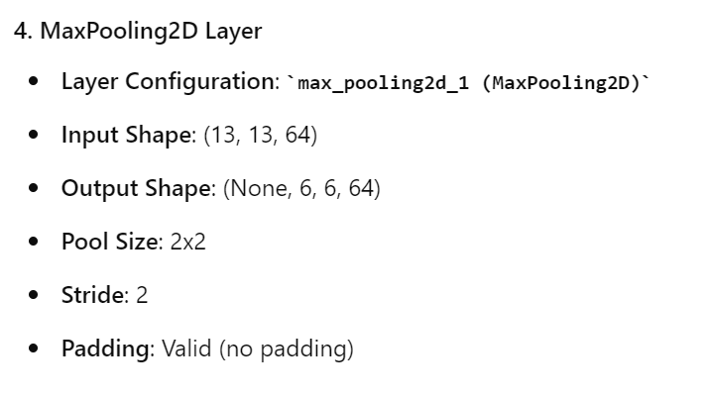

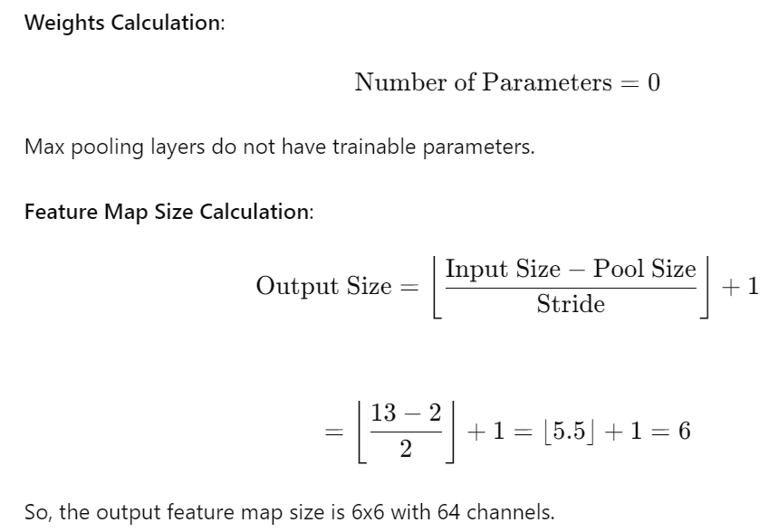

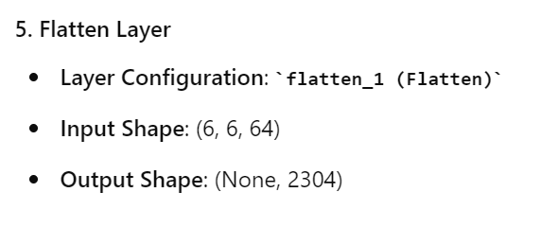

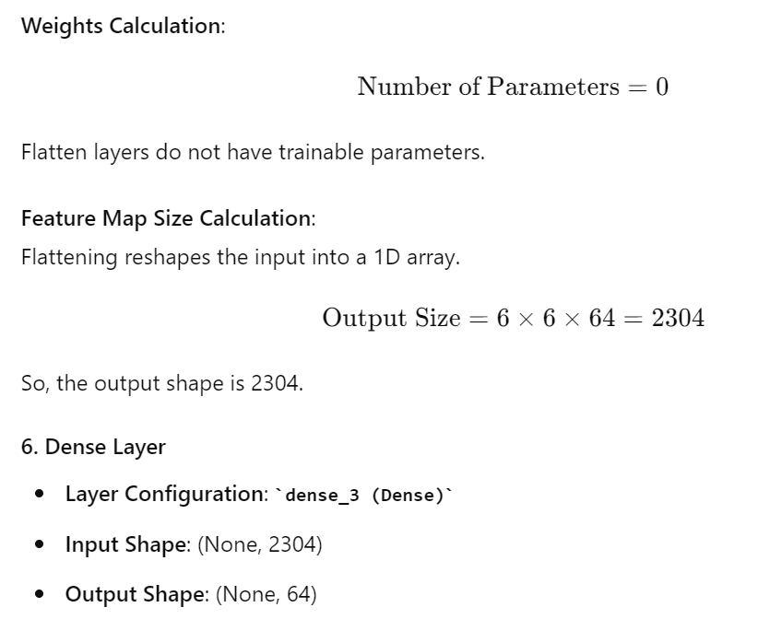

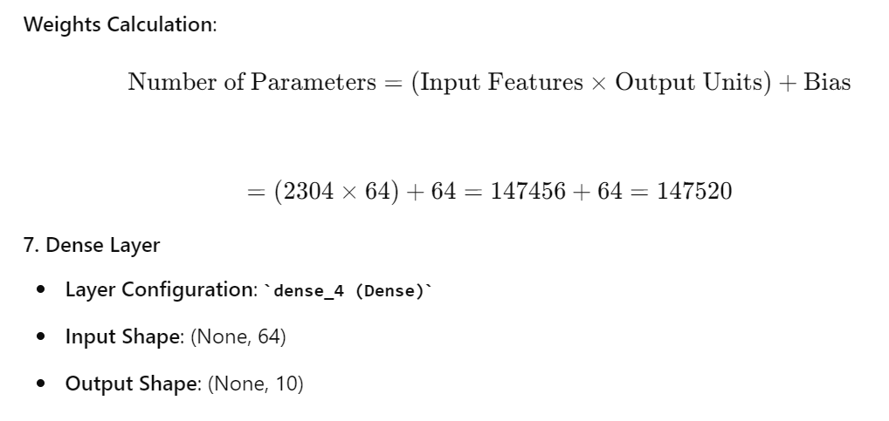

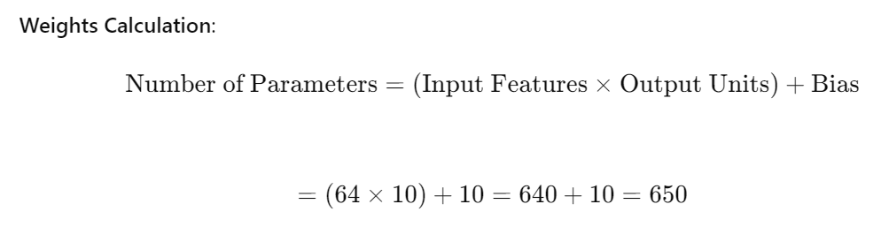

**Summary of Parameters and Feature Map Sizes:**

1. **conv2d (Conv2D)**:
   * Parameters: 896
   * Output Size: 30x30x32
2. **max_pooling2d (MaxPooling2D)**:
   * Parameters: 0
   * Output Size: 15x15x32
3. **conv2d_1 (Conv2D)**:
   * Parameters: 18496
   * Output Size: 13x13x64
4. **max_pooling2d_1 (MaxPooling2D)**:
   * Parameters: 0
   * Output Size: 6x6x64
5. **flatten_1 (Flatten)**:
   * Parameters: 0
   * Output Size: 2304
6. **dense_3 (Dense)**:
   * Parameters: 147520
   * Output Size: 64
7. **dense_4 (Dense)**:
   * Parameters: 650
   * Output Size: 10

**Total parameters**: 167,562  
**Trainable parameters**: 167,562  
**Non-trainable parameters**: 0