**Steps to Install Power BI on Windows**

Follow these simple steps to install Power BI on your Windows computer:

**Step 1: Open the Official Power BI Website**

Open any web browser like Chrome or Edge and go to the official Power BI website.

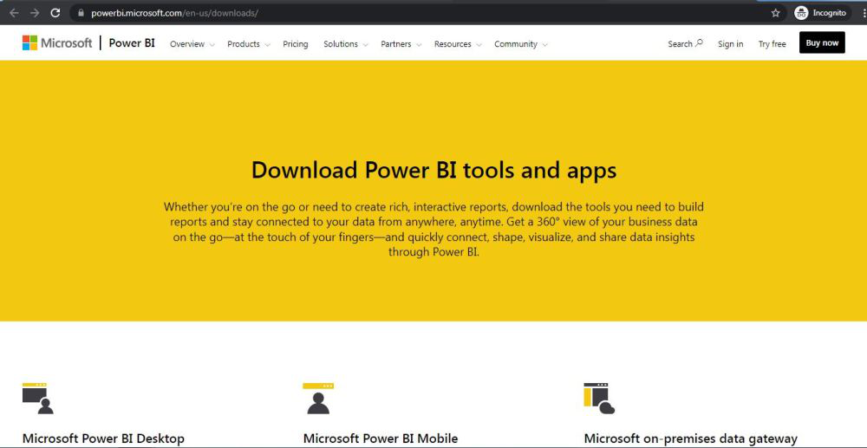

**Step 2: Go to the Power BI Desktop Section**

On the homepage click on the “Download Power BI Desktop” option.

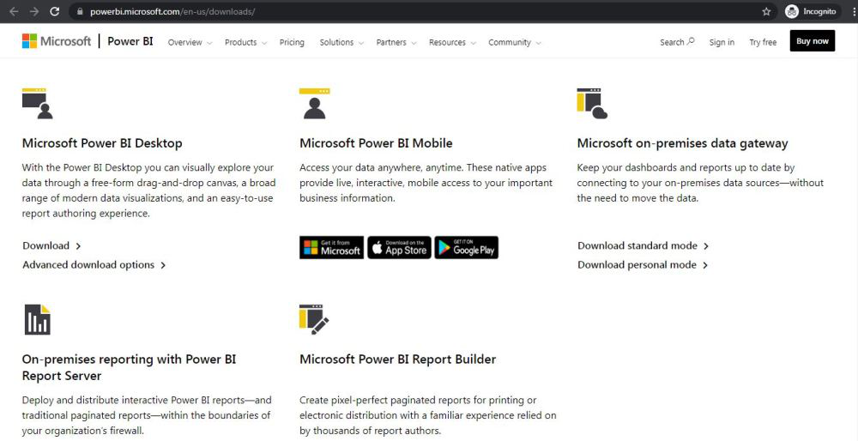

**Step 3: Click on the Download Button**

You will be taken to a new page. Click on the Download button to start the process.

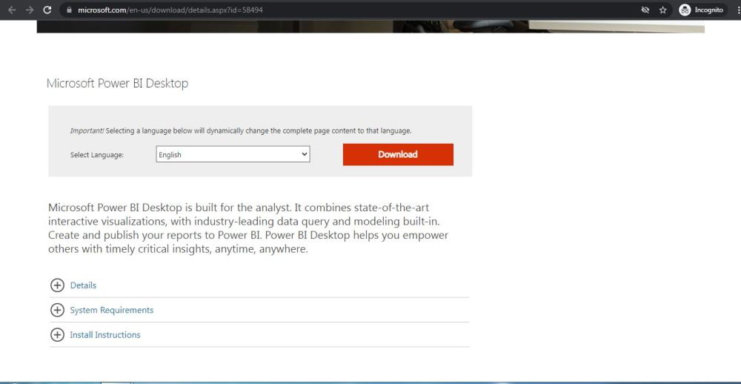

**Step 4: Choose the Installer Based on Your System**

On the next webpage choose the setup option according to your system configuration, let's take the first setup click on the Next button. Downloading of the executable file will start shortly. It is a big  361.7 MB file that will take some minutes.

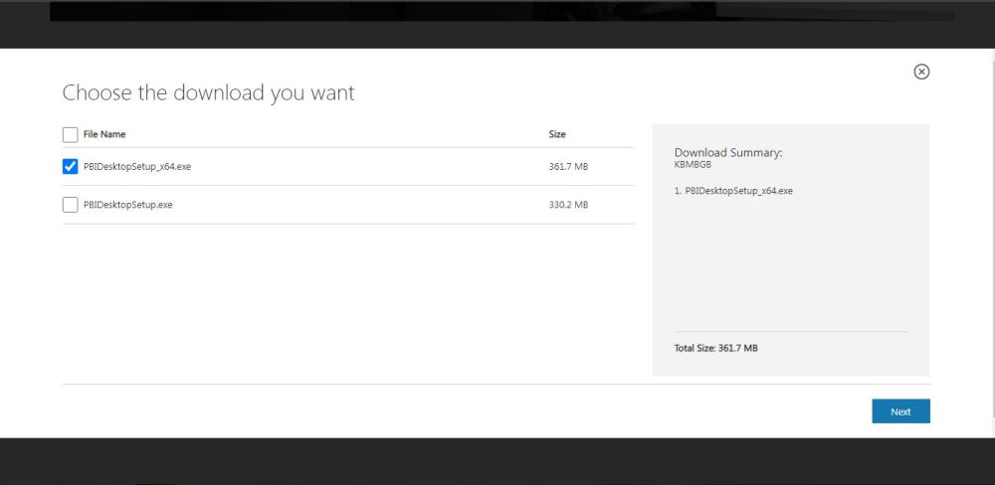

**Step 5: Find the Downloaded File**

Now check for the executable file in downloads in your system and run it.

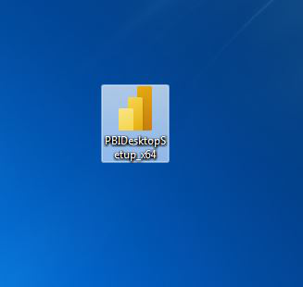

**Step 6: Run the Installer**

Double-click on the file. If prompted with a security warning click Run.

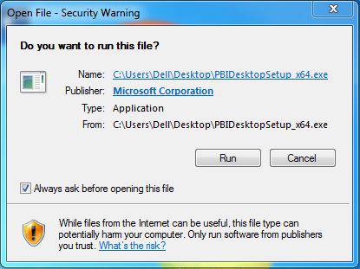

**Step 7: Select Your Language**

Choose your preferred language and click Next.

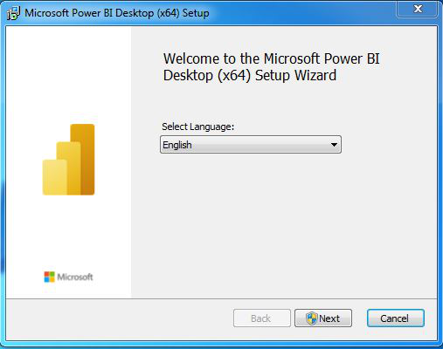

**Step 8: Allow Changes to Your System**

A pop-up will ask for permission to make changes to your system. Click Yes.

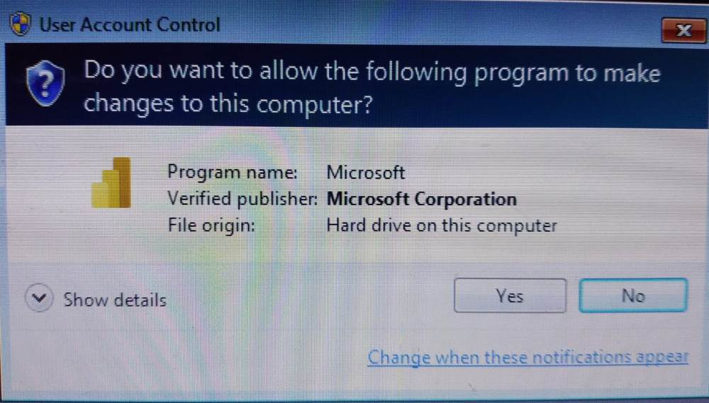

**Step 9: Setup Will Start**

Power BI will now begin preparing for the installation.

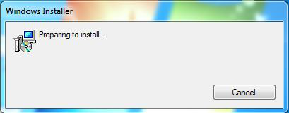

**Step 10: Start Installation Setup**

Click Next on the setup welcome screen.

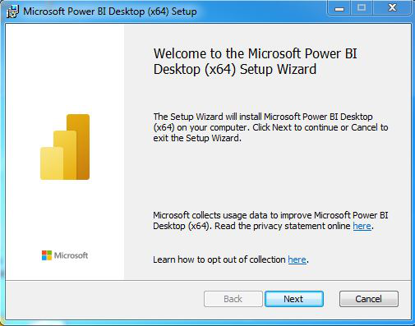

**Step 11: Accept the License Agreement**

Check the box that says “I accept the terms in the License Agreement” and click Next.

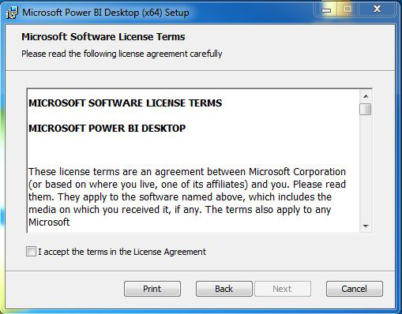

**Step 12: Choose Installation Folder**

You can either keep the default location or choose a different one. Then click Next.

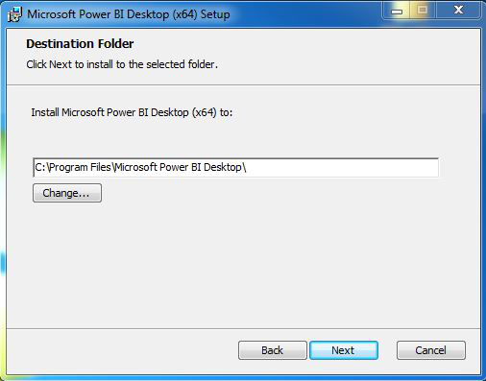

**Step 13: Begin Installation**

Click on the Install button. Installation will start and usually takes a minute or two.

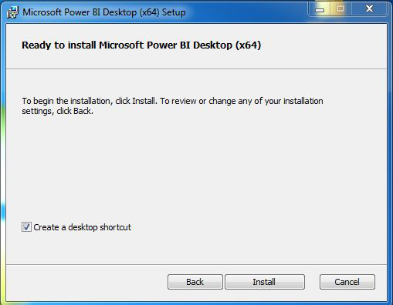

As you can see the installation is started in the below image

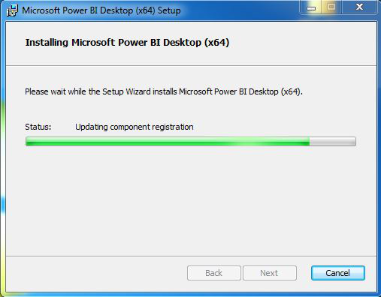

**Step 14: Complete Installation**

Once done click on the Finish button.

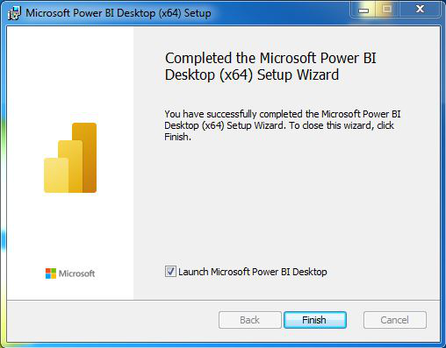

**Step 15: Launch Power BI**

A shortcut icon will appear on your desktop. Double-click it to open Power BI Desktop.

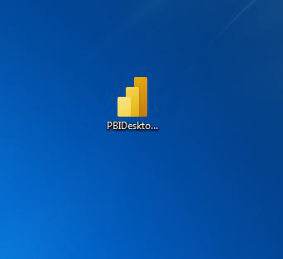

Now we run the software and see the interface.

