**Online Grocery Store**

**Gundrala Bharath Kumar**

**Project part - 5**

**29th April - 2022**

**Github::**

https://github.com/bharath4568/index-SQL

**Indexes :**

I have created two indexes like Payment_Details, Product_Details.

**Payment_Details**

create index payment_details on payment(Customer_name,Total_payment,Date,Product_product_Id);

Above index is used for user to view the payment details.

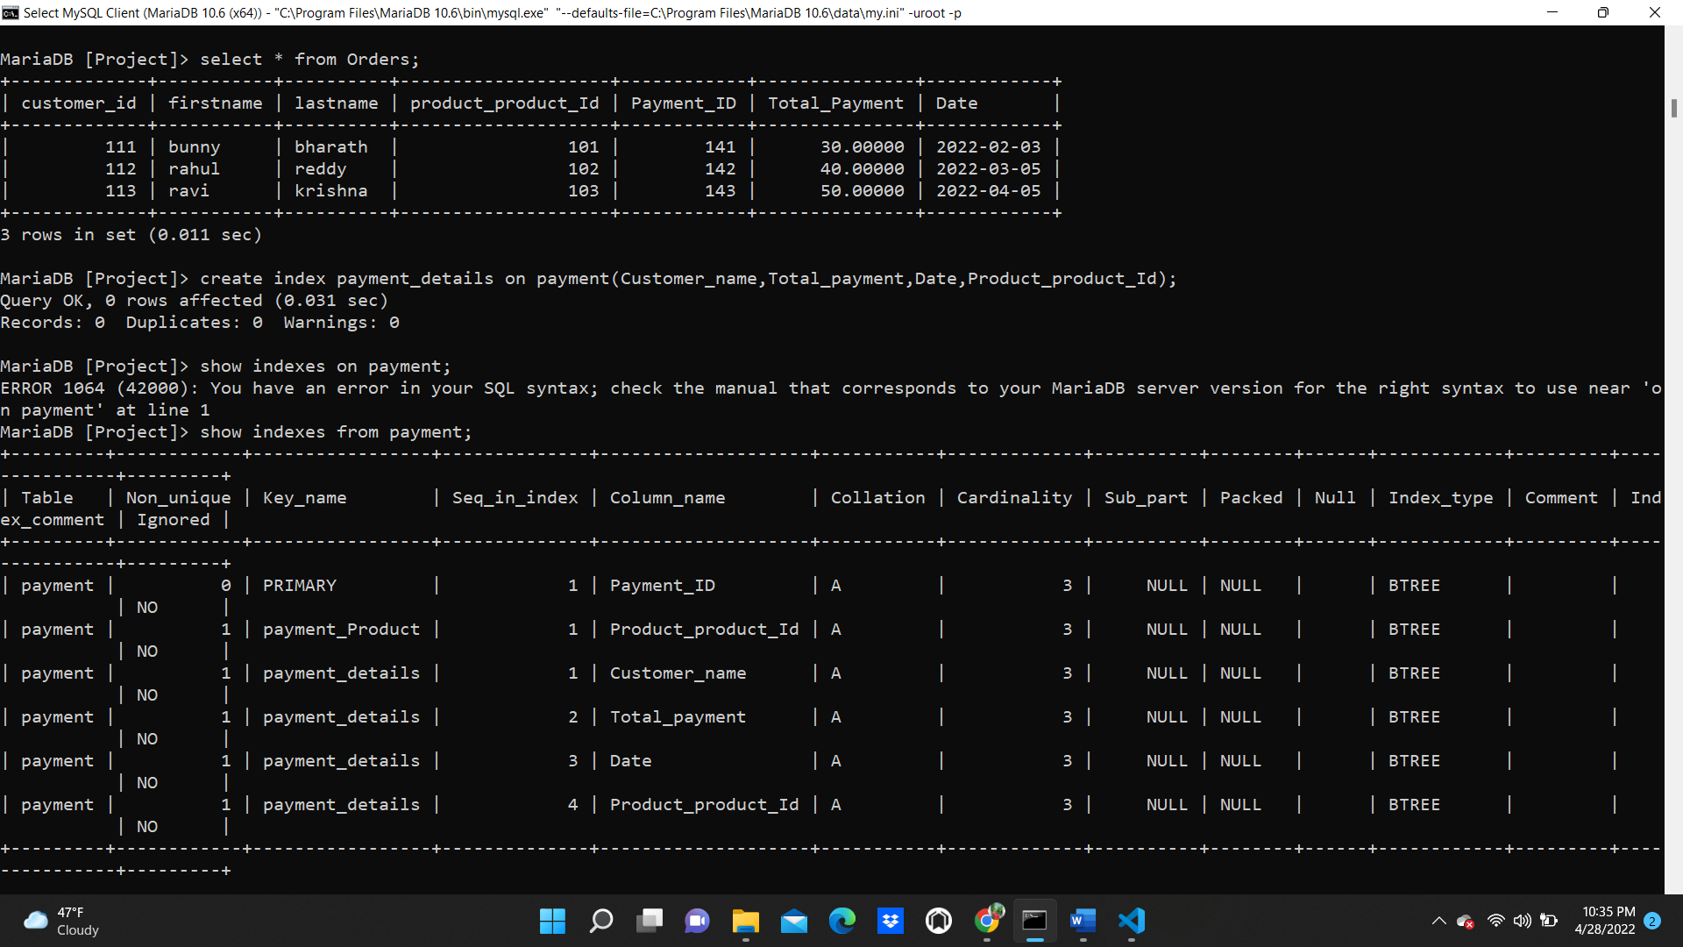

**Product_Details**

create index product_details on product(product_Id,Name,price);

Above index is used for user to search the product details.

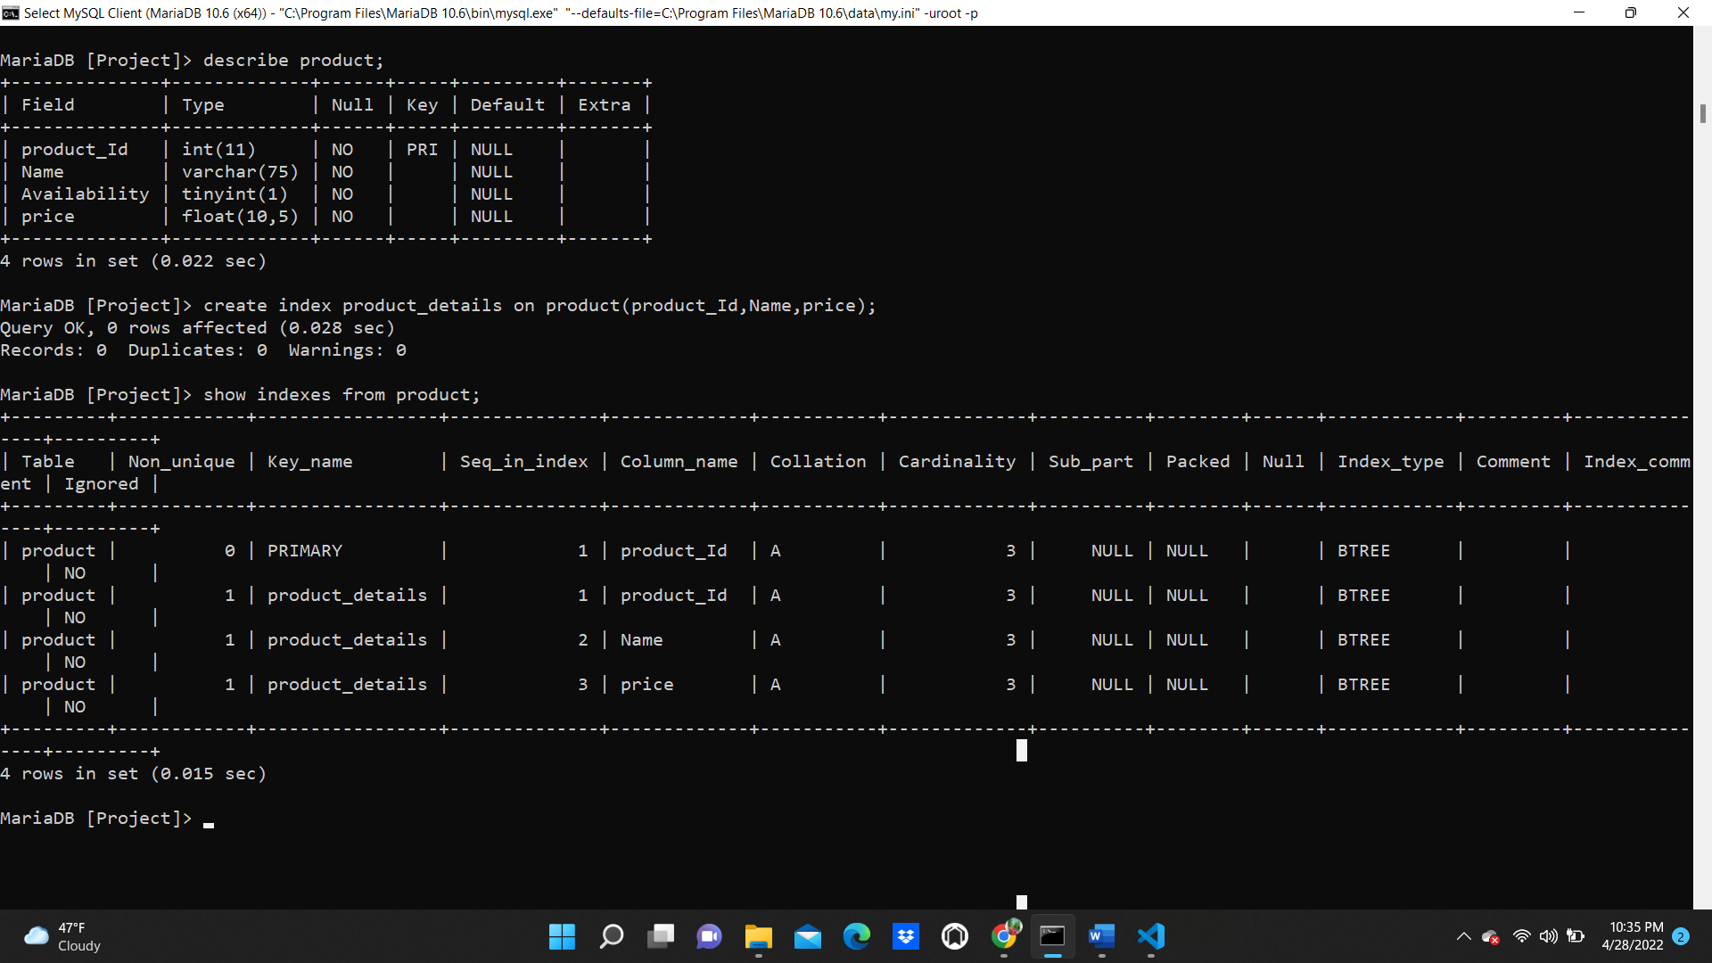

**Views :**

I have created two views as Product_Sales and orders

**Product_Sales :**

create view Product_Sales as select product.product_Id,product.Name,product.price,sales.Quantity,sales.Date_Purchase from product

-> inner join sales on product.product_Id=sales.product_product_Id order by product.Name;

This view is used by admin , when admin wants to see the product sales.

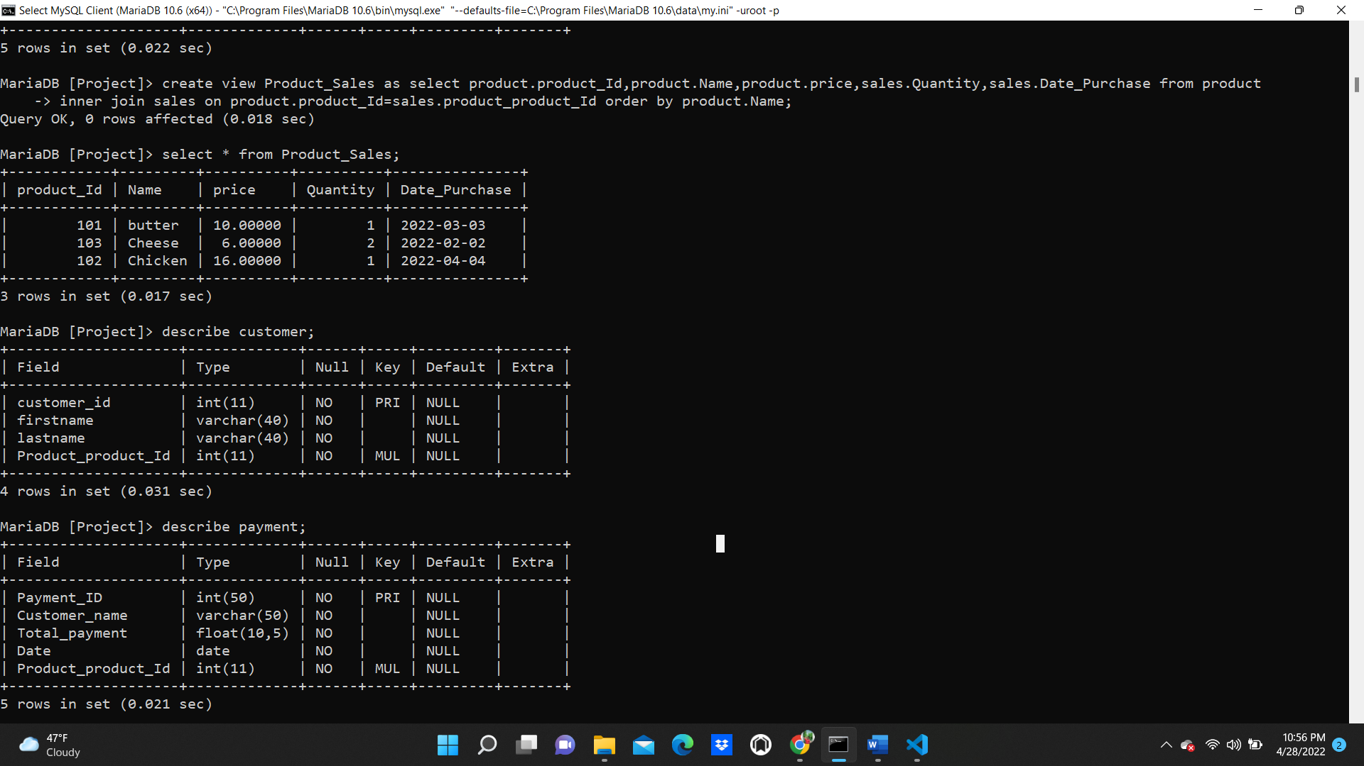

**Orders :**

create view Orders as select customer.customer_id,customer.firstname,customer.lastname,customer.product_product_Id,payment.Payment_ID,payment.Total_Payment,payment.Date from customer

-> inner join payment on customer.product_product_Id=payment.product_product_Id order by customer.firstname;

The above view is used for orders, it is useful to view the orders by admin.

