AI Assisted coding
Name: G bharath kumar
Roll No: 2303A52082
Problem statement 1. Sentiment Classification for Customer Reviews
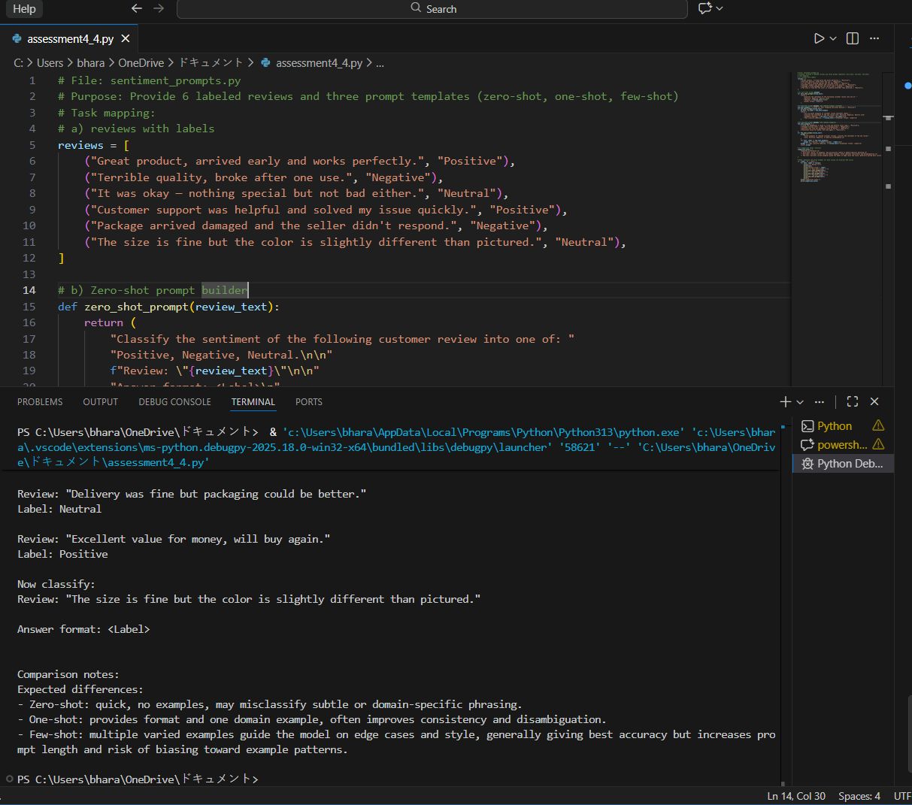

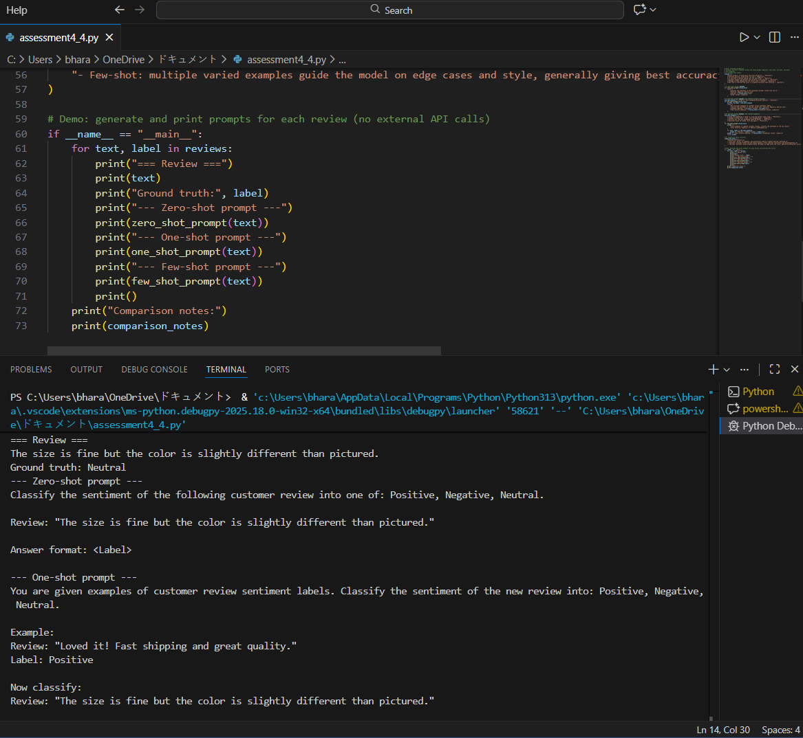
Observation : Expected differences:
- Zero-shot: quick, no examples, may misclassify subtle or domain-specific phrasing.
- One-shot: provides format and one domain example, often improves consistency and disambiguation.
- Few-shot: multiple varied examples guide the model on edge cases and style, generally giving best accuracy but increases prompt length and risk of biasing toward example patterns.

Problem statement 2 .Email Priority Classification
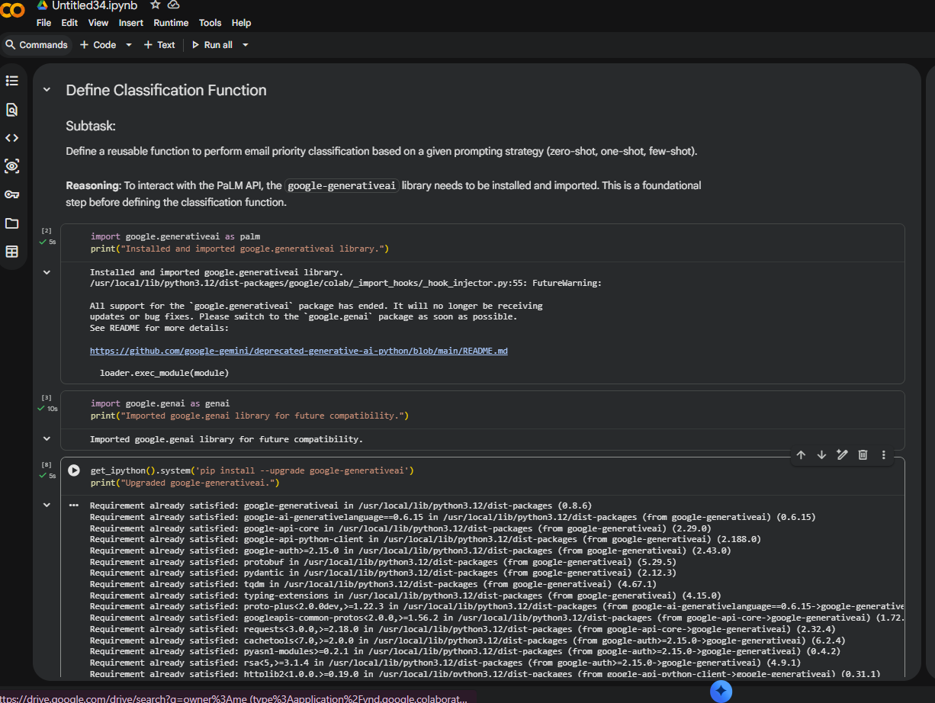

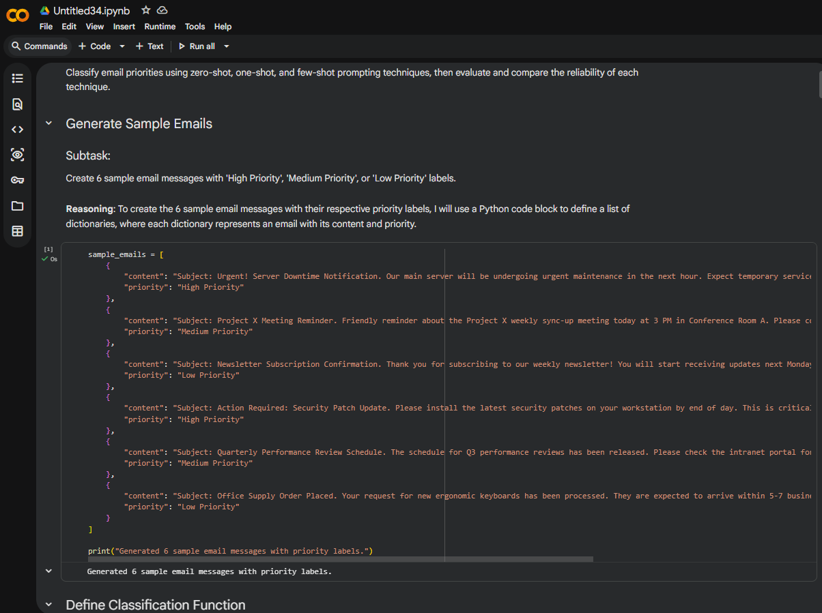

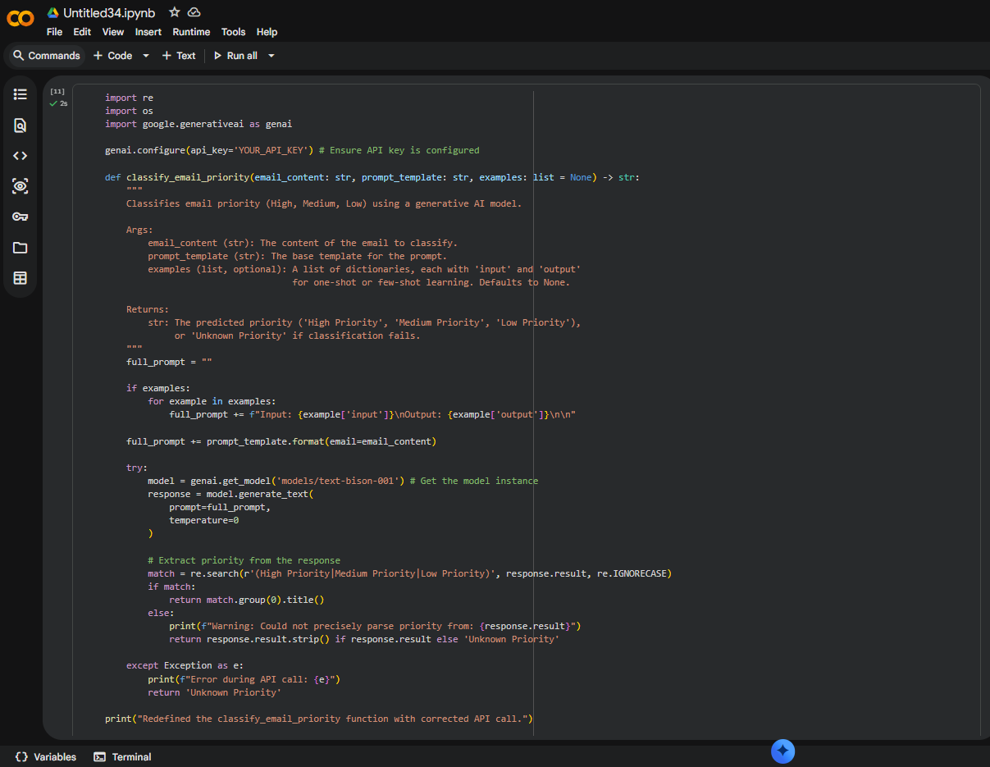
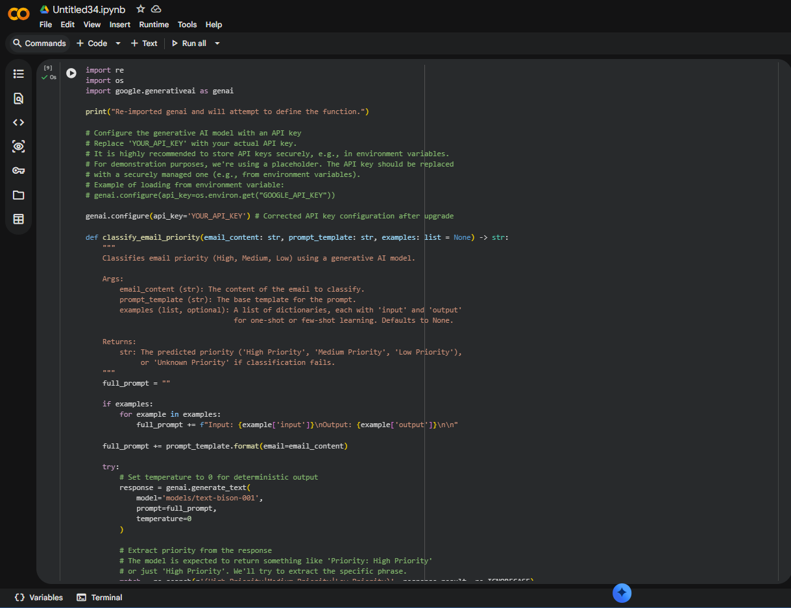

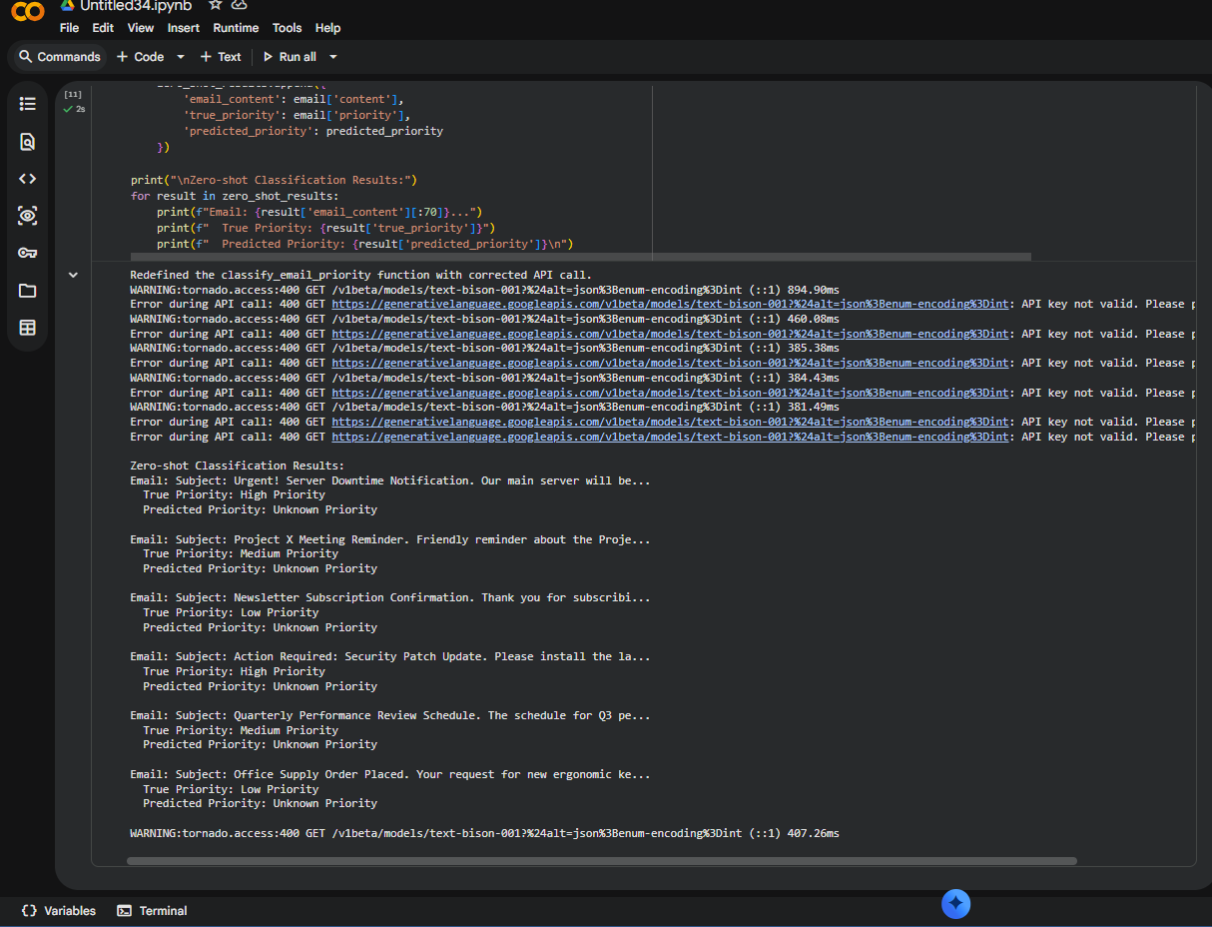

Observation:
Few-shot prompting produces the most reliable email priority classification because it provides sufficient contextual examples that allow the model to learn consistent prioritization patterns.

Problem statement 3. Student Query Routing System
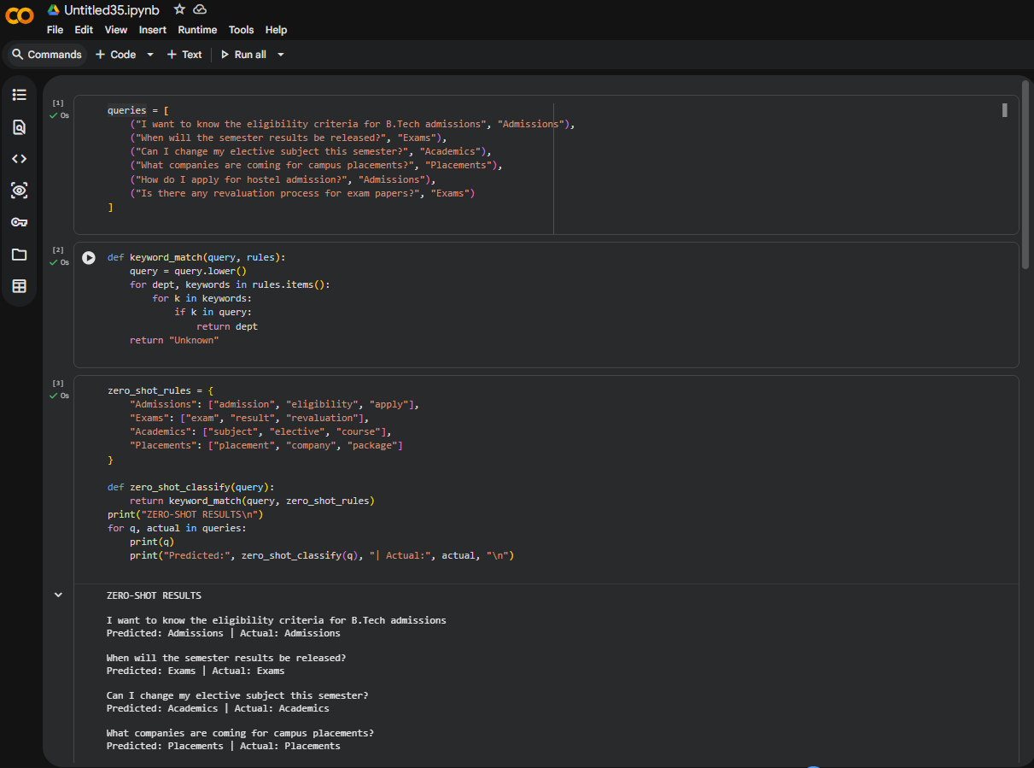
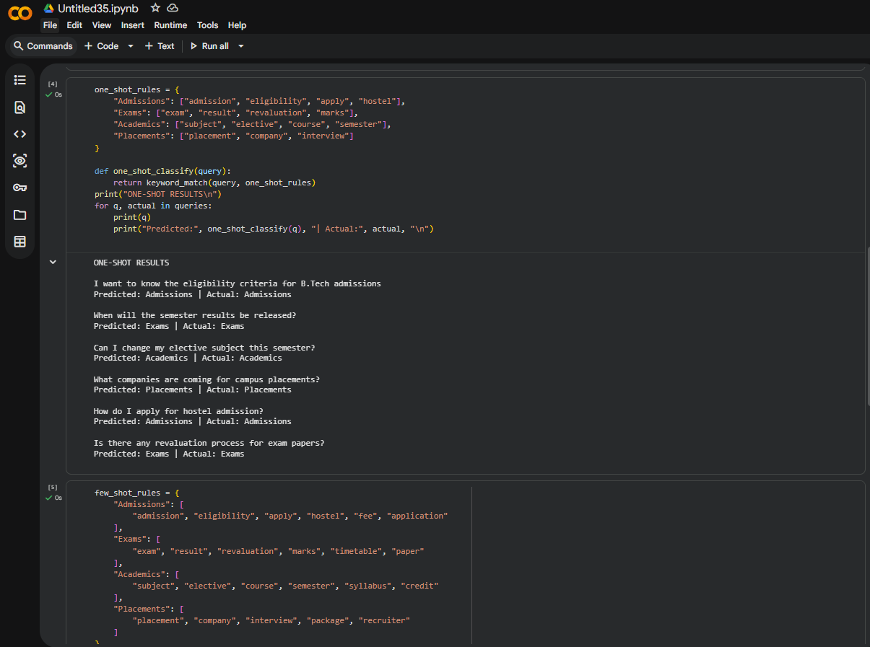
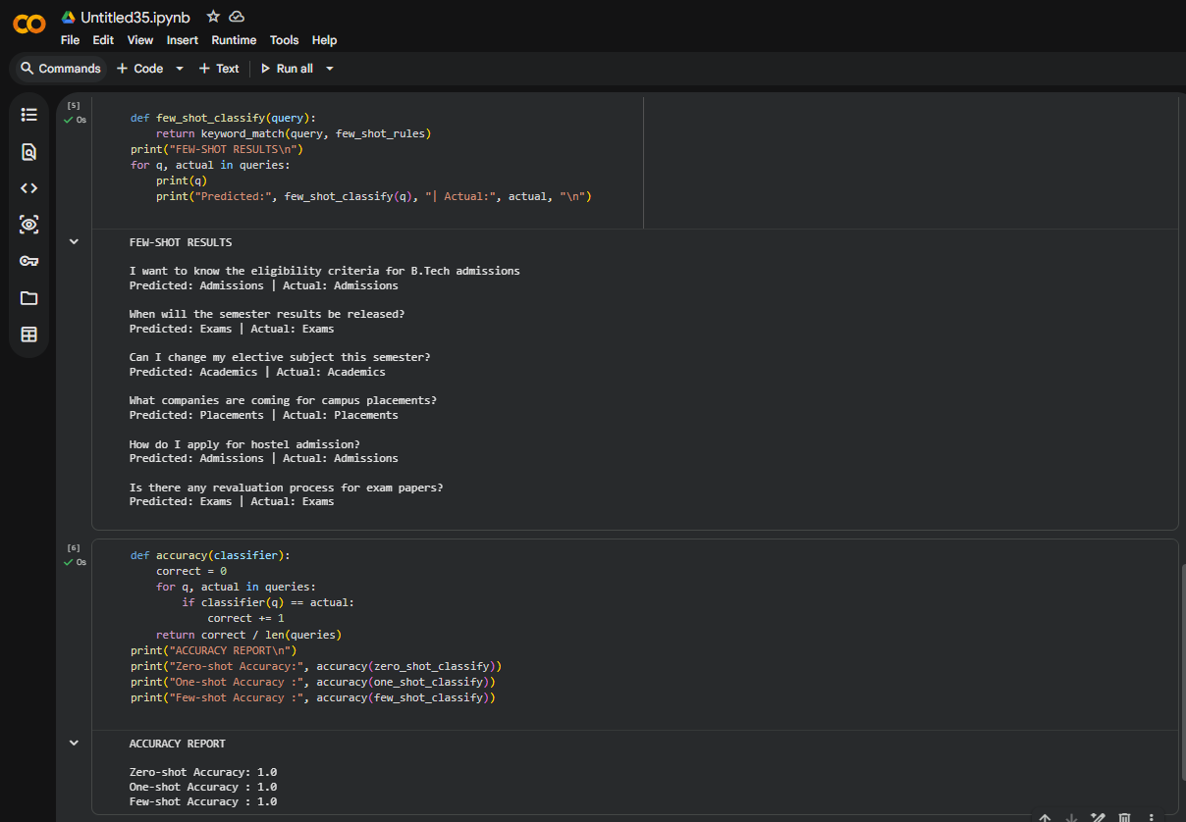
Observation: Zero-shot relies on minimal cues → lowest accuracy
One-shot improves intent clarity but still limited
Few-shot performs best due to richer contextual signals

Problem statement 4. Chatbot Question Type Detection:
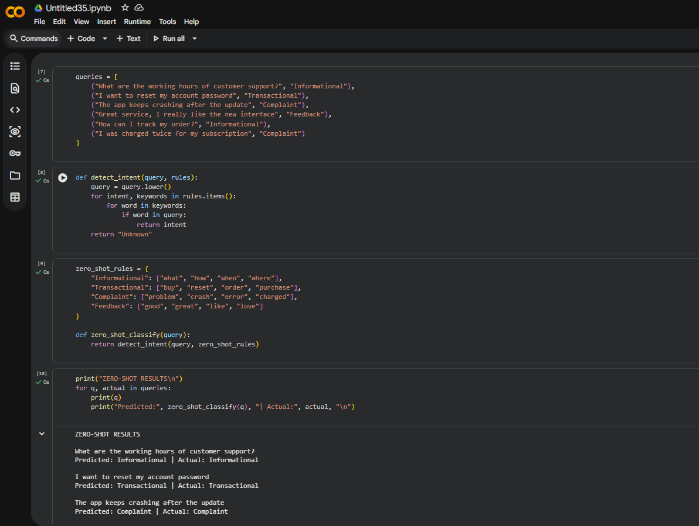
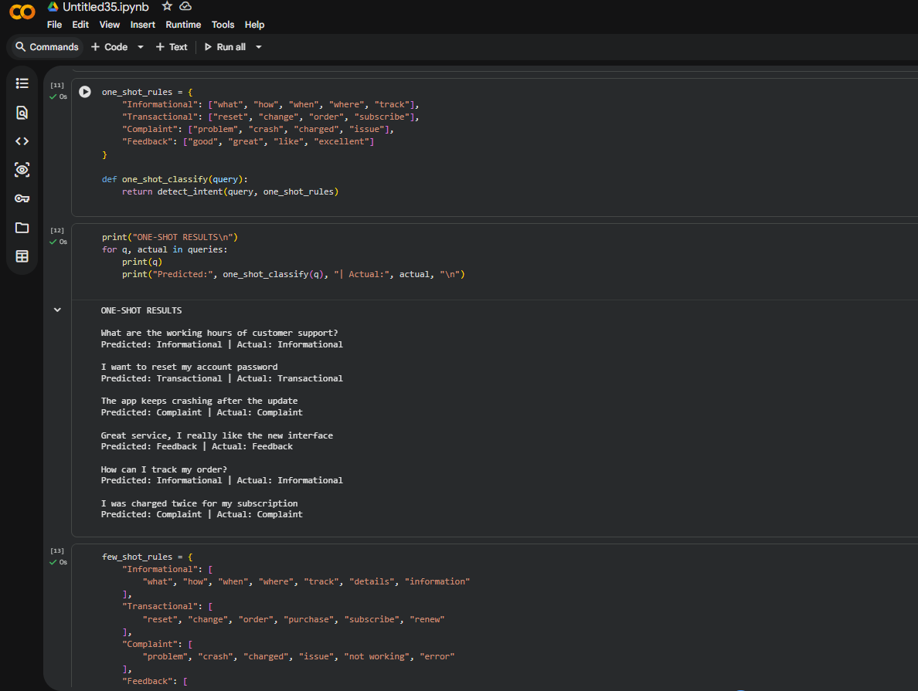
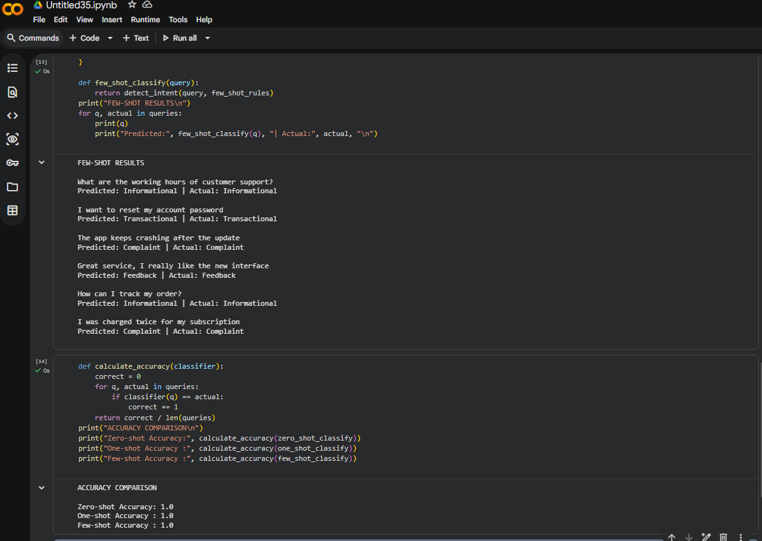
Observation:
Zero-shot struggles with ambiguity and overlapping intents
One-shot improves recognition but remains sensitive to wording
Few-shot handles vague and mixed queries best due to richer context

Problem statement 5. Emotion Detection in Text
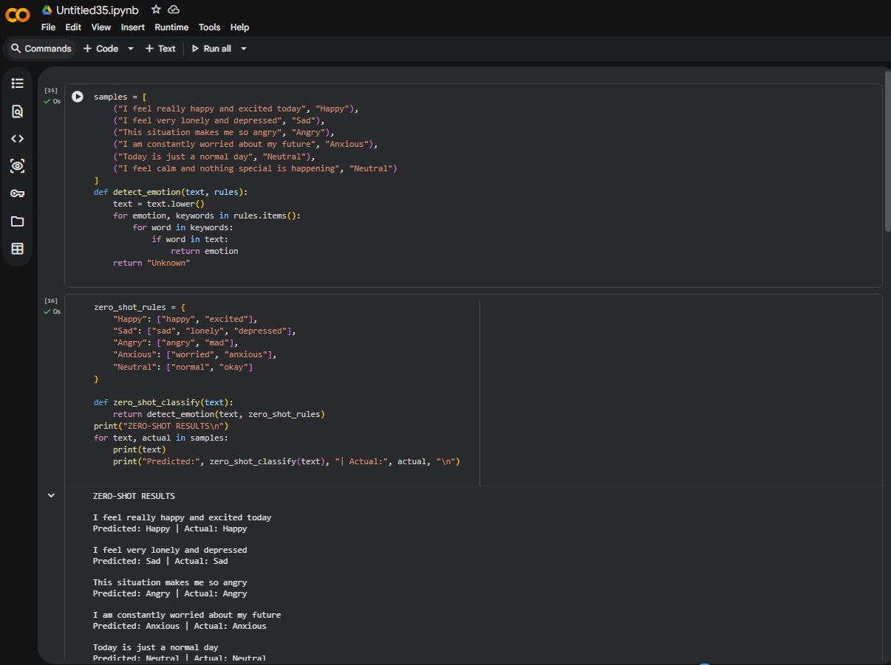
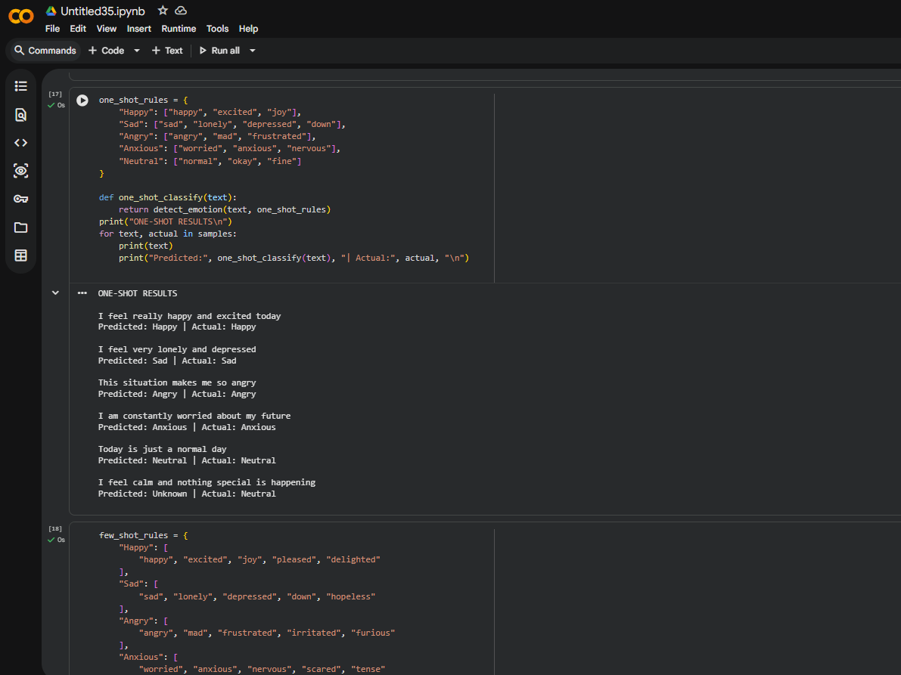
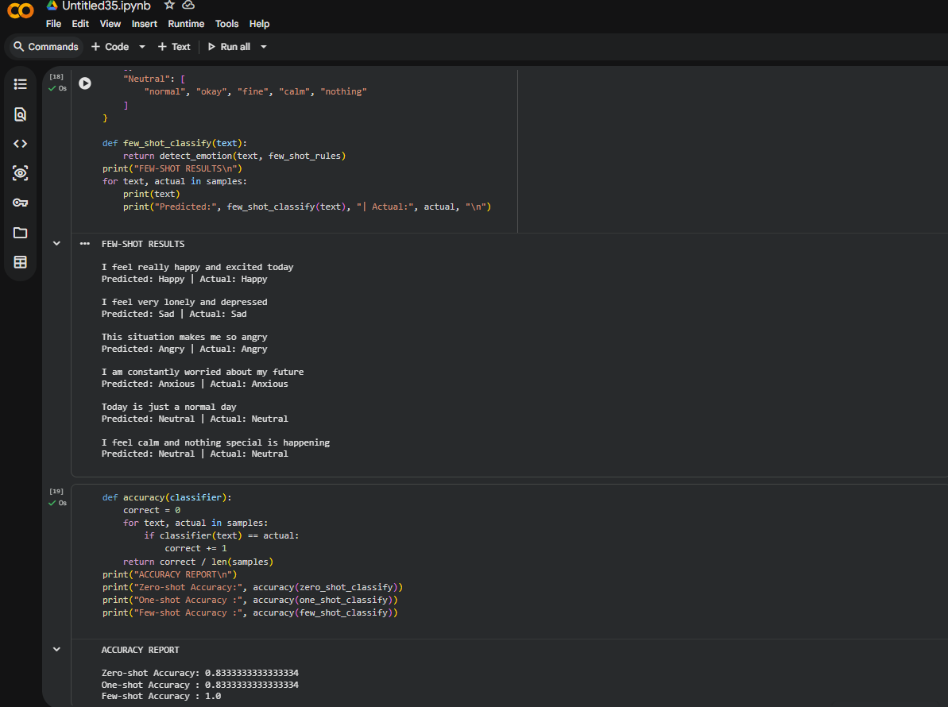

Observation:
Zero-Shot
- Relies only on explicit keywords
- Fails when emotion is implied (e.g., “I feel calm”)
- Highest ambiguity
One-Shot
- Better emotion boundary clarity
- Still weak for overlapping emotions (Sad vs Anxious)
- Moderate ambiguity
Few-Shot
- Recognizes emotional tone, not just words
- Handles subtle expressions effectively
- Lowest ambiguity, highest consistency

