Assignment-14.1 Name: G. Bharath Kumar
H. No:2303A52082
Batch:43

Task1: Portfolio Website Design Prompt:
Create a personal portfolio website with three main sections: About Me, Projects, and Contact. Suggest a suitable modern color palette and typography for a professional and visually appealing design.
Develop the layout using CSS Flexbox and Grid to ensure responsiveness across different screen sizes. Implement smooth
scrolling navigation for better user experience. The design should be clean, interactive, and user-friendly.

Code:
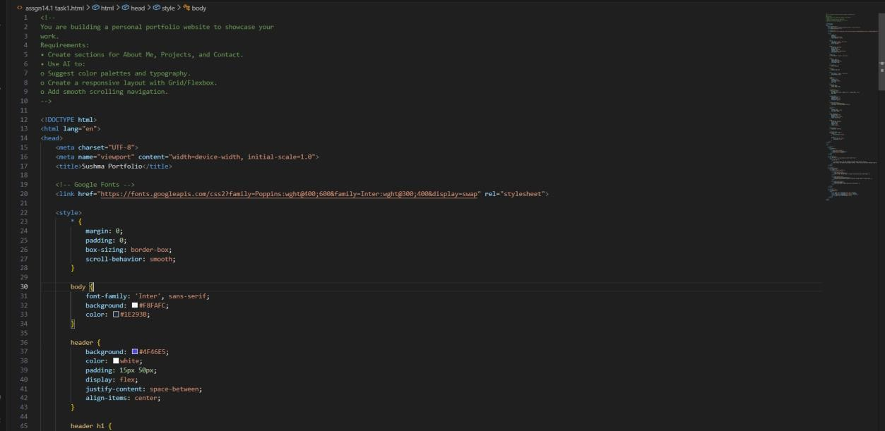


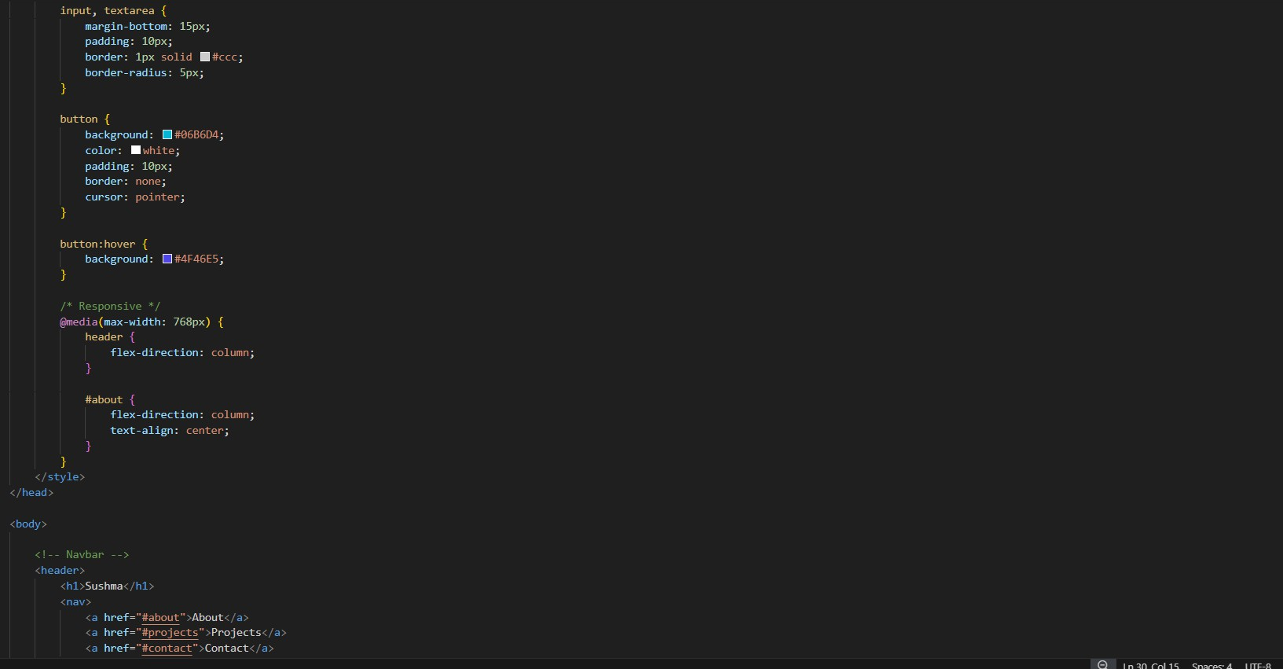

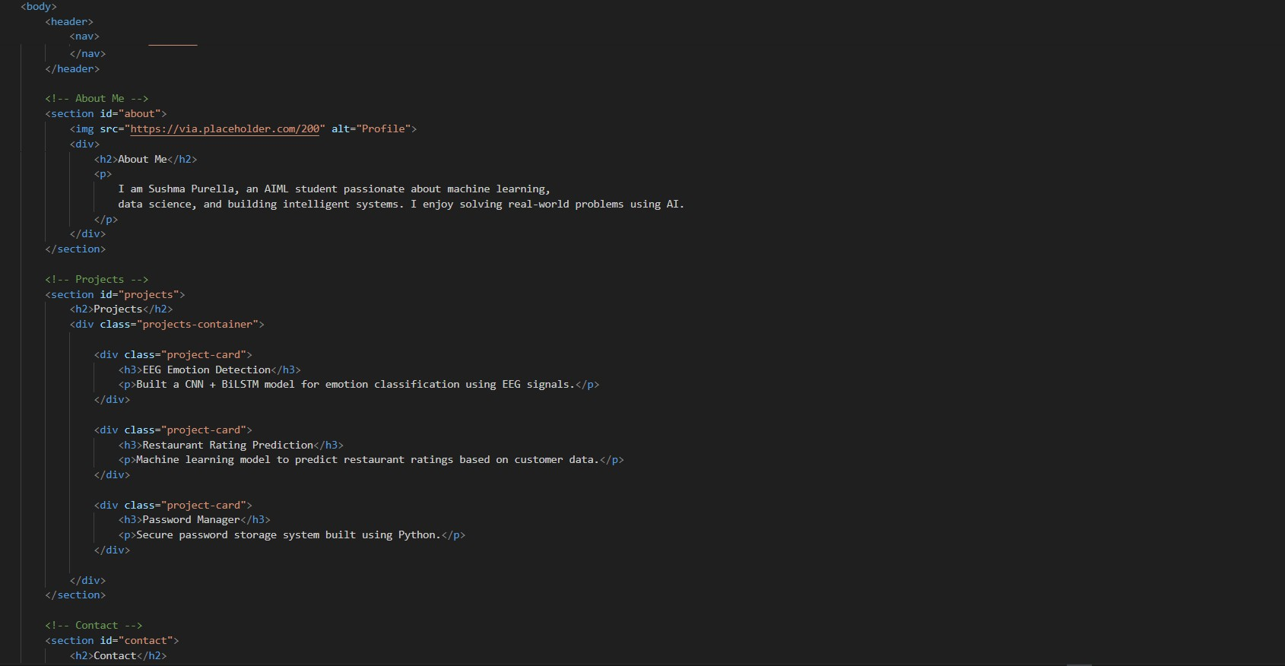

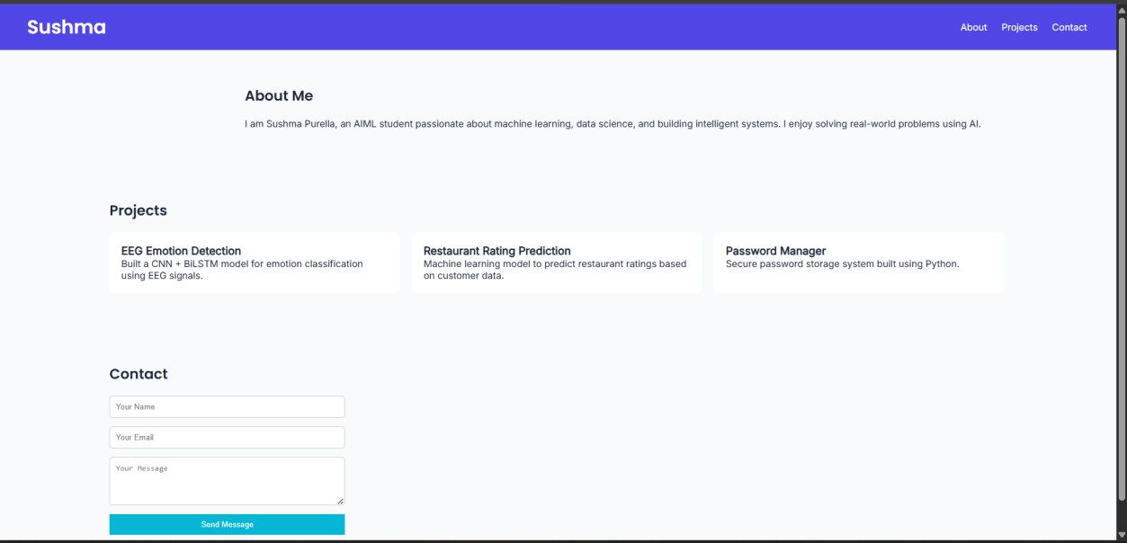
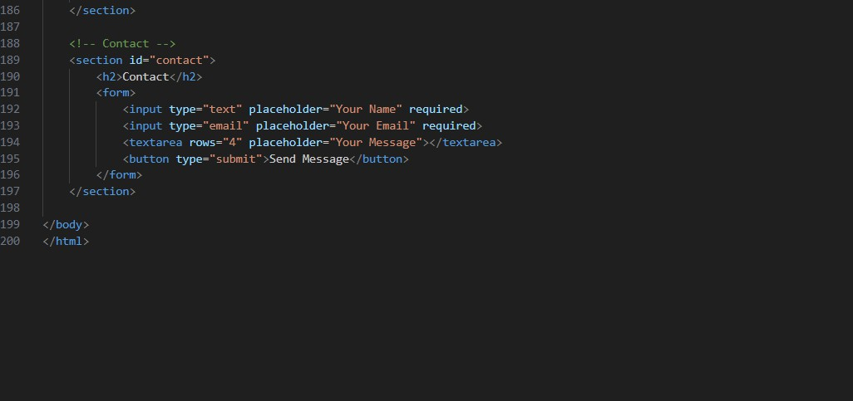

Observation:
The AI-generated design provided a clean and modern portfolio layout using a professional color palette and readable fonts. The use of Flexbox and Grid helped create a responsive structure that adapts well to different screen sizes. Smooth scrolling improved user navigation, making the website more interactive and user-friendly.
Overall, AI significantly reduced design effort and helped in quickly building a well-structured and visually appealing portfolio website.

Task 2 – Online Store Product Page Prompt:
Design a responsive product display page for an online store that includes product image, title, price, and an "Add to Cart" button. Use BEM (Block Element Modifier) methodology for CSS styling. Ensure the layout is responsive using Flexbox or Grid. Add hover effects for better user interaction and implement a JavaScript alert when the "Add to Cart" button is clicked.
Code:

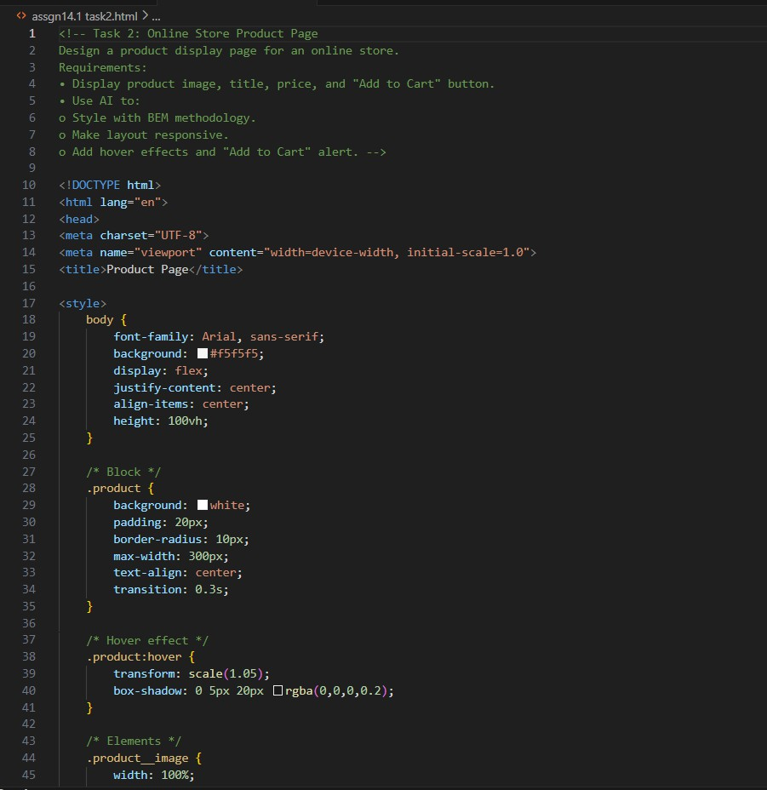

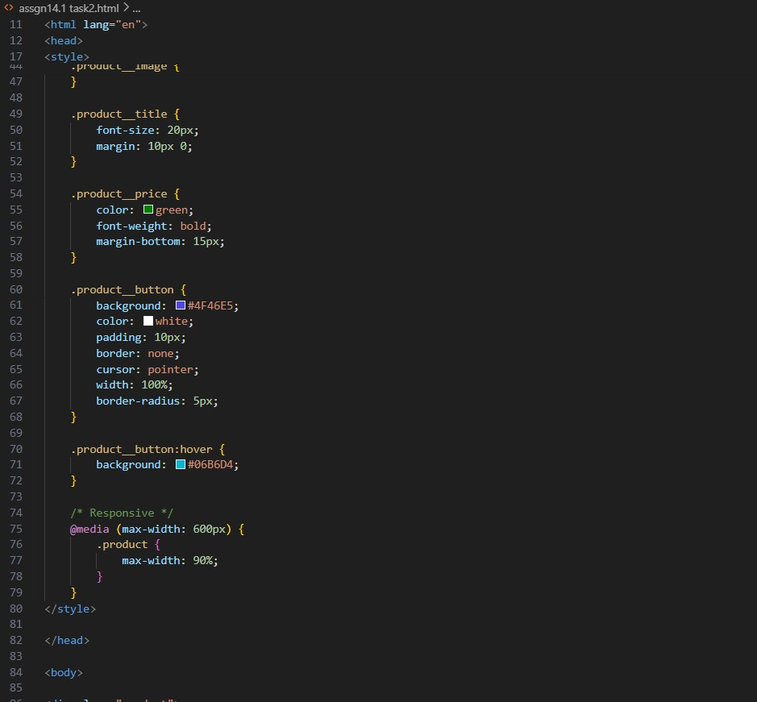

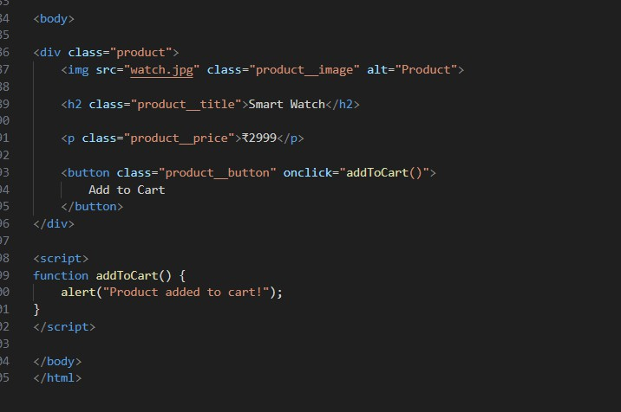
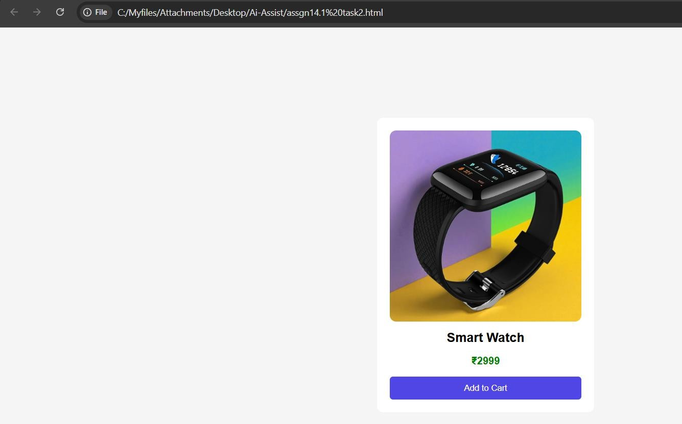
Observation:
The product page was successfully designed using BEM
methodology, which helped maintain clean and structured CSS. The responsive layout ensured proper display across different screen sizes.

Hover effects improved user interaction, making the design more engaging. The "Add to Cart" button functionality using JavaScript alert demonstrated basic interactivity. Overall, AI helped in quickly generating a professional and functional product page design.

Task 3 – Event Registration Form Prompt:
Design an event registration form for a conference that collects user details such as name, email, phone number, and session selection.
Implement JavaScript-based form validation to ensure correct input. Ensure accessibility by using proper labels and ARIA attributes. Style the form with a clean and professional user interface, and make it responsive for different screen sizes.

Code:

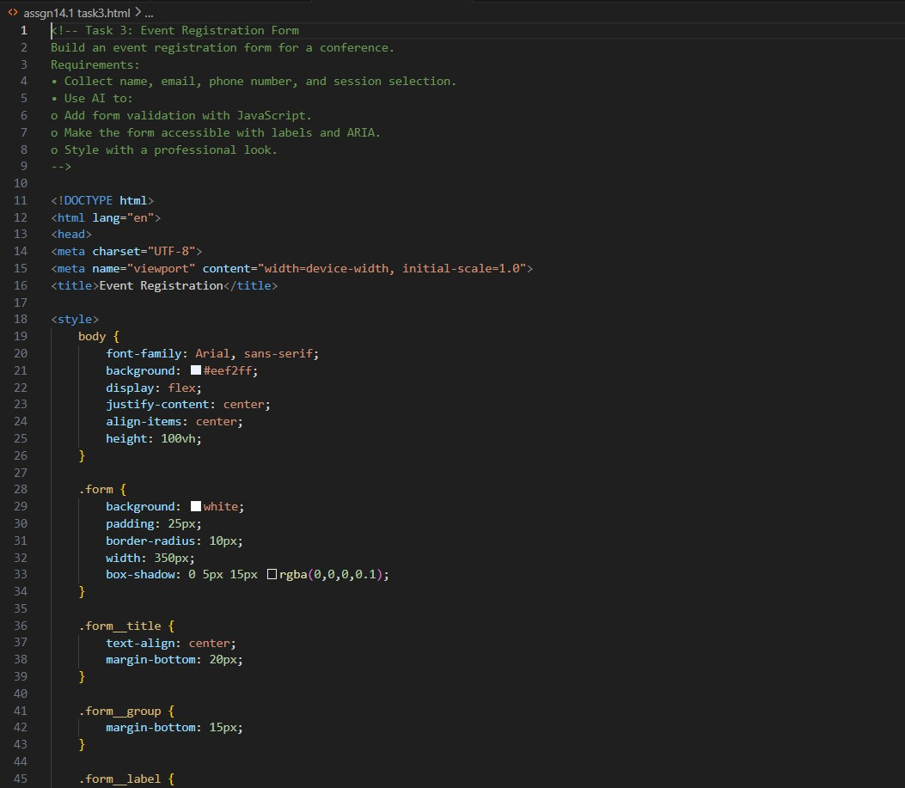

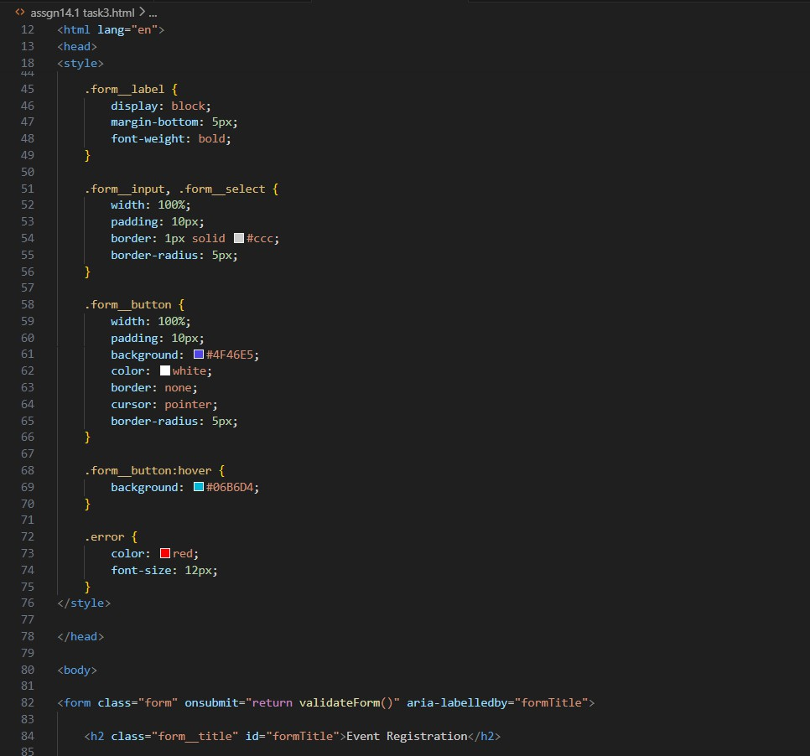

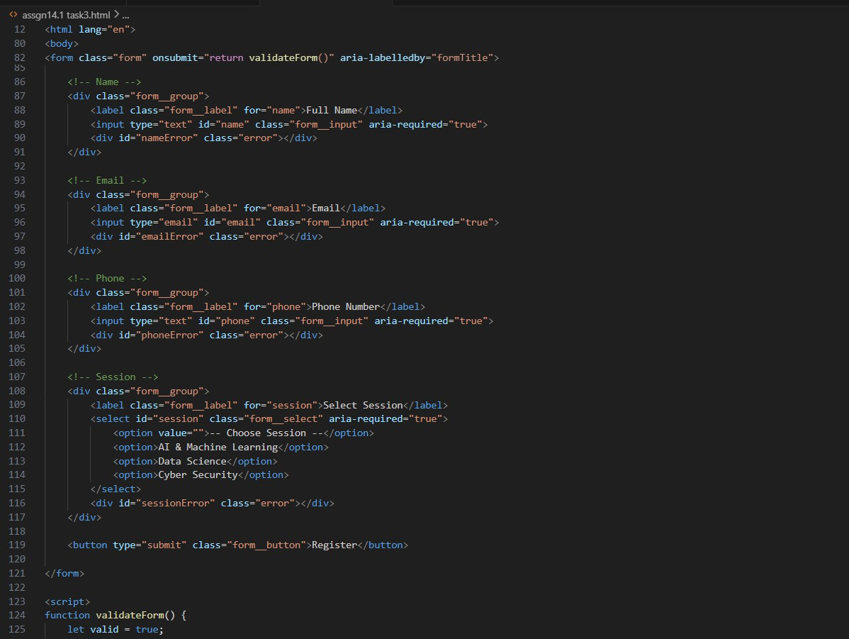

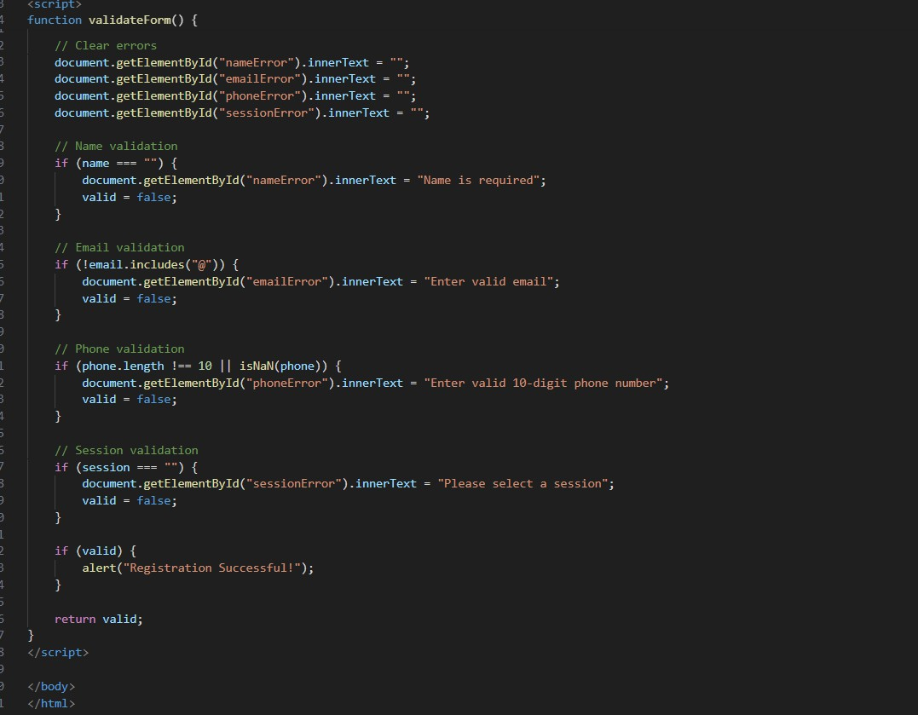
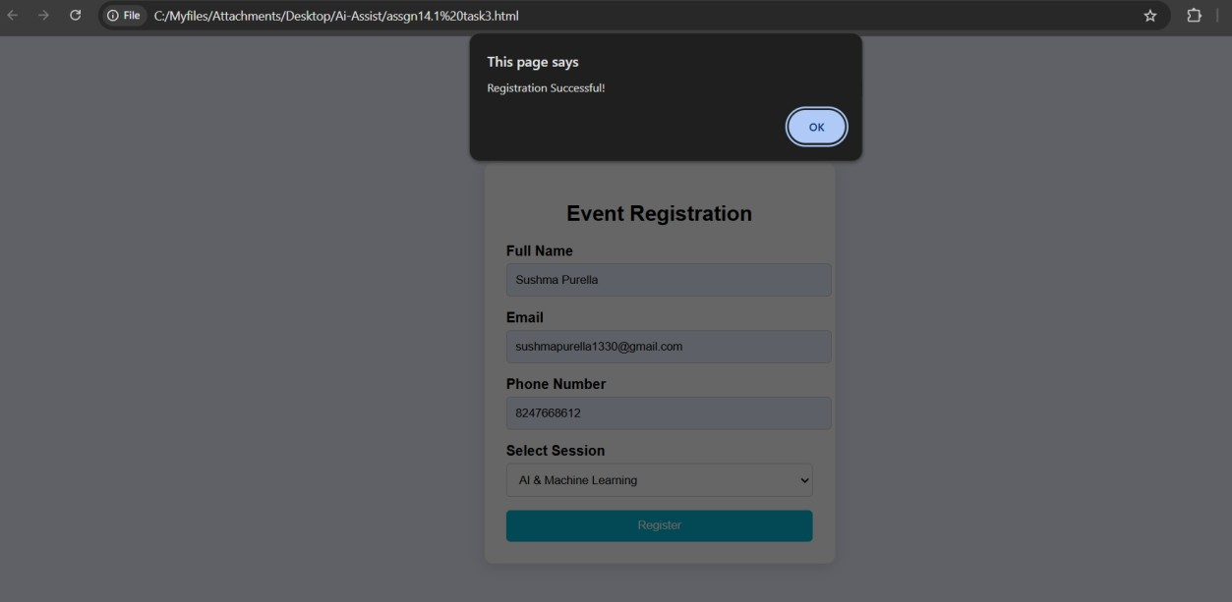
Observation:
The event registration form was successfully developed with proper input fields and validation using JavaScript. Accessibility features such as labels and ARIA attributes improved usability for all users.

The form was styled with a clean and professional design, ensuring a good user experience. AI helped in efficiently generating structured code with validation and responsive design.

Task 4 – Resume Website Prompt:
Design a one-page online resume website with sections for Profile Summary, Skills, Education, and Experience. Suggest professional typography styles suitable for a resume. Use CSS Grid to align
sections in a structured layout. Implement smooth scrolling navigation between sections for better user experience. Ensure the design is clean, modern, and responsive.

Code:
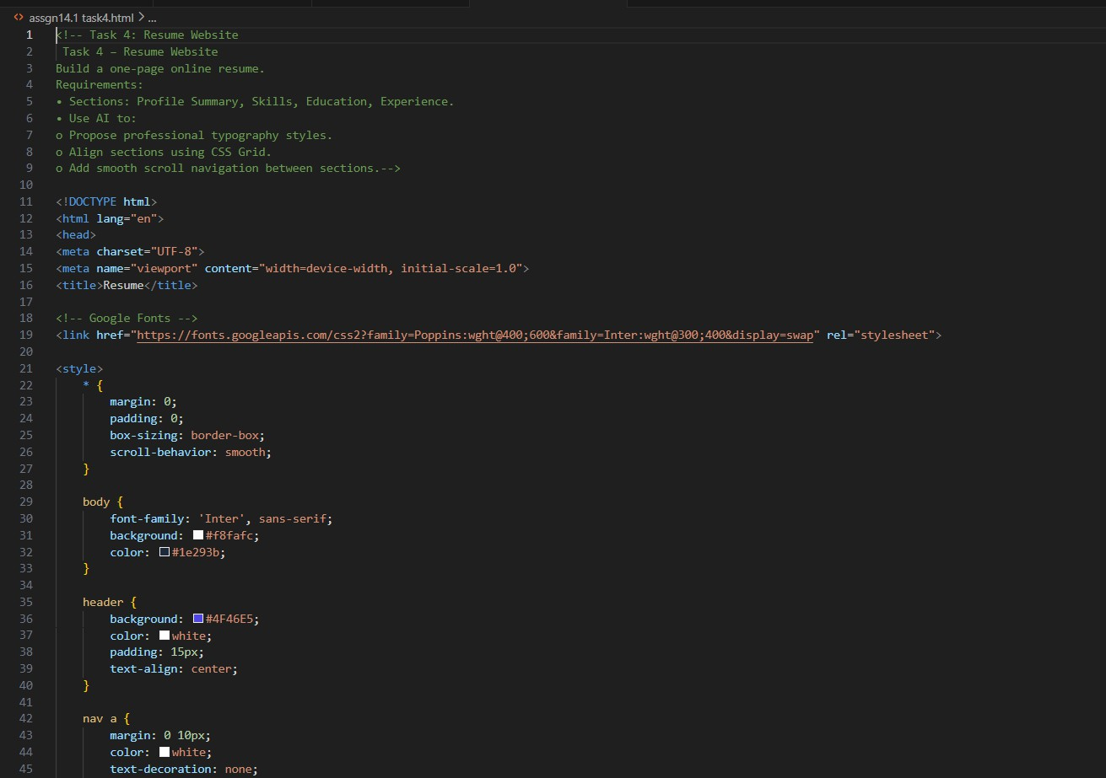

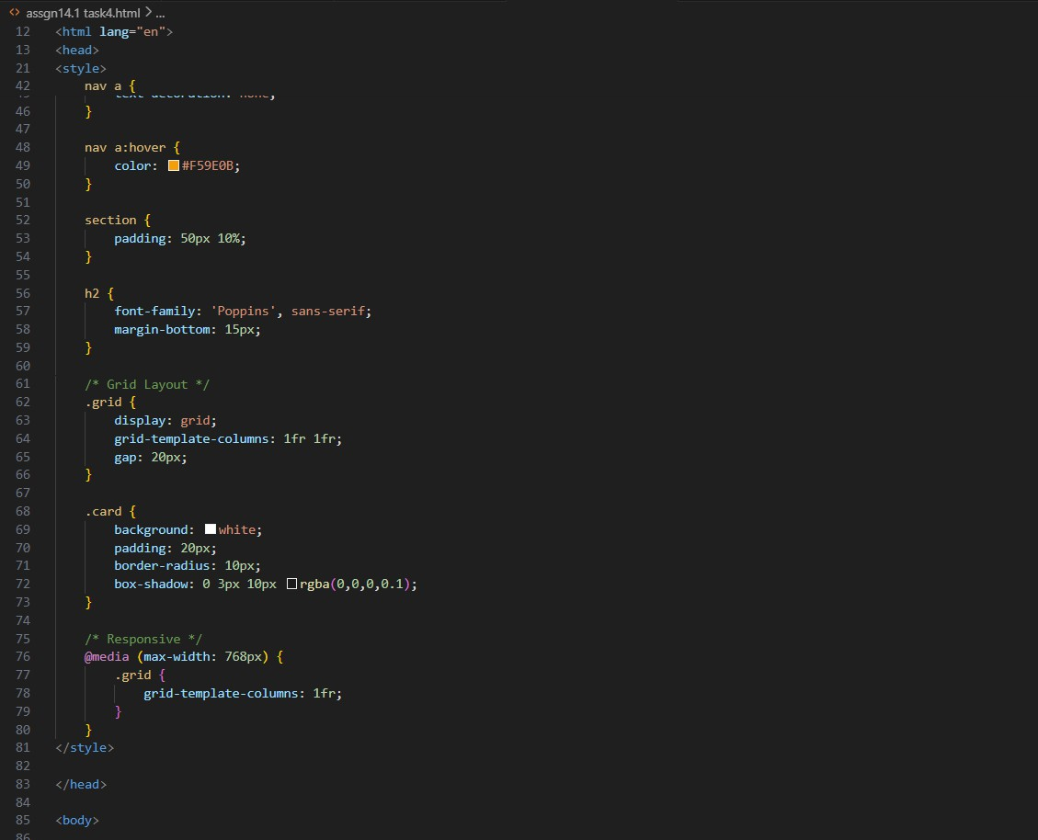

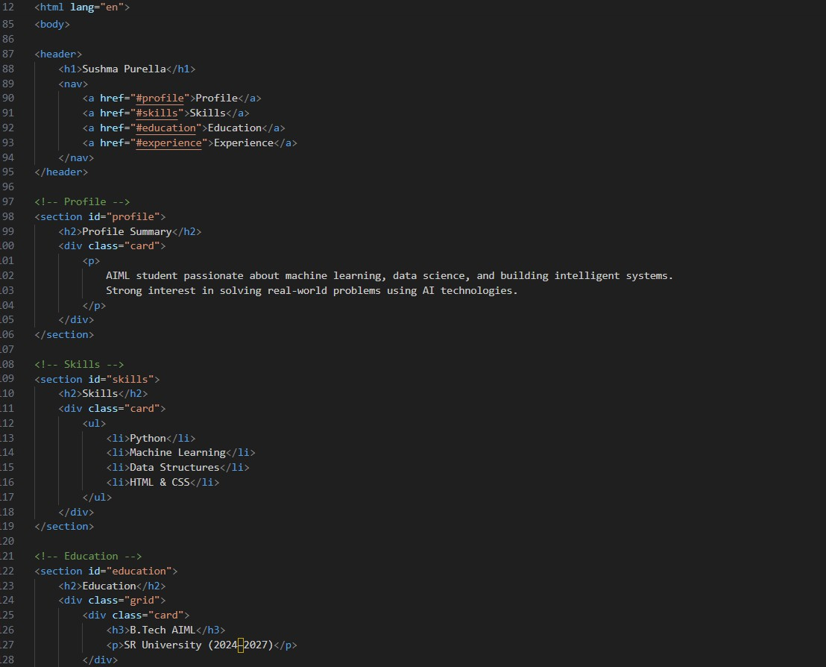
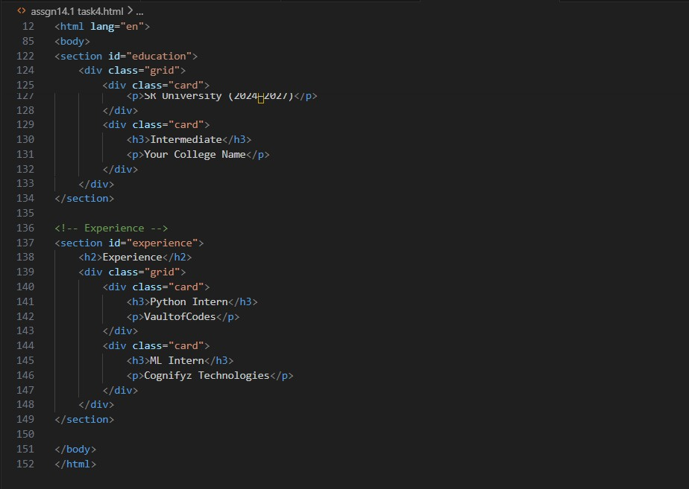

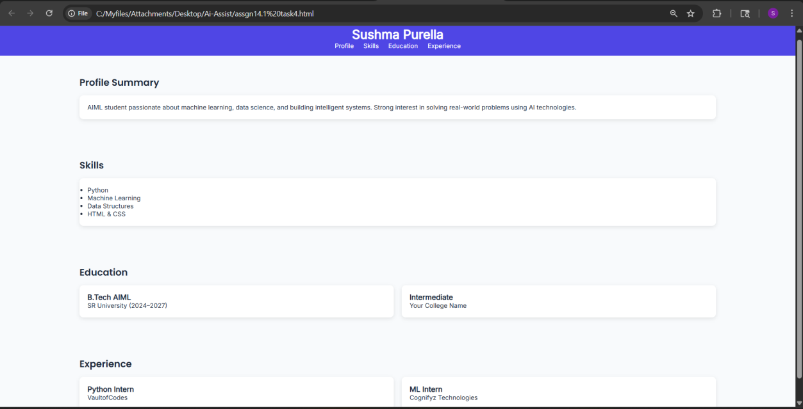
Observation:
The resume website was successfully designed as a one-page layout with structured sections for profile, skills, education, and experience. CSS Grid helped in organizing the content efficiently, while smooth scrolling improved navigation. The use of professional typography enhanced readability and visual appeal. AI assisted in creating a clean, modern, and responsive resume design quickly and effectively.

Task 5 – Restaurant Menu Page Prompt:
Design a digital restaurant menu page that displays menu items including name, description, and price. Suggest a food-friendly color palette suitable for a restaurant website. Create a responsive card- based layout using CSS Grid or Flexbox. Add hover effects to enhance user interaction and make the design visually appealing and user-friendly.

Code:

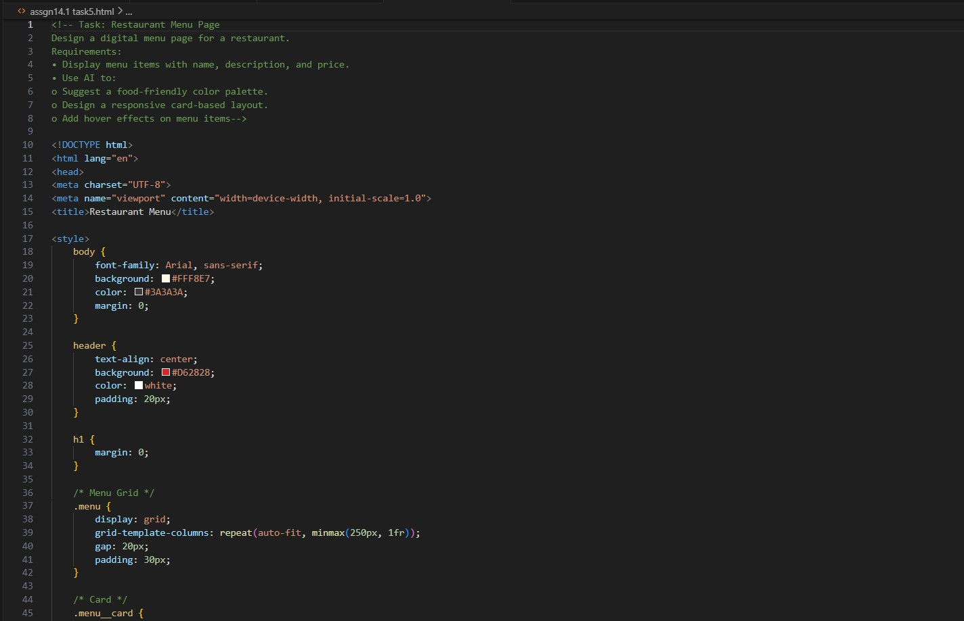

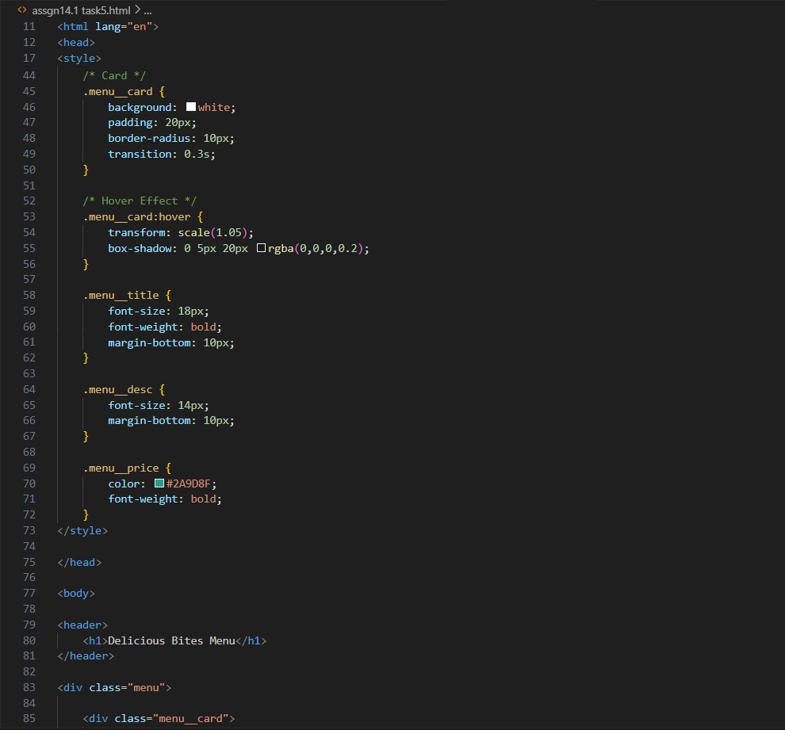

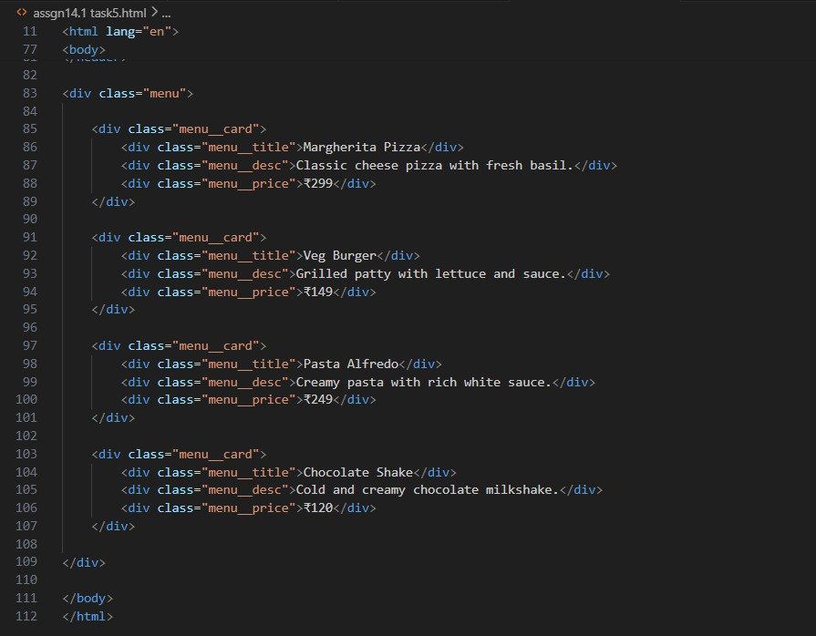
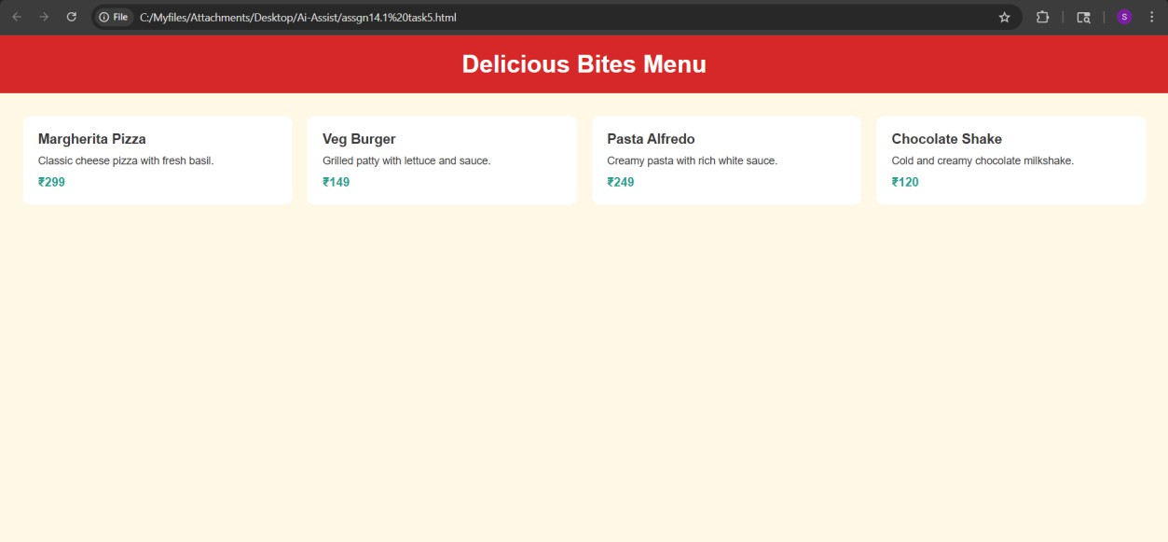
Observation:
The restaurant menu page was successfully designed using a card- based layout, which improved readability and visual structure. The food-friendly color palette enhanced the overall aesthetic and made the design appealing. Responsive design ensured proper display

across different devices, while hover effects added interactivity. AI helped in quickly generating a clean and professional menu layout.

