Assignment-15.4

Name: G. Bharath Kumar
H.No:2303A52082
Batch:43

Task 1: Initial API Setup for a Service Platform Prompt:
Generate a basic Flask application in Python. Requirements:
- Create a Flask app.
- Add a route '/status'.
- The route should return a JSON response: {"status": "API is running"}.
- Run the app on localhost with debug mode enabled.
- Keep the code simple and beginner-friendly.

Code:

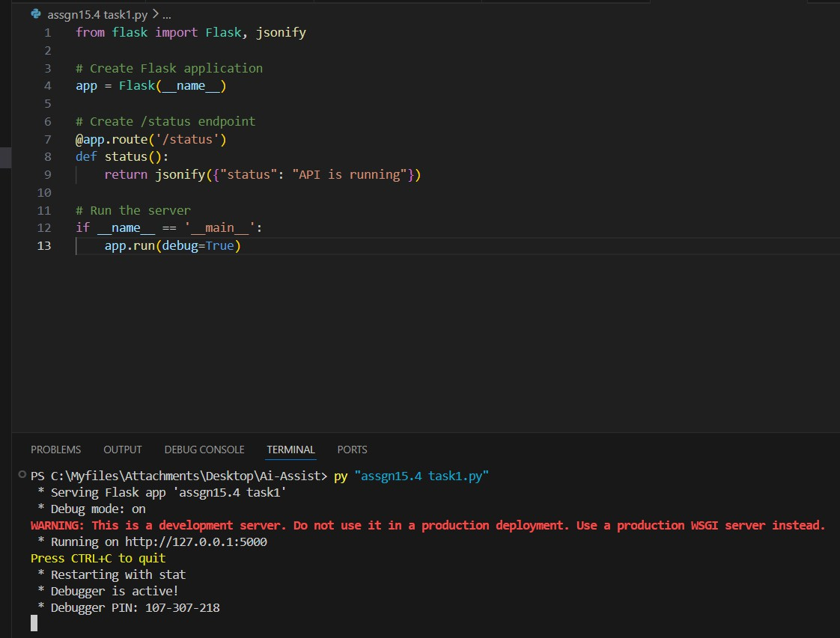
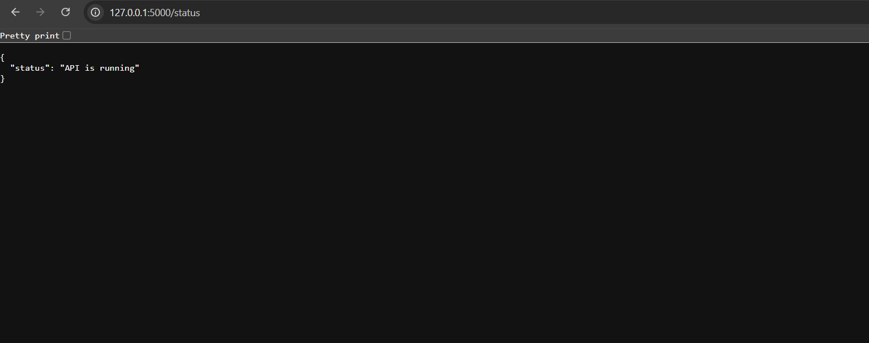

Observation:
- The Flask application was successfully created and executed.
- The server started without any errors in VS Code.
- The /status endpoint was tested using a browser.
- The API returned the correct JSON response.
- This confirms that the backend service is running properly

Task 2: Create API to Add and View Resources

Prompt:
Generate a Flask API in Python. Requirements:
- Create an in-memory list to store service requests.
- Implement a GET endpoint '/requests' to retrieve all requests.
- Implement a POST endpoint '/requests' to add a new request.
- Each request should contain 'title' and 'priority'.
- Return responses in JSON format.
- Keep the code simple and beginner-friendly.

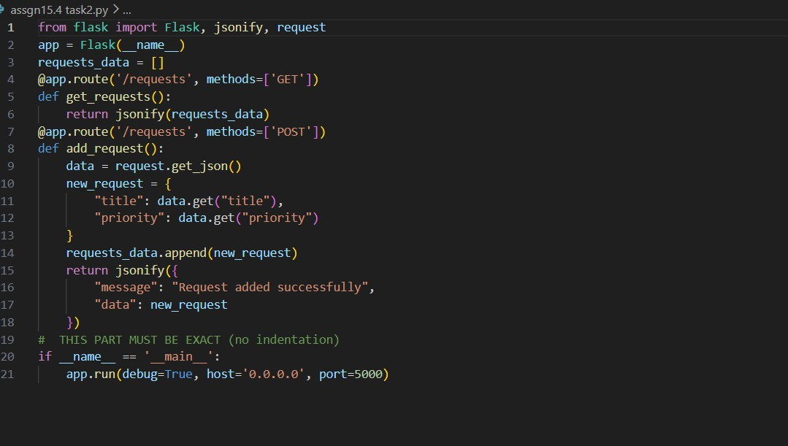
Code:

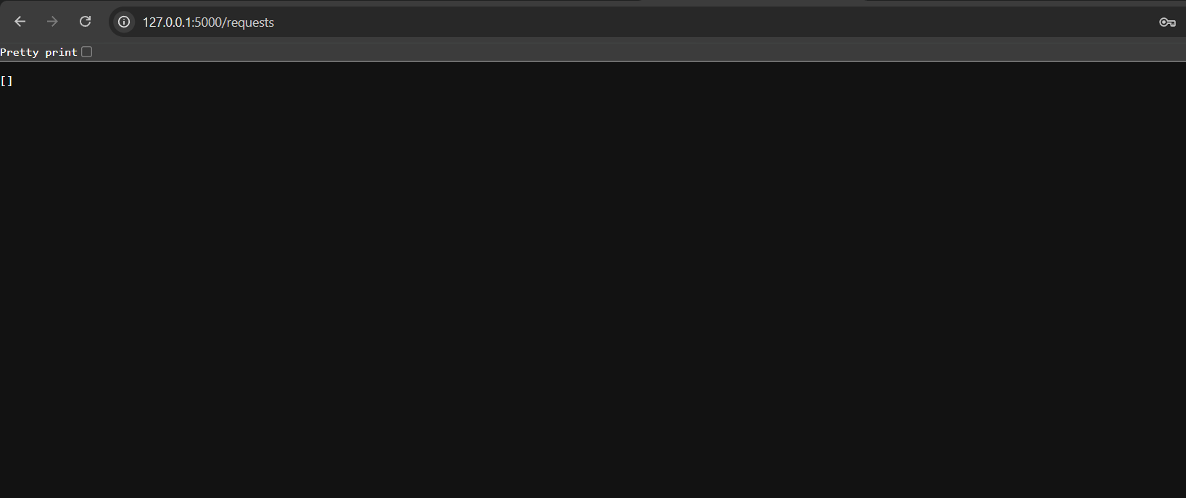
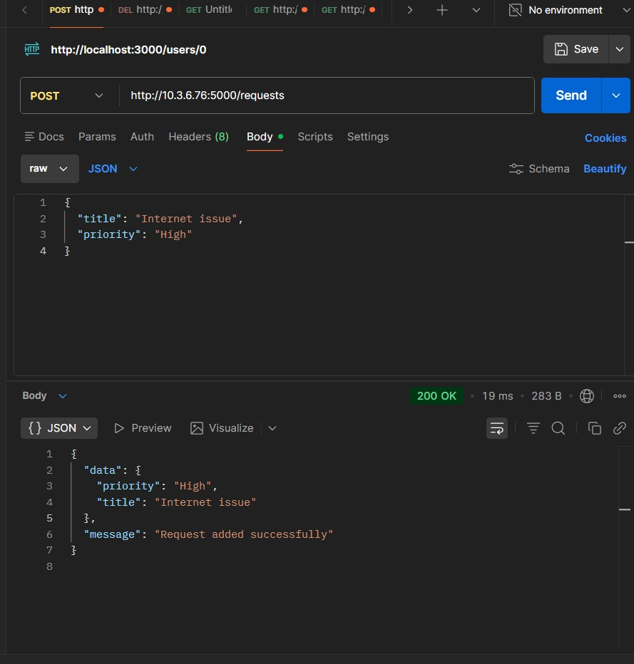

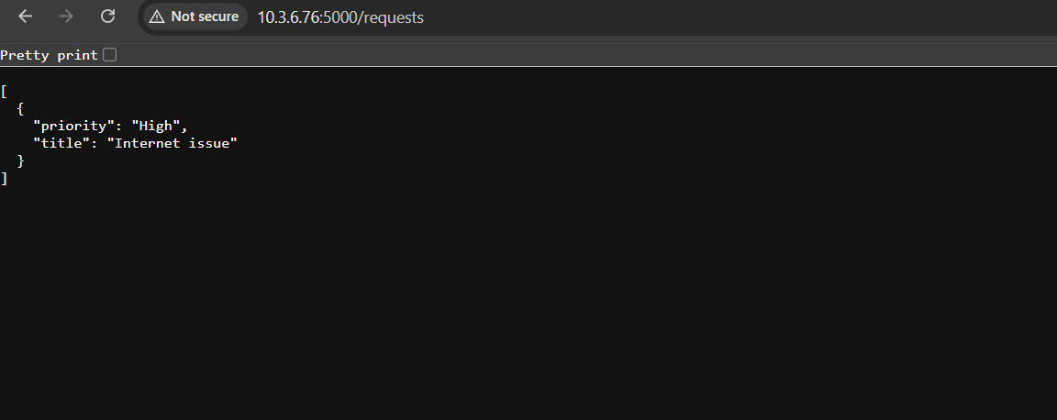
Observation:
  - The Flask API was successfully developed and executed in VS Code.
  - Initially, the GET request to /requests returned an empty list.
  - A POST request was used to add a new service request with title and priority.
  - The API returned a confirmation message along with the added data.
  - After adding data, the GET request returned the stored service request.
  - This confirms that both GET and POST endpoints are functioning correctly.
  - The data is stored temporarily in memory and is lost when the server restarts.

Task 3: Modify Existing Resource Using AI Assistance
Prompt:
Generate a Flask API in Python. Requirements:
- Maintain an in-memory list of service requests.

- Each request contains 'title' and 'priority'.
- Implement a PUT endpoint '/requests/<int:index>' to update a request by index.
- If index is valid, update the request and return:
{"message": "Request updated", "request": updated_object}
- If index is invalid, return a JSON error message with HTTP status code 404.
- Keep the code simple and beginner-friendly.

Code:

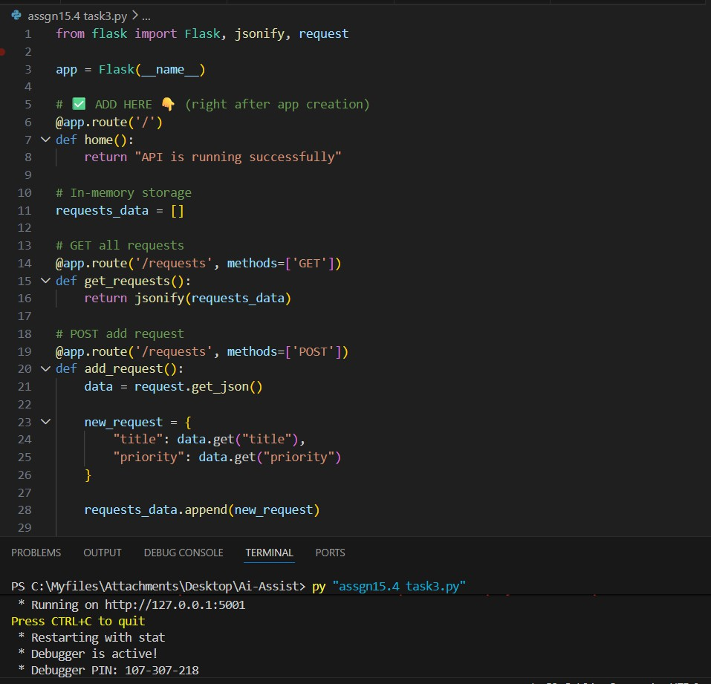

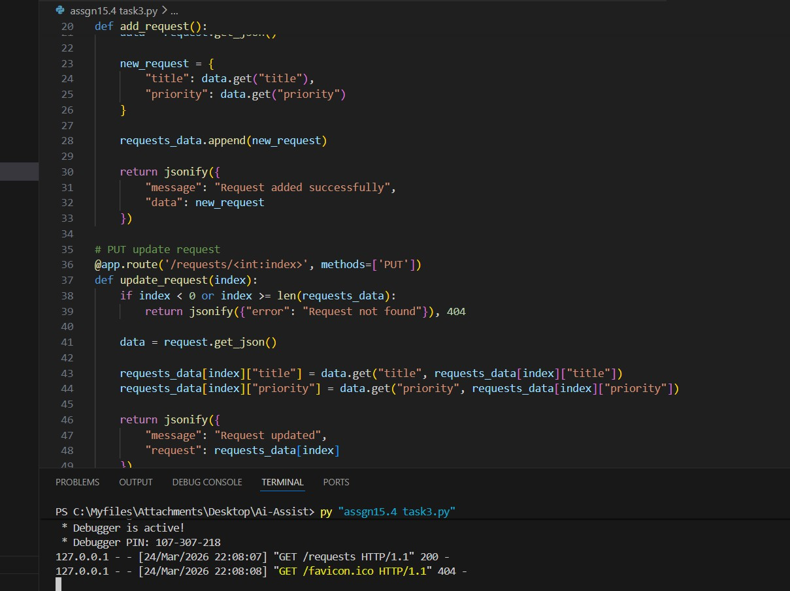
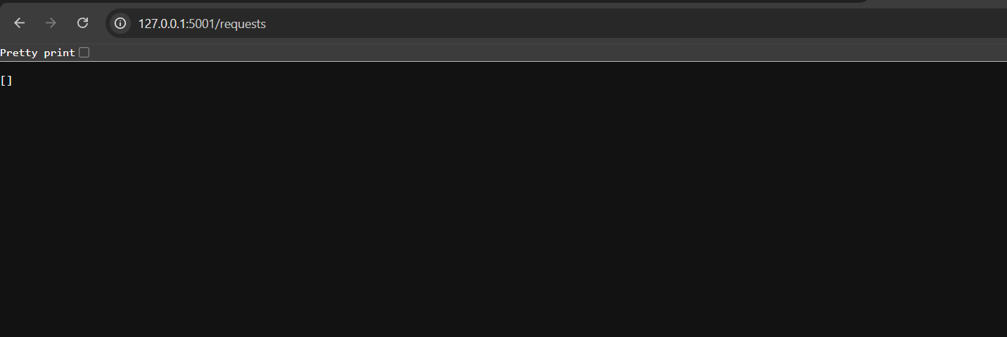

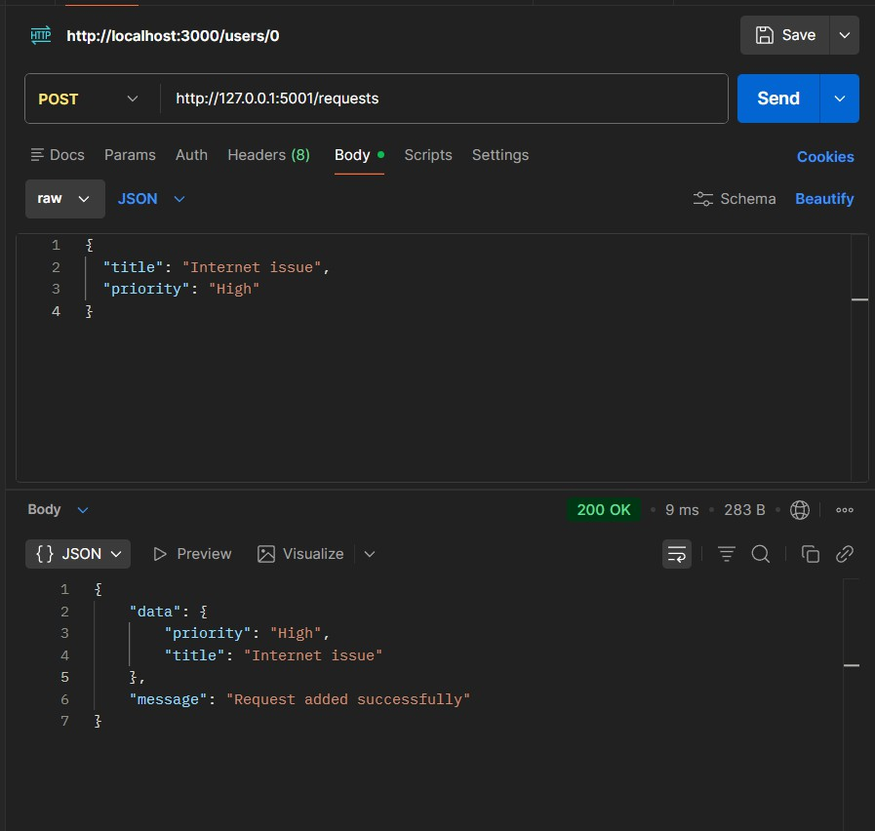

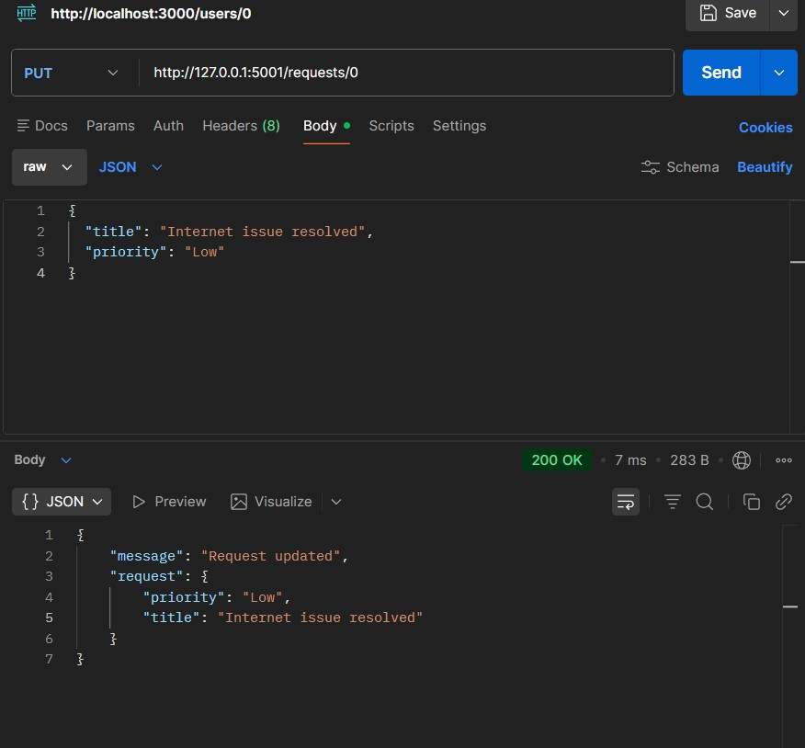

Observation:
- The PUT endpoint was successfully implemented to update service requests.
- When a valid index was provided, the request was updated correctly.
- The API returned a confirmation message along with the updated data.
- When an invalid index was used, the API returned a proper error message.
- The error response included HTTP status code 404, ensuring proper error handling.

- This confirms that the update functionality works correctly and handles edge cases.

Task 4: Remove a Resource Safely
Generate a Flask API in Python. Requirements:
- Maintain an in-memory list of service requests.
- Each request contains 'title' and 'priority'.
- Implement a DELETE endpoint '/requests/<int:index>' to remove a request by index.
- If index is valid, delete the request and return:
{"message": "Request deleted", "request": deleted_object}
- If index is invalid, return a JSON error message with HTTP status code 404.
- Ensure the server does not crash on invalid input.
- Keep the code simple and beginner-friendly.

Code:

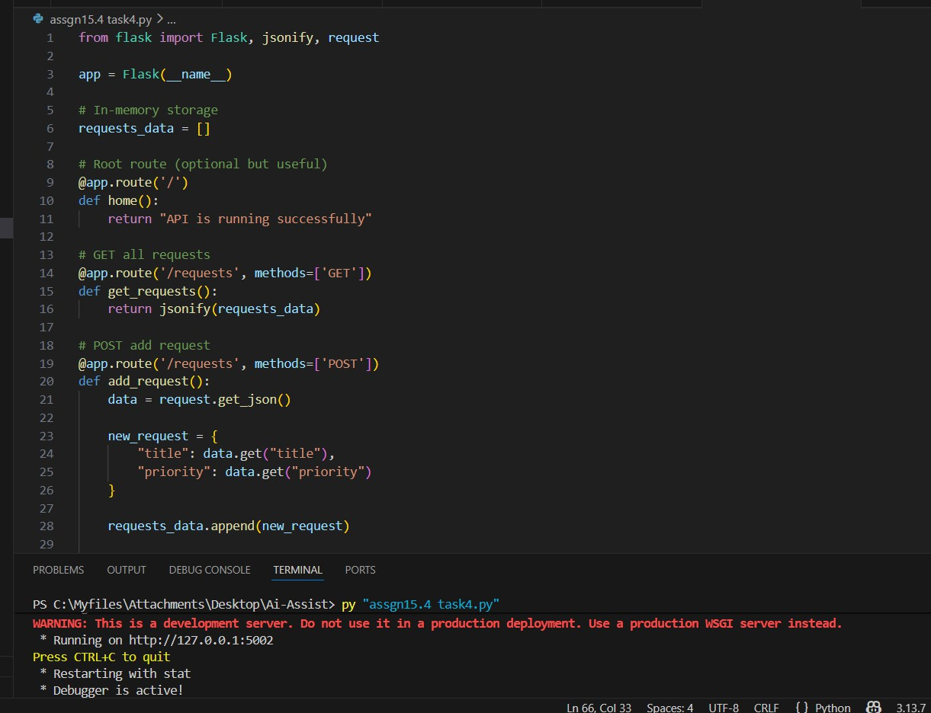
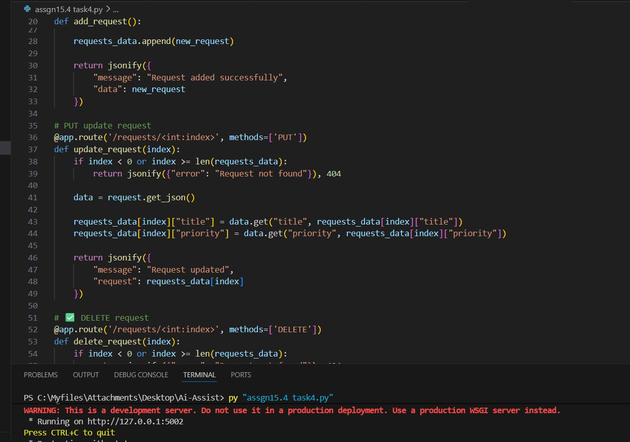

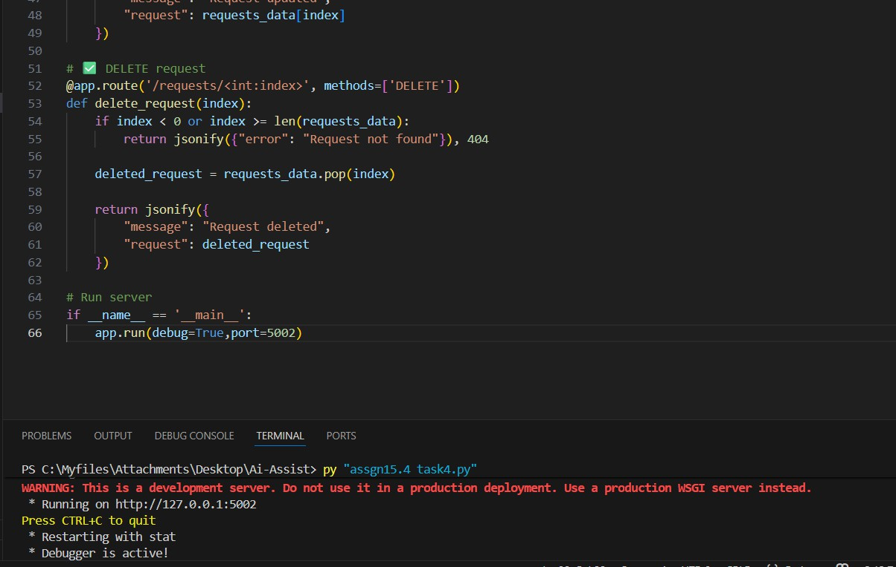
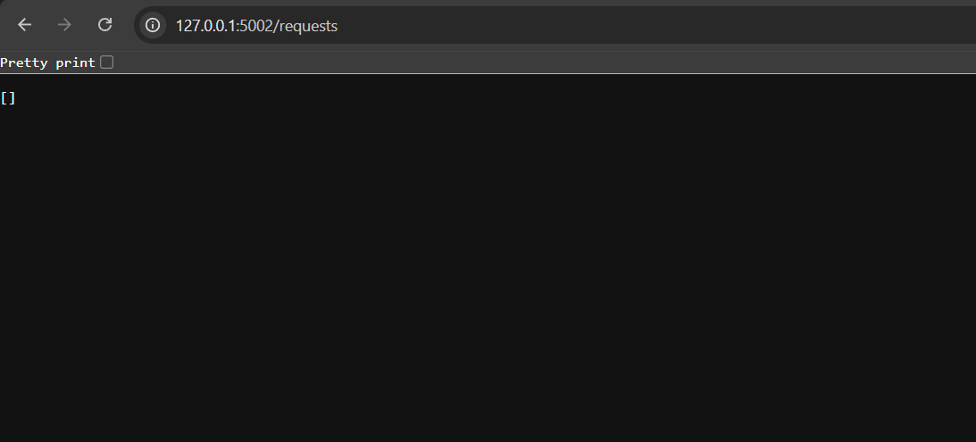

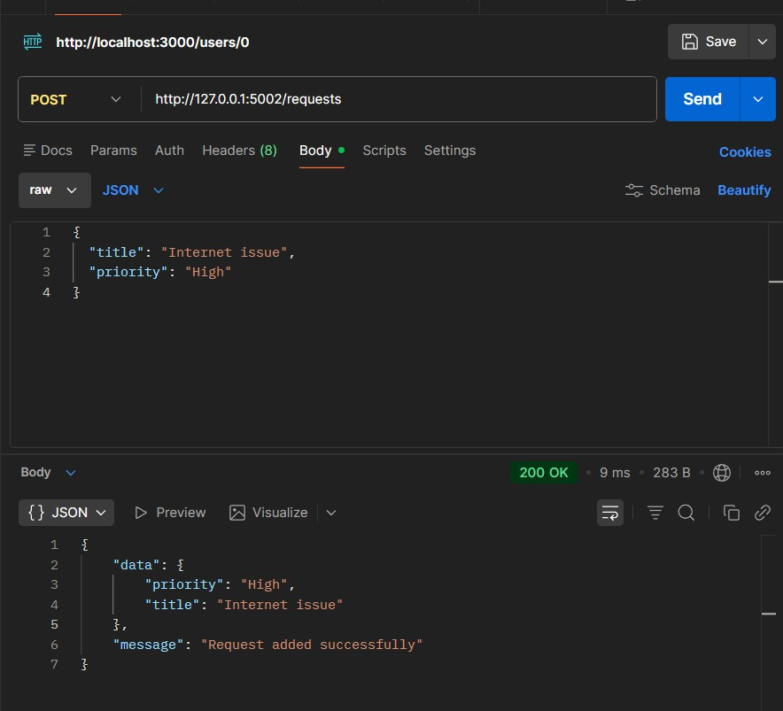

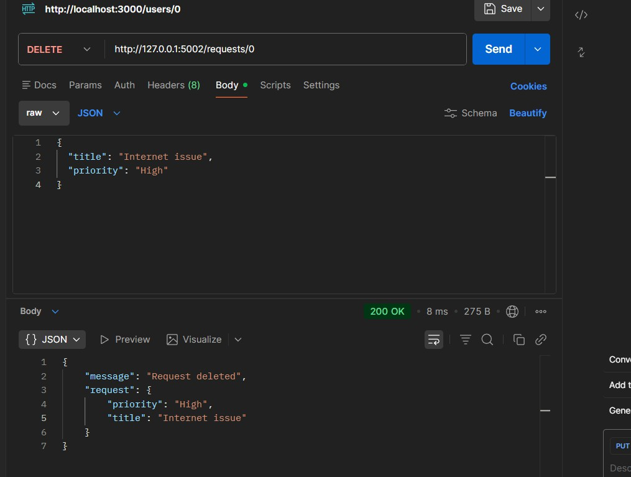

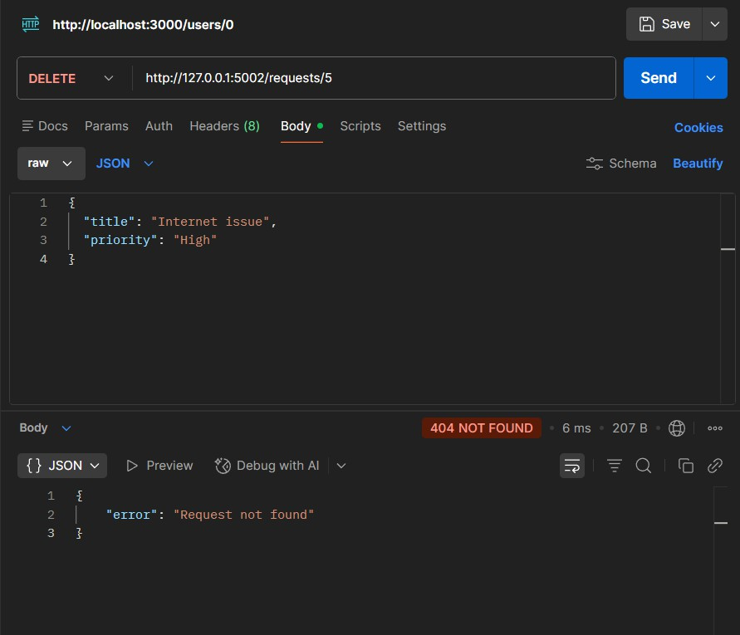

Observation:
- The DELETE endpoint was successfully implemented to remove service requests.
- When a valid index was provided, the request was deleted correctly.
- The API returned confirmation along with the deleted request details.
- When an invalid index was used, the API returned an appropriate error message.
- The server handled invalid input gracefully without crashing.
- This confirms proper functioning of the DELETE operation and error handling.

Task 5: AI-Assisted API Documentation and Readability
Prompt:
Enhance a Flask API by adding documentation. Requirements:
- Add meaningful docstrings to all endpoints.
- Include inline comments explaining the logic.
- Clearly describe HTTP methods, inputs, and outputs.
- Improve code readability for other developers.
- Optionally suggest integration with Swagger or Flask-RESTX for API documentation.
- Keep the code simple and beginner-friendly.

Code:

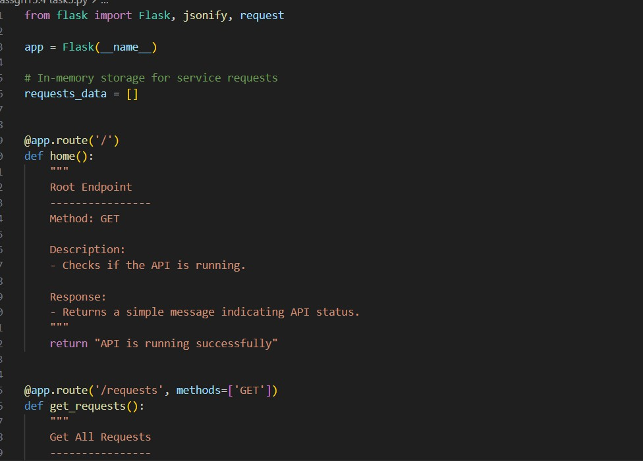
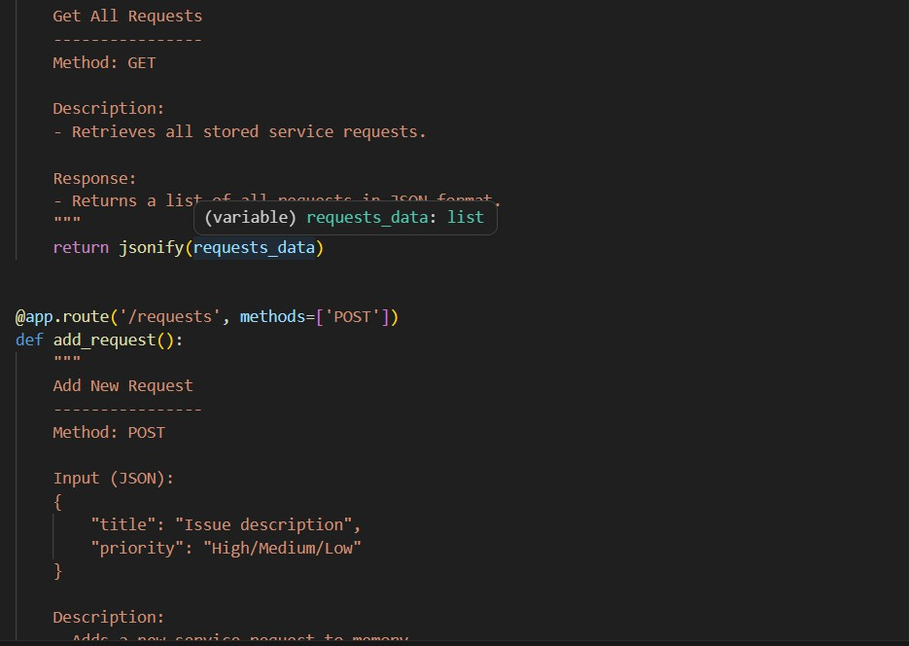

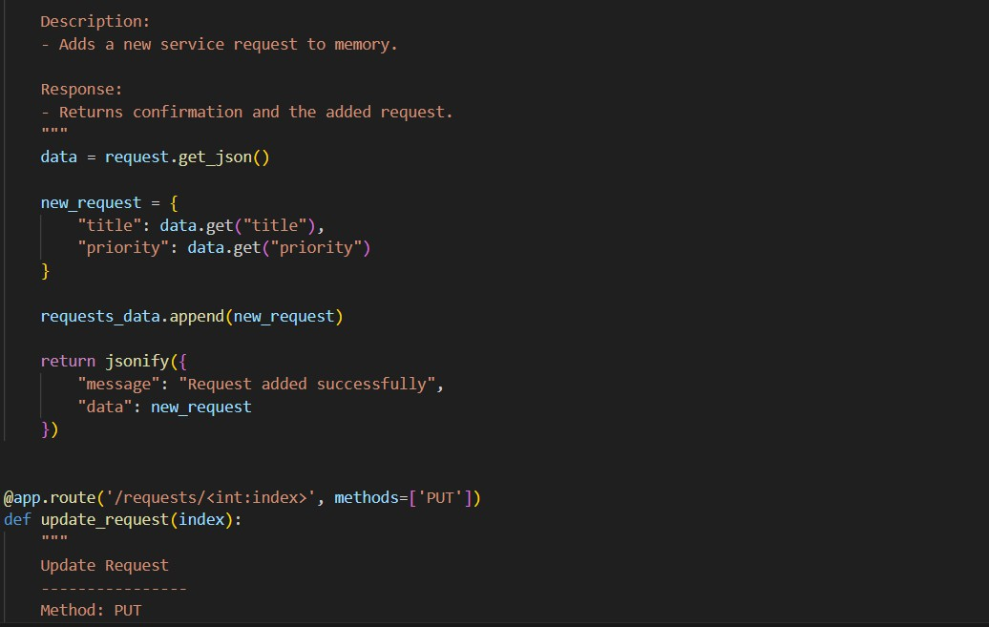
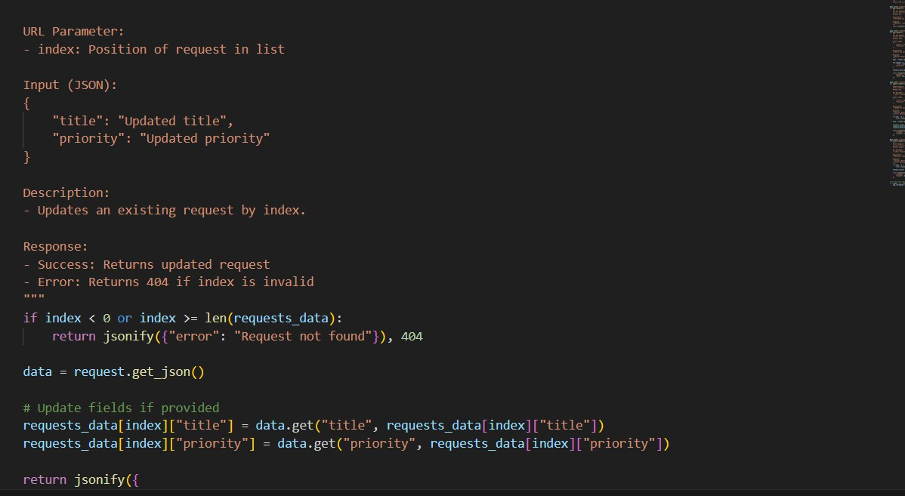

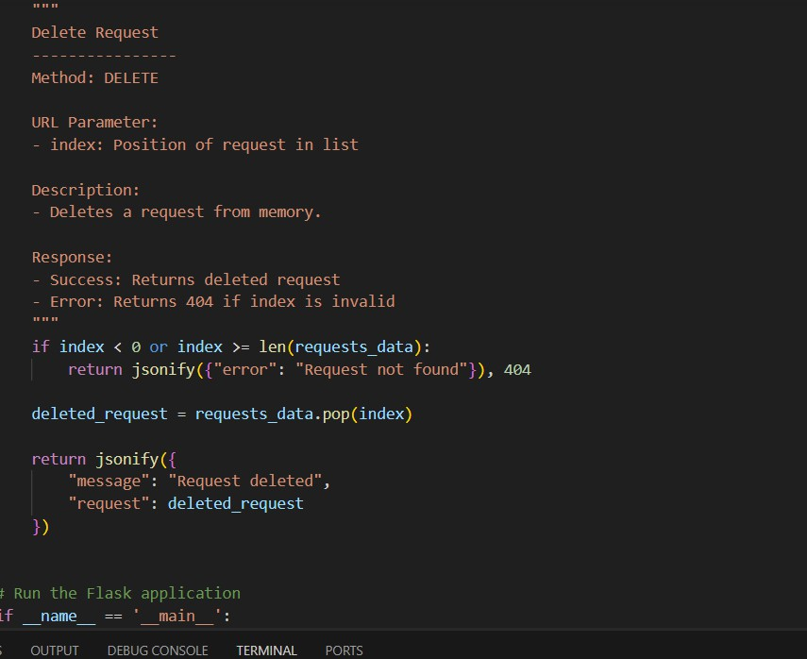

Observation:
  - Docstrings were added to all endpoints describing functionality, inputs, and outputs.
  - Inline comments improved code readability and understanding.
  - Each API method (GET, POST, PUT, DELETE) is clearly documented.
  - The API is now easier for other developers to use without reading full code.
  - Documentation ensures better maintainability and collaboration.
  - Optional tools like Swagger can further enhance API usability.

