Step 1. Download and install Virtualbox from: <https://www.virtualbox.org/wiki/Downloads>.

Step 2. Download the sandbox 2.2.4 from: http://hortonworks.com/products/hortonworks-sandbox/

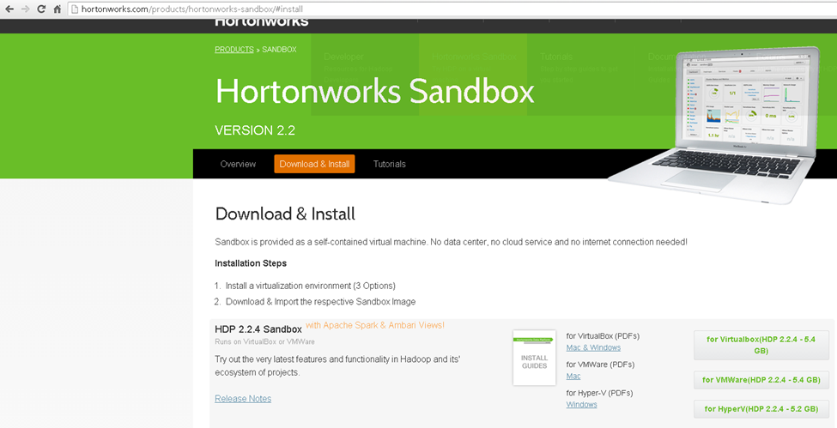

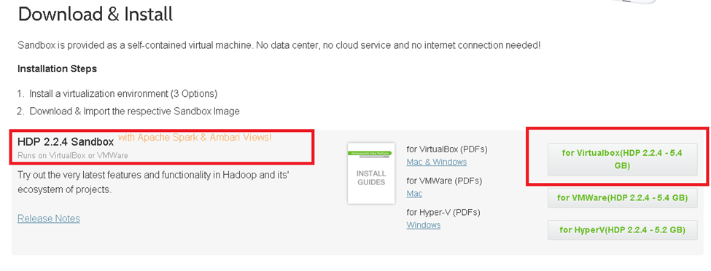

Step 3. Launching the sandbox for the first time using virtualbox

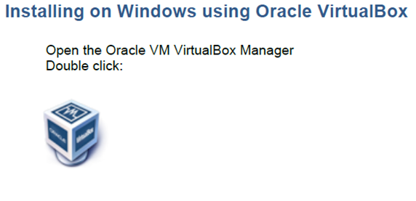

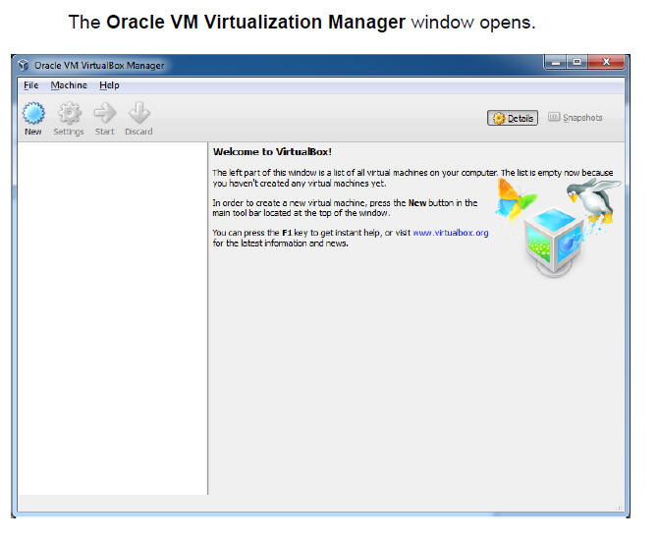

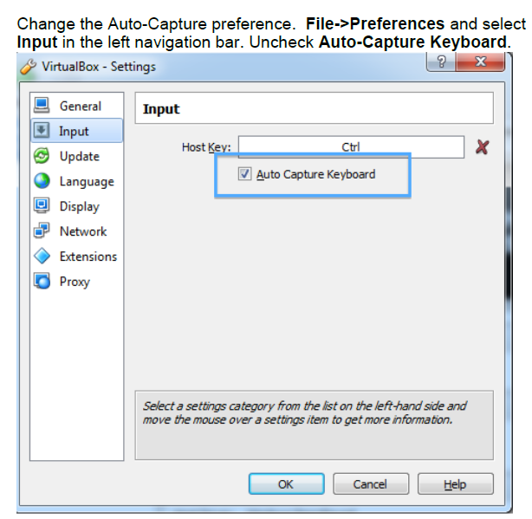

The settings box above may appear slightly different (line items below the Input field). The “Auto Capture Keyboard” check box is below this.

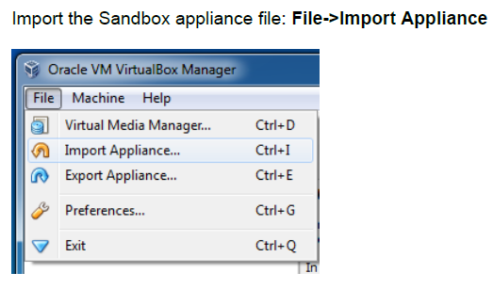

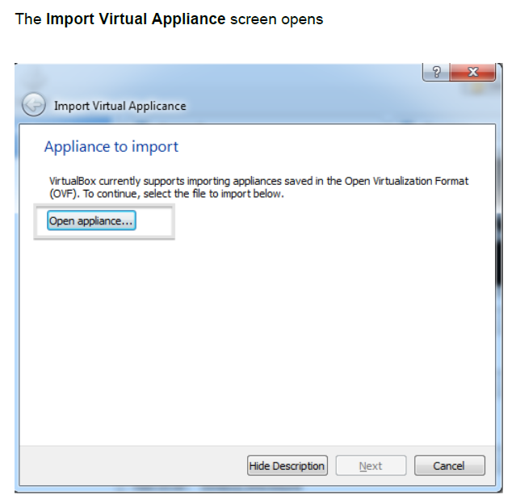

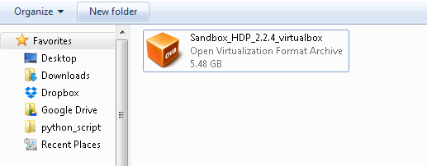

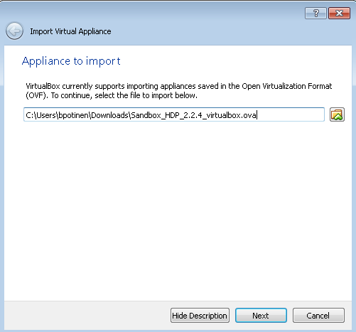

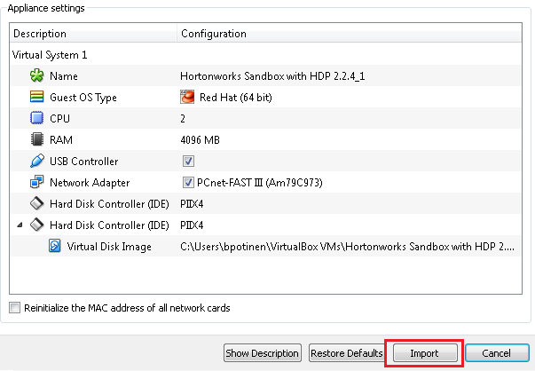

*WARNING: You may get an error depending on the settings of your computer.*

**VT -x disabled in BIOS (VER_VMX_MSR_VMXON_DISABLED)**

*This has to do with the way the VirtualBox interacts with your hardware and operating system. You will need to enable this setting so that the system will work.*

*To alter the settings in your BIOS, it is specific to your computer. A Google or YouTube search of the error statement will result in many tutorials on how to fix this. Below is a link for a YouTube video that addresses changing the BIOS on a basic Windows computer with an Intel processor.*

<https://www.youtube.com/watch?v=mFJYpT7L5ag>

*You will need administrative rights to change these settings.*

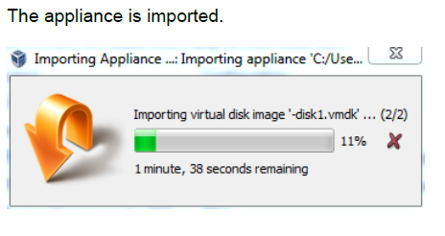

Once the sandbox is imported, you will see the following screen:

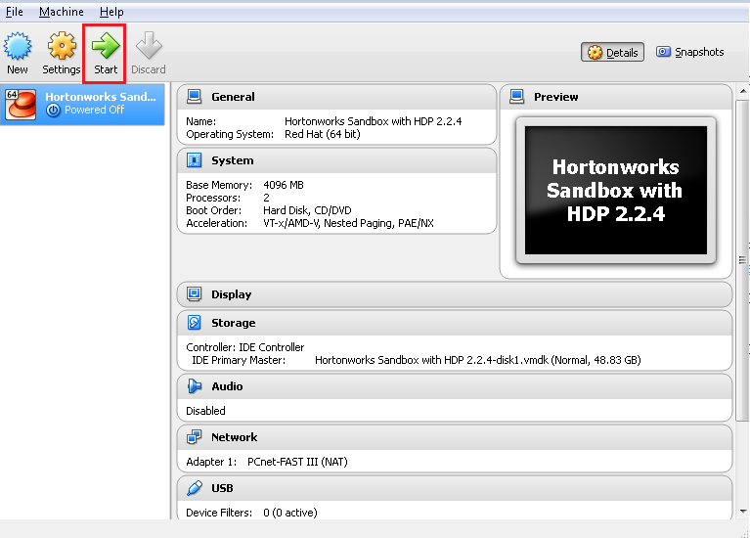

Now you can open Sandbox. Select Hortonworks Sandbox 2.2.4 in left virtual menu and then click on green arrow (Start), this will start the Sandbox virtualization.

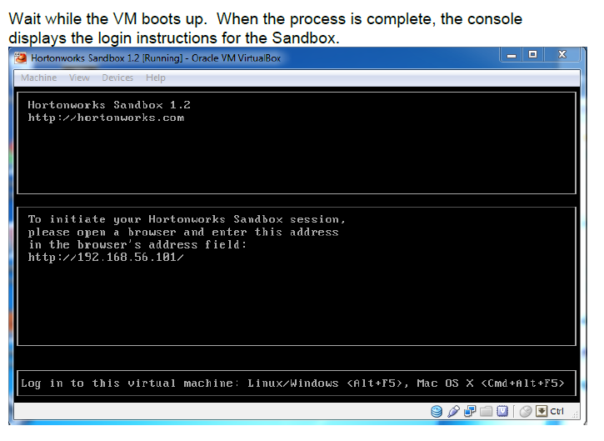

Now open a browser on your host computer and type in the following address:

**http://127.0.0.1:8000/**

This will take you to the Sandbox.

If this is the first time you have logged into the Sandbox from this machine it will ask you to register. Once you have submitted the required information it will take you to the page posted below.

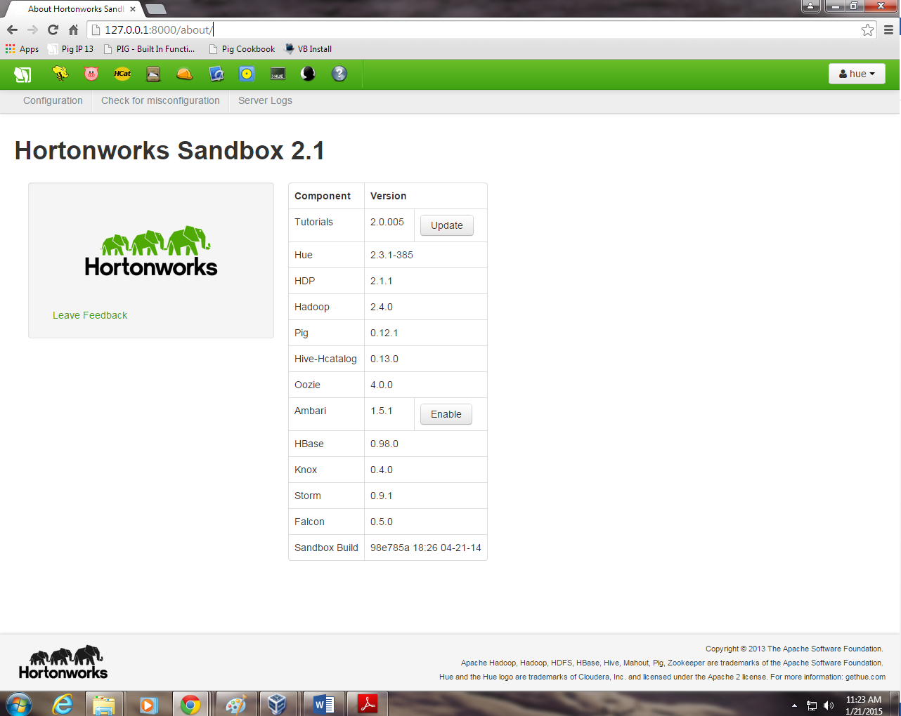

Step 4. Launching the sandbox after the first time using virtualbox

Start the virtual box, and the following screen appear:



Now you can open Sandbox. Select Hortonworks Sandbox 2.2.4 in left virtual menu and then click on green arrow (Start), this will start the Sandbox virtualization.

Step 5. Launching SSH terminal on Sandbox

Open the SSH secure Shell and click on “Quick Connect”

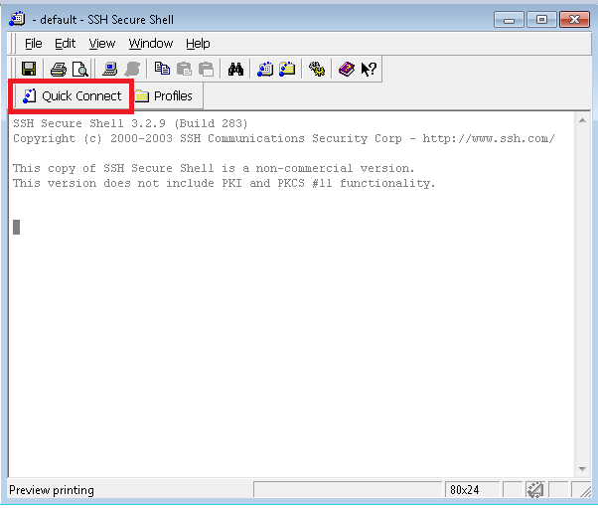

A windows will be appear, enter the details as shown below and click on “connect”

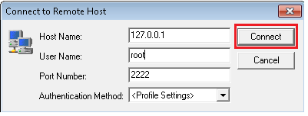

A new window will be pop up asking for password.

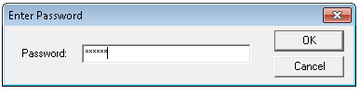

The details are:

Host Name: 127.0.0.1

User Name: root

Port Number: 2222

Password: Hadoop

Step 6. Transfer required course data (See the link under resources for every module) to Sandbox.

This step has to be performed for every module.

Each module will have its own resource page, where all the required data files and code files for lab exercise will be available.

Download the files to your local system and transfer them into Sandbox.

To Copy files from local system to Sandbox, follow the below steps.

Click on the File Transfer window

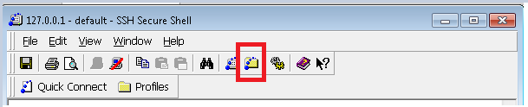

Copy the files to the sandbox.

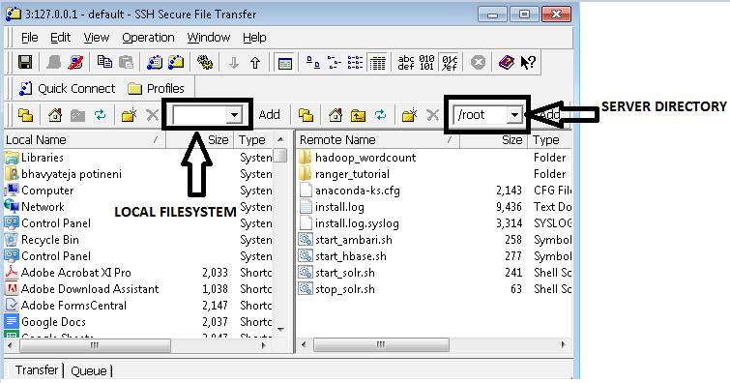

Select the file and drag it on to the server side. It will copy the files to the sandbox.