Progress Report – 3

25 December 2018

**Abhiraj Tiwari**

# Progress

* Completed 4 weeks of Andrew Ng and midway through week 5
* Learned basics of open CV
* Read more into the different libraries i was already using like matplotlib, numpy, etc.

# Implemented

* Logistic regression classifier for non-linear hypothesis with regularisation. (mentioned in the last report also but i was not able to plot it, had to learned more of matplotlib (contours))

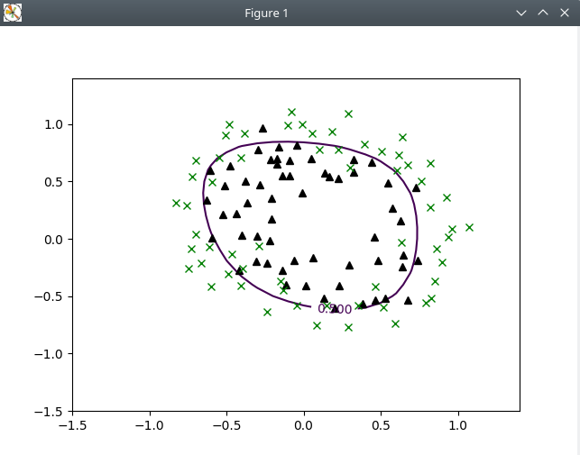

* Logistic Regression to classify handwritten digits in python
  + OneVsAll classification for 10 classes (0-9).
  + Getting an accuracy of around **83%** average on the *training dataset*

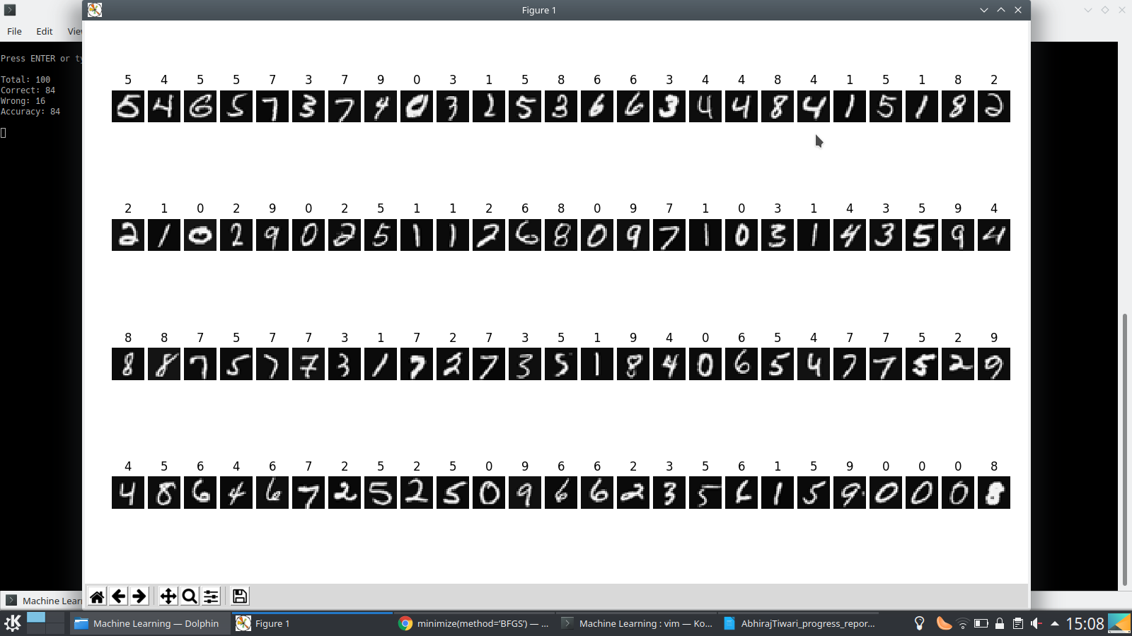

On 100 random cases from the training set 84 cases succeded

* + I wrote this program using self written gradient descent which takes ***A LOT*** of time to converge, so I stop it by limiting the number of iterations for gradient descent, I expect better results when using another algorithm like BFGS (from scipy) to minimize. I am currently trying to implement the same classifier using scipy.optimize’s minimize function.
* To extend the above classifier built an open cv program to extract hand written digits from a white piece of paper. The extracted image is resized to 20 x 20 pixels and the run through the logistic regression classifier. Its demo video is on GitHub

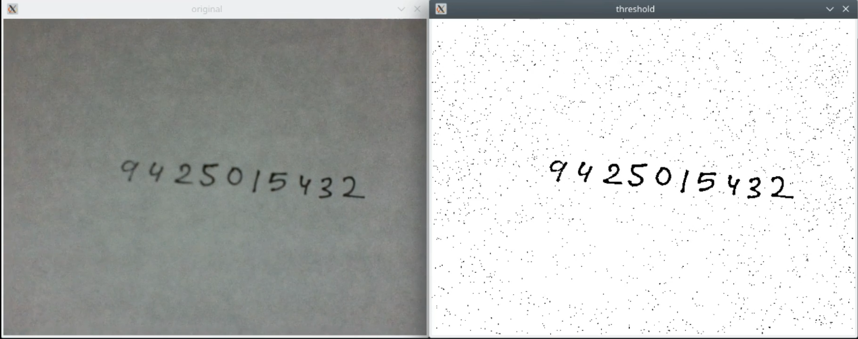

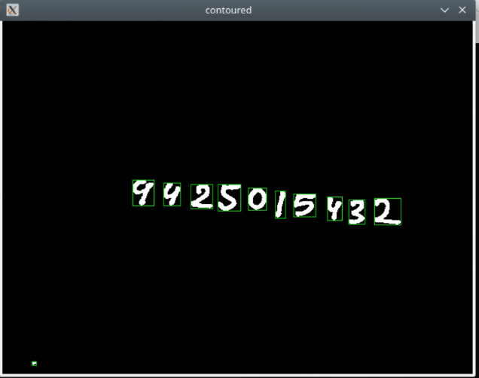

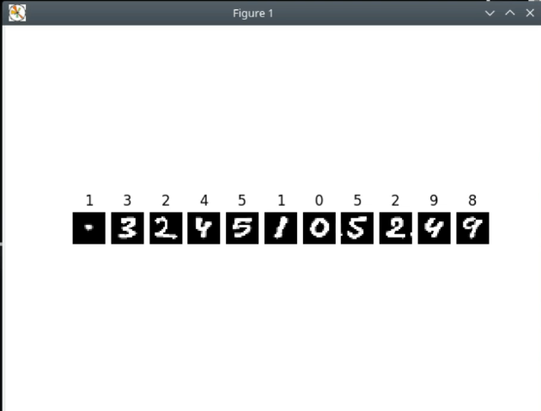

**Sometimes** some noise passes through as seen here. Also here alot of characters are correctly identified usually the accuracy from opencv to classifier character recognition is around 55 – 60%

*All the codes and demo video on GitHub*