**Progress Report**

-10/12/2018

**Machine Learning**

1. Successfully completed 2nd week of Andrew ng course on ML.

* **The first week** included lectures regarding introduction to Machine Learning and its types.
* Supervised and Unsupervised Learning. Classification based on type of output i.e. whether continuous (Regression Problem) or discrete (Classification Problem)
* Supervised Learning was further elaborated, and Linear Regression was introduced.
* Cost function & Gradient descent was discussed in detail.
* Introduction to Linear algebra was also given.
* **The Second week** included multivariate Linear Regression and Gradient descent algorithm for it.
* Certain ‘Tricks’ to improve gradient descent were also discussed. These included **Feature scaling** and **Mean normalization.**
* Choosing correct features and learning rate(alpha).
* It further had polynomial Regression. i.e. rather than trying to fit a given data into a linear function, fit it into a polynomial func. A simple trick to use multivariate Linear Regression algorithm for polynomial Regression was also discussed.
* Another alternative to gradient descent called **Normal Equation** was also discussed.
* Pros and cons of gradient descent and normal equation were discussed. When to use which one was also told.
* Introduction to coding on octave.
* Submission of first assignment.

The first assignment included writing code for Cost function & Gradient descent.

Following images show synopsis of my first Submission:

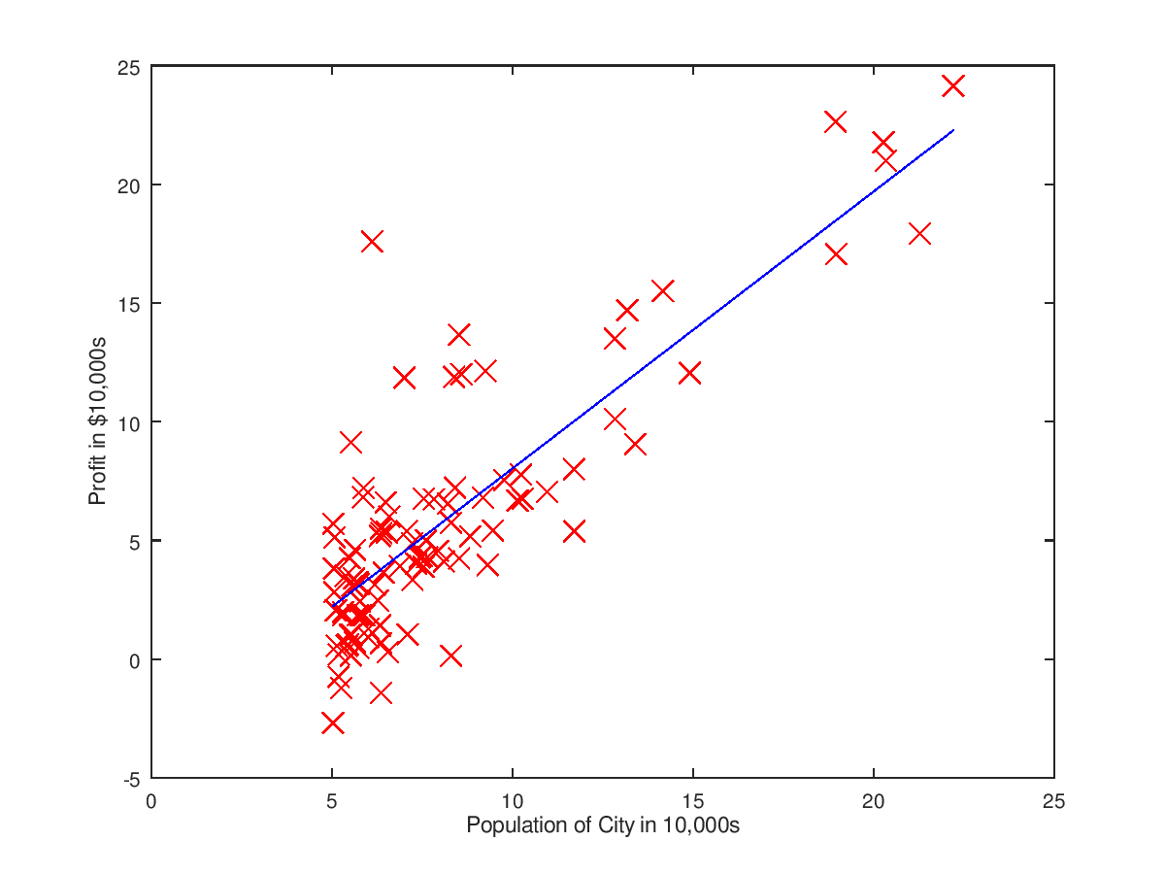

Using gradient descent to plot a linear function of closest fit

**Code for cost function**

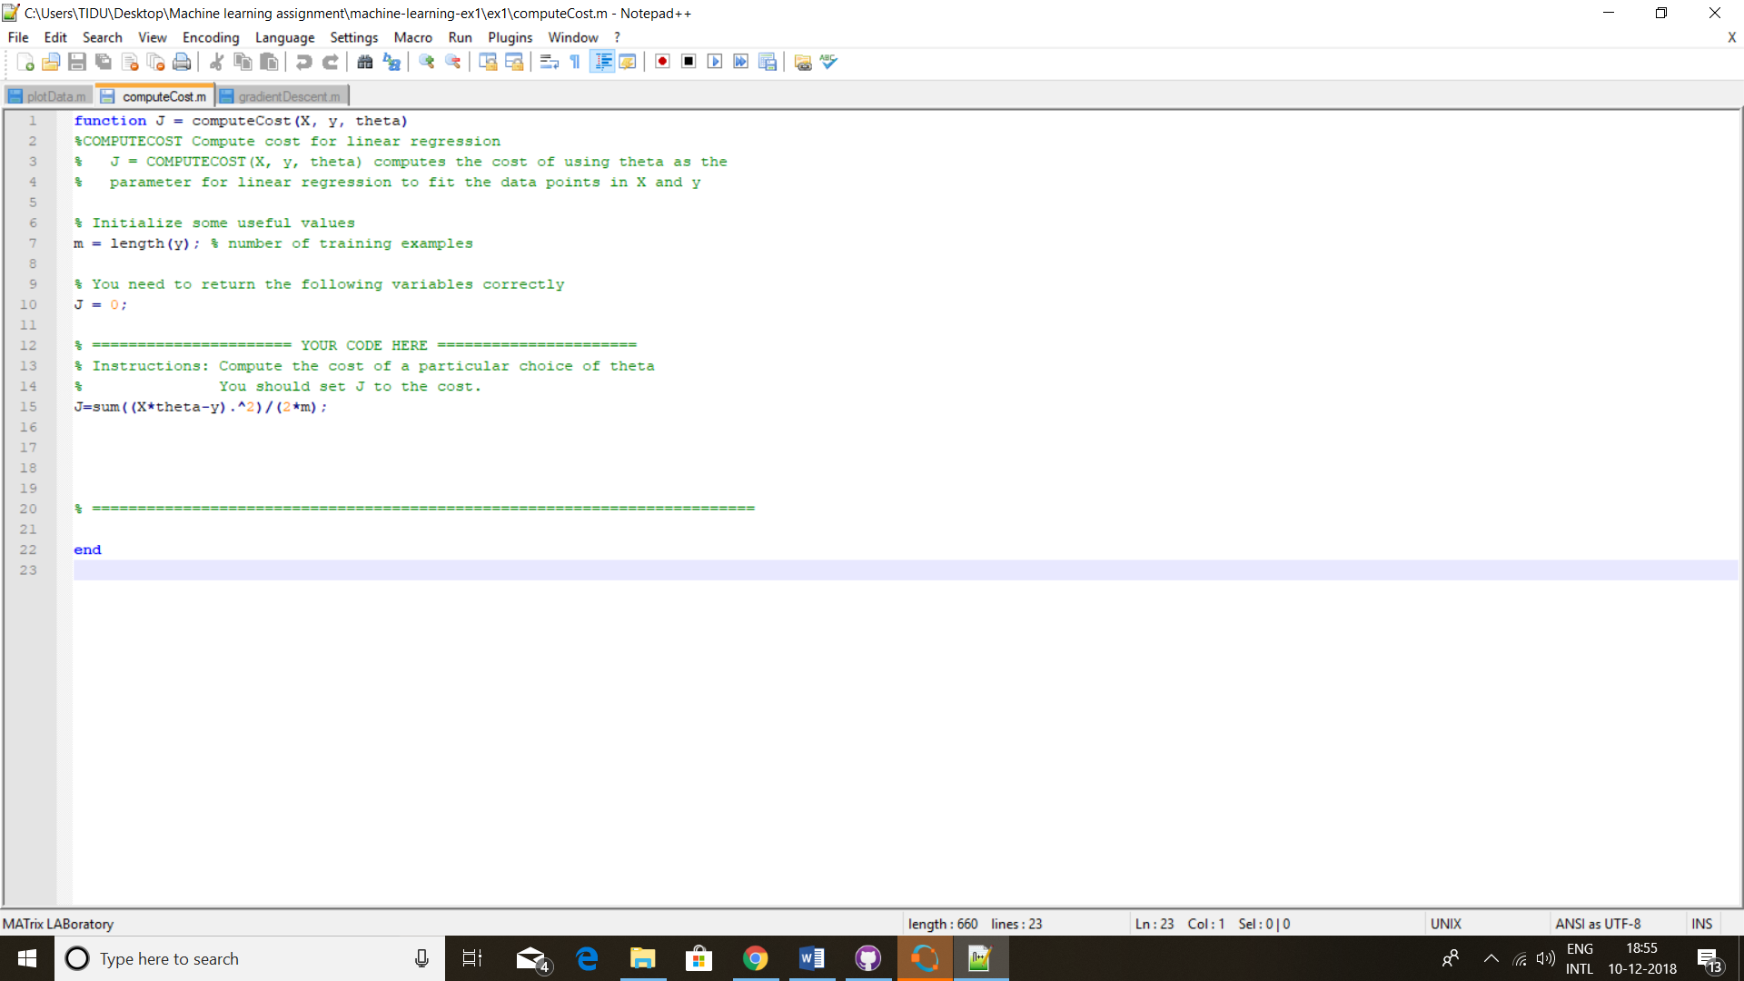

**Code for Gradient descent:**

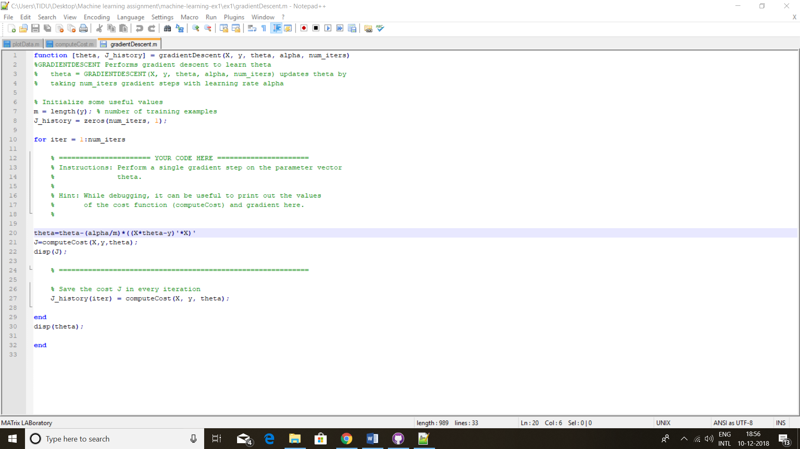

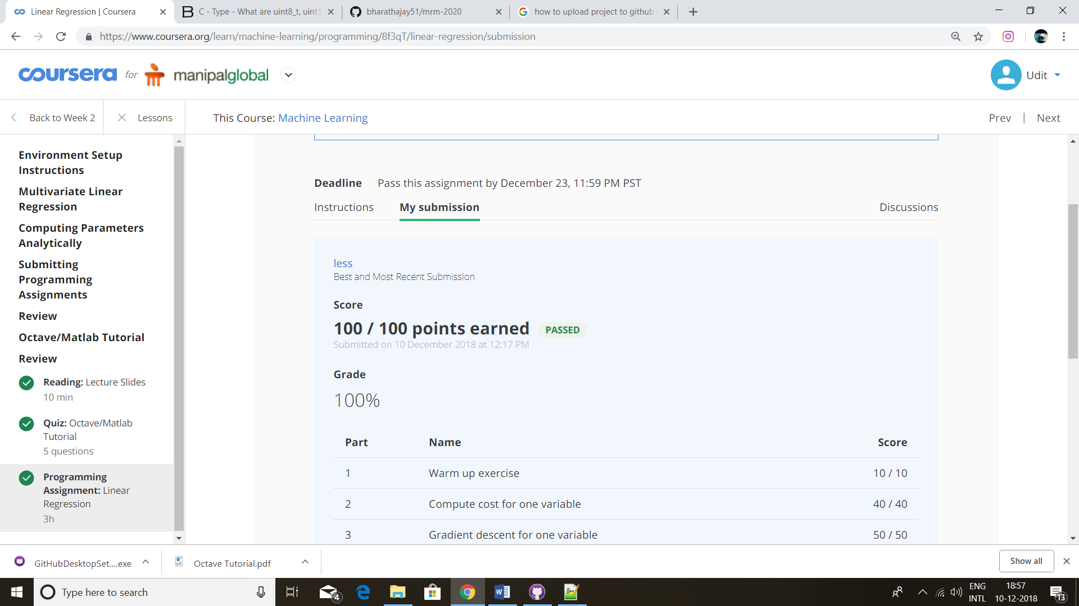

**Motor Code:**

I wrote the initial motor code. The same has been uploaded on Github.

I still need to smoothen the output.

**Python:**

I completed a course on python from course era. The certificate for the same is below:

