**Progress Report**

-17/12/2018

**Machine Learning**

1. Successfully completed till week 5 of Andrew ng course on ML.

* **The Third week** included lectures regarding introduction to Classification problems.
* Applying Linear Regression to Classify and its short comes.
* Introduction to Logistic regression, its cost function, gradient descent.
* Decision Boundary and One vs all
* Advanced Optimization problems.
* The problem of Over-fitting and regularization.
* Submitting 3rd Programming assignment included writing code for Logistic Regression, Regularized LR.

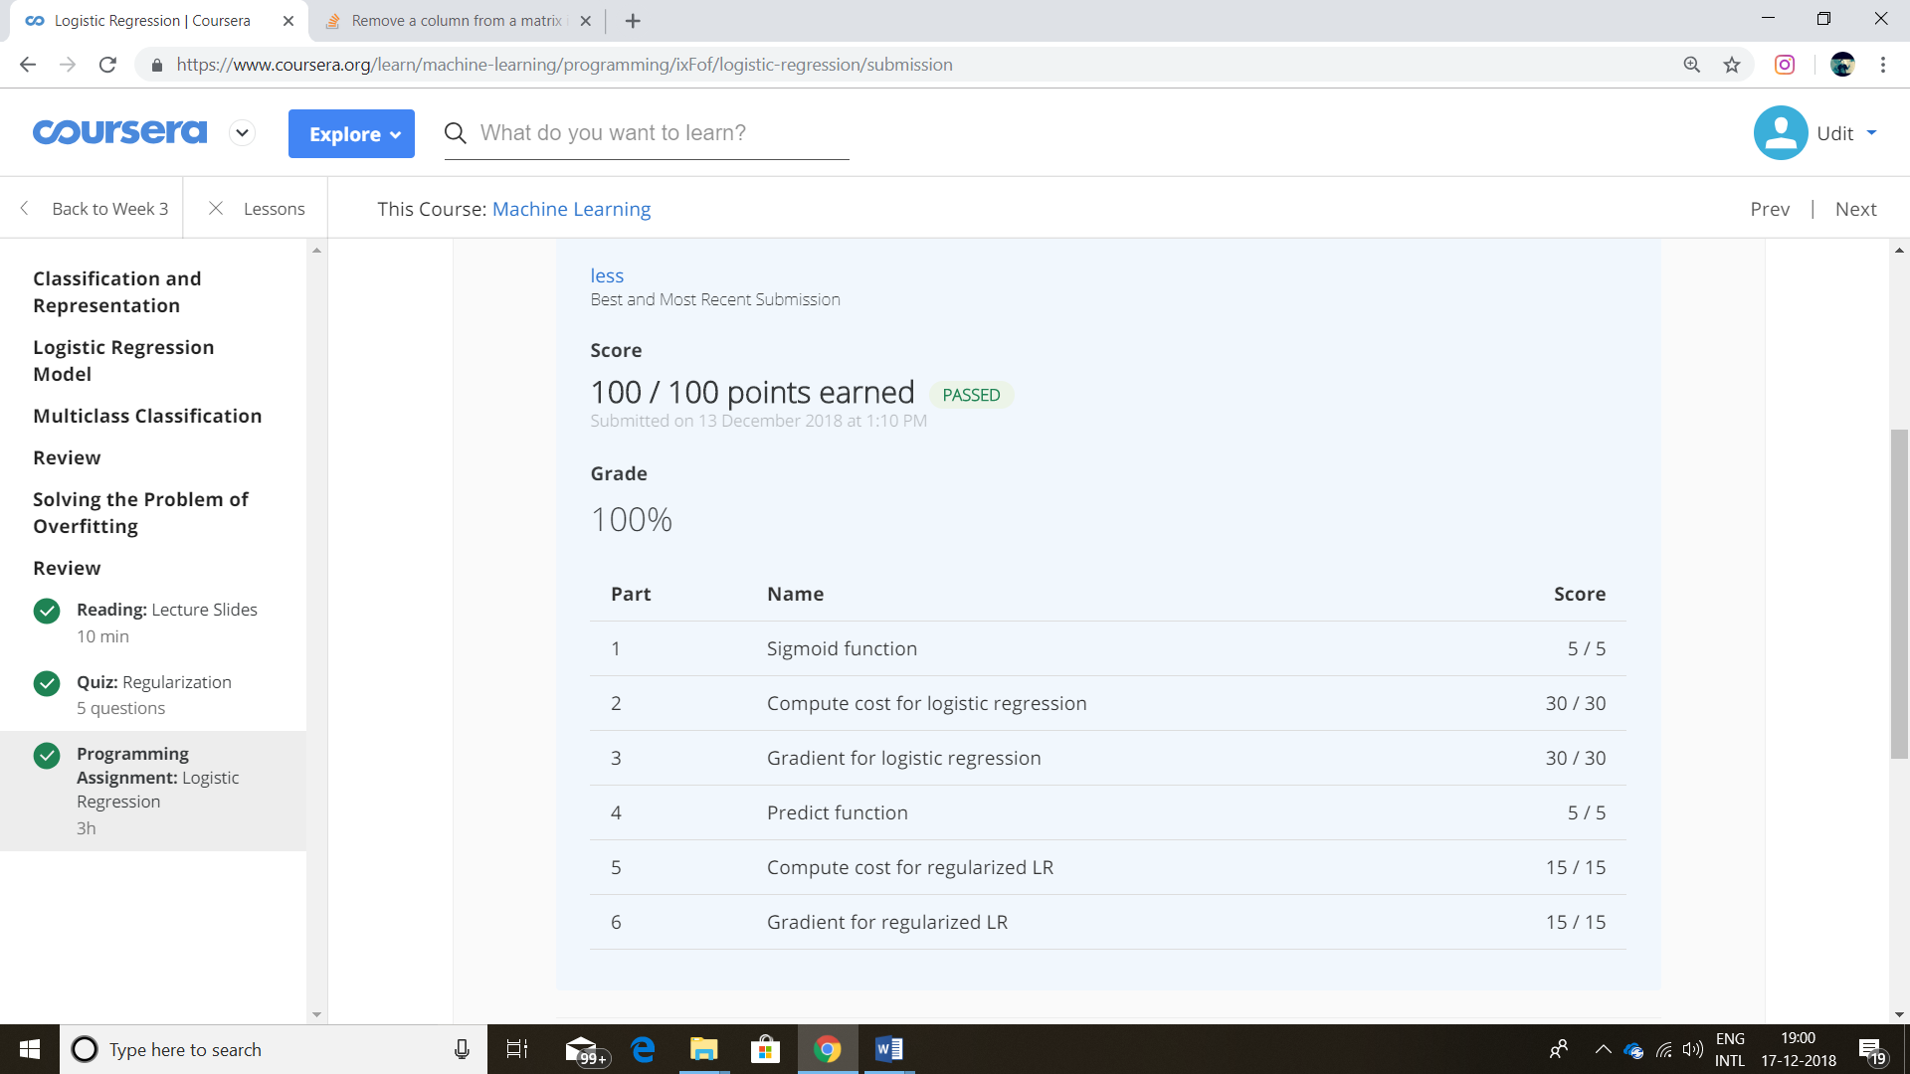

* **The Fourth week** gave introduction to Neural Networks
* Bio inspiration from nervous system and its application to AI.
* Model representation and Forward Propagation.
* Performing logical operations like- AND, OR, XOR, XNOR, NOT using neural networks. (Non-Linear Classification)
* Applying Neural networks to Multiclass- Classification.
* Submission of Fourth Programming assignment which had code for One vs All classification and Forward-Propagation.

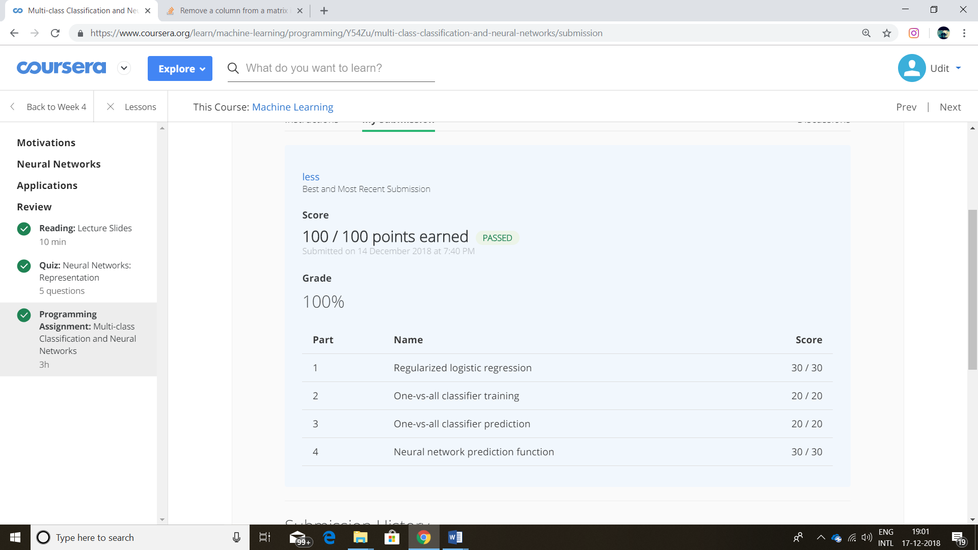

* **The Fifth week** expanded the concept of neural network.
* Cost function and Back-Propagationwere introduced. Back-propagation is an algorithm used to determine gradient of cost function.
* Gradient checking is a way to compute whether Back-Propagation Random initialization is a method to initialize the parameter vector to some non- zero vector (The parameters should be unequal when initialized).
* Unrolling of matrix was also discussed so as to use advanced optimization algo.
* A video regarding application of neural network in autonomous driving was also shown.
* Gradient checking is a way to compute whether Back-Propagation Submission of week 5 programming assignment which included backpropagation with and without regularization.

