**Progress Report**

-27/12/2018

**Machine Learning**

1. Successfully completed till half of 7th week of Andrew ng course on ML.

* The sixth week had lectures regarding application of ML. These included Causes behind poor performance of ML algorithm, shortlisting those causes, fixing it with the help of graphs (dividing the training set into three parts and the applying certain mechanisms to it). It also included error detection for skewed classes.

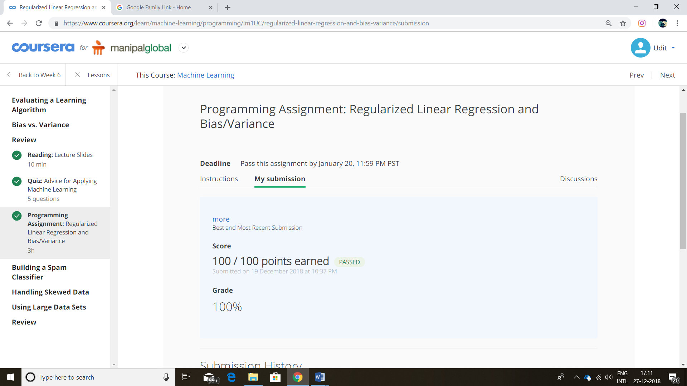

* The Seventh week included Support Vector Machines and the logic behind it. (i.e. its cost function, graph and working mechanism.)