Progress Report

# AI HOLIDAY PROJECT

Done with the AI holiday project. I have done cats vs dogs classifier using python and used images of cats and dogs. I obtained an accuracy of 81.6% on the validation set and 82.93% on the training set.

I have trained the model declaring the number of epochs as 5.

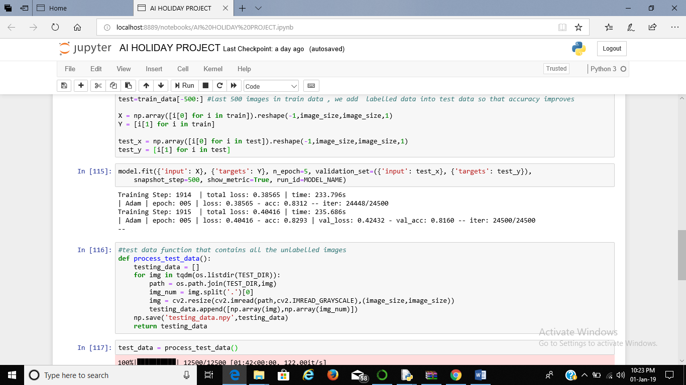

I observed an accuracy of around 80% on the test set.

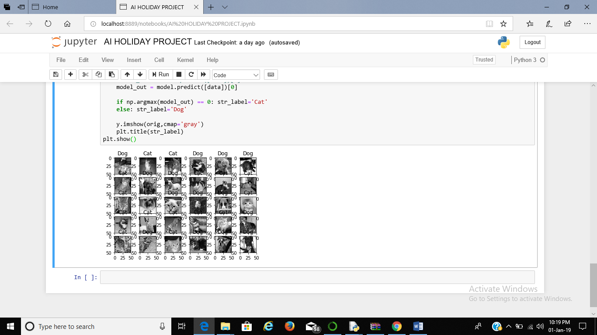

These are the first 30 images of the test set. Around 24-25 of them have been labelled correctly.

I have uploaded the code on github. It has been named as AI Holiday Project.

# Joystick Code

There is an error in my joystick program which I have not yet been able to figure out.