**PROGRESS REPORT 2**

Summary:

Completed the first and the second week (single variable) of the machine learning course of Andrew NG.

Started studying python (almost halfway) from newboston.com

Detailed:

The main objective of linear regression is to minimize the cost function. A cost function is a hypothesis or simply an equation that tries to fit in a labelled data so as to predict outcomes.

The cost function is given by

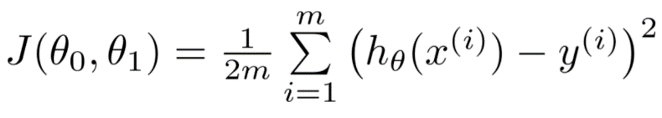

Where, h(x) = ϴ0 + ϴ1x

This is achieved by gradient descent. Gradient descent is an algorithm or steps that minimizes the cost function so as it fits the data set. Gradient descent always moves along the steepest slope and hence if we chose different starting points we may end up at some different local minima.

Algorithm for gradient descent:

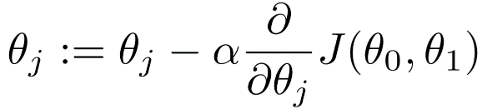

This step is repeated for a large number of iterations such as to make the variation in ϴ negligible or 0.

α is the learning rate and should be small.

