**Air-joystick:**

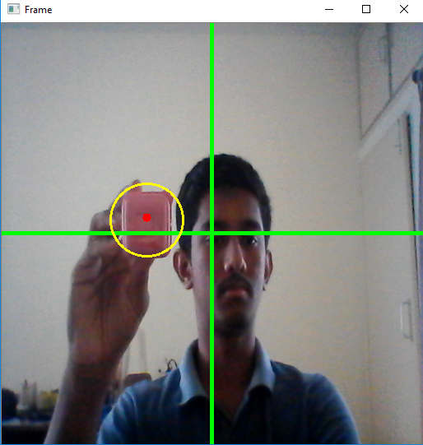The image below shows the program tracking an object w.r.t to a Cartesian plane where the X-axis and Y-axis have values ranging from 0 to 512.

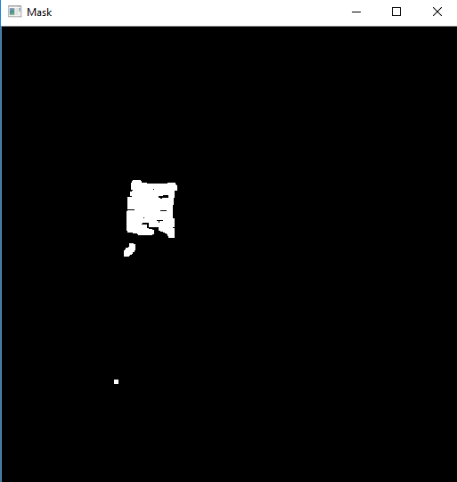To detect the object, the program is first provided with the HSV values of the object. Using this the program makes a mask i.e. it outputs a 1(white pixel) where the HSV values are “in Range” of the provided values and a 0(black pixel) everywhere else. The output mask is shown below:

After obtaining the mask, a function ‘findContours’ finds all the individual contours (blobs), then the largest of all these contours is chosen and its center is calculated.

The calculated center is then relayed to the Arduino via a COM port.

