**CASE1**: Input values in the excel Sheet:

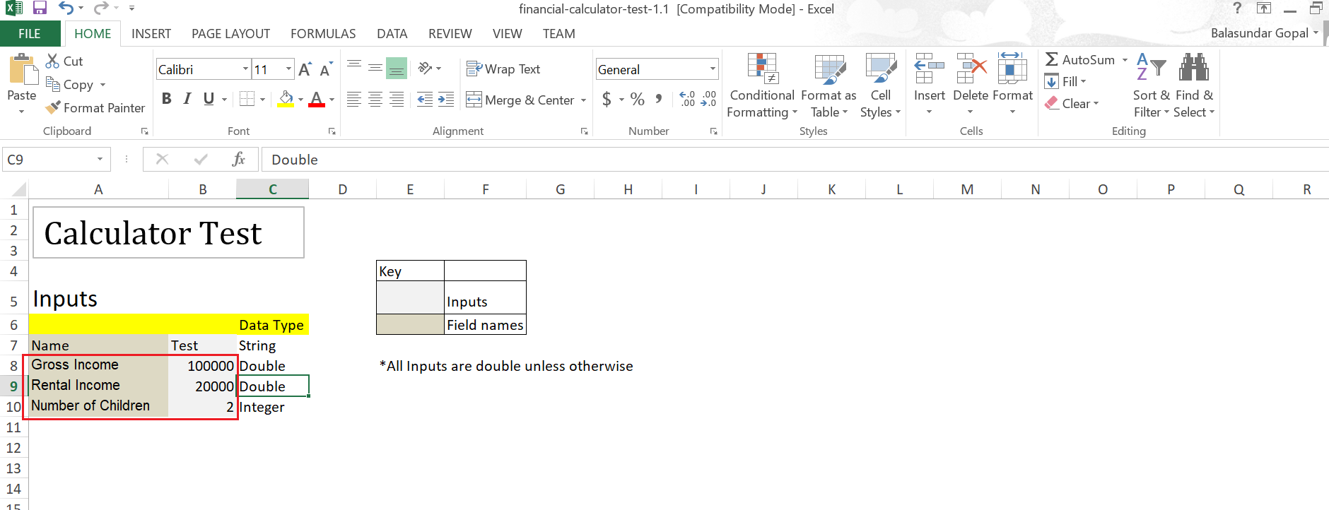

Input values in <https://bharathb04.github.io/Technical_Test/AppHome.html> –

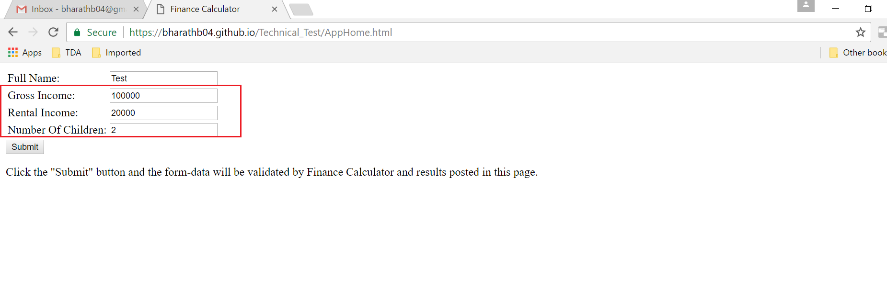

Post Submit the output in the HTML page, processed by FinCalculator.js-

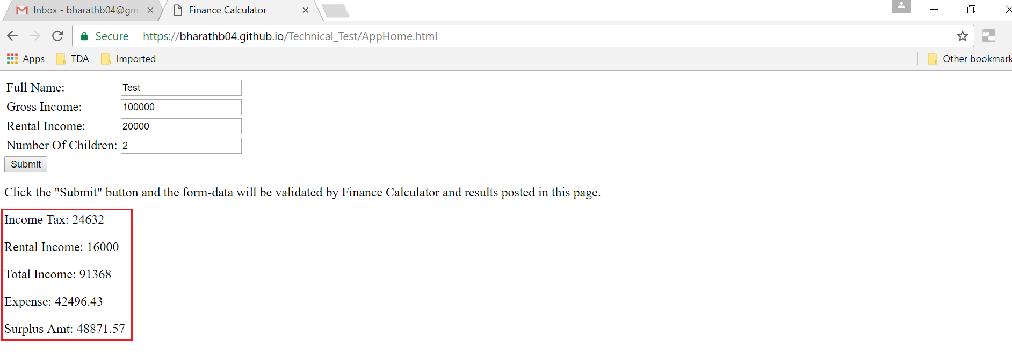

Output matches the excel output-

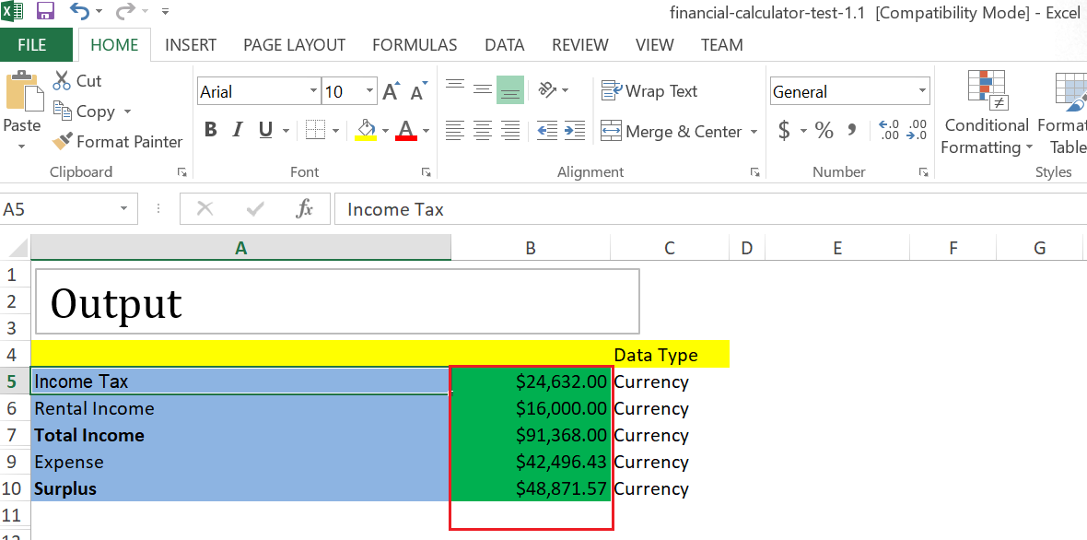

**CASE2**: Input values in the excel Sheet:

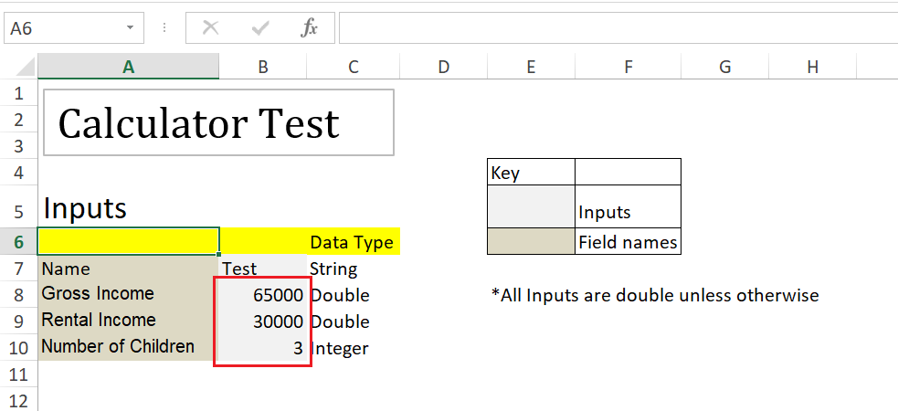

Input values in <https://bharathb04.github.io/Technical_Test/AppHome.html> –

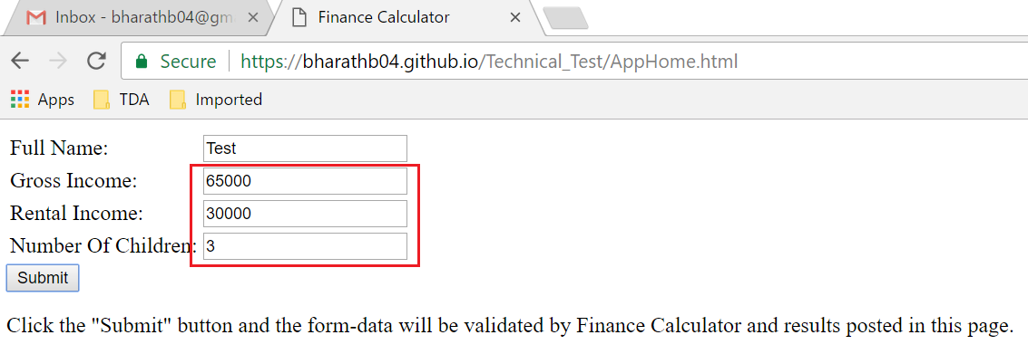

Post Submit the output in the HTML page, processed by FinCalculator.js-

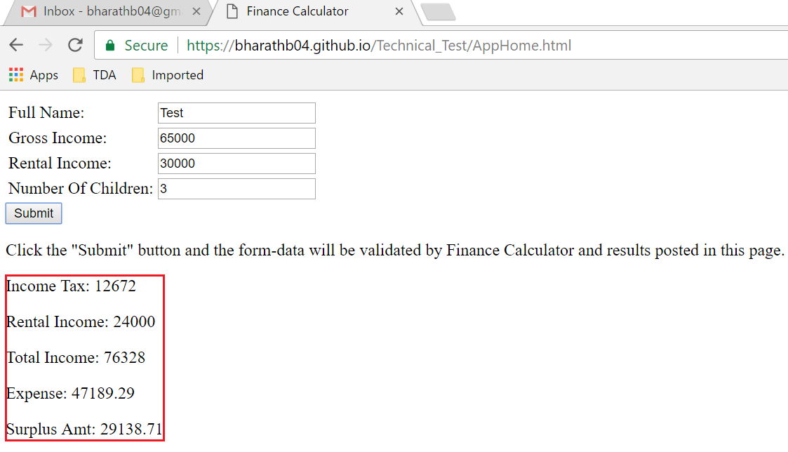

Output matches the excel output-

