AI-POWERED STUDENT PERFORMANCE ANALYSIS AND PREDICTION

Abstract
Student academic performance is influenced by several academic, behavioral, demographic, and family-related factors. This project focuses on analyzing student performance using data analytics and machine learning techniques.
The project uses the UCI Student Performance dataset, which contains information about students' demographic characteristics, family background, study habits, previous academic performance, absences, and final grades. The dataset contains 395 student records and 33 variables.
Data preprocessing, exploratory data analysis, visualization, feature encoding, and machine learning techniques were applied to understand patterns in student performance. Two regression models, Random Forest Regression and Linear Regression, were developed and evaluated using Mean Absolute Error (MAE), Root Mean Squared Error (RMSE), and R² Score.
The Random Forest model performed better than Linear Regression, achieving an MAE of 3.08, RMSE of 3.87, and R² score of 0.270 on the test dataset. The project demonstrates how data analytics and machine learning can provide useful insights into student performance and support data-driven academic decision-making.

2. INTRODUCTION
Academic performance is an important indicator of a student's educational progress. Understanding the factors associated with student performance can help educational institutions identify students who may require additional academic support.
Traditional academic analysis often focuses mainly on examination marks. However, student performance can also be associated with factors such as study habits, previous failures, absences, family background, and other student-related characteristics.
Data analytics provides an opportunity to examine these factors systematically. Machine learning can further be used to identify patterns in historical student data and develop predictive models.
This project, AI-Powered Student Performance Analysis and Prediction, applies data analytics and machine learning to the UCI Student Performance dataset. The project analyzes student information, explores relationships between different variables and final grades, and compares machine-learning models for predicting final academic performance.

3. PROBLEM STATEMENT
Educational institutions collect a large amount of information about students, but identifying patterns that are associated with academic performance can be difficult when analyzing the information manually.
The objective of this project is to analyze student-related data and determine whether machine-learning techniques can be used to predict final academic performance.
The project also aims to identify important features used by the predictive model and generate insights that may support early academic intervention and better educational planning.

4. OBJECTIVES
The main objectives of this project are:
- To analyze student academic and behavioral information.
- To perform data cleaning and preprocessing.
- To explore the distribution of student final grades.
- To investigate relationships between student characteristics and academic performance.
- To prepare categorical and numerical data for machine learning.
- To develop machine-learning models for predicting final grades.
- To compare Random Forest Regression and Linear Regression.
- To evaluate the models using MAE, RMSE, and R² Score.
- To identify important features using Random Forest feature importance.
- To provide data-driven recommendations for supporting student performance.

5. DATASET DESCRIPTION
Dataset Description
The project uses the UCI Student Performance Dataset.
Dataset source:
UCI Machine Learning Repository – Student Performance Dataset
Dataset link:
https://archive.ics.uci.edu/dataset/320/student+performance
For this project, the student-mat.csv dataset was used.
The dataset contains 395 student records and 33 variables. The variables include information related to:
- School
- Gender
- Age
- Address
- Family size
- Parent status
- Mother's education
- Father's education
- Mother's occupation
- Father's occupation
- Study time
- Previous failures
- School support
- Family support
- Absences
- Previous grades
- Final grade
The target variable used in this project is G3, representing the student's final grade.

6. DATA PREPROCESSING
Data Preprocessing
The dataset was loaded into Python using the Pandas library.
The following preprocessing and data-quality checks were performed:
Dataset Shape
The dataset contains:
- 395 rows
- 33 columns
Missing Values
The dataset was checked for missing values. No missing values were found in the loaded dataset.
Duplicate Records
Duplicate records were checked and no duplicate records were found.
Target Variable
The final grade variable G3 was selected as the target variable for the machine-learning models.
G1 and G2 were excluded from the prediction features because they represent earlier academic grades and could make the final-grade prediction unrealistically dependent on previous examination results.
Categorical Encoding
Categorical variables were converted into numerical representations using one-hot encoding with Pandas.
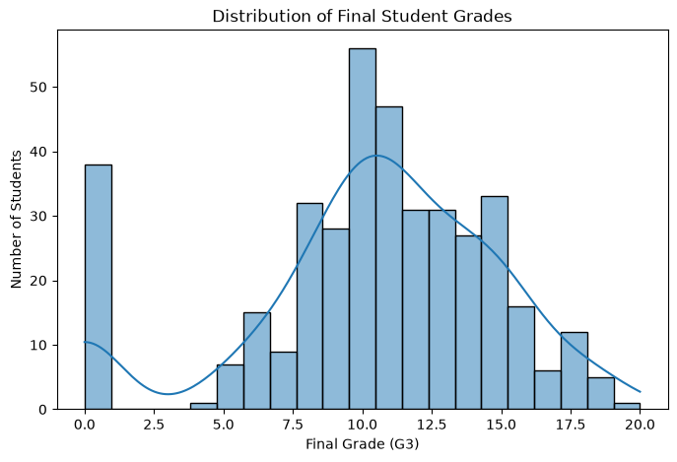

7. EXPLORATORY DATA ANALYSIS
Exploratory Data Analysis
Exploratory Data Analysis (EDA) was performed to understand the characteristics of the dataset and identify patterns in student performance.
Final Grade Distribution
The average final grade was:
10.42 / 20
The median final grade was:
11 / 20
The most frequently occurring final grade was 10, with 56 students.
There were also 38 students with a final grade of 0.

Performance Groups
Students were grouped into four performance categories based on their final grade:
Category | Grade Range | Percentage
Low | 0–9 | 32.91%
Average | 10–11 | 26.08%
Good | 12–14 | 22.53%
Excellent | 15–20 | 18.48%

The largest group was the Low performance category, representing approximately 32.91% of the students.
Absences
The average number of absences was approximately:
5.71
The dataset contains students with substantially different numbers of absences, with the maximum recorded value being 75.
Previous Failures
A total of 83 students had at least one previous failure.
This represents approximately 21% of the dataset.
8. MACHINE LEARNING METHODOLOGY
Machine Learning Methodology
After preprocessing the dataset, the data was divided into input features and the target variable.
The target variable was:
G3 – Final Grade
The dataset was divided into:
- 80% training data
- 20% testing data
A fixed random state of 42 was used to make the experiment reproducible.
Two regression algorithms were developed:
8.1 Random Forest Regression
Random Forest Regression was selected as one of the machine-learning approaches because it can model nonlinear relationships between multiple input variables.
The model was trained using 200 decision trees.
8.2 Linear Regression
Linear Regression was used as a second model to provide a simpler baseline for comparison.
The two models were evaluated using the same test dataset.
Model Evaluation
Three evaluation metrics were used:
Mean Absolute Error (MAE)
MAE represents the average absolute difference between the actual and predicted final grades.
A lower MAE indicates better prediction performance.
Root Mean Squared Error (RMSE)
RMSE measures prediction error while giving greater weight to larger errors.
A lower RMSE indicates better performance.
R² Score
R² indicates how much variation in the target variable is explained by the model.
A higher R² indicates better explanatory performance.

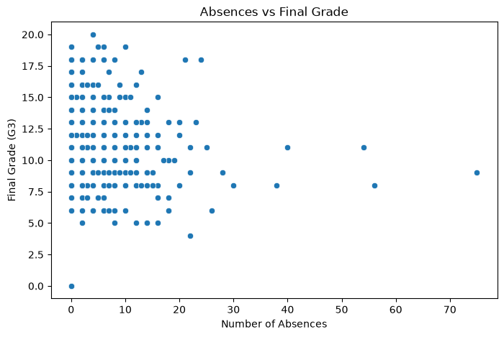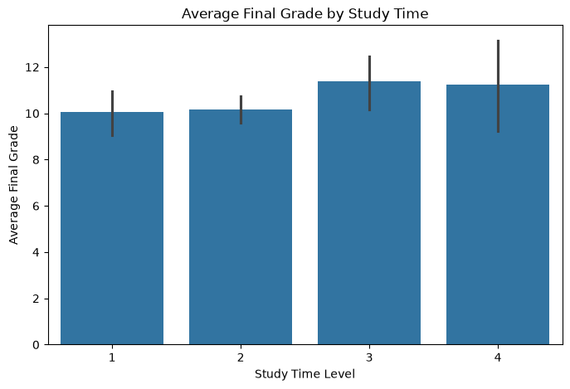

9. MODEL EVALUATION

Model Comparison
Model | MAE | RMSE | R² Score
Random Forest Regression | 3.08 | 3.87 | 0.270
Linear Regression | 3.40 | 4.20 | 0.141

The Random Forest model performed better than Linear Regression across all three evaluation metrics.
Therefore, Random Forest Regression was selected as the better-performing model for this project.

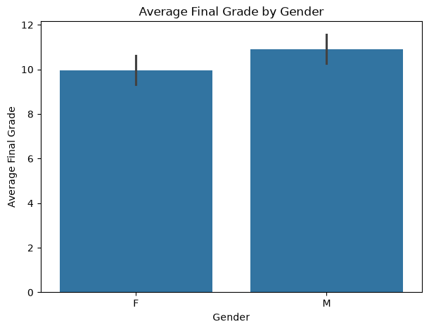

10. FEATURE IMPORTANCE
Feature Importance Analysis
Feature importance analysis was performed using the trained Random Forest model.
The purpose of this analysis was to identify which input variables the model relied on most when generating predictions.
The feature importance results help identify potentially relevant variables for understanding student performance.
However, feature importance should not be interpreted as proof that a variable directly causes a student's academic performance to increase or decrease.
The feature-importance visualization generated in the notebook can be included in this section of the report.

11. KEY FINDINGS
The major findings from the analysis are:
- The dataset contains 395 students and 33 variables.
- No missing values or duplicate records were found.
- The average final grade was approximately 10.42 out of 20.
- The median final grade was 11.
- The average number of absences was approximately 5.71.
- 83 students had at least one previous failure.
- 38 students had a final grade of 0.
- Random Forest Regression performed better than Linear Regression.
- The Random Forest model achieved an MAE of 3.08.
- The Random Forest model achieved an RMSE of 3.87.
- The Random Forest model achieved an R² score of 0.270.

12. RECOMMENDATIONS
Recommendations
Based on the analysis, the following recommendations can be considered:
- Educational institutions can identify students who may require additional academic support.
- Students with previous academic failures can be monitored more closely.
- Students can be encouraged to develop consistent study habits.
- Excessive absenteeism can be monitored so that appropriate academic support can be provided.
- Data analytics can be used as an early-support tool for identifying students who may need assistance.
- Future systems can combine additional academic and behavioral information to potentially improve prediction performance.
- Machine-learning predictions should support teacher and academic decision-making rather than replace human judgment.

13. LIMITATIONS
Limitations
This project has several limitations:
- The dataset contains information from a specific student population and may not represent all students.
- The dataset contains only 395 student records.
- The Random Forest model achieved moderate predictive performance.
- The R² score of 0.270 indicates that a substantial amount of variation in final grades is not explained by the model.
- The dataset does not contain every factor that may influence student academic performance.
- Feature importance represents model behavior and should not be interpreted as causal evidence.
- The model should not be used to make automatic decisions about individual students.

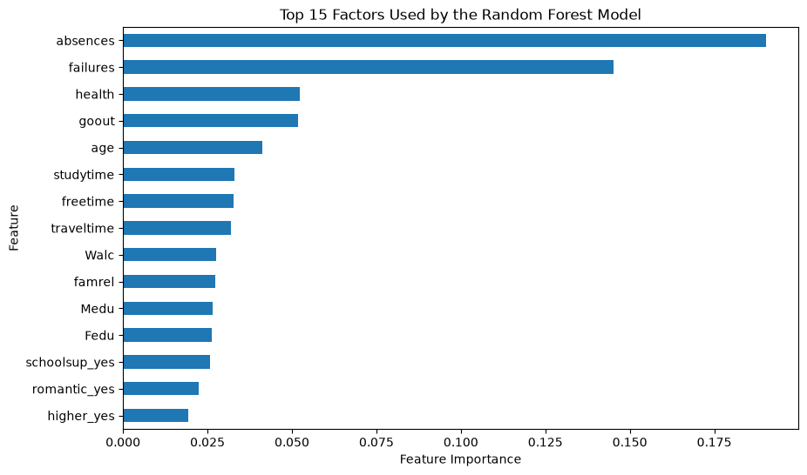
14. CONCLUSION
- This project analyzed student academic performance using data analytics and machine-learning techniques.
- The UCI Student Performance dataset was explored and preprocessed using Python. Exploratory data analysis was performed to understand the distribution of final grades and examine student-related factors.
- Two machine-learning regression models, Random Forest Regression and Linear Regression, were developed and evaluated.
- The Random Forest model performed better than Linear Regression, achieving an MAE of 3.08, RMSE of 3.87, and R² score of 0.270 on the test dataset.
- The project demonstrates how data analytics and machine learning can be applied to educational data to identify patterns, compare predictive models, and generate data-driven insights.
- Overall, the project demonstrates a practical application of Data Analytics and AI for understanding student performance and supporting evidence-based academic planning.

Submitted by

B.Bharath

