BHARAMIND AI

Author Details:
Name: B Bharath Kumar Reddy
Designation: Analyst
Organization: Capgemini
Program: SAP ABAP HANA & SD - AI Launchpad
Batch: 1

Technologies Used:
Frontend
- HTML
- CSS
- JavaScript
Backend
- Python
- FastAPI
Database
- SQLite
- SQLAlchemy
AI Integration
- OpenAI SDK
- OpenAI-Compatible Generative AI Models
Additional Technologies
- Marked.js
- Python Dotenv

Objective:
BharaMind AI is an AI-powered conversational assistant developed using FastAPI and OpenAI-compatible Generative AI services. The application enables users to interact with AI, upload files for analysis, maintain chat history, manage multiple conversations, and receive intelligent responses in a user-friendly interface.

Features
- AI-powered conversations
- Multiple chat sessions
- Persistent chat history
- File upload and analysis
- Markdown-formatted responses
- Copy response functionality
- Dark/Light theme support
- Chat delete functionality
- Dynamic chat titles

Technology Stack
Backend
- Python
- FastAPI
Database
- SQLite
- SQLAlchemy
AI Integration
- OpenAI Python SDK
- GPT Models
Frontend
- HTML
- CSS
- JavaScript

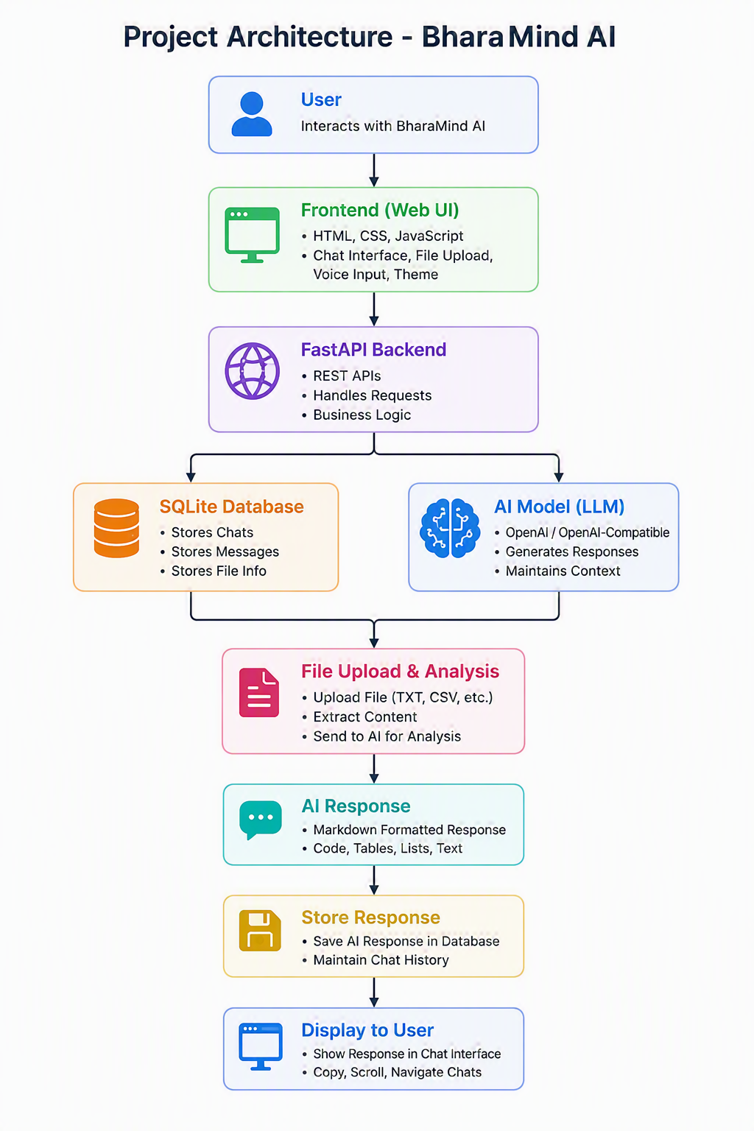
Project Architecture

Application Workflow

Step 1: Start Conversation
User creates a new chat and enters a prompt.
Example:
- Explain FastAPI
Step 2: Send Request
Frontend sends the user's prompt and chat ID to the FastAPI backend.
Step 3: Retrieve Chat Context
Existing conversation history is fetched from the SQLite database.
Step 4: AI Processing
The prompt (along with any uploaded file content) is sent to the configured AI model.
Step 5: Response Generation
The model generates a response and returns it to the application.
Step 6: Store Conversation
Both user and AI messages are stored in SQLite for future retrieval.
Step 7: Display Response
The response is rendered in the chat interface using Markdown formatting.

File Upload Workflow
- User uploads a file.
- Backend reads file content.
- File content is added to the AI prompt.
- AI analyses the content.
- Response is displayed in chat.

Configure Environment Variables
Create a .env file in the root directory.

GENAI_API_KEY=your_api_key
GENAI_BASE_URL=your_genai_endpoint
GENAI_MODEL=your_model_name

Environment Variables

Variable | Description
GENAI_API_KEY | API authentication key
GENAI_BASE_URL | AI endpoint URL
GENAI_MODEL | Model used for response generation

Run Application

Step 1: Start Backend
Open Command Prompt / Terminal and run:
uvicorn main:app --reload
Backend URL:
http://127.0.0.1:8000

Step 2: Start Frontend
Open Command Prompt / Terminal and run:
python -m http.server 5500
Frontend URL:
http://localhost:5500/

Folder Structure

BharaMind-AI/
│
├── main.py
├── llm.py
├── database.py
├── models.py
├── requirements.txt
├──. env
│
├── static/
│ ├── style.css
│ └── script.js
│
├── templates/
│ └── index.html
│
└── README.md

Screenshots
Home Page
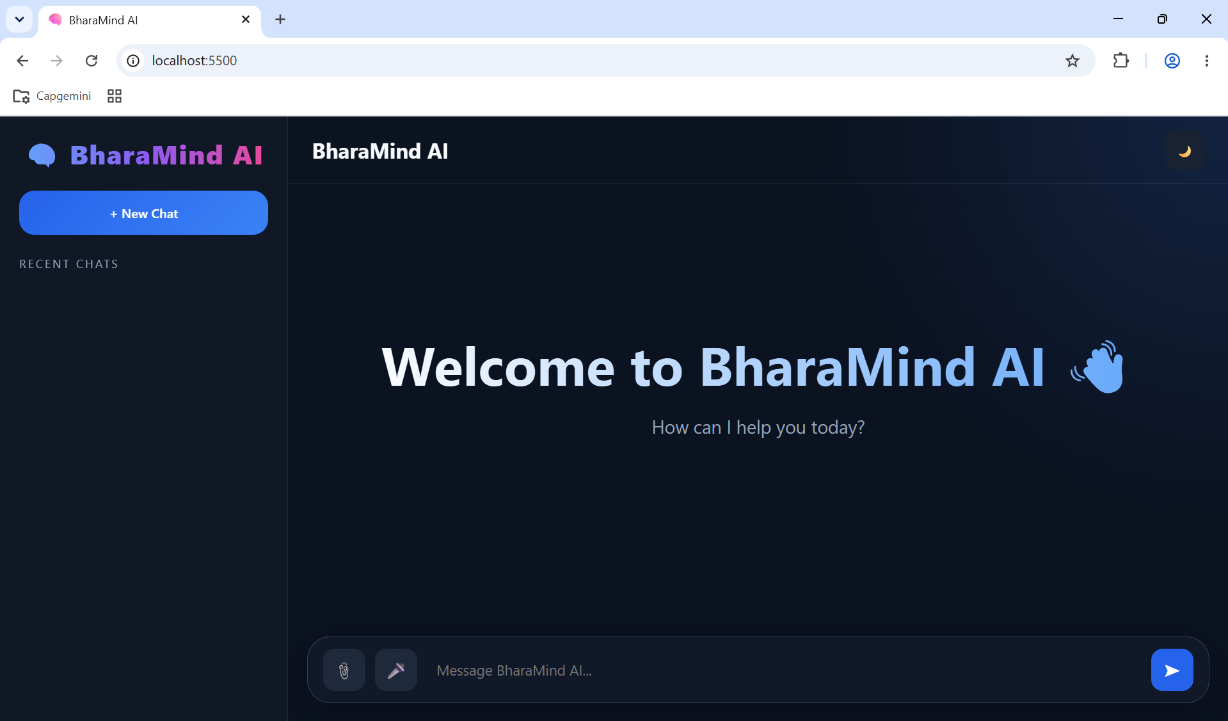
BharaMind AI landing page with chat sidebar and conversation area.
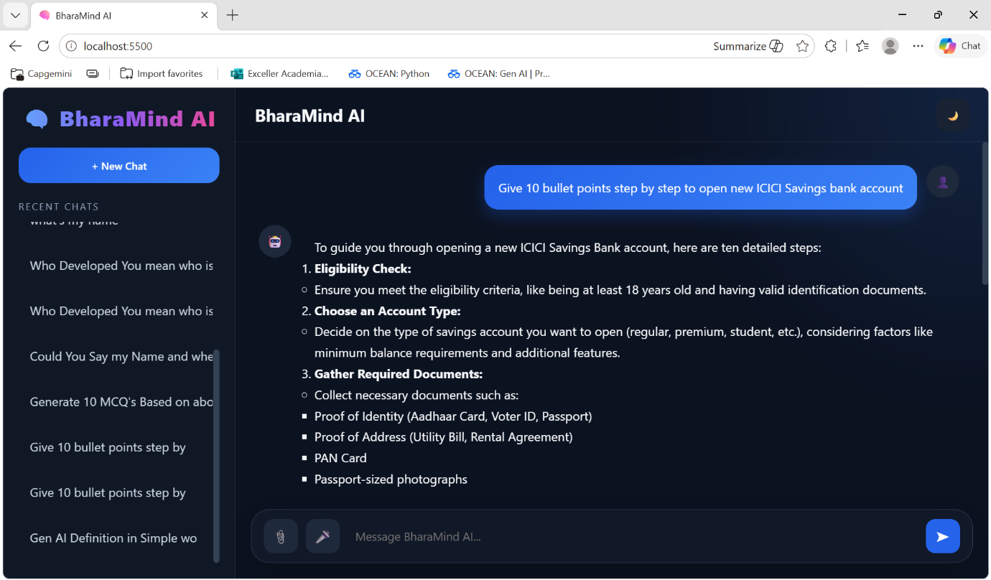
Chat Interface
User and AI conversation window.
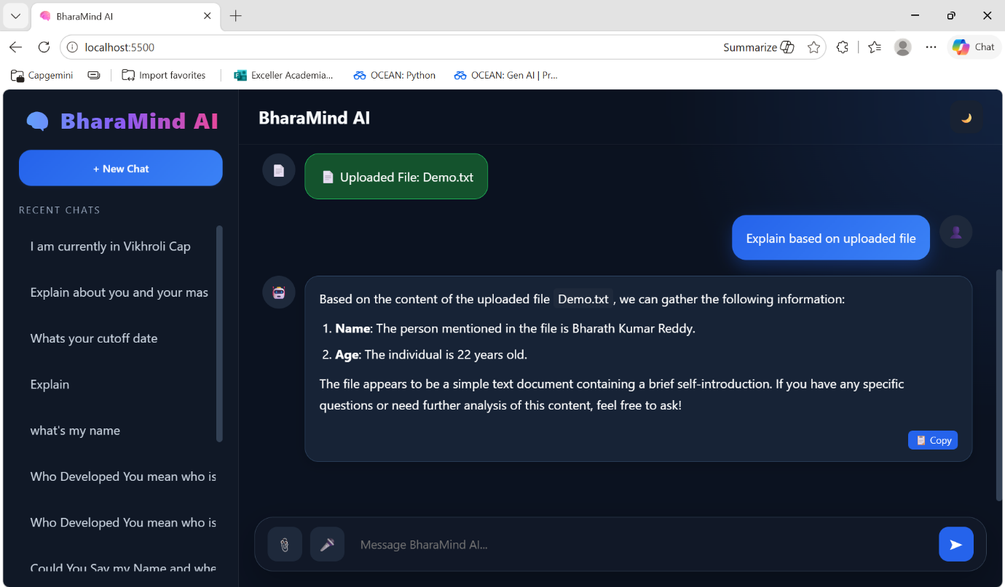
File Upload

File upload and analysis feature.
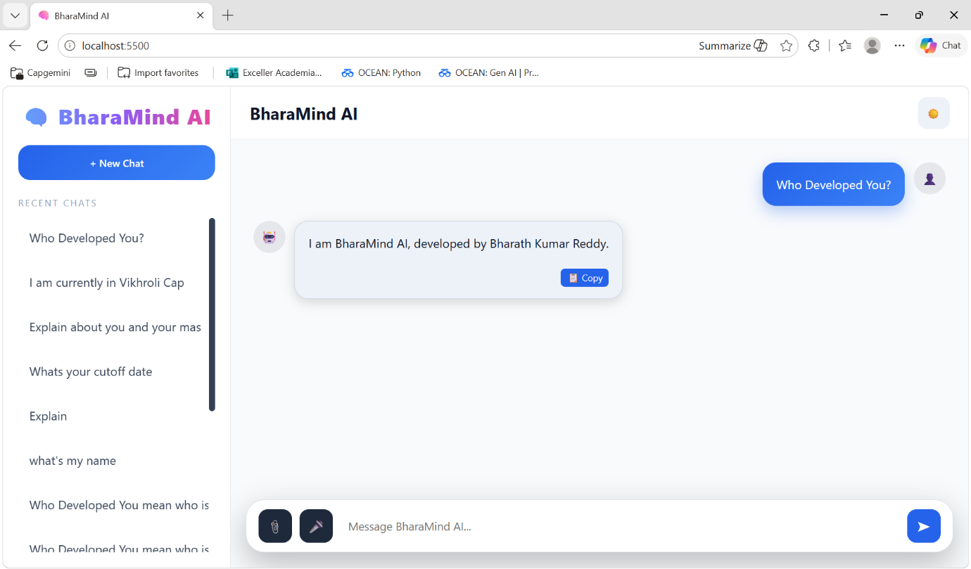
Light Mode
Light-themed user interface.

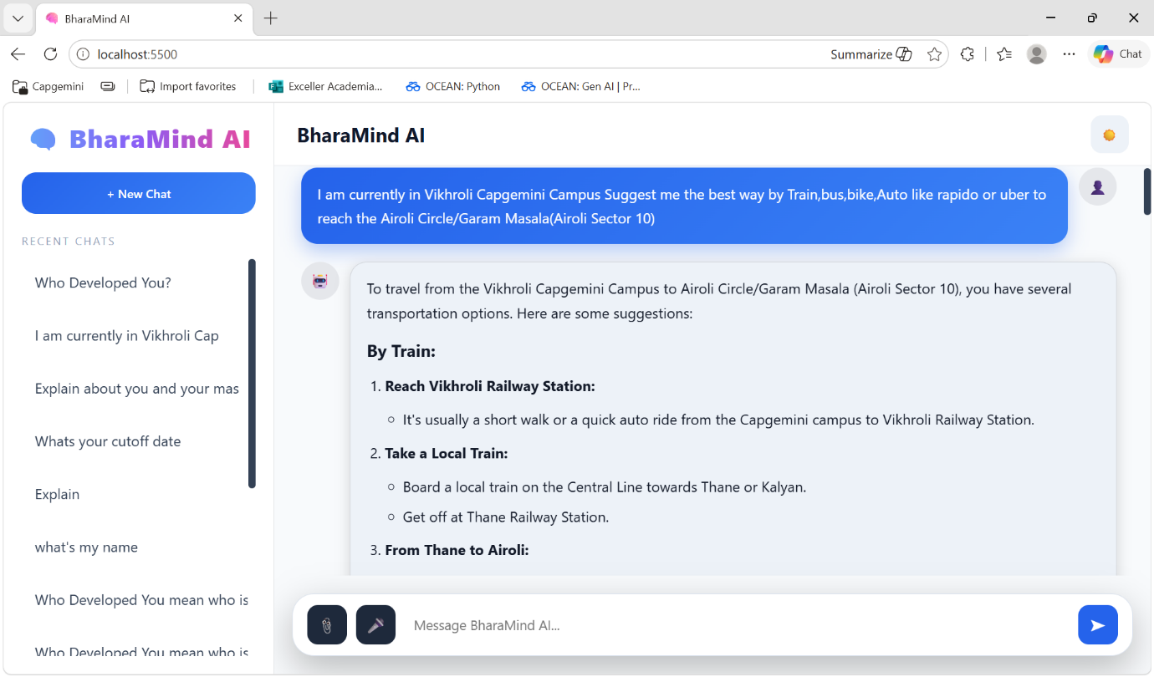
Chat History
Multiple chat management and retrieval.

