Critique and Recommended Plan: Synthetic CoT Triage Adaptor
Comparison of Claude-generated plan and Codex-generated plan, with final suggested implementation direction

1. Executive Verdict
Verdict: Claude's document is stronger as an engineering checklist, while the Codex plan is stronger as a defensible research protocol. I would not use either document alone. I suggest using the revised hybrid plan in this document: Codex's safety-first research spine plus selected Claude implementation details after verification.
Which is better: For a research project in mental-health triage, the Codex approach is better as the base because it is more careful about data governance, clinical overclaiming, locked human evaluation, evidence grounding, and failure analysis. Claude's plan is useful, but it contains too much false precision and several assumptions that could break the project if accepted uncritically.
Practical suggestion: Use the Codex/hybrid plan for the proposal and experimental design. Borrow Claude's concrete tables for model candidates, QLoRA defaults, sprint planning, repository structure, and compute estimates only after checking dataset access, current model availability, API pricing, and ethics constraints.

2. What Claude's Document Does Well
- It is implementation-oriented. It lists specific teacher models, student models, STT/TTS models, hyperparameters, experiments, tools, and compute estimates.
- It gives a strong build roadmap. The 4-week sprint, repository layout, and technology stack are immediately useful for organizing work.
- It includes many practical metrics: macro-F1, high-risk sensitivity, calibration, WER, CER, round-trip F1 drop, latency, readability, and hallucination rate.
- It treats speech integration as a real subsystem rather than a decorative add-on.
- It includes ablation IDs, which makes experiment tracking easier.

3. Main Critique of Claude's Document
Issue | Why it matters | Suggested correction
False precision in model and cost claims | It lists estimated parameter counts and prices for proprietary models such as GPT-4o, Claude, and Gemini. These details are often undisclosed or change over time. | Replace hard claims with 'verify at run time' fields. Cite only official pricing/model pages when finalizing.
Dataset access is too optimistic | CLPsych, eRisk, Crisis Text Line, and similar mental-health datasets often require data use agreements, are restricted, or cannot be redistributed. Calling them public can mislead the implementation plan. | Make data access the first milestone. Separate accessible public corpora, restricted corpora, and mentor-provided data.
Speech data assumptions are weak | Crisis call recordings are highly sensitive. Some listed speech datasets are general speech or impaired speech, not mental-health crisis speech. | Use synthetic TTS stress testing first. Treat real crisis audio as out of scope unless explicit ethics approval and access exist.
Overuse of 'Chain-of-Thought' | Training on or asking for full CoT can create hidden reasoning leakage, verbose rationales, and unsupported clinical interpretation. | Use concise structured rationales, evidence spans, risk factors, protective factors, and plain-language explanations. Do not require long hidden CoT.
Self-critique by the same teacher is not enough | A model judging its own hallucinations is weak evidence. This can make synthetic labels look cleaner than they are. | Use independent verifier models, schema checks, evidence-span validation, disagreement routing, and human audit.
Risk-tier definition needs tighter operationalization | Claude uses five labels but does not fully specify ordinal severity, escalation policy, and what counts as under-triage. | Define a tier rubric before generation. Use ordinal penalties and high-risk false-negative review.
Success targets may be arbitrary | Targets such as macro-F1 >= 0.75 or hallucination <= 10 percent may be unrealistic or meaningless without dataset baseline difficulty. | Report baseline-relative improvements, confidence intervals, and safety-critical error counts.
Ethics section is good but too permissive | It says anonymized posts can be sent to cloud APIs for teacher inference. That may violate data agreements or ethics constraints. | Add a data-policy decision gate: external teacher allowed, local teacher only, or synthetic-only pilot.
No embedded visual flowchart | The document has an ASCII flowchart but no clean diagram. That is less presentation-ready. | Use a proper system architecture diagram and a separate experimentation flowchart.

4. How the Codex Approach Is Different
Dimension | Claude plan | Codex plan | Recommended choice
Orientation | Engineering build spec with concrete tools and sprint details. | Research protocol with explicit hypotheses, safety framing, evaluation, and governance. | Use Codex as the base, add verified implementation details.
Teacher model | Names specific teacher models and prices. | Defines teacher roles: primary teacher, disagreement teacher, judge, and human auditor. | Role-based design is safer; choose exact models later.
Rationale supervision | Frames the output as CoT and teacher CoT distillation. | Frames outputs as concise structured rationales with evidence spans and no diagnosis. | Use structured rationales, not long CoT.
Dataset handling | Lists many datasets, sometimes with optimistic access assumptions. | Treats data access, de-identification, user-level split, and locked gold test as core requirements. | Start with governance and access audit.
Metrics | Very broad metric catalog with numeric targets. | Metrics tied to research claims: under-triage, grounding, calibration, speech degradation, fairness. | Use Codex metric framing; borrow Claude's concrete metric names.
Speech evaluation | Specific STT/TTS tools and targets. | Stress-test design: TTS, perturbation, STT, triage flip, evidence drift. | Use Codex design plus verified STT/TTS choices.
Safety | Includes ethics but accepts cloud teacher inference after anonymization. | Adds stronger separation of observed evidence vs inference, human review, and non-diagnostic framing. | Use stronger Codex safety gate.

5. Recommended Hybrid Research Pipeline
The recommended design keeps your original simple architecture but adds research-grade gates around it.
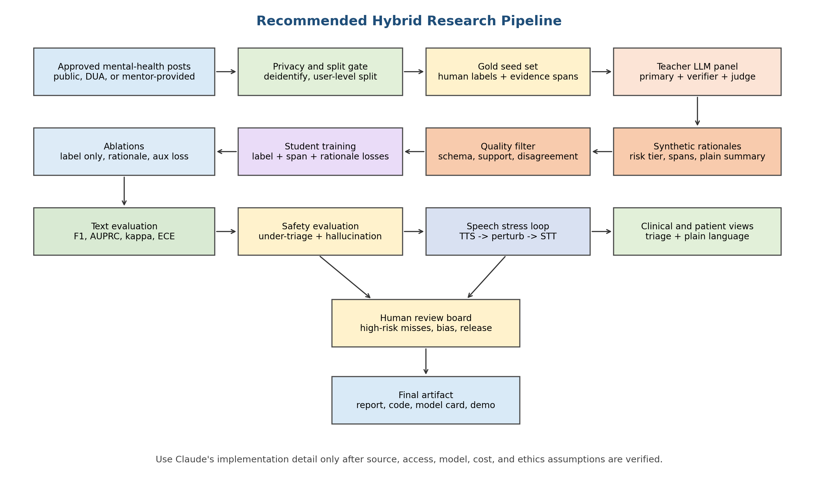

6. Final Research Plan to Use

6.1 Core Research Question
Can synthetic structured rationales generated by a strong teacher model improve a small local triage adaptor's ability to map lay mental-health crisis language into clinically useful, evidence-grounded, plain-language risk interpretation, while remaining robust to speech I/O errors?

6.2 Output Contract
Field | Purpose | Evaluation
risk_tier | Ordinal triage label, such as no acute crisis, low, moderate, high/imminent. | Macro-F1, high-risk recall, ordinal kappa, under-triage distance.
confidence | Uncertainty estimate for routing to human review. | ECE, Brier score, reliability plot.
evidence_spans | Exact short input spans that support the risk tier. | Span F1/IoU, unsupported claim rate.
risk_factors | Observed risk cues only. | Rubric coverage and hallucination audit.
protective_factors | Observed buffers such as support, future orientation, help-seeking. | Rubric coverage and human review.
clinical_rationale | Concise explanation for clinician/researcher view. | Clinician Likert score, label-rationale consistency.
plain_language_summary | Patient/caregiver-friendly explanation. | Readability, jargon reduction, meaning preservation.
recommended_next_step | Supportive, urgent support, or emergency escalation. | Escalation accuracy and safety review.

6.3 Teacher Model Strategy
- Use a primary teacher model only after confirming the data policy permits external inference. If not, use the strongest local instruction model available.
- Use a second model or independent judge to detect disagreement, unsupported evidence, invalid JSON, and label-rationale contradiction.
- Do not ask the model to reveal long hidden reasoning. Ask for a concise clinical rationale grounded in exact evidence spans.
- Route all high/imminent cases, all model disagreements, and all low-confidence cases to human review.
- Version every prompt, teacher model, temperature, filter, and schema.

6.4 Student Training Strategy
Experiment | Training target | Research purpose
B0 | Rule/keyword baseline. | Sanity check and interpretable lower bound.
B1 | Zero-shot/few-shot teacher prompt. | Prompt-only baseline.
S1 | Student label-only fine-tuning. | Tests whether rationales add value.
S2 | Student label plus generated rationale. | Tests visible rationale distillation.
S3 | Multi-task auxiliary objective: label, spans, factors, rationale, plain summary. | Main proposed method.
S4 | S3 plus counterfactual consistency training. | Tests robustness to minimal clinical cue edits.
S5 | S3/S4 plus speech-loop augmentation. | Tests STT/TTS robustness training.

6.5 Evaluation Strategy
Evaluation layer | Primary metrics | Decision rule
Triage | Macro-F1, weighted-F1, per-tier recall, high-risk AUPRC, quadratic weighted kappa. | Model must improve over S1 and must not increase high-risk false negatives.
Safety | Under-triage count, severity-distance error, high-risk miss audit. | Every high-risk miss is manually reviewed and categorized.
Rationale | Evidence span F1, unsupported claim rate, label-rationale consistency, clinician Likert score. | No unsupported clinical claims in accepted demo examples.
Calibration | ECE, Brier score, reliability curves. | Low confidence must correlate with ambiguous or difficult examples.
Speech | WER, CER, triage flip rate, high-risk recall loss, evidence drift. | Report degradation by WER/noise/accent bucket rather than hiding average failure.
Fairness | Counterfactual demographic swaps and subgroup analysis where ethically available. | Demographic wording alone should not cause systematic risk inflation or deflation.

6.6 Implementation Sequence
- Audit data access and ethics constraints before choosing teacher models.
- Define the triage rubric and JSON output schema.
- Build preprocessing, de-identification, deduplication, and user-level split scripts.
- Create a small human-labeled gold seed set with evidence spans.
- Generate teacher rationales, run quality filters, and route disagreements to review.
- Train baselines and the main auxiliary-loss student model.
- Run text evaluation, rationale evaluation, calibration, and safety error analysis.
- Add TTS/STT stress testing only after the text pipeline is stable.
- Write a model card, data card, error taxonomy, and release limitations.

7. Specific Changes I Would Make to Claude's Plan
- Replace the phrase 'full CoT' with 'structured clinical rationale' throughout.
- Remove proprietary model parameter counts unless independently verified from official sources.
- Mark all dataset access as 'to be verified' and make access verification a Week 1 deliverable.
- Remove Crisis Text Line or real crisis-call audio from the active plan unless formal access and ethics approval are confirmed.
- Change the fail-safe rule from 'confidence below 60 percent defaults to High Risk' to 'low confidence routes to human review or conservative escalation label depending on interface policy.'
- Add a locked human-authored test set that never contains teacher-generated labels.
- Replace BERTScore/ROUGE as primary rationale metrics with evidence support, unsupported-claim rate, and clinician/rubric scoring. Keep BERTScore only as secondary.
- Add confidence intervals and paired significance tests for model comparisons.
- Separate clinical view from patient view in output and evaluation.
- Add a source-verified references appendix before submission.

8. Bottom-Line Recommendation
Use the hybrid plan in this document. If you must choose only one existing document, use the Codex plan as the research foundation and use Claude's plan as a secondary implementation checklist. Claude's plan looks more complete at first glance, but the Codex approach is more robust for a mental-health triage project because it reduces clinical, ethical, and evaluation risks.
The strongest final proposal should sound like this: 'We will train a small local triage adaptor using teacher-generated structured rationales, but the teacher outputs are treated as noisy synthetic supervision. Final claims will be based on human-labeled test data, evidence-grounded rationale evaluation, safety-critical error analysis, and speech stress testing.'

9. Files Compared
- Claude document: CoT_Triage_Adaptor_Research_Plan.docx
- Codex document: Synthetic_CoT_Triage_Adaptor_Research_Plan.docx
- This recommended critique document: Codex_Critique_and_Recommended_CoT_Triage_Plan.docx

