Questions -5

1

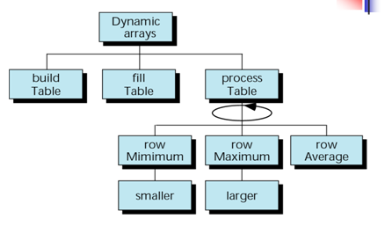

Make a ragged array (dynamic) somewhat as shown in the figure below

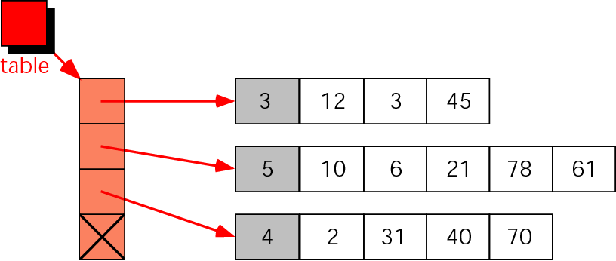

2

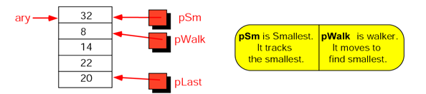

Write a program which shows a sample array .The pointers are defined as pSm (points to the smallest element ), pLast (to the last element , and pWalk ( see its definition in the yellow box) .

Write a progam which uses these three pointers and finds the smallest element in an array .

3 Programs using Structures

Write a C program to read a student record and to display the content. The student record must contain the following information of a student

student name

rollno

semester

4. Modify the above program by redefining student record to hold date of birth field. The date of birth again contains subfields like date, month and year. Define a function display( ) in the above program which takes a student record as an argument and display it

1. Modify Problem1 to read the details of 10 students .Arrange and display the details in alphabetical order of student’s name.
2. Create a student record having fields for storing Name, Rollnumber, Marks of 5 subjects and final grade. Define function readmark( ) for reading marks of a student and calculategrade( ) for calculating the grade of the student. Define function display to display the details of a student.

Grading policy:

|  |  |  |  |  |
| --- | --- | --- | --- | --- |
| Total mark | >=80 | >=60 | >=40 | <40 |
| Grade | A | B | C | F |

1. Develop a C program based on the student record specified in the above program to print the exam results of students in a class. Define a function printtoppers( )to print the details of all students who have scored 'A’ Grade.

**Program using Classes**

1. Write a C++ program to define class DATE with data members day, month and year