Heart Disease Prediction

In this project we are using heart disease dataset and then training this dataset with KNN, Random Forest, XGBoost and LightGBM. In all algorithms Random Forest is giving better accuracy. After training above dataset we are using below test values to predict presence of heart disease and its risk.

Below code screen showing all algorithms implementation

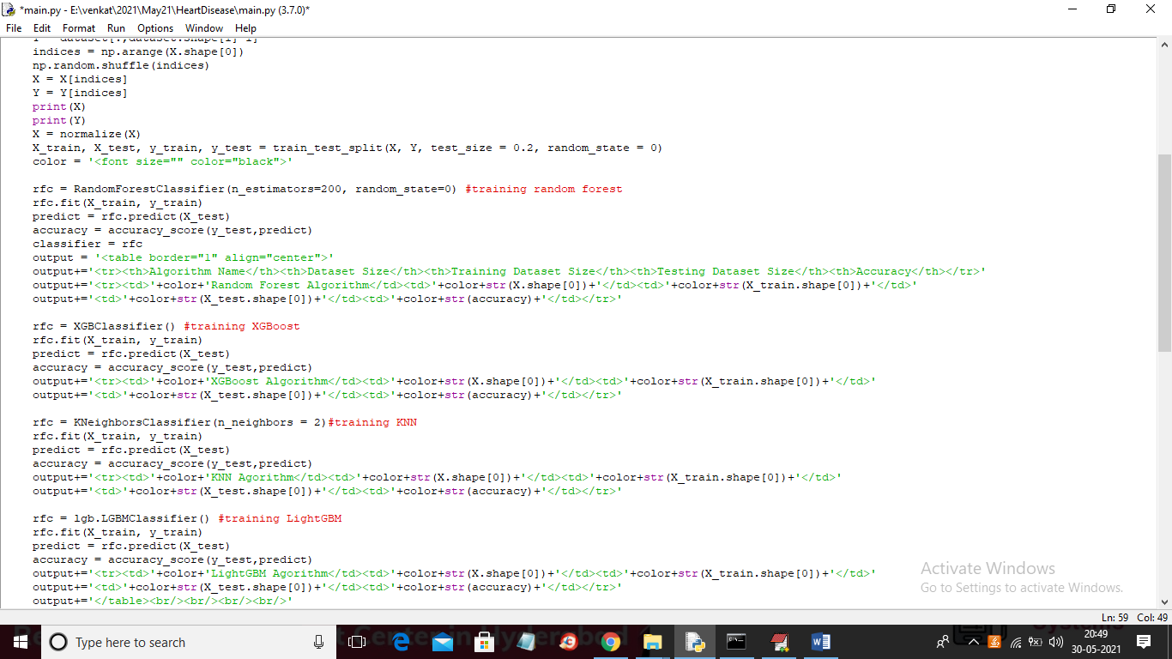

In above screen you can see we are training heart dataset with 4 algorithms and we are using below test data to predict heart disease

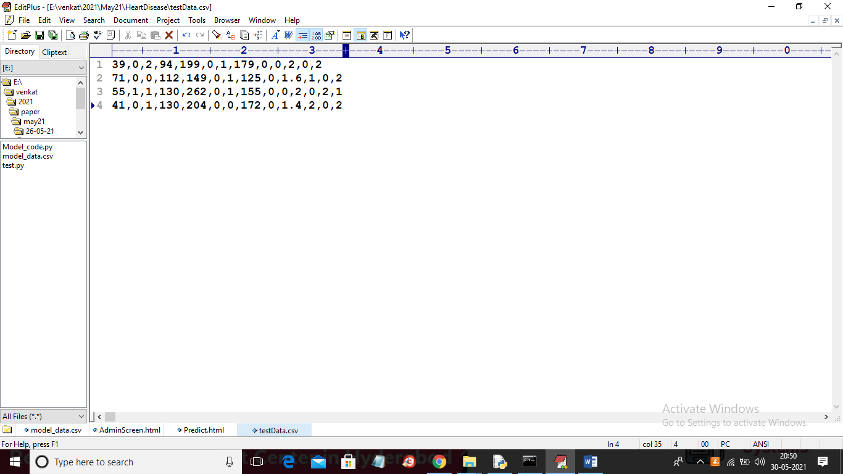

In above screen in last column we don’t have class label as 0 or 1 and this values will be predicted by machine learning algorithm.

SCREEN SHOTS

To run project double click on ‘run.bat’ file to start FLASK server

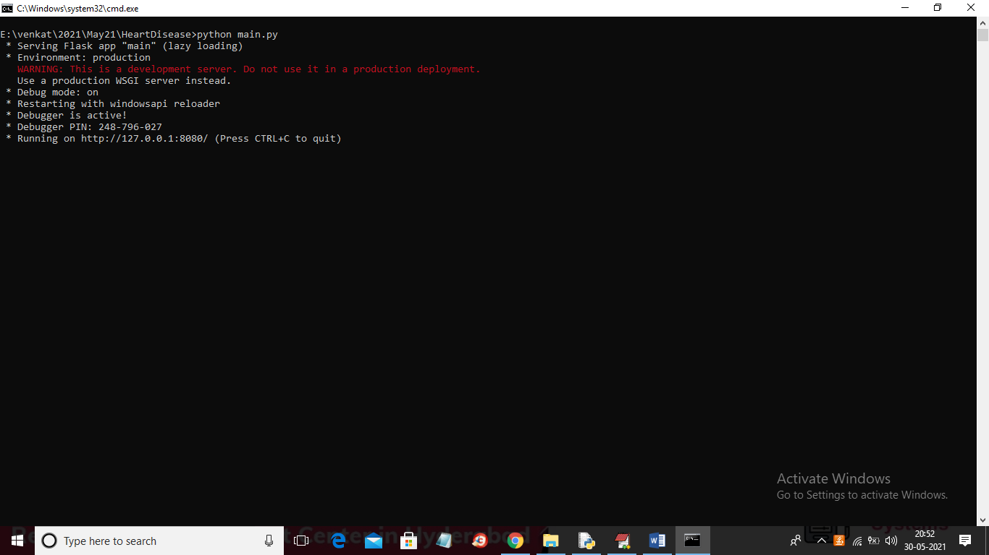

In above screen FLASK server started and now open browser and enter URL as ‘http://127.0.0.1:8080/index’ and press enter key to get below home page

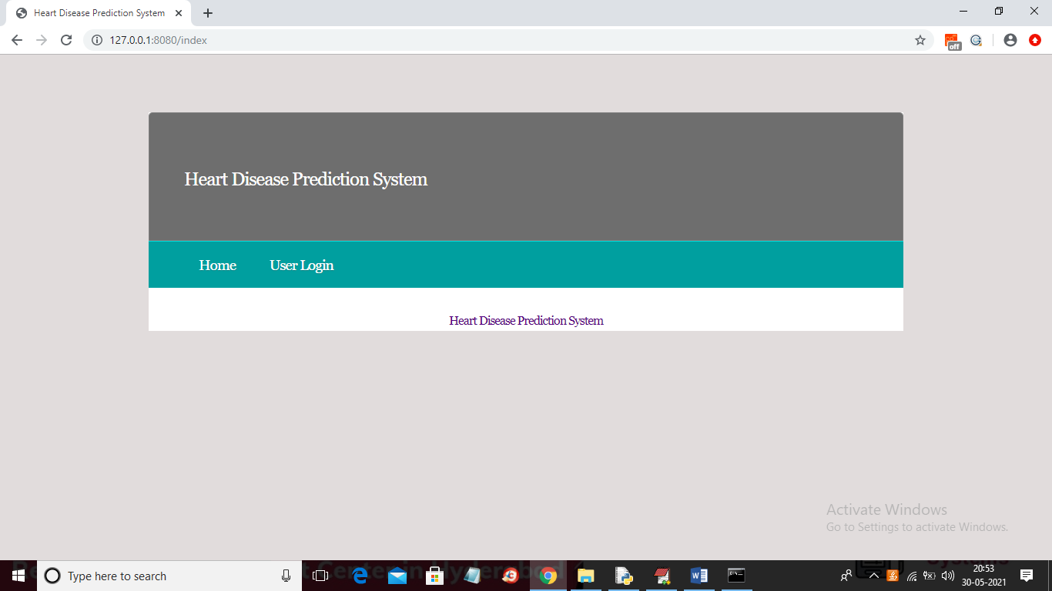

In above screen click on ‘User Login’ link to get below screen

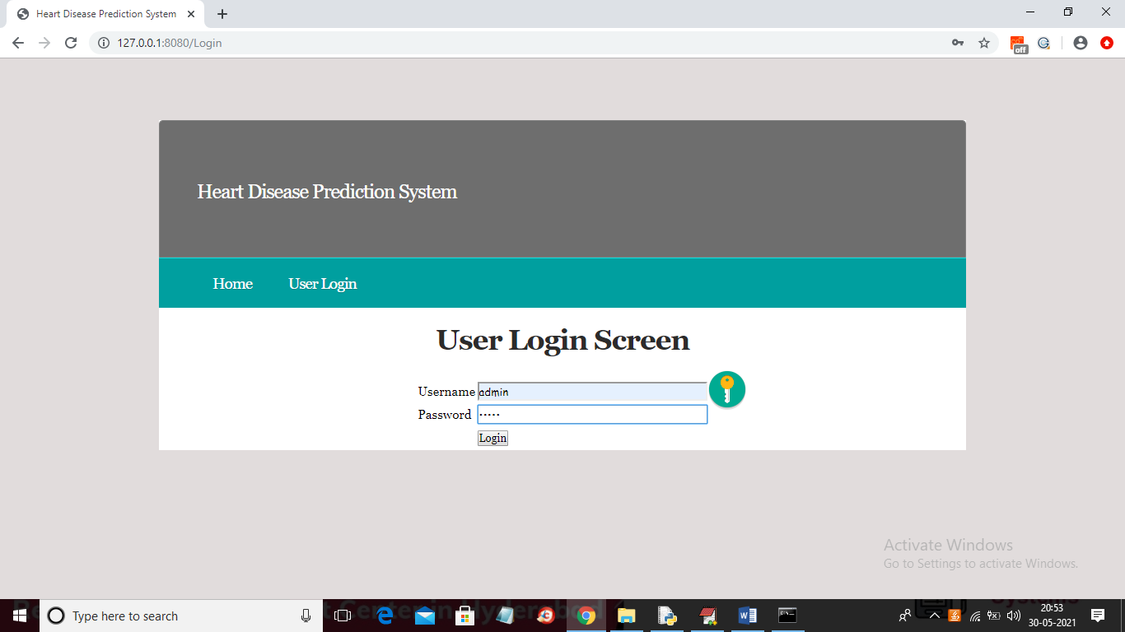

In above screen enter Username as ‘admin’ and password as ‘admin’ and then click on ‘Login’ button to get below screen

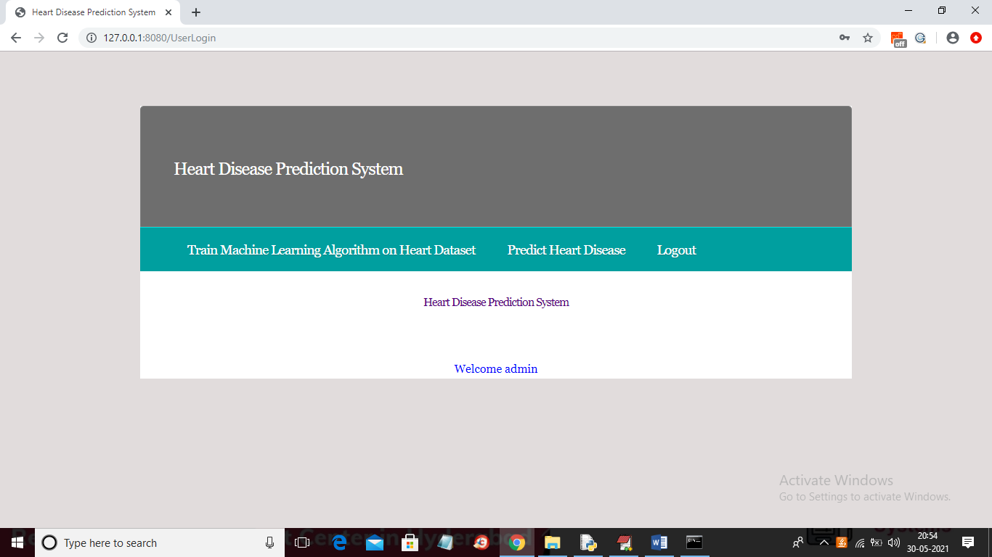

In above screen click on ‘Train Machine Learning Algorithm on Heart Dataset’ link to train all machine learning algorithms

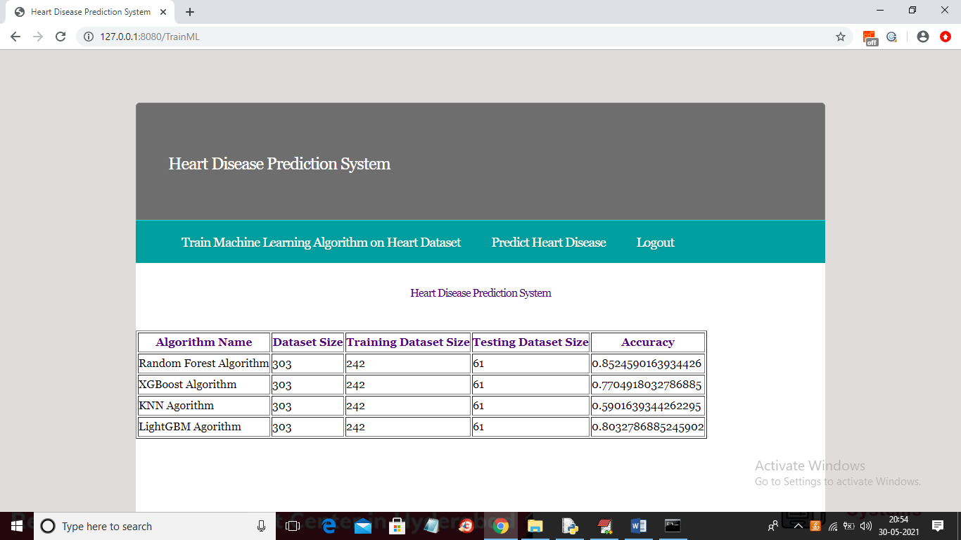

In above screen all algorithms are trained with heart dataset and we can see dataset size and the dataset size used to train and test all algorithms accuracy and in last column we can see accuracy of each algorithm. Now ML models are ready and now click on ‘Predict Heart Disease’ link to get below screen

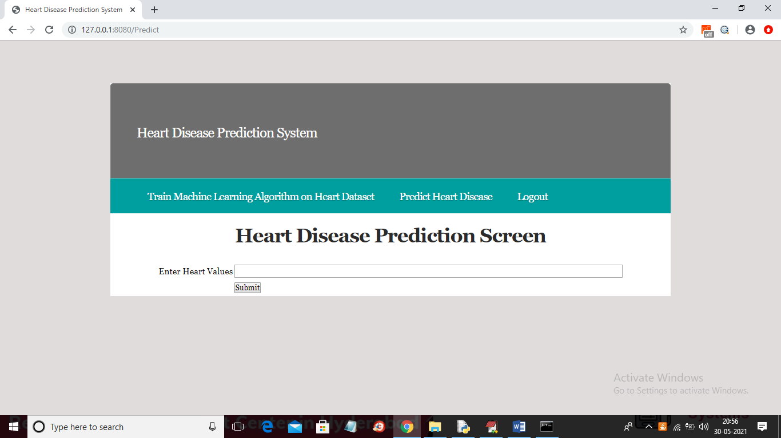

In above screen copy test data and then paste in text field

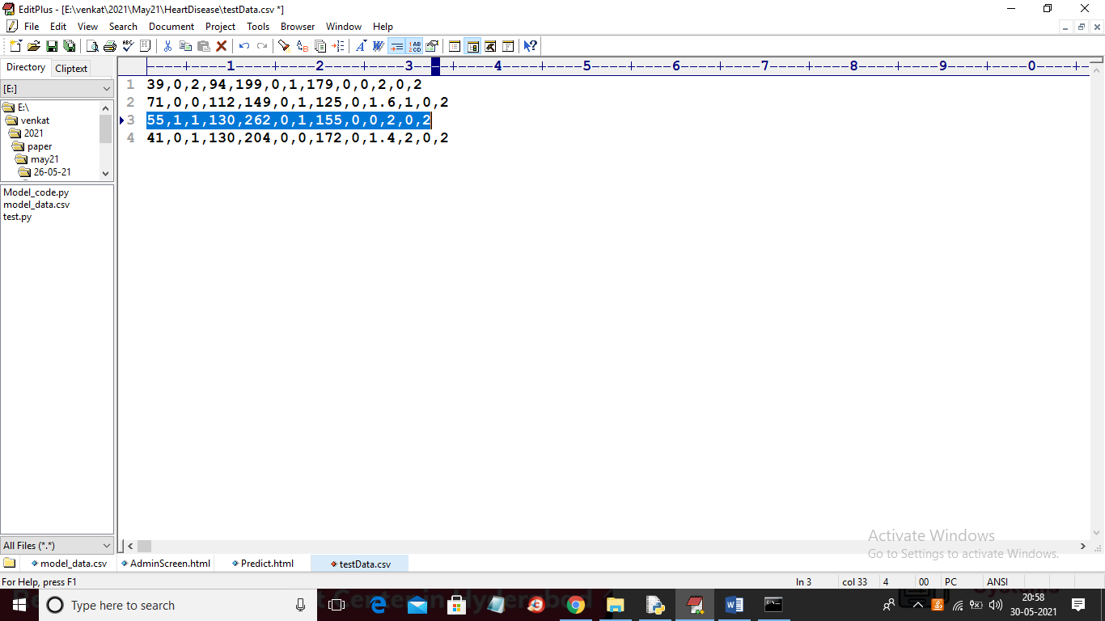

In above screen I am selecting and copy 3rd line and then paste in below screen

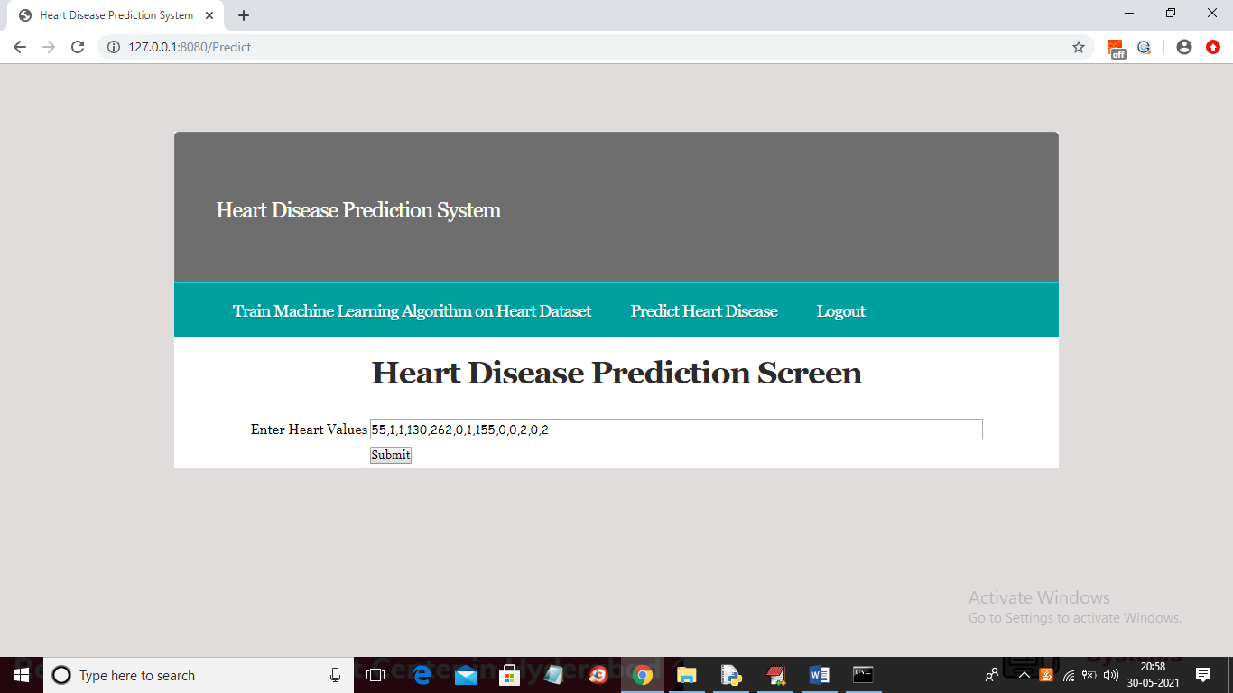

Now in above screen paste copied values and then press submit button to get below screen

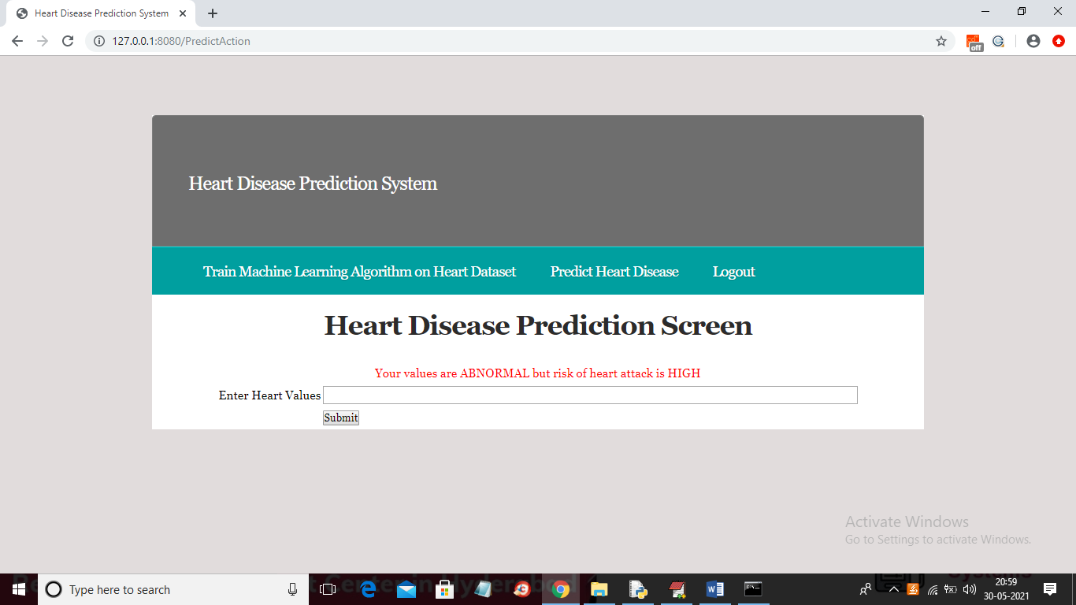

In above screen heart disease detected with HIGH risk and now try with other record

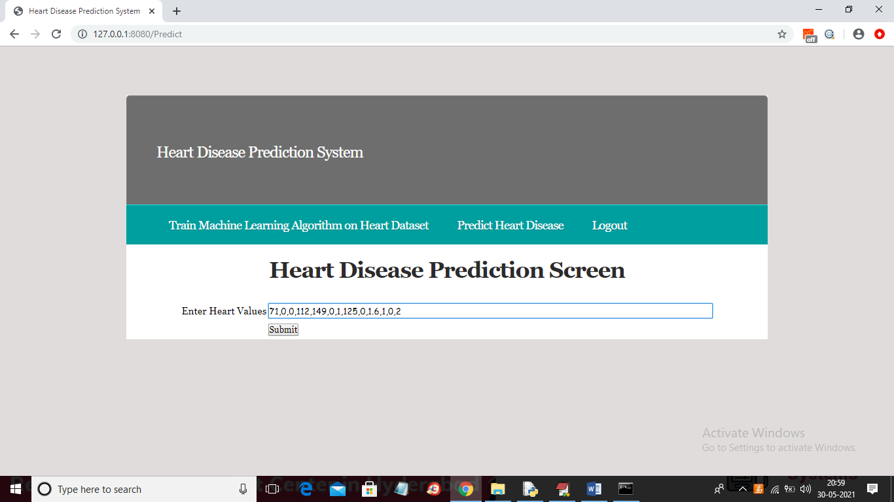

Press submit button to get below result

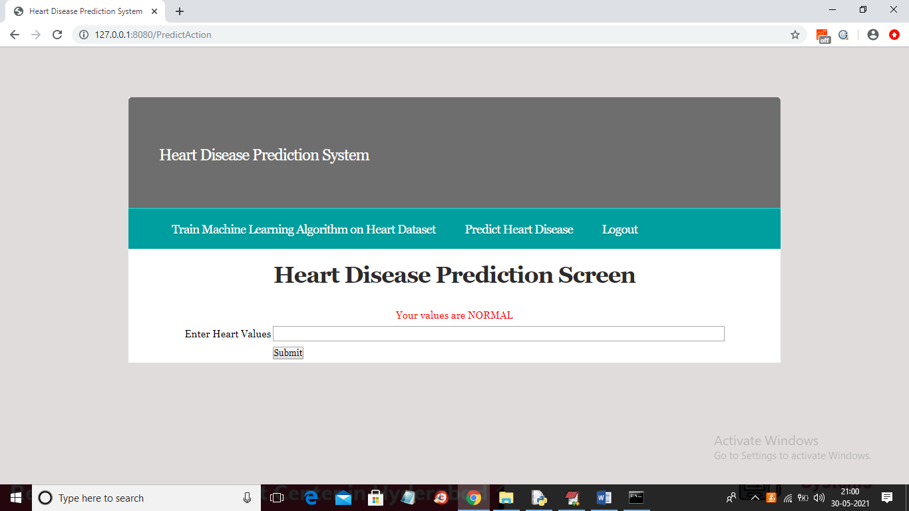

In above screen result is predicted as NORMAL. Similarly you can enter any own value to get prediction result