

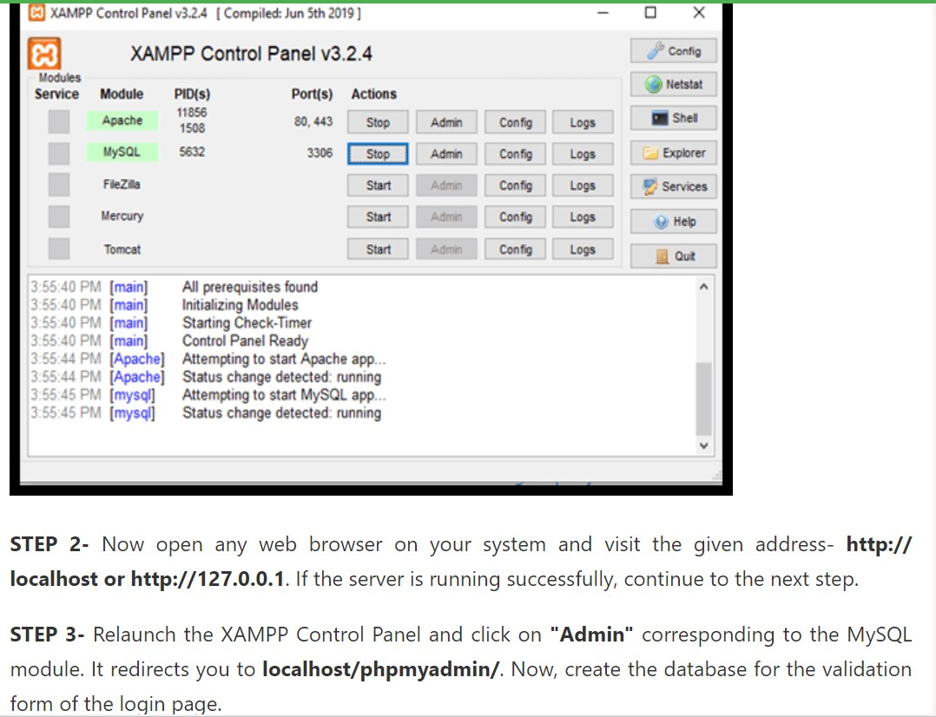

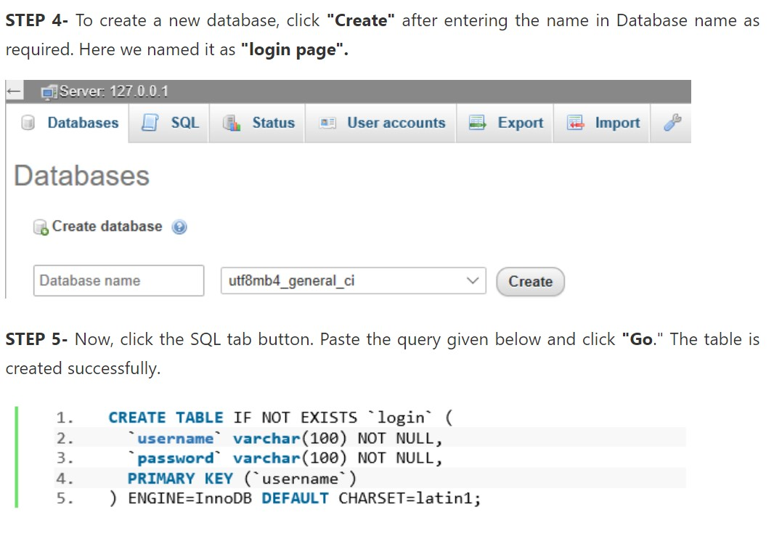

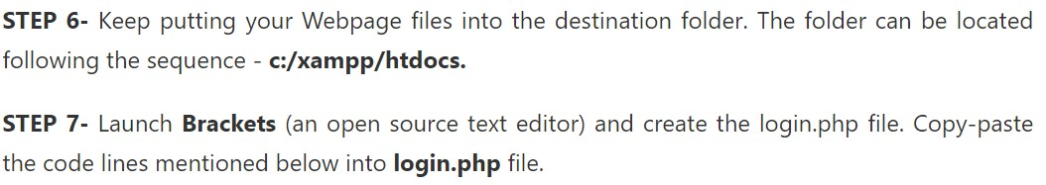

<?php

session_start();

if(!isset($_SESSION["sess_user"])){

header("location:login.php");

} else {

?>

<!doctype html>

<html>

<head>

<title>Welcome</title>

<style>

body{

margin-top: 110px;

margin-bottom: 110px;

margin-right: 160px;

margin-left: 90px;

background-color: lightcyan;

color: palevioletred;

font-family: verdana;

font-size: 100%

}

h2 {

color: darkred;

font-family: indigo;

font-size: 100%;

}

h1 {

color: darkred;

font-family: indigo;

font-size: 100%;

}

</style>

</head>

<body>

<center><h1>CREATE REGISTRATION AND LOGIN FORM USING PHP IN XAMPP</h1></center>

<h2>Welcome, <?=$_SESSION['sess_user'];?>! <a href="logout.php">Logout</a></h2>

<p>

WE DID IT. SUCCESSFULLY CREATED REGISTRATION AND LOGIN FORM USING PHP IN XAMPP

</p>

</body>

</html>

<?php

}

?>

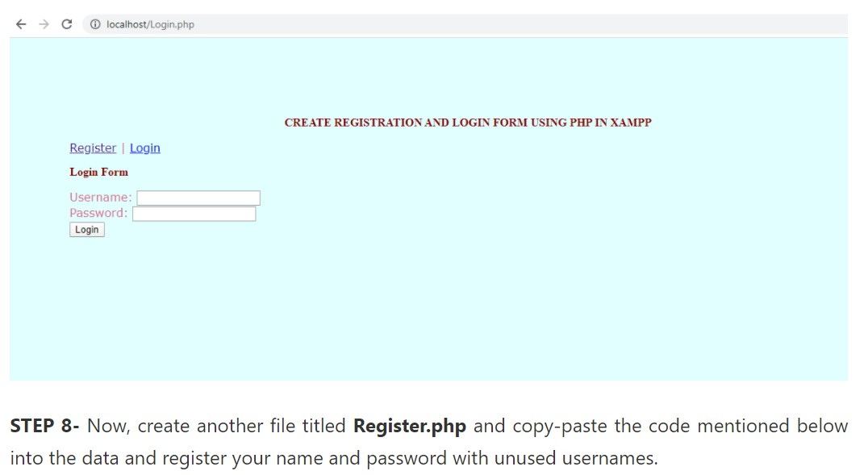

<!doctype html>

<html>

<head>

<title>Register</title>

<style>

body{

margin-top: 110px;

margin-bottom: 110px;

margin-right: 160px;

margin-left: 90px;

background-color: lightcyan;

color: palevioletred;

font-family: verdana;

font-size: 100%

}

h1 {

color: darkred;

font-family: indigo;

font-size: 100%;

}

h2 {

color: darkred;

font-family: indigo;

font-size: 100%;

}</style>

</head>

<body>

<center><h1>CREATE REGISTRATION AND LOGIN FORM USING PHP IN XAMPP</h1></center>

<p><a href="register.php">Register</a> | <a href="login.php">Login</a></p>

<center><h2>Registration Form</h2></center>

<form action="" method="POST">

<legend>

<fieldset>

Username: <input type="text" name="user"><br />

Password: <input type="password" name="pass"><br />

<input type="submit" value="Register" name="submit" />

</fieldset>

</legend>

</form>

<?php

if(isset($_POST["submit"])){

if(!empty($_POST['user']) && !empty($_POST['pass'])) {

$user=$_POST['user'];

$pass=$_POST['pass'];

$con=mysql_connect('localhost','root','') or die(mysql_error());

mysql_select_db('user_registration') or die("cannot select DB");

$query=mysql_query("SELECT * FROM login WHERE username='".$user."'");

$numrows=mysql_num_rows($query);

if($numrows==0)

{

$sql="INSERT INTO login(username,password) VALUES('$user','$pass')";

$result=mysql_query($sql);

if($result){

echo "Account Successfully Created";

} else {

echo "Failure!";

}

} else {

echo "That username already exists! Please try again with another.";

}

} else {

echo "All fields are required!";

}

}

?>

</body>

</html>

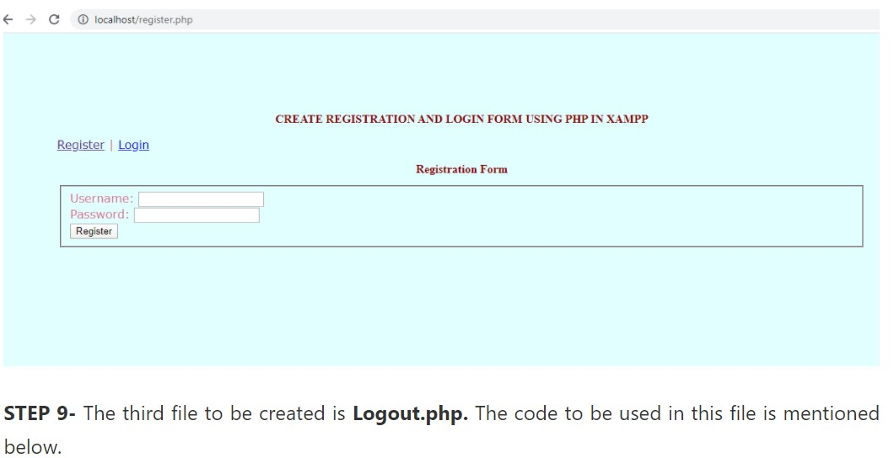

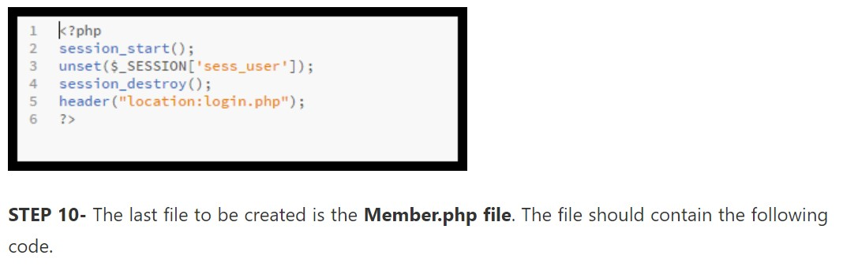

<?php

session_start();

if(!isset($_SESSION["sess_user"])){

header("location:login.php");

} else {

?>

<!doctype html>

<html>

<head>

<title>Welcome</title>

<style>

body{

margin-top: 110px;

margin-bottom: 110px;

margin-right: 160px;

margin-left: 90px;

background-color: lightcyan;

color: palevioletred;

font-family: verdana;

font-size: 100%

}

h2 {

color: darkred;

font-family: indigo;

font-size: 100%;

}

h1 {

color: darkred;

font-family: indigo;

font-size: 100%;

}

</style>

</head>

<body>

<center><h1>CREATE REGISTRATION AND LOGIN FORM USING PHP IN XAMPP</h1></center>

<h2>Welcome, <?=$_SESSION['sess_user'];?>! <a href="logout.php">logout</a></h2>

<p>

WE DID IT. SUCCESSFULLY CREATED REGISTRATION AND LOGIN FORM USING PHP IN XAMPP

</p>

</body>

</html>

<?php

}

?>

