**Exercise 3:**

**Main Task:**

**1.First, one person in the group should create a public repository using their GitHub account.**

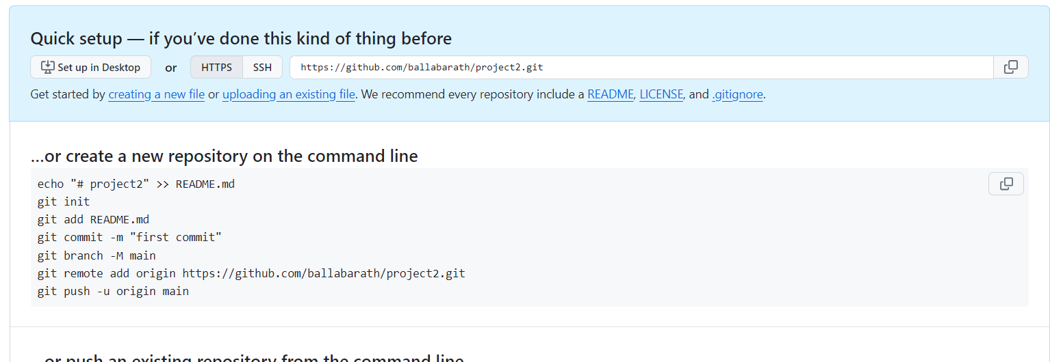

**2. This same person should then follow the instructions from GitHub to add a remote, and then push their repository. Do not forget the –u flag, as suggested by GitHub!**

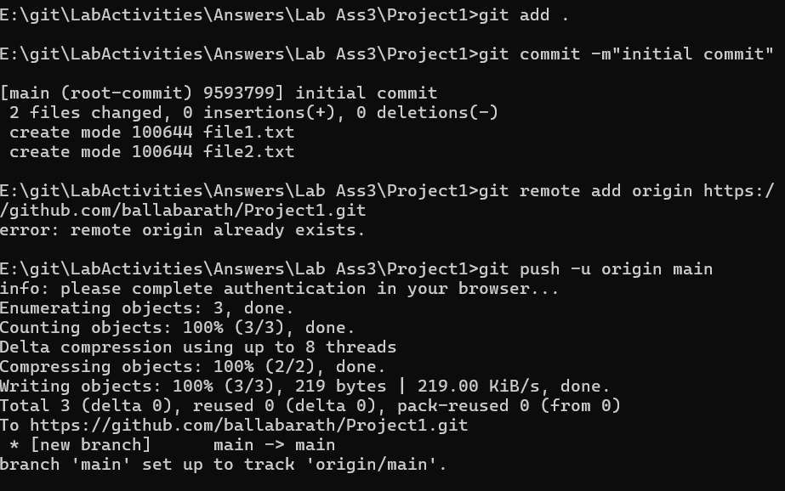

**3. All of the other members of the group should then be added as collaborators, so they can commit to the repository also.**

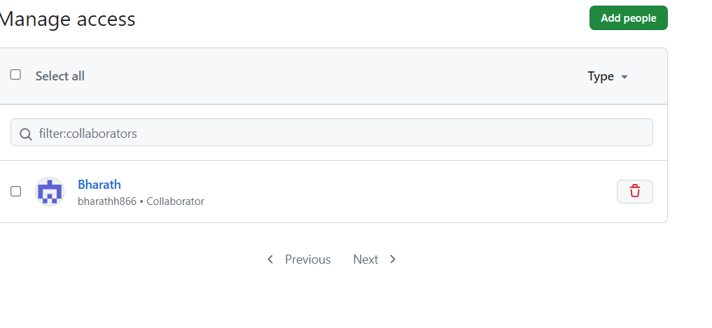

**4. Next, everyone else in the group should clone the repository from GitHub. Verify that the context of the repository is what is expected.**

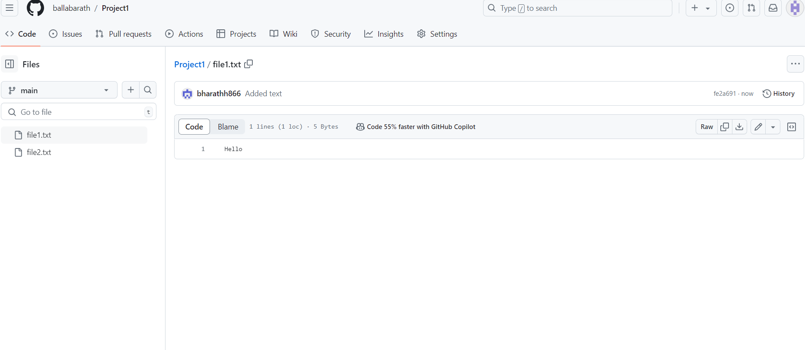

**5. One of the group members who just cloned should now make a local commit, then push it. Everyone should verify that when they pull, that commit is added to their local repository (use git log to check for it).**

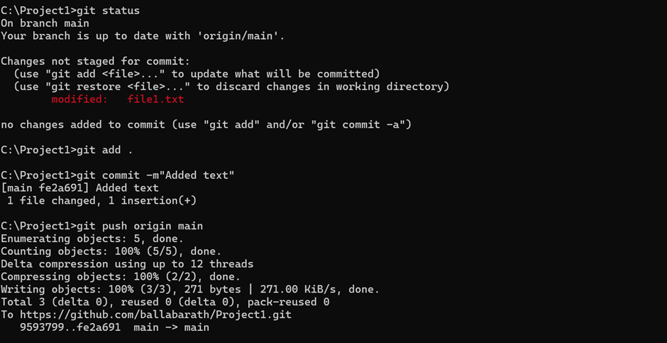

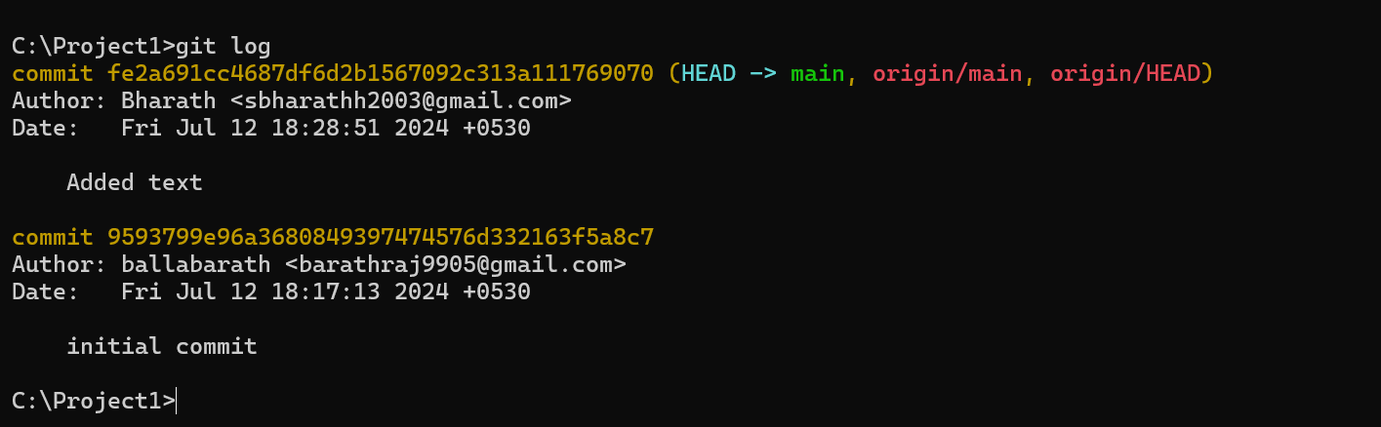

**6. Look at each other’s git log output. Notice how the SHA-1 is the same for a given commit across every copy of the repository. Why is this important?**

It is the reference for all the users working on it.

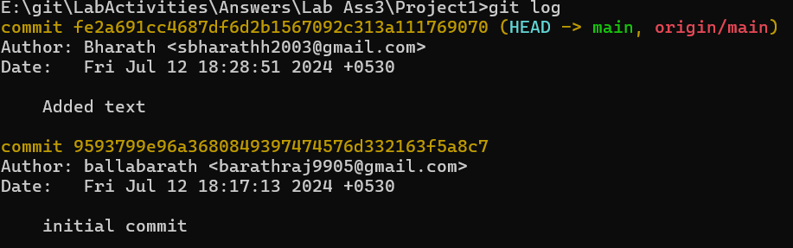

**7. Two members of the group should now make a commit locally, and race to push it. To keep things simple, be sure to edit different files. What happens to the runner-up?**

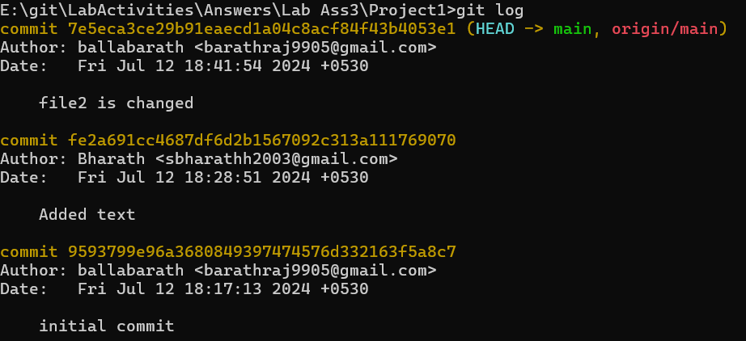**8. The runner-up should now pull. As a group, look at the output of the command. Additionally, look at the git log, and notice that there is a merge commit. You may also wish to view the DAG in gitk.**

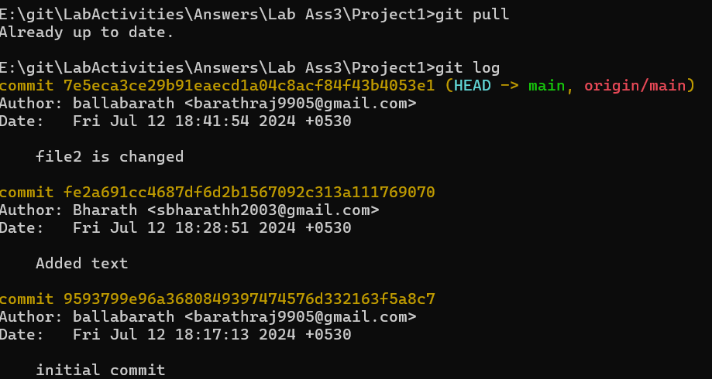

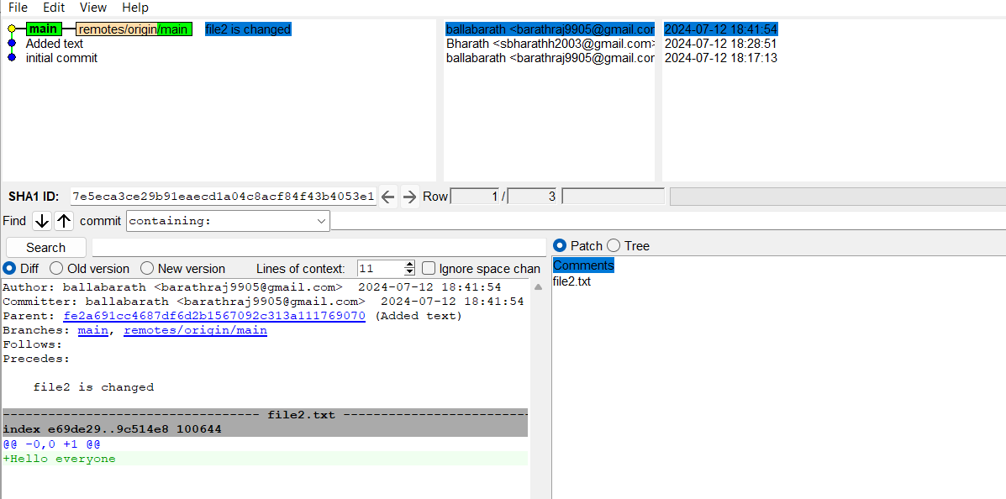

**9. Repeat the last two steps a couple of times, to practice.**

