**1.Make a commit, and make a silly typo in the commit message.**

**2.Use the --amend flag to enable you to fix the commit message.**

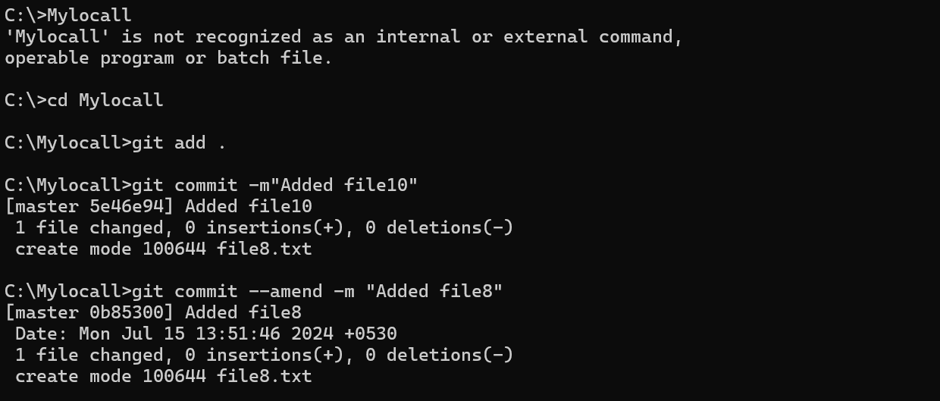

3.Look at the **log** and notice how the mistake is magically gone.

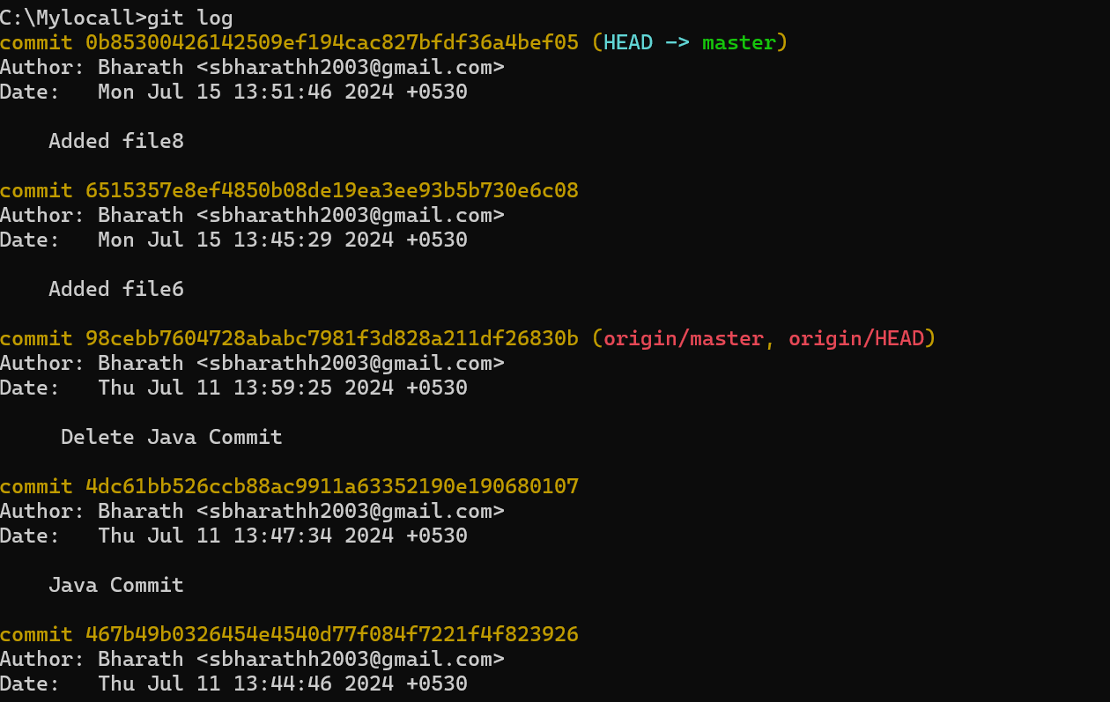

**5.Create a branch. Make a commit.**

**6.Now switch back to your master branch. Make a (non-conflicting) commit there also.**

**7.Now switch back to your branch.**

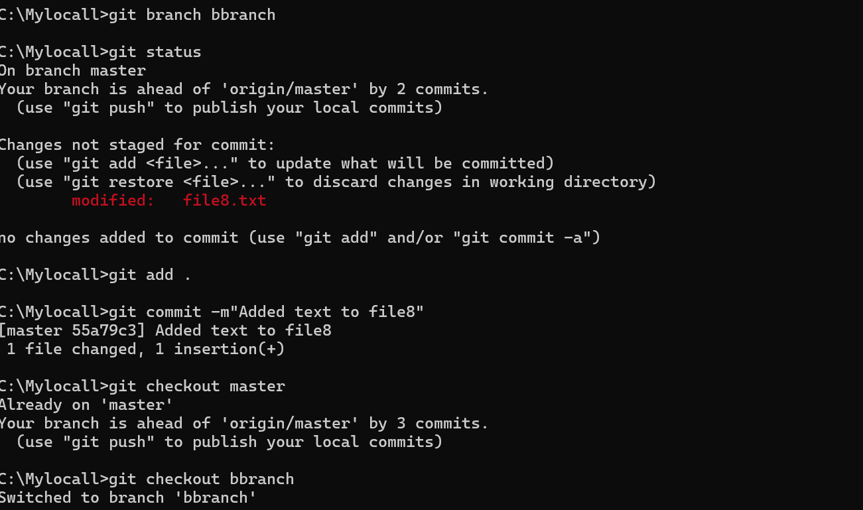

**8.Use the rebase command in your branch. Look at the DAG in gitk, and note that you have the commit from the master branch, but no merge commit.**

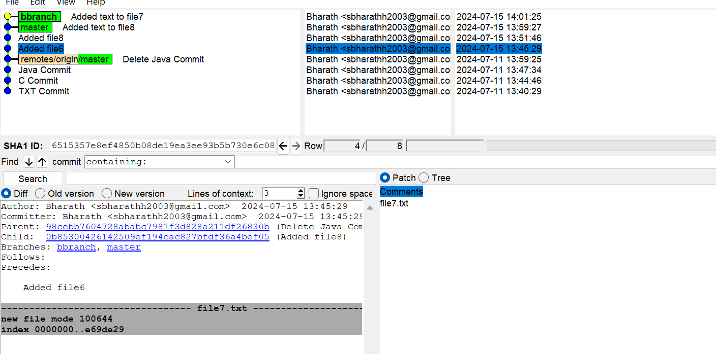

9.Make one more commit in your branch.

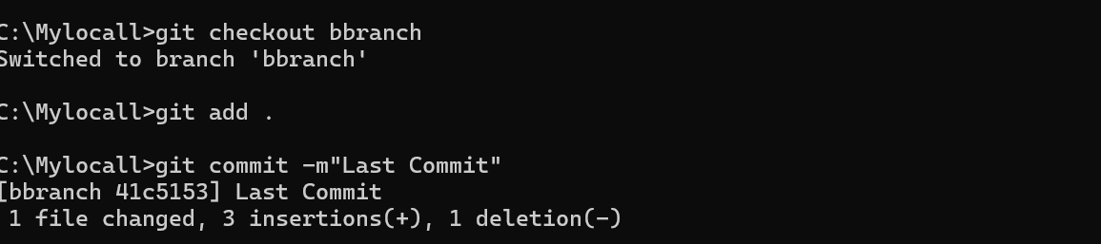

10.Return to master. Merge your branch. Notice how, thanks to the rebase, this is a fastforward merge.

