**Personal Blog on IBM Cloud Static Web Apps**

**Phase 3: Development Part 1**

Our project is designed to help individuals, bloggers, and content creators establish their online presence and share their thoughts, stories, and expertise with the world. By leveraging the power of IBM Cloud's Static Web Apps, you can ensure your blog is fast, secure, and easily accessible to your audience. This blog will serve as a platform for sharing personal experiences, knowledge, and insights with an online audience.

**1.Introduction:**

In this phase, our travel blog is deployed in the IBM Cloud’s Static Web App and generated a public URL. Deployment of web apps in IBM Cloud is the process of making your web application accessible to users by hosting it on IBM's cloud infrastructure. It involves configuring and uploading your application, setting up resources, and ensuring it runs securely and efficiently on IBM Cloud, allowing people to access it over the internet.

**2.Creation an IBM Cloud Account:**

1.Visit the IBM website

2.Click on "Sign In" or "Register": Look for the "Sign In" or "Register" button on the IBM website. Click on it to begin the registration process.

3. Fill in your information: We have got a prompt that provide your email address, and to create a password, and enter some personal information, such as your name, contact details, and company information if applicable.There we have filled our details.

4. Verification: IBM may require us to verify our email address by sending a verification link to our email inbox. Followed the instructions in the email to verify our account.

5. Accept terms and conditions: Review and accept IBM's terms and conditions and privacy policy.

6. Complete the registration: We've provided all the necessary information and verified our email, our IBM account has been created.

7. Sign in: Used our newly created IBM ID and password to sign in to our account.

**3.Create an IBM Cloud Object Storage Instance:**

* Logged in to our IBM Cloud account.
* Navigated to the IBM Cloud Dashboard.
* Click on "Create Resource" and search for "Object Storage."
* We’ve followed the prompts to create an Object Storage instance.

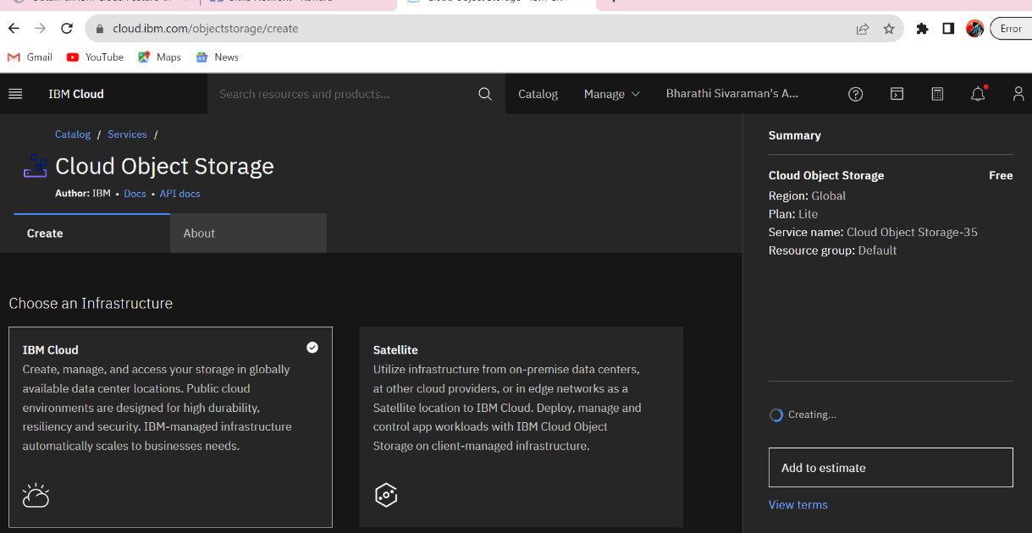

**4. Create a Bucket:**

* Inside our Object Storage instance, created a new bucket to store our website files. Buckets are similar to folders.

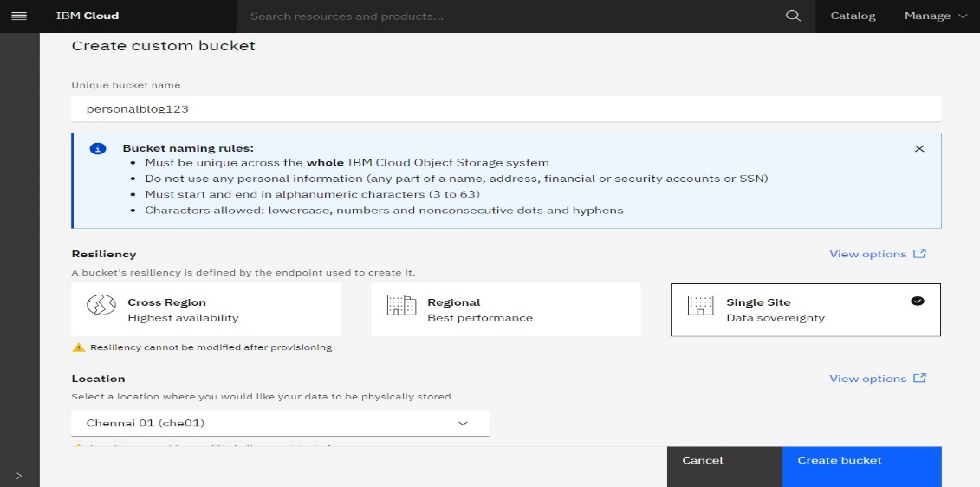

**4.Uploading the Website Files**:

* Uploaded our static website files (HTML, CSS, JavaScript, and other assets) to the bucket that we’ve created. We used the IBM Cloud Console and command-line tools for this.

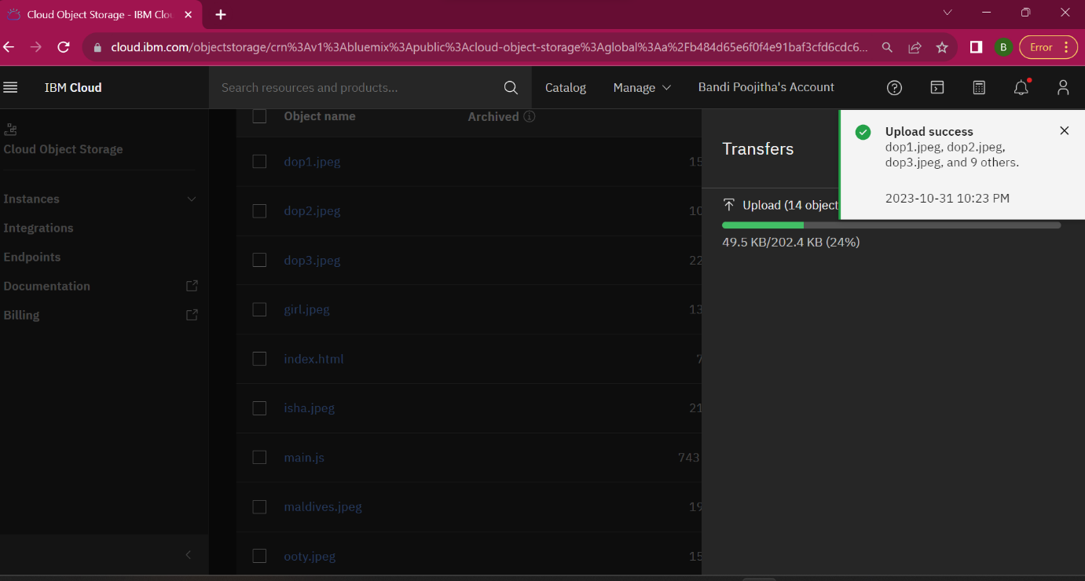

**5. Configure the Bucket for Web Hosting:**

* Go to the bucket settings.
* Under "Configuration," enable the option for "Static Website Hosting."
* Set the index document (e.g., index.html) and error document if necessary.

**6.** **Configure Bucket Access:**

* We’ve Selected the bucket that want to make public and click on its settings or properties**.**
* Edit Access Policies: In the bucket's settings, look for access policies or permissions settings. There will we see options related to access control.
* Change Access Control: Modify the access control settings to make the bucket public. We set options to make it public read-only or public read/write, depending on the specific requirements.

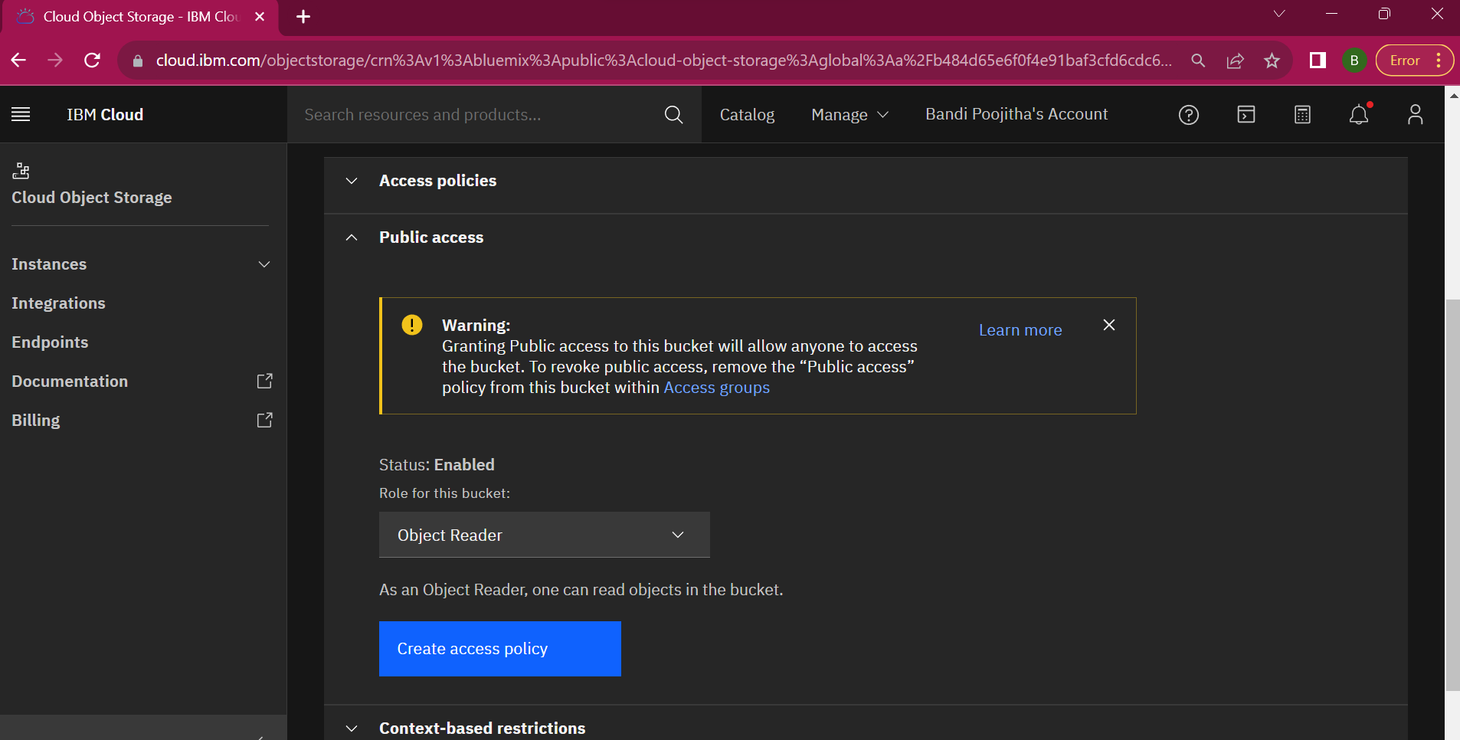

**6. Access the Website URL:**

* After enabling static website hosting, we were provided with a URL where our website is accessible.
* Remember that making a bucket public means that anyone with the URL can access the data within it.

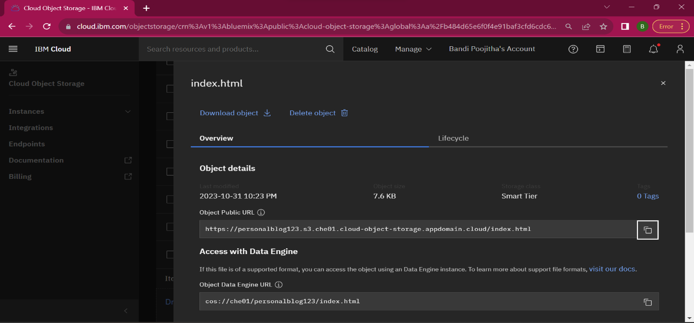

**7.Testing our Website:**

- Verified that our website is working by accessing the provided URL or your custom domain.

**8.Deployment of Static Website On IBM Cloud**

* The personal travel blog website which is deployed in the IBM cloud as it is shown in the below picture.