**Personal Blog on IBM Cloud Static Web Apps**

**Phase 5: Project Documentation & Submission**

**Problem Definition:**

The project aims to develop a captivating personal travel blog hosted on IBM Cloud Static Web Apps. The primary objective is to inspire and engage readers by sharing enriching travel experiences, insightful tips, and visually stunning photographs. The overarching goal is to motivate and guide individuals to explore the world, create unforgettable memories, and enhance their overall travel experiences. The project involves multifaceted tasks, including designing an intuitive and appealing blog structure, crafting engaging and informative content, configuring and setting up IBM Cloud Static Web Apps for seamless hosting, and establishing an efficient process for updating the blog to keep it current and engaging.

**Design Thinking:**

**Content Structure:** Develop a basic structure for the blog, including a few sample travel stories, tips, and photos, to visualize how the content will be organized.

**Content Planning:** Brainstorm ideas for organizing travel stories, tips, photos, and maps to optimize the blog's structure for a seamless and engaging user experience.

**Website Prototype:** Create a simple HTML/CSS prototype to demonstrate the website's layout, navigation, and basic interactive features.

**IBM Cloud Setup MVP(Minimal Viable Product):** Set up a minimal version of the blog on IBM Cloud to test the hosting functionality and ensure basic deployment works smoothly.

**Content Management Test:** Experiment with a chosen CMS or static site generator to understand its capabilities and how it facilitates content updates.

**User Testing:** Share the MVP with a small group of potential readers for feedback on content relevance, ease of navigation, and overall user experience.

**Technical Testing:** Conduct tests to ensure the blog functions well on various devices, browsers, and platforms, and identify any performance or compatibility issues.

**Feedback Analysis:** Analyze feedback to identify areas for improvement and iteration, including content enhancements, design tweaks, and technical adjustments.

**Website Refinement:** Make necessary design and functionality improvements based on feedback to create a polished and user-friendly blog.

**Gather Insights for Future Enhancements**

**Performance Monitoring:** Continuously monitor the blog's performance, user engagement, and feedback to gather insights for future enhancements and updates.

**User Behavior Analysis:** Analyze user behavior, preferences, and interactions to tailor content and design to meet evolving needs and preferences.

**Iterative Improvements:** Use the learnings to iteratively enhance the blog, introducing new features, improving content quality, and refining the user experience to maintain engagement and achieve the project's goals.

**Development:**

We have successfully created a static website using HTML and CSS. This website consists of four main webpages: a homepage with a navigation bar, individual pages for posts, an "about me" section, and a contact me page. At present, I've created content for three posts, which include detailed information about the places.

Expanding on the content, I've added high-resolution images, engaging text, and perhaps some multimedia elements to make each post more appealing and informative. Furthermore, to enhance user engagement and interactivity, I've included comment sections on each post, enabling visitors to leave their thoughts, questions, or feedback. This will help create a sense of community and encourage discussions around the topics presented on the website.

**Flow Path for Personal Blog:**

[Start] --> [Project Initiation]

--> [Define Blog Purpose and Audience]

--> [Choose Innovative Features]

--> [Content Management System] --> [User Authentication]

--> [Responsive Design] --> [Search Functionality]

--> [Tagging and Categorization] --> [Comment System]

--> [Social Media Integration] --> [SEO Optimization]

--> [Performance Optimization] --> [Analytics]

--> [Custom Domain] --> [HTTPS Security]

--> [Continuous Deployment] --> [Backup and Version Control]

--> [Monetization Options]

--> [Select Technologies] --> [IBM Cloud]

--> [Frontend Technologies]

--> [Backend Technologies]

--> [Database Solution]

--> [Authentication Method]

--> [Version Control System]

--> [Design User Interface]

--> [Develop Backend Logic]

--> [Implement User Authentication]

--> [Database Integration]

--> [Frontend Development]

--> [Integrate Innovative Features]

--> [Testing and Quality Assurance]

--> [Custom Domain Configuration]

--> [CI/CD Setup]

--> [Deployment to IBM Cloud]

**Technical implementations:**

**HTML Structure :**

Our HTML structure typically includes the following elements:

1. <!DOCTYPE html> : The document type declaration.
2. <html> : The root element of your HTML document.
3. <head> : Contains metadata such as the page title, link to stylesheets, and other information.

* <title> : Sets the title of your webpage.
* <link> : Links to external CSS files.

4. <body> : Contains the visible content of your webpage.

* <header>: Typically contains the site's name and navigation.
* <nav> : Navigation menu.
* <main> : The main content area.
* <article> : Represents an individual blog post.
* <section> : Used to divide content into different sections.
* <aside> : Sidebar for additional information.
* <footer> : Contains footer information like copyright and contact details.

**CSS Styling :**

Used CSS to style our website. Common CSS elements and properties include:

* Selectors (e.g., body, .header,#nav)
* Properties (e.g., color, font-size, background-color)
* Box model (e.g., margin, padding, border)
* Layout (e.g., display, position, float)
* Fonts (e.g., font-family, font-size)
* Colors (e.g., background-color, color)
* Text (e.g., text-align, line-height)
* Styling links (e.g., a:link, a:hover) - CSS Grid and Flexbox for layout design.
* Media queries for responsive design.

**Adding Content :**

* Create blog posts using HTML, typically within ‘<article>’ elements.
* Include headings (<h1>, <h2>, etc.) and paragraphs (<p).
* Add images using ‘<img>’ tags.
* Use lists (<ul>, <ol>) for items or articles.
* Format text using ‘<strong>’, ‘<em>’, and other inline elements.

**JavaScript Interactivity :**

Interacting with our personal blog, For that we used JavaScript tasks like:

* Implementing a comment system.
* Creating a search bar.
* Adding a light/dark mode switch.
* Animations or transitions.
* Handling forms for contact or comments.

**IBM Cloud Dashboard:**

* Log in to our IBM Cloud account and navigate to the IBM Cloud Dashboard.

**Create a New Static Web App:**

* In the search bar, need to search for object storage then we need to create a bucket.
* In the bucket, we need to add objects which is our website code.
* Then we need provide public access for our bucket, then we get a url of our site.

**URL of our personal blog:**

<https://personalblog123.s3.che01.cloud-object-storage.appdomain.cloud/index.html>

**User interface:**

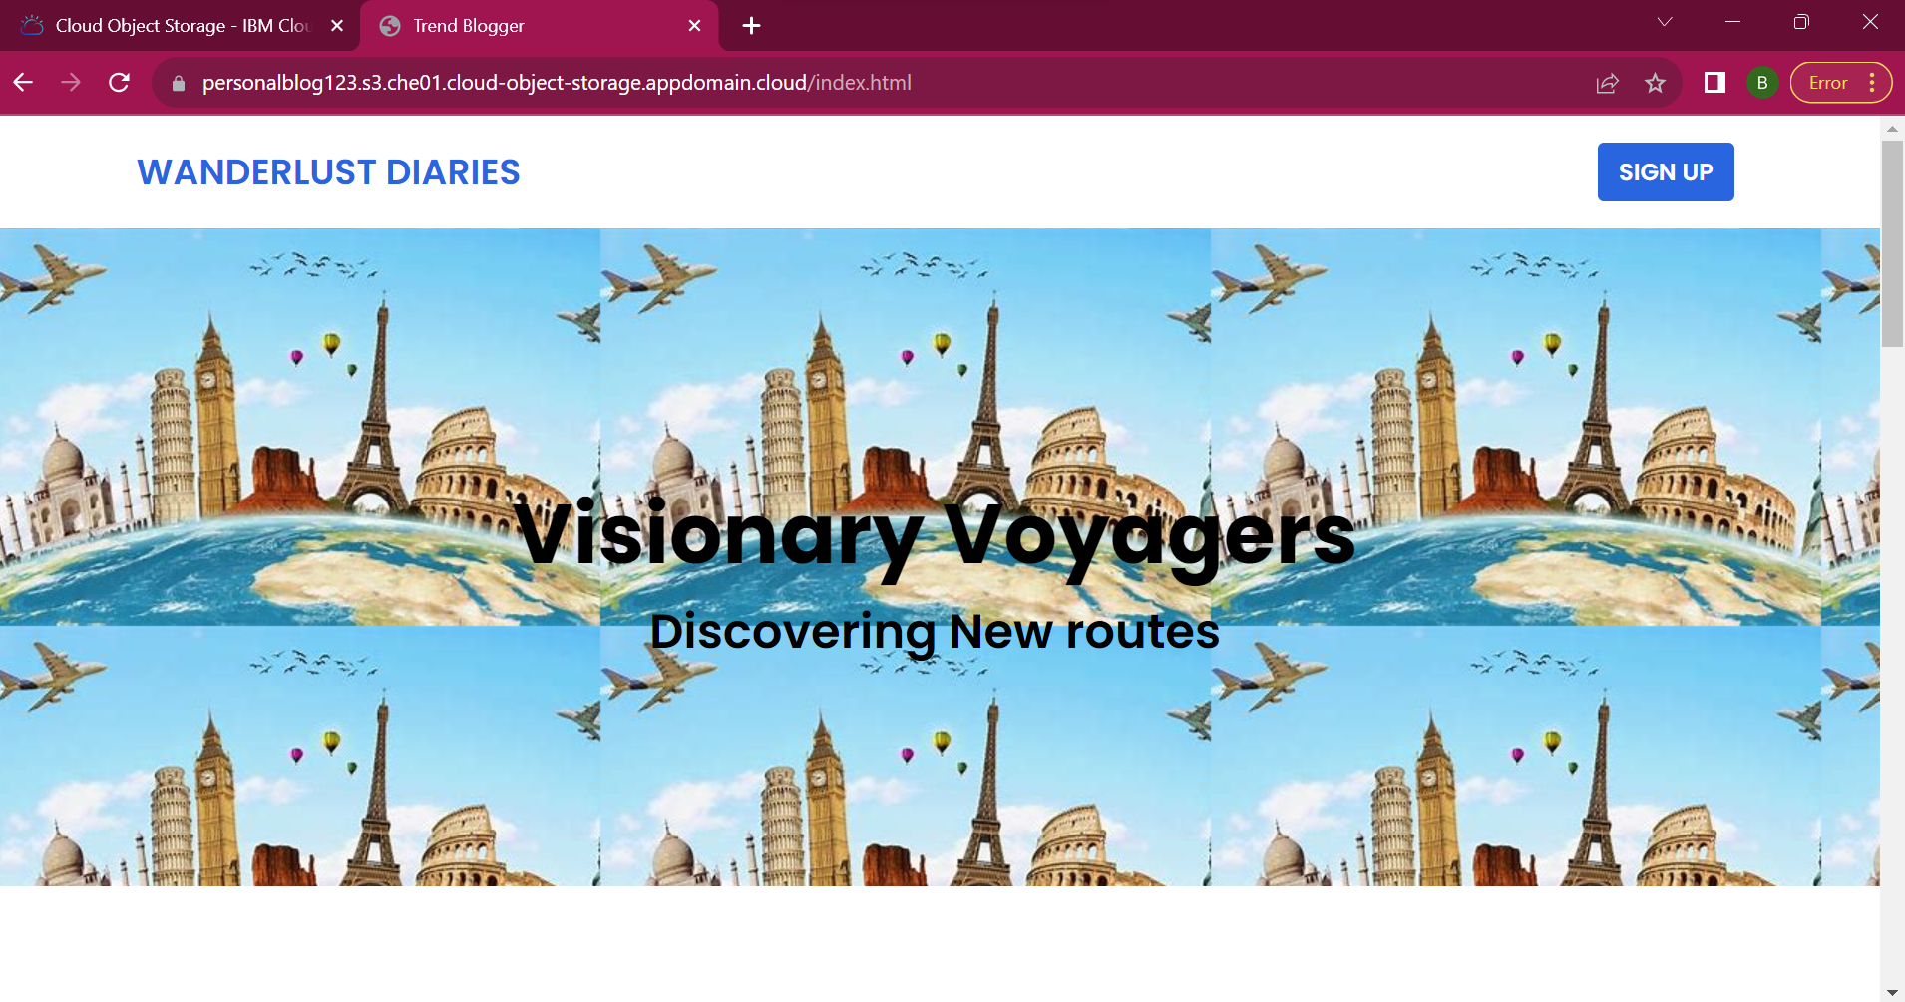

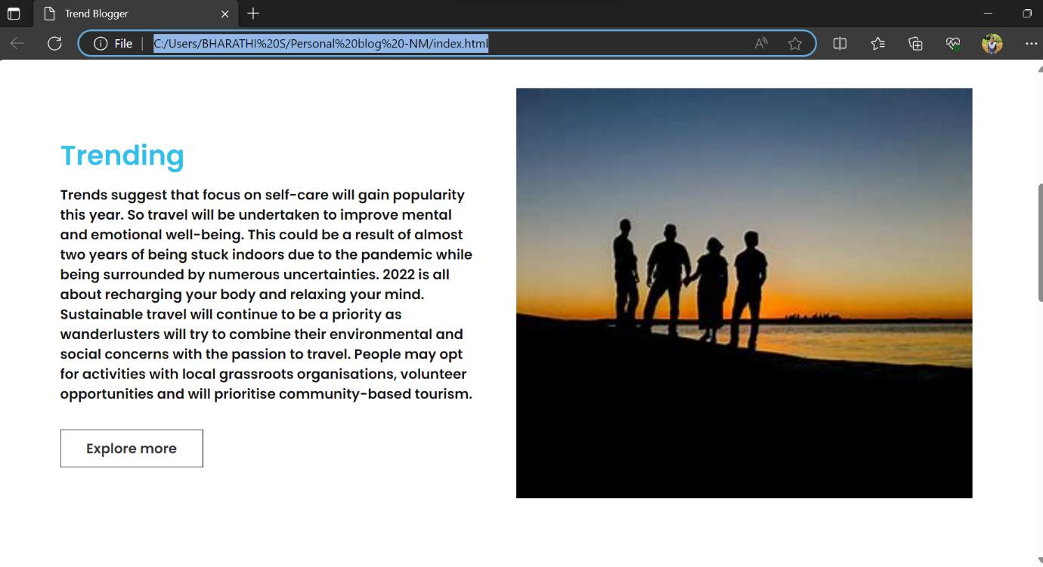

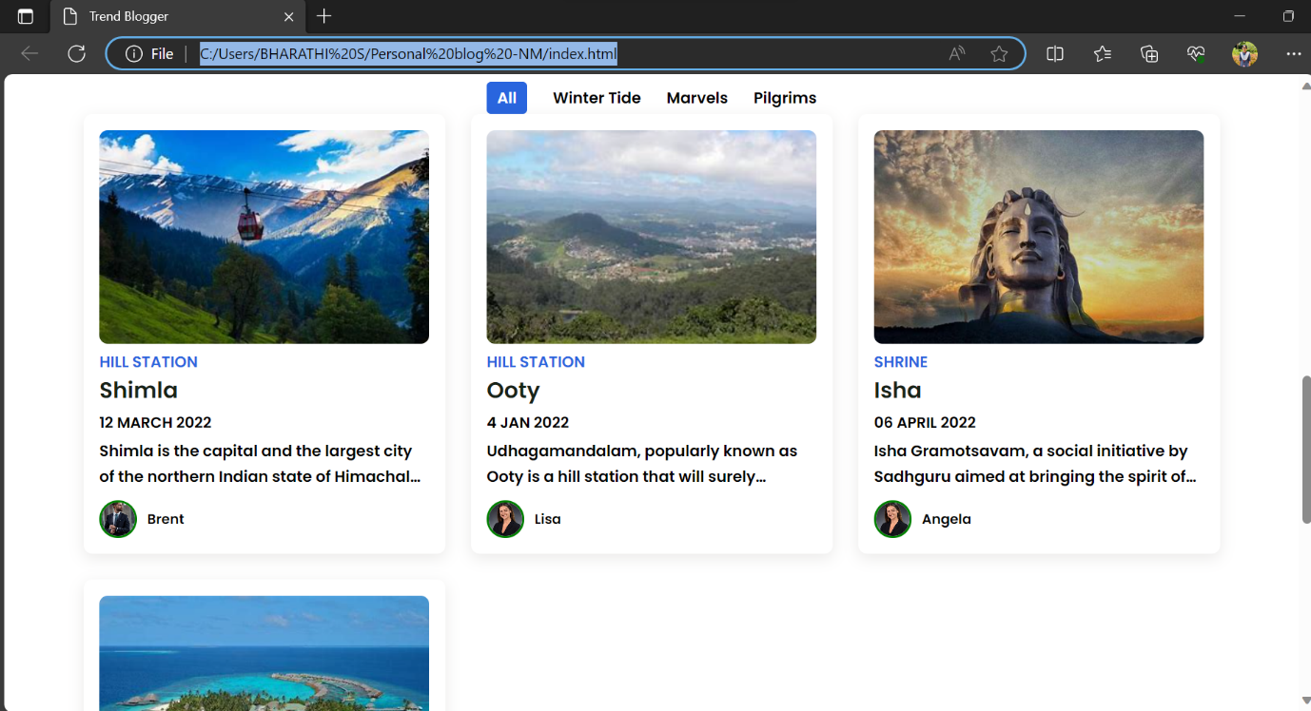

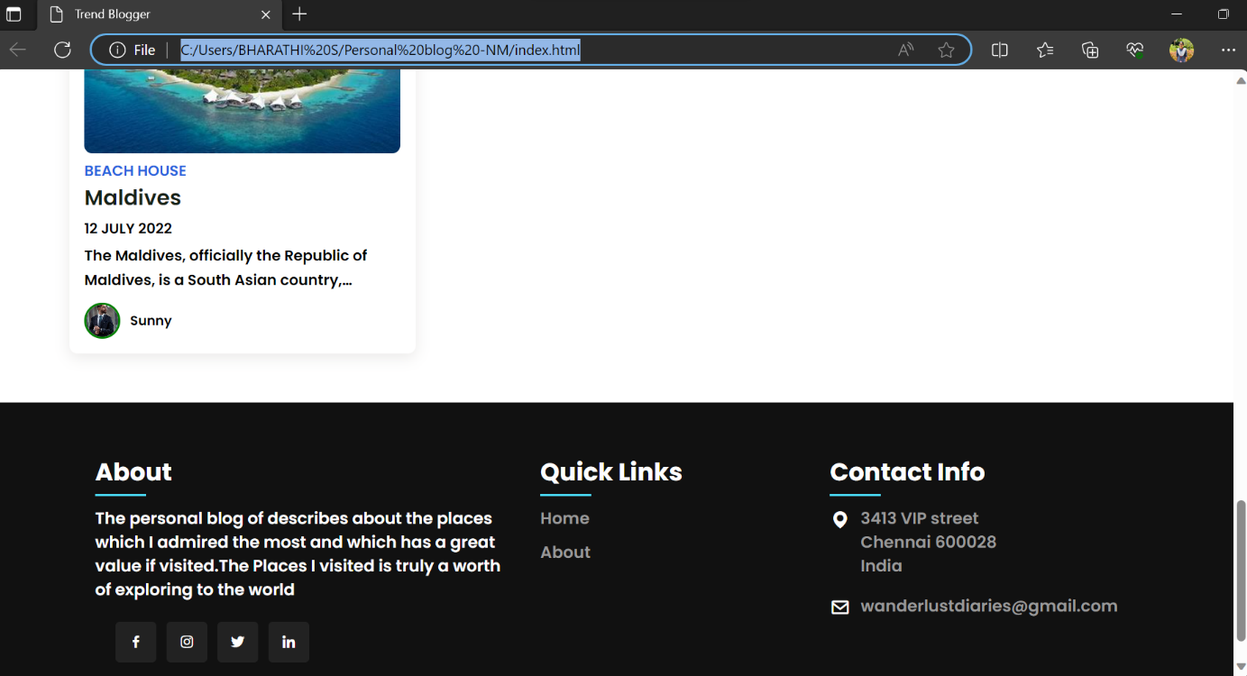

**Conclusion:**

In conclusion, Deploying a travel blog website in IBM Cloud offers a compelling solution for bloggers and content creators looking to share their adventures. With the platform's scalable infrastructure and global data centers, your travel blog can efficiently reach a diverse audience while maintaining low latency. IBM Cloud's security features help protect sensitive travel content and user data, ensuring a safe online environment. Furthermore, its cost-effective pricing and support resources allow bloggers to focus on creating captivating content, while the cloud platform takes care of reliable hosting and scalability needs.

The overarching goal goes beyond the technical aspects of website development. It's about motivating and guiding people to step out of their comfort zones, create unforgettable memories, and enhance their overall travel experiences. It's a platform for sharing the joys of travel and helping others embark on their own journeys.