Ethernet -Frame

You are given a ethernet frame.this challenge also can be solved in many ways.

1st method:-

Use a online hex packet decoder.then you copy paste the given ethernet frame in the onlone tool.

Then

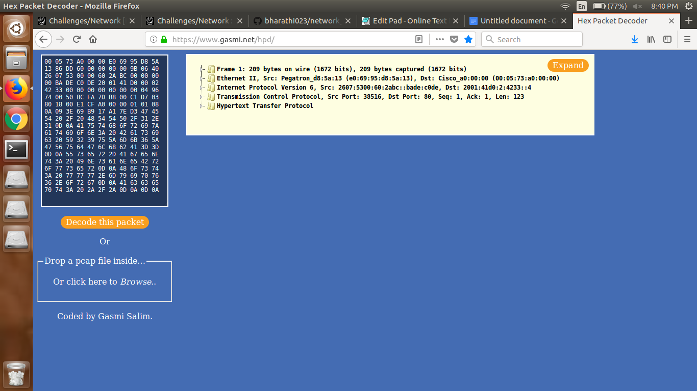

Then search for the password in the packet in the hypertext transfer protocol.

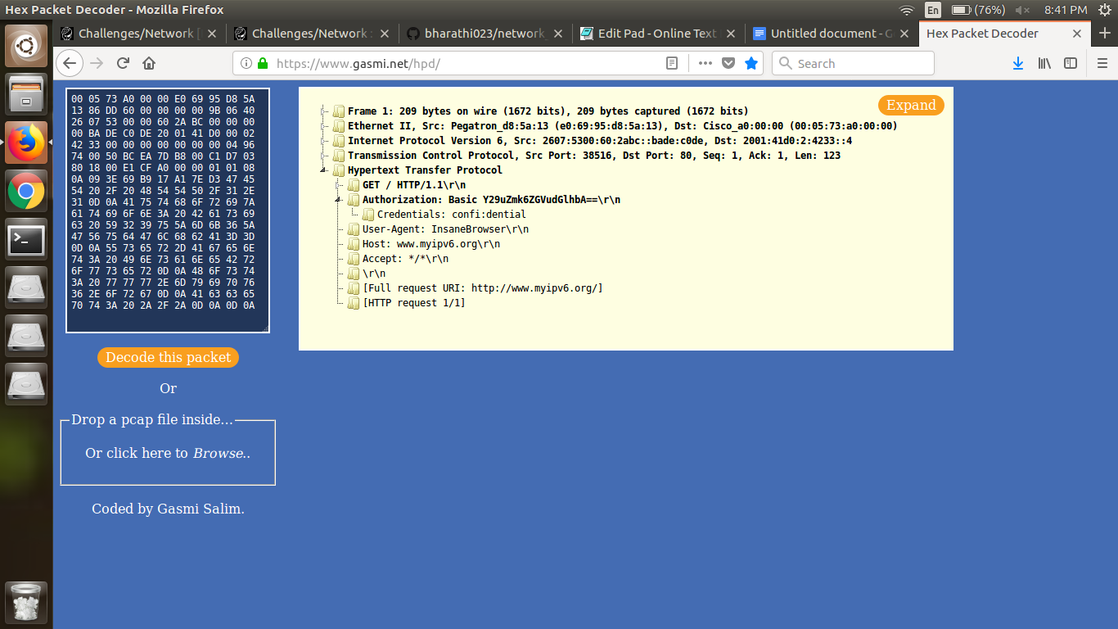

Either you can base 64 decode it whatever is after that basic.or else you can authorization there you can find username and password.

2nd way:

As it is in hex you can convert it to ascii.

Then

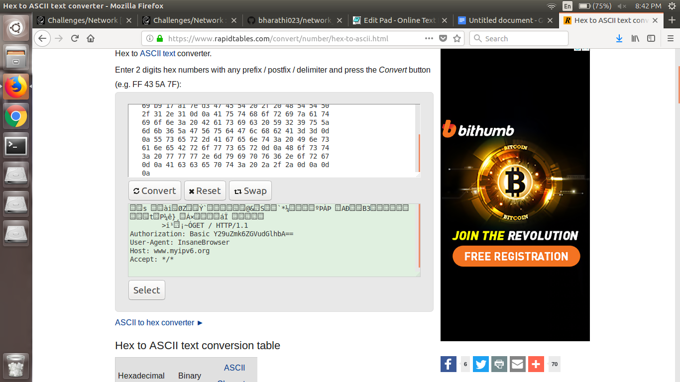

Then using online tool base64 decode it you will get the password.