CISCO-PASSWORD:-

Hashing is not encryption (it is hashing), so we do not "decrypt" MD5 hashes, since they were not "encrypted" in the first place.

Hashing is one-way, but deterministic, hash twice the same value, and you get twice the same output. So cracking a MD5 hash is about trying potential inputs (passwords) until a match is found. It works well when the input is "a password which a human user came up with" because human users are awfully unimaginative when it comes to choosing passwords.

There we are given a html page where we can find guest.hub,admin password which cannot be decrypted through md5.and there we can notice something there as 7.

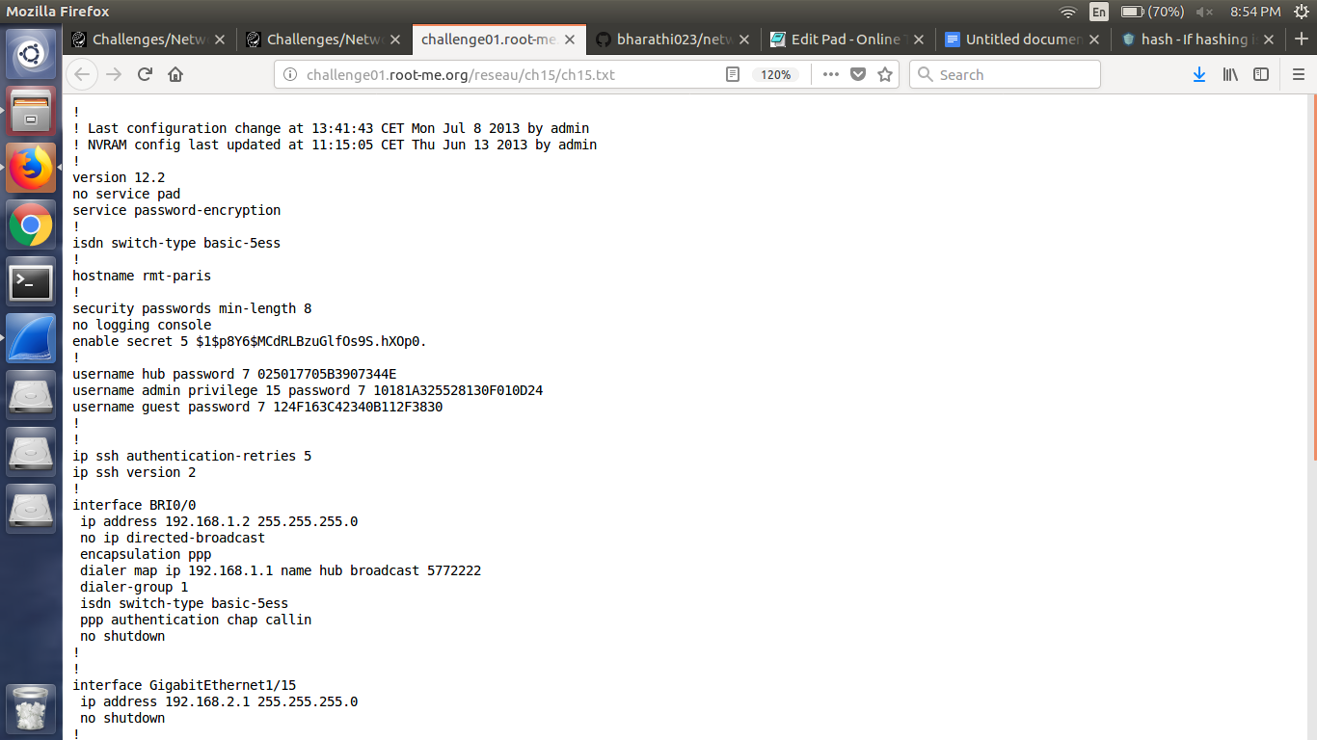

So we can guess that it might be something like a key.so google about decrypting cisco passwords.then we find.

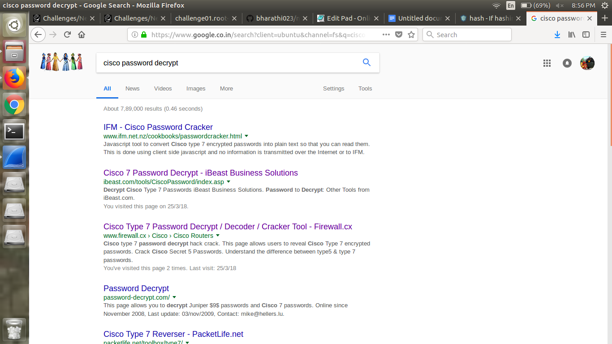

There we can find cisco 7 password decrypt there we can dercypt them.

Then we get.

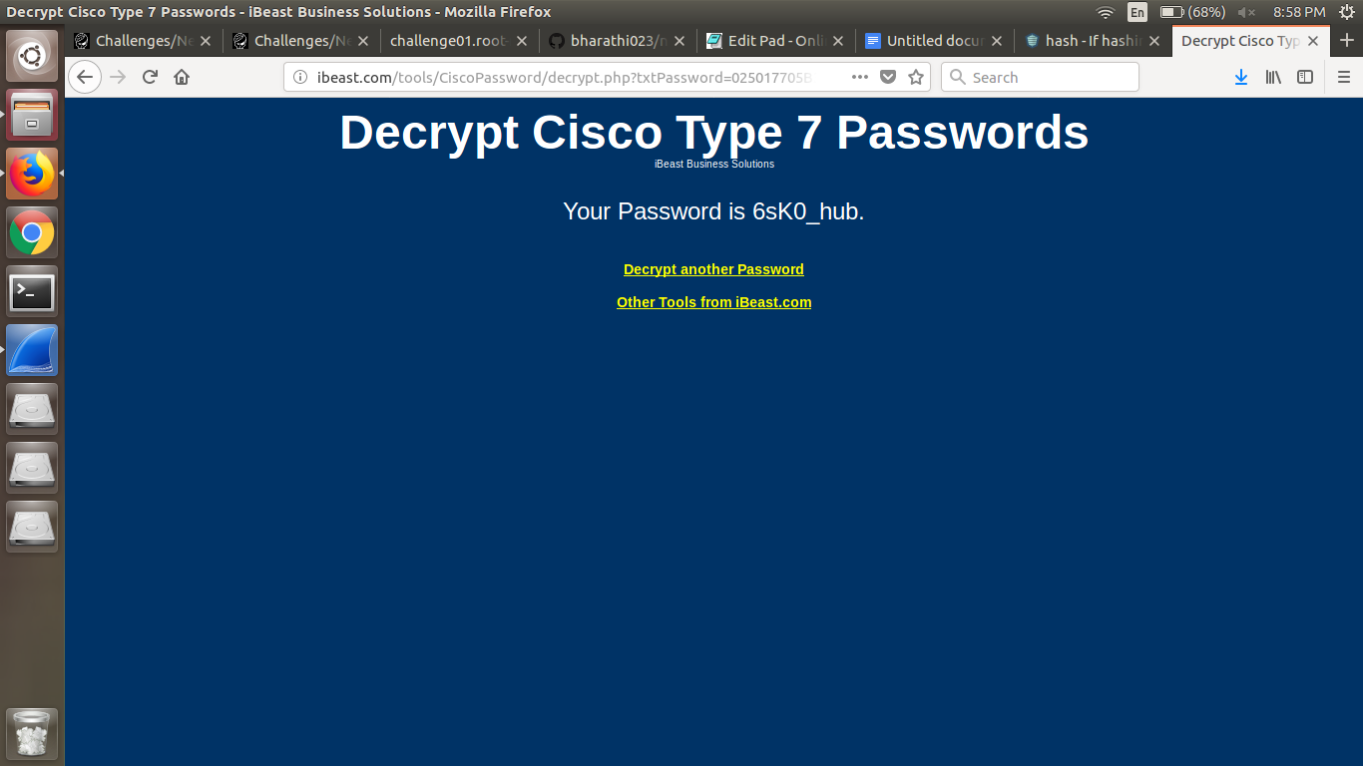

So we give admin we get 6sK0_admin. And if we give guest encrypted password we get th same thing with guest at the last. So as the give question is asking password for enable then the answer is the same pattern followed with enable at the end.