FTP Authenication:-

We need carefully watch all the packets and figure out where we can find the password.

There are many Ways to solve this problem.

1st way:-

What you need to do is just follow the tcp stream the you will find username aswell as password.Go to analyze and follow tcp stream.

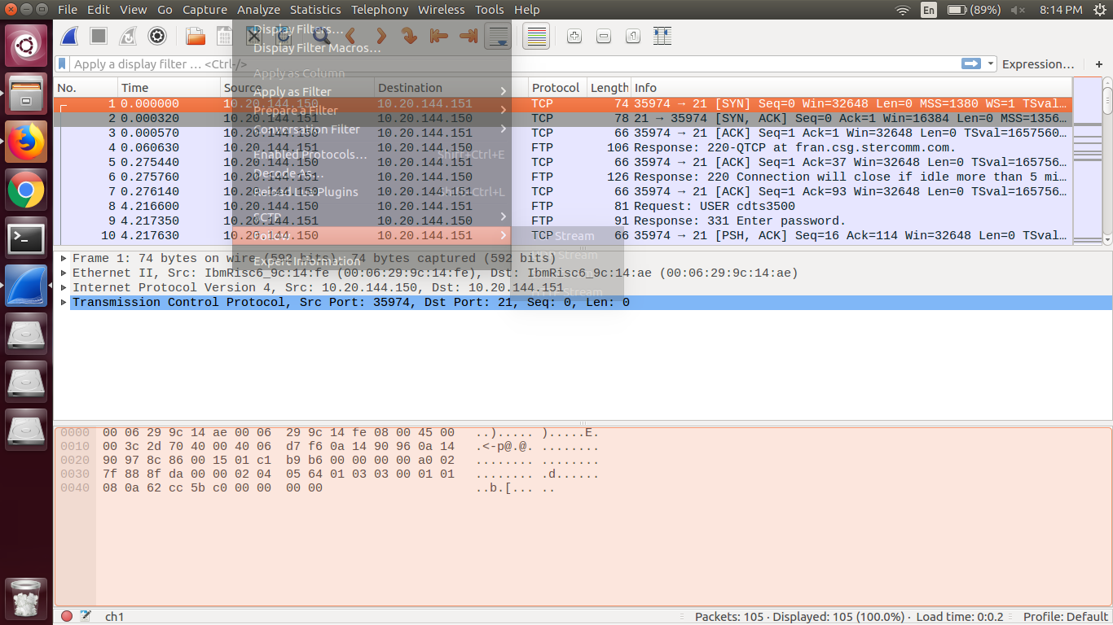

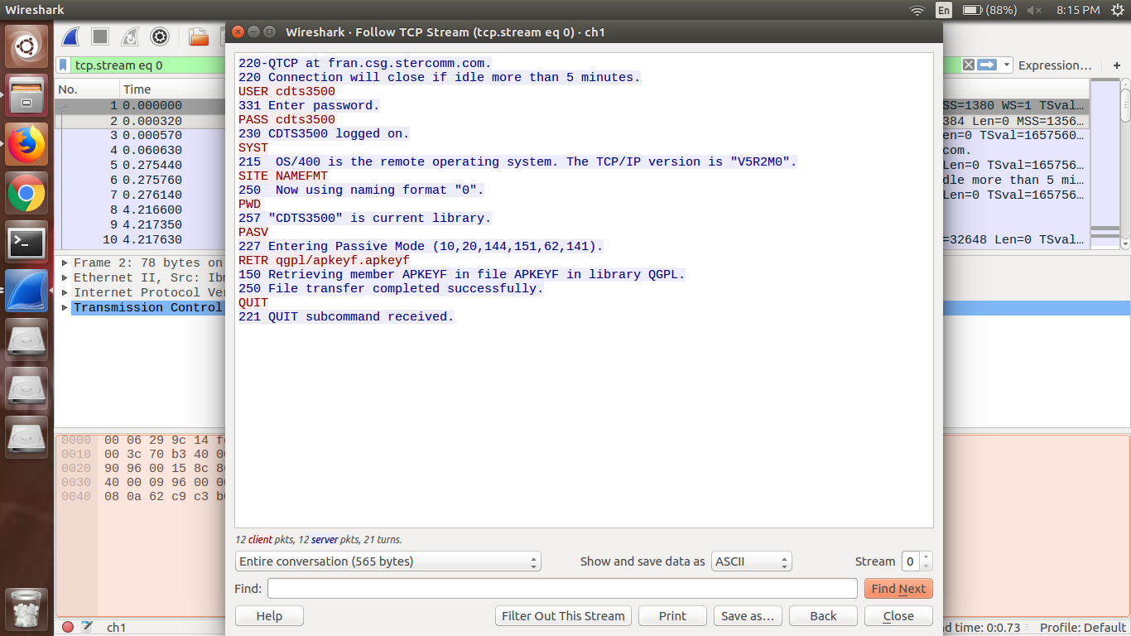

There you can find username and password.

Another way to solve this :

Just carefully watch the packets.

Then you will find.

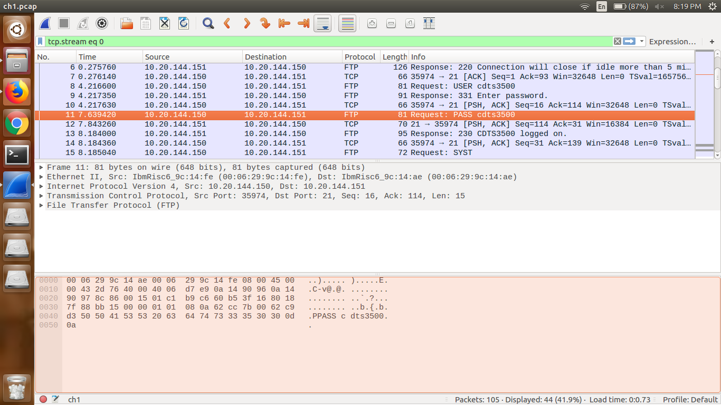

In that packet you will find the password.

There are still many ways to solve this challenge.