SIP - AUTHENICATION

We are given this html page.

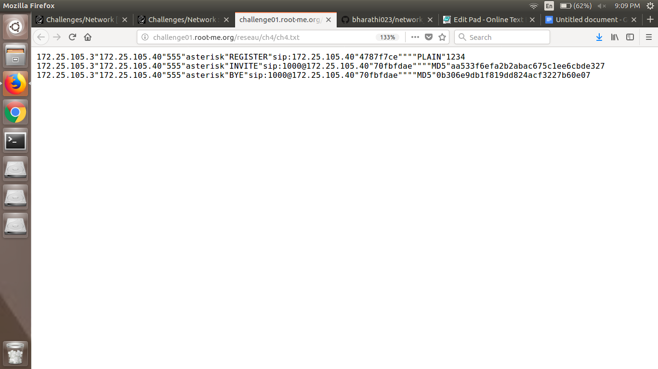

I assume that REGISTER is used to register a location from a SIP user. And then we have been found a password which is also in plain text "1234".