**ULTRASOUND MOTION SENSOR**

**Introduction**:

Used to detect the move of human or object. Suitable for indoor and outdoor burglar-proof application, vehicle burglar-proof application, ATM surveillance camera, warehouse surveillance camera, and safety warning application in dangerous site where voltage and temperature exist.

**Product Features**:

1. High sensitivity, Reliability and stability.
2. Extreme-temp Resistant, vibration-proof, etc.

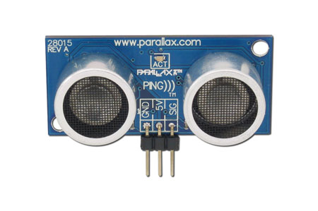

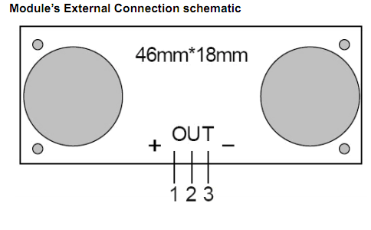

1 Power In: positive+

2 Out : signal output

3 Power In : negative –

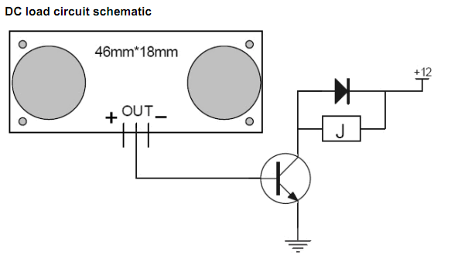

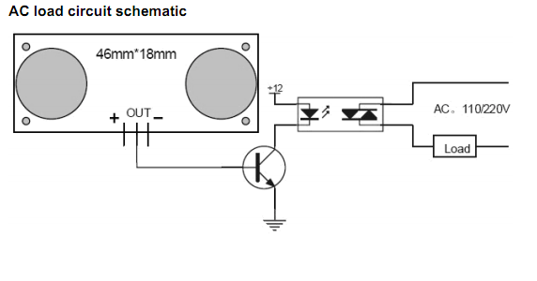

Main Technical Specifications

1. Power Voltage: DC 6-12V
2. Quiescent current: Less than 2mA
3. Output Level: Low 0V
4. Sensing Angle: no greater than 15 degree
5. Sensing Distance: 2mm-3m

**OPERATION**

The timing diagram of HC-SR04 is shown. To start measurement, Trig of SR04 must receive a pulse of high (5V) for at least 10us, this will initiate the sensor will transmit out 8 cycle of ultrasonic burst at 40kHz and wait for the reflected ultrasonic burst. When the sensor detected ultrasonic from receiver, it will set the Echo pin to high (5V) and delay for a period (width) which proportion to distance. To obtain the distance, measure the width (Ton) of Echo pin.

Time = Width of Echo pulse, in uS (micro second)

* Distance in centimeters = Time / 58
* Distance in inches = Time / 148
* Or you can utilize the speed of sound, which is 340m/s

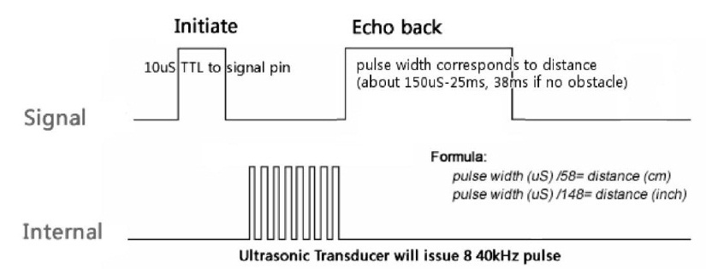

The HC-SR04 ultrasonic sensor uses sonar to determine distance to an object like bats or dolphins do. It offers excellent range accuracy and stable readings in an easy-to-use package. It operation is not affected by sunlight or black material like Sharp rangefinders are (although acoustically soft materials like cloth can be difficult to detect).  
  
Ultrasonic Ranging Module HC-SR04 provides 2cm-300cm non-contact distance sensing capabilities,Ranging accuracy up to 3mm; module comprises an ultrasonic transmitter, a receiver and a control circuit.

Module's main technical parameters:

1. Working Voltage : 5V(DC)  
2. Static current: Less than 2mA.  
3. Output signal: Electric frequency signal, high level 5V, low level 0V.  
4. Sensor angle: Not more than 15 degrees.  
5. Detection distance: 2cm-450cm.  
6. High precision: Up to 0.3cm  
7. Input trigger signal: 10us TTL impulse  
8. Echo signal : output TTL PWL signal

Mode of connection:  
1.VCC  
2.Trig(T)  
3.Echo(R)  
4.GND

Method of use:  
Supply module with 5V, the output will be 5V while obstacle in range, or 0V if not.The out pin of this module is used as a switching output when anti-theft module, and without the feet when ranging modules.  
Note: the module should be inserted in the circuit before power is ON, which avoids producing high level of misoperation;if not, then power again.

Module Working Principle:  
1.Adopt IO trigger through supplying at least 10us sequence of high level signal.  
2.The module automatically send eight 40khz square wave and automatically detect whether receive the returning pulse signal.  
3.If there is signals returning, through outputting high level and the time of high level continuing is the time of that from the ultrasonic transmitting to receiving. Test distance = (high level time * sound velocity (340M/S) / 2.  
  
Note : This module is not suitable to connect with electric power, if you need to connect this module with electronic power,then let the GND terminal of this module to be connected first,otherwise, it will affect the normal work of the module.