2.4. LM35
The LM35 series are precision integrated-circuit temperature sensors, whose output voltage is linearly proportional to the Celsius (Centigrade) temperature. The LM35 thus has an advantage over linear temperature sensors calibrated in Kelvin, as the user is not required to subtract a large constant voltage from its output to obtain convenient Centigrade scaling. The LM35 does not require any external calibration or trimming to provide typical accuracies of ±1⁄4˚C at room temperature and ±3⁄4˚C over a full −55 to +150˚C temperature range. Low cost is assured by trimming and calibration at the wafer level. The LM35’s low output impedance, linear output, and precise inherent calibration make interfacing to readout or control circuitry especially easy. It can be used with single power supplies, or with plus and minus supplies. As it draws only 60 µA from its supply, it has very low self-heating, less than 0.1˚C in still air. The LM35 is rated to operate over a −55˚ to +150˚C temperature range.
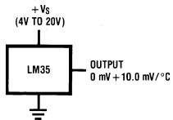
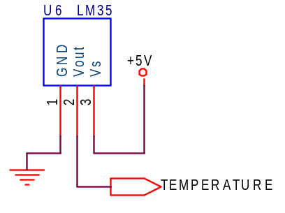
The LM35 can be applied easily in the same way as other integrated-circuit temperature sensors. It can be glued or cemented to a surface and its temperature will be within about 0.01˚C of the surface temperature.
This presumes that the ambient air temperature is almost the same as the surface temperature; if the air temperature were much higher or lower than the surface temperature, the actual temperature of the LM35 die would be at an intermediate temperature between the surface temperature and the air temperature. This is especially true for the TO-92 plastic package, where the copper leads are the principal thermal path to carry heat into the device, so its temperature might be closer to the air temperature than to the surface temperature.

