NAME : M.BHARATHI

COLLEGE CODE : 4101

DEPARTMENT : CSE

DATA ANALYTICS WITH COGNOS

PROJECT TITLE : AIR QUALITY ANALYSIS.

PHASE 3 : Development part 1

AIM: To begin building project by loading and preprocessing the dataset. To begin the analysis by loading and preprocessing the air quality dataset.

Step 1:

Download the dataset from the given below link as a CSV file:

***Link:*** [***https://tn.data.gov.in/resource/location-wise- daily-ambient-air-quality-tamil-nadu-year-2014***](https://tn.data.gov.in/resource/location-wise-%20daily-ambient-air-quality-tamil-nadu-year-2014)

Step 2:

Create a folder in a desktop and save the downloaded CSV file in it.

Step 3:

Open anaconda & Import necessary libraries such as numpy, pandas ,…

Step 4:

Load the dataset.

Data=pd.read_csv(‘weather.csv.csv’)

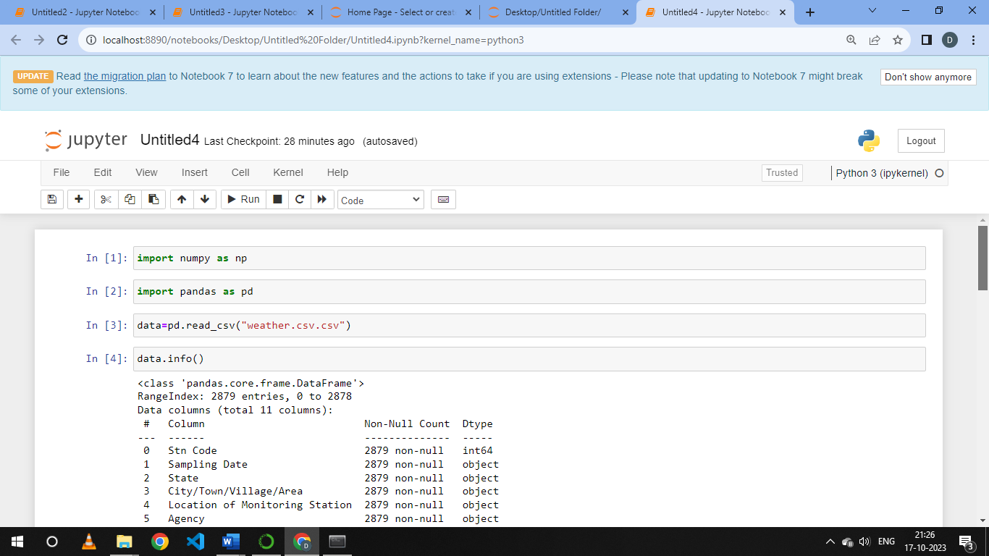

Step 5:

Handling Missing Values.

Data.dropna(inplace=True)

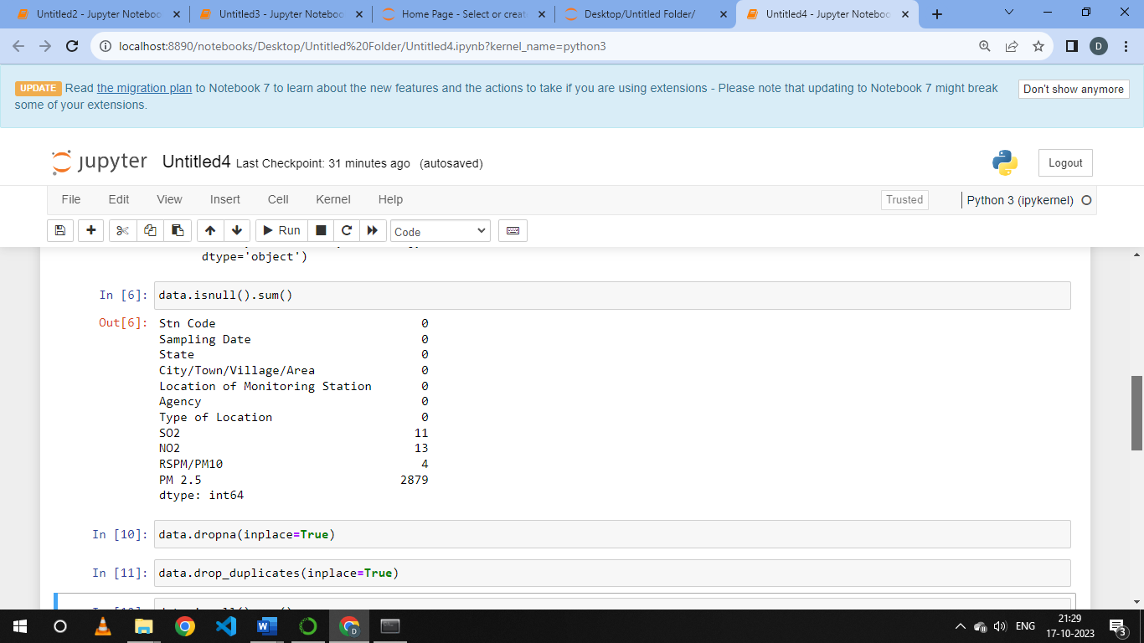

Step 6:

Data Cleaning (removing duplicates)

Data.drop_duplicates(inplace=True)

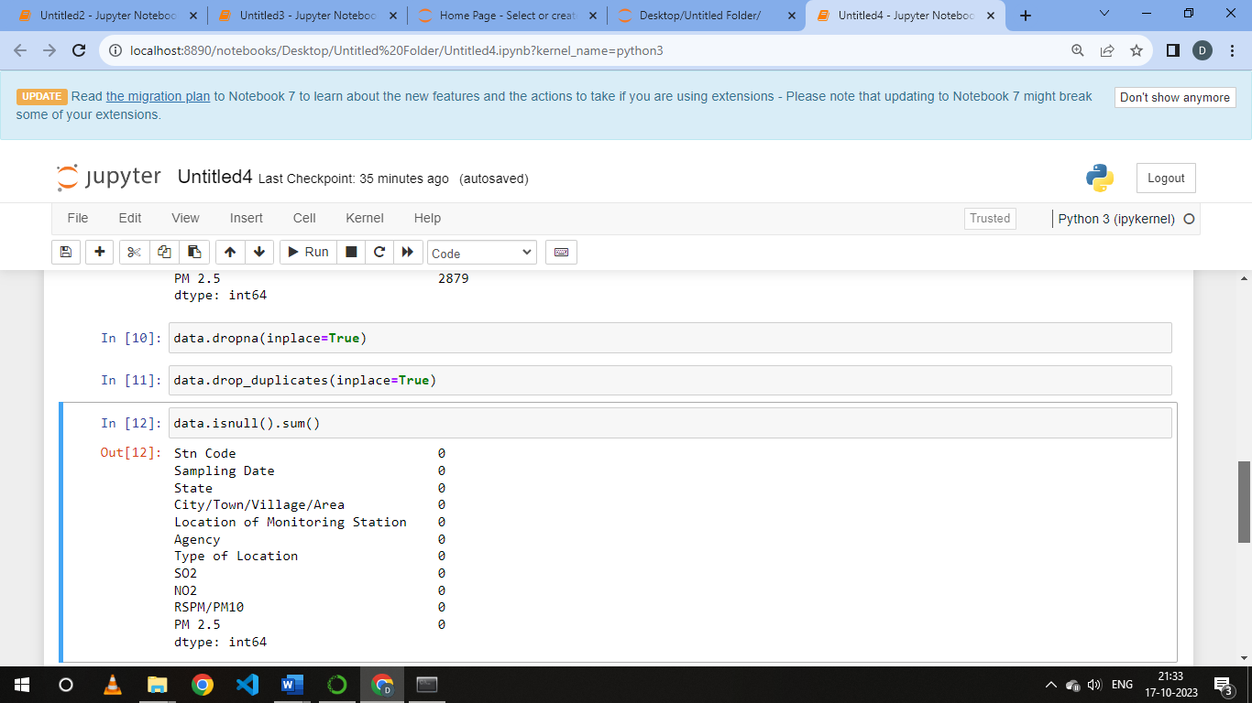

Step 7:

Save Preprocessed Data

Data.to_csv(‘preprocessed_dataset.csv’,index=False)