Introduction:

Agriculture is the practice of cultivating plants and livestockin order to provide facilities the human beings. In the rice of the sedendary human life style agriculture was the key devolpment.

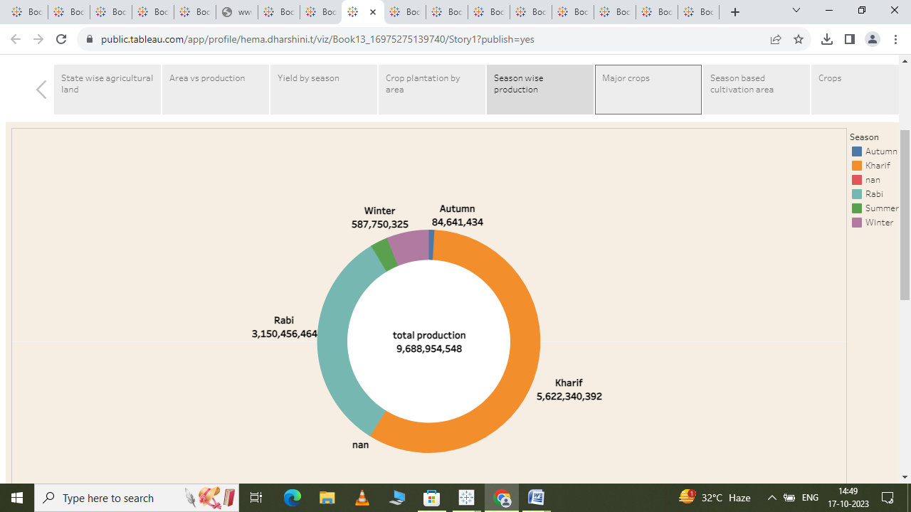

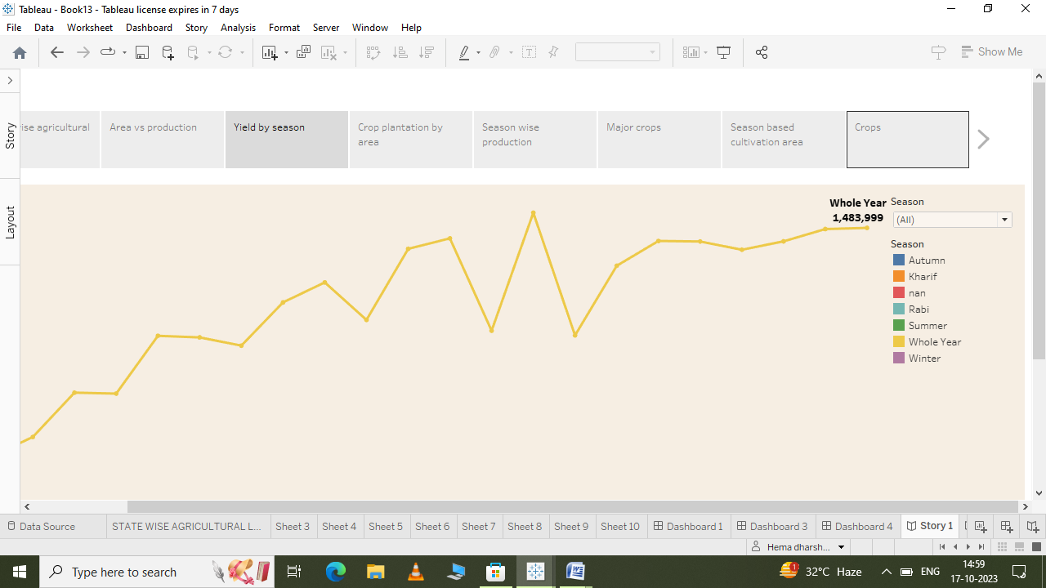

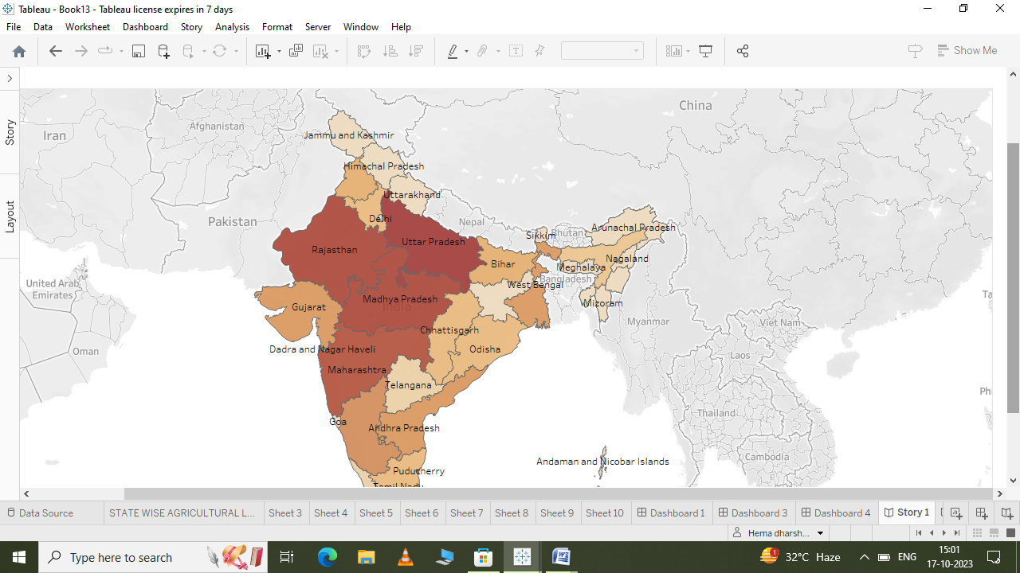

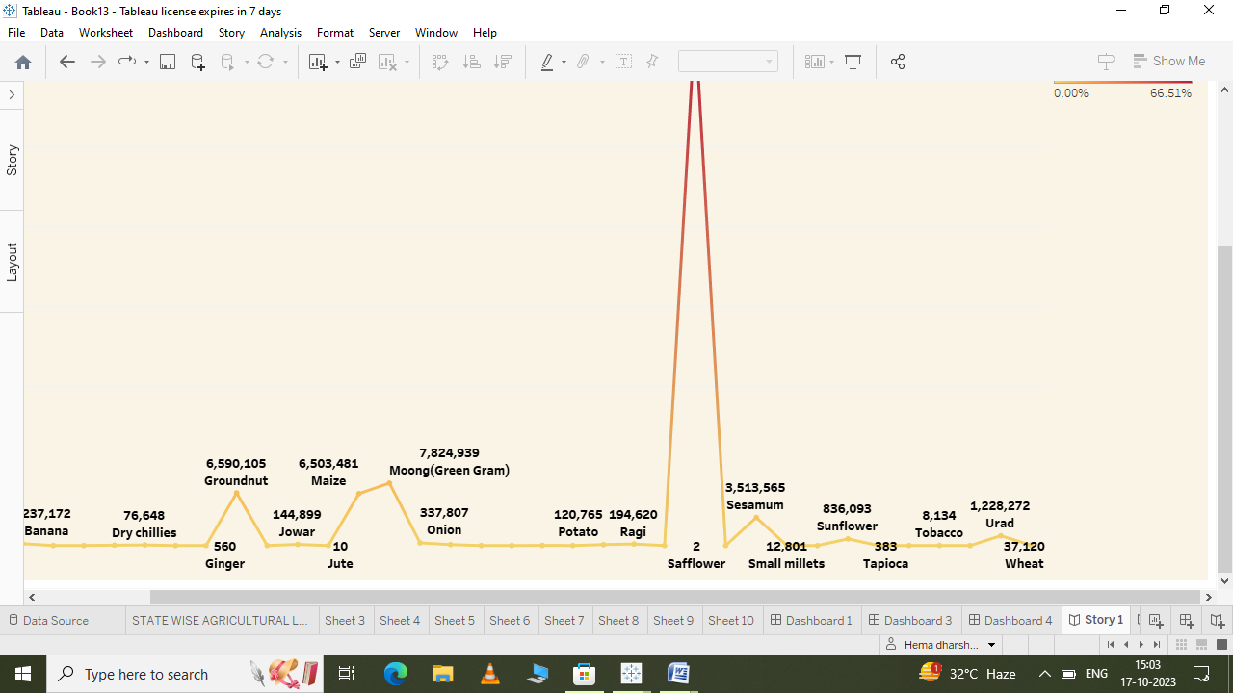

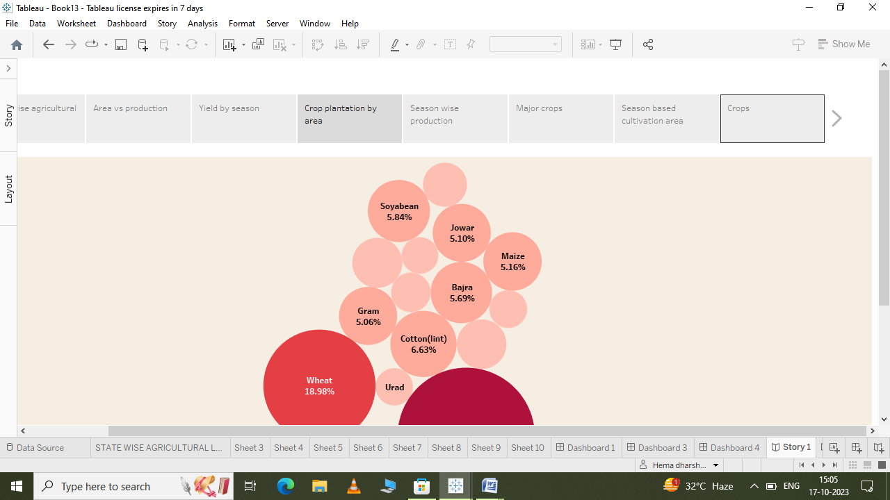v

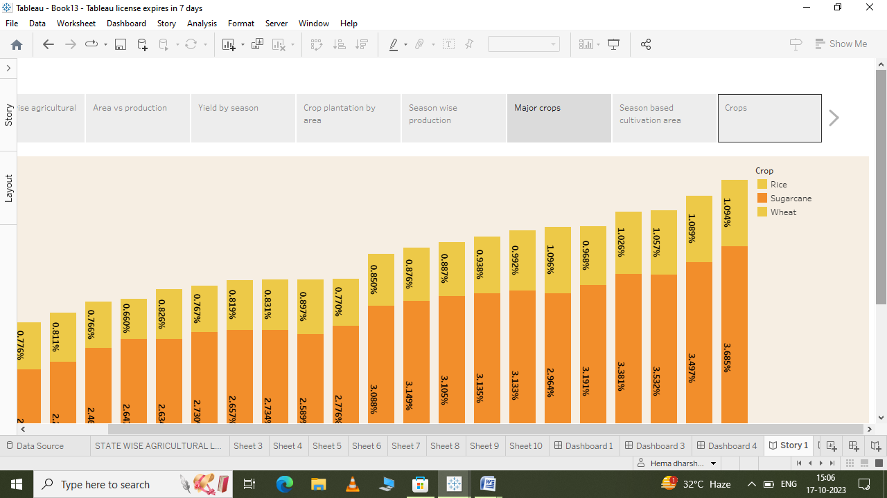   
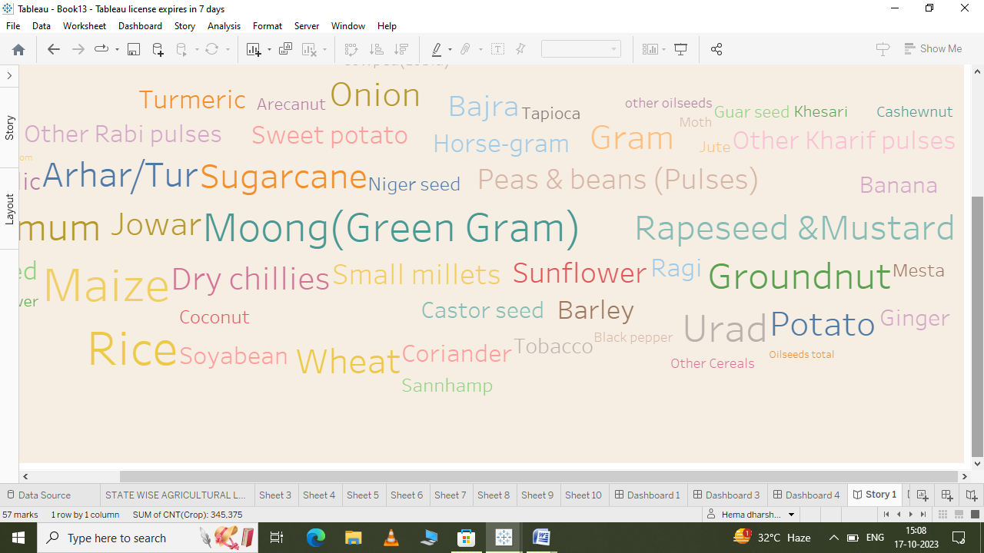

ADVANTAGES:

It provides employment opportunity to the rural agriculture as well as non agriculture labourers

It is the source of food and footer.

DISADVANTAGES:

Poor living condition and hygiene for live stock and risk to human health. Higher risk of cancer and Birth defects.