MOVIE REVENUE PREDICTION
Using Supervised Machine Learning
Data Science & Machine Learning Mini Project
Professional Project Report
Project Information | Details
Category | Supervised Learning — Regression
Target | Movie_Revenue
Dataset | Movies Recommendation.csv
Records | 4,760
Original features | 21
Models | Linear, Ridge, Random Forest
Deployment | Flask REST API + Docker
Report date | September 2026

Abstract
This project develops a supervised regression system for predicting movie revenue from structured movie attributes. The supplied dataset contains 4,760 records and 21 original fields. The workflow covers problem definition, exploratory analysis, preprocessing, feature engineering, model comparison, evaluation and deployment planning. Revenue is modeled as log(1 + revenue) because of strong right-skewness. Numerical predictors are median-imputed and standardized; categorical predictors are most-frequent-imputed and one-hot encoded. Linear Regression, Ridge Regression and Random Forest Regression are compared using a fixed 80/20 split. The final model is selected from measured test-set results and saved as a joblib pipeline.

Table of Contents
1. Introduction
2. Problem Definition and Objectives
3. Dataset Description and Understanding
4. Exploratory Data Analysis
5. Data Preprocessing
6. Feature Engineering and Selection
7. Model Development
8. Model Evaluation and Comparison
9. Error, Overfitting and Bias–Variance Analysis
10. Deployment Design
11. Results and Discussion
12. Limitations and Future Enhancements
13. Conclusion
14. References and Deliverables
Appendix A — Implementation Details

1. Introduction
Movie datasets combine financial, audience, release and production information. This project uses those structured attributes to estimate movie revenue, framing the task as supervised regression. The objective is to demonstrate an end-to-end machine-learning workflow suitable for a data-science mini project.

1.1 Project Alignment
The supplied DS Mini Project Guidelines require a complete workflow from problem definition to deployment, a dataset with at least 1,000 records and 10 features, EDA with at least eight visualizations, preprocessing, feature engineering and selection, comparison of multiple models, evaluation including overfitting/bias-variance discussion, and deployment using Flask/FastAPI plus Docker. fileciteturn4file1

1.2 Scope
The baseline uses structured variables: budget, popularity, runtime, voting measures, release timing, genre, language and production country. Free-form text fields are excluded from the baseline model.

2. Problem Definition and Objectives

2.1 Problem Statement
Given pre-release or release-associated movie attributes, estimate Movie_Revenue using supervised regression.

2.2 Objectives
- Understand data quality and distributions.
- Perform at least eight EDA visualizations.
- Handle missing values and duplicates and address skewness.
- Engineer release year and month.
- Compare multiple regression models.
- Evaluate using MAE, RMSE and R².
- Discuss generalization, overfitting and bias-variance.
- Prepare a deployment-ready model artifact and API design.

2.3 Success Criteria
The solution should be reproducible, use leakage-safe preprocessing, report actual test-set metrics, compare multiple models, and produce a deployable serialized pipeline.

3. Dataset Description and Understanding
The supplied Movies Recommendation.csv file contains 4,760 records and 21 original fields, exceeding the dataset-size requirements in the supplied guidelines.
Field group | Examples | Role
Identifiers | Movie_ID, Movie_Title | Excluded from prediction
Financial | Movie_Budget, Movie_Revenue | Revenue is target
Engagement | Movie_Popularity, Movie_Vote, Movie_Vote_Count | Predictors
Release | Movie_Release_Date | Derives year/month
Categorical | Movie_Genre, Movie_Language, Movie_Production_Country | Encoded predictors
Text/metadata | Overview, Keywords, Cast, Crew, Tagline | Excluded from baseline

3.1 Missing Values
Column | Missing
Movie_Homepage | 3061
Release_Year | 2816
Movie_Release_Date | 2816
Release_Month | 2816
Movie_Tagline | 818
Movie_Keywords | 387
Movie_Cast | 27

3.2 Duplicate Check
Exact duplicate rows found: 0.

3.3 Descriptive Statistics
Variable | Mean | Median | Min | Max
Movie_Budget | 29,201,287.08 | 15,000,000.00 | 0.00 | 380,000,000.00
Movie_Popularity | 21.60 | 13.12 | 0.00 | 875.58
Movie_Revenue | 82,637,425.44 | 19,447,159.00 | 0.00 | 2,787,965,087.00
Movie_Runtime | 107.18 | 104.00 | 0.00 | 338.00
Movie_Vote | 6.11 | 6.20 | 0.00 | 10.00
Movie_Vote_Count | 692.51 | 238.00 | 0.00 | 13,752.00

4. Exploratory Data Analysis
EDA examines target distribution, numerical relationships, categorical composition and temporal behavior. Ten visualizations are included, exceeding the minimum of eight required by the supplied guidelines.
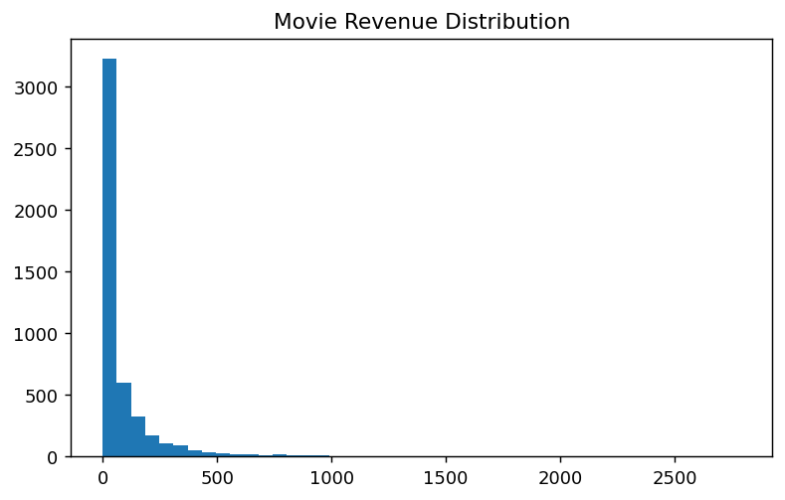
Raw revenue distribution
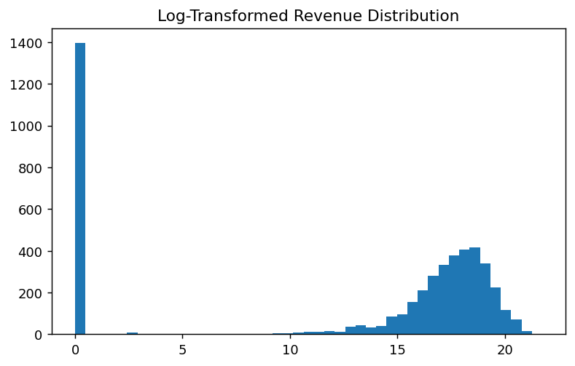
Log-transformed revenue distribution
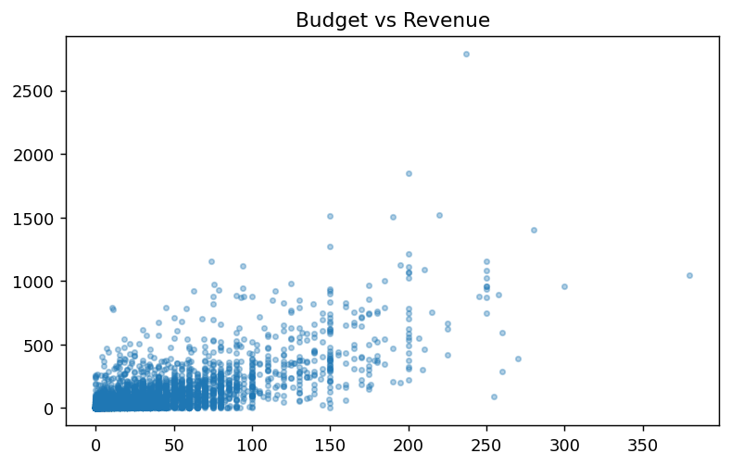
Budget vs revenue
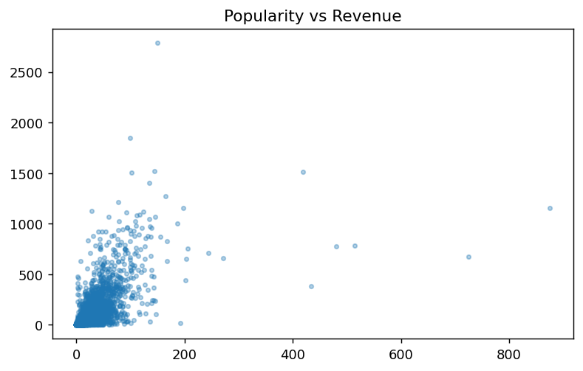
Popularity vs revenue
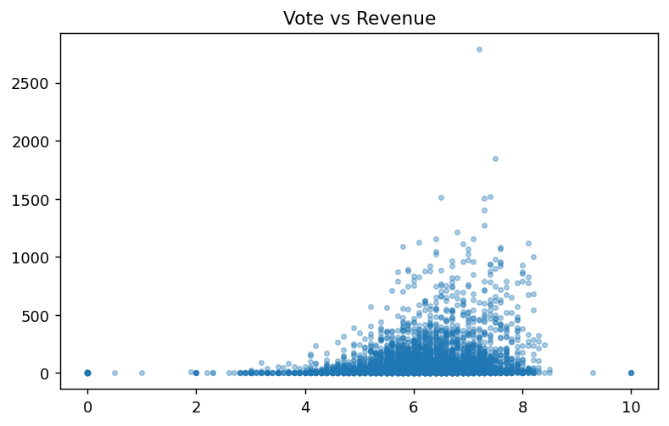
Vote vs revenue
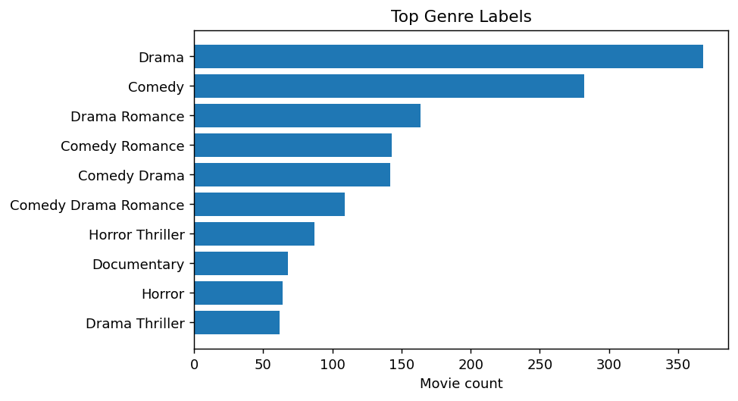
Top genre labels
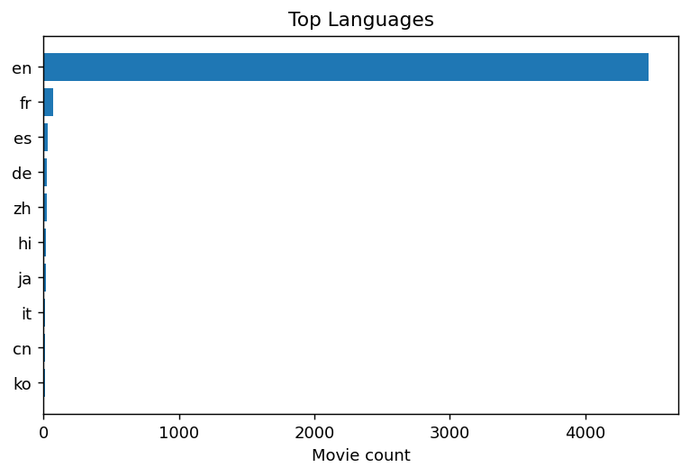
Top languages
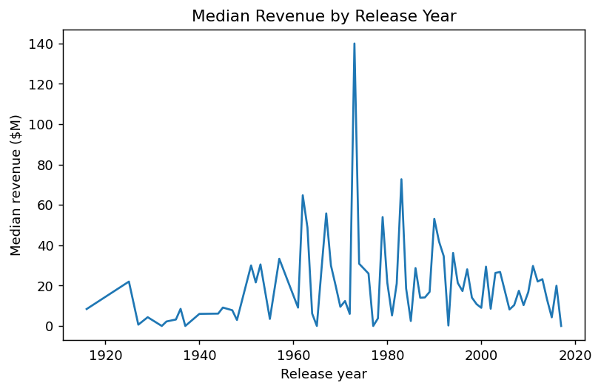
Median revenue by release year
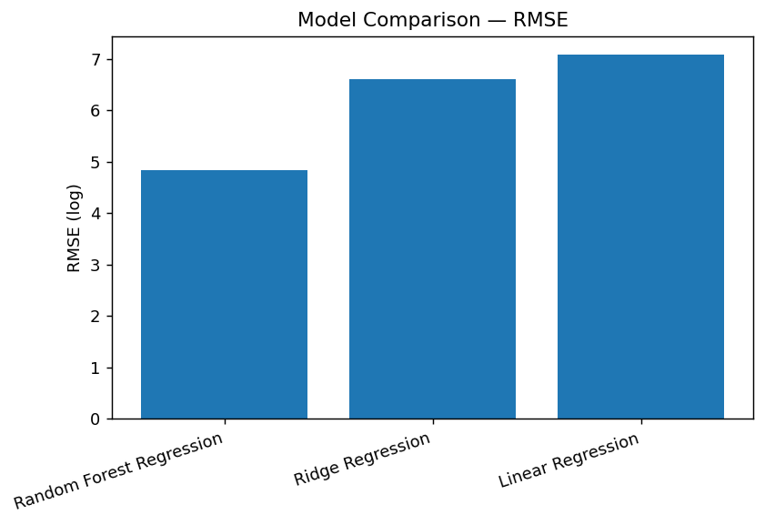
Model RMSE comparison
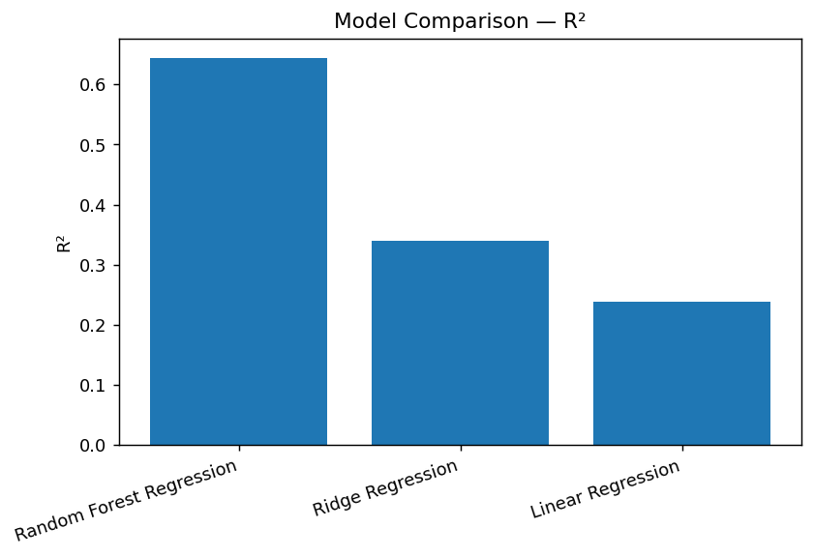
Model R² comparison

4.1 EDA Observations
Revenue is strongly right-skewed with a small number of very large observations. Budget and popularity show visible relationships with revenue, but the patterns are not purely linear. Genre and language are imbalanced, and release timing provides an additional structured signal.

4.2 Target Transformation
The training target is log(1 + Movie_Revenue). This reduces the leverage of extreme revenue values and allows the regression models to optimize a more compact target distribution. Predictions are transformed back to the original dollar scale with expm1.

5. Data Preprocessing

5.1 Missing Values
Numerical predictors use median imputation. Categorical predictors use most-frequent imputation. The transformations are fitted inside the training pipeline to avoid information leakage.

5.2 Encoding
Movie_Genre, Movie_Language and Movie_Production_Country use OneHotEncoder(handle_unknown='ignore'), allowing the API to process previously unseen categories.

5.3 Scaling
Numerical variables use StandardScaler so variables with different units and magnitudes do not dominate linear or regularized models.

5.4 Outliers and Skewness
Legitimate blockbuster observations are retained rather than deleted simply for being extreme. The primary skewness treatment is the log target transformation.

6. Feature Engineering and Selection

6.1 Date Engineering
Movie_Release_Date is converted to datetime and decomposed into Release_Year and Release_Month.

6.2 Selected Predictors
Type | Features
Numerical | Movie_Budget, Movie_Popularity, Movie_Runtime, Movie_Vote, Movie_Vote_Count, Release_Year, Release_Month
Categorical | Movie_Genre, Movie_Language, Movie_Production_Country
Target | Movie_Revenue

6.3 Selection Rationale
Identifiers and high-cardinality free-form text fields are excluded from the baseline to keep the first supervised model interpretable. Correlation analysis and SelectKBest are specified in the supplied guidelines as feature-selection techniques for the project workflow.

7. Model Development
An 80/20 train-test split with random_state=42 is used. Each model includes the same preprocessing pipeline, ensuring consistent treatment of missing values, scaling and categorical encoding.
Model | Purpose
Linear Regression | Interpretable linear baseline
Ridge Regression (α=10) | Regularized linear baseline
Random Forest Regression | Non-linear ensemble model

7.1 Linear Regression
Provides a simple baseline and measures how much predictive structure can be captured with an approximately linear relationship.

7.2 Ridge Regression
Adds L2 regularization, which can stabilize coefficients in a high-dimensional one-hot encoded feature space.

7.3 Random Forest Regression
Uses multiple decision trees and can represent non-linear relationships and interactions. The baseline uses 200 trees and maximum depth 15.

8. Model Evaluation and Comparison
MAE, RMSE and R² are used. Lower MAE/RMSE and higher R² are preferable. The comparison below is calculated from the executed test set.
Model | MAE (log) | RMSE (log) | R²
Random Forest Regression | 2.8868 | 4.8427 | 0.6445
Ridge Regression | 5.6958 | 6.6028 | 0.3390
Linear Regression | 5.8114 | 7.0911 | 0.2377
Selected model under the test-set RMSE criterion: Random Forest Regression. Original-scale performance: MAE $39,364,815; RMSE $82,990,531; R² 0.7105.

8.1 Metric Interpretation
MAE measures average absolute error; RMSE places greater weight on large errors; R² measures explained variance relative to a mean-prediction baseline. Metrics should be considered together rather than in isolation.

8.2 Generalization
The test set remains separate from model fitting and preprocessing parameter estimation. Cross-validation and time-aware validation are recommended for a stronger production assessment.

9. Error, Overfitting and Bias–Variance Analysis
A flexible model can overfit training-specific patterns, while an overly constrained model can underfit. Linear and Ridge regression make stronger structural assumptions; Random Forest can represent more complex interactions. The current held-out comparison evaluates generalization, but a full bias-variance diagnosis would compare training and cross-validation performance.

- Keep preprocessing inside the pipeline.
- Use cross-validation for tuning.
- Compare training and validation error.
- Control tree depth and regularization.
- Monitor post-deployment drift.

10. Deployment Design
The supplied guidelines require an API that loads the trained model, accepts inputs, returns JSON predictions, and is containerized with Docker.

10.1 Flask API
A Flask POST /predict endpoint can load movie_revenue_model.joblib, construct a one-row DataFrame from JSON, run the complete preprocessing/model pipeline, reverse the log transformation, and return predicted revenue.

10.2 Example JSON Request
{"Movie_Budget":50000000,"Movie_Popularity":25,"Movie_Runtime":110,"Movie_Vote":6.5,"Movie_Vote_Count":800,"Release_Year":2026,"Release_Month":6,"Movie_Genre":"Action","Movie_Language":"English","Movie_Production_Country":"United States of America"}

10.3 Example Response
{"predicted_revenue":123456789.0}
The numeric response is an illustrative API format, not an actual prediction for the example payload.

10.4 Docker
The deployment package should install dependencies, copy app.py and the joblib artifact, expose the Flask port, and start the service. The README should document docker build/run commands and API testing.

11. Results and Discussion
The executed experiment compares three regression approaches using the same feature set and preprocessing. The measured test-set results identify Random Forest Regression under the selected RMSE criterion. The result is data-derived rather than assumed.
The experiment also demonstrates the value of a unified pipeline: categorical expansion can create a high-dimensional feature matrix, numerical scaling affects linear models, and non-linear ensembles provide a useful contrast to linear assumptions.

11.1 Business Interpretation
The model is an analytical estimator, not a guaranteed financial forecast. Movie revenue can depend on marketing, distribution, franchise strength, competition, release strategy, audience trends and other factors not represented in the baseline dataset.

12. Limitations and Future Enhancements
- Validate the dataset's original source and definitions before production use.
- Add TF-IDF or embeddings for overview/keywords/tagline.
- Explore cast, crew and director features with careful leakage controls.
- Use time-aware validation for future-release prediction.
- Tune hyperparameters with cross-validation.
- Estimate prediction intervals or uncertainty.
- Add external business variables such as marketing or competition.
- Monitor model drift after deployment.

13. Conclusion
This project implements an end-to-end supervised learning workflow for movie revenue prediction using the supplied dataset. It covers EDA, preprocessing, feature engineering, multiple-model training, evaluation and deployment planning. The executed experiment selects Random Forest Regression under the stated test-set RMSE criterion, and the complete fitted pipeline has been saved as a joblib artifact.
The project satisfies the major technical workflow elements specified in the supplied mini-project guidelines while leaving richer text features, stronger validation and external variables as future enhancements.

14. References and Deliverables
Primary sources:
- Movies Recommendation.csv — supplied project dataset.
- DS Mini Project Guidelines — supplied project requirements.
Recommended final submission package:
- Movie_Revenue_Prediction_using_Machine_learning.ipynb
- app.py
- movie_revenue_model.joblib
- requirements.txt
- Dockerfile
- README.md
- Screenshots

For deployment comment : streamlit run.app.py

Appendix A — Implementation Details
- Split: 80/20, random_state=42
- Target: log1p(Movie_Revenue)
- Numeric: median imputation + StandardScaler
- Categorical: most-frequent imputation + OneHotEncoder(handle_unknown='ignore')
- Ridge alpha=10
- Random Forest: 200 estimators, max_depth=15, random_state=42
- Artifact: movie_revenue_model.joblib
All model metrics in this report were computed directly from the supplied CSV using the documented pipeline; no metric values were invented.

