

SonarQuBe SeTUP and Usage

Date: October 12, 2016

Introduction

- SonarQube is an open platform to manage code quality. As such, it covers the 7 axes of code quality:

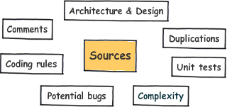

- More than 20 programming languages are covered through plugins including Java, C#, C/C++, PL/SQL, Cobol, ABAP… .

Installation

- You can install SonarQube from the below location.
http://www.sonarqube.org/downloads/

- Extract it and change the database configurations(configure mysql db) in the below location.

\conf\sonar.properties file.

- Start the sonar server by using bat file in the below location .

\bin\windows-x86-32\StartSonar.bat

- Access the sonar in the browser.

http://localhost:9000/

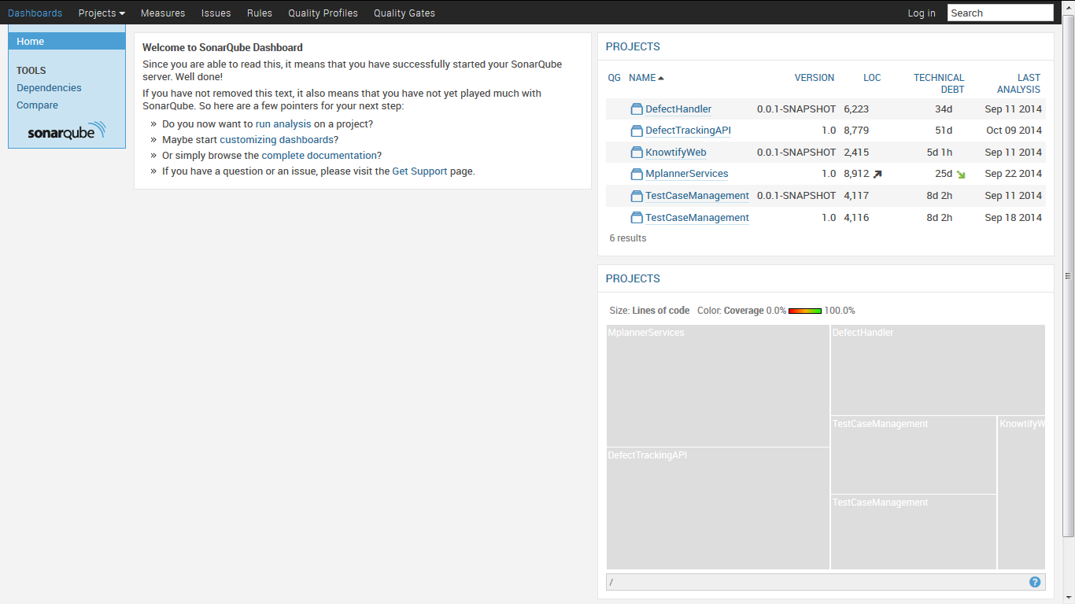

SonarLint Eclipse Plug-in usage

- SonarLint for Eclipse is an extension that provides on-the-fly feedback to
developers on new bugs and quality issues injected into you code.

- It gives you alerts when you write the code which gives any bugs , quality issues, etc.

Steps to Install SonarLint in Eclipse

- First Click on Help at the top of your eclipse screen and click on Eclipse market place , enter sonar in textbox as shown in the below screen. And click on install button of Sonar Lint plug-in and later click on confirm.
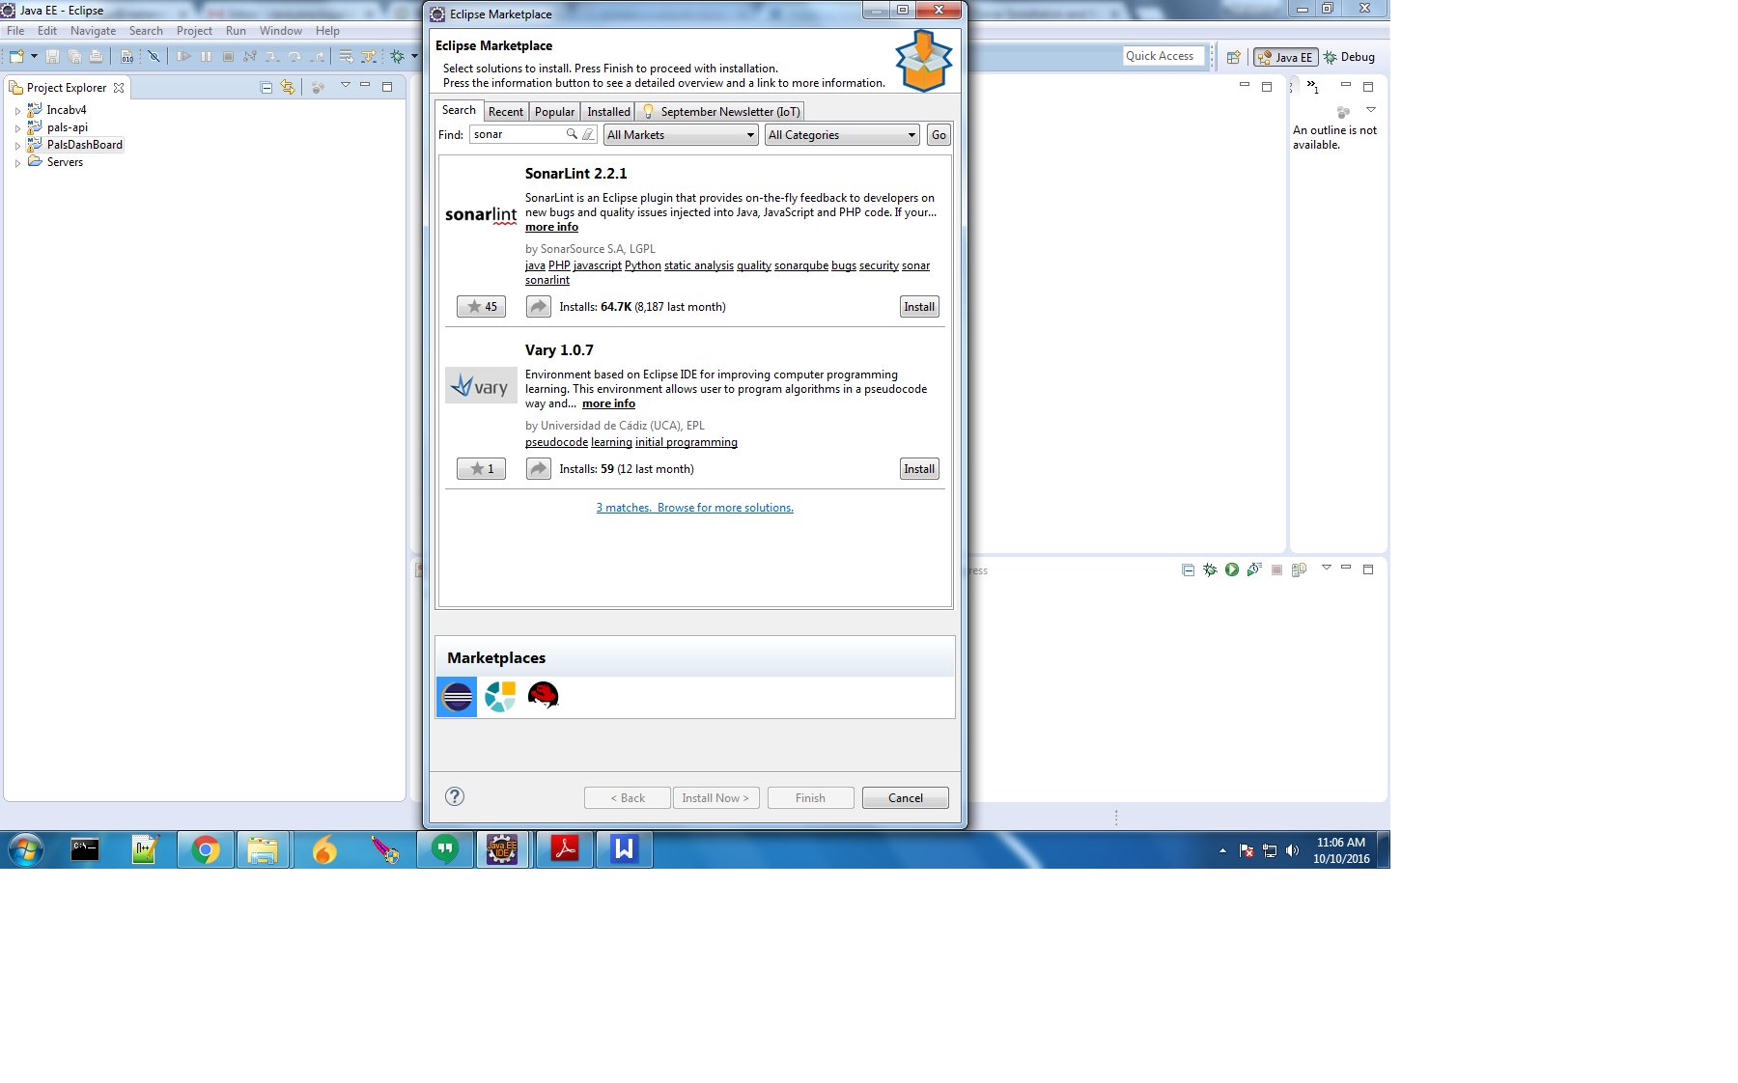

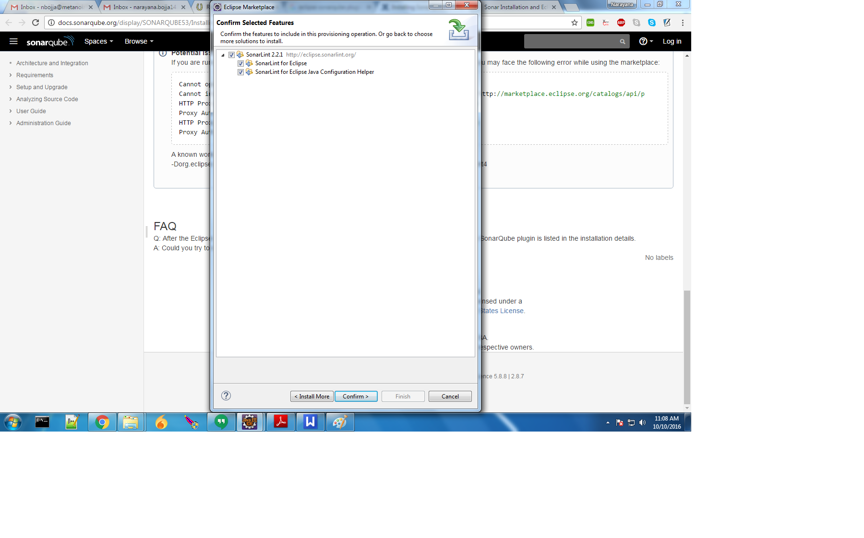
- Accept the terms and conditions and click on Finish button.

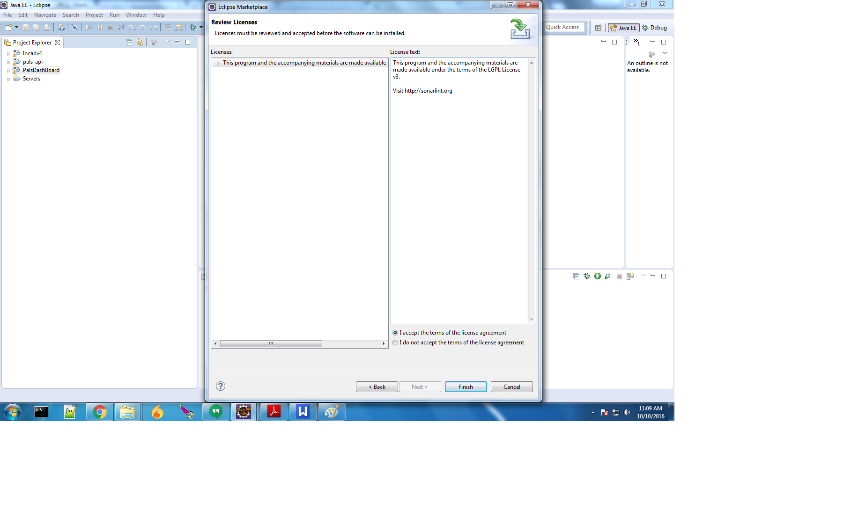
- Right click on Project folder. Select Solar Lint option and Bind to a SonarQube project.

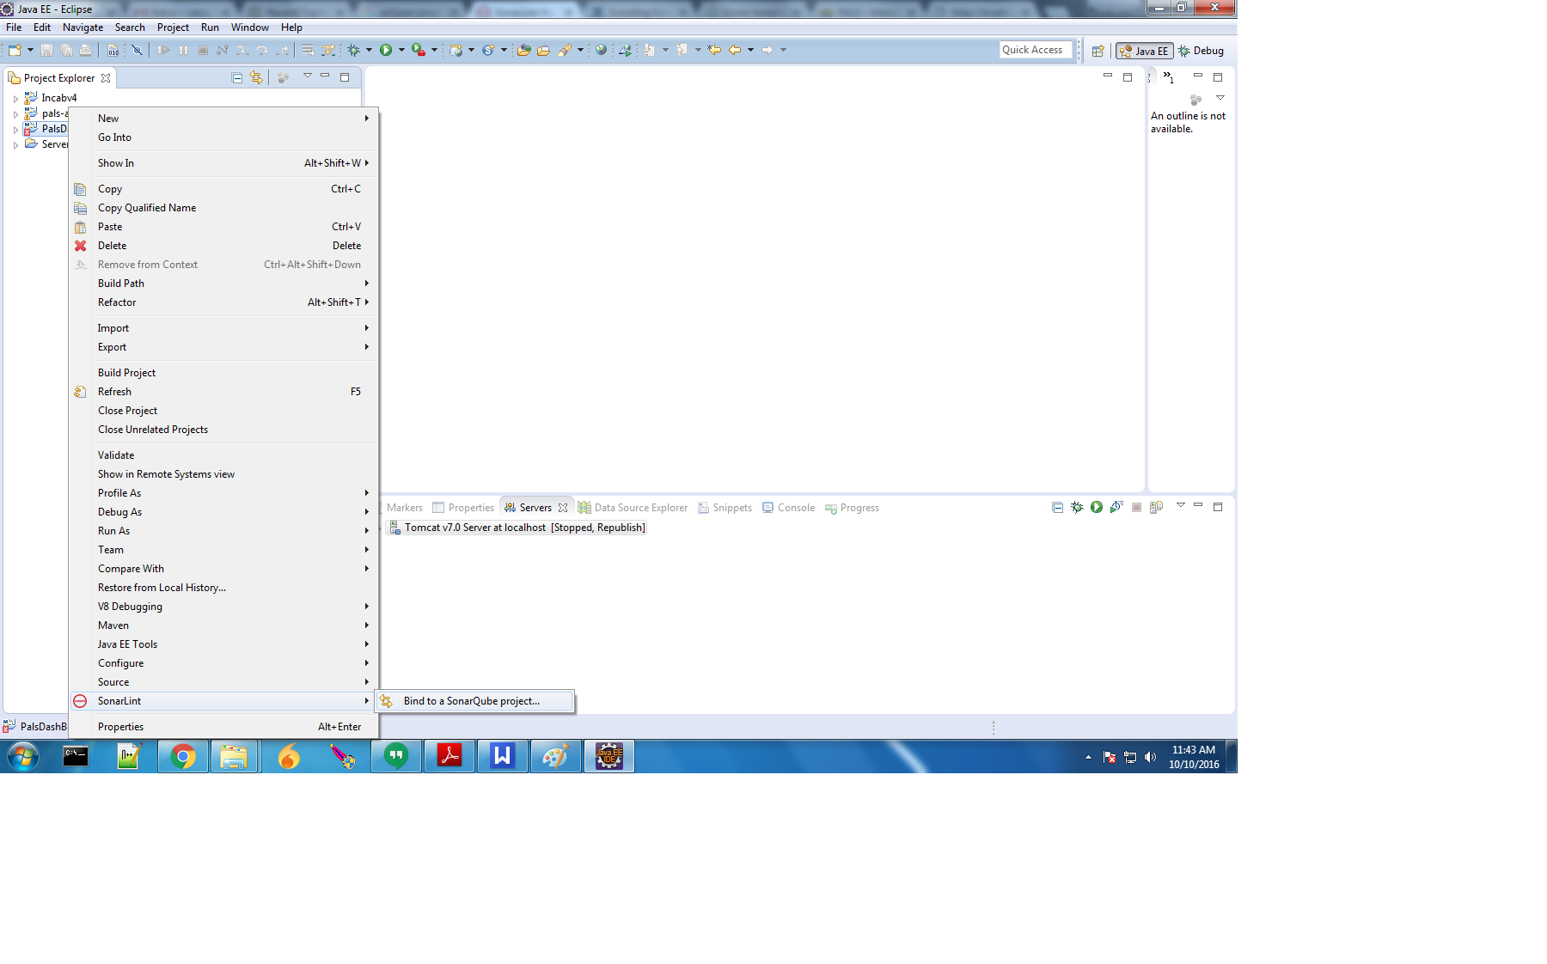

- Click on Connect to SonarQube Server to configure SonarQube Server

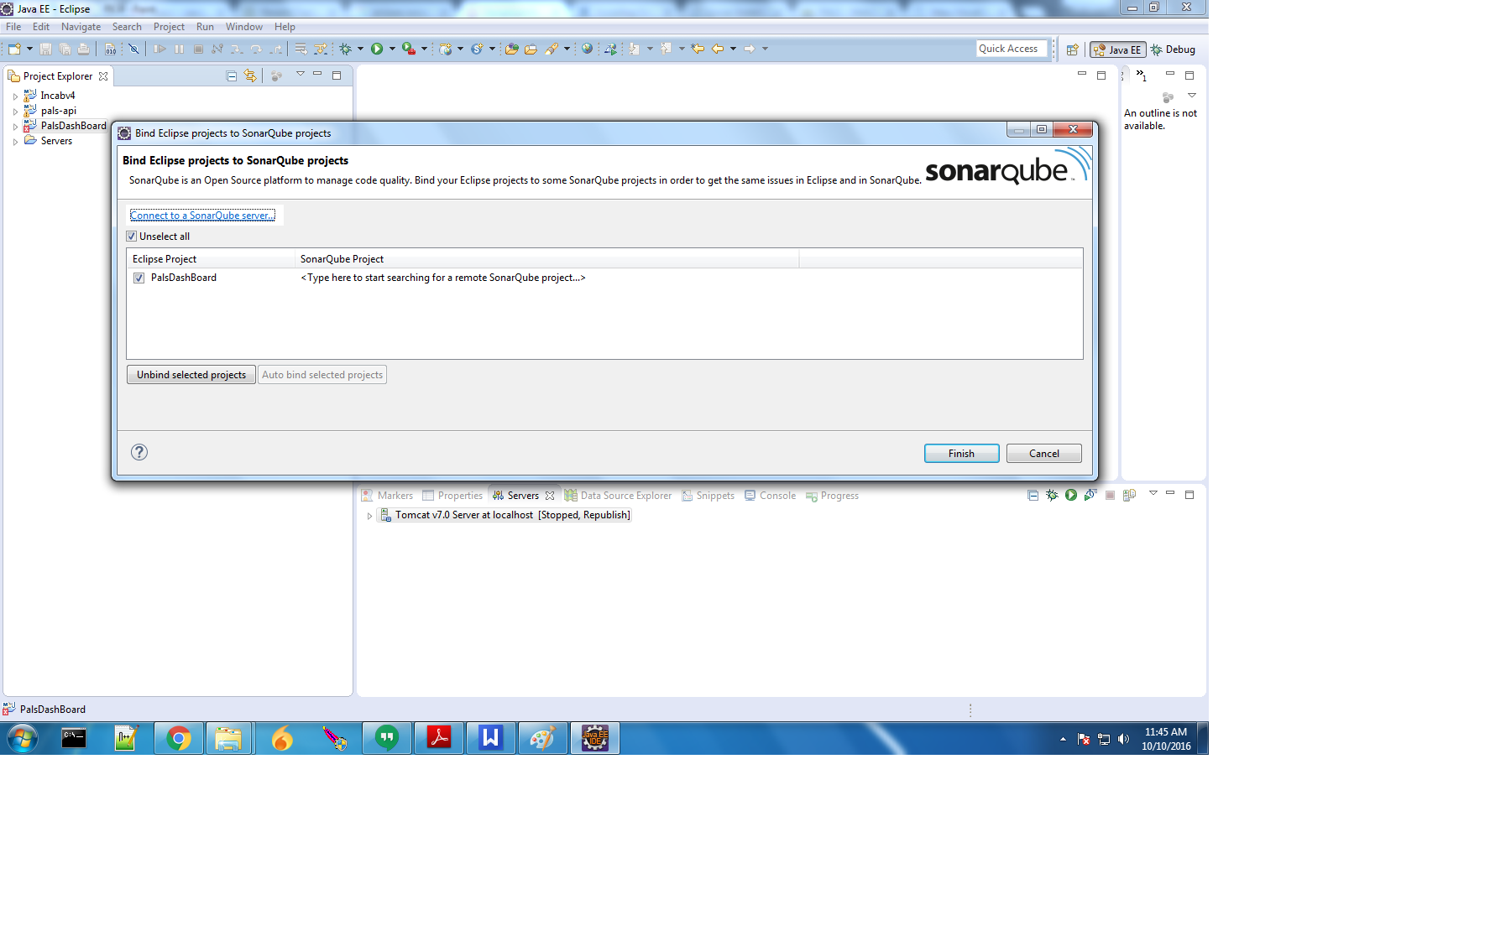
- Enter Server details and click on Test Connection Button. If it shows successful message, your Server details are correct and server is connected. Finally click on Finish button.
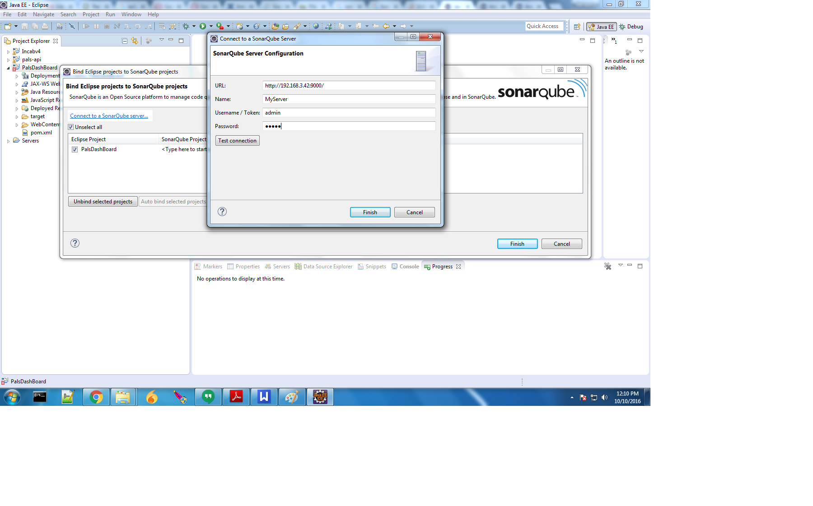

- Click on Auto Bind Projects and Finish Button.
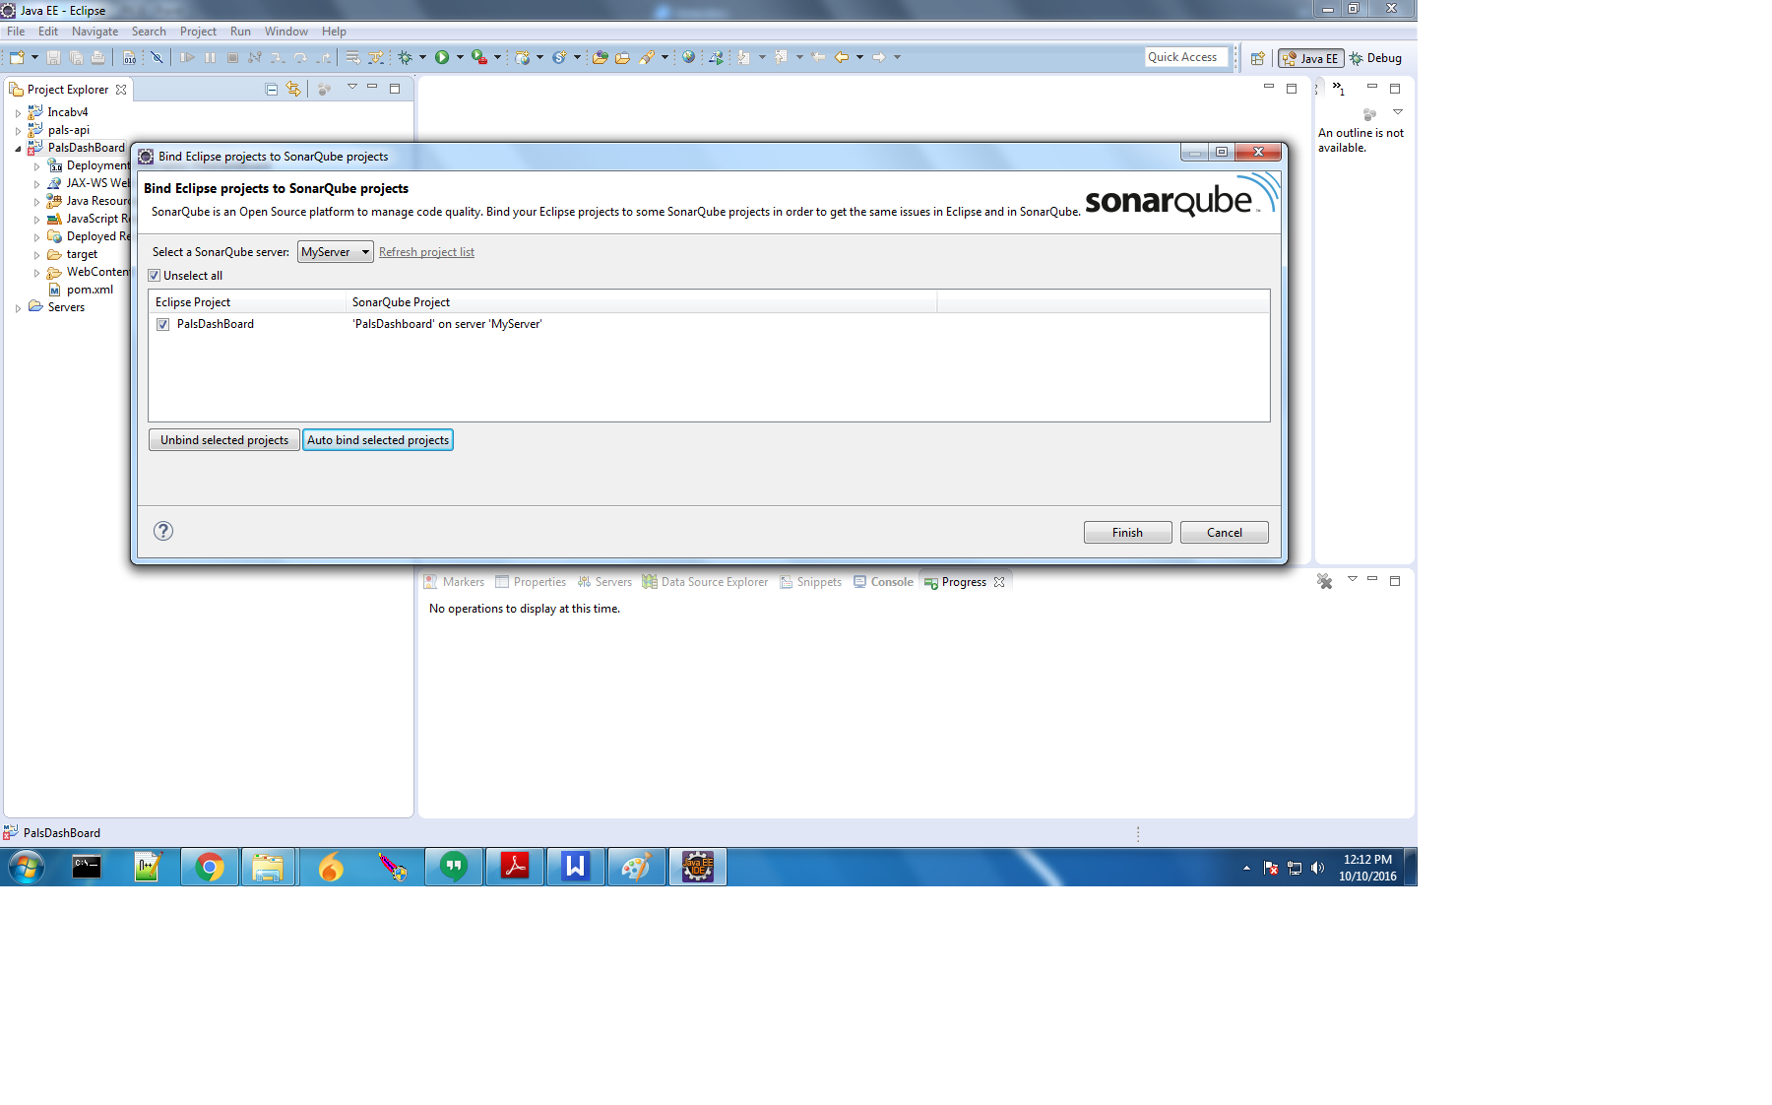
- Edit your project’s pom.xml file to add sonar plug-in code and SonarQube server details as shown below.

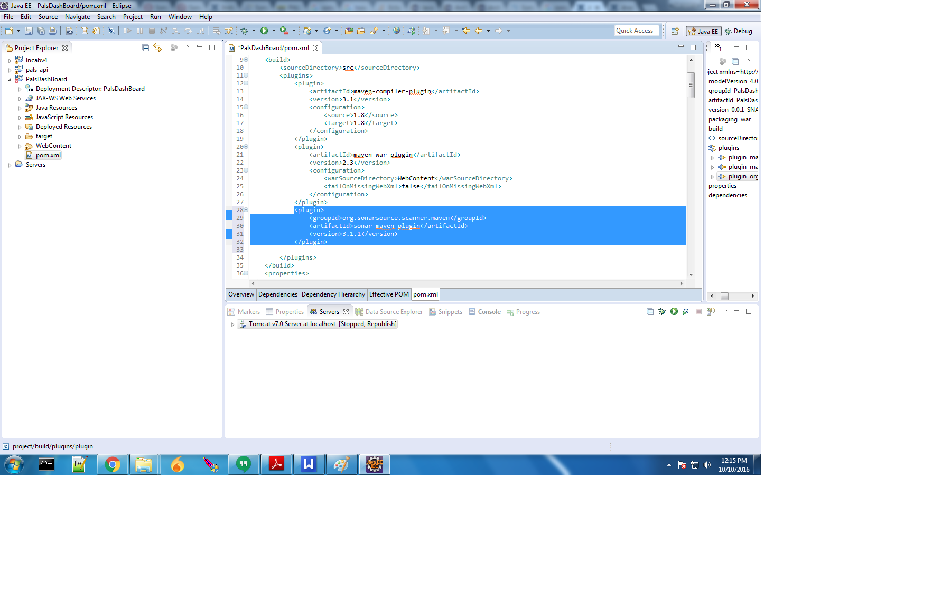
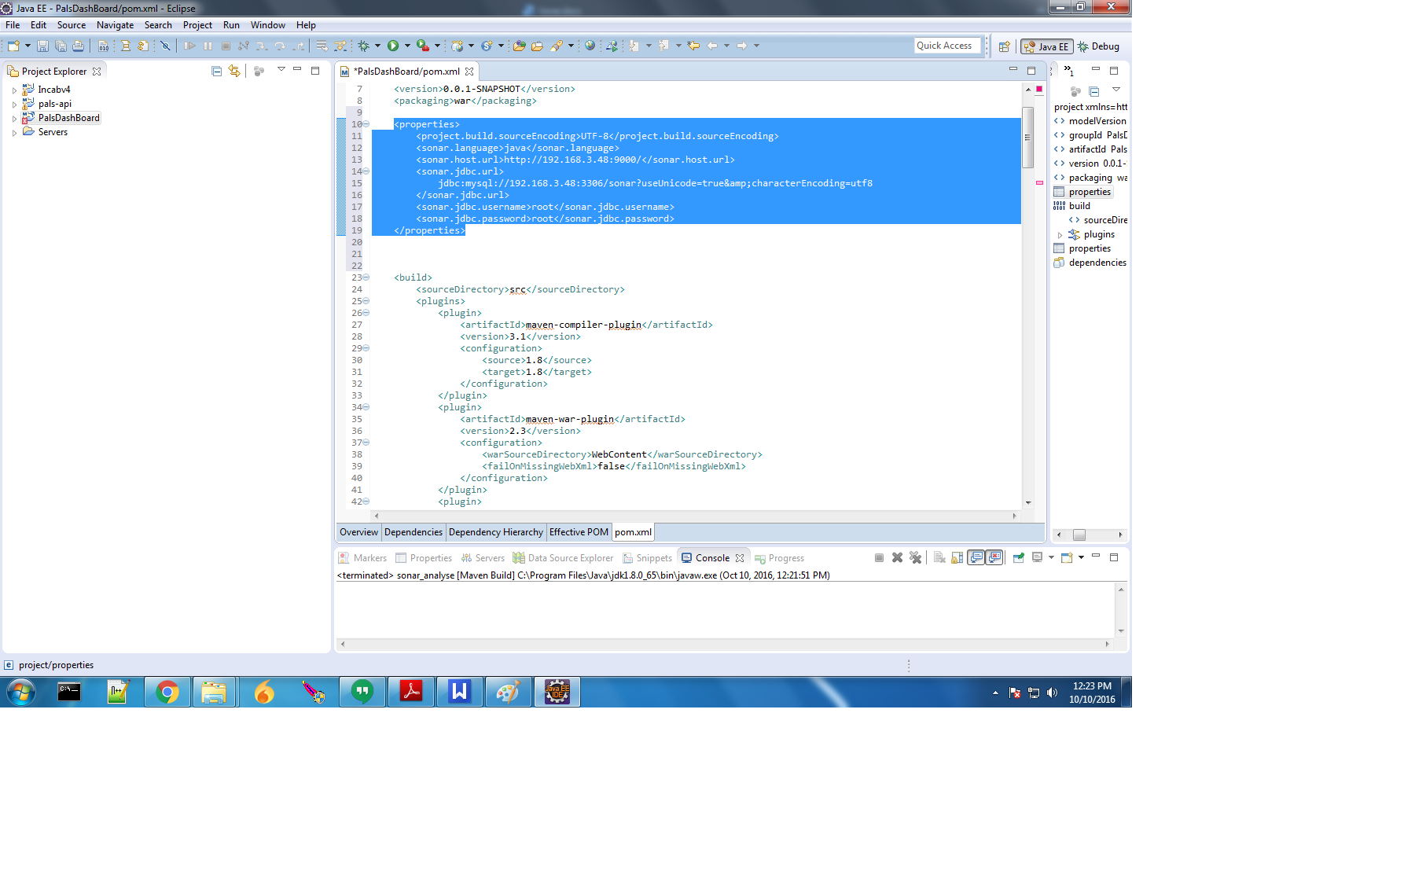
- Now it’s time to run SonarQube using maven command “sonar:sonar”.

- Right click on Project. Go to Run as --> Run configurations.
- Double click on Maven build and Give the name . Select base directory.
- Type sonar:sonar in the goals and click on Apply and then Run Buttons.
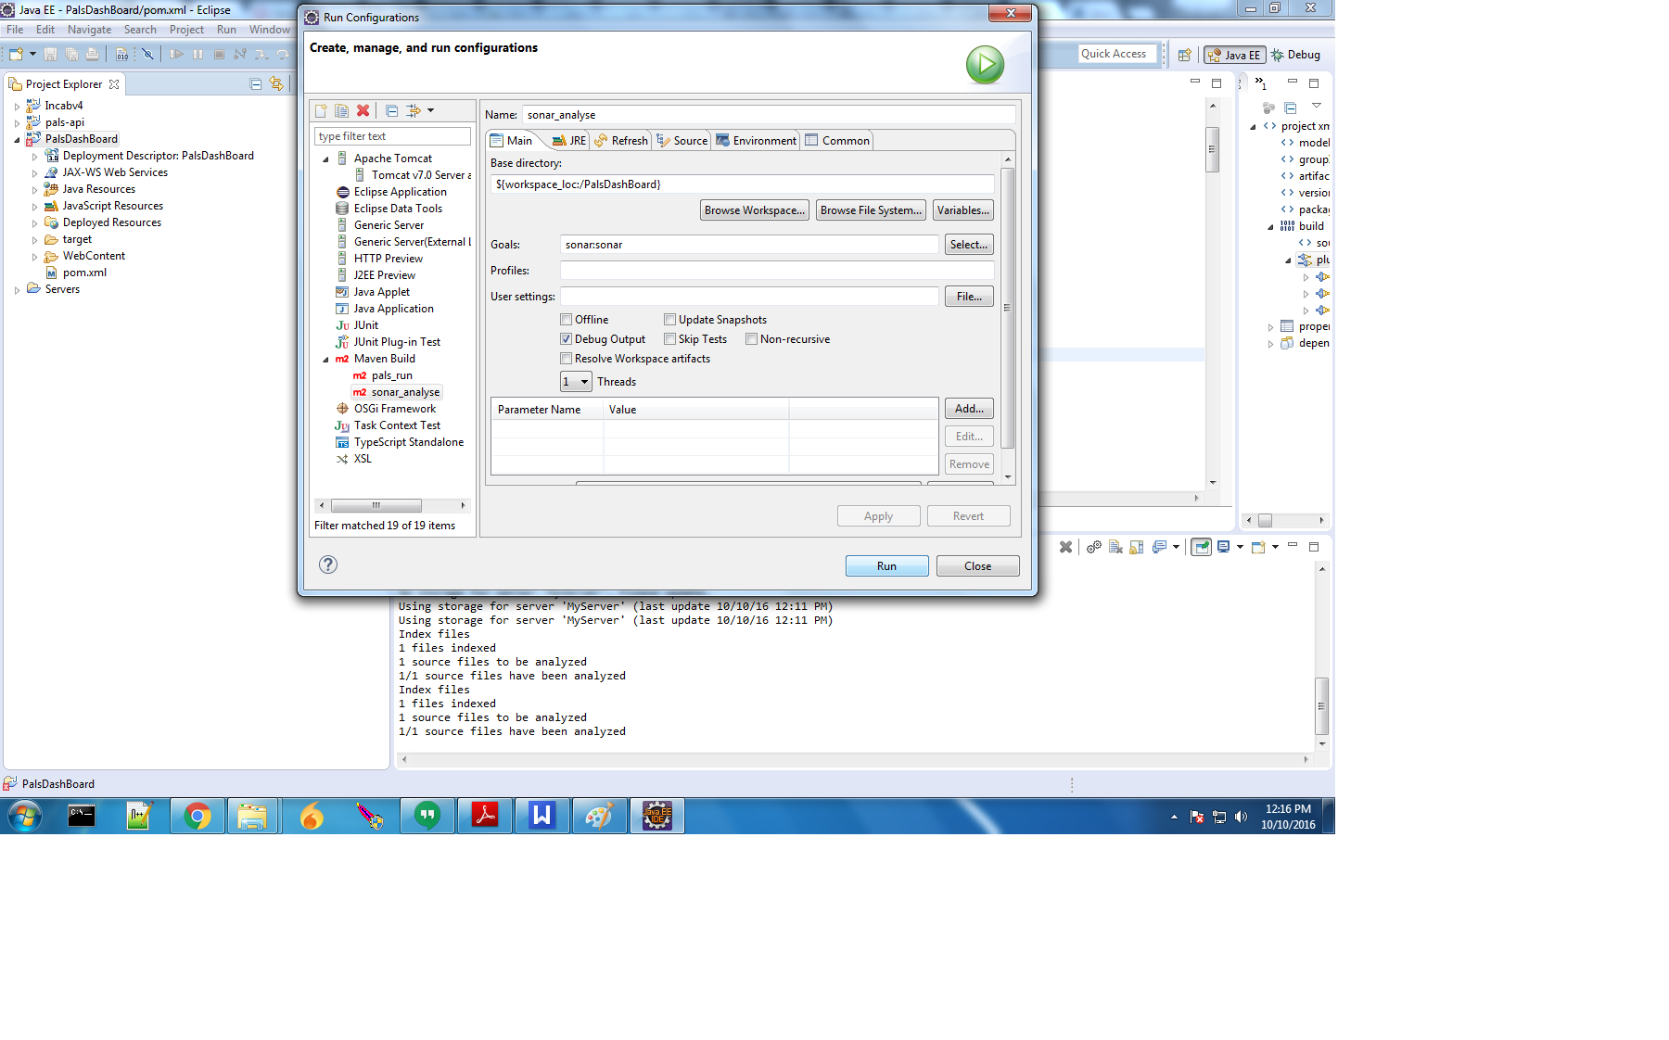

- Now select the url to see the result as highlighted in the image.

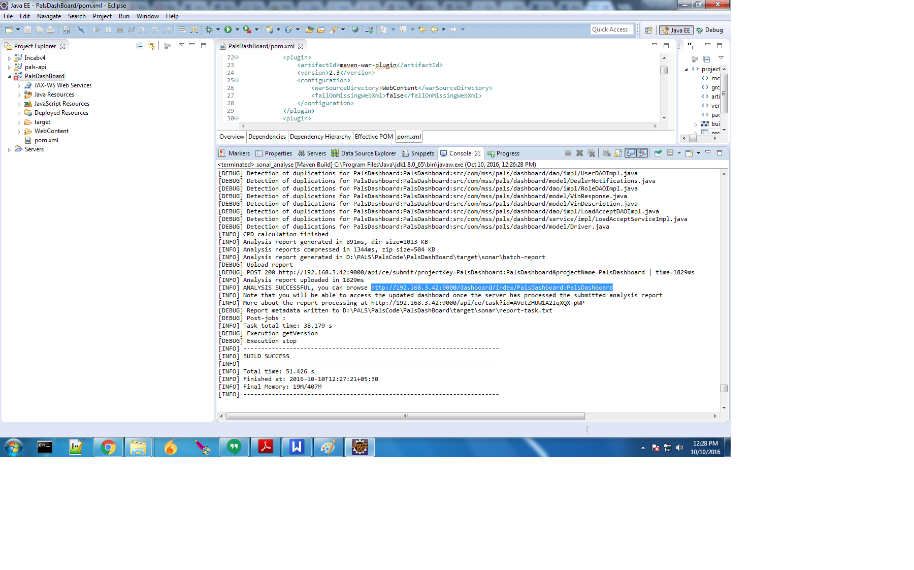
- Open that url in the browser and it will show as like in the below image.

