AI-Driven Export Market Decision Support System for Indian Exporters Using
Public Trade and Macroeconomic Data

Interim Report
Pavithra Bharathi
Walsh College
QM640: Data Analytics Capstone
Mentor: Vikas
Term 3
August 2026

GitHub Repository
https://github.com/bharathipavithra10-cmd/AI-Export-Market-Decision-Support

Introduction

Background and Context
International trade is a major contributor to India's economic growth, yet selecting suitable export markets remains a complex decision requiring the simultaneous evaluation of market demand, historical growth, supplier competition, and macroeconomic conditions. This challenge is particularly significant for micro, small, and medium enterprises (MSMEs), which often have limited access to integrated market-intelligence systems and advanced analytical resources.
Public sources such as TradeStat, UN Comtrade, and World Bank Open Data provide valuable information, but the datasets are maintained separately and differ in structure, naming conventions, units, coverage, and reporting periods. Considerable cleaning and integration are therefore required before they can support a consistent product-country-year analysis. TradeStat provides India-specific exports by commodity and destination; UN Comtrade provides broader international trade flows; and World Bank indicators describe the economic environment of destination countries.
The project develops an AI-driven Export Market Decision Support System that combines public trade and macroeconomic data with descriptive analysis, statistical methods, machine learning, and business-intelligence visualization. The intended outcome is a transparent framework that helps Indian exporters identify promising markets, understand the reasons behind rankings, and distinguish between large established destinations and emerging markets with favorable growth conditions.

Problem Statement
Indian exporters currently rely on fragmented trade information, historical reports, and manual market analysis. Existing public portals provide descriptive statistics, but they do not jointly evaluate destination demand, India's export performance, supplier competition, macroeconomic conditions, and future potential in one workflow. Consequently, exporters may focus on large but saturated markets or overlook smaller markets with stronger growth opportunities. This study addresses the gap by creating an integrated, data-driven decision-support workflow using publicly available sources.

Purpose of the Study
The purpose of the study is to develop and evaluate an AI-driven decision-support system that assists Indian exporters in identifying and prioritizing international markets. The study analyzes export demand and historical trends, examines macroeconomic and trade-related drivers, plans predictive models for future export opportunities, and ultimately aims to rank destination markets using demand, competition, market share, macroeconomic conditions, and predicted growth.

Table 1

Interim Project Status (Progress Snapshot)
Status | Work items
Completed | Repository setup; TradeStat, World Bank and UN Comtrade data loading; data cleaning and integration; feature engineering; exploratory data analysis; missing-value analysis; multicollinearity assessment (VIF); RQ1 statistical analysis (Kruskal–Wallis test); RQ2 multiple regression analysis; RQ4 predictive modelling using Linear Regression, Random Forest and XGBoost.
In progress | RQ3 supplier competition analysis (pending correction of UN Comtrade extraction); Export Market Attractiveness Score design and dashboard development.
Pending | Final RQ3 analysis, attractiveness scoring framework, dashboard deployment, business recommendations, model refinement and final report preparation.

Scope and Objectives
The initial synopsis proposed evaluation of at least 20 product categories over approximately ten years, subject to data availability. At the interim stage, the implemented notebook contains 29 TradeStat workbooks representing five HS chapters (27, 30, 71, 84, and 85) over the available annual periods. The current unit of analysis is the product-country-year observation. The report therefore distinguishes the initial target scope from the currently available analytical scope and does not overstate the completed coverage.

Objectives
- Analyze current export demand and historical market trends for selected Indian export categories across international destinations.
- Evaluate the association of macroeconomic and trade-related variables with export performance.
- Develop and evaluate statistical and machine-learning models for future export demand and growth.
- Build a transparent export-market decision framework that integrates demand, competition, market characteristics, and predictive analytics.

Research Questions
RQ1: Which Indian products and destination markets currently demonstrate the highest export demand, and how have these patterns evolved over time?
RQ2: Which macroeconomic and trade-related factors significantly influence export demand across international markets?
RQ3: How do supplier competition and India’s market share influence export opportunities across international markets?
RQ4: Which international markets represent the most attractive export opportunities based on demand, competition, market characteristics, and future growth potential?

Literature Survey

Literature Review Approach
The literature base was selected to cover four themes aligned with the research questions: international market selection, export diversification and product-space analysis, supplier concentration and market competition, and the use of machine learning for trade forecasting. Peer-reviewed journal articles, institutional methodologies, and recognized working papers were prioritized. Sources were retained when they offered a clear theoretical or methodological contribution to market screening, export opportunity assessment, competition measurement, or predictive modelling.
Table 2
Literature Review Summary
Author (Year) | Domain/context | Method | Key finding | Relevance
Andersen & Strandskov (1998) | International market selection | Conceptual/ cognitive mapping | Market choice depends on how decision makers structure multiple market signals. | Supports transparent multi-factor decision design.
Papadopoulos et al. (2002) | Market screening | Trade-off model | Market attractiveness requires balancing opportunity and risk dimensions. | Supports composite ranking rather than single-indicator selection.
Gaston-Breton & Martin Martin (2011) | Market selection and segmentation | Two-stage model | Initial country screening should precede detailed segmentation. | Supports staged workflow from screening to recommendation.
Brenton & Newfarmer (2007) | Export diversification | Cross-country trade analysis | Export growth reflects both intensive and extensive margins. | Supports analysis of established and emerging markets.
Hidalgo et al. (2007) | Product space | Network analysis | Countries develop through related product capabilities. | Supports commodity-level differentiation.
Hausmann & Hidalgo (2011) | Economic complexity | Network structure | Product mix and capabilities shape economic output. | Provides theoretical basis for product-market structure.
Caldarelli et al. (2012) | Export networks | Network analysis | Export relationships reveal structural patterns not captured by totals alone. | Supports later competition/network extension.
Decreux & Spies (2016) | Export potential | ITC assessment methodology | Export opportunities combine supply, demand, and market-access considerations. | Directly informs attractiveness scoring.
Rhoades (1993) | Supplier concentration | HHI methodology | HHI summarizes market concentration using squared shares. | Supports planned RQ3 competition metric.
Batarseh et al. (2019) | Trade forecasting | Machine learning | ML can identify nonlinear patterns in international trade data. | Supports planned comparison of predictive models.
El Kefi (2021) | International market selection | Data envelopment analysis | Multi-criteria efficiency techniques can prioritize export markets. | Offers benchmark for ranking design.
Silva et al. (2024) | Trade networks and forecasting | Machine learning/network features | Network structure may improve economic forecasting. | Supports future feature engineering.
Across the literature, international market selection is consistently treated as a multi-criteria decision rather than a simple ranking by market size. This supports the project’s decision to combine export values, growth, macroeconomic variables, competition measures, and forecast outputs. A second theme is the importance of product-level heterogeneity: a country attractive for one HS chapter may not be attractive for another. Accordingly, the notebook retains commodity identifiers and calculates country and commodity summaries separately.
A third theme concerns competition and diversification. Export opportunity is not equivalent to high import demand; supplier concentration, India’s current share, and market accessibility can materially change the attractiveness of a destination. These variables remain pending because the current UN Comtrade filtering produced an empty India subset. The limitation is documented rather than concealed, and RQ3 will be completed after the Comtrade extraction logic is corrected.
Finally, the forecasting literature supports comparison of interpretable baselines with nonlinear machine-learning models. The final project plans to compare linear regression, random forest regression, and XGBoost using out-of-time validation and error metrics such as MAE and RMSE.At the interim stage, Multiple Linear Regression, Random Forest, and XGBoost models have been developed and evaluated. Their comparative performance is presented in the Preliminary Model Performance section.

Data Description

Table 3

Data Sources and Access
Source | Notebook input | Purpose | Current status
TradeStat, Department of Commerce, Government of India | 29 Excel files | India’s exports by destination, commodity, current/previous value, and growth | Loaded and cleaned; 6,040 rows.
UN Comtrade | 1 Excel file; 100,000 rows and 47 original columns | Destination imports, quantities, weights, partner information, and competition inputs | Loaded, reduced to 10 fields; India reporter filter returned zero rows and requires correction.
World Bank Open Data | 1 Excel workbook; 2,125 initial rows | GDP, GDP growth, GDP per capita, population, inflation, exports/imports/trade as % of GDP | Cleaned, reshaped, pivoted, and merged by country-year.

Dataset Overview
The TradeStat loader read 29 commodity-year workbooks and combined them into 6,040 records with 10 source variables. The World Bank workbook initially contained 2,125 rows and 10 columns; after empty-row removal, 2,122 records remained. Reshaping the annual columns from 2020 through 2025 produced 12,732 country-indicator-year records, which were pivoted into a country-year table. Following country-name standardization and merging, the final EDA dataset contains 6,040 rows and 21 columns.
Table 4
Dataset Overview
Attribute | Interim value
Rows | 6,040
Columns used in EDA | 21
Unit of analysis | Commodity-country-year
TradeStat files | 29
UN Comtrade files | 1
World Bank files | 1
Years represented in TradeStat summaries | 2021-2026
HS chapters currently represented | 27, 30, 71, 84, 85
Primary outcome | Export_Current / Export_Value
RQ2 predictors | GDP, GDP growth, GDP per capita, population, inflation, trade as % of GDP

Table 5

Data Dictionary
Variable | Definition | Type | Source | Role/handling
Serial_No | Source row number | Object | TradeStat | Identifier only
Country | Destination market | Categorical | TradeStat | Grouping and merge key
Commodity | HS chapter code | Categorical | TradeStat | Product grouping
Year | Reporting year | Integer | TradeStat | Time key
Export_Previous | Previous-period export value | Continuous | TradeStat | Growth baseline
Export_Current | Current-period export value | Continuous | TradeStat | Primary demand outcome
Export_Growth | Reported export growth (%) | Continuous | TradeStat | Source growth measure
Exports_GDP | Exports of goods/services (% GDP) | Continuous | World Bank | Trade openness predictor
GDP | GDP in current US dollars | Continuous | World Bank | Economic size predictor
GDP_Growth | Annual GDP growth (%) | Continuous | World Bank | Economic momentum predictor
GDP_Per_Capita | GDP per capita (current US$) | Continuous | World Bank | Income/market-development predictor
Imports_GDP | Imports of goods/services (% GDP) | Continuous | World Bank | Import orientation predictor
Inflation | Consumer-price inflation (%) | Continuous | World Bank | Stability predictor
Population | Total population | Continuous | World Bank | Market-size predictor
Trade_GDP | Trade as % of GDP | Continuous | World Bank | Trade openness predictor
Import_Value | Comtrade trade value | Continuous | UN Comtrade | Currently fully missing due to filter issue
Import_Quantity | Comtrade quantity | Continuous | UN Comtrade | Currently fully missing
Import_Net_Weight | Comtrade net weight | Continuous | UN Comtrade | Currently fully missing
Export_Value | Copy of Export_Current | Continuous | Derived | Convenience outcome
Export_Growth_Rate | Calculated growth from current/previous | Continuous | Derived | Growth analysis; infinities later replaced
Market_Share | Row export value / annual export total | Continuous | Derived | Relative contribution within year

GitHub Data Availability Statement
Raw and processed data, notebooks, figures, and code are maintained in the project repository.
Repository:
https://github.com/bharathipavithra10-cmd/AI-Export-Market-Decision-Support
Raw data:
https://github.com/bharathipavithra10-cmd/AI-Export-Market-Decision-Support/tree/main/data/raw
Processed / Clean data:
https://github.com/bharathipavithra10-cmd/AI-Export-Market-Decision-Support/tree/main/data/processed
Cleaned source datasets:
https://github.com/bharathipavithra10-cmd/AI-Export-Market-Decision-Support/tree/main/data/cleaned
Code / Notebooks:
https://github.com/bharathipavithra10-cmd/AI-Export-Market-Decision-Support/tree/main/notebooks
Outputs (Figures & Tables):
https://github.com/bharathipavithra10-cmd/AI-Export-Market-Decision-Support/tree/main/outputs

Analysis

Sample Size Assessment
The minimum sample size for each research question was estimated based on the planned analytical method to ensure sufficient statistical power and reliable model estimation. The actual sample size differed across research questions because each analysis required a different subset of complete observations after data cleaning and variable selection. Table 6 compares the minimum recommended sample size with the actual sample used in each analysis.
Table 6
Sample Size Assessment for Each Research Question
Research Question | Analysis Method | Minimum Required Sample | Actual Sample Used | Adequacy
RQ1 | Market comparison + Kruskal-Wallis test | 237 | 5806 | Adequate
RQ2 | Multiple Linear Regression | 109 | 2651 | Adequate
RQ3 | Supplier competition and market concentration analysis | 85 | Pending | Pending
RQ4 | Predictive modelling | 109 | 4985 | Adequate

Data Cleaning and Integration
The TradeStat, World Bank, and UN Comtrade datasets were preprocessed and integrated to create a consistent analytical dataset for the subsequent analyses. Data cleaning included removing blank and duplicate records, standardizing numeric variables, harmonizing country names, handling missing values, engineering analytical features, and integrating the datasets using Country and Year as the common merge keys. These preprocessing steps improved data consistency and ensured compatibility across the three data sources. Table 7 summarizes the principal cleaning and integration activities undertaken during this study.
During preprocessing, the UN Comtrade dataset was filtered to obtain India-specific supplier information for the selected commodities. However, the current extraction returned no valid India records after filtering, resulting in missing import-related variables. This issue has been documented as an interim limitation and will be resolved before completing the supplier competition analysis for Research Question 3.
World Bank indicator data were transformed into a country-year format, standardized, and merged with the TradeStat dataset. Macroeconomic indicators were converted to numeric values, while unused variables with no analytical value were removed.
Outliers were assessed using descriptive statistics, histograms, and boxplots. The export value distribution exhibited substantial positive skewness, with a small number of high-value observations representing genuine international trade activity rather than data errors. Consequently, these observations were retained. A logarithmic transformation of the dependent variable was applied during regression modelling, while HC3 heteroskedasticity-robust standard errors were used to improve the reliability of statistical inference.
Following data cleaning, feature engineering, and dataset integration, separate analytical datasets were created for each research question based on the availability of the required variables. These datasets formed the basis for the exploratory analysis, hypothesis testing, regression modelling, and predictive modelling presented in the subsequent sections.

Table 7
Data Cleaning and Integration Log
Issue | Variables affected | Detection | Treatment applied | Rationale / next action
Formatting and numeric strings | TradeStat value/growth fields | dtype inspectioncan y and coercion | Removed commas; converted with errors="coerce" | Creates valid numerical variables while preserving invalid entries as missing.
Total/blank rows | TradeStat | Workbook inspection | Dropped blank rows and country rows containing “Total” | Avoids double counting.
Duplicate rows | TradeStat | duplicated().sum() | No duplicates found | No action required.
Country naming | All sources | Merge-key inspection | Trimmed and title-cased names | Improves matching, though a formal concordance is still required.
All-null quantities | TradeStat quantity fields | Missing-value analysis | Dropped four unused quantity variables | They provide no analytical information.
Empty Comtrade India subset | Import value/quantity/weight | Filter output and 100% missingness | Retained as documented limitation; filtering/extraction must be corrected | Required for RQ3 and true destination-demand metrics.
Infinite calculated growth | Export_Growth_Rate | Descriptive statistics showed infinity | Replaced positive/negative infinity with missing | Occurs when previous exports equal zero.
Partial World Bank coverage | Eight macro variables | Missingness percentages | Retained for preliminary pairwise correlation; complete-case/imputation strategy pending | Avoids undocumented imputation at interim stage.

Table 8

Missing-Value Analysis
Variable | Missing count | Missing %
Import_Value | 6,040 | 100.00
Import_Quantity | 6,040 | 100.00
Import_Net_Weight | 6,040 | 100.00
Exports_GDP | 3,204 | 53.05
Imports_GDP | 3,204 | 53.05
Trade_GDP | 3,204 | 53.05
Inflation | 3,016 | 49.93
GDP | 2,793 | 46.24
GDP_Per_Capita | 2,793 | 46.24
GDP_Growth | 2,792 | 46.23
Population | 2,655 | 43.96
Export_Growth_Rate | 615 | 10.18
Export_Growth | 473 | 7.83
Export_Current | 234 | 3.87
The missingness pattern has two distinct causes. First, the Comtrade variables are structurally missing because the reporter filter produced an empty subset; this is a data-extraction problem rather than random item nonresponse. Second, World Bank coverage varies by country and year, with approximately 44%-53% missingness across the macroeconomic fields. Consequently, complete-case datasets were created separately for each research question, resulting in different analytical sample sizes.

Table 9

Descriptive Statistics and Distribution
Measure | Export_Current | GDP | GDP growth | GDP per capita | Population | Inflation
Count | 5,806 | 3,247 | 3,248 | 3,247 | 3,385 | 3,024
Mean | 184.43 | 3.19e11 | 4.10 | 21,640.78 | 2.39e7 | 9.45
Median | 5.60 | 4.93e10 | 3.75 | 7,578.90 | 9.51e6 | 4.51
75th percentile | 53.44 | 2.68e11 | 5.71 | 27,103.91 | 2.96e7 | 8.33
Maximum | 25,682.64 | 5.23e12 | 63.33 | 288,001.57 | 2.86e8 | 359.09
Current export values are strongly right-skewed: the mean (184.43) is far above the median (5.60), and the maximum reaches 25,682.64. The notebook’s histogram and boxplot therefore indicate a large number of small product-country flows and a limited number of extremely large observations. This pattern supports later use of a logarithmic transformation or robust modelling strategy. Export growth also contains extreme observations when the previous value is very small or zero; the notebook subsequently replaces infinite growth values with missing values.

EDA Results (Interpretation Emphasis)
Figure 1
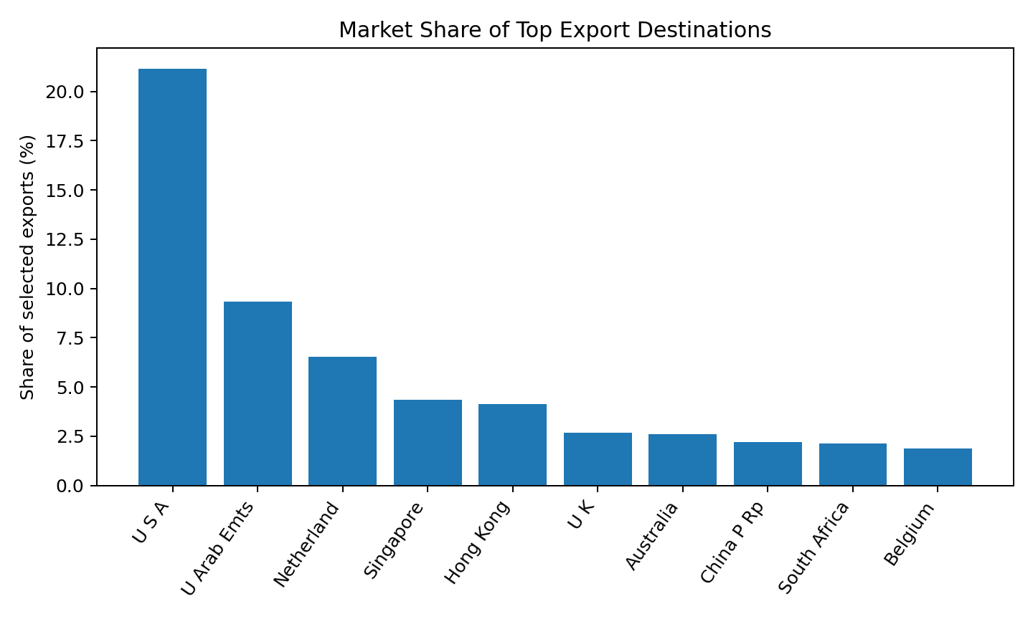
Insight: The United States accounted for 21.14% of export value, more than twice the share of the United Arab Emirates. This concentration indicates a need to balance established-market strength with diversification opportunities.
Figure 2
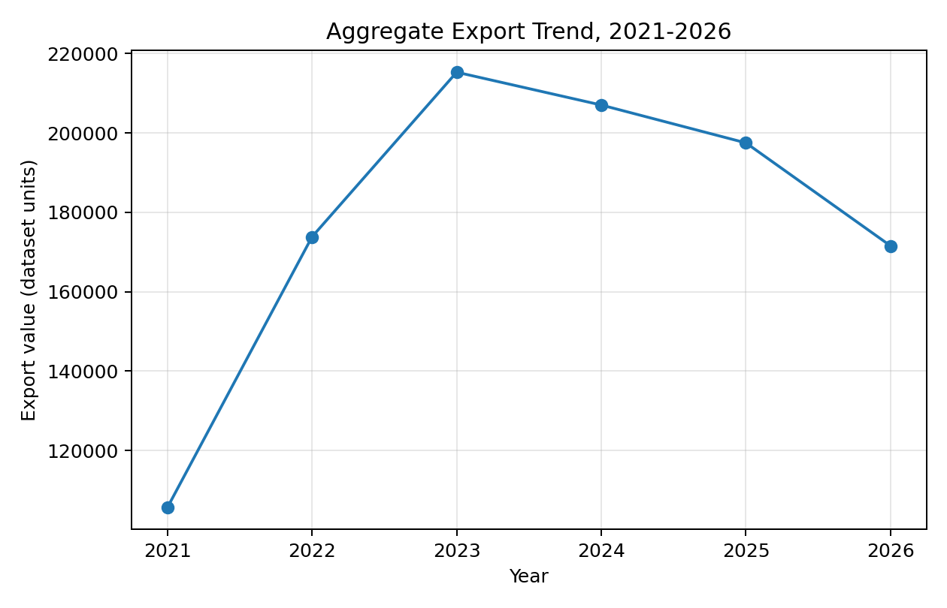
Insight: Figure 2 shows aggregate export value increasing from 105,623.29 in 2021 to 215,301.71 in 2023, followed by moderation to 207,030.96 in 2024, 197,492.25 in 2025, and 171,550.58 in 2026. The apparent 2026 decline must not be interpreted as a completed annual contraction until the reporting period is confirmed, because 2026 data may be partial. T
Figure 3
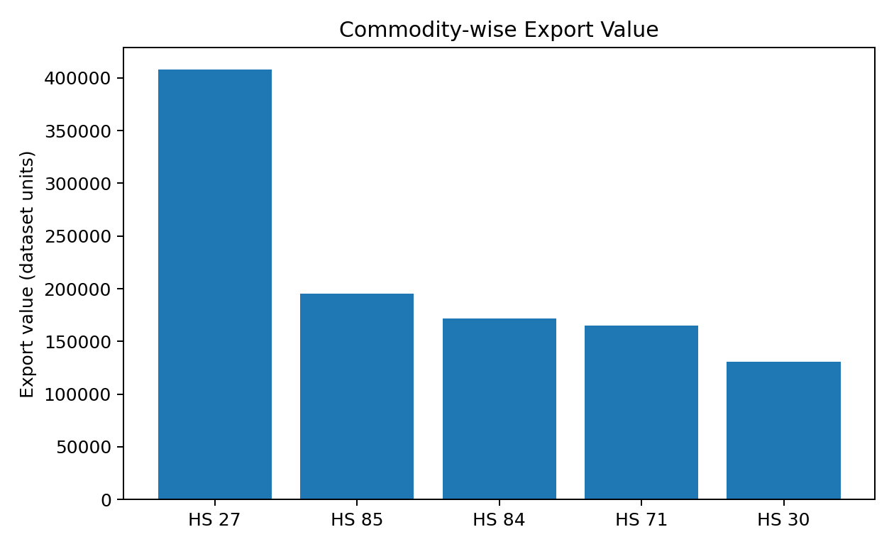
Insight: HS Chapter 27 recorded the highest export value throughout the study period, followed by HS Chapters 85, 84, 71, and 30. The variation across commodity groups supports commodity-specific export analysis.
Figure 4
Correlation Matrix for Export and Macroeconomic Variables
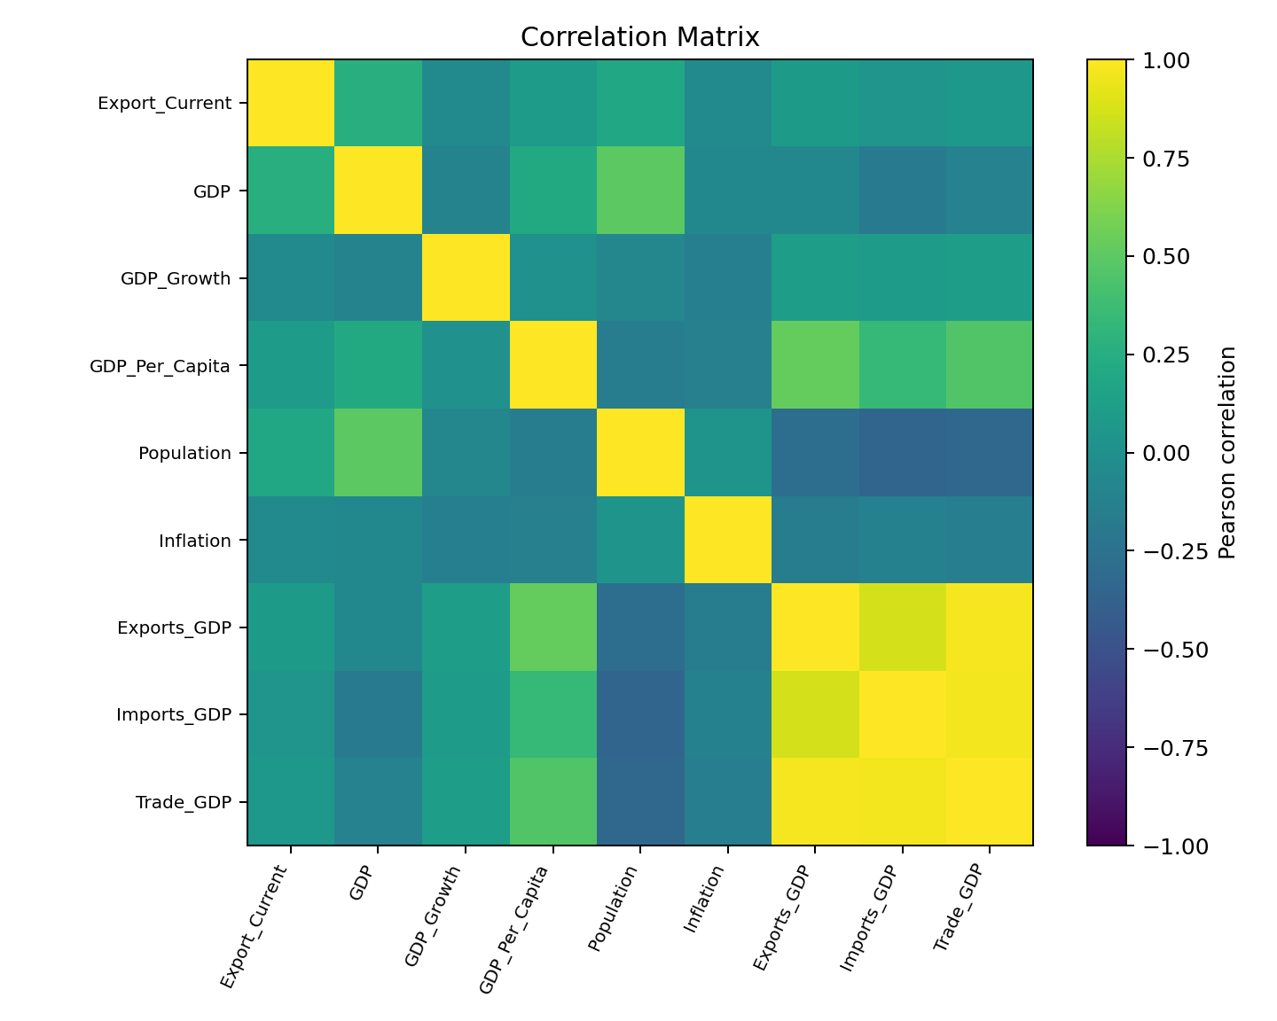
Insight: GDP showed the strongest positive correlation with export demand, followed by Population. Strong correlations among Exports (% GDP), Imports (% GDP), and Trade (% GDP) indicated multicollinearity, which was addressed using VIF analysis.
Table 10
EDA Insight Summary
Figure/Table | What it shows | Key insight | Why it matters | Decision/next step
Figure 1 | Country shares | USA is dominant at 21.14% | Answers market-demand component of RQ1 | Create product-specific destination rankings.
Figure 2 | Annual export totals | Growth to 2023, then lower totals | Shows temporal evolution for RQ1 | Verify whether 2026 is partial; use comparable annual periods.
Figure 3 | Commodity totals | HS 27 dominates current sample | Demonstrates product heterogeneity | Avoid one ranking for all products.
Figure 4 | Pairwise correlations | GDP has strongest export correlation; trade ratios are collinear | Preliminary evidence for RQ2 | Use VIF and alternative model specifications.
Missing-value table | Data completeness | Comtrade variables 100% missing; macro variables partially missing | Constrains RQ2 and prevents RQ3 | Correct extraction and define missing-data strategy.

Multicollinearity Assessment
Following the correlation analysis, multicollinearity among the predictor variables was assessed using the Variance Inflation Factor (VIF) before proceeding with regression modelling. Although the correlation matrix provided an initial indication of strong relationships among several macroeconomic indicators, VIF analysis was performed to quantify the extent of multicollinearity. The analysis was conducted using 2,688 complete observations after excluding records with missing values in the selected predictor variables.

Table 11

Final Variance Inflation Factor (VIF) Results
Variable | Final VIF | Decision
GDP | 1.93 | Retained
GDP_Per_Capita | 1.82 | Retained
Population | 1.67 | Retained
Trade_GDP | 1.55 | Retained
GDP_Growth | 1.06 | Retained
Inflation | 1.06 | Retained

Modelling

Choice of Models with Justification
Three regression models were developed to evaluate export demand. Multiple Linear Regression was used as an interpretable baseline, while Random Forest and XGBoost were applied to capture nonlinear relationships and interactions within the structured trade dataset. The models were evaluated using an 80:20 train-test split, with Mean Absolute Error (MAE), Root Mean Squared Error (RMSE), and R² used to compare predictive performance. Random Forest achieved the strongest performance and was therefore selected as the preferred predictive model for the interim analysis.

Table 12
Choice of Models with Justification
Model | Purpose | Justification | Interim Status
Multiple Linear Regression | Estimate the influence of macroeconomic indicators on export demand | Provides interpretable coefficients, hypothesis tests, confidence intervals, and adjusted R² for statistical inference | Completed
Random Forest Regression | Predict export demand and identify key predictive features | Captures nonlinear relationships and feature interactions without requiring strict statistical assumptions | Completed
XGBoost Regression | Benchmark predictive performance against other models | Well suited for structured tabular data and complex nonlinear relationships, often achieving high predictive accuracy | Completed
Export Market Attractiveness Score | Rank export markets based on multiple decision criteria | Combines normalized demand, growth, competition, macroeconomic indicators, and model predictions into a composite score | In Progress

Table 13

Features Included and Feature Engineering
Feature | Original/engineered | Type | Reason for inclusion | Status
Export_Current / Export_Value | Original/copy | Continuous | Current export demand outcome | Available
Export_Growth_Rate | Engineered | Continuous | Measures period-over-period growth | Available; infinities treated
Export_Previous | Original | Continuous | Captures historical export performance and temporal persistence | Available ; Used in RQ4 models
Market_Share | Engineered | Continuous | Relative annual export contribution | Available, but not India share of destination imports
Commodity | Original | Categorical | Controls product heterogeneity | Available
Country | Original | Categorical | Controls destination heterogeneity | Available
Year | Original | Integer/time | Captures time pattern | Available
GDP | Original | Continuous | Market economic size | Available with missingness
GDP_Growth | Original | Continuous | Economic momentum | Available with missingness
GDP_Per_Capita | Original | Continuous | Market income/development | Available with missingness
Population | Original | Continuous | Market size | Available with missingness
Inflation | Original | Continuous | Economic stability | Available with missingness
Trade_GDP | Original | Continuous | Trade orientation/openness | Retained after VIF-based feature selection; Exports_GDP
Destination import value and HHI | Planned | Continuous | Demand and supplier competition | Unavailable until Comtrade correction

Table 14

Evaluation Metrics
Metric | Formula | Interpretation | Use
Growth rate | ((Current - Previous) / Previous) x 100 | Percentage change between periods | RQ1 trend analysis
Pearson correlation | Cov(X,Y)/(σXσY) | Direction and strength of linear association | RQ2 – Correlation analysis
Adjusted R² | 1 - [(1-R²)(n-1)/(n-p-1)] | Measures the proportion of variance explained after adjusting for the number of predictors | RQ2 Regression model evaluation
Variance Inflation Factor | 1/(1-Rj²) | Detects multicollinearity among predictors | RQ2 Multicollinearity assessment
MAE | (1/n)Σ|yi-ŷi| | Average absolute prediction error | RQ4 model comparison
RMSE | sqrt[(1/n)Σ(yi-ŷi)²] | Penalizes larger errors | RQ4 model comparison
R² | 1 − (SSres / SStot) | Measures the proportion of variance explained by the predictive model | RQ4 – Predictive model comparison

Preliminary Results
Q1 Preliminary Findings
Analysis of 5,806 observations identified the United States as the largest export destination, accounting for 21.14% of total export value, followed by the United Arab Emirates (9.32%) and the Netherlands (6.52%). HS Chapter 27 recorded the highest export value, while HS Chapter 85 showed sustained growth over time. A Kruskal–Wallis test confirmed significant differences in export values across commodity groups, H = 415.89, p < .001. Therefore, H0₁ was rejected.

Table 15
Top Export Destination Markets (RQ1)
Rank | Destination | Share (%)
1 | U S A | 21.14
2 | U Arab Emts | 9.32
3 | Netherland | 6.52
4 | Singapore | 4.36
5 | Hong Kong | 4.12
6 | U K | 2.69
7 | Australia | 2.60
8 | China P Rp | 2.21
9 | South Africa | 2.12
10 | Belgium | 1.86

RQ2 Preliminary Findings
The RQ2 regression used 2,651 complete observations and six predictors retained after VIF-based feature selection. The overall model was statistically significant, F = 107.48, p < .001, and explained 23.3% of the variation in log-transformed export demand (adjusted R² = .232). GDP, Population, and GDP per Capita were significant positive predictors, while GDP Growth, Trade (% GDP), and Inflation were not significant at the 5% level. Therefore, H0₂ was rejected.

RQ3 Preliminary Findings

RQ3 remains in progress because the current UN Comtrade extraction did not produce usable India-specific supplier records. Consequently, India’s destination market share, supplier count, and Herfindahl–Hirschman Index have not yet been calculated, and H0₃ has not been evaluated. The extraction logic will be corrected before the final report.

Table 16

Multiple Linear Regression Results
Predictor | Coefficient | p-value | Interpretation
GDP | 0.592 | <0.001 | Significant positive influence
Population | 0.492 | <0.001 | Significant positive influence
GDP per Capita | 0.224 | <0.001 | Significant positive influence
GDP Growth | -0.063 | 0.055 | Marginal negative relationship; not statistically significant
Trade (% GDP) | 0.033 | 0.526 | Not statistically significant
Inflation | -0.000 | 0.993 | No statistically significant relationship

Preliminary Model Performance (RQ4)
Three predictive models were evaluated using an 80:20 train-test split consisting of 3,979 training observations and 1,006 testing observations (total sample = 4,985). Model performance was assessed using Mean Absolute Error (MAE), Root Mean Squared Error (RMSE), and the coefficient of determination (R²).
Table 17
Preliminary Model Performance Comparison
Model | Feature Set | Validation Approach | MAE | RMSE | Key Takeaway
Multiple Linear Regression | Export_Previous, GDP, GDP Growth, GDP per Capita, Population, Inflation, Trade (% GDP), Country, Commodity, Year | 80:20 Train-Test Split | 19,185.39 | 579,601.44 | Baseline model with poor predictive performance (R² = -365,776.36), indicating that linear regression could not capture the complex nonlinear relationships within the dataset..
Random Forest Regression | Same feature set | 80:20 Train-Test Split | 59.03 | 291.46 | Best-performing model with the lowest prediction errors and highest predictive accuracy (R² = 0.908).
XGBoost Regression | Same feature set | 80:20 Train-Test Split | 65.11 | 363.92 | Strong predictive performance, but slightly less accurate than Random Forest (R² = 0.856).

Interpretation: Random Forest produced the best predictive performance, followed by XGBoost, while Multiple Linear Regression performed poorly. These results indicate that nonlinear machine learning models are more suitable for predicting export demand than the baseline regression model. Therefore, H0₄ was rejected.

Interim Limitations and Risks
Despite the progress achieved in this interim phase, several limitations remain that will be addressed in the final report:
- The current analysis focuses on five major HS commodity chapters, rather than the full set of export product categories. Additional commodity groups will be incorporated during the final phase to improve the generalizability of the findings.
- Several World Bank macroeconomic indicators contain missing observations, reducing the usable sample size for the regression analysis from 5,806 to 2,651 observations.
- The UN Comtrade extraction currently requires further validation before supplier competition and market concentration measures can be computed for Research Question 3. Consequently, RQ3 remains incomplete in the interim report.
- Country names across multiple datasets required standardization. While harmonization procedures were applied, additional validation using ISO country codes will further improve data consistency.
- Export values exhibited substantial positive skewness and several extreme observations. These were retained because they represent genuine trade activity; instead, a logarithmic transformation and HC3 robust standard errors were applied to improve model reliability.
- The 2026 trade data may represent a partial reporting period and should therefore be interpreted with caution when comparing annual export trends.

Next Steps for the Final Report
The following activities will be completed during the final phase of the project:
- Correct the UN Comtrade extraction and complete Research Question 3, including India's destination market share, supplier competition analysis, and the Herfindahl–Hirschman Index (HHI).
- Develop the Export Market Attractiveness Score by combining historical export demand, macroeconomic indicators, supplier competition, market growth, and predictive model outputs.
- Perform feature importance interpretation and sensitivity analysis to improve the explainability and robustness of the predictive models.
- Build an interactive Power BI dashboard to visualize export opportunities, market rankings, and model predictions.
- Validate the predictive modelling framework using additional robustness checks and finalize business recommendations for Indian exporters.
- Complete the project documentation, including the repository README, data dictionary, and reproducibility guidelines.

References
Andersen, P. H., & Strandskov, J. (1998). International market selection: A cognitive mapping perspective. Journal of Global Marketing, 11(3), 65-84.
Batarseh, F. A., Gopinath, M., Nalluru, G., & Beckman, J. (2019). Application of machine learning in forecasting international trade trends. arXiv. https://arxiv.org/abs/1910.03112
Brenton, P., & Newfarmer, R. (2007). Watching more than the discovery channel: Export cycles and diversification in development (Policy Research Working Paper No. 4302). World Bank.
Caldarelli, G., Cristelli, M., Gabrielli, A., Pietronero, L., Scala, A., & Tacchella, A. (2012). A network analysis of countries’ export flows: Firm grounds for the building blocks of the economy. PLOS ONE, 7(10), e47278. https://doi.org/10.1371/journal.pone.0047278
Decreux, Y., & Spies, J. (2016). Export potential assessments: A methodology to identify export opportunities for developing countries. International Trade Centre.
El Kefi, S. (2021). Application of DEA in international market selection for the export of products from Spain. arXiv. https://arxiv.org/abs/2110.03512
Gaston-Breton, C., & Martin Martin, O. (2011). International market selection and segmentation: A two-stage model. International Marketing Review, 28(3), 267-290. https://doi.org/10.1108/02651331111132857
Hausmann, R., & Hidalgo, C. A. (2011). The network structure of economic output. Journal of Economic Growth, 16, 309-342. https://doi.org/10.1007/s10997-011-9071-4
Hidalgo, C. A., Klinger, B., Barabasi, A.-L., & Hausmann, R. (2007). The product space conditions the development of nations. Science, 317(5837), 482-487. https://doi.org/10.1126/science.1144581
Papadopoulos, N., Chen, H., & Thomas, D. R. (2002). Toward a tradeoff model for international market selection. International Business Review, 11(2), 165-192.
Rhoades, S. A. (1993). The Herfindahl-Hirschman Index. Federal Reserve Bulletin, 79, 188-189.
Silva, T. C., Wilhelm, P. V. B., & Amancio, D. R. (2024). Machine learning and economic forecasting: The role of international trade networks. arXiv. https://arxiv.org/abs/2404.08712

