Data Analytics Capstone

AI-Driven Export Market Decision Support System for Indian Exporters Using
Public Trade and Macroeconomic Data

Final Report
Pavithra Bharathi
Walsh College
QM640: Data Analytics Capstone
Mentor: Vikas
Term 3
September 2026

GitHub Repository
https://github.com/bharathipavithra10-cmd/AI-Export-Market-Decision-Support

Abstract
International market selection is a complex decision for Indian exporters because export opportunities depend on multiple factors, including historical export performance, market growth, destination demand, macroeconomic conditions, India’s existing market presence, supplier competition, and future demand potential. Although public sources provide extensive trade and economic information, these datasets are fragmented and do not directly provide an integrated mechanism for prioritizing country–commodity export opportunities. This study develops an AI-driven Export Market Decision Support System to address this gap.
The study integrates India-specific export data from TradeStat, international trade and supplier information from UN Comtrade, and macroeconomic indicators from the World Bank. The analytical workflow combines exploratory data analysis, statistical hypothesis testing, supplier-competition analysis using the Herfindahl–Hirschman Index (HHI), standardized regression analysis, and machine-learning models. Linear Regression, Random Forest, and XGBoost were evaluated using an out-of-time validation design in which historical observations through 2024 were used for model development and 2025 was retained as the test period. Random Forest achieved the strongest predictive performance, with a log-scale RMSE of 0.6299 and R² of 0.9224, representing a 41.79% reduction in RMSE relative to the Linear Regression baseline.
The final Export Market Attractiveness Score (EMAS) integrates six dimensions: Export Performance, Growth, Economic Strength, Import Demand, India Opportunity, and Competition. The framework evaluated 231 country–commodity combinations across 48 destination countries and five HS commodity groups. China–HS85 emerged as the highest-ranked opportunity with an EMAS score of 87.103, followed by China–HS27 at 86.713 and China–HS84 at 78.793. Sensitivity analysis identified 13 Priority Export Opportunities that remained within the Top 20 across all five weighting scenarios.
The framework is implemented using Python and commonly used statistical and machine-learning libraries and is designed as a first-stage strategic market-screening tool. It can support exporters, analysts, and trade-development decision-makers in prioritizing promising international markets before conducting detailed product-level, tariff, regulatory, logistics, pricing, and market-entry feasibility assessments.

Introduction

Background and Context
International trade contributes materially to India's economic activity, yet selecting suitable export markets requires exporters to evaluate multiple signals simultaneously. Market size alone is insufficient: a large destination may already be highly competitive, while a smaller destination may offer stronger growth, lower concentration, or greater room for Indian suppliers. This challenge is especially relevant for micro, small, and medium enterprises, which may not have access to integrated market-intelligence platforms or dedicated analytical teams.
Public sources such as TradeStat, UN Comtrade, and World Bank Open Data provide complementary information, but they are maintained separately and differ in structure, naming conventions, units, coverage, and reporting periods. TradeStat provides India-specific exports by destination and commodity; UN Comtrade provides destination import demand and supplier structure; and World Bank indicators describe destination-country economic conditions. Integrating these sources creates a more complete country-commodity view than any single source can provide.
This project develops an AI-driven Export Market Decision Support System that combines descriptive analytics, statistical inference, machine learning, competition analysis, and a transparent composite ranking framework. The system is designed to identify promising country-commodity opportunities and explain why they rank highly, while retaining a clear distinction between analytical screening and a final commercial market-entry decision.

Problem Statement
The objective of this study is to predict and explain Y = export demand and strategic export-market attractiveness for Indian commodity-country-year observations using X = historical exports, export growth, destination import demand, India's market share, supplier concentration, macroeconomic indicators, country, commodity, and year over the available 2021-2026 trade period. Success is evaluated using statistical significance at α = .05, regression diagnostics, out-of-time MAE/RMSE/R², and the stability of final EMAS rankings under alternative weighting scenarios.

Purpose of the Study
The study aims to explain current export-demand patterns, identify significant macroeconomic drivers, quantify competitive market structure, predict export demand using machine learning, and combine these signals into an interpretable Export Market Attractiveness Score. The final objective is a reproducible screening framework that prioritizes international markets for further commercial evaluation.

Research Problem/ Research Questions
RQ1: Which Indian products and destination markets currently demonstrate the highest export demand, and how have these patterns evolved over time?
RQ2: Which macroeconomic and trade-related factors significantly influence export demand across international markets?
RQ3: How do supplier competition and India’s market share influence export opportunities across international markets?
RQ4: Can machine-learning models improve prediction of export demand relative to a linear baseline and support identification of attractive export markets?

Contributions and Expected Value
Practical contribution: A transparent market-screening framework that converts fragmented trade, economic, competition, and predictive information into prioritized country-commodity opportunities.
Technical contribution: An integrated workflow combining statistical hypothesis testing, robust regression, HHI-based competition measures, out-of-time machine-learning evaluation, composite scoring, and sensitivity analysis.
Value to stakeholders/target users: Exporters and trade-development analysts can reduce manual screening effort, focus detailed due diligence on a smaller set of defensible opportunities, and understand the factors contributing to each ranking.

Literature Review

Literature Review Approach
The literature review was organized around four themes aligned with the research questions: international market selection and screening, export diversification and product structure, supplier concentration and market competition, and machine learning for international trade forecasting. Peer-reviewed articles, institutional methodologies, and recognized working papers were prioritized when they provided a direct theoretical or methodological link to market

Summary of Key Literature
Table 1. Literature Relevance Matrix
Author (Year) | Domain/Context | Method(s) | Key Finding | Project Relevance
Andersen & Strandskov (1998) | International market selection | Conceptual/cognitive mapping | Market choice depends on how decision-makers structure multiple signals. | Supports transparent multi-factor screening.
Papadopoulos et al. (2002) | Market screening | Trade-off model | Market attractiveness requires balancing opportunity and risk. | Supports composite ranking.
Gaston-Breton & Martin Martin (2011) | Market selection | Two-stage model | Country screening should precede detailed segmentation. | Supports staged screening-to-recommendation workflow.
Brenton & Newfarmer (2007) | Export diversification | Cross-country trade analysis | Export growth reflects intensive and extensive margins. | Supports established and emerging market analysis.
Hidalgo et al. (2007) | Product space | Network analysis | Development depends on related product capabilities. | Supports commodity-level differentiation.
Hausmann & Hidalgo (2011) | Economic complexity | Network structure | Product mix and capabilities shape economic output. | Supports product-market structure.
Caldarelli et al. (2012) | Export networks | Network analysis | Trade networks reveal structural relationships beyond totals. | Supports competition/network perspective.
Decreux & Spies (2016) | Export potential | ITC methodology | Export potential combines supply, demand and market access. | Directly informs EMAS design.
Rhoades (1993) | Supplier concentration | HHI methodology | HHI summarizes concentration using squared supplier shares. | Supports RQ3 competition metric.
Batarseh et al. (2019) | Trade forecasting | Machine learning | ML can capture nonlinear patterns in trade data. | Supports RF/XGBoost comparison.
El Kefi (2021) | Market selection | Data envelopment analysis | Multi-criteria methods can prioritize export markets. | Provides ranking benchmark.

Literature Synthesis and Relevance to the Present Study

International Market Selection and Multi-Criteria Decision Making
International market selection is inherently a multi-dimensional decision problem. Prior research indicates that market attractiveness cannot be adequately determined using market size or historical export performance alone. Papadopoulos et al. (2002) proposed a trade-off perspective for international market selection in which multiple dimensions of market attractiveness are considered simultaneously. Gaston-Breton and Martin Martin (2011) similarly emphasized a structured approach to international market selection and segmentation, while El Kefi (2021) demonstrated the applicability of quantitative multi-criteria methods to export-market prioritization. Collectively, these studies support the central design principle of the present project: export opportunities should be evaluated using multiple complementary indicators rather than ranked using a single trade measure. Accordingly, the Export Market Attractiveness Score (EMAS) combines export performance, growth, economic strength, import demand, India opportunity, and supplier competition within a transparent decision-support framework.

Export Potential, Diversification, and Product-Market Structure
The literature on export diversification further demonstrates that export opportunity varies across products as well as destination markets. Brenton and Newfarmer (2007) highlight the importance of product and market diversification in export development. Hidalgo et al. (2007) show that the relationships among products exported by countries provide information about underlying productive capabilities, while Hausmann and Hidalgo (2011) further demonstrate that the structure of economic output is related to a country's productive knowledge and product composition. Decreux and Spies (2016) propose an export-potential assessment methodology that combines supply capacity, destination demand, and market-access considerations. These findings support the use of country–commodity combinations as the unit of strategic analysis in the present study rather than generating a single overall attractiveness score for each destination country.

Supplier Competition and Market Structure
A destination with high import demand may not necessarily represent an equally attractive opportunity for every exporter because supplier structure and existing market presence can materially influence the potential for expansion. The Herfindahl–Hirschman Index provides a systematic approach for measuring market concentration based on the squared shares of participating suppliers (Rhoades, 1993). Trade-network research also demonstrates that structural relationships among countries and trading partners contain information that cannot be observed from aggregate trade values alone (Caldarelli et al., 2012). These findings directly support RQ3 and the inclusion of supplier concentration and India's existing market share within the final EMAS framework. Incorporating competition indicators helps distinguish between markets with substantial import demand but concentrated supplier structures and those that may provide comparatively greater room for Indian exporters.

Machine Learning and Export-Demand Prediction
Machine-learning methods provide an additional mechanism for identifying nonlinear relationships and interactions that may not be adequately represented by traditional linear models. Batarseh et al. (2019) demonstrate the applicability of machine-learning methods to international trade forecasting, supporting their use alongside conventional statistical approaches. In the present study, Linear Regression is therefore used as an interpretable baseline, while Random Forest and XGBoost provide nonlinear alternatives capable of capturing interactions among trade, destination, commodity, and macroeconomic characteristics. Rather than assuming that the more complex models necessarily provide superior performance, all three models are evaluated using the same out-of-time test period. This enables model selection to be based on empirical generalization performance on unseen temporal data.

Literature Gap and Contribution of the Present Study
The reviewed literature provides strong foundations for international market selection, export-potential assessment, supplier-concentration analysis, economic structure, and machine-learning-based trade prediction. However, these analytical perspectives are often considered independently. The present study contributes an integrated and explainable decision-support workflow combining Indian export performance, destination import demand, macroeconomic conditions, India's existing market position, supplier competition, machine-learning-based demand prediction, and sensitivity analysis. The resulting EMAS framework is intended as a first-stage strategic screening mechanism rather than an automatic market-entry rule. Its purpose is to reduce a large set of potential country–commodity combinations to a smaller and analytically defensible shortlist for subsequent commercial, regulatory, tariff, logistics, pricing, and firm-specific feasibility assessment.

Materials and Methods

Data Sources and Analytical Scope
The project uses three public data sources. TradeStat provides India-specific export values by destination, commodity and year; UN Comtrade provides destination import demand and supplier-level trade values; and World Bank World Development Indicators provide Inclusion and Exclusion Criteria
macroeconomic measures. The integrated TradeStat analytical dataset contains 6,040 rows. Final EMAS scoring is conducted on 231 eligible country-commodity observations spanning 48 countries and five HS chapters (27, 30, 71, 84 and 85).
Table 2. Data Sources
Source | Purpose | Key Variables | Role
TradeStat, Government of India | India export performance | Country, Commodity, Year, Export_Current, Export_Previous, growth | RQ1, RQ4, EMAS
UN Comtrade | Destination demand and supplier competition | Total imports, India imports/share, supplier count, HHI | RQ3, EMAS
World Bank WDI | Destination economic conditions | GDP, GDP growth, GDP per capita, population, inflation, trade/GDP | RQ2, RQ4, EMAS

The analytical datasets were constructed according to the data requirements of each research question. Trade observations relating to the five selected HS commodity chapters—HS27, HS30, HS71, HS84, and HS85—were retained for the study. Country names were standardized across TradeStat, UN Comtrade, and World Bank sources to enable consistent integration. Numeric variables were converted to appropriate numeric formats, invalid or infinite values were treated as missing where applicable, and export-growth measures were recalculated when required.
Analysis-specific subsets were created according to variable availability and methodological requirements. RQ1 used observations suitable for descriptive export-demand and commodity-group analysis. RQ2 retained complete observations required for standardized multiple-regression analysis. RQ3 used destination–commodity market information required to evaluate supplier competition, market concentration, and India's existing market position. RQ4 retained observations suitable for temporal predictive modeling and separated historical training data from the held-out 2025 test period.

For construction of the final EMAS framework, eligible country–commodity observations with the information required for the final scoring dimensions were retained, resulting in 231 candidate opportunities across 48 destination countries and five HS commodity groups. For required Economic Strength variables, the latest complete World Bank observation available at or before the corresponding trade year was used. This approach preserved the final EMAS candidate population without applying mean or median imputation to the required macroeconomic indicators.

Data Preprocessing and Feature Engineering
Country names were standardized across sources before merging. Numeric fields were coerced to valid numeric types and infinite values were treated as missing. Export growth was recalculated where required. Because percentage growth can become unstable when the previous export base is very small, analytical growth was winsorized and observations with missing or very small historical bases received a neutral Growth Score in EMAS. For RQ2, Exports_GDP and Imports_GDP were removed after multicollinearity assessment, leaving all retained VIF values between 1.06 and 1.93.
For EMAS macroeconomic integration, the latest available complete World Bank observation at or before the relevant trade year was used for GDP, GDP per capita and population. This preserved all 231 EMAS candidate observations without mean or median imputation of the required economic-strength variables. Optional inflation and trade/GDP values could remain missing because they were not used in the final EMAS Economic Strength dimension.

Research Hypotheses and Sample Size
Table 3. Research Questions, Hypotheses and Methods
RQ | Null Hypothesis (H₀) | Alternative Hypothesis (Hₐ) | Method | Usable Sample / Unit
RQ1 | Export-value distributions do not differ across commodity groups. | Export-value distributions significantly differ across at least one of the selected commodity groups. | Descriptive analysis; Kruskal-Wallis test | 5,019 growth-analysis observations; commodity groups
RQ2 | Selected macroeconomic indicators do not significantly influence export demand. | At least one selected macroeconomic indicator significantly influences export demand. | VIF; standardized OLS with HC3 robust SE | 2,651 complete observations
RQ3 | Supplier competition and India market share do not materially differentiate export opportunities. | Supplier competition and/or India market share materially differentiate export opportunities. | Market share, supplier count, HHI, opportunity screening | Country-commodity destination markets
RQ4 | ML models do not improve predictive performance over Linear Regression. | At least one machine-learning model improves out-of-time predictive performance relative to Linear Regression. | Out-of-time Linear/RF/XGBoost comparison | Train ≤ 2024; Test=2025

Formal inferential hypothesis testing was evaluated at the 5% significance level (α = .05) where applicable. RQ1 was evaluated using the Kruskal–Wallis test because export-value distributions were strongly skewed across multiple independent commodity groups. RQ2 was evaluated using standardized Ordinary Least Squares (OLS) regression with HC3 robust standard errors after multicollinearity assessment. RQ3 was evaluated primarily as a descriptive market-structure and strategic-screening question using India market share, supplier count, and the Herfindahl–Hirschman Index (HHI), rather than a single inferential significance test. RQ4 was evaluated through comparative out-of-time predictive performance, with log-scale Root Mean Squared Error (RMSE) serving as the primary model-selection metric.

Minimum Sample Size and Analytical Adequacy
Table 3A. Sample Size Assessment by Research Question
Research Question | Analysis Method | Minimum Required Sample | Actual Sample / Evaluation Basis | Adequacy
RQ1 | Kruskal–Wallis test | 237 | 5,019 usable observations | Adequate
RQ2 | Multiple Linear Regression | 109 | 2,651 complete observations | Adequate
RQ3 | Supplier competition and market-concentration analysis | 85 | 317 destination–commodity markets | Adequate
RQ4 | Out-of-time predictive modeling | 109 | Train ≤ 2024; Test = 2025 | Adequate
Minimum sample-size requirements were assessed separately for each research question because the analytical methods and units of analysis differ across the four analyses. The established minimum sample requirements were 237 observations for RQ1, 109 observations for RQ2, 85 market-level observations for RQ3, and 109 observations for RQ4. The final analytical datasets provided sufficient coverage relative to these requirements. RQ1 used 5,019 usable growth-analysis observations, while RQ2 used 2,651 complete observations. RQ3 was evaluated using eligible country–commodity destination markets with the required supplier-competition and India-share information. RQ4 used a temporal validation design in which historical observations through 2024 were used for model development and 2025 observations were reserved for out-of-time testing.
For RQ1, the final growth-analysis dataset contains 5,019 usable observations across the selected commodity groups, substantially exceeding the minimum sample requirement of 237 observations. This provides substantial empirical coverage for the Kruskal–Wallis comparison and supports stable assessment of differences among commodity-group export-value distributions.
For RQ2, 2,651 complete observations were available for the final standardized OLS regression, substantially exceeding the minimum sample requirement of 109 observations. Multicollinearity was evaluated before model estimation, and Exports_GDP and Imports_GDP were removed following the Variance Inflation Factor (VIF) assessment. The retained predictors had VIF values between 1.06 and 1.93. HC3 robust standard errors were used to account for heteroskedasticity identified during model diagnostics.
For RQ3, the minimum required sample was 85 market-level observations. The final analytical sample contained 317 destination–commodity markets, substantially exceeding this requirement. The analysis used destination import demand, India market share, supplier count, and HHI to characterize supplier competition and identify potential export opportunities. Application of the opportunity- screening criteria subsequently identified 45 potential opportunity markets. Thus, the 45 markets represent the screened opportunity subset rather than the full RQ3 analytical sample.
For RQ4, the minimum required sample was 109 observations. The final predictive dataset substantially exceeded this requirement. Historical observations through 2024 were used for model development, while 2025 was reserved as the out-of-time test period. Linear Regression, Random Forest, and XGBoost were evaluated using the same held-out period, preventing future-period observations from being used during model training and providing a realistic assessment of predictive generalization.
Overall, the final analytical samples exceed the established minimum requirements for the inferential analyses in RQ1 and RQ2, while RQ3 and RQ4 use adequacy criteria appropriate to their descriptive and predictive objectives, respectively. Analysis-specific sample coverage, statistical diagnostics, and temporal validation were therefore used to ensure that each research question was evaluated using data appropriate to its methodological purpose.

Architecture diagram/Workflow
System Overview
The end-to-end pipeline transforms three independent public data sources into a unified analytical dataset, research-question outputs, machine-learning predictions, and a final market-prioritization layer. Figure 1 summarizes the workflow.
Figure 1. End-to-End Workflow of the Proposed System
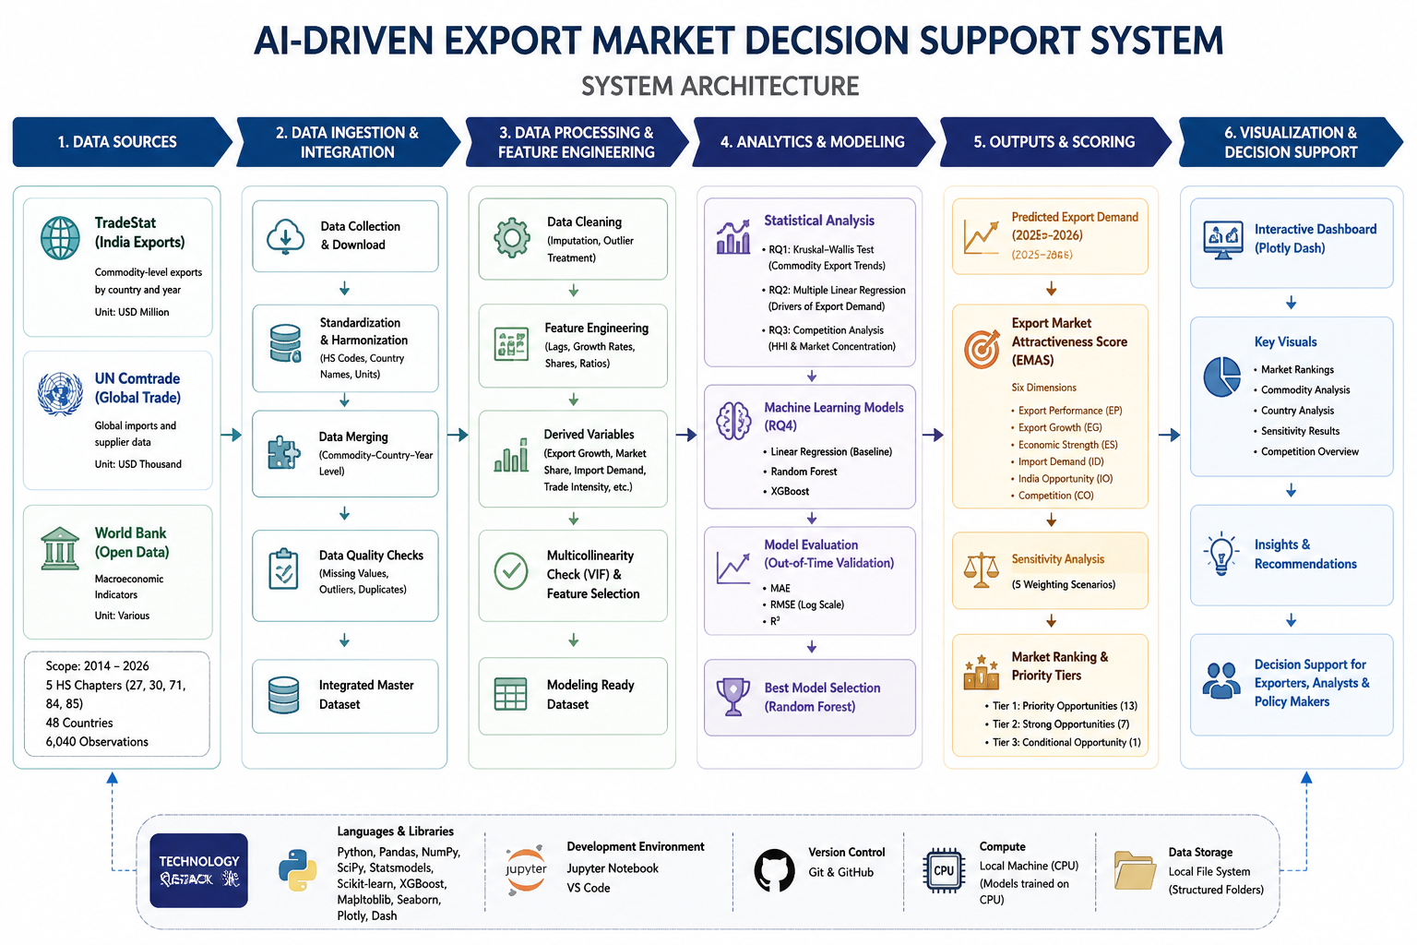

Workflow Components
Data Ingestion
TradeStat Excel workbooks, a UN Comtrade extract, and a World Bank workbook are loaded into a repository-based Python environment. Source-specific fields are retained only where needed for the research questions and final scoring framework.
Data Preprocessing
Preprocessing includes country-name harmonization, numeric conversion, missing-value checks, year alignment, removal of infinite values, log transformation for skewed export demand, one-hot encoding of categorical predictors, median imputation for numeric model inputs, and scaling where required by the preprocessing pipeline.
Exploratory Data Analysis (EDA)
EDA evaluates dataset structure, missingness, export distributions, destination shares, commodity trends, growth distributions, correlations, and multicollinearity. These diagnostics guide the selection of robust statistical and predictive methods.
Feature Engineering
Engineered features include recalculated export growth, market-share measures, HHI-based competition indicators, log-transformed export demand, Random Forest demand predictions, normalized EMAS component scores, and robustness measures derived from sensitivity analysis.
Model Development
Linear Regression provides an interpretable baseline. Random Forest and XGBoost capture nonlinearities and interactions. The final Random Forest uses 300 trees with min_samples_leaf=2; XGBoost uses 400 estimators, learning rate 0.05, maximum depth 5, subsample 0.8 and column subsample 0.8.
Model Evaluation
Models are evaluated primarily on the log-transformed target using MAE, RMSE and R², with original-scale metrics retained for business interpretation. Model selection is based primarily on log-scale RMSE because the export distribution is strongly right-skewed.
Deployment
The current implementation is a reproducible Python notebook and repository workflow. The final EMAS outputs are structured for use in a dashboard or lightweight analytical application; a production API or cloud deployment is a future extension rather than a completed component of this study.
Tools and Technologies
Python; pandas; NumPy; SciPy; statsmodels; scikit-learn; XGBoost; Matplotlib; Jupyter/Google Colab; GitHub; Microsoft Excel source files. The analysis is designed for standard CPU execution and does not require GPU computing.

Results

Model Performance
Table 4. RQ4 Model Performance Comparison (Test Data)
Model | MAE (Log) | RMSE (Log) | R² (Log) | MAE Original | RMSE Original | R² Original
Random Forest | 0.3181 | 0.6299 | 0.9224 | 59.03 | 291.46 | 0.9075
XGBoost | 0.3267 | 0.6602 | 0.9148 | 65.11 | 363.92 | 0.8558
Linear Regression | 0.8036 | 1.0821 | 0.7710 | 19,185.39 | 579,601.44 | -365,776.36

Table 5. RQ4 Train–Test Performance Comparison (Log Scale)
Model | Train MAE | Test MAE | Train RMSE | Test RMSE | Train R² | Test R²
Random Forest | 0.1702 | 0.3181 | 0.3386 | 0.6299 | 0.9771 | 0.9224
XGBoost | 0.2305 | 0.3267 | 0.3648 | 0.6602 | 0.9735 | 0.9148
Linear Regression | 0.7767 | 0.8036 | 1.0627 | 1.0821 | 0.7749 | 0.7710

Train–Test Generalization and Model Selection
Train and test performance were compared to assess model generalization and potential overfitting. Linear Regression showed similar train and test performance, with RMSE increasing from 1.0627 to 1.0821 and R² decreasing from 0.7749 to 0.7710, indicating limited overfitting but substantially weaker predictive performance. Random Forest exhibited a larger train–test gap, with RMSE increasing from 0.3386 to 0.6299 and R² decreasing from 0.9771 to 0.9224, indicating some overfitting while retaining strong out-of-time generalization. XGBoost showed a similar pattern, with RMSE increasing from 0.3648 to 0.6602 and R² decreasing from 0.9735 to 0.9148.
Random Forest was selected as the final predictive model because it achieved the lowest test log-scale RMSE (0.6299) and the highest test R² (0.9224). XGBoost also demonstrated strong out-of-time performance, with RMSE of 0.6602 and R² of 0.9148, while Linear Regression produced substantially weaker results with RMSE of 1.0821 and R² of 0.7710. Random Forest therefore reduced test RMSE by 41.79% relative to the Linear Regression baseline.
Log-scale RMSE was used as the primary model-selection criterion because export demand is strongly right-skewed. Although both nonlinear models exhibited larger train–test gaps than Linear Regression, they retained substantially stronger performance on the held-out 2025 test data. Random Forest was therefore retained to generate the predicted export-demand component incorporated into the final EMAS framework.
Figure 2. Out-of-Time Model Performance
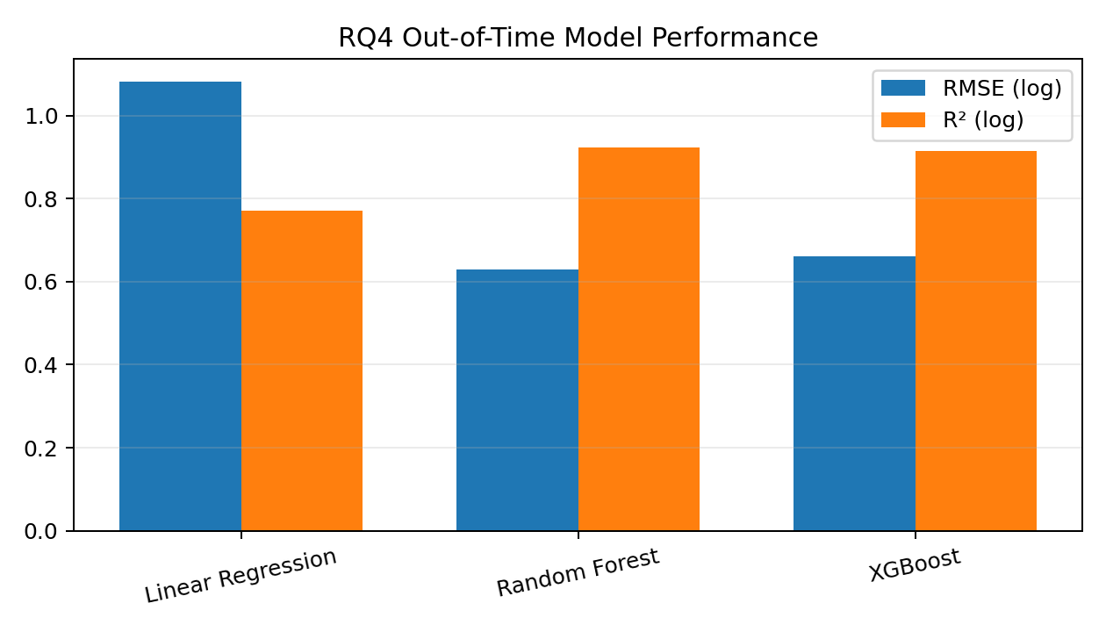

Visual Evidence
The final notebook also evaluates actual-versus-predicted values, residuals versus fitted values, Q-Q behavior, correlation structure, and Random Forest feature importance. The residual diagnostics indicate non-constant variance and departures in the tails, supporting the use of robust inference for RQ2 and nonlinear models for RQ4.

Results by Research Question

Research Question 1
RQ1 identified substantial differences in export demand across destination markets and commodity groups. The United States accounted for 21.14% of total export value in the selected dataset, followed by the United Arab Emirates (9.32%) and the Netherlands (6.52%). HS27 recorded the highest export value, while commodity growth patterns differed materially over time. The Kruskal-Wallis test was statistically significant, H = 415.8915, p < .001, so H0₁ was rejected. Export-value distributions therefore differ significantly across the five commodity groups.
Table 6. Top Export Destinations in RQ1
Rank | Destination | Share (%)
1 | United States | 21.14
2 | United Arab Emirates | 9.32
3 | Netherlands | 6.52
4 | Singapore | 4.36
5 | Hong Kong | 4.12
6 | United Kingdom | 2.69
7 | Australia | 2.6
8 | China | 2.21
9 | South Africa | 2.12
10 | Belgium | 1.86

Research Question 2
The Research Question 2 regression used 2,651 complete observations. The overall model was statistically significant (F = 107.5, p < .001) and explained 23.3% of the variation in log export demand (adjusted R² = .232). GDP (β = .592, p < .001), Population (β = .492, p < .001), and GDP per capita (β = .224, p < .001) were significant positive predictors. GDP growth was marginal but not significant at 5% (p = .055), while Inflation (p = .993) and Trade/GDP (p = .526) were not significant. H0₂ was rejected because at least one macroeconomic indicator significantly influenced export demand.
Table 7. RQ2 Multiple Regression Results
Predictor | Standardized Coefficient | p-value | Interpretation
GDP | 0.592 | <.001 | Significant positive
Population | 0.492 | <.001 | Significant positive
GDP per capita | 0.224 | <.001 | Significant positive
GDP growth | -0.063 | .055 | Not significant at 5%
Trade/GDP | 0.033 | .526 | Not significant
Inflation | -0.0003 | .993 | Not significant

Research Question 3
Research Question 3 uses UN Comtrade supplier-level imports to characterize destination demand, India's share, supplier count and HHI. Across the final market-screening data, the median destination total imports were approximately 494.64 million, the median India market share was 0.596%, and the median HHI was 2,068.78. Applying the RQ3 opportunity criteria identified 45 potential country-commodity opportunity markets. Large low-share, relatively unconcentrated examples included China-HS85, China-HS27, China-HS84, France-HS84, Belgium-HS30 and other European markets. These findings show that large import demand alone is insufficient; India's current penetration and supplier concentration materially change the opportunity interpretation.
Table 8. Illustrative RQ3 Opportunity Markets
Destination | HS | Total Imports | India Share (%) | Suppliers | HHI | Competition
China | 85 | 408.98B | 0.190 | 201 | 1318.94 | Unconcentrated
China | 27 | 273.27B | 0.059 | 109 | 573.45 | Unconcentrated
China | 84 | 172.76B | 0.502 | 182 | 1062.97 | Unconcentrated
France | 84 | 140.68B | 0.594 | 220 | 898.63 | Unconcentrated
Czechia | 84 | 62.92B | 0.271 | 188 | 1651.34 | Moderately concentrated
Belgium | 30 | 36.89B | 0.142 | 124 | 1317.48 | Unconcentrated

Research Question 4
Random Forest outperformed both XGBoost and Linear Regression in the out-of-time 2025 test set. Random Forest achieved log RMSE = 0.6299 and R² = 0.9224, compared with Linear Regression RMSE = 1.0821 and R² = 0.7710. The 41.79% RMSE improvement over the linear baseline supports rejection of H0₄. Random Forest was therefore selected to generate the predictive demand signal used in the final market-screening framework.

Overall Interpretation
The results across the four research questions demonstrate that export-market attractiveness is multidimensional. RQ1 establishes that export-demand distributions differ significantly across the selected commodity groups, supporting commodity-specific market assessment rather than treating all products uniformly. RQ2 demonstrates that destination macroeconomic conditions provide meaningful explanatory information for export demand. RQ3 shows that destination import demand should be interpreted together with supplier concentration and India's existing market position when identifying potential expansion opportunities. RQ4 demonstrates that nonlinear machine-learning models provide stronger out-of-time predictive performance than the Linear Regression baseline, with Random Forest achieving the best overall predictive performance.
Together, these findings provide the analytical foundation for the Export Market Attractiveness Score (EMAS). Rather than relying on historical export value, predicted demand, economic conditions, or competition independently, EMAS integrates six complementary dimensions: Export Performance, Growth, Economic Strength, Import Demand, India Opportunity, and Competition. Sensitivity analysis further evaluates whether the resulting market priorities remain stable under alternative strategic weighting assumptions.

Export Market Attractiveness Score (EMAS)
The final EMAS framework evaluates 231 country-commodity combinations using six dimensions. Historical export demand and Random Forest predicted demand were consolidated into Export Performance to avoid double-counting after a correlation of approximately 0.97 was observed between their normalized scores. Growth was treated separately, while Economic Strength, Import Demand, India Opportunity and Competition represent distinct market characteristics.
Table 9. Final EMAS Dimensions and Weights
Dimension | Weight | Interpretation
Export Performance | 0.25 | Historical and predicted export demand consolidated into one performance dimension
Growth | 0.10 | Recent export momentum, with small-base neutralization
Economic Strength | 0.15 | GDP, GDP per capita and population
Import Demand | 0.20 | Destination demand for the commodity
India Opportunity | 0.15 | Greater room for India where current share is lower
Competition | 0.15 | More favorable score where supplier concentration is lower

All 231 observations received complete normalized scores. Twenty-six observations received a neutral Growth Score because growth was missing or the previous export base was too small for a reliable percentage-growth interpretation. This prevents tiny historical values from producing disproportionate ranking effects.

Final Strategic Recommendations
China-HS85 ranks first with EMAS 87.103, followed by China-HS27 at 86.713 and China-HS84 at 78.793. HS84 has the highest average EMAS (53.445), followed by HS85 (52.596), HS27 (50.510), HS30 (49.067) and HS71 (42.745). The final recommendation framework classifies 13 opportunities as Priority, 7 as Strong, 30 as Secondary and 181 as Monitor/Lower Priority.
Figure 3. Consensus Priority Export Opportunities
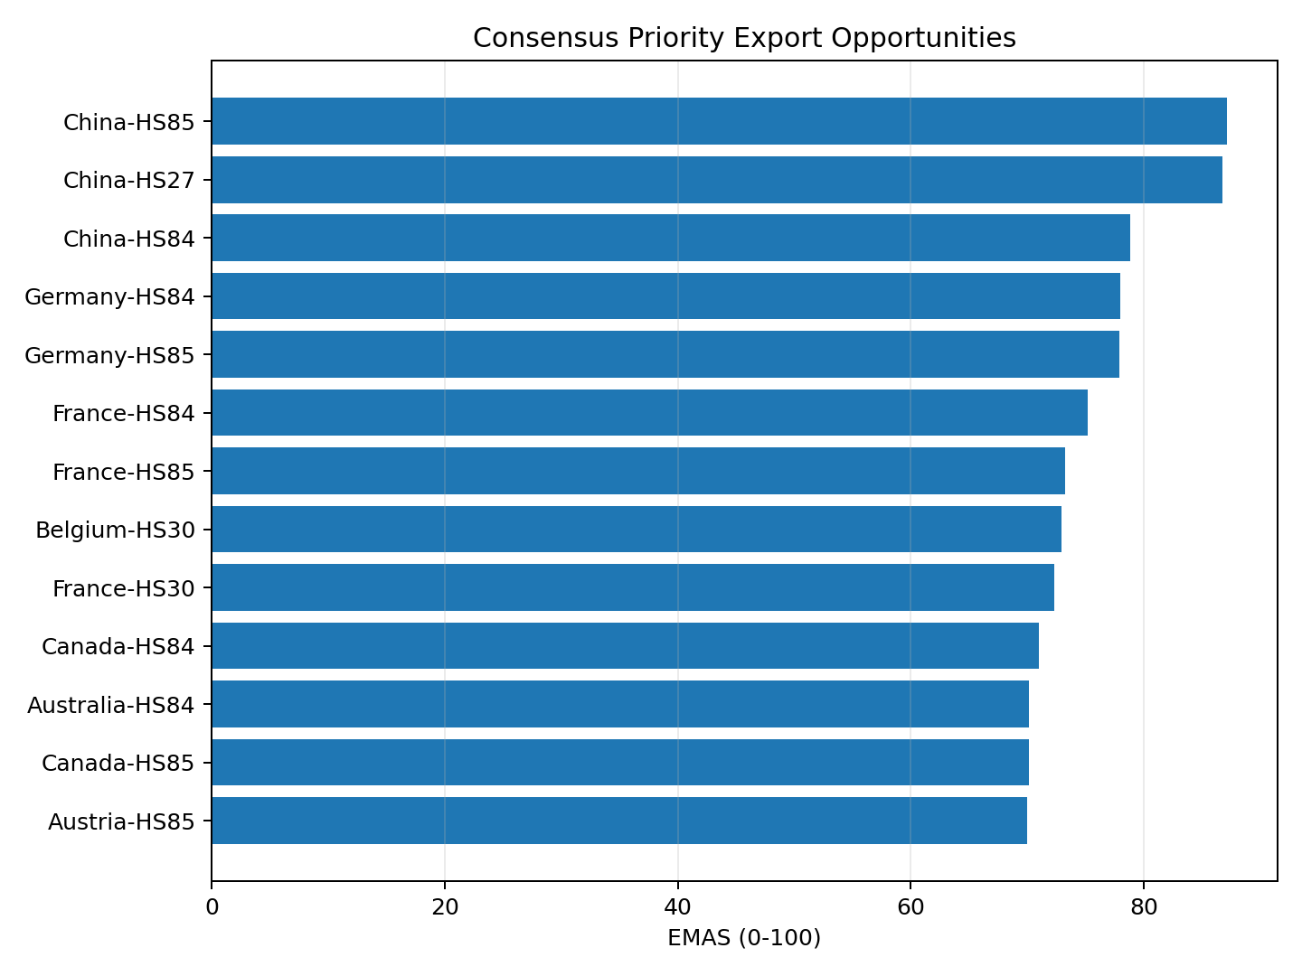
Table 10. Consensus Tier-1 Priority Opportunities
Rank | Market | EMAS | Robustness
1 | China-HS85 | 87.103 | Very Robust
2 | China-HS27 | 86.713 | Very Robust
3 | China-HS84 | 78.793 | Very Robust
4 | Germany-HS84 | 77.961 | Very Robust
5 | Germany-HS85 | 77.895 | Very Robust
6 | France-HS84 | 75.142 | Very Robust
7 | France-HS85 | 73.261 | Very Robust
8 | Belgium-HS30 | 72.954 | Very Robust
9 | France-HS30 | 72.318 | Very Robust
10 | Canada-HS84 | 70.982 | Very Robust
11 | Australia-HS84 | 70.158 | Very Robust
12 | Canada-HS85 | 70.152 | Very Robust
13 | Austria-HS85 | 69.985 | Very Robust

Sensitivity Analysis
Alternative weighting scenarios produced Spearman rank correlations of 0.993 for Equal Weights, 0.970 for Demand Focused, 0.964 for Forward Looking, and 0.951 for Opportunity Focused relative to the baseline ranking. Thirteen markets remained in the Top 20 under all five scenarios. This provides strong evidence that the leading recommendations are not artifacts of a single weighting configuration, although some markets such as Australia-HS27 are more sensitive to the strategic emphasis placed on individual dimensions.

Practical Significance
The final EMAS framework provides a practical mechanism for reducing a large set of potential export destinations into a smaller and analytically defensible shortlist. The framework evaluates 231 country–commodity combinations and enables decision-makers to compare opportunities using multiple dimensions rather than relying solely on historical export value or destination import size. The identification of Priority, Strong, Secondary, and Monitor/Lower Priority opportunities can help exporters and trade analysts focus detailed market research and commercial due diligence on comparatively stronger opportunities.
The results should be interpreted as first-stage strategic screening rather than automatic market-entry recommendations. Before entering a shortlisted market, exporters should additionally assess product-level tariffs, regulatory requirements, certification, logistics, pricing, distribution channels, and firm-specific capabilities.

Implementation and User Benefit

Deployment Approach
The current solution is implemented as a reproducible Python notebook and GitHub-based analytical workflow. A practical future deployment path is a Power BI, Streamlit, or similar interactive dashboard that reads the final ranked EMAS output and allows users to filter opportunities by HS commodity group, destination country, recommendation tier, robustness classification, and individual EMAS dimensions. A scheduled data-refresh process could rerun the preprocessing, prediction, and scoring workflow when updated TradeStat, UN Comtrade, and World Bank observations become available. A production dashboard, API, or cloud deployment is considered a future implementation rather than a completed component of the present study.

System Integration
The ranked EMAS output can be exported as CSV/Excel or connected to an internal business-intelligence workflow. Export-promotion teams could combine the EMAS shortlist with internal sales, distributor, pricing or lead data before making market-entry decisions.

User Interaction
A user would select a commodity or destination and review the EMAS score, rank, recommendation tier, robustness classification and component scores. Filters can narrow the output to Priority or Strong opportunities, while a sensitivity view can show whether a recommendation remains stable under alternative strategic weightings.

Benefits to Users
Operational efficiency: reduces manual consolidation of multiple public datasets. Financial value: focuses costly due diligence on a smaller set of promising markets. Strategic value: provides a transparent rationale for prioritization and makes weight-sensitive recommendations visible rather than hiding uncertainty.

Example Use Case
An Indian exporter of HS84 products can filter the final output to HS84 and immediately identify China, Germany, France, Canada, and Australia among the Very Robust Priority opportunities. The exporter can then compare India market share, import demand, competition, economic strength, and export performance across these destinations and select two or three markets for detailed assessment of tariffs, customs duties, certification requirements, distributor availability, logistics costs, product pricing, and expected commercial feasibility.

Limitations and Further Improvements

Limitations
- Historical dependence: several EMAS dimensions use historical trade and macroeconomic information and may not capture sudden policy, geopolitical, exchange-rate or supply-chain changes.
- Growth instability: percentage growth is unreliable when the previous export base is extremely small; winsorization and neutral scoring reduce distortion but do not create evidence of true growth.
- Indicator dependence: some dimensions are related. Historical and predicted demand were consolidated into Export Performance, but Economic Strength and Import Demand still show meaningful correlation.
- Weight subjectivity: EMAS weights reflect analytical priorities. Sensitivity analysis reduces this concern but cannot eliminate the need for stakeholder-specific judgment.
- Macroeconomic timing: exact-year World Bank data were not always available, so the latest complete observation at or before the trade year was used for required economic-strength variables.
- Predictive uncertainty: strong historical out-of-time performance does not guarantee equal accuracy after structural market changes.
- Market-level scope: the framework evaluates country-commodity opportunities, not firm-specific readiness, capacity, pricing or distribution capabilities.
- Commercial and trade-cost factors: The current EMAS does not directly incorporate destination-specific import tariffs, customs duties, applicable trade taxes, preferential tariff rates under bilateral or regional trade agreements, non-tariff barriers, certification requirements, freight and logistics costs, channel-access costs, political risk, or product-level pricing. Consequently, a destination with a high strategic attractiveness score may not necessarily provide the highest commercial profitability after landed costs and market-entry expenses are considered.

Impact of Limitations
These limitations mean that EMAS should be interpreted as a comparative screening framework rather than a causal model or automatic market-entry rule. Rankings are most reliable for prioritizing where to investigate next; they should not replace product-level feasibility analysis. Temporal data gaps and future structural changes may alter both predicted demand and relative rankings, while omitted commercial factors can materially affect realized profitability.

Future Improvements
- Incorporate destination-specific tariffs, customs duties, applicable trade taxes, preferential tariff rates under bilateral or regional trade agreements, and non-tariff barriers.
- Add logistics cost, geographic distance and shipping-time indicators.
- Include exchange-rate volatility, political risk and regulatory-complexity measures.
- Extend to more detailed HS product codes and additional years of historical data.
- Evaluate additional time-series and machine-learning models as longitudinal coverage grows.
- Automate data refresh and develop a production dashboard/API with user-adjustable weights.

Future Scope
Future work can extend EMAS from strategic country-commodity screening to product-level recommendation, firm-specific suitability scoring and scenario analysis. An interactive dashboard could allow decision-makers to modify weights and immediately observe changes in rankings. With richer time-series data, the predictive layer could incorporate explicit forecasting models and uncertainty intervals, while integration with firm-level sales and cost data could support expected-margin or risk-adjusted opportunity scoring.
Cost-Adjusted Export Market Attractiveness. A particularly valuable extension would be the development of a cost-adjusted version of EMAS. Destination-specific import tariffs, customs duties, applicable taxes, preferential rates under trade agreements, non-tariff barriers, certification expenses, freight costs, insurance, and other market-entry expenses could be combined with the existing attractiveness dimensions. This extension would allow the framework to distinguish between markets that appear attractive based on demand, growth, economic strength, India opportunity, and competition and those that remain commercially attractive after the practical cost of exporting is considered. With sufficiently detailed product-level and firm-level information, future versions could estimate landed cost, expected margin, or risk-adjusted export opportunity.

Bibliography
Andersen, P. H., & Strandskov, J. (1998). International market selection: A cognitive mapping perspective. Journal of Global Marketing, 11(3), 65-84.
Batarseh, F. A., Gopinath, M., Nalluru, G., & Beckman, J. (2019). Application of machine learning in forecasting international trade trends. arXiv:1910.03112.
Brenton, P., & Newfarmer, R. (2007). Watching more than the discovery channel: Export cycles and diversification in development (Policy Research Working Paper No. 4302). World Bank.
Caldarelli, G., Cristelli, M., Gabrielli, A., Pietronero, L., Scala, A., & Tacchella, A. (2012). A network analysis of countries’ export flows: Firm grounds for the building blocks of the economy. PLOS ONE, 7(10), e47278. https://doi.org/10.1371/journal.pone.0047278
Decreux, Y., & Spies, J. (2016). Export potential assessments: A methodology to identify export opportunities for developing countries. International Trade Centre.
El Kefi, S. (2021). Application of DEA in international market selection for the export of products from Spain. arXiv:2110.03512.
Gaston-Breton, C., & Martin Martin, O. (2011). International market selection and segmentation: A two-stage model. International Marketing Review, 28(3), 267-290. https://doi.org/10.1108/02651331111132857
Hausmann, R., & Hidalgo, C. A. (2011). The network structure of economic output. Journal of Economic Growth, 16, 309-342. https://doi.org/10.1007/s10997-011-9071-4
Hidalgo, C. A., Klinger, B., Barabási, A.-L., & Hausmann, R. (2007). The product space conditions the development of nations. Science, 317(5837), 482-487. https://doi.org/10.1126/science.1144581
Papadopoulos, N., Chen, H., & Thomas, D. R. (2002). Toward a tradeoff model for international market selection. International Business Review, 11(2), 165-192.
Rhoades, S. A. (1993). The Herfindahl-Hirschman Index. Federal Reserve Bulletin, 79, 188-189.
World Bank. (2026). World Development Indicators. World Bank Open Data.
United Nations Statistics Division. (2026). UN Comtrade Database.
Department of Commerce, Government of India. (2026). TradeStat export data.

Appendix

Appendix A: Final EMAS Scoring Logic
The Export Market Attractiveness Score (EMAS) is a composite 0–100 score designed to rank eligible country–commodity export opportunities. The final framework contains six normalized dimensions: Export Performance (0.25), Growth (0.10), Economic Strength (0.15), Import Demand (0.20), India Opportunity (0.15), and Competition (0.15).
Historical export demand and Random Forest predicted demand were consolidated into the Export Performance dimension because their normalized scores exhibited a high correlation of approximately 0.97. Export Performance combines the historical Export Demand Score and Prediction Score using weights of 0.60 and 0.40, respectively. This consolidation reduces the risk of double-counting two closely related indicators.
The six dimensions are combined using the stated weights and converted to a final 0–100 EMAS score. Country–commodity observations are subsequently ranked according to the resulting score. Recommendation tiers provide relative strategic classifications, while sensitivity analysis generates a separate robustness classification by examining rank stability under alternative weighting scenarios.
The final framework evaluates 231 country–commodity combinations across 48 destination countries and five HS commodity groups. EMAS is intended as a comparative first-stage screening measure and should not be interpreted as a probability of export success or an automatic recommendation to enter a market.

Appendix B: Key Reproducibility Notes
The project repository contains the notebooks, data folders, analytical outputs, and supporting materials required to reproduce the analysis. Source datasets from TradeStat, UN Comtrade, and World Bank Open Data are processed through source-specific cleaning steps before being integrated into the analytical workflow.
Country names are standardized across data sources before merging. Numeric variables are converted to appropriate data types, invalid and infinite values are treated as missing where necessary, and analysis-specific datasets are created according to the requirements of each research question.
For RQ4, numeric and categorical preprocessing is handled through the modeling pipeline. Historical observations through 2024 are used for model development, while 2025 observations are reserved for out-of-time testing. Linear Regression, Random Forest, and XGBoost are evaluated using the same temporal test data. Random Forest is retained as the final model because it achieves the lowest log-scale RMSE.
The trained Random Forest pipeline is subsequently applied to the eligible EMAS candidate population to generate predicted export demand. Required macroeconomic values are matched using the latest complete World Bank observation available at or before the corresponding trade year. The final EMAS calculation, sensitivity analysis, ranking, and recommendation classifications are generated from these processed analytical inputs.

Appendix C: Final Strategic Classification
Table A1. Final Recommendation Distribution
Classification | Count
Priority Export Opportunity | 13
Strong Opportunity | 7
Secondary Opportunity | 30
Monitor / Lower Priority | 181
Total | 231

Sensitivity analysis was used separately to determine the robustness of the resulting rankings. Thirteen Priority Export Opportunities remained within the Top 20 across all five weighting scenarios and were classified as Very Robust. These opportunities represent the most stable strategic shortlist within the evaluated dataset.

The recommendation tiers should be interpreted as comparative screening categories rather than guarantees of export-market success. Detailed market-entry assessment should consider tariffs, regulatory requirements, logistics, pricing, distribution channels, firm-specific capabilities, and current market conditions before a commercial decision is made.

Appendix D: Data Description

Table 3

Data Sources and Final Analytical Role
Source | Notebook input | Purpose | Current status
TradeStat, Department of Commerce, Government of India | 29 Excel files | India export performance by destination and commodity, including current export value, previous export value, and growth | Loaded, standardized, and used for export-performance, growth, RQ1, RQ4, and EMAS analyses.
UN Comtrade | 1 Excel file; 100,000 rows and 47 original columns | Destination import demand, India market share, supplier structure, supplier count, and HHI | Cleaned and integrated into RQ3 and the final EMAS framework.
World Bank Open Data | 1 Excel workbook; 2,125 initial rows | GDP, GDP growth, GDP per capita, population, inflation, exports/imports/trade as % of GDP | Cleaned, reshaped, country-year standardized, and integrated into statistical, predictive, and EMAS analyses.

Dataset Overview
The TradeStat data loader combined 29 commodity-year workbooks into 6,040 source records. Country names and commodity identifiers were standardized before integration with the other analytical sources. The World Bank data were transformed from their original annual-column structure into a country–year analytical format and merged with the trade data after country-name harmonization.
UN Comtrade data were used to derive destination import demand and supplier-market information required for RQ3 and the final EMAS framework. Supplier-level trade shares were used to characterize market concentration through the Herfindahl–Hirschman Index (HHI), while India's existing market position was incorporated into the India Opportunity dimension.
The final EMAS candidate population contains 231 country–commodity combinations representing 48 destination countries across five HS commodity groups: HS27, HS30, HS71, HS84, and HS85.
Table A3. Dataset Overview
Attribute | Description
Rows | 6,040
Columns used in EDA | 21
Unit of analysis | Commodity-country-year
TradeStat files | 29
UN Comtrade files | 1
World Bank files | 1
Years represented in TradeStat summaries | 2021-2026
HS chapters represented | 27, 30, 71, 84, 85
Primary outcome | Export_Current / Export_Value
RQ2 predictors | GDP, GDP growth, GDP per capita, population, inflation, trade as % of GDP

Table A4. Data Dictionary
Variable | Definition | Type | Source | Role/handling
Serial_No | Source row number | Object | TradeStat | Identifier only
Country | Destination market | Categorical | TradeStat | Grouping and merge key
Commodity | HS chapter code | Categorical | TradeStat | Product grouping
Year | Reporting year | Integer | TradeStat | Time key
Export_Previous | Previous-period export value | Continuous | TradeStat | Growth baseline
Export_Current | Current-period export value | Continuous | TradeStat | Primary demand outcome
Export_Growth | Reported export growth (%) | Continuous | TradeStat | Source growth measure
Exports_GDP | Exports of goods/services (% GDP) | Continuous | World Bank | Trade openness predictor
GDP | GDP in current US dollars | Continuous | World Bank | Economic size predictor
GDP_Growth | Annual GDP growth (%) | Continuous | World Bank | Economic momentum predictor
GDP_Per_Capita | GDP per capita (current US$) | Continuous | World Bank | Income/market-development predictor
Imports_GDP | Imports of goods/services (% GDP) | Continuous | World Bank | Import orientation predictor
Inflation | Consumer-price inflation (%) | Continuous | World Bank | Stability predictor
Population | Total population | Continuous | World Bank | Market-size predictor
Trade_GDP | Trade as % of GDP | Continuous | World Bank | Trade openness predictor
Export_Value | Copy of Export_Current | Continuous | Derived | Convenience outcome
Export_Growth_Rate | Calculated growth from current/previous | Continuous | Derived | Growth analysis; infinities later replaced
Market_Share | Row export value / annual export total | Continuous | Derived | Relative contribution within year
Total_Imports | Total destination imports for the country–commodity market | Continuous | UN Comtrade | Destination import-demand measure
India_Imports | Imports supplied by India to the destination–commodity market | Continuous | UN Comtrade | Used to calculate India's market position
India_Share | India's share of destination imports | Continuous | Derived from UN Comtrade | RQ3 and India Opportunity dimension
Supplier_Count | Number of suppliers represented in the destination–commodity market | Integer | Derived from UN Comtrade | Supplier-competition analysis
HHI | Herfindahl–Hirschman Index based on supplier market shares | Continuous | Derived from UN Comtrade | Market-concentration measure for RQ3 and Competition dimension

Appendix E: GitHub Data Availability Statement
Raw and processed data, notebooks, figures, and code are maintained in the project repository.
Repository:
https://github.com/bharathipavithra10-cmd/AI-Export-Market-Decision-Support
Raw data:
https://github.com/bharathipavithra10-cmd/AI-Export-Market-Decision-Support/tree/main/data/raw
Processed / Clean data:
https://github.com/bharathipavithra10-cmd/AI-Export-Market-Decision-Support/tree/main/data/processed
Cleaned source datasets:
https://github.com/bharathipavithra10-cmd/AI-Export-Market-Decision-Support/tree/main/data/cleaned
Code / Notebooks:
https://github.com/bharathipavithra10-cmd/AI-Export-Market-Decision-Support/tree/main/notebooks
Outputs (Figures & Tables):
https://github.com/bharathipavithra10-cmd/AI-Export-Market-Decision-Support/tree/main/outputs

Appendix F: EDA Results (Interpretation Emphasis)
Figure A1
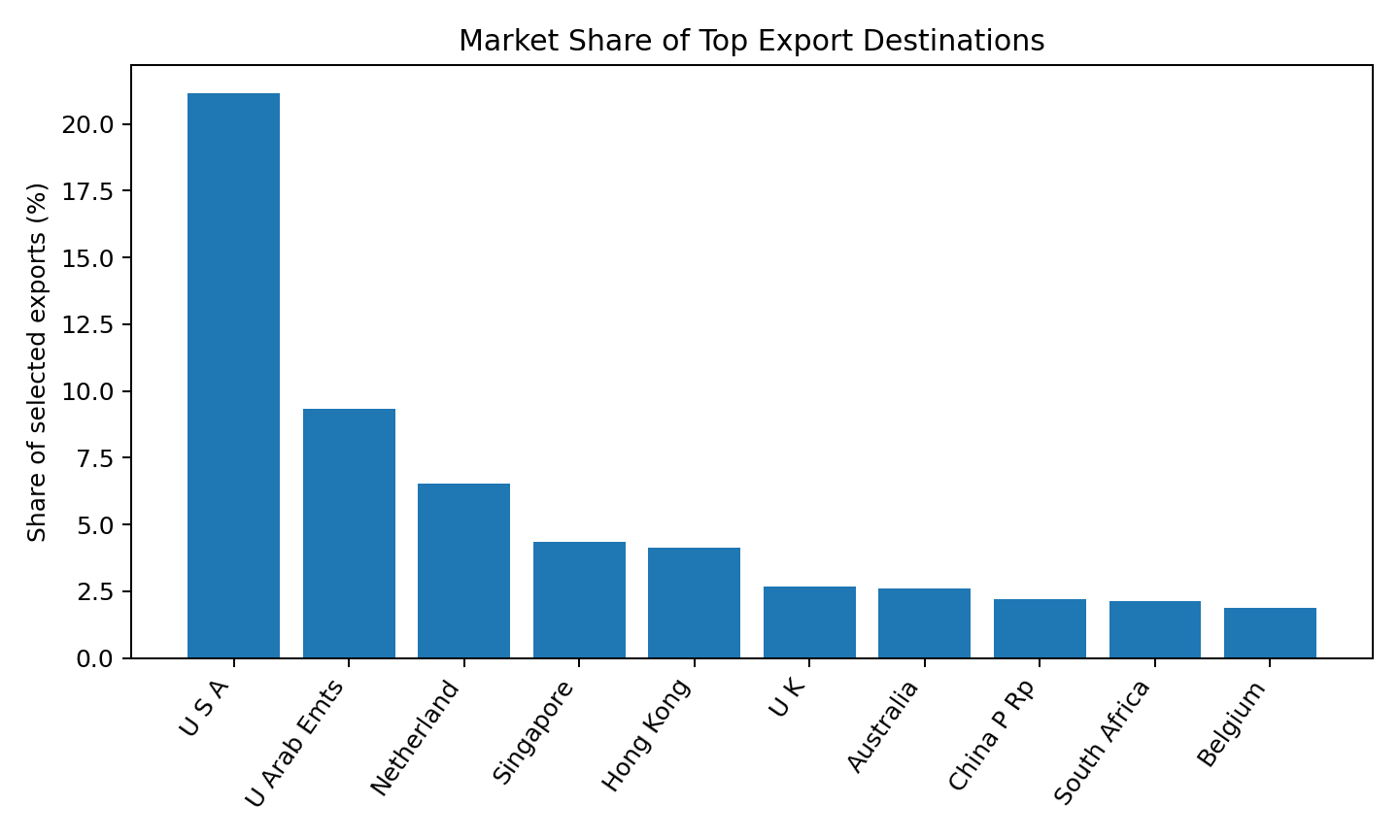
Insight: The United States accounted for 21.14% of export value, more than twice the share of the United Arab Emirates. This concentration indicates a need to balance established-market strength with diversification opportunities.
Figure A2
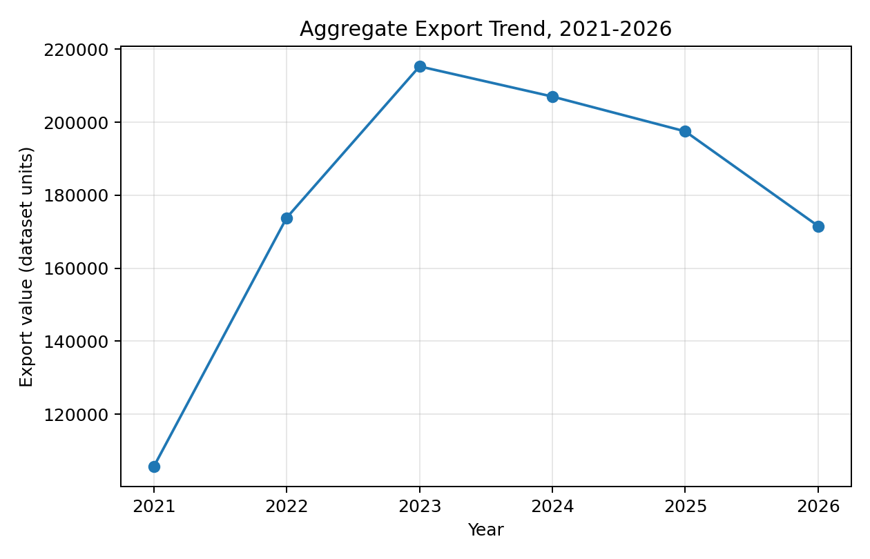
Insight: Figure 2 shows aggregate export value increasing from 105,623.29 in 2021 to 215,301.71 in 2023, followed by moderation to 207,030.96 in 2024, 197,492.25 in 2025, and 171,550.58 in 2026. The apparent 2026 decline must not be interpreted as a completed annual contraction until the reporting period is confirmed, because 2026 data may be partial.
Figure A3
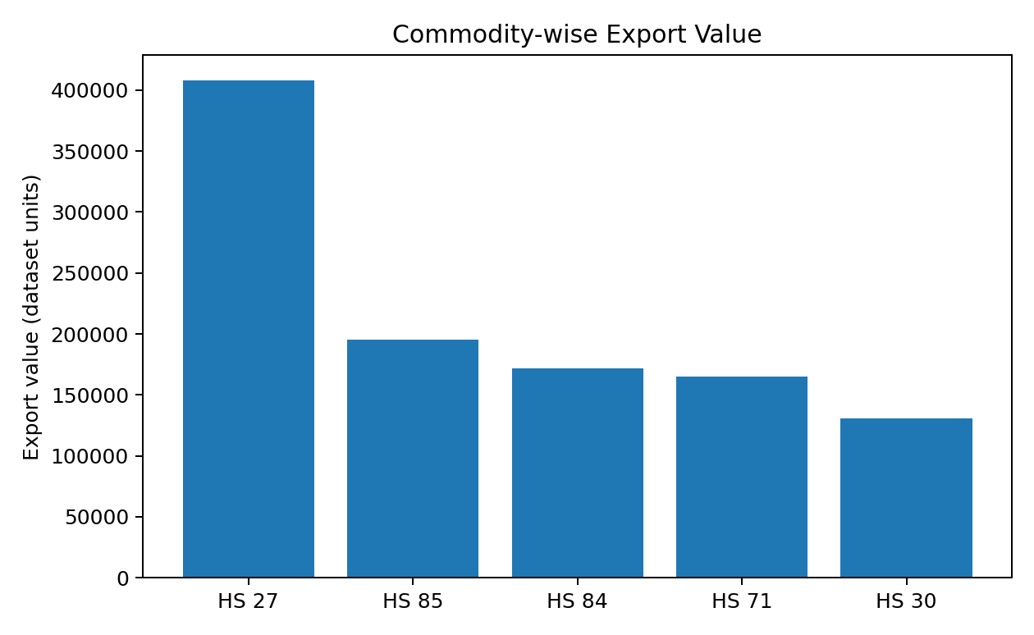
Insight: HS Chapter 27 recorded the highest export value throughout the study period, followed by HS Chapters 85, 84, 71, and 30. The variation across commodity groups supports commodity-specific export analysis.
Figure A4
Correlation Matrix for Export and Macroeconomic Variables
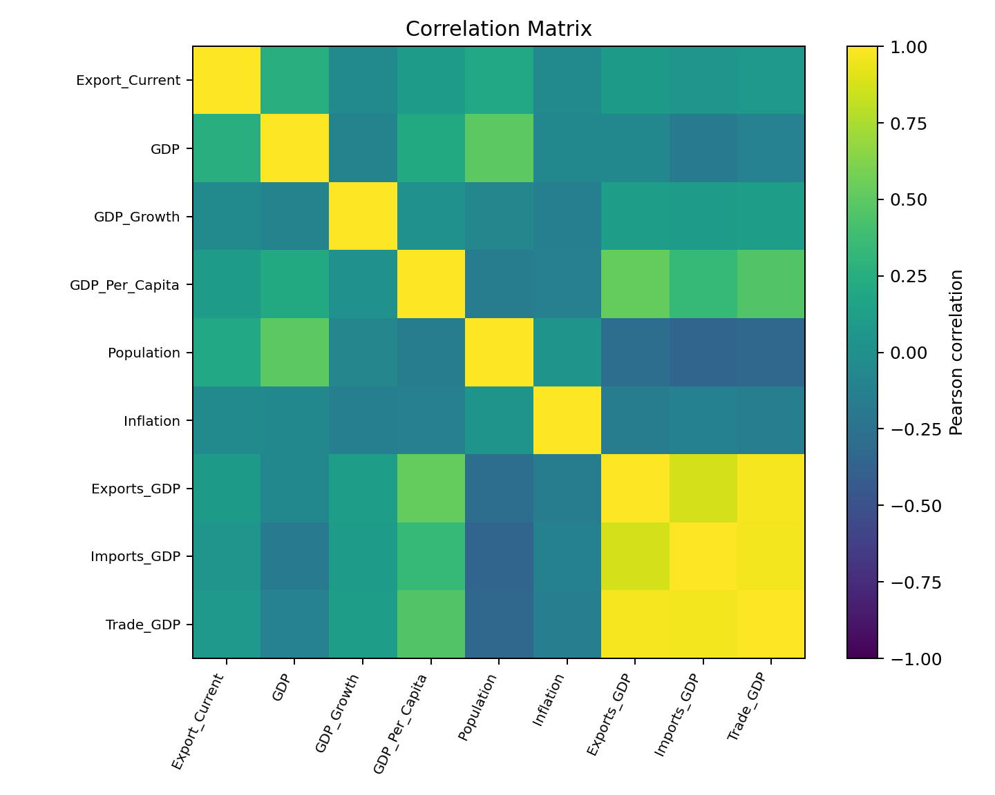
Insight: GDP showed the strongest positive correlation with export demand, followed by Population. Strong correlations among Exports (% GDP), Imports (% GDP), and Trade (% GDP) indicated multicollinearity, which was addressed using VIF analysis.

Table 10
EDA Insight Summary
Figure/Table | What it shows | Key insight | Why it matters | Decision/next step
Figure 1 | Country shares | USA is dominant at 21.14% | Answers market-demand component of RQ1 | Create product-specific destination rankings.
Figure 2 | Annual export totals | Growth to 2023, then lower totals | Shows temporal evolution for RQ1 | Verify whether 2026 is partial; use comparable annual periods.
Figure 3 | Commodity totals | HS 27 dominates current sample | Demonstrates product heterogeneity | Avoid one ranking for all products.
Figure 4 | Pairwise correlations | GDP has strongest export correlation; trade ratios are collinear | Preliminary evidence for RQ2 | Use VIF and alternative model specifications.

Multicollinearity Assessment
Following the correlation analysis, multicollinearity among the predictor variables was assessed using the Variance Inflation Factor (VIF) before proceeding with regression modelling. Although the correlation matrix provided an initial indication of strong relationships among several macroeconomic indicators, VIF analysis was performed to quantify the extent of multicollinearity. The analysis was conducted using 2,688 complete observations after excluding records with missing values in the selected predictor variables.

Table 11

Final Variance Inflation Factor (VIF) Results
Variable | Final VIF | Decision
GDP | 1.93 | Retained
GDP_Per_Capita | 1.82 | Retained
Population | 1.67 | Retained
Trade_GDP | 1.55 | Retained
GDP_Growth | 1.06 | Retained
Inflation | 1.06 | Retained

