Data Analytics Capstone

AI-Driven Export Market Decision Support System for Indian Exporters Using
Public Trade and Macroeconomic Data

Final Report
Pavithra Bharathi
Walsh College
QM640: Data Analytics Capstone
Mentor: Vikas
Term 3
August 2026

GitHub Repository
https://github.com/bharathipavithra10-cmd/AI-Export-Market-Decision-Support

Abstract
International market selection is a complex decision for Indian exporters because trade opportunities depend on multiple factors, including historical export performance, market growth, destination demand, macroeconomic conditions, India’s existing market presence, supplier competition, and future demand potential. Although public sources provide extensive trade and economic information, these datasets are fragmented and do not directly provide an integrated mechanism for prioritizing country–commodity export opportunities. This study develops an AI-driven Export Market Decision Support System to address this gap.
The study integrates export data from TradeStat, international trade and supplier information from UN Comtrade, and macroeconomic indicators from the World Bank. The analytical workflow combines exploratory data analysis, statistical hypothesis testing, competition analysis using the Herfindahl–Hirschman Index (HHI), multiple regression, and machine-learning models. Linear Regression, Random Forest, and XGBoost were evaluated using an out-of-time validation approach. Random Forest achieved the strongest predictive performance, with a log-scale RMSE of 0.6299 and R² of 0.9224, representing a 41.79% improvement in RMSE over the Linear Regression baseline.
The final Export Market Attractiveness Score (EMAS) integrates six dimensions: Export Performance, Export Growth, Economic Strength, Import Demand, India Opportunity, and Competition. The framework evaluated 231 country–commodity combinations across 48 countries and five HS commodity groups. China–HS85 emerged as the highest-ranked opportunity with an EMAS score of 87.103, followed by China–HS27 at 86.713 and China–HS84 at 78.793. Sensitivity analysis further identified 13 Priority Export Opportunities that remained within the Top 20 under all five weighting scenarios.
The framework is implemented using Python and commonly used data-analysis and machine-learning libraries and is designed as a first-stage strategic market-screening tool. It can support exporters, analysts, and trade-development decision-makers in identifying and prioritizing promising international markets before conducting detailed product-level, regulatory, logistics, pricing, and market-entry feasibility assessments.

Introduction

Background and Context
International trade contributes materially to India's economic activity, yet selecting suitable export markets requires exporters to evaluate multiple signals simultaneously. Market size alone is insufficient: a large destination may already be highly competitive, while a smaller destination may offer stronger growth, lower concentration, or greater room for Indian suppliers. This challenge is especially relevant for micro, small, and medium enterprises, which may not have access to integrated market-intelligence platforms or dedicated analytical teams.
Public sources such as TradeStat, UN Comtrade, and World Bank Open Data provide complementary information, but they are maintained separately and differ in structure, naming conventions, units, coverage, and reporting periods. TradeStat provides India-specific exports by destination and commodity; UN Comtrade provides destination import demand and supplier structure; and World Bank indicators describe destination-country economic conditions. Integrating these sources creates a more complete country-commodity view than any single source can provide.
This project develops an AI-driven Export Market Decision Support System that combines descriptive analytics, statistical inference, machine learning, competition analysis, and a transparent composite ranking framework. The system is designed to identify promising country-commodity opportunities and explain why they rank highly, while retaining a clear distinction between analytical screening and a final commercial market-entry decision.

Problem Statement
The objective of this study is to predict and explain Y = export demand and strategic export-market attractiveness for Indian commodity-country-year observations using X = historical exports, export growth, destination import demand, India's market share, supplier concentration, macroeconomic indicators, country, commodity, and year over the available 2021-2026 trade period. Success is evaluated using statistical significance at α = .05, regression diagnostics, out-of-time MAE/RMSE/R², and the stability of final EMAS rankings under alternative weighting scenarios.

Purpose of the Study
The study aims to explain current export-demand patterns, identify significant macroeconomic drivers, quantify competitive market structure, predict export demand using machine learning, and combine these signals into an interpretable Export Market Attractiveness Score. The final objective is a reproducible screening framework that prioritizes international markets for further commercial evaluation.

Research Problem/ Research Questions
RQ1: Which Indian products and destination markets currently demonstrate the highest export demand, and how have these patterns evolved over time?
RQ2: Which macroeconomic and trade-related factors significantly influence export demand across international markets?
RQ3: How do supplier competition and India’s market share influence export opportunities across international markets?
RQ4: Can machine-learning models improve prediction of export demand relative to a linear baseline and support identification of attractive export markets?

Contributions and Expected Value
Practical contribution: A transparent market-screening framework that converts fragmented trade, economic, competition, and predictive information into prioritized country-commodity opportunities.
Technical contribution: An integrated workflow combining statistical hypothesis testing, robust regression, HHI-based competition measures, out-of-time machine-learning evaluation, composite scoring, and sensitivity analysis.
Value to stakeholders/target users: Exporters and trade-development analysts can reduce manual screening effort, focus detailed due diligence on a smaller set of defensible opportunities, and understand the factors contributing to each ranking.

Literature Review

Literature Review Approach
The literature review was organized around four themes aligned with the research questions: international market selection and screening, export diversification and product structure, supplier concentration and market competition, and machine learning for international trade forecasting. Peer-reviewed articles, institutional methodologies, and recognized working papers were prioritized when they provided a direct theoretical or methodological link to market

Summary of Key Literature
Table 1. Literature Relevance Matrix
Author (Year) | Domain/Context | Method(s) | Key Finding | Project Relevance
Andersen & Strandskov (1998) | International market selection | Conceptual/cognitive mapping | Market choice depends on how decision-makers structure multiple signals. | Supports transparent multi-factor screening.
Papadopoulos et al. (2002) | Market screening | Trade-off model | Market attractiveness requires balancing opportunity and risk. | Supports composite ranking.
Gaston-Breton & Martin Martin (2011) | Market selection | Two-stage model | Country screening should precede detailed segmentation. | Supports staged screening-to-recommendation workflow.
Brenton & Newfarmer (2007) | Export diversification | Cross-country trade analysis | Export growth reflects intensive and extensive margins. | Supports established and emerging market analysis.
Hidalgo et al. (2007) | Product space | Network analysis | Development depends on related product capabilities. | Supports commodity-level differentiation.
Hausmann & Hidalgo (2011) | Economic complexity | Network structure | Product mix and capabilities shape economic output. | Supports product-market structure.
Caldarelli et al. (2012) | Export networks | Network analysis | Trade networks reveal structural relationships beyond totals. | Supports competition/network perspective.
Decreux & Spies (2016) | Export potential | ITC methodology | Export potential combines supply, demand and market access. | Directly informs EMAS design.
Rhoades (1993) | Supplier concentration | HHI methodology | HHI summarizes concentration using squared supplier shares. | Supports RQ3 competition metric.
Batarseh et al. (2019) | Trade forecasting | Machine learning | ML can capture nonlinear patterns in trade data. | Supports RF/XGBoost comparison.
El Kefi (2021) | Market selection | Data envelopment analysis | Multi-criteria methods can prioritize export markets. | Provides ranking benchmark.
Silva et al. (2024) | Trade forecasting | ML/network features | Network structure may improve economic forecasting. | Supports future feature engineering.

Across the literature, international market selection is consistently treated as a multi-criteria problem rather than a ranking by market size alone. This supports the EMAS design, which combines export performance, growth, economic strength, import demand, India opportunity, and competition. The literature also emphasizes product heterogeneity, justifying separate country-commodity observations rather than a single country ranking.
A second theme concerns diversification and competition. High import demand does not necessarily imply a favorable opportunity if India already has a high share or if the supplier structure is difficult to penetrate. HHI provides a transparent summary of supplier concentration and complements India market share when identifying markets with room for expansion.
Finally, the forecasting literature supports comparison of an interpretable linear baseline with nonlinear machine-learning methods. Random Forest and XGBoost were therefore evaluated alongside Linear Regression, while out-of-time validation was used to better reflect future deployment and reduce temporal leakage.

Materials and Method

Data Sources and Analytical Scope
The project uses three public data sources. TradeStat provides India-specific export values by destination, commodity and year; UN Comtrade provides destination import demand and supplier-level trade values; and World Bank World Development Indicators provide macroeconomic measures. The integrated TradeStat analytical dataset contains 6,040 rows. Final EMAS scoring is conducted on 231 eligible country-commodity observations spanning 48 countries and five HS chapters (27, 30, 71, 84 and 85).
Table 2. Data Sources
Source | Purpose | Key Variables | Role
TradeStat, Government of India | India export performance | Country, Commodity, Year, Export_Current, Export_Previous, growth | RQ1, RQ4, EMAS
UN Comtrade | Destination demand and supplier competition | Total imports, India imports/share, supplier count, HHI | RQ3, EMAS
World Bank WDI | Destination economic conditions | GDP, GDP growth, GDP per capita, population, inflation, trade/GDP | RQ2, RQ4, EMAS

Data Preprocessing and Feature Engineering
Country names were standardized across sources before merging. Numeric fields were coerced to valid numeric types and infinite values were treated as missing. Export growth was recalculated where required. Because percentage growth can become unstable when the previous export base is very small, analytical growth was winsorized and observations with missing or very small historical bases received a neutral Growth Score in EMAS. For RQ2, Exports_GDP and Imports_GDP were removed after multicollinearity assessment, leaving all retained VIF values between 1.06 and 1.93.
For EMAS macroeconomic integration, the latest available complete World Bank observation at or before the relevant trade year was used for GDP, GDP per capita and population. This preserved all 231 EMAS candidate observations without mean or median imputation of the required economic-strength variables. Optional inflation and trade/GDP values could remain missing because they were not used in the final EMAS Economic Strength dimension.

Research Hypotheses and Sample Size
Table 3. Research Questions, Hypotheses and Methods
RQ | Null Hypothesis | Method | Usable Sample / Unit
RQ1 | Export-value distributions do not differ across commodity groups. | Descriptive analysis; Kruskal-Wallis test | 5,019 growth-analysis observations; commodity groups
RQ2 | Selected macroeconomic indicators do not significantly influence export demand. | VIF; standardized OLS with HC3 robust SE | 2,651 complete observations
RQ3 | Supplier competition and India market share do not materially differentiate export opportunities. | Market share, supplier count, HHI, opportunity screening | Country-commodity destination markets
RQ4 | ML models do not improve predictive performance over Linear Regression. | Out-of-time Linear/RF/XGBoost comparison | Train ≤2024; test=2025
All inferential hypothesis tests were evaluated at the 5% significance level. The available sample sizes substantially exceeded conventional minimum requirements for the selected group-comparison and regression procedures. For predictive modeling, the time-based holdout was prioritized over a random split because the intended use is future-oriented prediction.

Architecture diagram/Workflow
System Overview
The end-to-end pipeline transforms three independent public data sources into a unified analytical dataset, research-question outputs, machine-learning predictions, and a final market-prioritization layer. Figure 1 summarizes the workflow.
Figure 1. End-to-End Workflow of the Proposed System
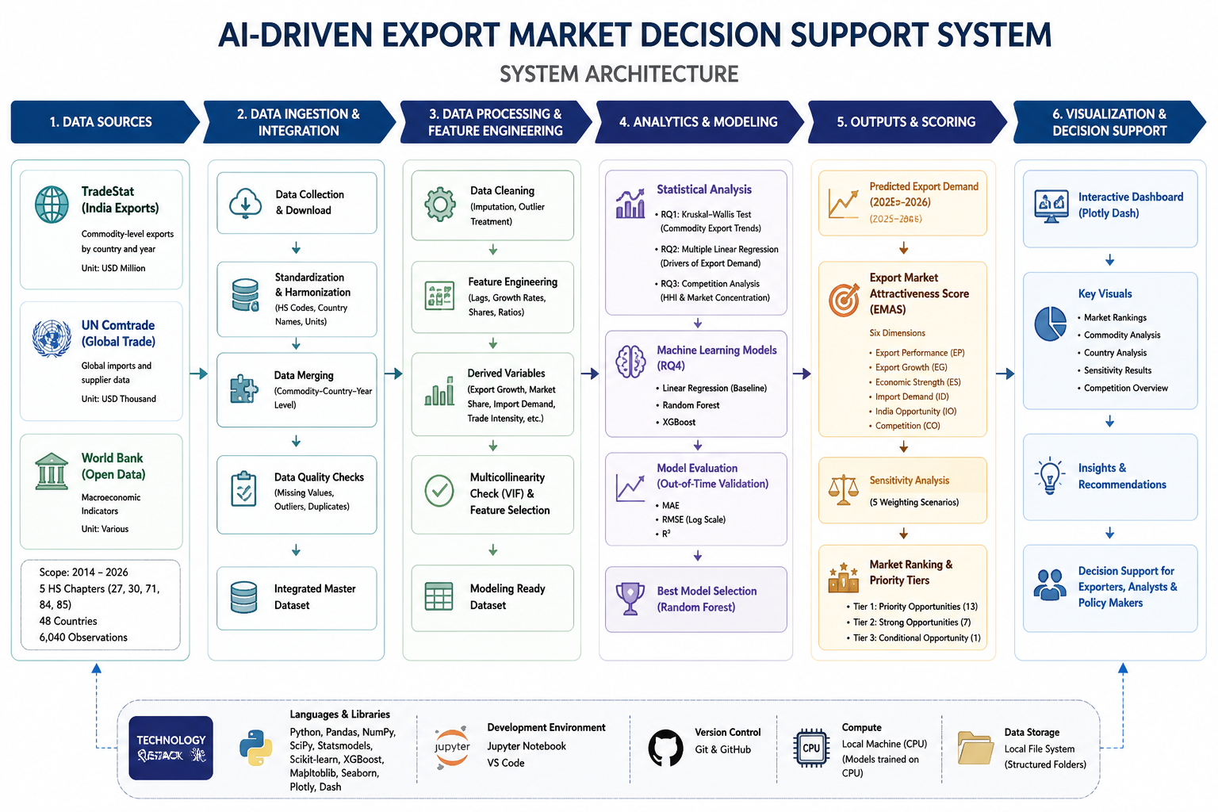

Workflow Components
Data Ingestion
TradeStat Excel workbooks, a UN Comtrade extract, and a World Bank workbook are loaded into a repository-based Python environment. Source-specific fields are retained only where needed for the research questions and final scoring framework.
Data Preprocessing
Preprocessing includes country-name harmonization, numeric conversion, missing-value checks, year alignment, removal of infinite values, log transformation for skewed export demand, one-hot encoding of categorical predictors, median imputation for numeric model inputs, and scaling where required by the preprocessing pipeline.
Exploratory Data Analysis (EDA)
EDA evaluates dataset structure, missingness, export distributions, destination shares, commodity trends, growth distributions, correlations, and multicollinearity. These diagnostics guide the selection of robust statistical and predictive methods.
Feature Engineering
Engineered features include recalculated export growth, market-share measures, HHI-based competition indicators, log-transformed export demand, Random Forest demand predictions, normalized EMAS component scores, and robustness measures derived from sensitivity analysis.
Model Development
Linear Regression provides an interpretable baseline. Random Forest and XGBoost capture nonlinearities and interactions. The final Random Forest uses 300 trees with min_samples_leaf=2; XGBoost uses 400 estimators, learning rate 0.05, maximum depth 5, subsample 0.8 and column subsample 0.8.
Model Evaluation
Models are evaluated primarily on the log-transformed target using MAE, RMSE and R², with original-scale metrics retained for business interpretation. Model selection is based primarily on log-scale RMSE because the export distribution is strongly right-skewed.
Deployment
The current implementation is a reproducible Python notebook and repository workflow. The final EMAS outputs are structured for use in a dashboard or lightweight analytical application; a production API or cloud deployment is a future extension rather than a completed component of this study.
Tools and Technologies
Python; pandas; NumPy; SciPy; statsmodels; scikit-learn; XGBoost; Matplotlib; Jupyter/Google Colab; GitHub; Microsoft Excel source files. The analysis is designed for standard CPU execution and does not require GPU computing.

Results

Model Performance
Table 4. RQ4 Model Performance Comparison
Model | MAE (Log) | RMSE (Log) | R² (Log) | MAE Original | RMSE Original | R² Original
Random Forest | 0.3181 | 0.6299 | 0.9224 | 59.03 | 291.46 | 0.9075
XGBoost | 0.3267 | 0.6602 | 0.9148 | 65.11 | 363.92 | 0.8558
Linear Regression | 0.8036 | 1.0821 | 0.7710 | 19,185.39 | 579,601.44 | -365,776.36

Random Forest produced the lowest log-scale RMSE and the highest log-scale R². Its RMSE was 41.79% lower than the Linear Regression baseline. The extreme deterioration of Linear Regression after back-transformation illustrates the effect of skewness and model misspecification on the original scale; consequently, log-scale metrics are the primary basis for model comparison.
Figure 2. Out-of-Time Model Performance
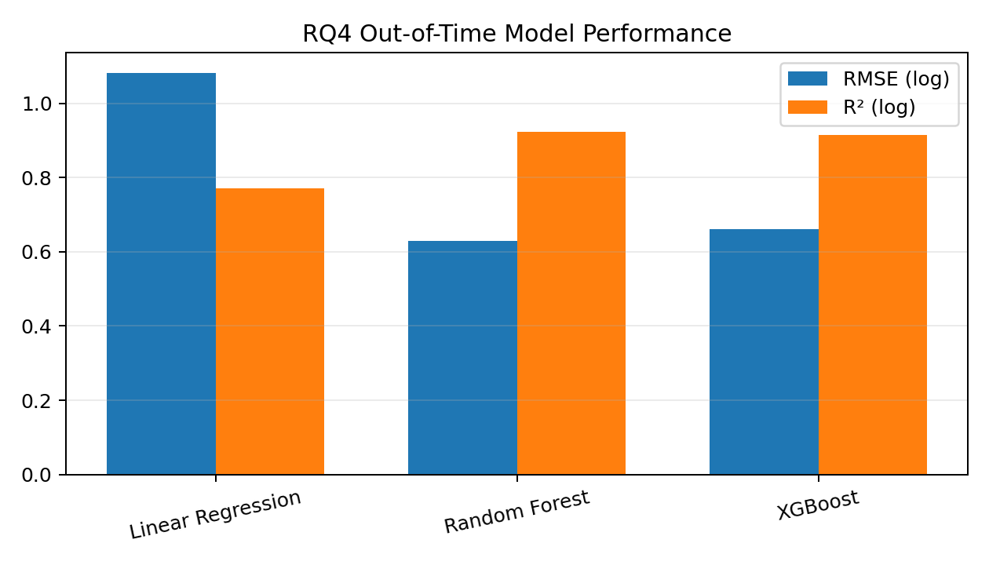

Visual Evidence
The final notebook also evaluates actual-versus-predicted values, residuals versus fitted values, Q-Q behavior, correlation structure, and Random Forest feature importance. The residual diagnostics indicate non-constant variance and departures in the tails, supporting the use of robust inference for RQ2 and nonlinear models for RQ4.

Results by Research Question

Research Question 1
RQ1 identified substantial differences in export demand across destination markets and commodity groups. The United States accounted for 21.14% of total export value in the selected dataset, followed by the United Arab Emirates (9.32%) and the Netherlands (6.52%). HS27 recorded the highest export value, while commodity growth patterns differed materially over time. The Kruskal-Wallis test was statistically significant, H = 415.8915, p < .001, so H0₁ was rejected. Export-value distributions therefore differ significantly across the five commodity groups.
Table 5. Top Export Destinations in RQ1
Rank | Destination | Share (%)
1 | United States | 21.14
2 | United Arab Emirates | 9.32
3 | Netherlands | 6.52
4 | Singapore | 4.36
5 | Hong Kong | 4.12
6 | United Kingdom | 2.69
7 | Australia | 2.6
8 | China | 2.21
9 | South Africa | 2.12
10 | Belgium | 1.86

Research Question 2
The Research Question 2 regression used 2,651 complete observations. The overall model was statistically significant (F = 107.5, p < .001) and explained 23.3% of the variation in log export demand (adjusted R² = .232). GDP (β = .592, p < .001), Population (β = .492, p < .001), and GDP per capita (β = .224, p < .001) were significant positive predictors. GDP growth was marginal but not significant at 5% (p = .055), while Inflation (p = .993) and Trade/GDP (p = .526) were not significant. H0₂ was rejected because at least one macroeconomic indicator significantly influenced export demand.
Table 6. RQ2 Multiple Regression Results
Predictor | Standardized Coefficient | p-value | Interpretation
GDP | 0.592 | <.001 | Significant positive
Population | 0.492 | <.001 | Significant positive
GDP per capita | 0.224 | <.001 | Significant positive
GDP growth | -0.063 | .055 | Not significant at 5%
Trade/GDP | 0.033 | .526 | Not significant
Inflation | -0.0003 | .993 | Not significant

Research Question 3
Research Question 3 uses UN Comtrade supplier-level imports to characterize destination demand, India's share, supplier count and HHI. Across the final market-screening data, the median destination total imports were approximately 494.64 million, the median India market share was 0.596%, and the median HHI was 2,068.78. Applying the RQ3 opportunity criteria identified 45 potential country-commodity opportunity markets. Large low-share, relatively unconcentrated examples included China-HS85, China-HS27, China-HS84, France-HS84, Belgium-HS30 and other European markets. These findings show that large import demand alone is insufficient; India's current penetration and supplier concentration materially change the opportunity interpretation.
Table 7. Illustrative RQ3 Opportunity Markets
Destination | HS | Total Imports | India Share (%) | Suppliers | HHI | Competition
China | 85 | 408.98B | 0.190 | 201 | 1318.94 | Unconcentrated
China | 27 | 273.27B | 0.059 | 109 | 573.45 | Unconcentrated
China | 84 | 172.76B | 0.502 | 182 | 1062.97 | Unconcentrated
France | 84 | 140.68B | 0.594 | 220 | 898.63 | Unconcentrated
Czechia | 84 | 62.92B | 0.271 | 188 | 1651.34 | Moderately concentrated
Belgium | 30 | 36.89B | 0.142 | 124 | 1317.48 | Unconcentrated

Research Question 4
Random Forest outperformed both XGBoost and Linear Regression in the out-of-time 2025 test set. Random Forest achieved log RMSE = 0.6299 and R² = 0.9224, compared with Linear Regression RMSE = 1.0821 and R² = 0.7710. The 41.79% RMSE improvement over the linear baseline supports rejection of H0₄. Random Forest was therefore selected to generate the predictive demand signal used in the final market-screening framework.

Overall Interpretation
The research questions collectively show that export opportunity is multidimensional. Commodity groups differ significantly; larger and wealthier destination economies tend to support higher demand; competition and India market share alter the attractiveness of large import markets; and nonlinear machine-learning models materially improve prediction. These findings motivate a composite decision layer rather than reliance on a single metric.

Export Market Attractiveness Score (EMAS)
The final EMAS framework evaluates 231 country-commodity combinations using six dimensions. Historical export demand and Random Forest predicted demand were consolidated into Export Performance to avoid double-counting after a correlation of approximately 0.97 was observed between their normalized scores. Growth was treated separately, while Economic Strength, Import Demand, India Opportunity and Competition represent distinct market characteristics.
Table 8. Final EMAS Dimensions and Weights
Dimension | Weight | Interpretation
Export Performance | 0.25 | Historical and predicted export demand consolidated into one performance dimension
Growth | 0.10 | Recent export momentum, with small-base neutralization
Economic Strength | 0.15 | GDP, GDP per capita and population
Import Demand | 0.20 | Destination demand for the commodity
India Opportunity | 0.15 | Greater room for India where current share is lower
Competition | 0.15 | More favorable score where supplier concentration is lower

All 231 observations received complete normalized scores. Twenty-six observations received a neutral Growth Score because growth was missing or the previous export base was too small for a reliable percentage-growth interpretation. This prevents tiny historical values from producing disproportionate ranking effects.

Final Strategic Recommendations
China-HS85 ranks first with EMAS 87.103, followed by China-HS27 at 86.713 and China-HS84 at 78.793. HS84 has the highest average EMAS (53.445), followed by HS85 (52.596), HS27 (50.510), HS30 (49.067) and HS71 (42.745). The final recommendation framework classifies 13 opportunities as Priority, 7 as Strong, 30 as Secondary and 181 as Monitor/Lower Priority.
Figure 3. Consensus Priority Export Opportunities
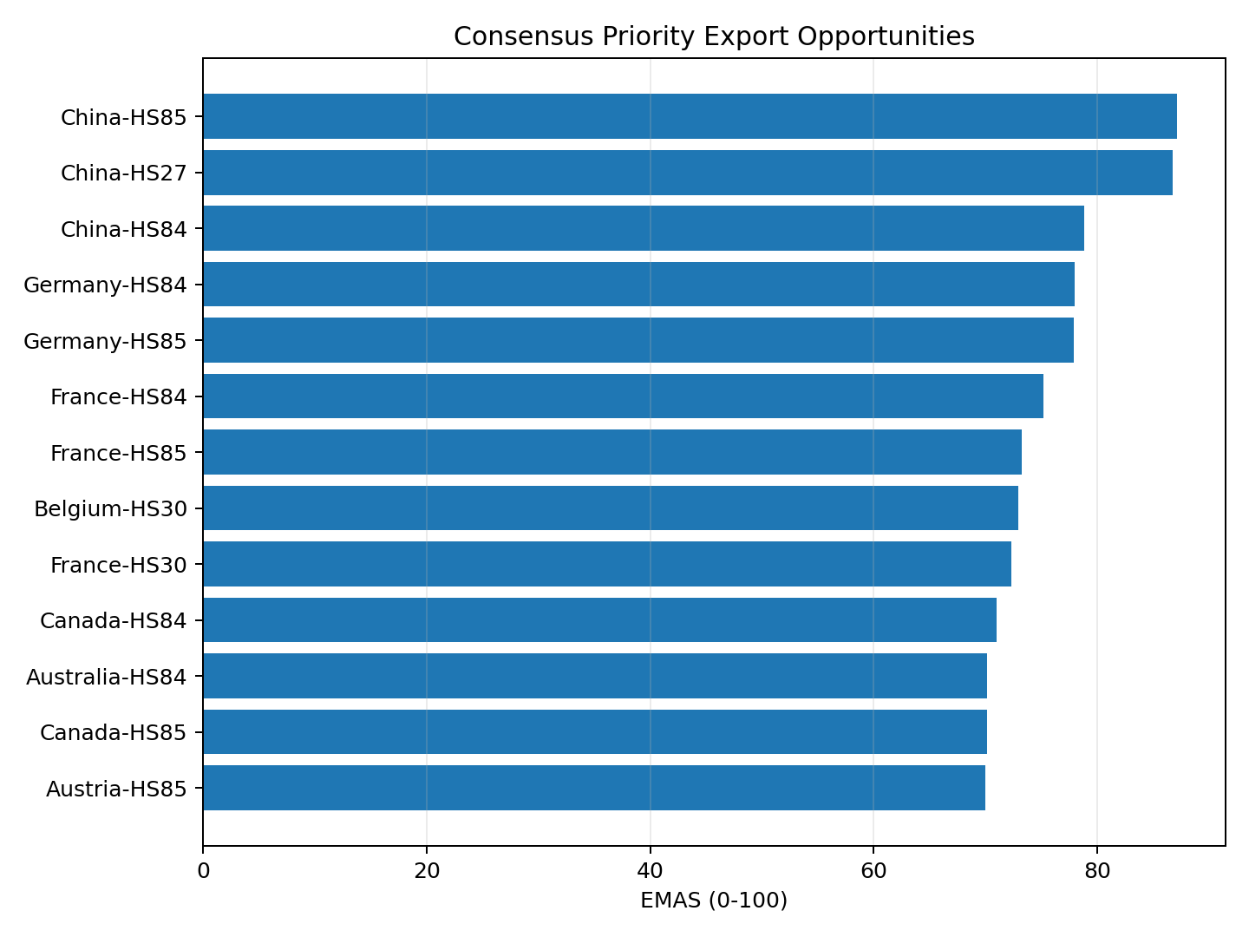
Table 9. Consensus Tier-1 Priority Opportunities
Rank | Market | EMAS | Robustness
1 | China-HS85 | 87.103 | Very Robust
2 | China-HS27 | 86.713 | Very Robust
3 | China-HS84 | 78.793 | Very Robust
4 | Germany-HS84 | 77.961 | Very Robust
5 | Germany-HS85 | 77.895 | Very Robust
6 | France-HS84 | 75.142 | Very Robust
7 | France-HS85 | 73.261 | Very Robust
8 | Belgium-HS30 | 72.954 | Very Robust
9 | France-HS30 | 72.318 | Very Robust
10 | Canada-HS84 | 70.982 | Very Robust
11 | Australia-HS84 | 70.158 | Very Robust
12 | Canada-HS85 | 70.152 | Very Robust
13 | Austria-HS85 | 69.985 | Very Robust

Sensitivity Analysis
Alternative weighting scenarios produced Spearman rank correlations of 0.993 for Equal Weights, 0.970 for Demand Focused, 0.964 for Forward Looking, and 0.951 for Opportunity Focused relative to the baseline ranking. Thirteen markets remained in the Top 20 under all five scenarios. This provides strong evidence that the leading recommendations are not artifacts of a single weighting configuration, although some markets such as Australia-HS27 are more sensitive to the strategic emphasis placed on individual dimensions.

Practical Significance
EMAS converts a large set of fragmented indicators into a prioritized screening list. Instead of manually reviewing dozens of countries for each commodity, an exporter can begin with the Priority and Strong tiers, inspect the component scores that drive each recommendation, and then allocate detailed market-research resources to the most defensible opportunities. The framework also prevents a common screening error: equating high growth or high import value with attractiveness without considering base effects, India’s existing share, competition, economic strength and predictive demand.

Implementation and User Benefit

Deployment Approach
The current solution is implemented as a reproducible Python notebook and GitHub project. A practical deployment path is a Power BI, Streamlit or similar dashboard that reads the final ranked output and allows users to filter by HS chapter, country, recommendation tier and robustness. A scheduled data-refresh pipeline could rerun the preprocessing, prediction and scoring workflow when new TradeStat, Comtrade and World Bank observations become available.

System Integration
The ranked EMAS output can be exported as CSV/Excel or connected to an internal business-intelligence workflow. Export-promotion teams could combine the EMAS shortlist with internal sales, distributor, pricing or lead data before making market-entry decisions.

User Interaction
A user would select a commodity or destination and review the EMAS score, rank, recommendation tier, robustness classification and component scores. Filters can narrow the output to Priority or Strong opportunities, while a sensitivity view can show whether a recommendation remains stable under alternative strategic weightings.

Benefits to Users
Operational efficiency: reduces manual consolidation of multiple public datasets. Financial value: focuses costly due diligence on a smaller set of promising markets. Strategic value: provides a transparent rationale for prioritization and makes weight-sensitive recommendations visible rather than hiding uncertainty.

Example Use Case
An Indian exporter of HS84 products can filter the final output to HS84 and immediately see China, Germany, France, Canada and Australia among the Very Robust Priority opportunities. The exporter can then compare India market share, import demand, competition and economic strength for those destinations and select two or three markets for detailed tariff, distributor, logistics and pricing assessment.

Limitations and Further Improvements

Limitations
- Historical dependence: several EMAS dimensions use historical trade and macroeconomic information and may not capture sudden policy, geopolitical, exchange-rate or supply-chain changes.
- Growth instability: percentage growth is unreliable when the previous export base is extremely small; winsorization and neutral scoring reduce distortion but do not create evidence of true growth.
- Indicator dependence: some dimensions are related. Historical and predicted demand were consolidated into Export Performance, but Economic Strength and Import Demand still show meaningful correlation.
- Weight subjectivity: EMAS weights reflect analytical priorities. Sensitivity analysis reduces this concern but cannot eliminate the need for stakeholder-specific judgment.
- Macroeconomic timing: exact-year World Bank data were not always available, so the latest complete observation at or before the trade year was used for required economic-strength variables.
- Predictive uncertainty: strong historical out-of-time performance does not guarantee equal accuracy after structural market changes.
- Market-level scope: the framework evaluates country-commodity opportunities, not firm-specific readiness, capacity, pricing or distribution capabilities.
- Commercial factors: tariffs, non-tariff barriers, certification, logistics, channel access, political risk and product-level pricing are not directly included in the final score.

Impact of Limitations
These limitations mean that EMAS should be interpreted as a comparative screening framework rather than a causal model or automatic market-entry rule. Rankings are most reliable for prioritizing where to investigate next; they should not replace product-level feasibility analysis. Temporal data gaps and future structural changes may alter both predicted demand and relative rankings, while omitted commercial factors can materially affect realized profitability.

Future Improvements
- Incorporate tariffs, non-tariff barriers and bilateral trade agreements.
- Add logistics cost, geographic distance and shipping-time indicators.
- Include exchange-rate volatility, political risk and regulatory-complexity measures.
- Extend to more detailed HS product codes and additional years of historical data.
- Evaluate additional time-series and machine-learning models as longitudinal coverage grows.
- Automate data refresh and develop a production dashboard/API with user-adjustable weights.

Future Scope
Future work can extend EMAS from strategic country-commodity screening to product-level recommendation, firm-specific suitability scoring and scenario analysis. An interactive dashboard could allow decision-makers to modify weights and immediately observe changes in rankings. With richer time-series data, the predictive layer could incorporate explicit forecasting models and uncertainty intervals, while integration with firm-level sales and cost data could support expected-margin or risk-adjusted opportunity scoring.

Bibliography
Andersen, P. H., & Strandskov, J. (1998). International market selection: A cognitive mapping perspective. Journal of Global Marketing, 11(3), 65-84.
Batarseh, F. A., Gopinath, M., Nalluru, G., & Beckman, J. (2019). Application of machine learning in forecasting international trade trends. arXiv:1910.03112.
Brenton, P., & Newfarmer, R. (2007). Watching more than the discovery channel: Export cycles and diversification in development (Policy Research Working Paper No. 4302). World Bank.
Caldarelli, G., Cristelli, M., Gabrielli, A., Pietronero, L., Scala, A., & Tacchella, A. (2012). A network analysis of countries’ export flows: Firm grounds for the building blocks of the economy. PLOS ONE, 7(10), e47278. https://doi.org/10.1371/journal.pone.0047278
Decreux, Y., & Spies, J. (2016). Export potential assessments: A methodology to identify export opportunities for developing countries. International Trade Centre.
El Kefi, S. (2021). Application of DEA in international market selection for the export of products from Spain. arXiv:2110.03512.
Gaston-Breton, C., & Martin Martin, O. (2011). International market selection and segmentation: A two-stage model. International Marketing Review, 28(3), 267-290. https://doi.org/10.1108/02651331111132857
Hausmann, R., & Hidalgo, C. A. (2011). The network structure of economic output. Journal of Economic Growth, 16, 309-342. https://doi.org/10.1007/s10997-011-9071-4
Hidalgo, C. A., Klinger, B., Barabási, A.-L., & Hausmann, R. (2007). The product space conditions the development of nations. Science, 317(5837), 482-487. https://doi.org/10.1126/science.1144581
Papadopoulos, N., Chen, H., & Thomas, D. R. (2002). Toward a tradeoff model for international market selection. International Business Review, 11(2), 165-192.
Rhoades, S. A. (1993). The Herfindahl-Hirschman Index. Federal Reserve Bulletin, 79, 188-189.
Silva, T. C., et al. (2024). Trade-network and machine-learning approaches to economic forecasting. [Source retained from the interim literature review; full bibliographic details should be verified against the final reference manager before submission].
World Bank. (2026). World Development Indicators. World Bank Open Data.
United Nations Statistics Division. (2026). UN Comtrade Database.
Department of Commerce, Government of India. (2026). TradeStat export data.

Appendix

Appendix A: Final EMAS Scoring Logic
The final EMAS score is a weighted sum of six normalized dimensions: Export Performance (0.25), Growth (0.10), Economic Strength (0.15), Import Demand (0.20), India Opportunity (0.15), and Competition (0.15). Scores are converted to a 0-100 scale and ranked across the 231 country-commodity observations. Quartile-based categories provide relative attractiveness labels, while sensitivity analysis supplies a separate robustness classification.

Appendix B: Key Reproducibility Notes
The project repository contains the notebooks and data folders used for the analysis. The modeling pipeline separates numeric and categorical preprocessing, uses an out-of-time test year for RQ4, and applies the trained Random Forest pipeline to the EMAS candidate population. Required macroeconomic values are matched using the latest complete World Bank year at or before the trade year. The final report should be read together with the repository for code-level reproducibility.

Appendix C: Final Strategic Classification
Table A1. Final Recommendation Distribution
Classification | Count
Priority Export Opportunity | 13
Strong Opportunity | 7
Secondary Opportunity | 30
Monitor / Lower Priority | 181
Total | 231

Appendix C: Data Description

Table 3

Data Sources and Access
Source | Notebook input | Purpose | Current status
TradeStat, Department of Commerce, Government of India | 29 Excel files | India’s exports by destination, commodity, current/previous value, and growth | Loaded and cleaned; 6,040 rows.
UN Comtrade | 1 Excel file; 100,000 rows and 47 original columns | Destination imports, quantities, weights, partner information, and competition inputs | Loaded, reduced to 10 fields; India reporter filter returned zero rows and requires correction.
World Bank Open Data | 1 Excel workbook; 2,125 initial rows | GDP, GDP growth, GDP per capita, population, inflation, exports/imports/trade as % of GDP | Cleaned, reshaped, pivoted, and merged by country-year.

Dataset Overview
The TradeStat loader read 29 commodity-year workbooks and combined them into 6,040 records with 10 source variables. The World Bank workbook initially contained 2,125 rows and 10 columns; after empty-row removal, 2,122 records remained. Reshaping the annual columns from 2020 through 2025 produced 12,732 country-indicator-year records, which were pivoted into a country-year table. Following country-name standardization and merging, the final EDA dataset contains 6,040 rows and 21 columns.
Table 4
Dataset Overview
Attribute | Interim value
Rows | 6,040
Columns used in EDA | 21
Unit of analysis | Commodity-country-year
TradeStat files | 29
UN Comtrade files | 1
World Bank files | 1
Years represented in TradeStat summaries | 2021-2026
HS chapters currently represented | 27, 30, 71, 84, 85
Primary outcome | Export_Current / Export_Value
RQ2 predictors | GDP, GDP growth, GDP per capita, population, inflation, trade as % of GDP

Table 5

Data Dictionary
Variable | Definition | Type | Source | Role/handling
Serial_No | Source row number | Object | TradeStat | Identifier only
Country | Destination market | Categorical | TradeStat | Grouping and merge key
Commodity | HS chapter code | Categorical | TradeStat | Product grouping
Year | Reporting year | Integer | TradeStat | Time key
Export_Previous | Previous-period export value | Continuous | TradeStat | Growth baseline
Export_Current | Current-period export value | Continuous | TradeStat | Primary demand outcome
Export_Growth | Reported export growth (%) | Continuous | TradeStat | Source growth measure
Exports_GDP | Exports of goods/services (% GDP) | Continuous | World Bank | Trade openness predictor
GDP | GDP in current US dollars | Continuous | World Bank | Economic size predictor
GDP_Growth | Annual GDP growth (%) | Continuous | World Bank | Economic momentum predictor
GDP_Per_Capita | GDP per capita (current US$) | Continuous | World Bank | Income/market-development predictor
Imports_GDP | Imports of goods/services (% GDP) | Continuous | World Bank | Import orientation predictor
Inflation | Consumer-price inflation (%) | Continuous | World Bank | Stability predictor
Population | Total population | Continuous | World Bank | Market-size predictor
Trade_GDP | Trade as % of GDP | Continuous | World Bank | Trade openness predictor
Import_Value | Comtrade trade value | Continuous | UN Comtrade | Currently fully missing due to filter issue
Import_Quantity | Comtrade quantity | Continuous | UN Comtrade | Currently fully missing
Import_Net_Weight | Comtrade net weight | Continuous | UN Comtrade | Currently fully missing
Export_Value | Copy of Export_Current | Continuous | Derived | Convenience outcome
Export_Growth_Rate | Calculated growth from current/previous | Continuous | Derived | Growth analysis; infinities later replaced
Market_Share | Row export value / annual export total | Continuous | Derived | Relative contribution within year

Appendix D: GitHub Data Availability Statement
Raw and processed data, notebooks, figures, and code are maintained in the project repository.
Repository:
https://github.com/bharathipavithra10-cmd/AI-Export-Market-Decision-Support
Raw data:
https://github.com/bharathipavithra10-cmd/AI-Export-Market-Decision-Support/tree/main/data/raw
Processed / Clean data:
https://github.com/bharathipavithra10-cmd/AI-Export-Market-Decision-Support/tree/main/data/processed
Cleaned source datasets:
https://github.com/bharathipavithra10-cmd/AI-Export-Market-Decision-Support/tree/main/data/cleaned
Code / Notebooks:
https://github.com/bharathipavithra10-cmd/AI-Export-Market-Decision-Support/tree/main/notebooks
Outputs (Figures & Tables):
https://github.com/bharathipavithra10-cmd/AI-Export-Market-Decision-Support/tree/main/outputs

Appendix E: Analysis

Sample Size Assessment
The minimum sample size for each research question was estimated based on the planned analytical method to ensure sufficient statistical power and reliable model estimation. The actual sample size differed across research questions because each analysis required a different subset of complete observations after data cleaning and variable selection. Table 6 compares the minimum recommended sample size with the actual sample used in each analysis.
Table 6
Sample Size Assessment for Each Research Question
Research Question | Analysis Method | Minimum Required Sample | Actual Sample Used | Adequacy
RQ1 | Market comparison + Kruskal-Wallis test | 237 | 5806 | Adequate
RQ2 | Multiple Linear Regression | 109 | 2651 | Adequate
RQ3 | Supplier competition and market concentration analysis | 85 | Pending | Pending
RQ4 | Predictive modelling | 109 | 4985 | Adequate

Appendix F: EDA Results (Interpretation Emphasis)
Figure 1
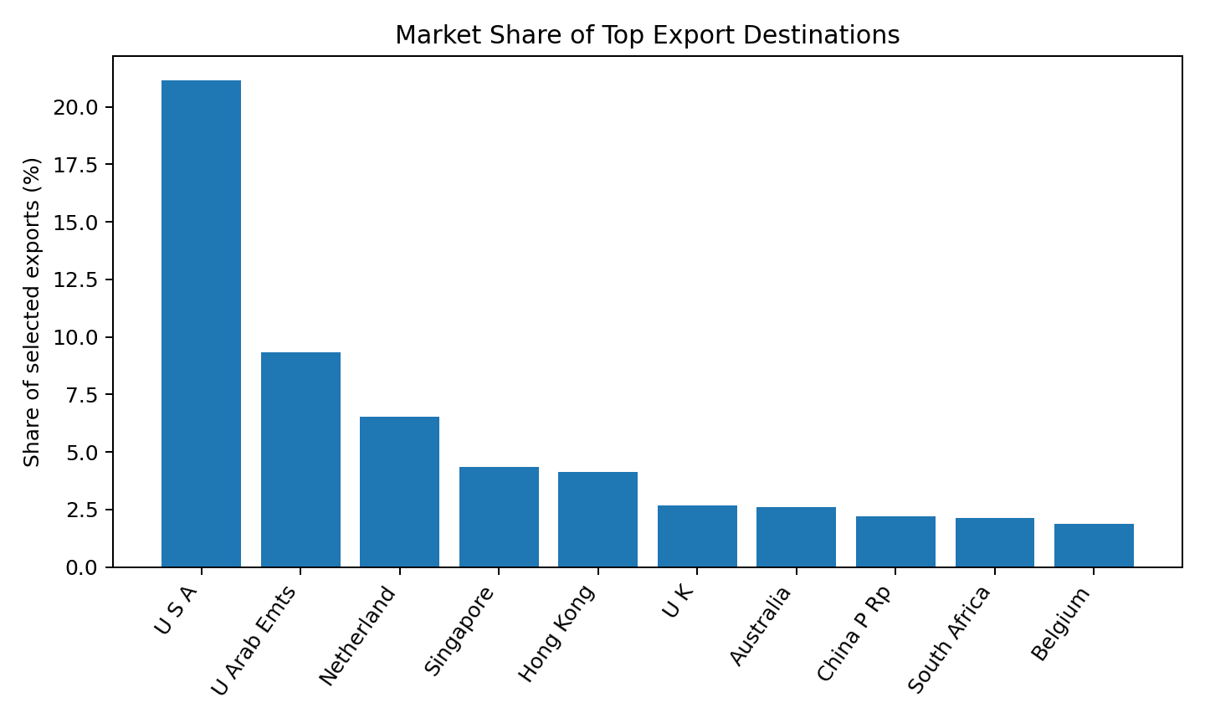
Insight: The United States accounted for 21.14% of export value, more than twice the share of the United Arab Emirates. This concentration indicates a need to balance established-market strength with diversification opportunities.
Figure 2
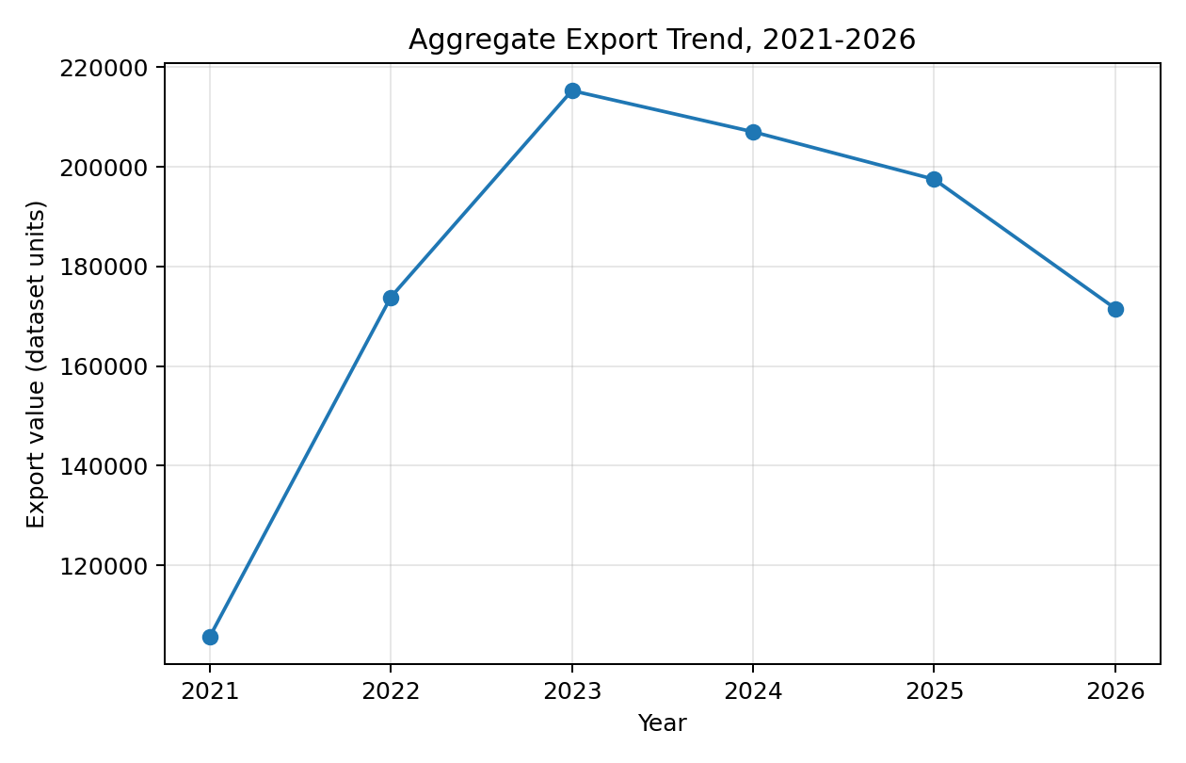
Insight: Figure 2 shows aggregate export value increasing from 105,623.29 in 2021 to 215,301.71 in 2023, followed by moderation to 207,030.96 in 2024, 197,492.25 in 2025, and 171,550.58 in 2026. The apparent 2026 decline must not be interpreted as a completed annual contraction until the reporting period is confirmed, because 2026 data may be partial. T
Figure 3
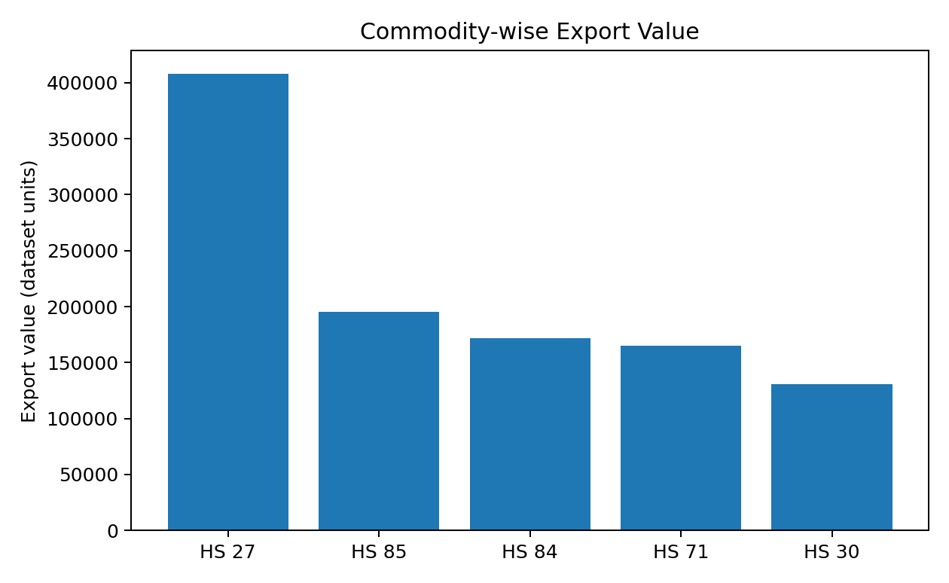
Insight: HS Chapter 27 recorded the highest export value throughout the study period, followed by HS Chapters 85, 84, 71, and 30. The variation across commodity groups supports commodity-specific export analysis.
Figure 4
Correlation Matrix for Export and Macroeconomic Variables
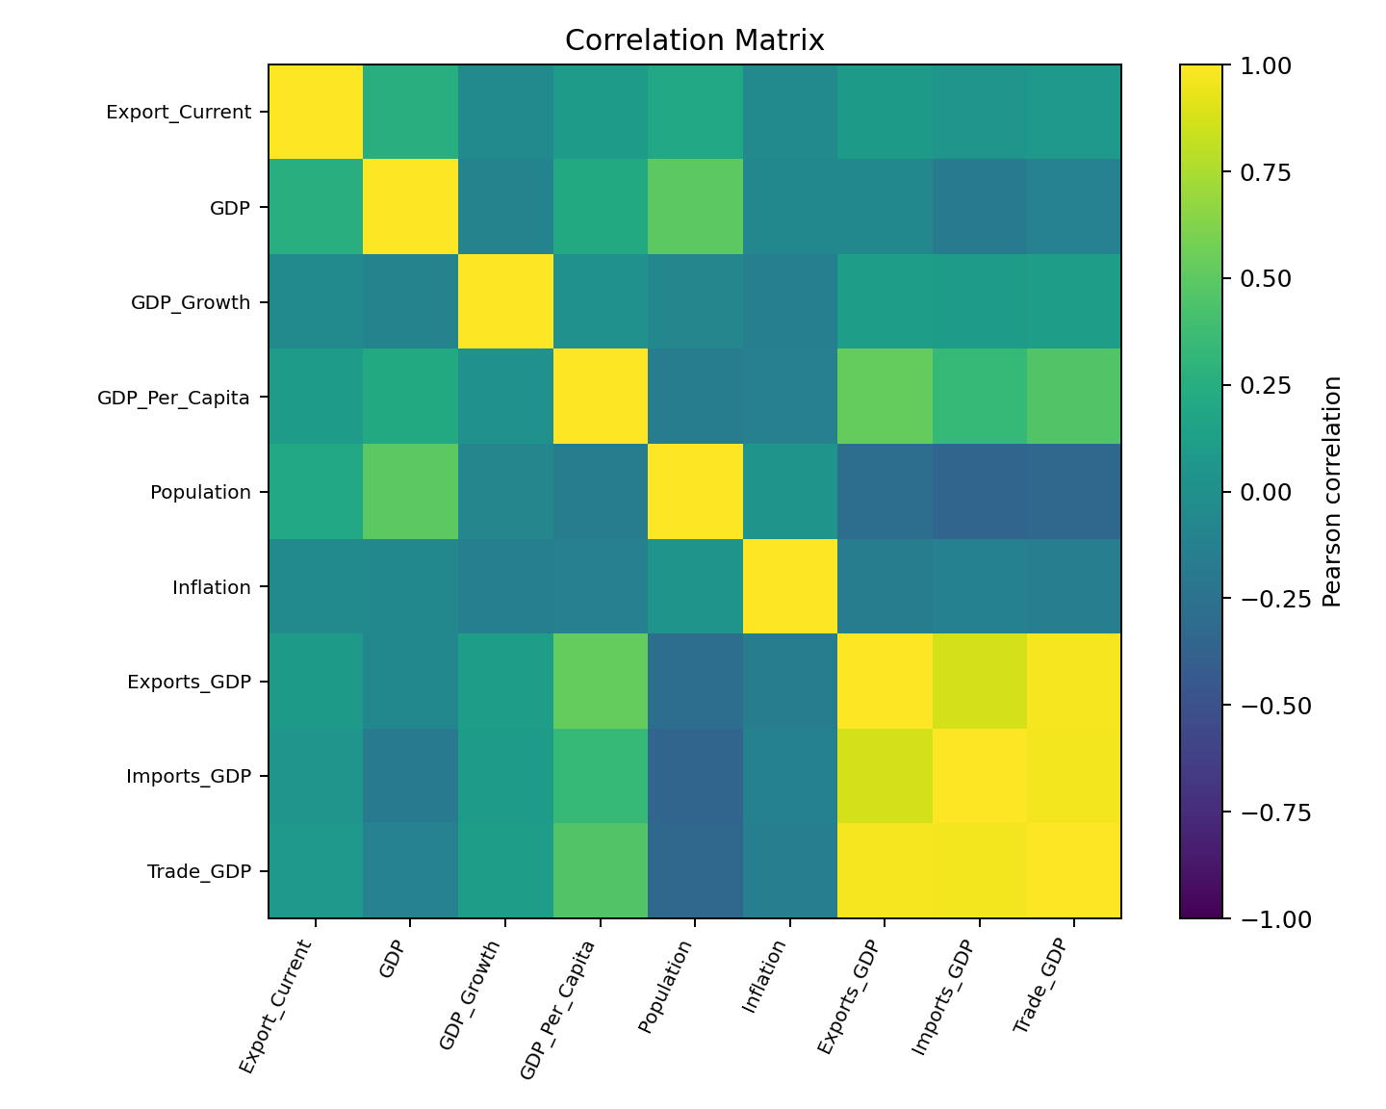
Insight: GDP showed the strongest positive correlation with export demand, followed by Population. Strong correlations among Exports (% GDP), Imports (% GDP), and Trade (% GDP) indicated multicollinearity, which was addressed using VIF analysis.
Table 10
EDA Insight Summary
Figure/Table | What it shows | Key insight | Why it matters | Decision/next step
Figure 1 | Country shares | USA is dominant at 21.14% | Answers market-demand component of RQ1 | Create product-specific destination rankings.
Figure 2 | Annual export totals | Growth to 2023, then lower totals | Shows temporal evolution for RQ1 | Verify whether 2026 is partial; use comparable annual periods.
Figure 3 | Commodity totals | HS 27 dominates current sample | Demonstrates product heterogeneity | Avoid one ranking for all products.
Figure 4 | Pairwise correlations | GDP has strongest export correlation; trade ratios are collinear | Preliminary evidence for RQ2 | Use VIF and alternative model specifications.
Missing-value table | Data completeness | Comtrade variables 100% missing; macro variables partially missing | Constrains RQ2 and prevents RQ3 | Correct extraction and define missing-data strategy.

Multicollinearity Assessment
Following the correlation analysis, multicollinearity among the predictor variables was assessed using the Variance Inflation Factor (VIF) before proceeding with regression modelling. Although the correlation matrix provided an initial indication of strong relationships among several macroeconomic indicators, VIF analysis was performed to quantify the extent of multicollinearity. The analysis was conducted using 2,688 complete observations after excluding records with missing values in the selected predictor variables.

Table 11

Final Variance Inflation Factor (VIF) Results
Variable | Final VIF | Decision
GDP | 1.93 | Retained
GDP_Per_Capita | 1.82 | Retained
Population | 1.67 | Retained
Trade_GDP | 1.55 | Retained
GDP_Growth | 1.06 | Retained
Inflation | 1.06 | Retained

