Task on monitoring

1. Enable CloudTrail monitoring and store the events in s3 and CloudWatch log events.

Create one cloud trail give name specific name which able to understand

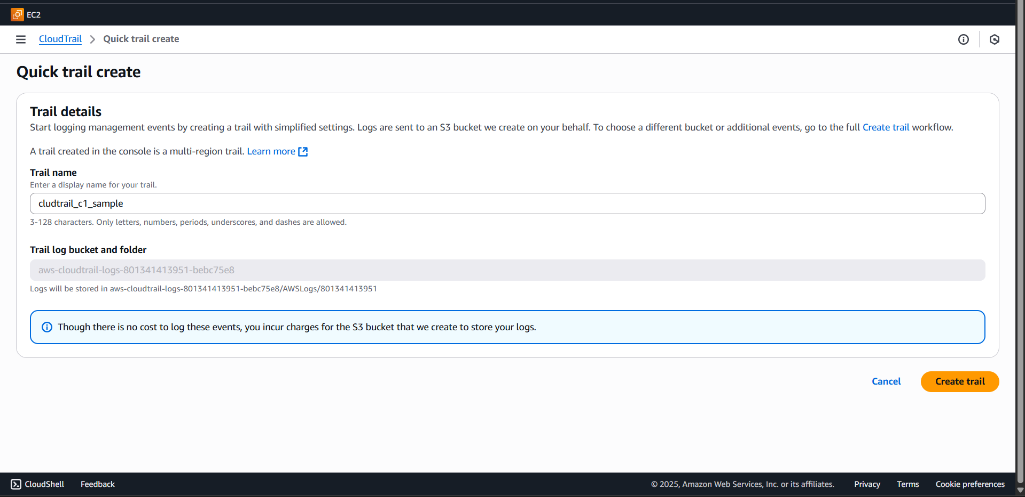

Cloud trail created

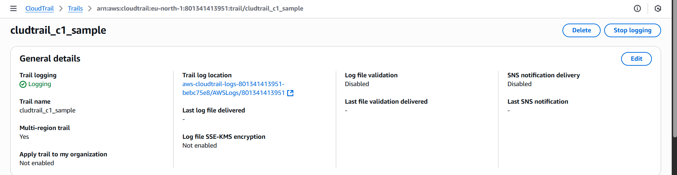

Go to Cloud, create a trail

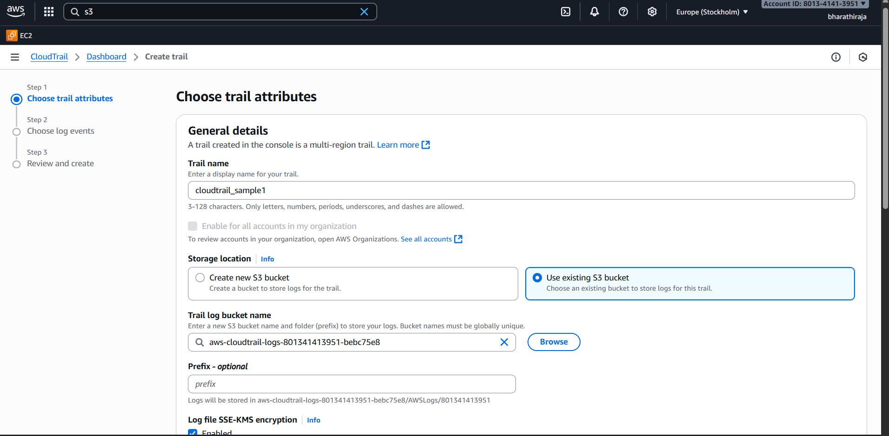

In the event choice management event

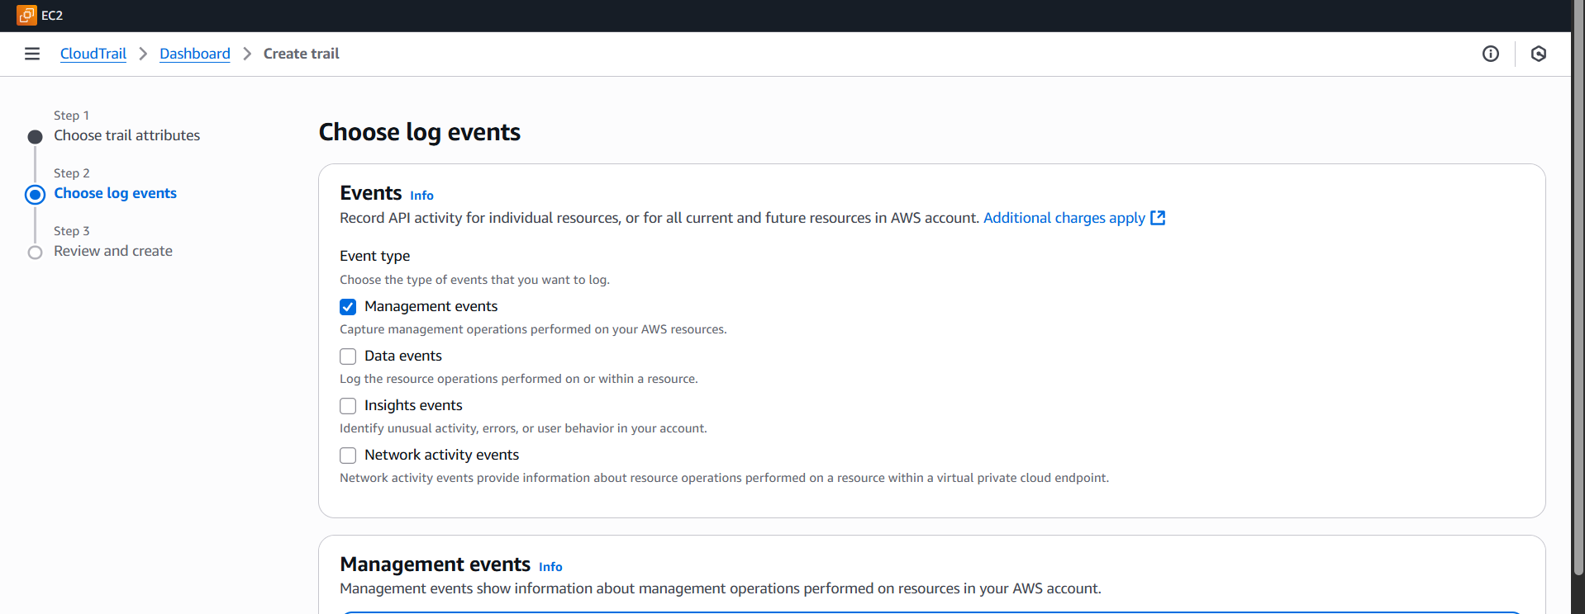

Created cloud trail I was created 2

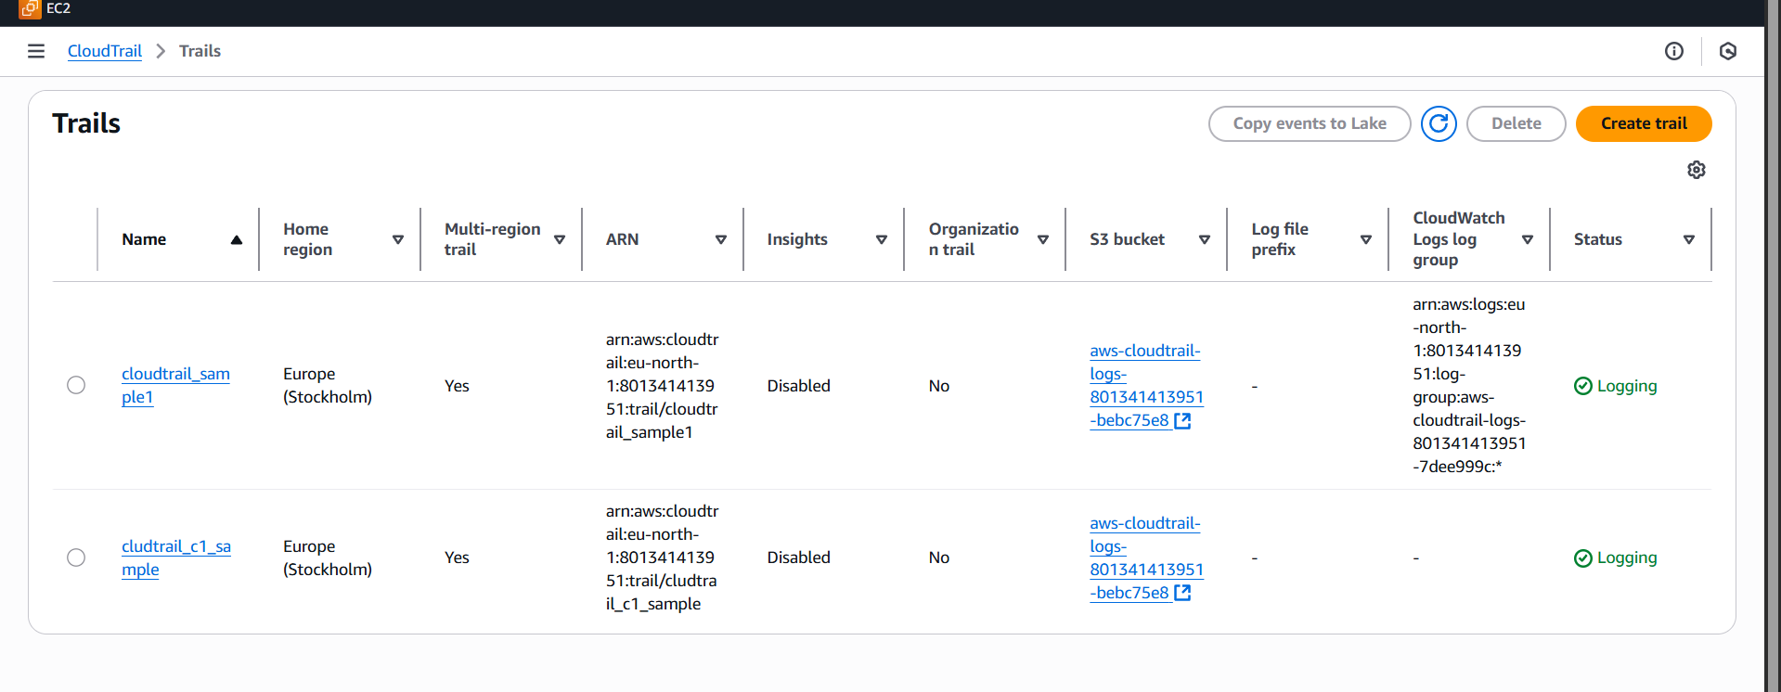

1. Enable SNS for cloudtrial to send alert on email.

Go to amazon SNS first   
choice first topics, then start to create one topic and subscrption   
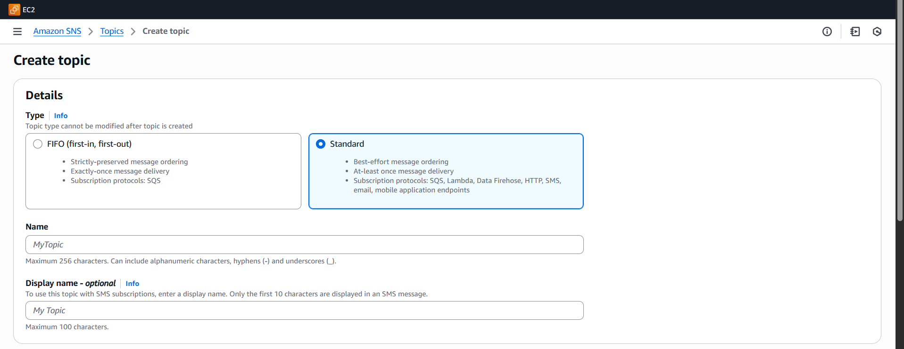

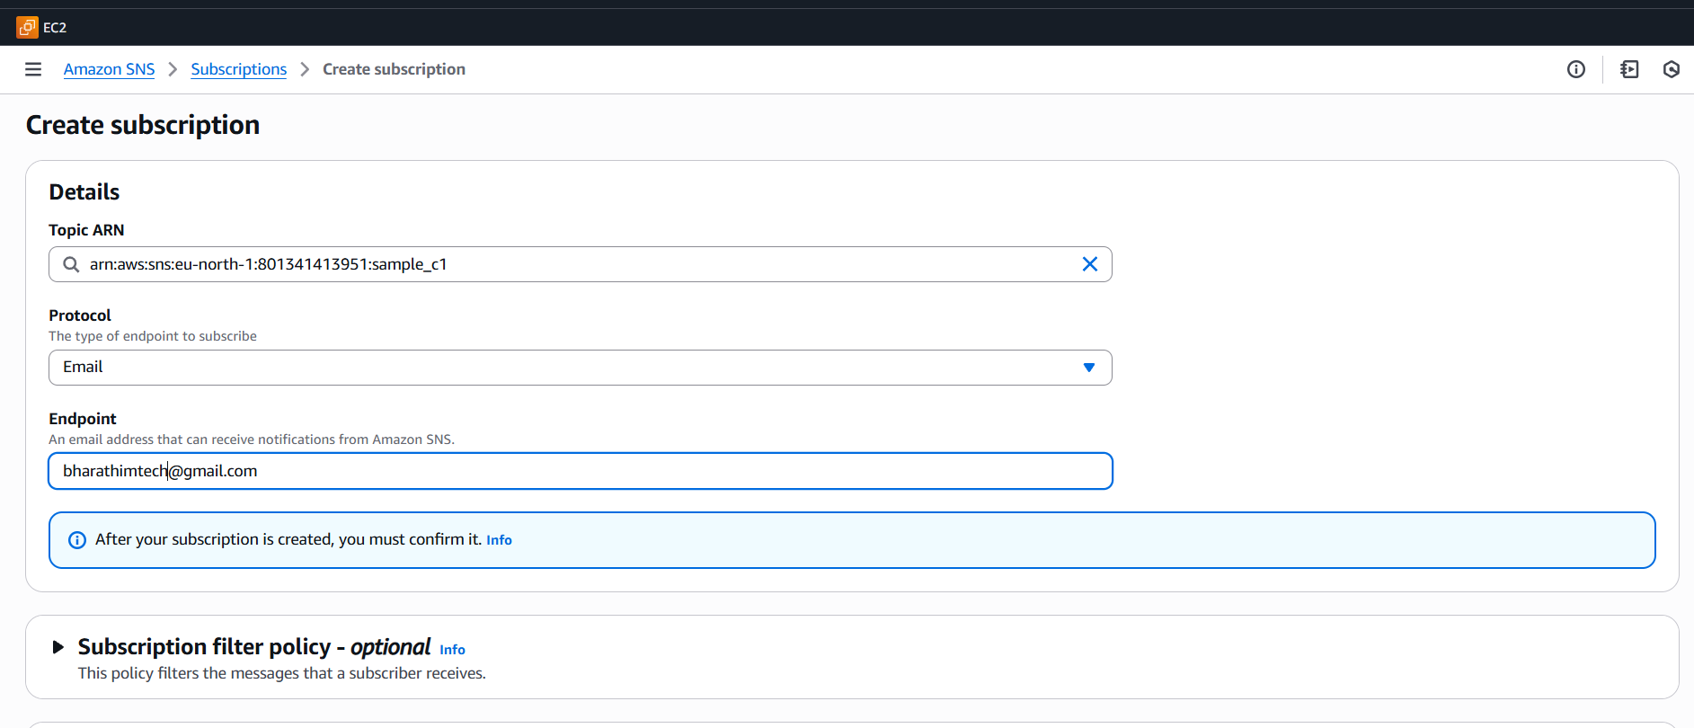

See, there is pending confirmation we have to go email we ashould accept 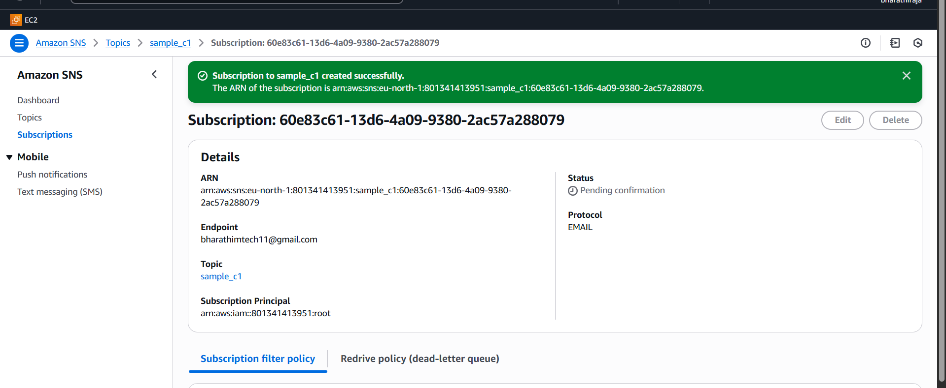

I got the mail to confirm the mail

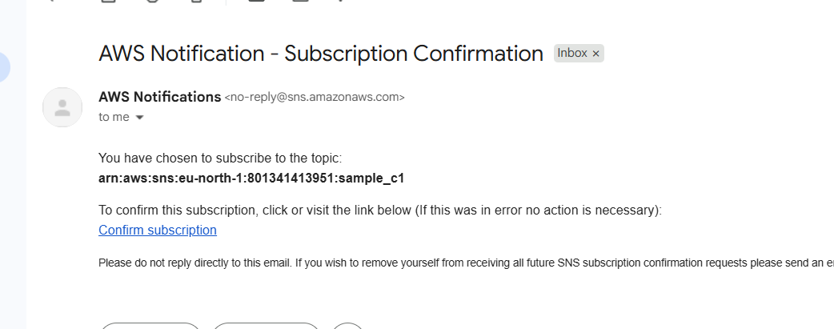

Confirm the mail

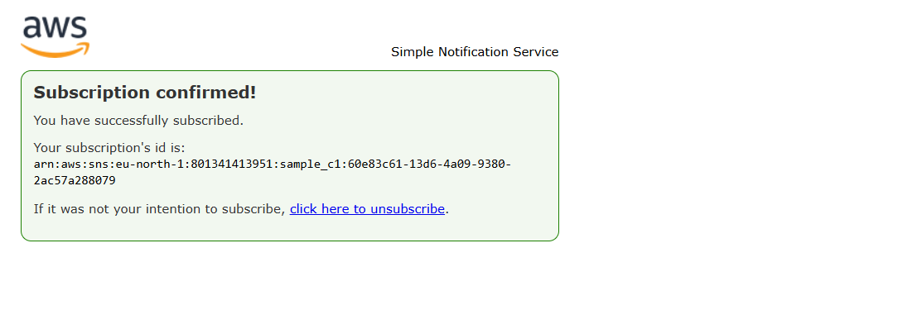

Now we can check the configuration

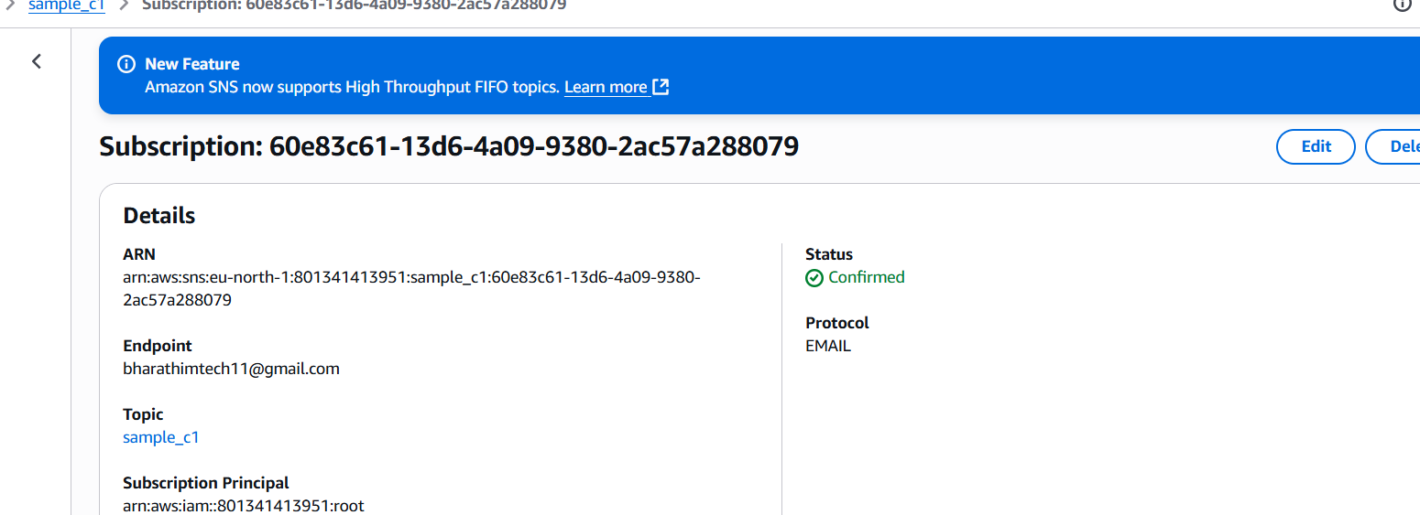

I got mail notification

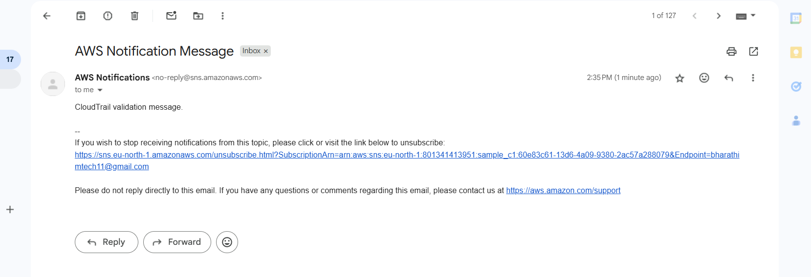

3) Configure CloudWatch monitoring and record the CPU utilization and other metrics of EC2.

4) Create one alarm to send alert to email if the cpu utilization is more than 70 percent.

5) Create a Dashboard and monitor tomcat service wether it is running or not and send the alert.

6) Create Dashboard and monitor nginx service to send the alert if nginx is not running.