1. Create user with name Techie and provide sudo access to user.

Step 1: use **useradd techie** command to create a user

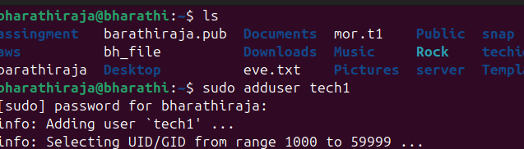

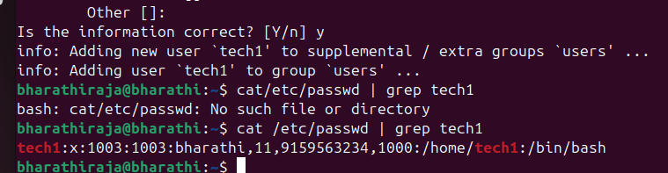

Step 2: switch to root user by using **sudo su -** command and search for a file named sudoers by using **find / -name sudoers** command

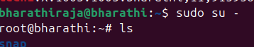

**1)  Create user with name Techie and provide sudo access to user.  
2)  Navigate to the home directory.  
3)  Create a new directory.  
4)  List the contents of a directory.  
5)  Change the current directory.  
6)  Create a new empty file.  
7)  View the contents of a file.  
8)  Copy a file to another location.  
9)  Move a file to another location.  
10) Rename a file.  
11) Delete a file.  
12) Grant or revoke permissions on a file or directory.  
13) View the current date and time.  
14) Check the system uptime.  
15) View the running processes.  
16) Kill a running process.  
17) Install a package using the package manager (e.g., apt or yum).  
18) Update the system packages.  
19) Create a symbolic link.  
20) Search for files using the find command.  
21) Compress and decompress files using tar.  
22) Monitor system resources with top or htop.  
23) Create and manage user groups.  
24) Set up SSH password less authentication.  
25) Monitor log files using tail or grep.  
26) Set up a web server (e.g., Apache or Nginx).  
27) Configure and secure a MySQL Database.  
28) Set up a Application Server (e.g.,Apache Tomcat)  
29) create a service file for Apache Tomcat.(Should execute by using systemtctl command)  
30) Print specific columns from a delimited file.  
31) Filter and print lines based on a specific pattern or condition.  
32) Calculate and print the average, sum, or other statistics of a column.  
33) Perform string manipulation, such as extracting substrings or changing case.  
34) Count the occurrences of a specific pattern in a file.  
35) Sort lines based on a specific field or column.  
36) Merge multiple files based on a common field or column.  
37) Substitute text in a file using search and replace.  
38) Delete specific lines based on a pattern or line number.  
39) Append or insert text before or after a specific pattern or line.  
40) Print only specific lines from a file.  
41)  Copy file from linux to windows machine  
42)  5 use cases for AWK and 5 use cases for sed**

1. Navigate to the home directory.

Step 1: use command **cd** tonavigate to home directory

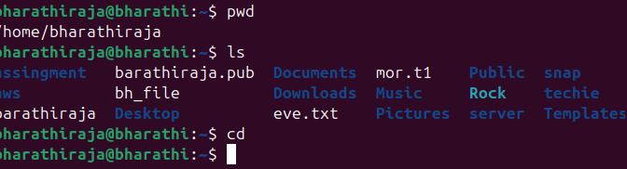

1. Create a new directory.

Step 1: use command **mkdir techie** to create a directory

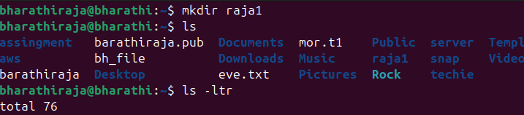

1. List the contents of a directory.

Step 1: use command **ls** to list the content of a directory

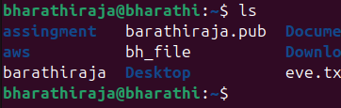

1. Change the current directory.

Step 1: Use command **cd a** to change to a directory

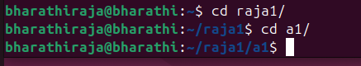

1. Create a new empty file.

Step 1: Use command **touch file** to create a new empty file

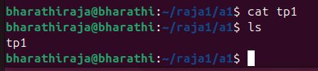

1. View the contents of a file.

Step 1: Use the command **cat file** to view the content of a

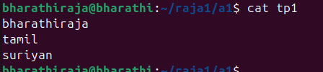

1. Copy a file to another location.

Copy a file to another location

Step 1: Use **cp /source_path /destination_path** commandto copy a file to another location.

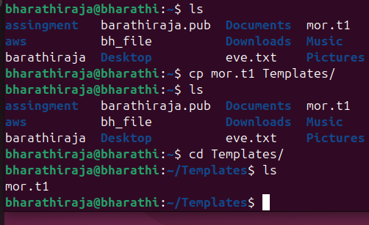

1. Move a file to another location.

Step 1: Use **mv /source_path /destination_path** command to copy a file to another

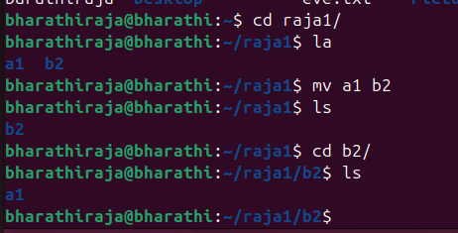

1. Rename a file.

Step 1: Use **mv file cp_file** commandto rename a file

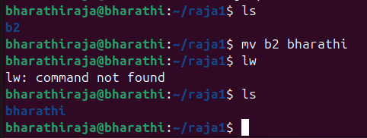

1. Delete a file.

Step 1: Use **rm filename** command to delete a file

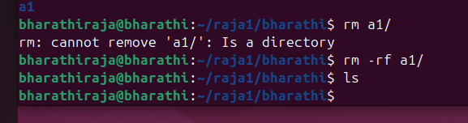

1. Grant or revoke permissions on a file or directory.

Step 1: Use **chmod 147 filename** command to grant or revoke permission for a file or directory

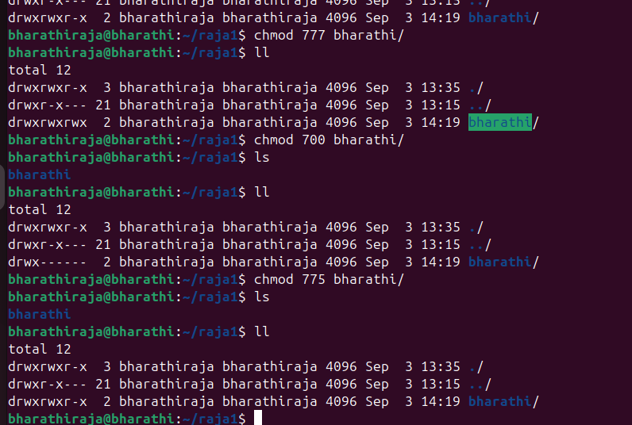

1. View the current date and time.

Use date command to check time and dates

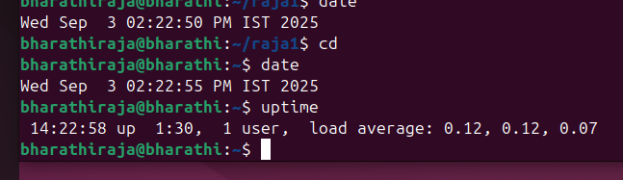

1. Check the system uptime.

tep 1: Use **uptime** commandto check the system uptime



1. View the running processes.

Step 1: Use **ps -ef** command to view the running process

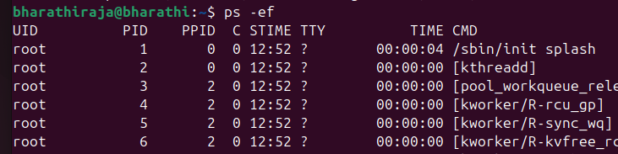

1. Kill a running process.

Step 1: Use **kill -9 pid** command to kill the running process

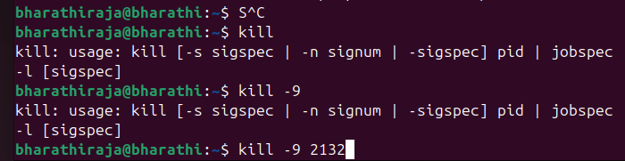

1. Install a package using the package manager (e.g., apt or yum).

Step 1: Use **sudo apt install package_name** command to install a package

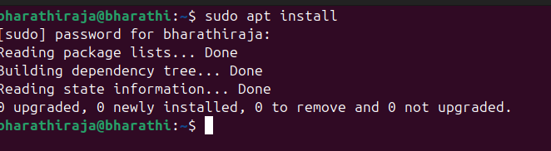

1. Update the system packages.

Step 1: Use **sudo apt update**  command



1. Create a symbolic link.

Step 1: Use **ln -s source_path destination_path** command to create a symbolic link.

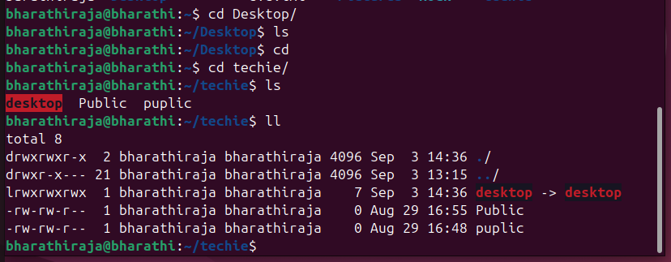

1. Search for files using the find command.

Step 1: Use **find / -name file_name**  command to search for a file

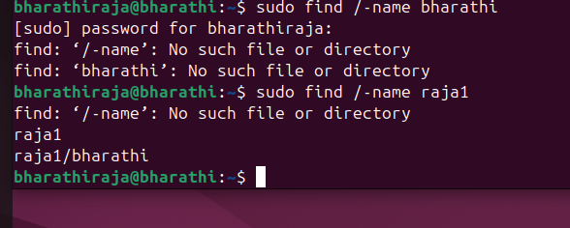

1. Compress and decompress files using tar.

Step 1: Use **tar cvf filename.tar source_path** command to compress and **tar xvf**

**filename.tar** command to extract

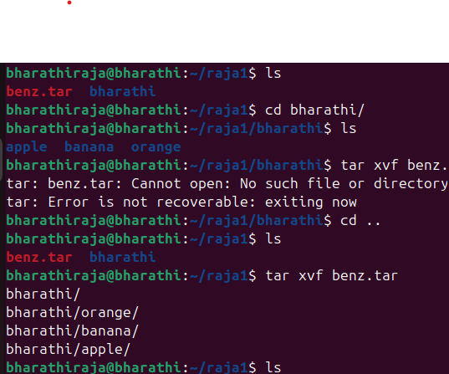

1. Monitor system resources with top or htop.

Using command top and htop(htop with colour it display )

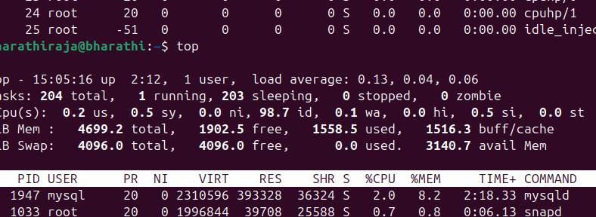

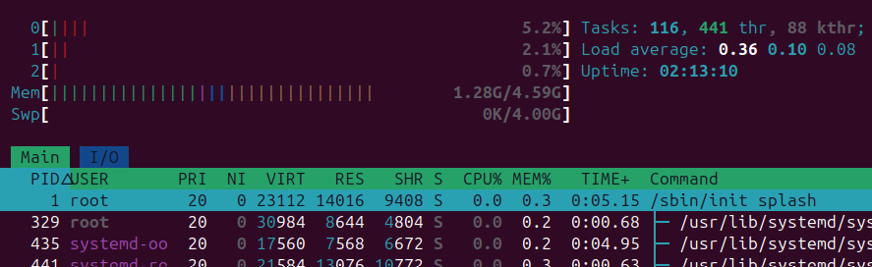

1. Create and manage user groups.

Step 1: Use **sudo groupadd group_name** command to create a groupand **sudo usermod -aG groupname username** to add a user.

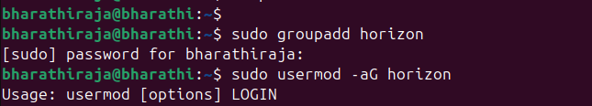

1. Set up SSH password less authentication.

Set up SSH password less authentication.

Step 1: Use **ssh -i securitykey.pem ec2-user@public_ip** to

Set up SSH password less authentication.

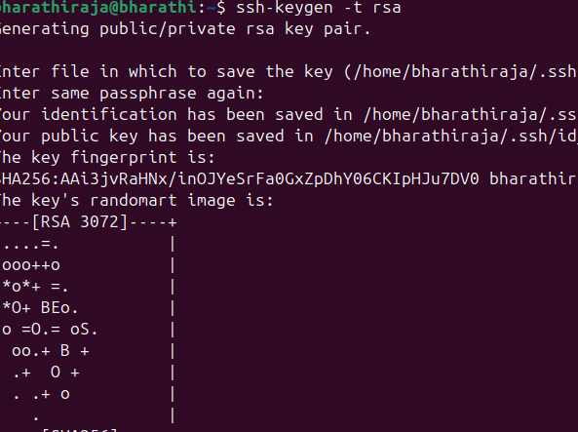

1. Monitor log files using tail or grep.

Step 1: use **tail -f /var/log/syslog** to monitor log files

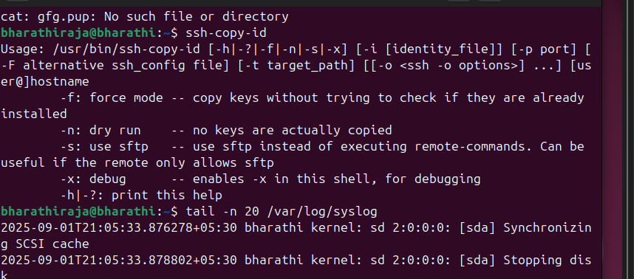

1. Set up a web server (e.g., Apache or Nginx).

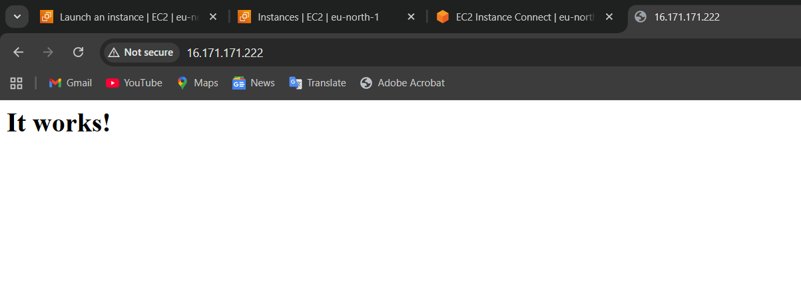

1. Configure and secure a MySQL Database.

Step 1: Use **sudo apt install mysql-server** to install mysql

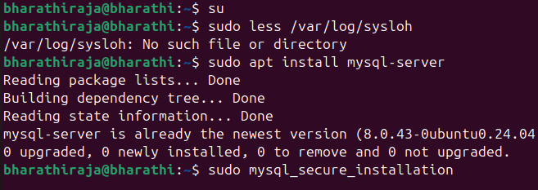

1. Set up a Application Server (e.g.,Apache Tomcat)

if we want to set up application server tomcat  
Firstly we need to do a yum java install then  
Go to the official page of tomcat go to core take copy of link   
then wget that link paste here the results are:

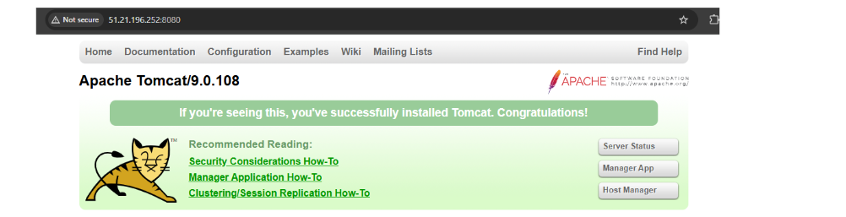

29) create a service file for Apache Tomcat.(Should execute by using systemctl command)

Step 1: Use **sudo nano /etc/systemed/system/tomcat.service** to create a service file and add data to the file

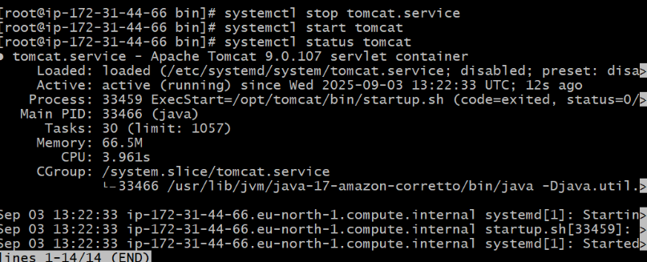

30) Print specific columns from a delimited file.

Step 1: Use **awk '{print $m, $n}' file.txt** command to print specific column

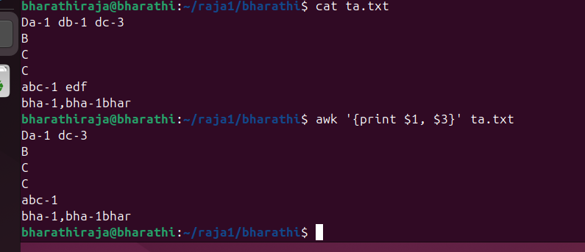

31) Filter and print lines based on a specific pattern or condition.Step 1: Use **grep "error" file.txt** command to print

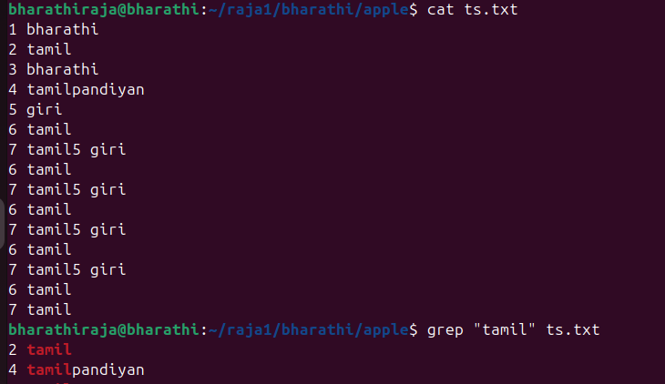

32) Calculate and print the average, sum, or other statistics of a column.

Step 1: use **awk '{sum += $3} END {print "Sum =", sum}' file.txt** command to calculate sum and use **awk '{sum += $3; count++} END {print "Average =", sum/count}' file.txt** command for average.

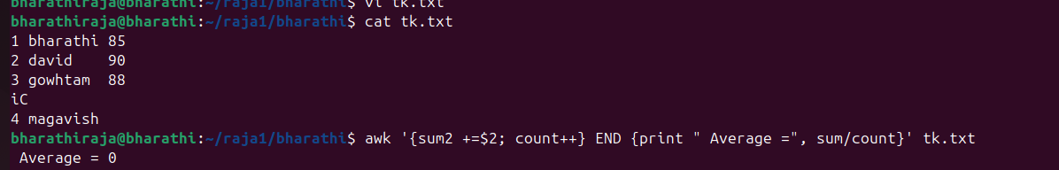

33) Perform string manipulation, such as extracting substrings or changing case.

**Step 1: Use cut -c1-9 file.txt to extract substring**

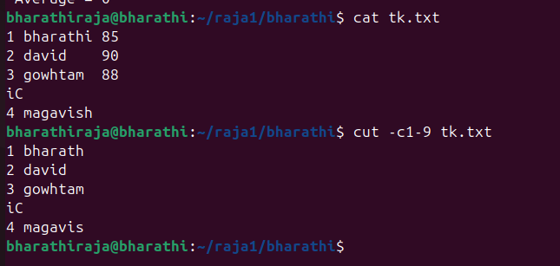

34) Count the occurrences of a specific pattern in a file.

Step 1: Use **grep -c “pattern” file.txt** to count occurance

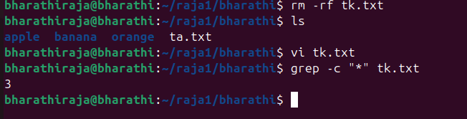

35) Sort lines based on a specific field or column.

Step 1: **Use sort -k3,3n file.txt**  to sort based on column.

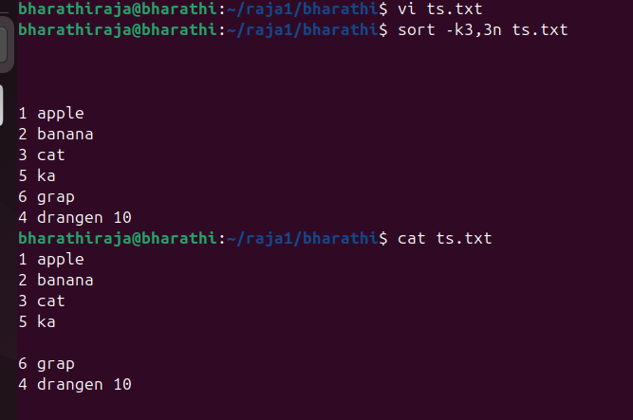

36) Merge multiple files based on a common field or column.

Step 1: Use  **join file1 file2 > merged** command to merge multiple files

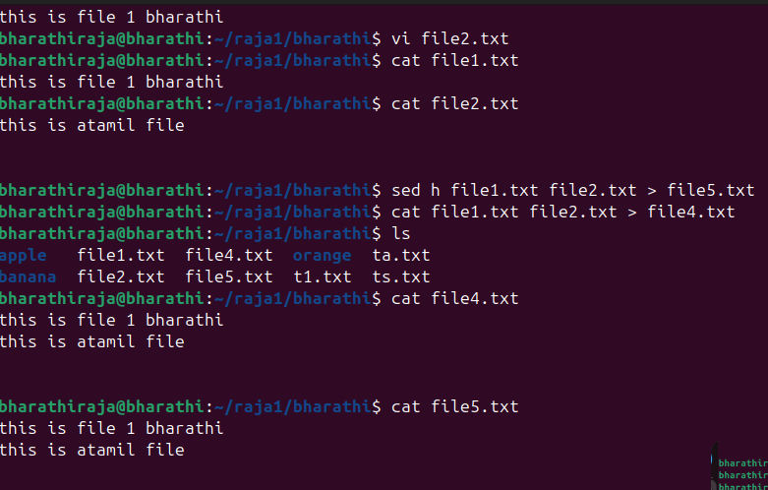

37) Substitute text in a file using search and replace.

Step 1: Use **sed’s/old/new/g’ file_name** to substitute text in a file

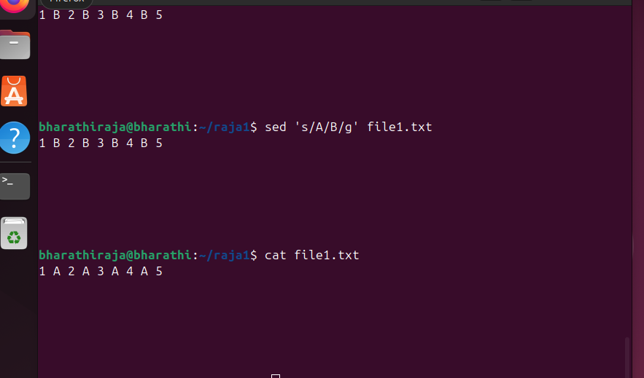

38) Delete specific lines based on a pattern or line number.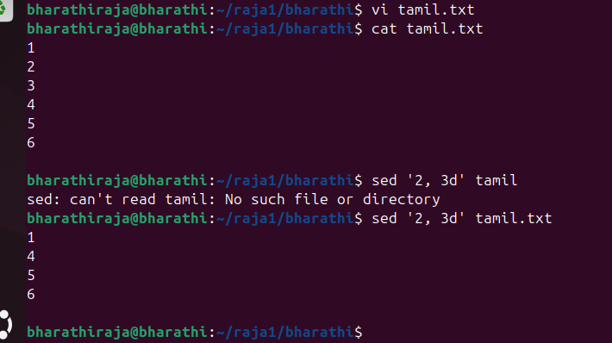

39) Append or insert text before or after a specific pattern or line.

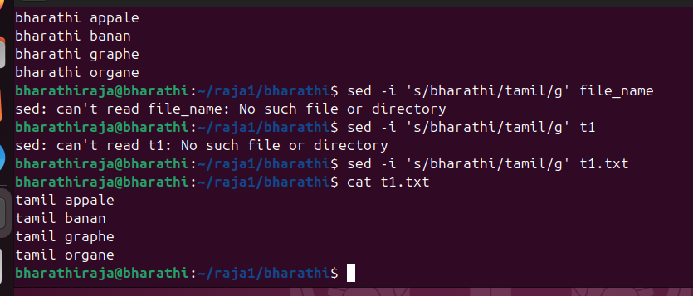

40) Print only specific lines from a file.

Using command for specfi line printing sed -n ‘2p’ t1.txt

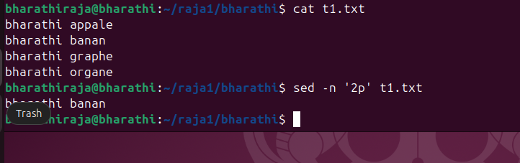

41) Copy a file from Linux to Windows machine  
Step 1: Use scp -i  
/path/to/your/keypair.pem /path/to/local/file.txt Administrator@<Public_IP>:/path/on/windows/server/ to copy from linux to windows machine.

42) 5 use cases for AWK and 5 use cases for sed

. 5 use cases for AWK and 5 use cases for sed awk  
a. awk '{print}' filename.txt – to print the whole file

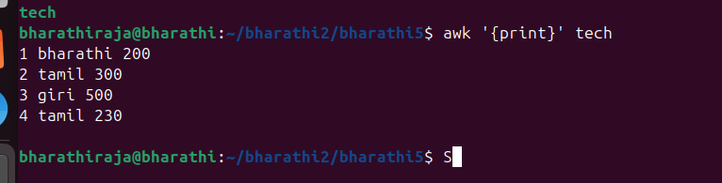

awk '{print $1, $3}' filename.txt – to print specific column

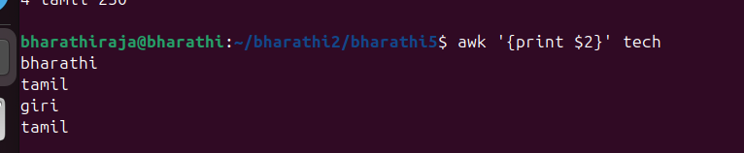

c.awk '/pattern/ {print}' filename.txt – to print specific pattren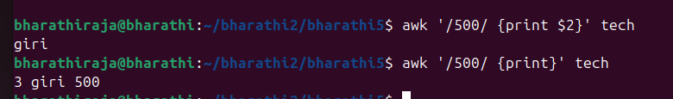

awk '{sum += $2} END {print "Total sum:", sum}' data.txtto do arithmetic operations



e. awk '$4 > 80 {print $1, $2, $3}' file.txt – for condition

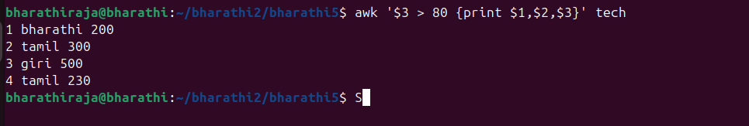

Sed  
a. sed ‘nd’ file,txt to delete a specific line

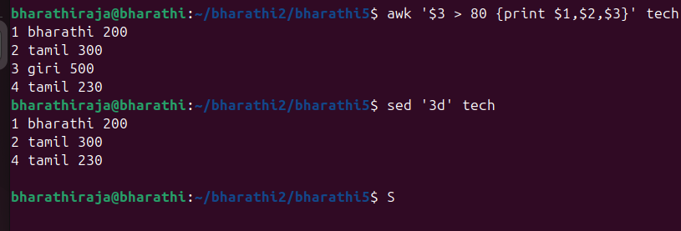

b. sed ‘m, nd’ file.txt to delete a range of lines

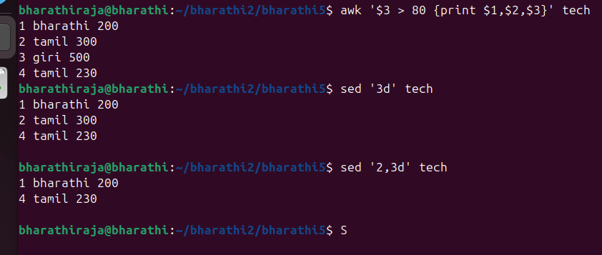

c. sed ‘/pattern/d’ file.txt to delete lines folling pattern

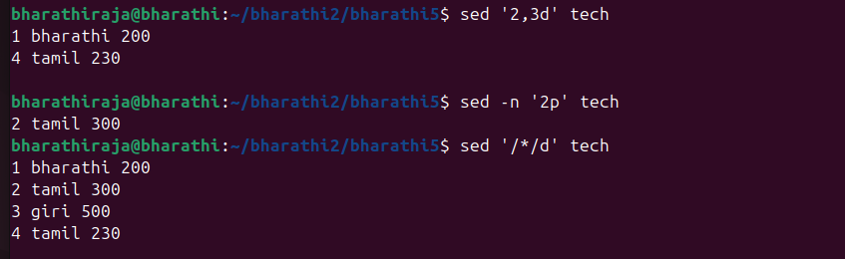

d. sed -n ‘3p’ file.txt to print a specific line



e. sed ‘ni\ line’ file.txt to add data before a line

