step1: switch to user to user

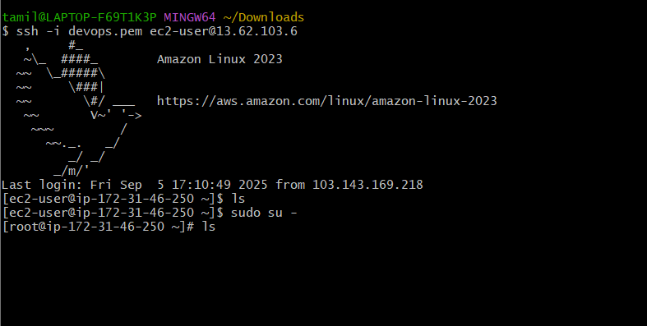

Install httpd

* Y Installing the Apache HTTP Server (httpd) package using Yum.

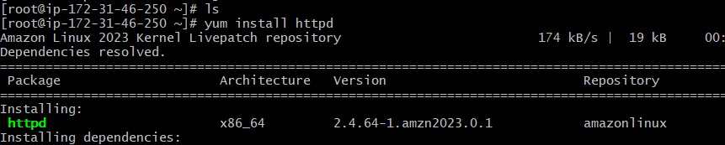

Step 2: we should check the httpd status => systemctl status httpd

If the system is not activated, we should activate it => systemctl start httpd =>systemctl status httpd

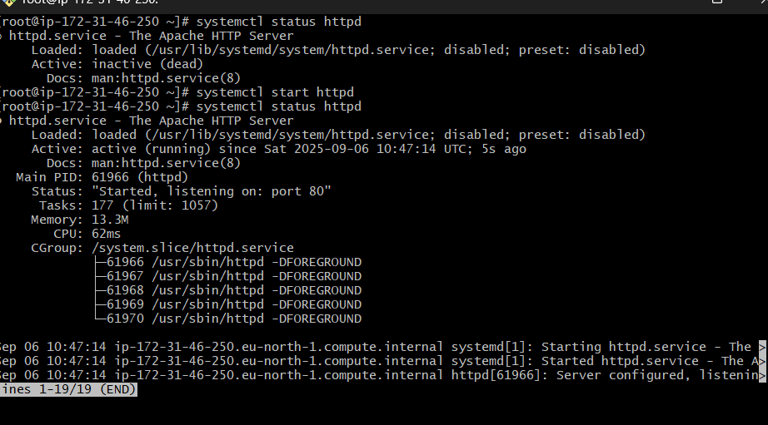

To know the services running in 80 port

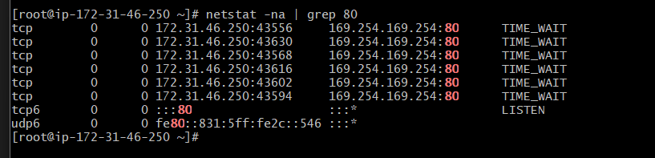

Lsof -I tcp:80

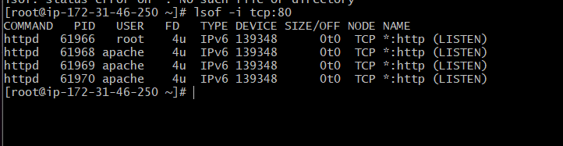

ps -ef | grep 80 : check specific   
service running.→copy ipv4 adress

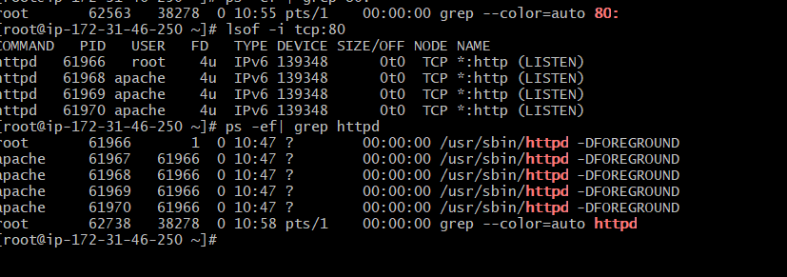  
i.e   
16.171.5.124 from aws instance   
→go to web browser and paste

ip address 80 is the port where the service

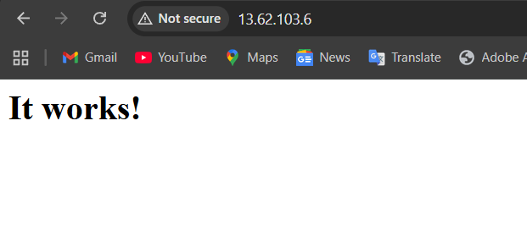

How change the change the webserver output give your own static web

→Vi “filename”.html  
→And enter the <h1>”output you want” </h1>  
→Save it by - enter esc then enter- “:wq!” to save and exit the file.  
→Then restart the service- “systemctl restart httpd

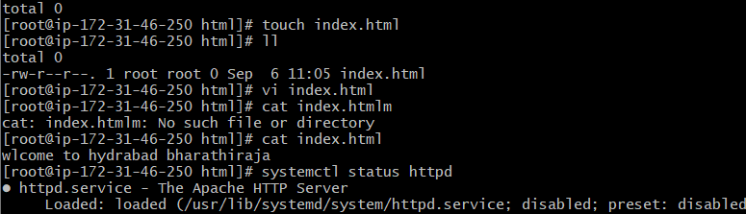

Create one file, type like it as you wish

Come to systemctl restart httpd  
systemctl status httpd  
you can its activated

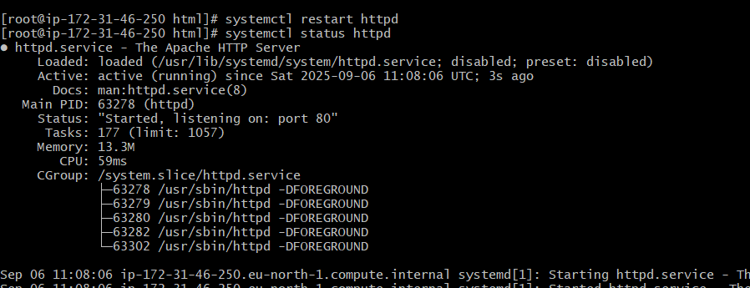

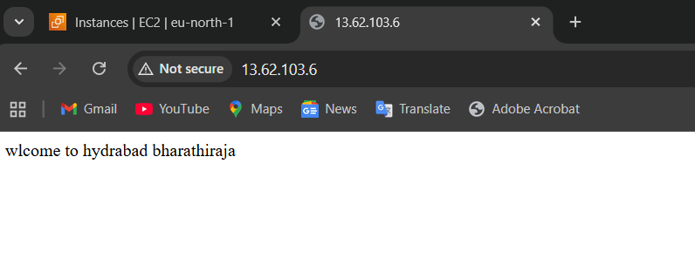

Then i went to this file path after the change

Port number from 80 to 82

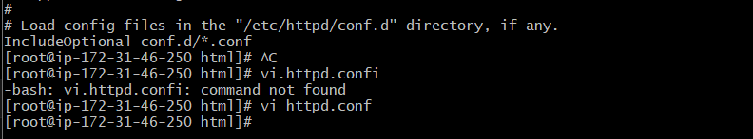

Open vi httpd.conf file

Etc/ httpd/conf/httpd.conf

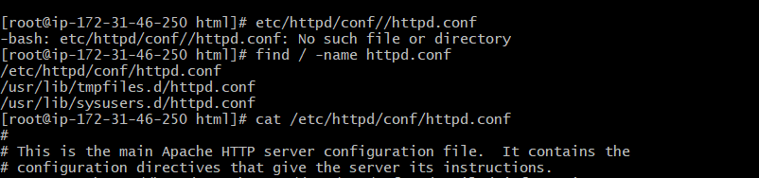

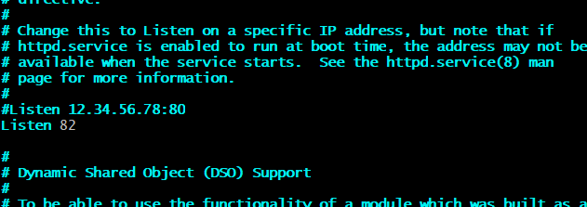

Ip address and (ip:82)

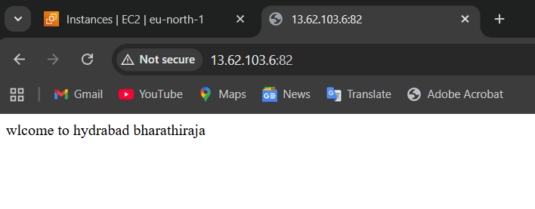

Start to install nginx

I=> yum install nginx

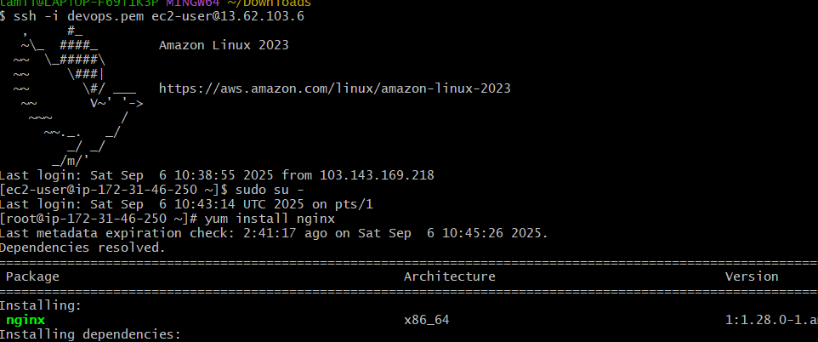

Check the status and start

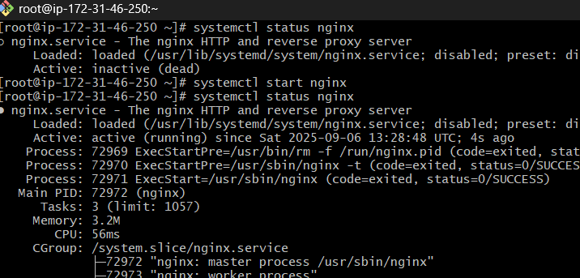

If its active, you can check the web browser's IP address: 80

Then it will get this page

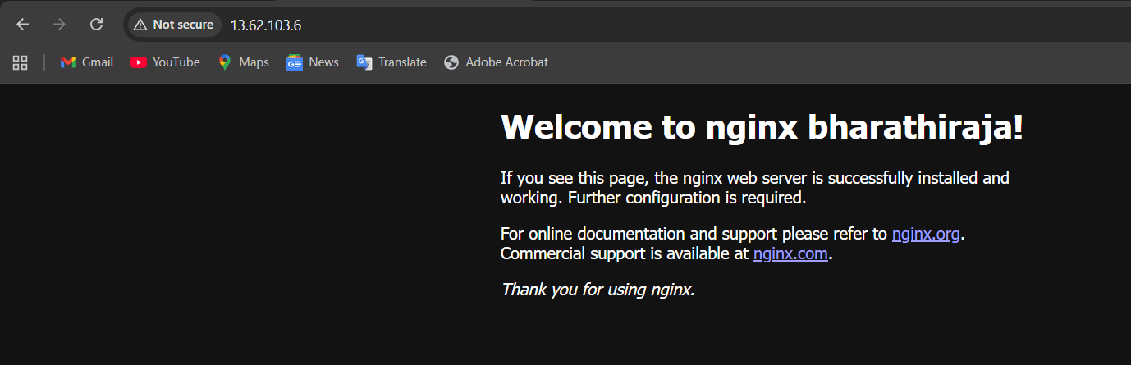

Then, after you can change the prot 80 to 81   
which mean I mentioned there first you should go cd /etc/nginx => create a file vi nginx.conf

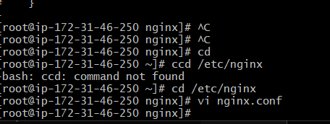

Indeed we need to change the port number

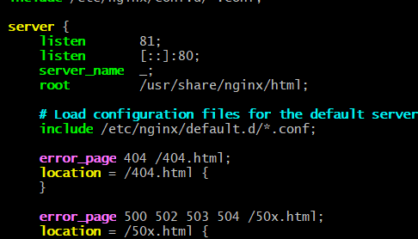

Then you get a page it works

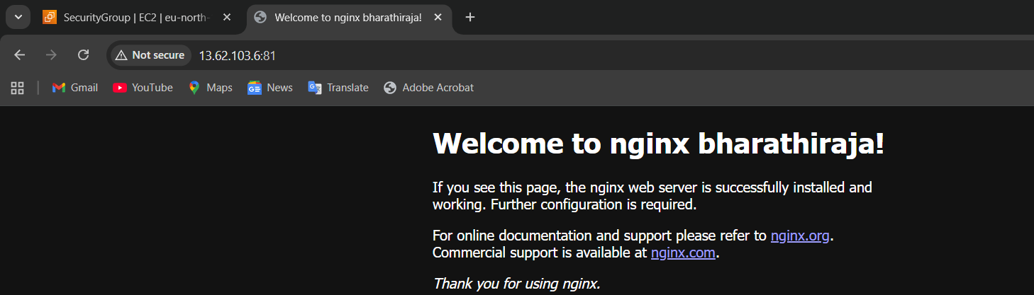

5 ) Apache Tomcat/application server

Connect ec2

Tomcat install wget (link) from the browser that link, which version we want takes from there

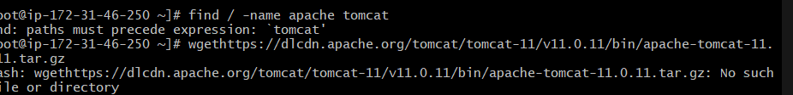

Ten extract the tar file using command tar xvf file name Tomcat apeche

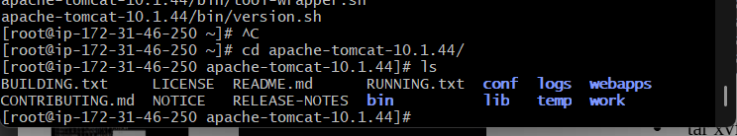

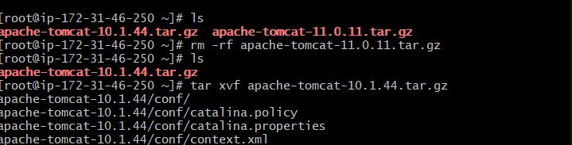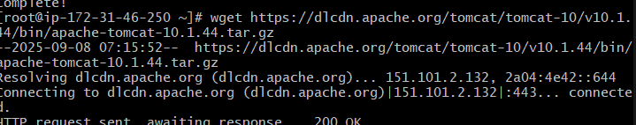

Its needs Java installation because of Java-related applications run the Tomcat application, which is why 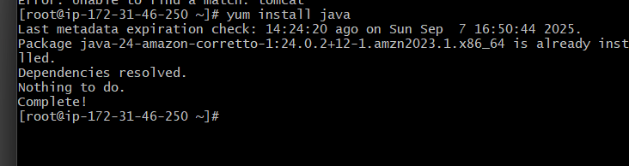

Cd open Apache Tomcat file   
then open bin it will open some file

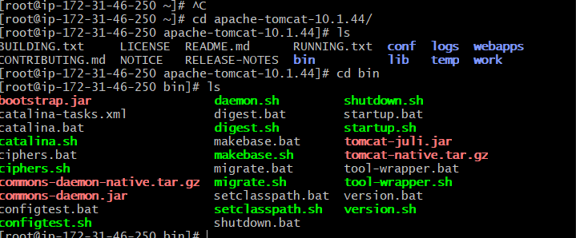

We need start using the command => bash ./startup.sh

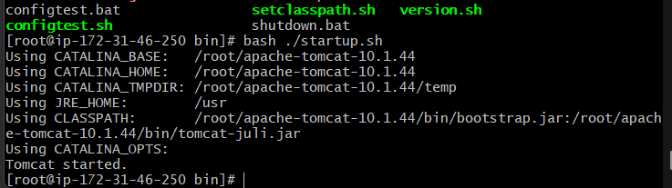

Netstat -na | grep 8080, whether it's connected or not

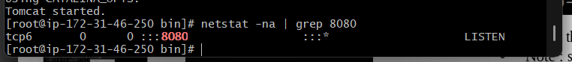

Open the server.xml file and write

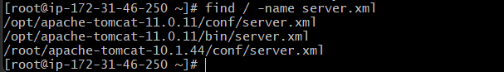

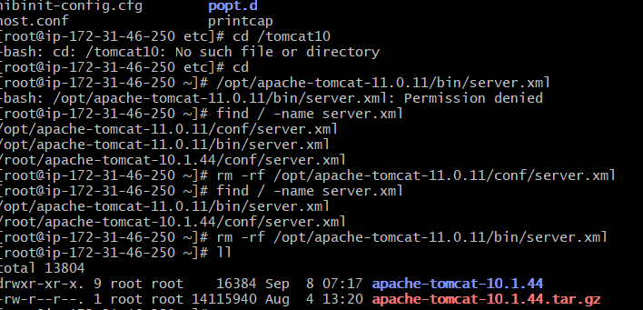

Open logs file open Catalina.out file

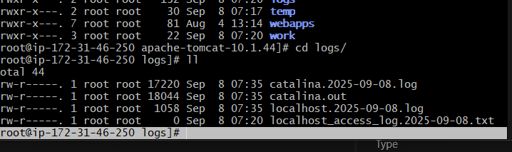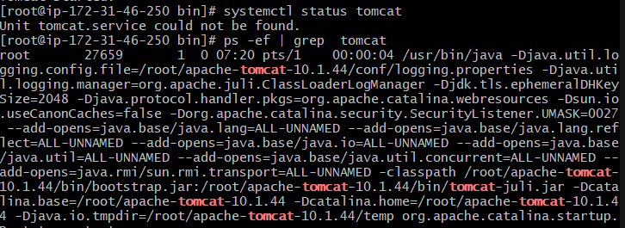

Then start again

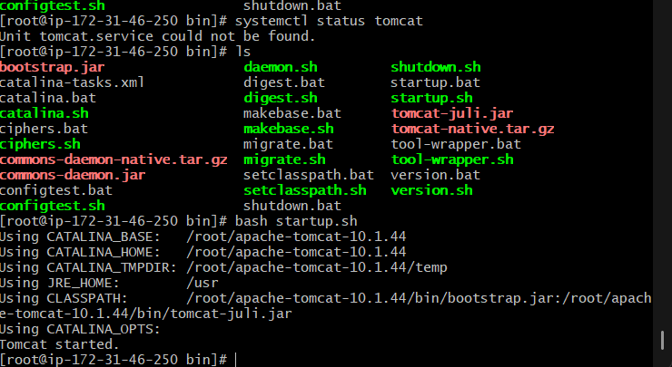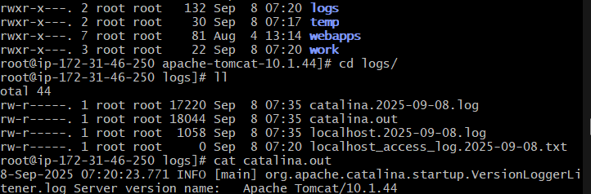

Check ip address

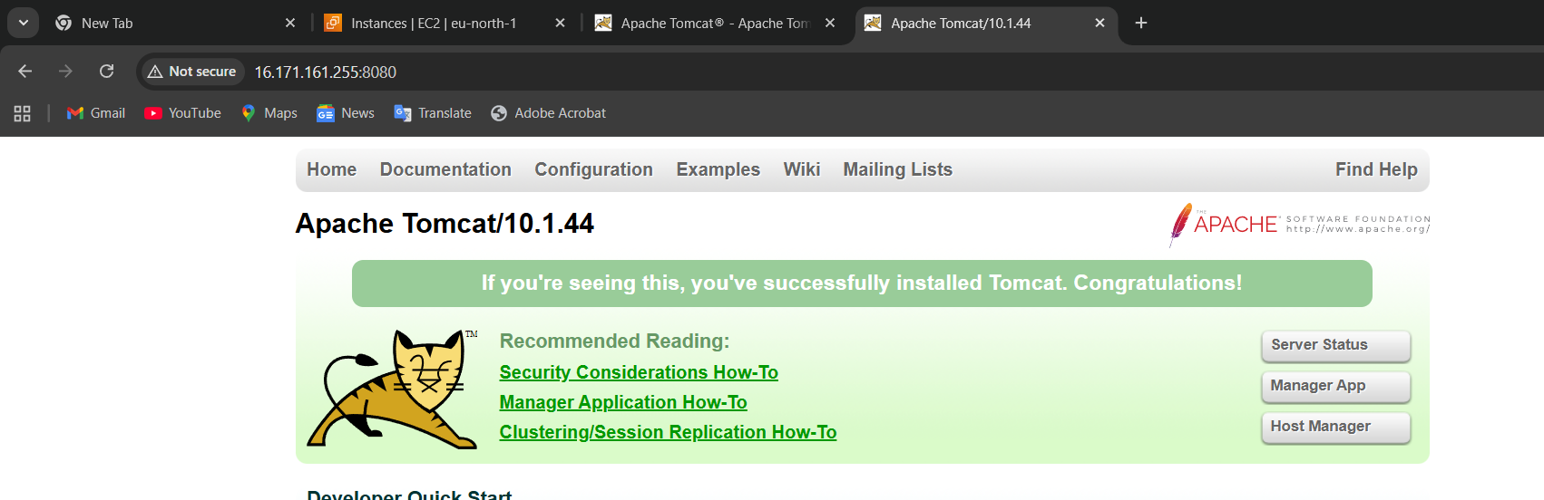

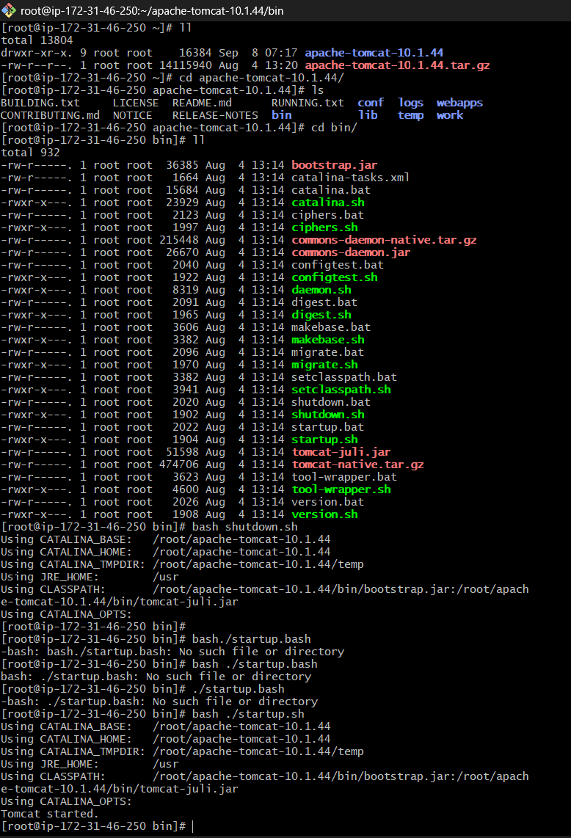

Change the port number after check it will work

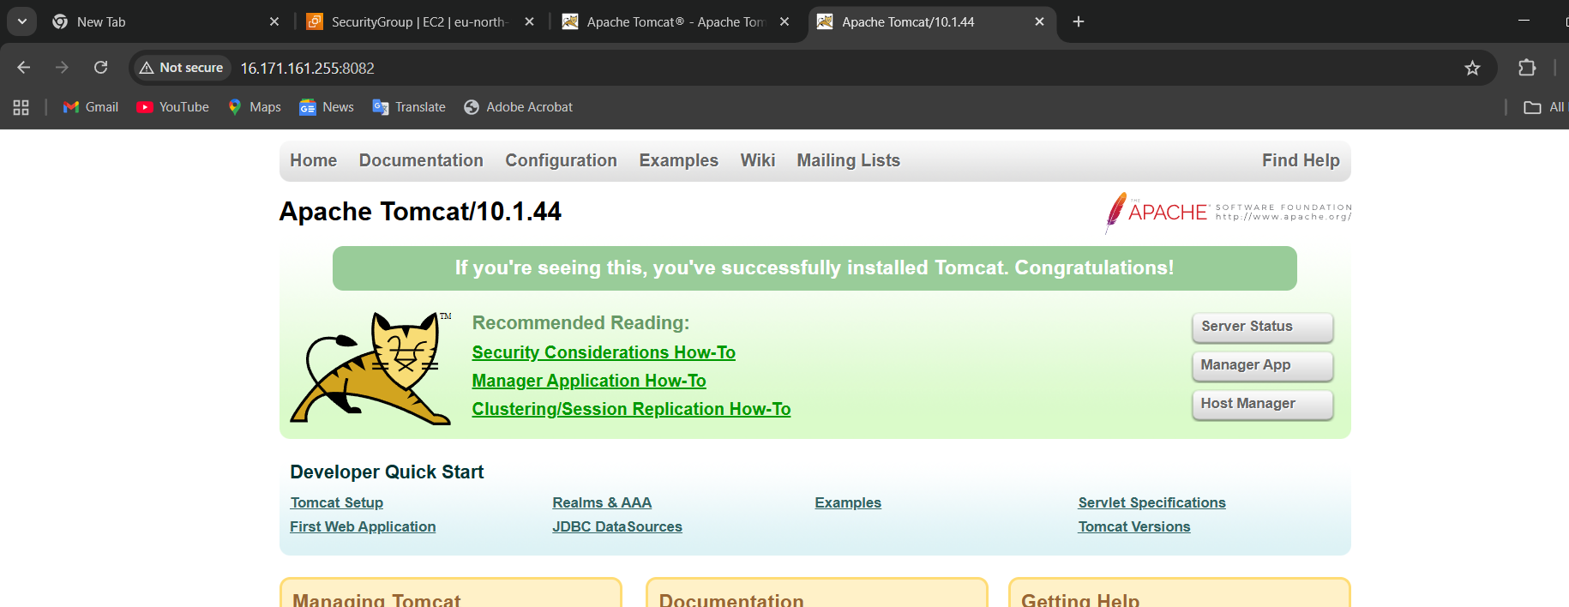

6)Deploy a sample app on webapps

Checking to get a link from the website

Wget using the link to download the CD webapps

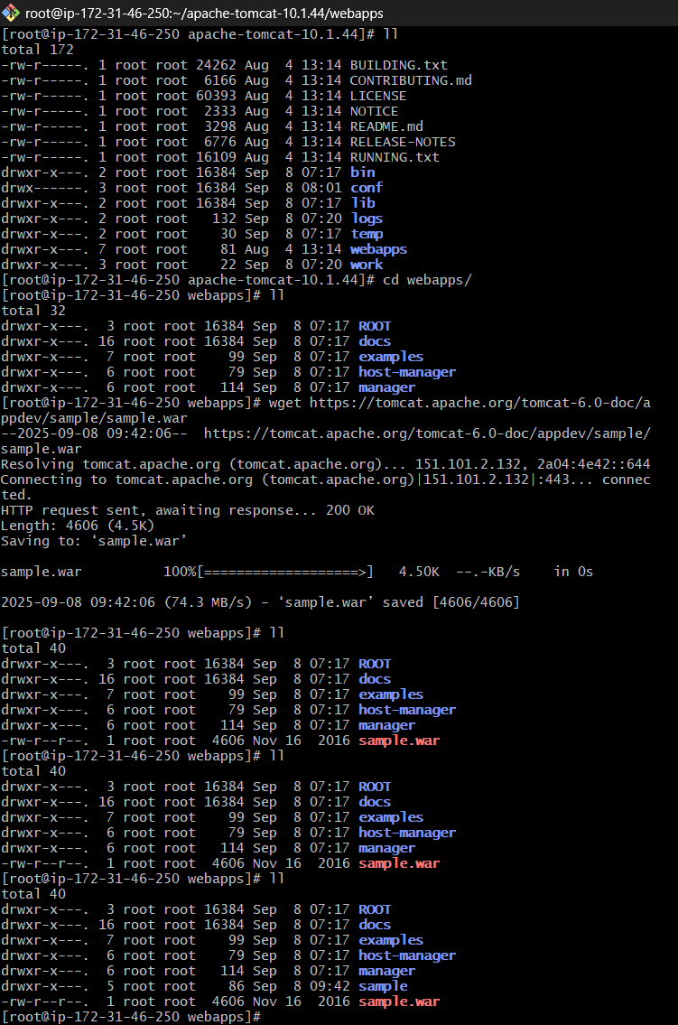

Then extract a file sample using 2 times, ll automatically extract

Using ip:8082/sample/ => give like that we can see output

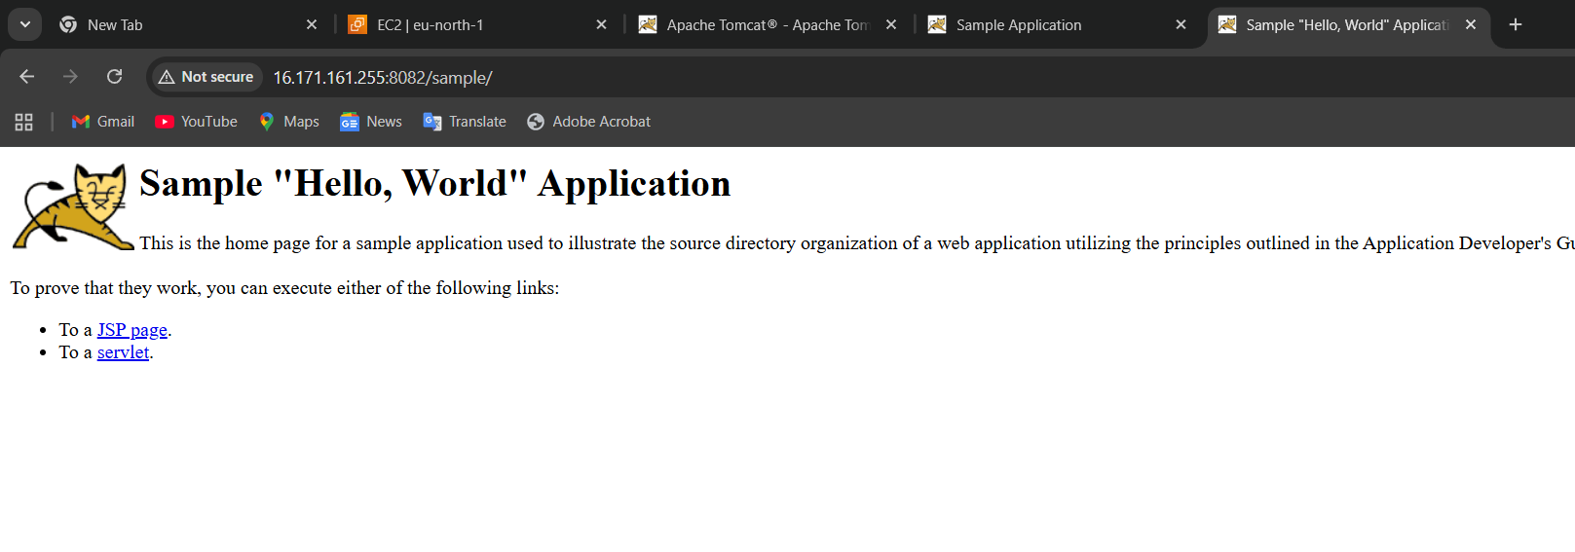

8): HAProxy installation

Open the first 3 EC2 instances

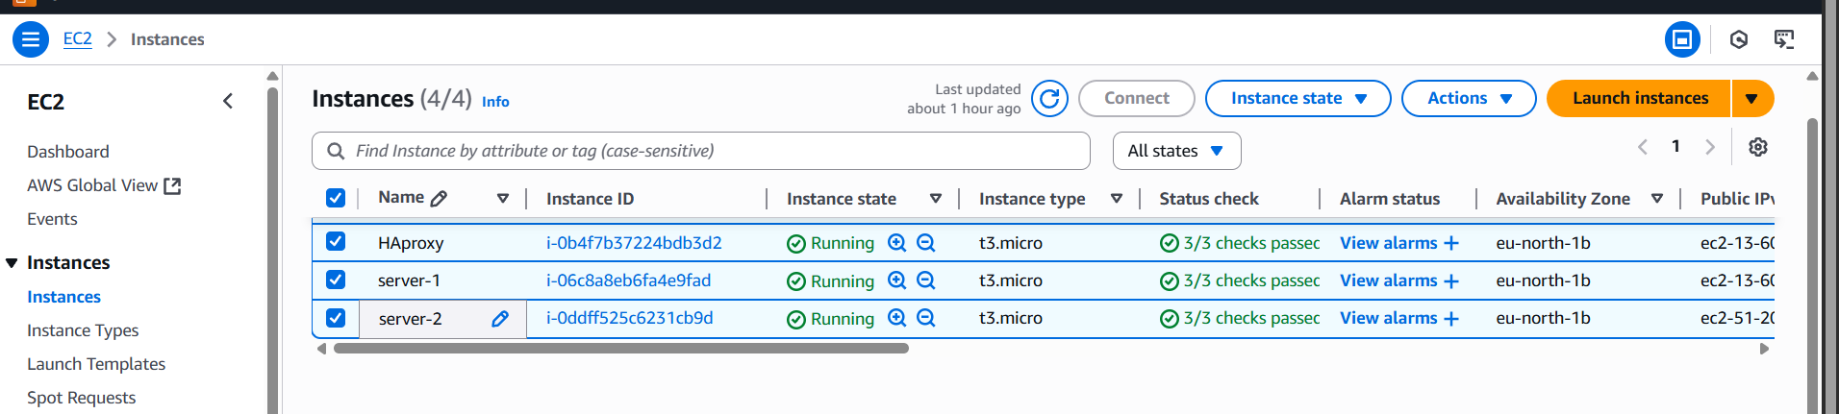

Step 1:

Connect the server 1 first to git bash

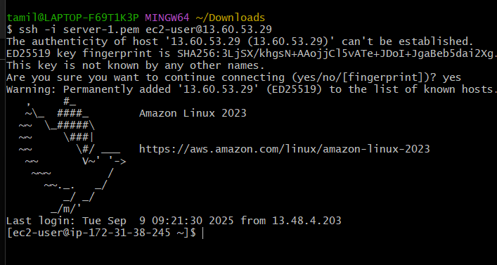

Change the ec2-user to root user

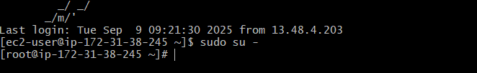

Step : yum update -y

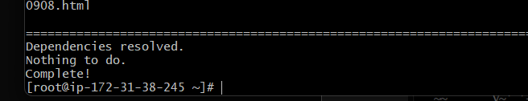

Next yum install httpd -y

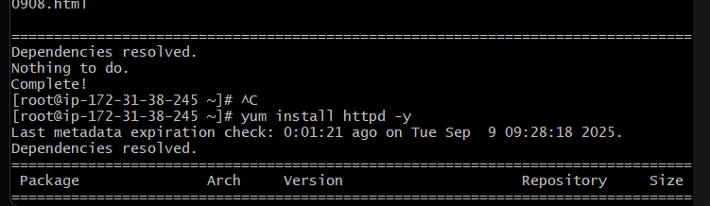

Open the file using : vi /etc/hosts  
then add your IP ADDRESS HERE. I added our ip address so that we can see there

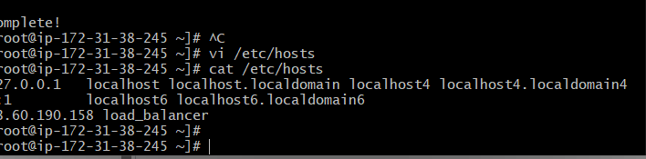

AFTER YOU ADD YOUR IP, You SHOULD EXECUTE THIS COMMAND   
ping load_balancer -c 4

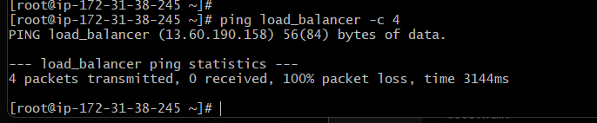

Then after checking the system status

Using these commands, systemctl start httpd and systemctl status httpd   
after you can check whether it's run or not

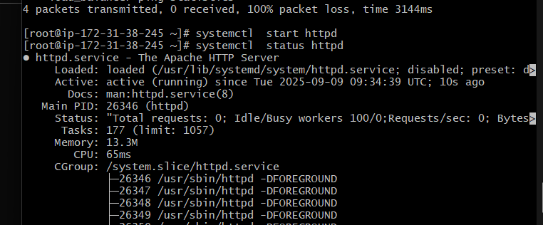

Copy you ip address paste it web browser you check whether its work or not

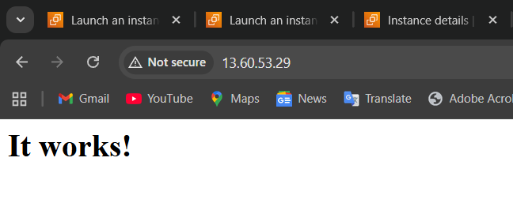

2)Server -2 connect

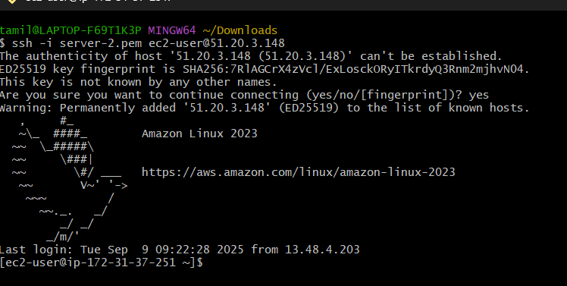

Change user to root using the command sudo su -

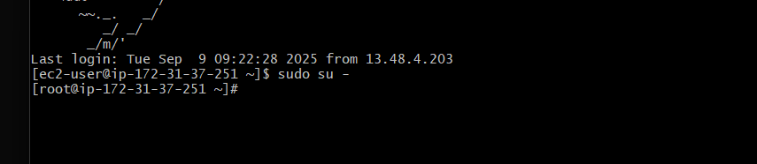

After yum update -y

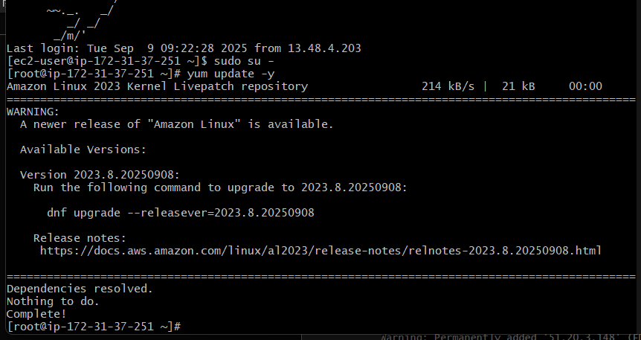

Step : yum Install nginx -y

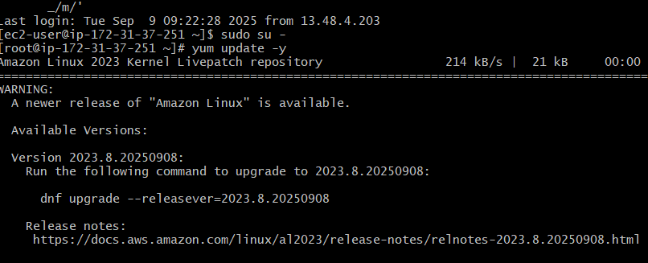

Open: vi /etc/hosts

Cat / etc/hosts => you able to see the change I added the IP address

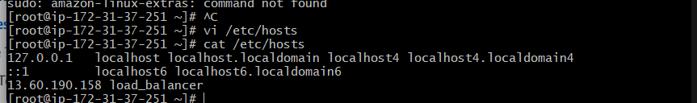

After adding, execute these commands  
ping load_balancer -c 4

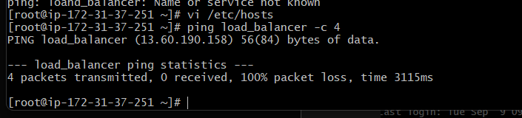

Check the status   
systemctl start nginx

Systemctl status nginx

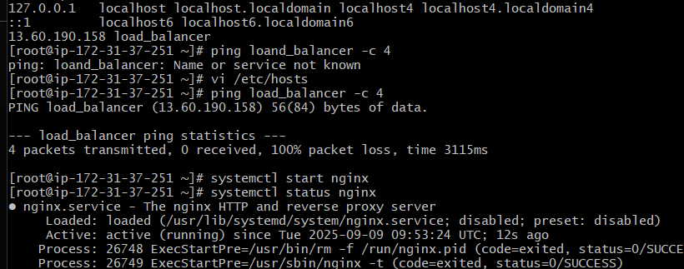

Check your ip in the web server (IP:80)

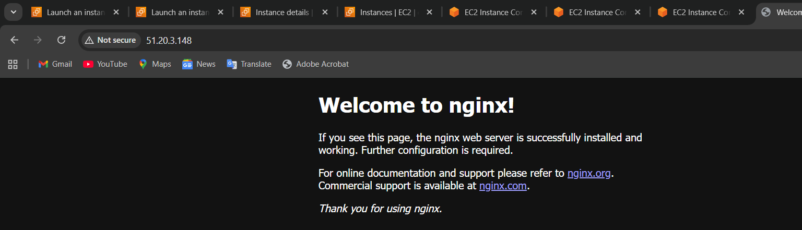

3)haproxy installation

Connect EC2 instance

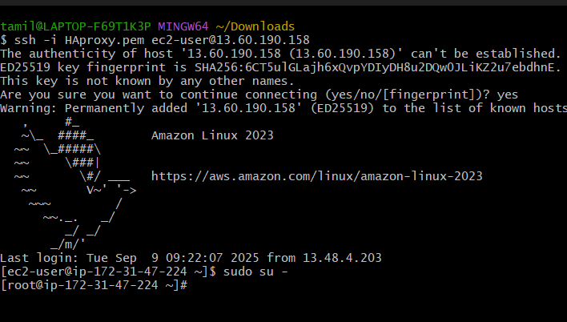

Change the user to root sudo su –

Then after yum update -y

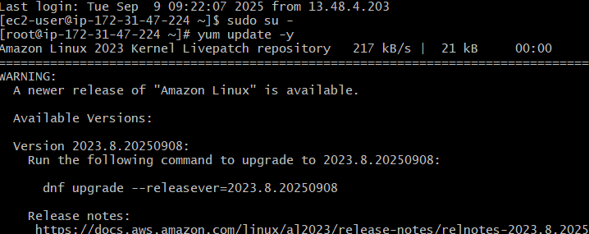

Ysue this command for install haproxy Yum install haproxy -y

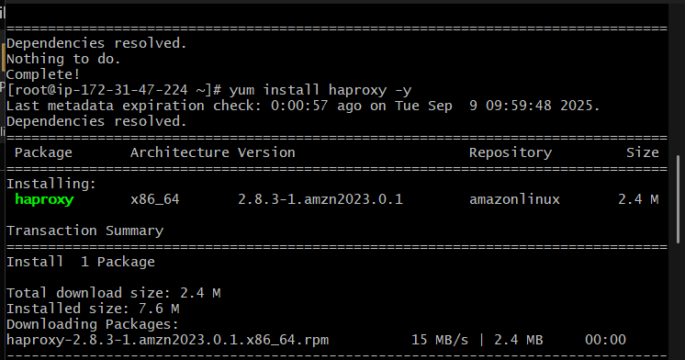

Install after open a file   
vi /etc/hosts

Cat /etc/hosts  
you can add the server 1 ip address and the server 2 address   
you can see there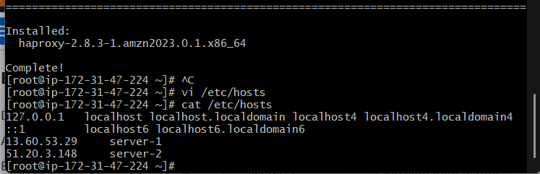

We need to make a change in two places. There is 80 and below in one screenshot that also

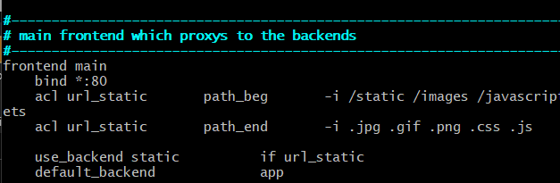

Then, after you can change the settings below the server 5 and server 6  
we should add both IP addresses we need to add here

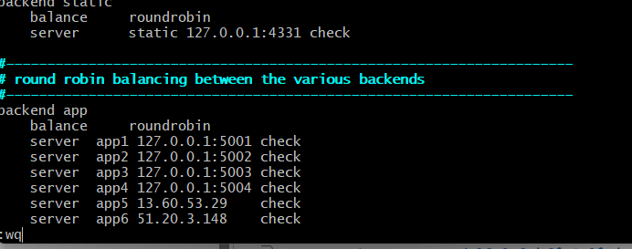

Add after that some commands we have to execute  
systemctl enable haproxy => it takes some time to execute   
The first one screen short failed because the server was down, which resulted in failure.   
then, after I can change properly I got the correct output

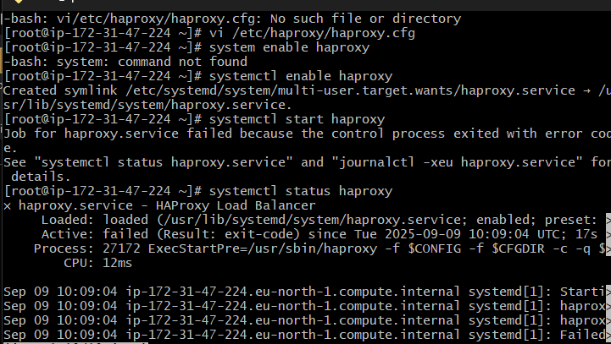

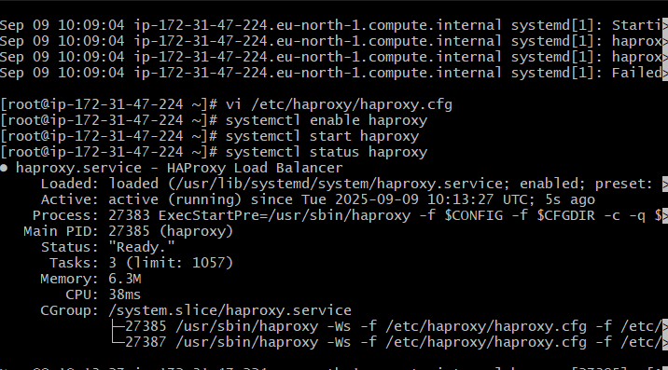

Then it works well

