1)Install git.t ‘—version used to check which version we are using version

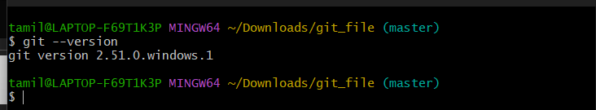

2)Create a repo in GitHub with README.md and a.gitignore file.

Create a new repo => enable the option README.md and Visual Studio (.gitignore)

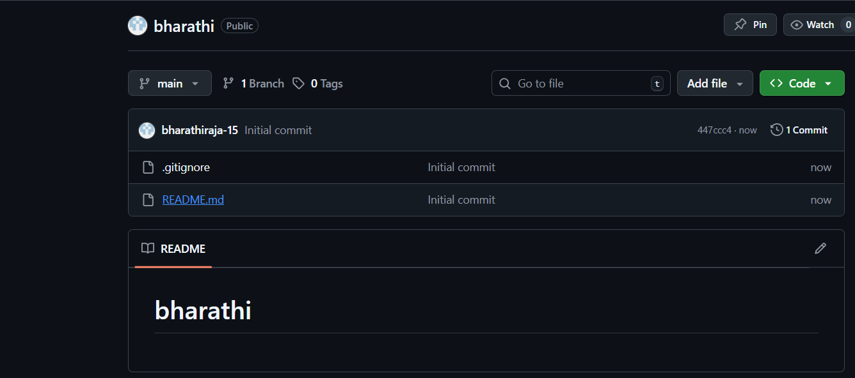

3)Clone the created repo to local.

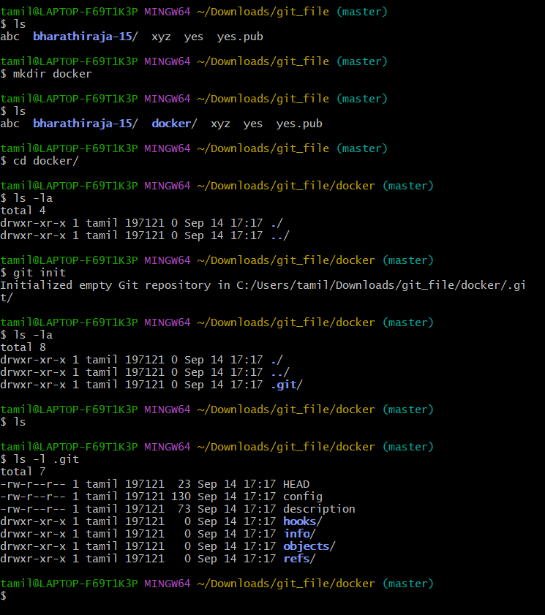

Use the command git clone(link)

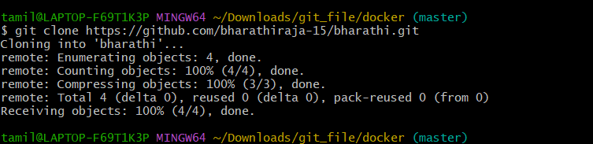

4’)Create two files in the local repo.

Use the command touch file1.txt

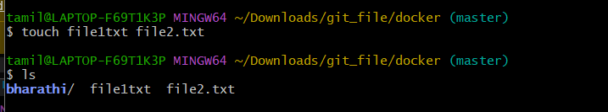

5) Commit two files and push to the central Repository.

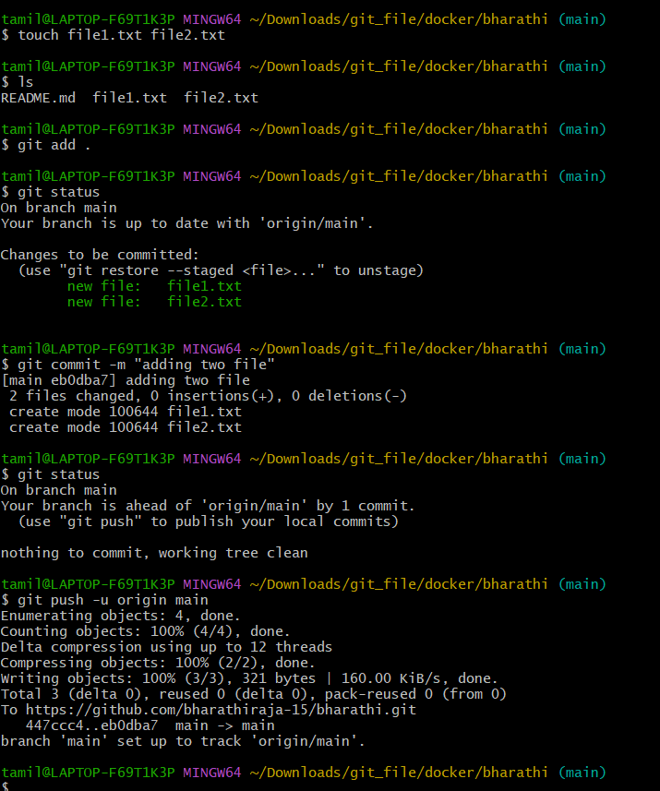

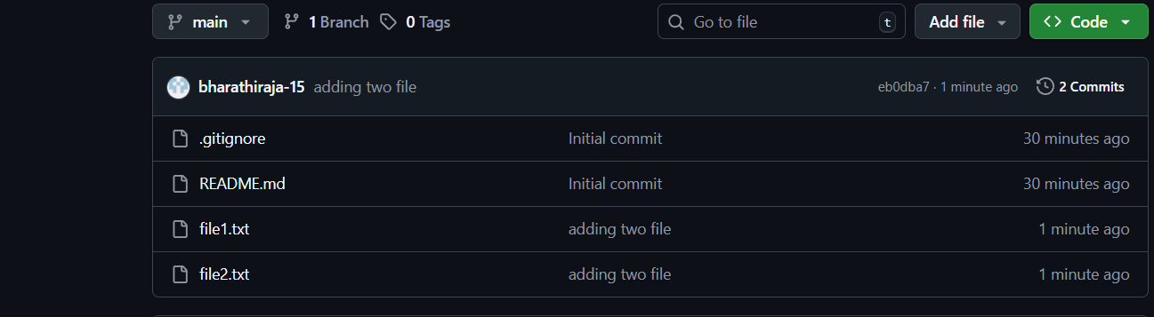

6)Create a branch in local, create a sample file, and push to central.

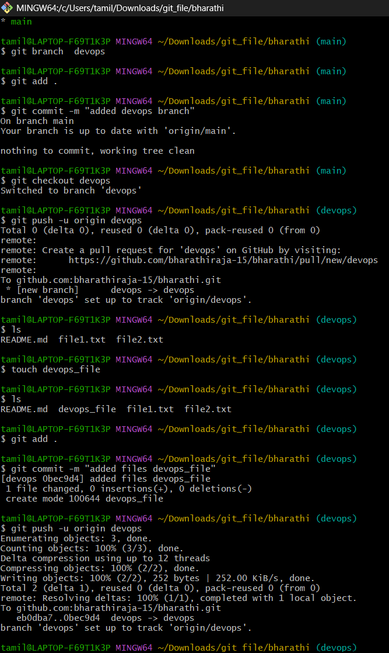

We can see the DevOps branch and file also

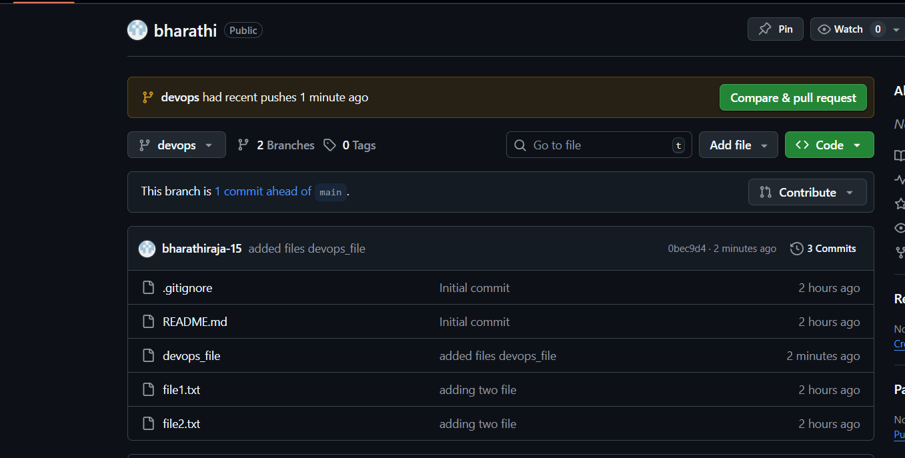

7)Create a branch in github and clone it to local.

I created a Chennai branch in GitHub, and we can see it there

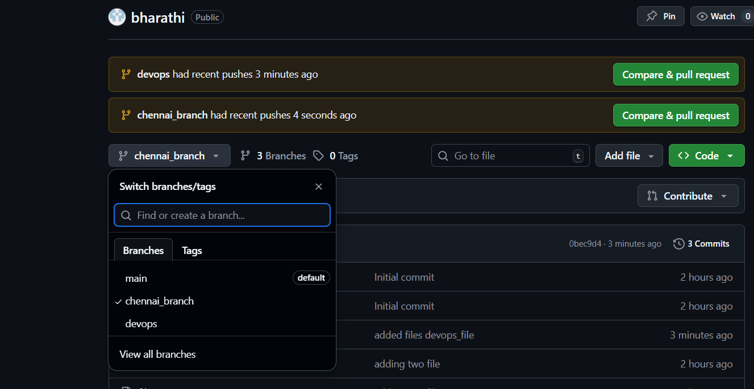

Use git clone (link )

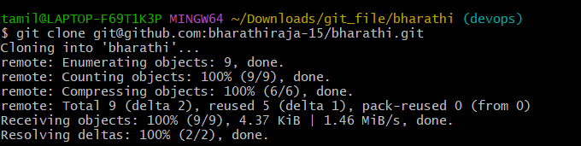

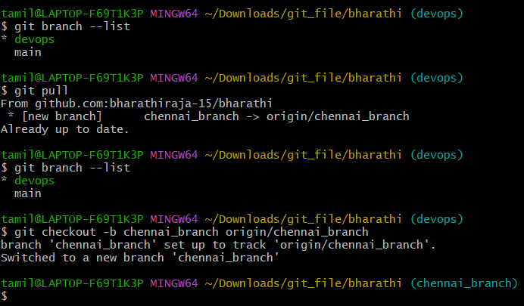

8)Merge the created branch with master in git local.

Firs I changed branch to devops you able to see files

Second step I check files you devops file one there. later I switch the main branch

Main branch also file not there bacusae file megre to the main branch files also merged

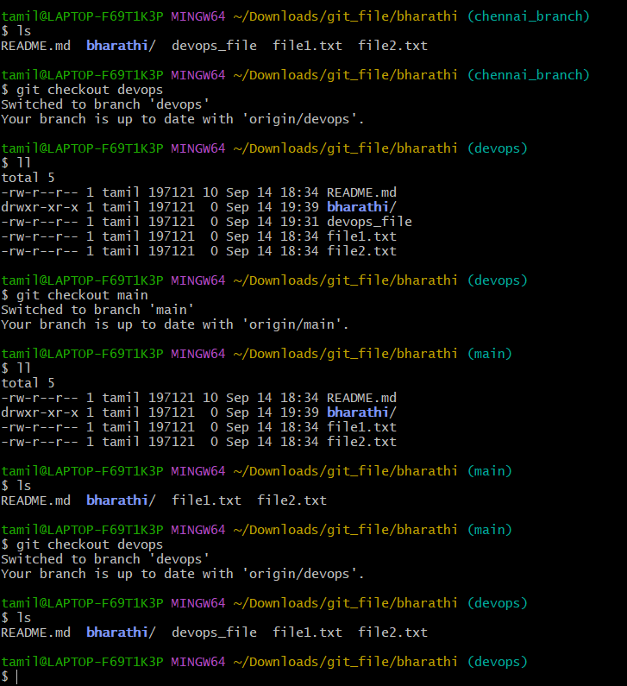

8)Merge the created branch with master in github by sending a pull request.

See there I merge the branch

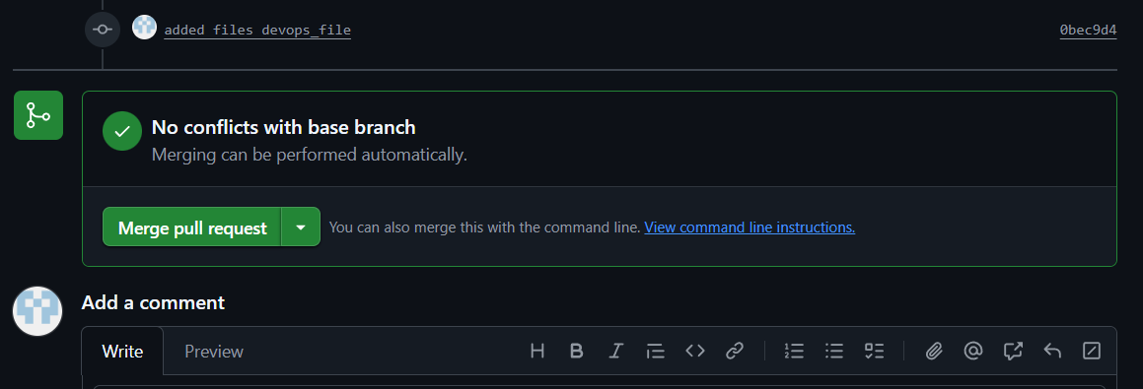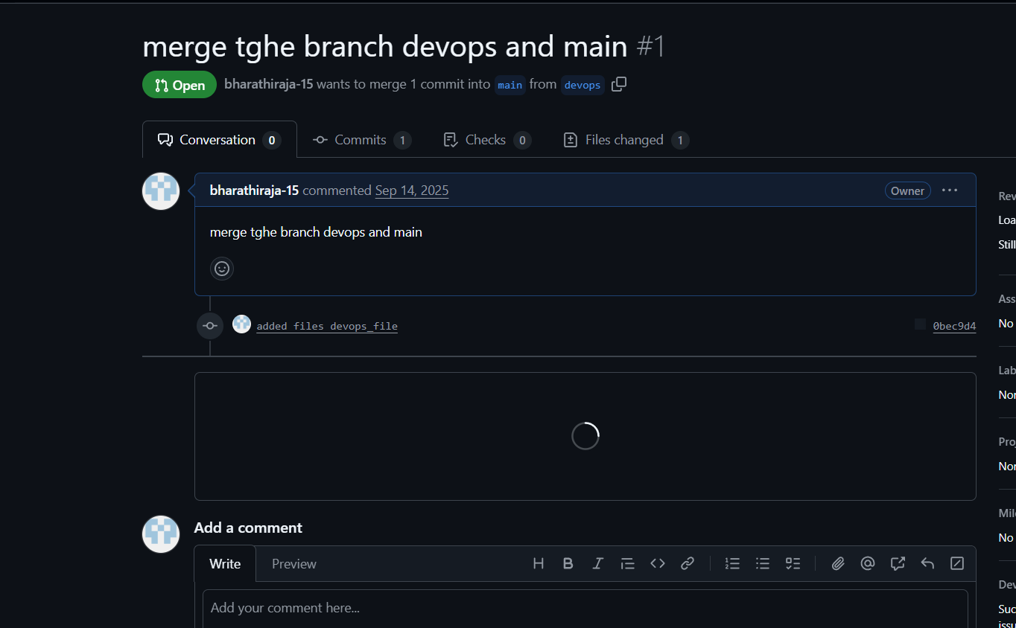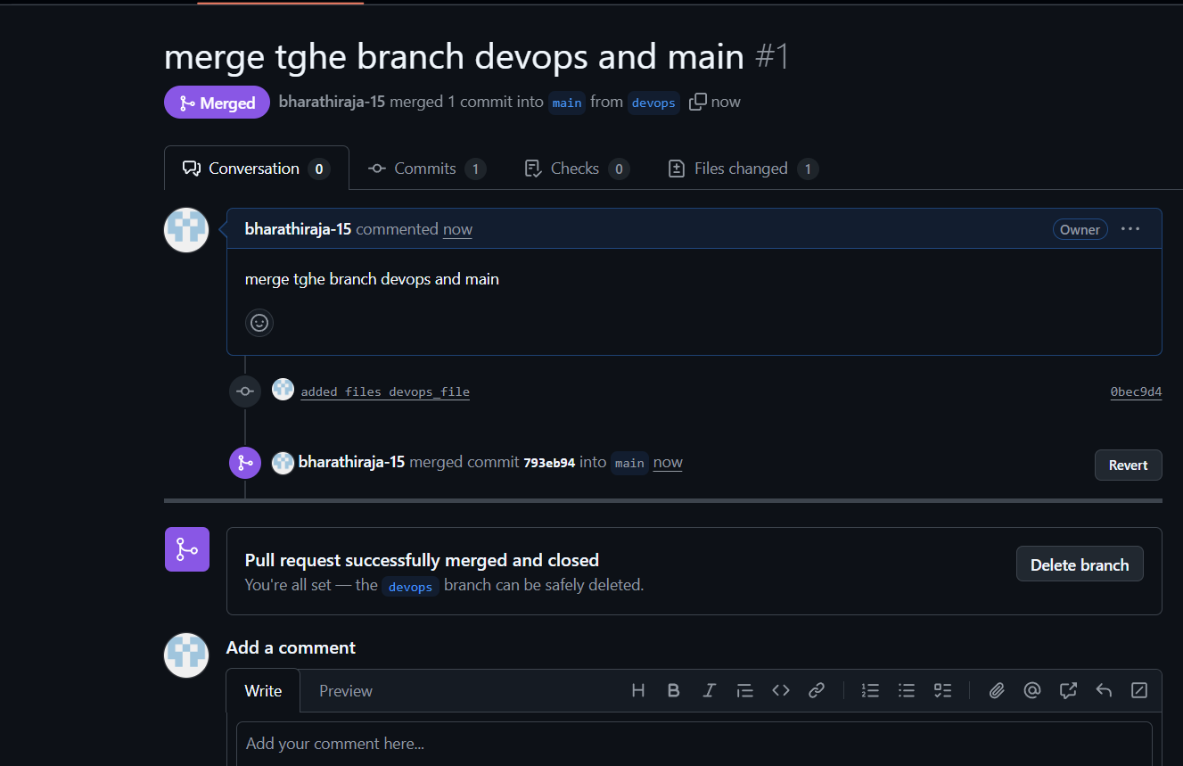

10 )Create a file in local and send that to branch in github.

I created a file ffile3_local

The I added used (git add .)

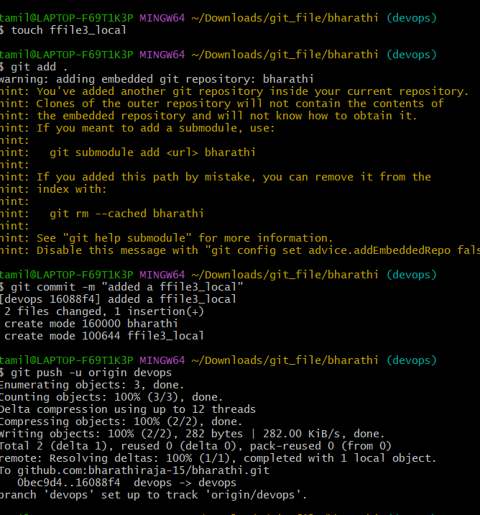

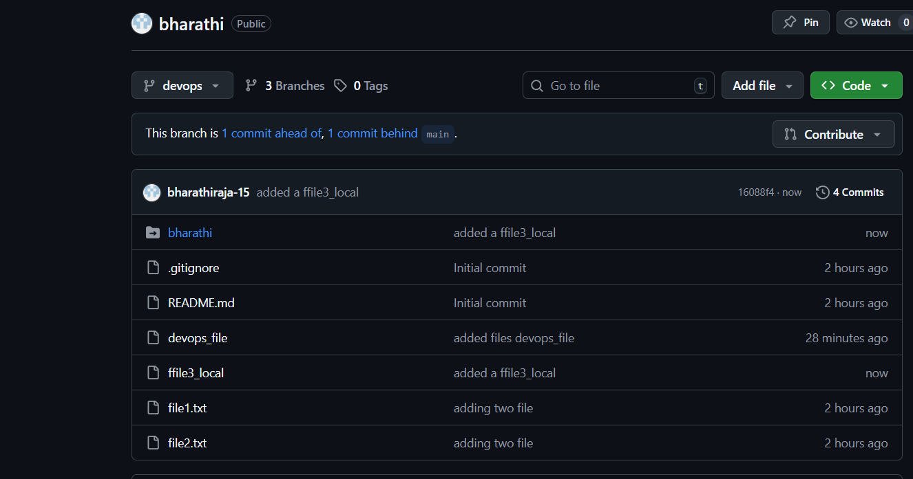

11 )Clone only a branch from GitHub to local.

I created DevOps.2.1 branch

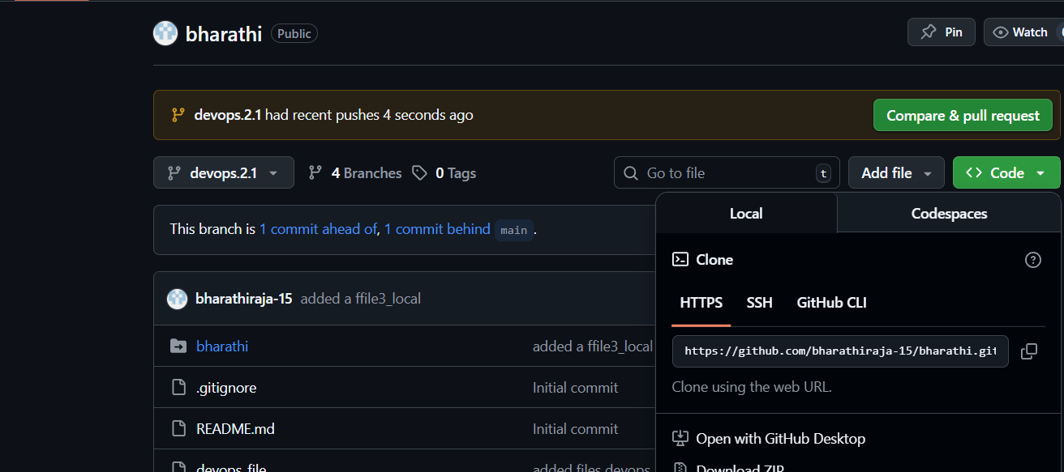

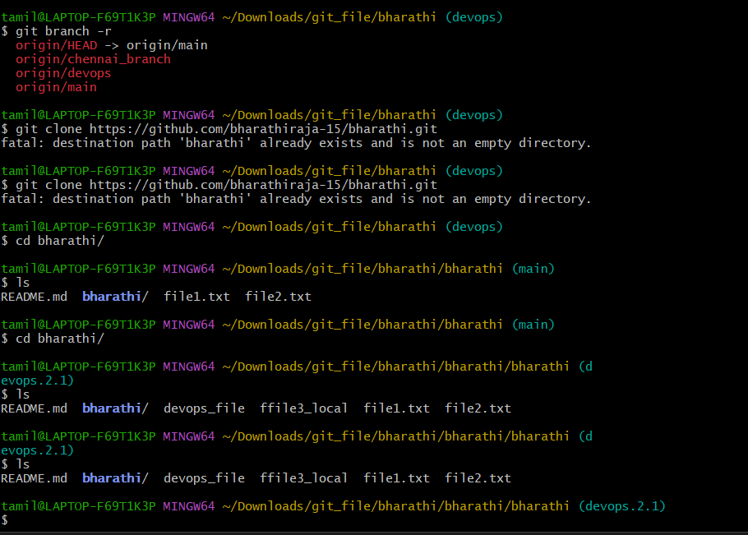

12 )Create a file with all passwords and make that untrackable with git.

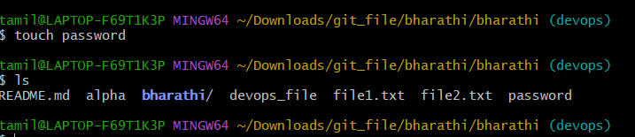

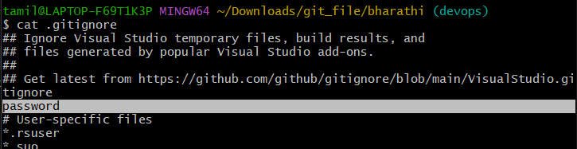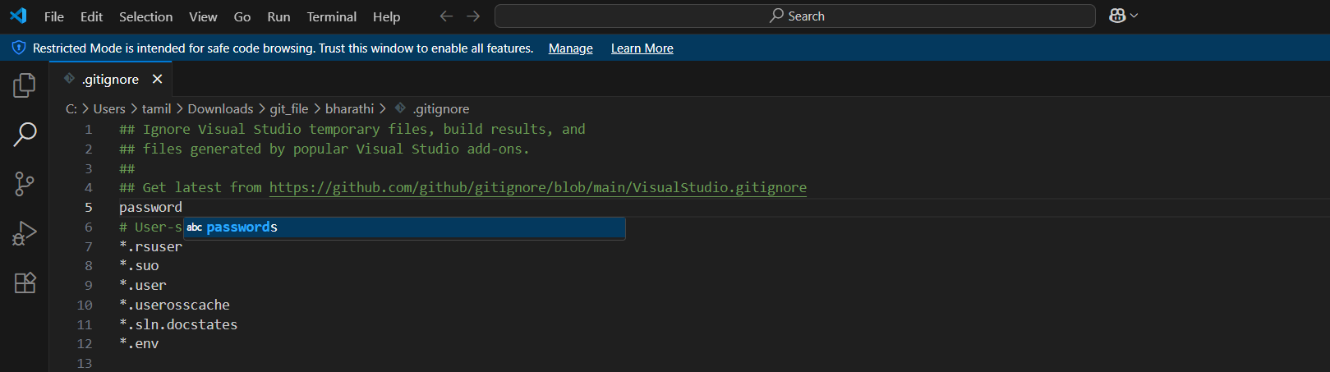

Git push origin devops –force “this command pusdh forcefull to github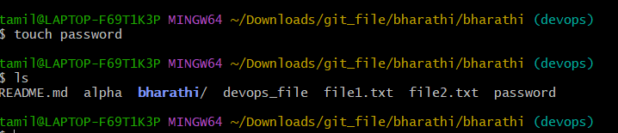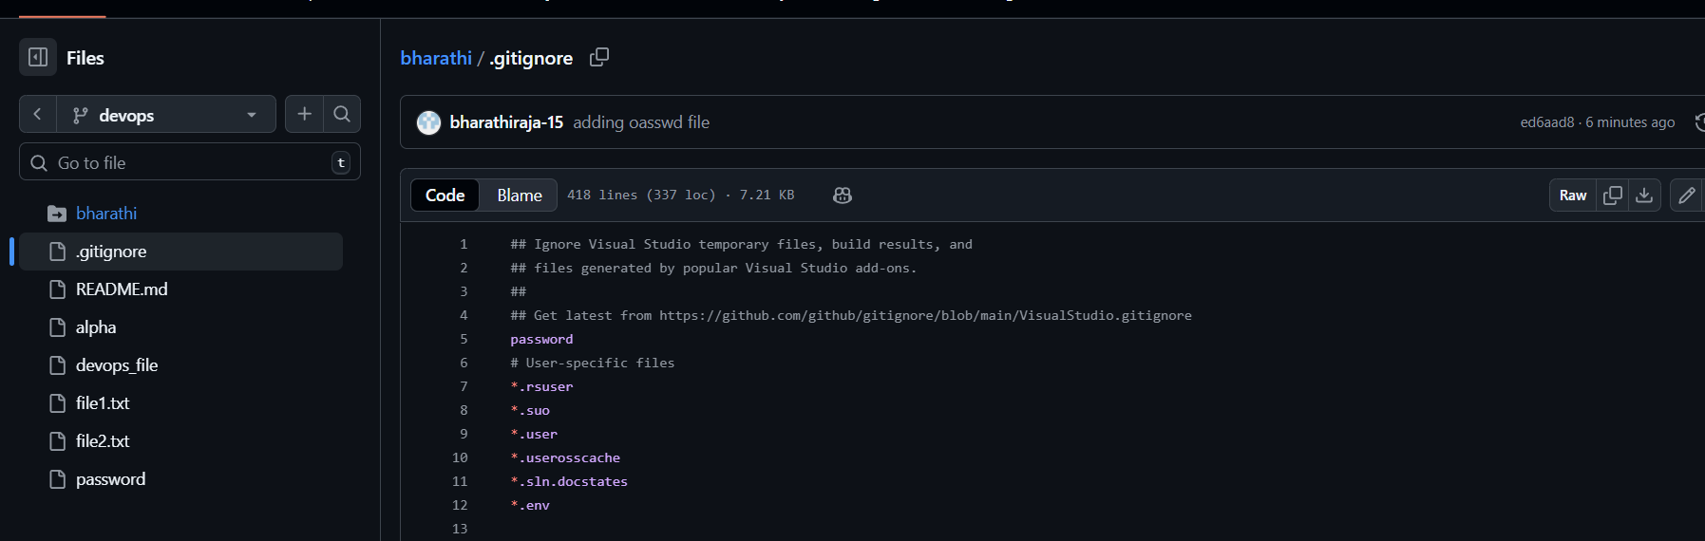

13 )Make a commit and make that commit reset without saving changes.

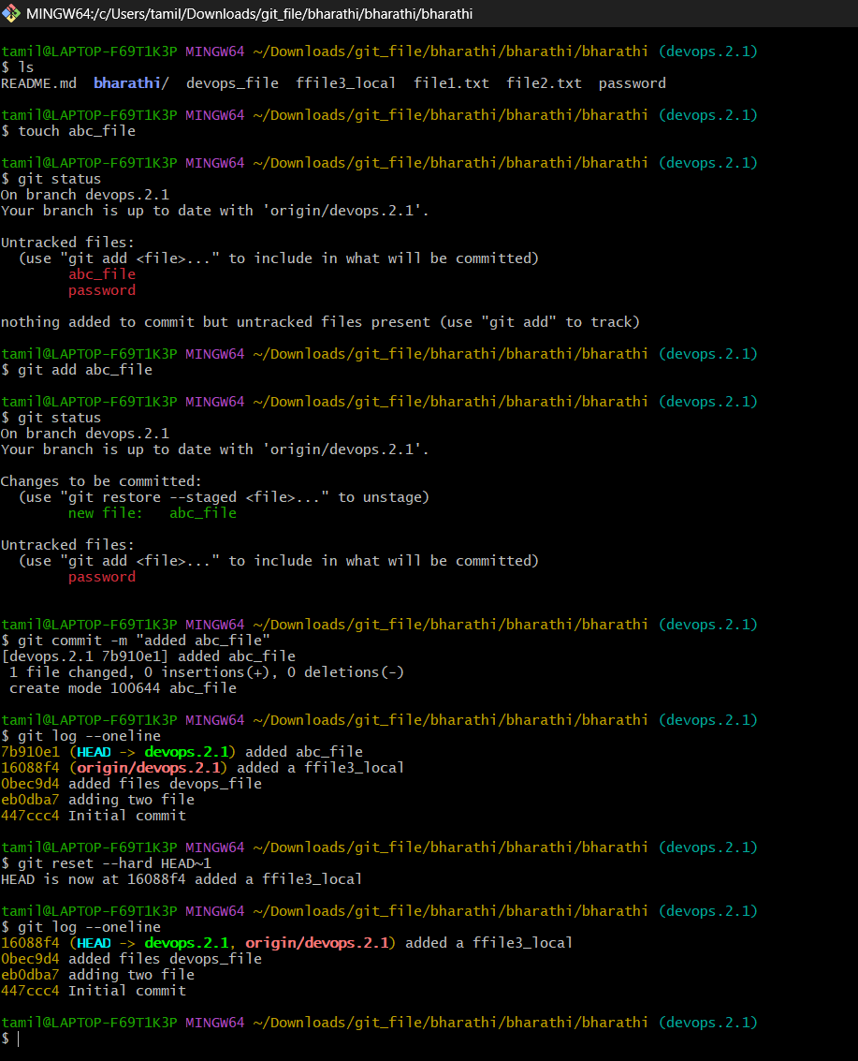

14 )Revert a committed commit to the older version.

Git commit –amned give this command this page will show whatever we want to change. First line we can

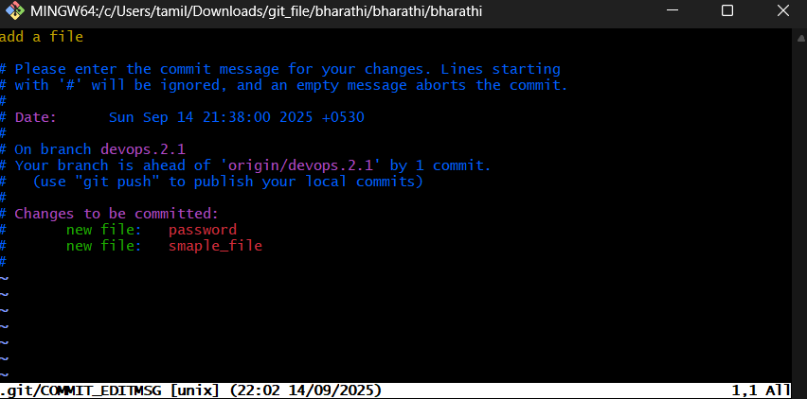

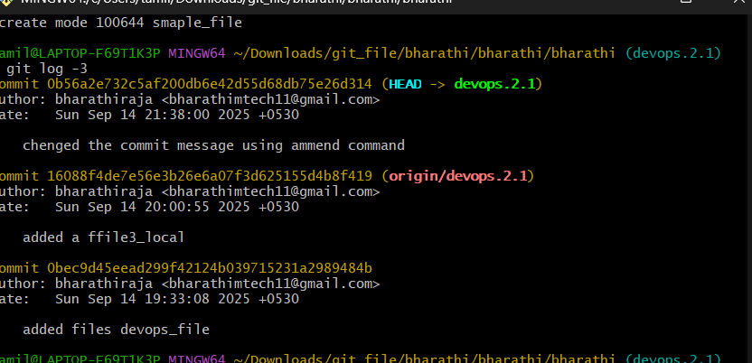

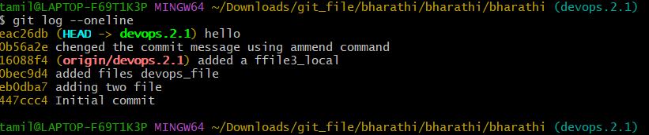

15 )Push a file to stash without savings the changes and work on another file.

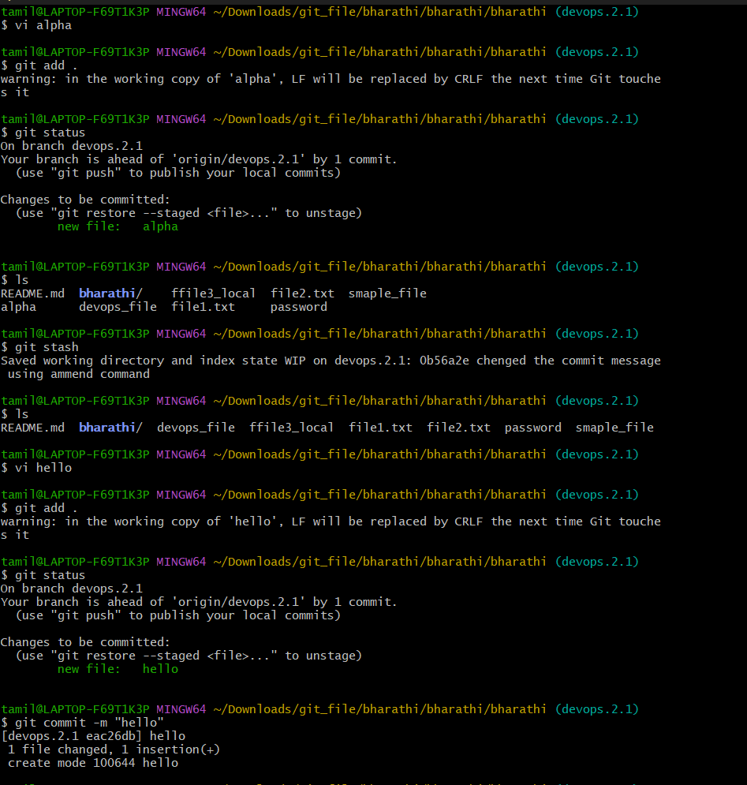

16 )Undo the stash file and start working on that again.

If you want revert the file use (git stash) (git stash pop )

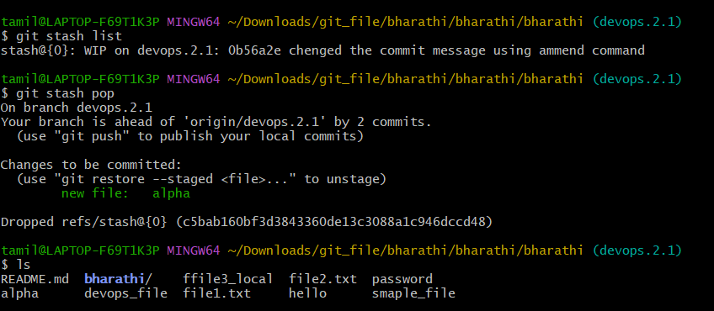

17 )Generate an SSH key and configure in GitHub.

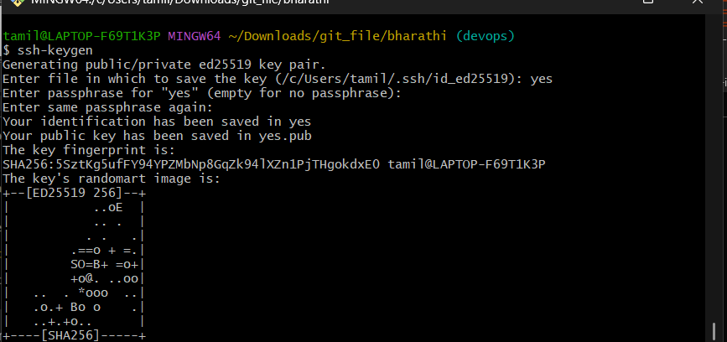

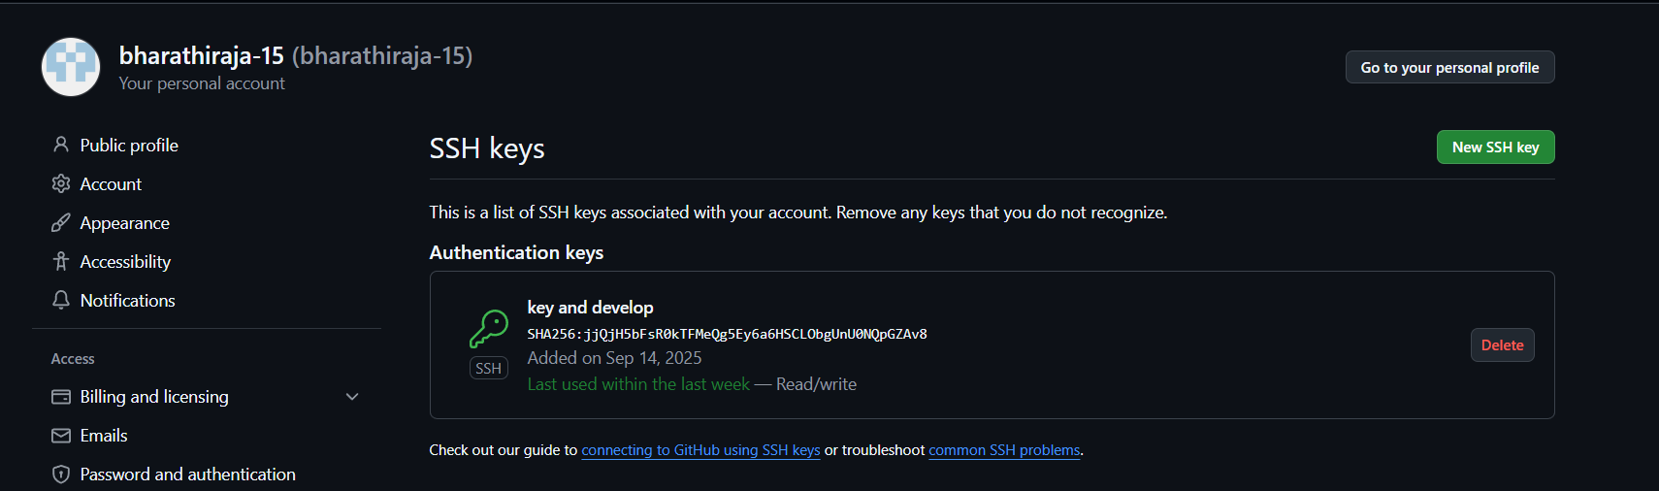

18) Configure webhooks to github.

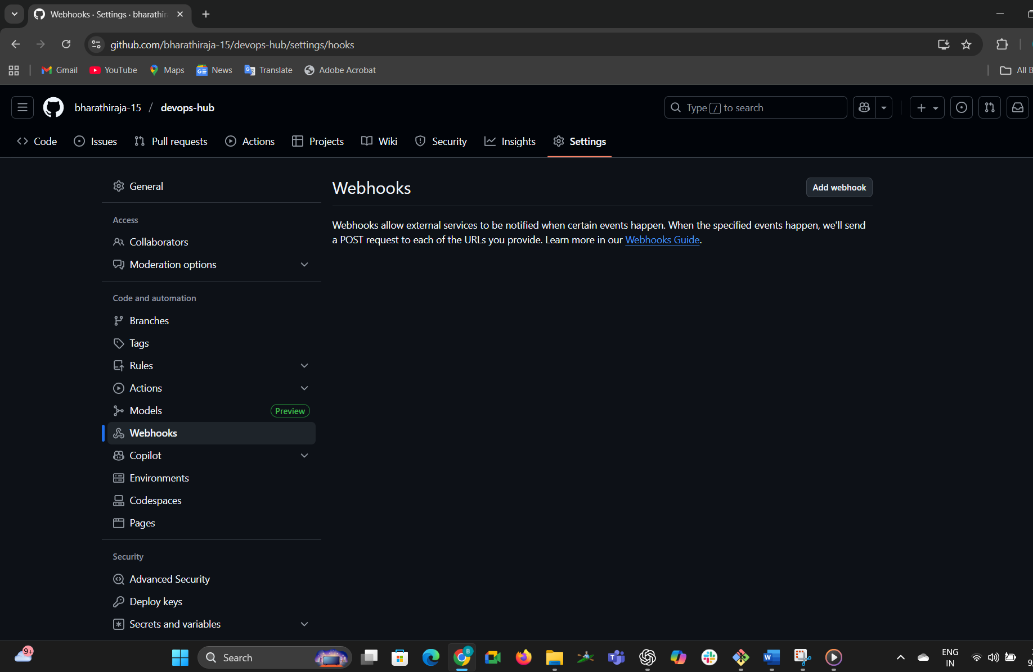

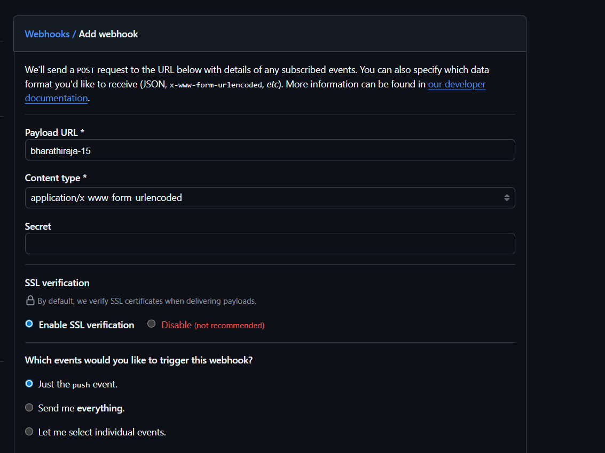

When you provide all the details like payload URL, secret and in which event we want to trigger, then we can see the GitHub webhook configured:

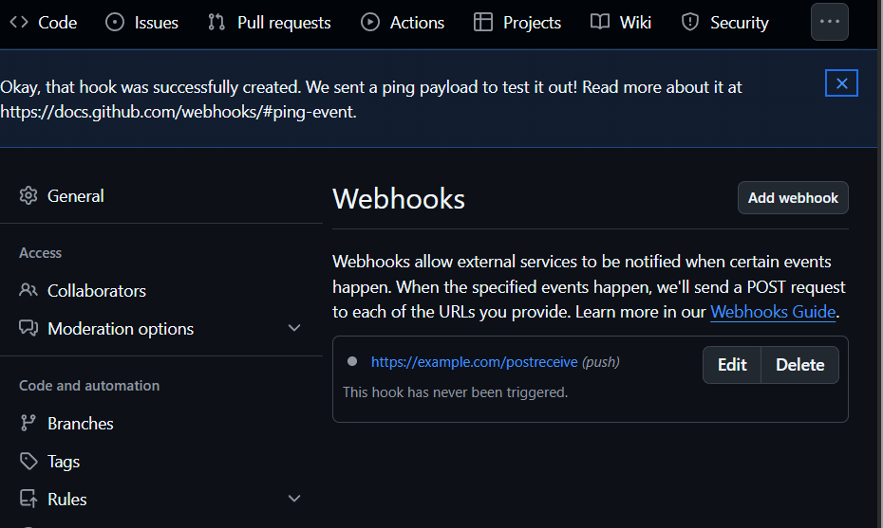

19)Basic understanding of .git file.1.When you run git init in a project, Git creates a hidden folder called **.git** at the root.

2.This folder is the **local database of Git**.

3.It stores **everything Git needs**: commit history, branches, tags, configuration, and objects.

4.That’s why deleting .git makes your project “forget” it’s a Git repo.

20) Check all the logs of git.

git log

Shows all commits in the repo (by default, from your current branch):

Compact view:

git log - -oneline

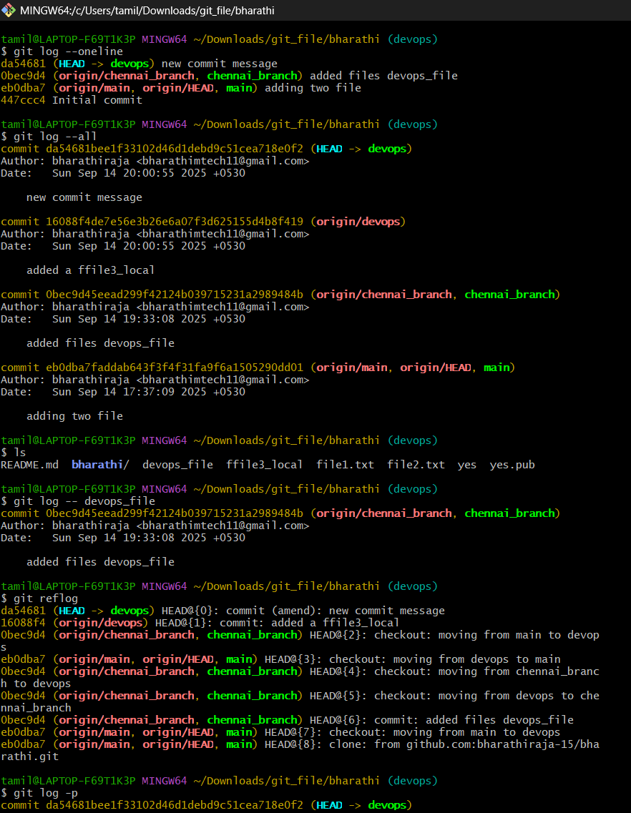

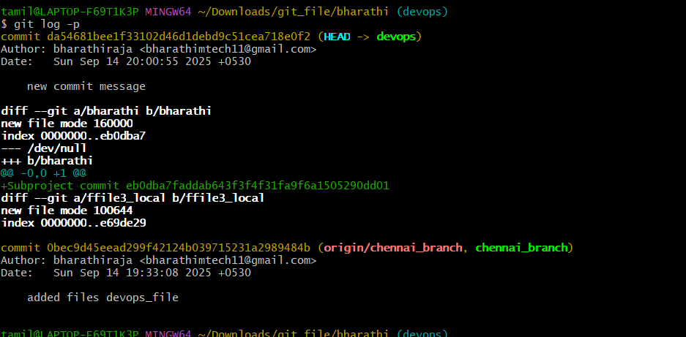

21)Rename the commit message.

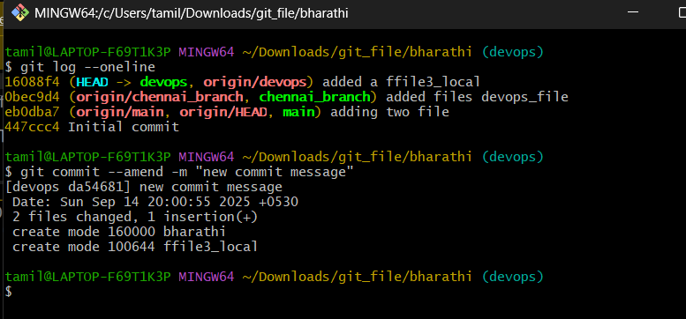

22 )Merge multiple commits into a single commit.

